Enhancing Team Performance: The Role of Key Models in Building Effective Teams within Organizations

Module Name
Module Code
Student Name
Student ID
Word Count
Submission Date

Introduction
Every organization requires effective teamwork, as it helps to bring together its people, increase their problem-solving capability and achieve the collective goal of the organization (Askari et al., 2020). In today's turbulent business world, organizations must deal with tough challenges and competition; high-performance teams are crucial for organizations to succeed. Teamwork weaves disparate strengths, skills and brains into a cohesive greater whole, providing better decision-making, innovation and productivity.
Theoretical Framework
Understanding different team dynamics, roles, team development stages and conflict management strategies is mandatory for teams to function successfully in organizations.
Using Belbin’s Team Roles Theory, they argue about how different roles a team member can play will contribute to the success of the team based on their natural strength in those roles (Belbin, 2024). In contrast, it highlights how collaboratively writing software requires striking a balance within your team structure around a team's Plant, Shaper, and Coordinator roles.
Tuckman’s Stages of Team Development provides the framework for how teams progress over time. The Forming, Storming, Norming, Performing and Adjourning five stages describe the issues and benefits of a team's development from formation to high performance (Wale, 2024). Knowing these stages can help managers steer their teams past obstacles and work together.
The Kilmann Conflict Management Model allows one to see how teams can solve their conflicts and how they can better manage them. This model helps teams learn how to deal with disputes and keep the working relationships healthy (Sayadat, 2024).
Team Roles (Belbin Model)
The concept of Belbin Team Roles, first developed in the 1980s by Dr. Meredith Belbin, is built on identifying the strengths and weaknesses of individual team members as well as how they reinforce the effectiveness of a team as a whole (Adamis et al., 2023). The model of Belbin suggests that teams work better when they are made up of a combination of interdependent roles, of complementary characters where each role responds to different needs within the team.
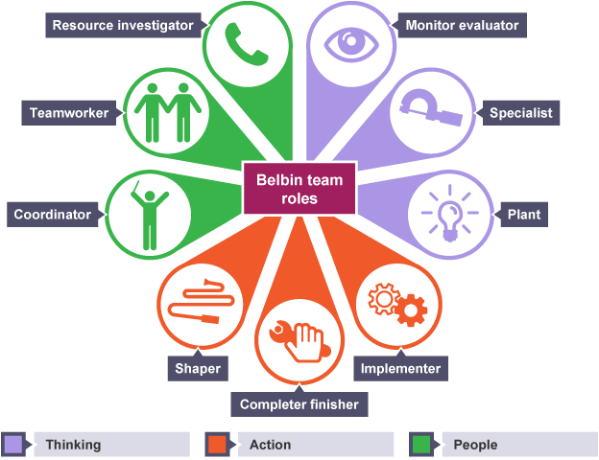
The Nine Team Roles identified by Belbin are as follows:
- Plant: The creative thinker who generates innovative ideas and solutions. Plants are often original and unconventional in their thinking but may need help with the practical application of their ideas.
- Shaper: The dynamic and challenging team member who drives the team forward, setting goals and pushing others to achieve them. Shapers thrive in high-pressure environments but can sometimes be overly critical.
- Coordinator: The organizer and leader who ensures that everyone is involved and that the team works cohesively towards its objectives. Coordinators excel at delegating tasks but may be perceived as manipulative or over-controlling.
- Monitor-Evaluator: The logical, objective thinker who analyzes ideas and options critically. They provide strategic insight but can sometimes be overly critical or indecisive.
- Implementer: The practical and reliable team member who turns ideas into action by implementing plans efficiently. Implementers are disciplined but can sometimes be inflexible.
- Completer-Finisher: The perfectionist who ensures that all tasks are completed to a high standard. Completer-finishers are detail-oriented but may be overly concerned with minor details.
- Resource Investigator: The extroverted and enthusiastic team member who explores opportunities and builds external relationships. They bring in new ideas but may need help to focus easily.
- Teamwork: The supportive and diplomatic team member who helps create a harmonious team environment. Team workers are good at resolving conflicts but may avoid difficult decisions.
- Specialist: The expert who brings deep knowledge in a particular area. Specialists contribute valuable expertise but can be less flexible and overly focused on their area of specialization.
The Belbin model has been applied by many organizations to improve those teams. For example, in global consulting firms, teams are typically composed of Shaper, Coordinators and specialists who each bring a certain role – their role complements others but also requires a certain technical expertise (Aranzabal, Epelde and Artetxe, 2022). Organizations must, therefore, strike a balance in having each team diverse enough with creative thinkers, action-oriented members and problem solvers to receive optimal task allocation and performance. Teams made up of a collection of various roles at Google provide innovative solutions, collaborative endeavors and an extremely successful environment (Aritzeta, Swailes and Senior, 2007).
If one knows the Belbin roles, understanding the role helps with task allocation. You want to get the right people matched with the right tasks. For example, the Assignees may be a Plant who would take part in a creative brainstorming session to propose solutions, and an Implementer to make those solutions implemented. With these natural preferences known, team leaders can better build a team that is more harmonious, more qualified to work together, and more fully utilizing individual strengths (IAMP, 2024).
Understanding Team Development (Tuckman Model)
In 1965, Bruce Tuckman introduced the Tuckman Model of Team Development, which is a series of stages teams experience while forming and developing (Chapman, 2017).
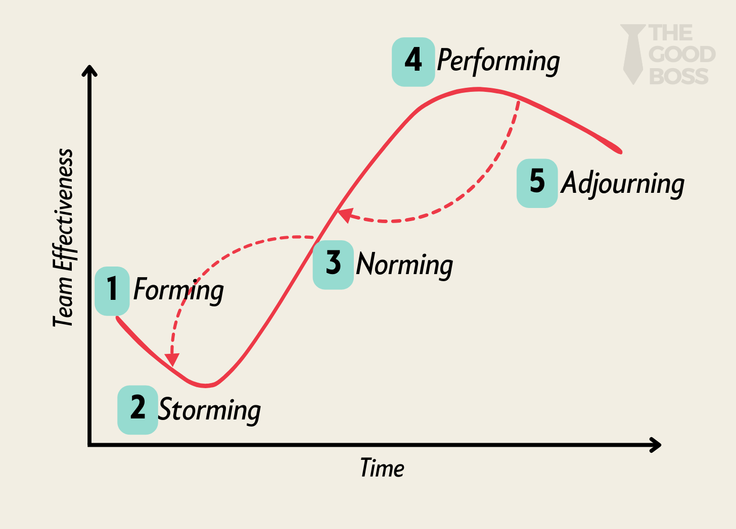
- Forming: This is the initial stage where team members are introduced, and the team’s goals and structure are defined (Bitesize Learning, 2023). During this phase, team members are typically polite and cautious as they get to know each other and build trust and communication.
- Storming: Conflict arises as team members start to express their individual opinions and vie for leadership or influence. This is a critical stage, as team members challenge ideas, and disagreements may occur (Overton and Lowry, 2013). Managing conflict and fostering cooperation. While tensions are common, healthy conflict resolution at this stage can lead to stronger team cohesion.
- Norming: In this stage, team members begin to establish relationships, clarify roles, and agree on how they will work together. Norms and expectations are set, and collaboration becomes more effective. Establishing clear roles and standards that guide behavior helps the team function more cohesively.
- Performing: The team reaches its peak in this phase. It functions efficiently with minimal friction, and members are highly focused on achieving the team’s goals. Roles are clear, and communication flows freely (Hout and Davis, 2021). Achieving synergy and high performance. Team members work together toward common objectives, demonstrating a high level of trust and respect.
- Adjourning: This final stage occurs when the team completes its objectives or when a project concludes. The team disbands, and members reflect on their experiences. Managing closure and reflection. Teams should celebrate their successes and address any unresolved issues before disbanding.
Looking at companies like Apple showed how a team is able to move forward by Tuckman’s stages, particularly in the product development stage (Chester, 2022). At the beginning of the project, new ideas are presented, and the teams go through the Forming and Storming stages. When teams make it to the Performing stage, they are working so well together that they are able to deliver innovative products to market. Creating psychological safe for teams at Google has allowed them to speed through the stages a bit more, allowing them to reach the Performing stage quicker.
These stages need to be navigated successfully by team leaders through ‘open communication’, ‘opportunity for constructive feedback’, and ‘clear leadership’. Therefore, during Storming, conflict should be handled positively, i.e., through collaboration (Sokman et al., 2023). Team building activities and close communication can help teams easily transition to the norming and performing stages of work where teams are at their most productive.
Managing Conflict in the Workplace (Kilmann Model)
The Kilmann Conflict Management Model is key to knowing how individuals deal with conflict in teams. There are five steps that each amount to a particular level of assertiveness coupled with cooperativeness, and each carries a role in team dynamics, depending on the circumstances (McPheat, 2022).
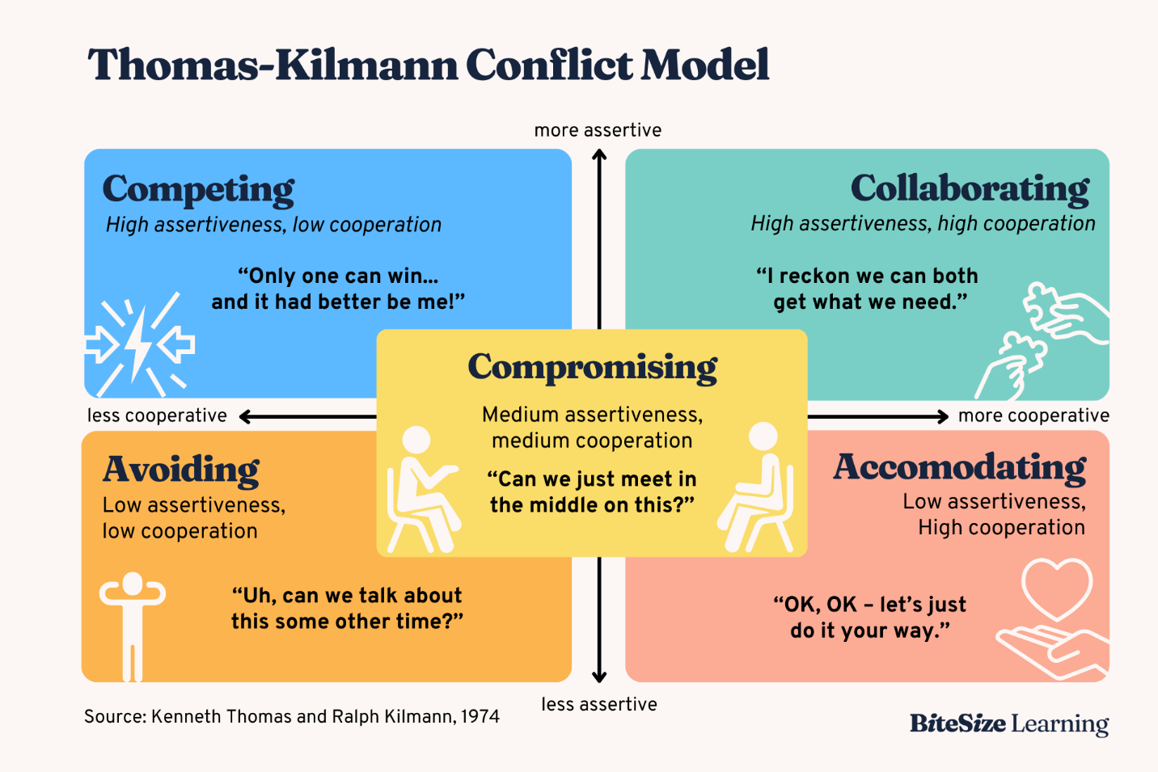
- Competing: This style is characterized by high assertiveness and low cooperativeness. Individuals using this style focus on winning the conflict, often at the expense of others. It is appropriate in high-stakes situations, such as when defending critical organizational goals or during time-sensitive decisions.
- Collaborating: Collaborating is a highly effective style for resolving complex conflicts where a win-win solution is sought. It involves high assertiveness and cooperativeness, focusing on understanding all parties' viewpoints and generating creative solutions (Bhardwaj and Sharma, 2024). This style is commonly used in innovation-driven organizations or during team brainstorming sessions, where diverse ideas and perspectives are needed.
- Compromising: Compromise involves moderate assertiveness and cooperativeness. It seeks a middle ground where each party sacrifices something. This style is often used in situations where time is limited and a quick resolution is necessary. It works well in situations where both parties must give something up to reach an agreement without damaging relationships.
- Avoiding: Individuals using the avoiding style are low in both assertiveness and cooperativeness. They prefer to delay addressing the conflict or sidestep it altogether (Kilmann, 2019). This style can be useful when the conflict is trivial or when emotions are running high, allowing time for reflection before re-engaging.
- Accommodating: The accommodating style is characterized by high cooperativeness and low assertiveness. Individuals prioritize the other party’s concerns over their own. It is effective when maintaining relationships is more important than winning the argument, such as in cases where one party has a greater stake in the outcome.
It is extremely important to recognize and understand these conflict styles because it will help in effectively resolving disputes and keeping team cohesion. For example, a team at a tech company might take a collaborative route to solve a complex problem and encourage teamwork and innovation. Yet, in the setting of time pressure, such as sales, compromise can sometimes be a way to break stalemates. Avoidance may be useful if conflicts are minor and not something that needs to be discussed now before tension escalates.
For example, organizations such as Google and Apple use similar styles (collaborating in decision-making) that can nurture idea-sharing and creativity and create a positive work environment. However, the competing style is used in contrast to Amazon by employing it in critical decision making for the sake of meeting urgent goals.
Conclusion
Finally, a number of models, like Belbin’s Team Roles, Tuckman’s stages of team development and Kilmann’s conflict management styles, among others, are necessary to have effective and functioning teams within organizations. By understanding team roles and the roles of individuals within a team, it will be easier to distribute tasks on the basis of individual strengths and foster collaboration as well as optimize team performance. Tuckman’s model is a framework that teams follow to progress through varied stages of team development so they can tackle problems and ultimately work efficiently. The Kilmann model is used meanwhile in controlling conflicts, improving communication, and maintaining team cohesion.
Reference List
Adamis, D., Krompa, G.M., Rauf, A., Mulligan, O. and O’Mahony, E. (2023). Belbin’s Team Role Balance and Team Effectiveness in Community Mental Health Teams in an Area of Northwest Ireland: Implications for Leadership. Merits, [online] 3(3), pp.604–614. doi:https://doi.org/10.3390/merits3030036.
Aranzabal, A., Epelde, E. and Artetxe, M. (2022). Team Formation on the Basis of Belbin’s Roles to Enhance Students’ Performance in Project Based Learning. Education for Chemical Engineers, [online] 38(1), pp.22–37. doi:https://doi.org/10.1016/j.ece.2021.09.001.
Aritzeta, A., Swailes, S. and Senior, B. (2007). Belbin’s Team Role model: Development, Validity and Applications for Team Building. Journal of Management Studies, 44(1), pp.96–118. doi:https://doi.org/10.1111/j.1467-6486.2007.00666.x.
Askari, G., Asghri, N., Gordji, M.E., Asgari, H., Filipe, J.A. and Azar, A. (2020). The Impact of Teamwork on an Organization’s Performance: A Cooperative Game’s Approach. Mathematics, [online] 8(10), pp.1–14. doi:https://doi.org/10.3390/math8101804.
Belbin, M. (2024). The Nine Belbin Team Roles. [online] Belbin. Available at: https://www.belbin.com/about/belbin-team-roles.
Bhardwaj, B. and Sharma, D. (2024). Uncovering Styles of Conflict Management. Emerald Publishing Limited eBooks, pp.39–49. doi:https://doi.org/10.1108/978-1-83797-971-420241004.
Bitesize Learning (2023). Forming Norming Storming Performing | Tuckman’s stages of group development explained [with diagram]. [online] BiteSize Learning. Available at: https://www.bitesizelearning.co.uk/resources/tuckman-stages-team-development-forming-norming-storming-performing.
Chapman, A. (2017). Tuckman: Forming, Storming, Norming and Performing - BusinessBalls.com. [online] Businessballs.com. Available at: https://www.businessballs.com/team-management/tuckman-forming-storming-norming-performing-model/.
Chester (2022). Tuckman’s stages of group development. [online] West Chester University. Available at: https://www.wcupa.edu/coral/tuckmanStagesGroupDelvelopment.aspx.
Hout, J.J.J. van den and Davis, O.C. (2021). Promoting the Emergence of Team Flow in Organizations. International Journal of Applied Positive Psychology, [online] 7, pp.143–189. doi:https://doi.org/10.1007/s41042-021-00059-7.
IAMP (2024). The 9 Team Roles according to Belbin | IAPM. [online] www.iapm.net. Available at: https://www.iapm.net/en/blog/team-roles-according-to-belbin/.
Kilmann (2019). An Overview of the Thomas-Kilmann Conflict Mode Instrument (TKI) A long-term collaboration by Kenneth W. Thomas and Ralph H. Kilmann - Kilmann Diagnostics. [online] Kilmann Diagnostics. Available at: https://kilmanndiagnostics.com/overview-thomas-kilmann-conflict-mode-instrument-tki/.
McPheat, S. (2022). What is the thomas kilmann conflict management model? [online] MTD Training. Available at: https://www.mtdtraining.com/blog/thomas-kilmann-conflict-management-model.htm.
Overton, A. and Lowry, A. (2013). Conflict management: Difficult conversations with difficult people. Clinics in Colon and Rectal Surgery, [online] 26(4), pp.259–264. doi:https://doi.org/10.1055/s-0033-1356728.
Sayadat, N. (2024). Review The Thomas Kilmann Conflict Resolution Model: What Lesson for Organizational Conflict Management... [online] ResearchGate. Available at: https://www.researchgate.net/publication/382078559_Review_The_Thomas_Kilmann_Conflict_Resolution_Model_What_Lesson_for_Organizational_Conflict_Management_can_be_Drawn_from_this_Model.
Sokman, Y., Othman, A.K., Aziz, A.A., Musa, M.H., Azizan, N. and Rahmat, N.H. (2023). Stages in Group Work: Is There A Relationship Among Them? International journal of academic research in business & social sciences, 13(11). doi:https://doi.org/10.6007/ijarbss/v13-i11/19764.
Wale, H. (2024). Understanding Tuckman’s Team Development Stages. [online] Corporate Finance Institute. Available at: https://corporatefinanceinstitute.com/resources/team-development/understanding-tuckmans-team-development-stages/.

