Report Title: Reflective Report
Student Name: Renata Messa Gutuzzo
Student Number: 2337141
Module Code: LCLM4001
Module Title: Academic Skills
Lecturer: Tim Hopkins
Date: 16/08/2024

Content Page
1 Introduction 3
2 Reflection Topics
2.1 Find information / Research skills 3
2.2 Paraphrasing skills 4
2.3 Reflection skills 5
3 Conclusion 6
4 References 7
5 Appendices 8

1. Introduction
During 10 weeks, I have learned a variety of academic skills that will be useful throughout my time at university and in my professional life. Using what I learned in class, the content provided by the lecturer, and my notes, I will reflect on some of these skills in more detail. This report is focused not only describe the skills shown, but also on analysing my personal experience in each class and highlight the importance of developing critical thinking. To do this, I will use the Gibbs Reflective Cycle (Gibbs, 1988). In my opinion, this model is the most complete and comprehensive, and can guide any topic I will write now or in the future.

2. Reflection Topics

2.1 Finding Information
Description
In week 3, I learned about different sources of information, which sources I should use (See Appendix 1), and how to choose which results to use for my research. For example, I learned the CRAAP Test (Blakeslee, 2004) and how to use the resources of the University library.
Feelings
I feel comfortable with this process, confident that it would be easy to apply what I learned, excited about having access to a wide variety of information and sources.
Evaluation
I believe that I am responsible for the information I intend to share with others, which makes this class highly important. Knowing how to filter sources based on their authority and credibility, and being able to select good content, are indispensable skills.
Analysis
I have always tried to select the best possible way for all the information I consume, but now I have the best tools to do so. This is extremely positive because it is very important that I know how and where to look for reliable information, and I also need to know how to analyse the results I find. This class gave me the tools I could to do this. The CRAAP test, for example, has steps that work as a guide to check the currency of the information, the relevance of what is being said here, such as the credentials of the person providing the information, the veracity of the facts and what is the intention of what is being reported (See Appendix 2).
Conclusion
This class improved my academic skills because it became very clear in my mind what steps I should follow to choose my sources and now I can extract the best answer to my questions. I used everything I learned in this class when I was creating my Digital Skills poster, for example.
Action
I will continue to use what I have learned, because it is always essential to obtain updated and reliable information about everything, whether in studies, work or personal life.

2.2 Paraphrasing
Description
In week 4, I learned techniques for paraphrasing, learning a step-by-step process that helps to obtain good results. Then we practiced this together with the lecturer (See Appendix 3). I had another paraphrasing of a sentence created by me (See Appendix 4).
Feelings
At the beginning of the class I was excited because I already knew the topic and I had always done it easily in Portuguese, which is my main language. However, during the class I could not feel confident, I felt lost and very frustrated for not being able to perform a task, especially when it came to finding synonyms.

Evaluation
So far this has been the most difficult topic for me, as I have also found it difficult to summarize, in both cases my challenge is in the language. However, I recognize that this skill is very necessary and is constantly used in academic work.
Analysis
My difficulty with this topic and my frustration is because my English vocabulary is still very limited. I cannot express what I think in English with the clarification that I want. In fact, during my quiz in class, I left two paraphrasing activities blank because I could not understand/translate the sentences, making it impossible to rewrite them in my own words.
Conclusion
Paraphrasing is the most efficient way to demonstrate that you understood what you were reading. It also helps to clarify ideas after absorbing a new subject. Rewriting something gives you the chance to reframe the understanding you had before.
Action
This class showed me in which areas I need to improve my English, and it became a challenge that I want to overcome. Since the day of the class, I have been doing exercises to expand my vocabulary, especially correspondence exercises.

2.3 Reflection
Description
In week 6 I had my first lesson on reflection skills, I read and heard the definition of this topic, using questions that can help at the time of writing (See Appendix 5) and learned three different types of styles that can be used in reflective writing. I also did an exercise in class using what I learned (See Appendix 6)
Feelings
I was excited to be able to express my opinion, confident in realizing that I had no difficulties with this task, encouraged by the opportunities that this skill provides.
Evaluation
I consider that an opportunity to talk about a subject from my point of view is an essential tool because it stimulates my critical thinking, I need to go depth into the subject to be able to write about it and I have to judge what I learned, what I feel and how I will use this in the future.
Analysis
Reflecting about an experience is a process that goes beyond simply describing the events. This practice helps me understand my emotions and reactions, as well as decide whether I want to explore these experiences. I realized that this lesson is a link with the class I had on Critical Thinking, together these practices can help to increase my understanding of anything.
Conclusion
This class proved to be fundamental to my academic development, as it increased my capacity for self-criticism, giving me a better understanding of my own experiences and their impact on my learning. This skill is valuable not only in my academic career, but also in my professional life, where continuous learning and analysis are essential.
Action
I plan to use the practice of reflection regularly throughout my university career. You will dedicate time each week to reflect on what I learn in the class, analysing what worked well and what could be improved. In addition, you will use reflection models, such as the Gibbs Cycle, to guide my analysis and ensure that I make the most of each opportunity. Over time, I hope this practice will become a natural habit that will help me grow professionally.

3. Conclusion
Throughout this report, I was able to reflect on the academic skills I learned during this term. Each topic I chose played a crucial role in my academic and personal development. These classes improved my study tools and my ability to think more clearly and objectively. All the activities and examples shown in class helped me fully understand what was being taught. And now that I can practice using these skills while developing this report, I can see that the constant practice of these techniques will allow me to go through learning challenges with more confidence and effectiveness.

4. References
Gibbs, G. (1988) Learning by doing: a guide to teaching and learning methods. London: FEU.
Blakeslee, S. (2004) The CRAAP Test. California State University. Available at: https://commons.emich.edu/loexquarterly/vol31/iss3/4 [Accessed: 13 08 2020].

5. Appendices
Appendix 1 – Types of sources.
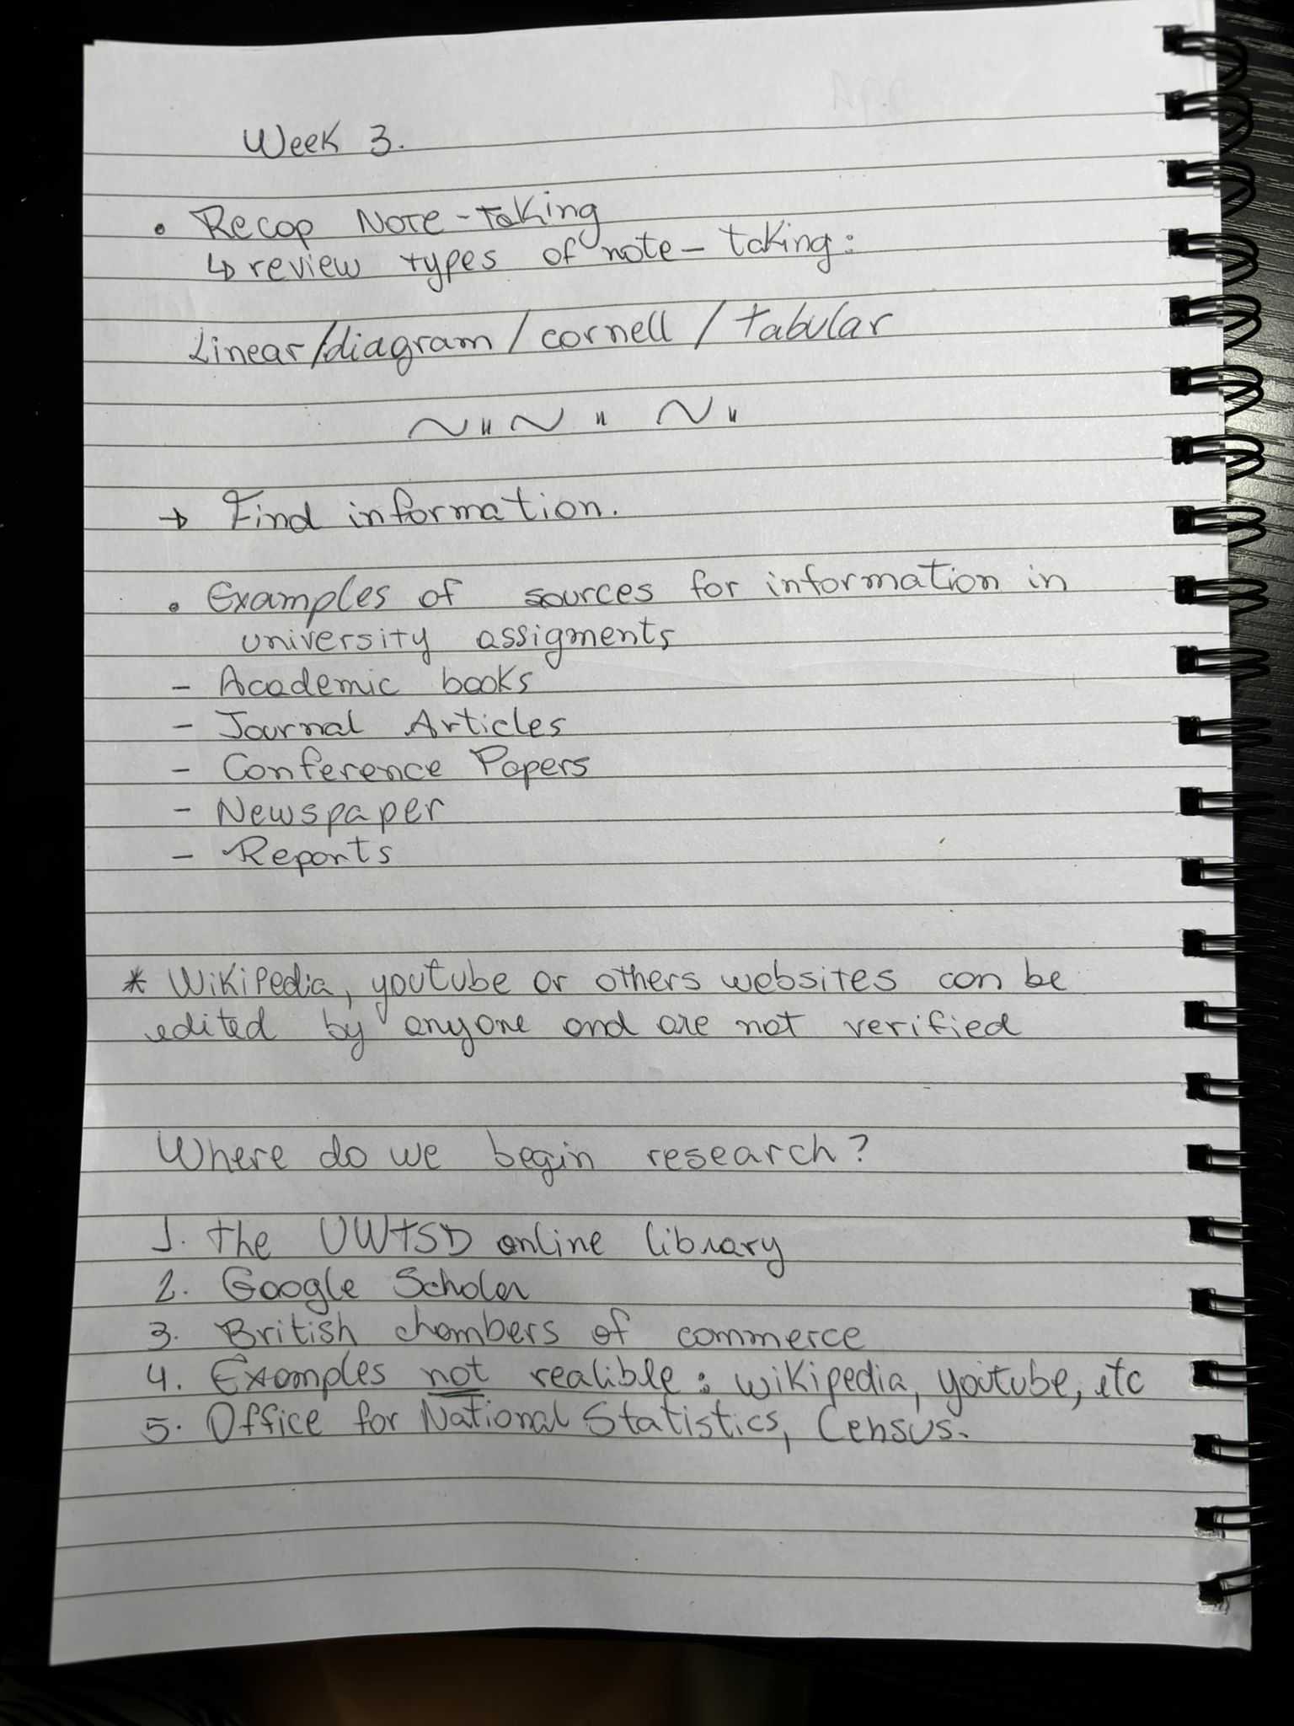

Appendix 2 – CRAAP test steps.
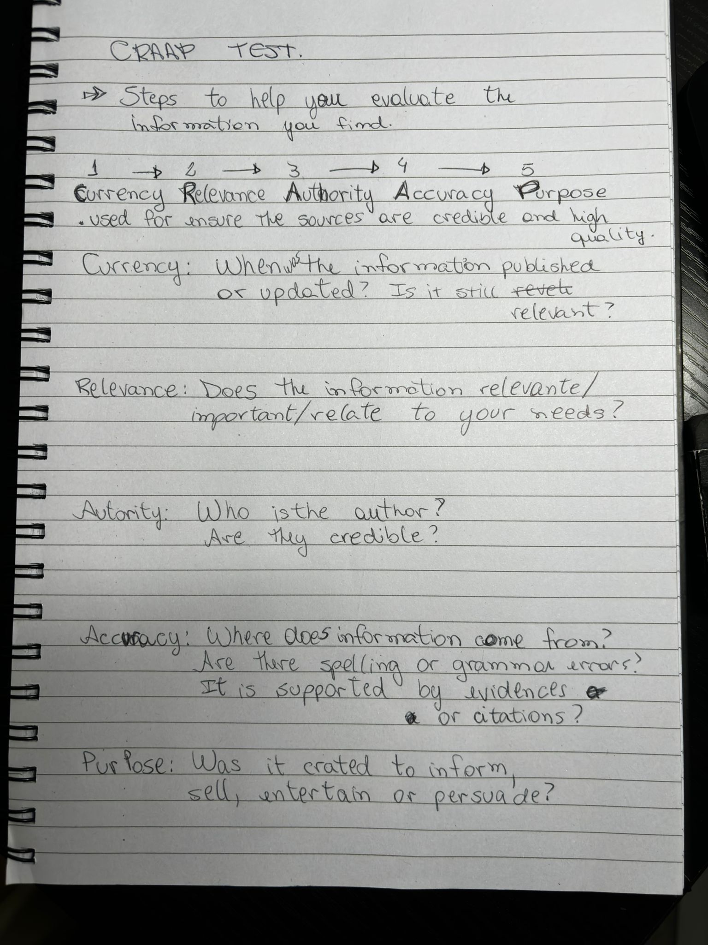

Appendix 3 – Practice paraphrasing.
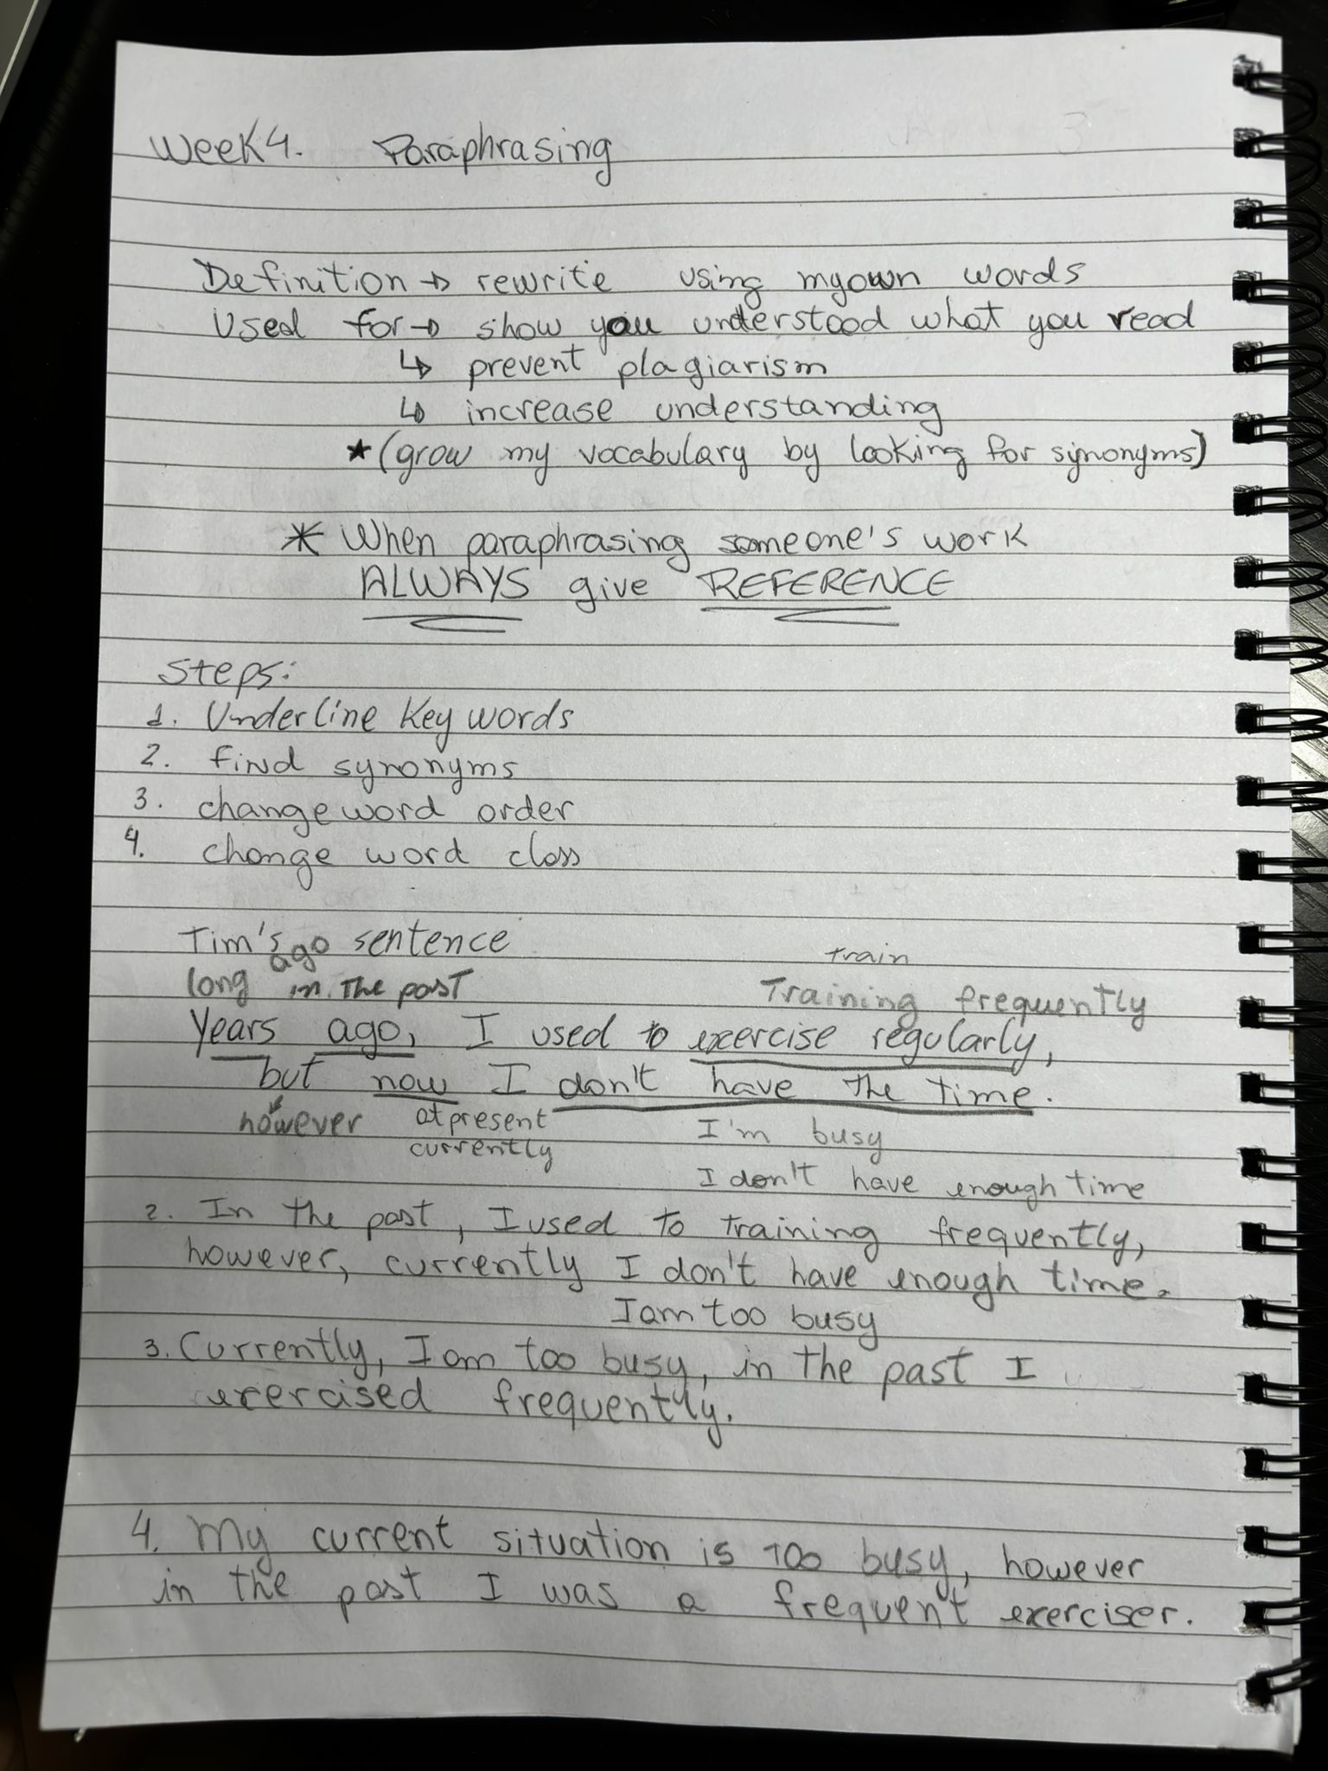

Appendix 4 – Second practice paraphrasing.
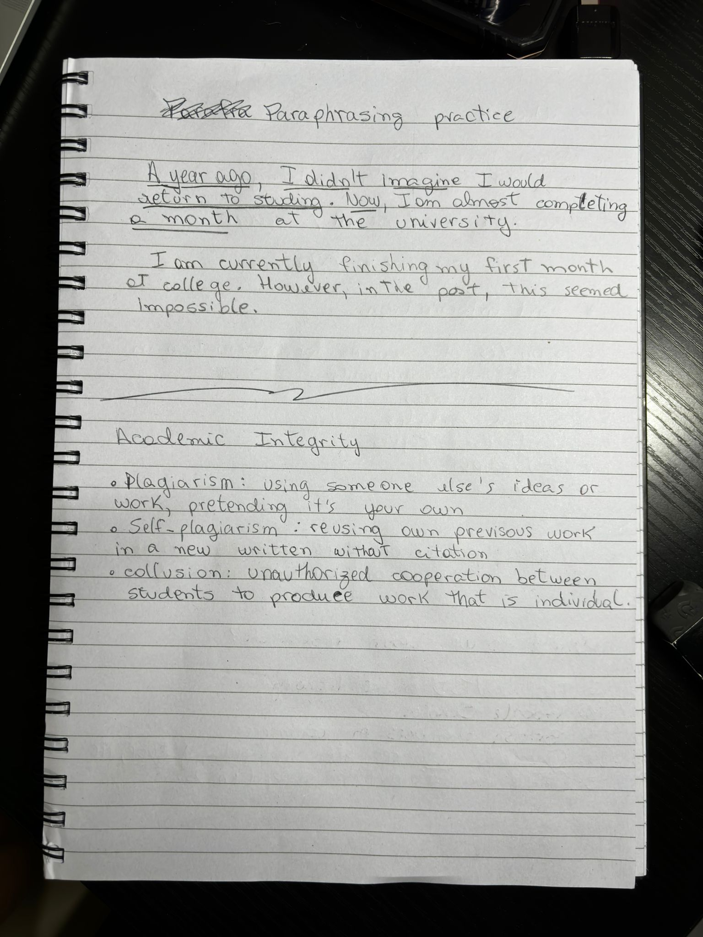

Appendix 5 – Reflective class.
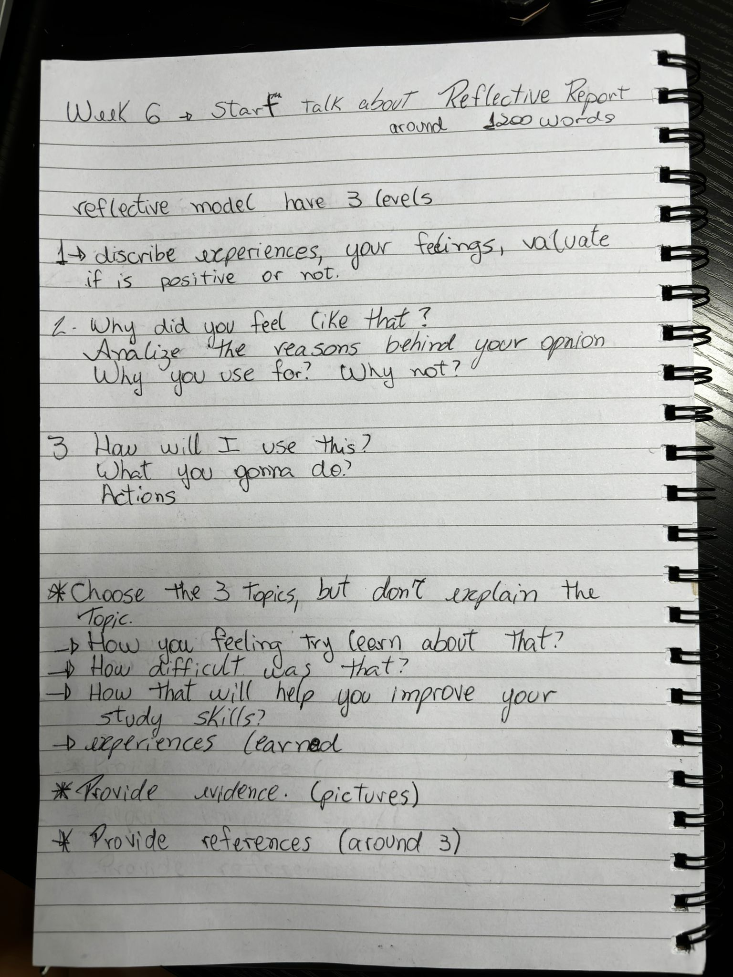

Appendix 6 – Reflective exercise


