Student Name(ID): Marina Munteanu (2222673)
Lecturer: Balendran Kandasamy

Stroke Prediction using Data Mining Techniques
A Data Mining Analysis using Weka and Tableau

DATA WAREHOUSing & Data mining
(ACCA6026)
Assignment: Data Mining

Contents

Introduction 2
1. Purpose and Practice of Data Mining 2
2. Dataset Description and Exploration 3
2.1 Dataset Overview 3
2.2 Missing Values Analysis 4
2.3 Class Distribution 5
2.4 Data Visualisation 5
3. Data Pre-processing and Post-processing 7
3.1 Handling Missing Values 7
3.2 Data Type Correction ( Target Variable) 8
3.3 Data Balancing 9
3.4 Feature Selection 10
3.5 Data Transformation (Encoding Categorical Variables) 11
3.6 Post-processing 11
4. Sample Runs and Analysis Methods 12
4.1 J48 Decision Tree 12
4.2 Random Forest 14
4.3 Logistic Regression 15
4.4 Model Comparison 16
4.5 Justification of Choices 17
4.6 K-Means Clustering 17
5. Business Recommendations 18
6. Reflective Commentary 18
7. Conclusion 19
8. References 20

Introduction

This report analyses the Stroke Prediction dataset using data mining techniques. The main aim is to understand the data and build models that can predict the risk of stroke.
The dataset includes information related to health and lifestyle, such as age, hypertension, glucose level, BMI, and smoking status. These factors are important because they can influence the risk of stroke. [1]
In this project, two main tools are used. Tableau is used for data exploration and visualisation, while Weka is the main tool used to build and evaluate the models. Both classification methods and clustering techniques are applied to identify patterns and groups in the data.
The analysis includes several steps, such as data exploration, data pre-processing, applying models, and interpreting the results. The final goal is to obtain clear results and provide useful recommendations that can support decision-making in healthcare by providing actionable insights for healthcare organisations.
The dataset is also not balanced, with a much smaller number of stroke cases, which is considered during the modelling process.
- Purpose and Practice of Data Mining

Data mining is the process of analysing large volumes of data in order to identify useful patterns and relationships. It helps organisations make decisions based on data, rather than assumptions [2].
In healthcare, data mining is used to identify risks, support diagnosis, and improve patient care [3]. For example, it can help identify individuals who have a higher risk of developing certain conditions, such as stroke. This allows preventive actions to be taken at an early stage. However, predicting stroke risk can be difficult. The dataset is not balanced, with only a small number of stroke cases. In this situation, accuracy is not always reliable. It is more important to use metrics such as recall and AUC, because missing a stroke case [3] can have serious consequences.
For this project, data mining is applied to the Stroke Prediction dataset to build models that can predict the risk of stroke. Classification algorithms, such as Random Forest and Logistic Regression, are used to estimate whether a person may experience a stroke [3]. Clustering techniques are also used to group individuals with similar characteristics.
The purpose of using these techniques is to better understand the data and identify the factors that influence stroke risk. This can support decision-making and help improve prevention strategies in healthcare. In addition, data mining allows large volumes of healthcare data to be analysed more efficiently, helping to identify patterns that may not be visible through traditional methods. This can improve the quality of decisions and support more effective healthcare planning.
- Dataset Description and Exploration
This section aims to provide a clear understanding of the dataset used in the analysis. It examines the structure of the dataset, missing values, class distribution, and data visualisation. The purpose is to identify the main characteristics of the data and any potential issues that may affect the modelling process and the performance of the models.

2.1 Dataset Overview
Prediction dataset contains 5,110 instances and 12 attributes, as observed in Weka. Each instance represents an individual, described by medical and lifestyle factors.
Table 1. Summary statistics of numerical variables
Variable | Mean | Std Dev | Min | Max
age | 43.227 | 22.613 | 0.08 | 82
avg_glucose_level | 106.148 | 45.284 | 55.12 | 271.74
hypertension | 0.097 | 0.297 | 0 | 1
heart_disease | 0.054 | 0.226 | 0 | 1

As shown in Table 1, age varies widely (0.08-82 years), while hypertension and heart
disease are binary variables with low mean values (0.097 and 0.054). The dataset includes numerical variables such as age and avg_glucose_level, and categorical variables such as gender, work_type, and smoking_status [3].
Around 58.6% of individuals are female and about 41.4% work in the private sector. The dataset is relatively balanced in terms of residence type. The target variable stroke is highly imbalanced, with only about 4.9% of instances representing stroke cases [3].
Preliminary analysis suggests that age and avg_glucose_level may have a stronger relationship with stroke, while other variables appear less influential.

2.2 Missing Values Analysis
In the initial Weka import, the bmi attribute is detected as a string (“neither numeric nor nominal”), which hides potential missing values and indicates data inconsistencies. As shown in Figure 1, Weka reports no explicit missing values across most attributes.
The smoking_status attribute includes an “Unknown” category, representing incomplete information. Although this is not a direct missing value, it may affect the performance of classification models.
Overall, while no explicit missing values are reported by Weka, certain attributes indicate underlying data quality issues that require further processing.
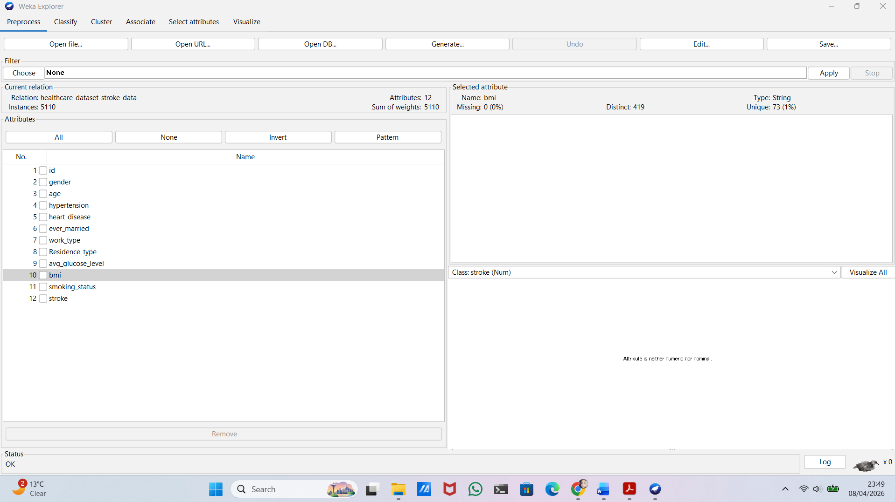
Figure 1. Missing values analysis in Weka

2.3 Class Distribution
The dataset is highly imbalanced: 4,861 non-stroke cases (95.1%) and only 249 stroke cases (4.9%), as shown in Figure 2. This imbalance can bias classification models toward the majority class and reduce the ability to correctly identify stroke cases.
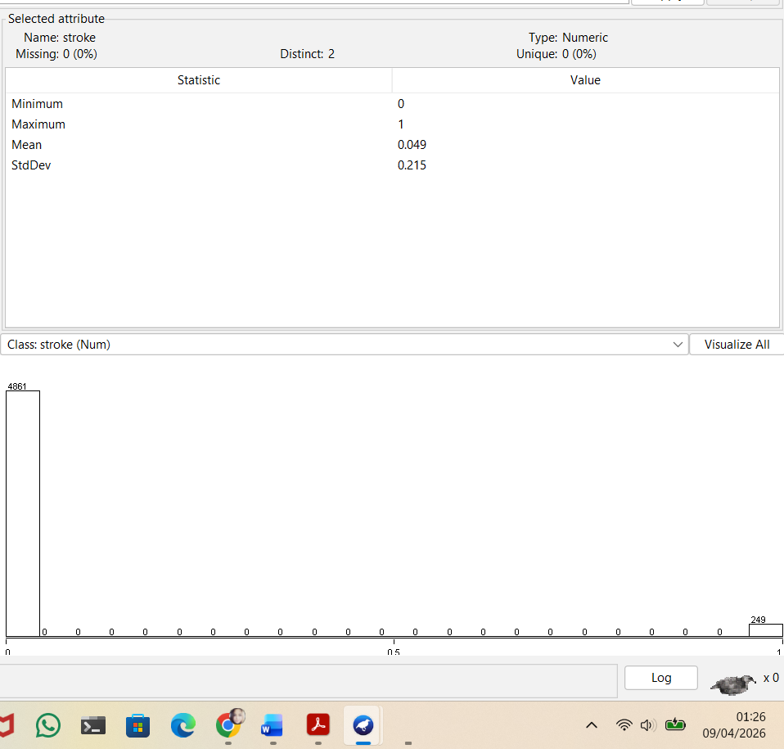
Figure 2. Class distribution of the stroke variable in Weka
This issue is important to consider when evaluating model performance.

2.4 Data Visualisation
This section presents key patterns in the dataset using Tableau visualisations [4]. These figures help to better understand the distribution of variables and their relationship with stroke risk.
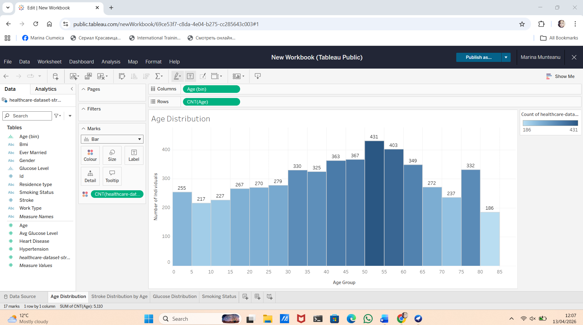
Figure 3. Age Distribution
As shown in Figure 3, most individuals are middle-aged, with the highest concentration between 40 and 60 years.
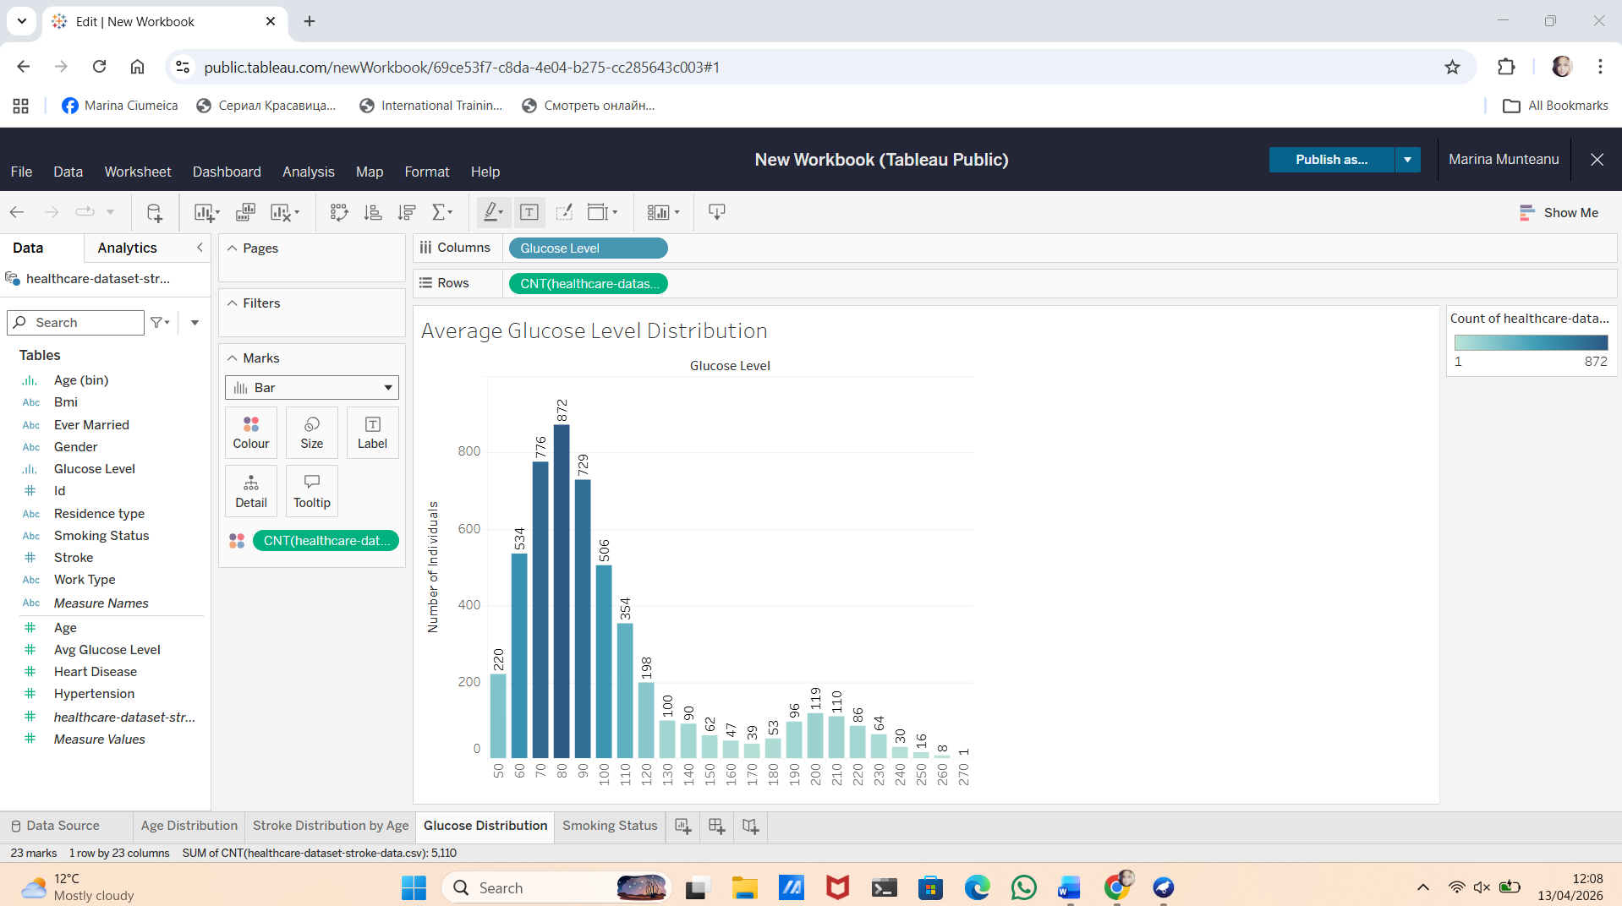
Figure 4. Average Glucose Level Distribution
Figure 4 shows that most glucose levels are within the normal range (70–100), with fewer higher values.
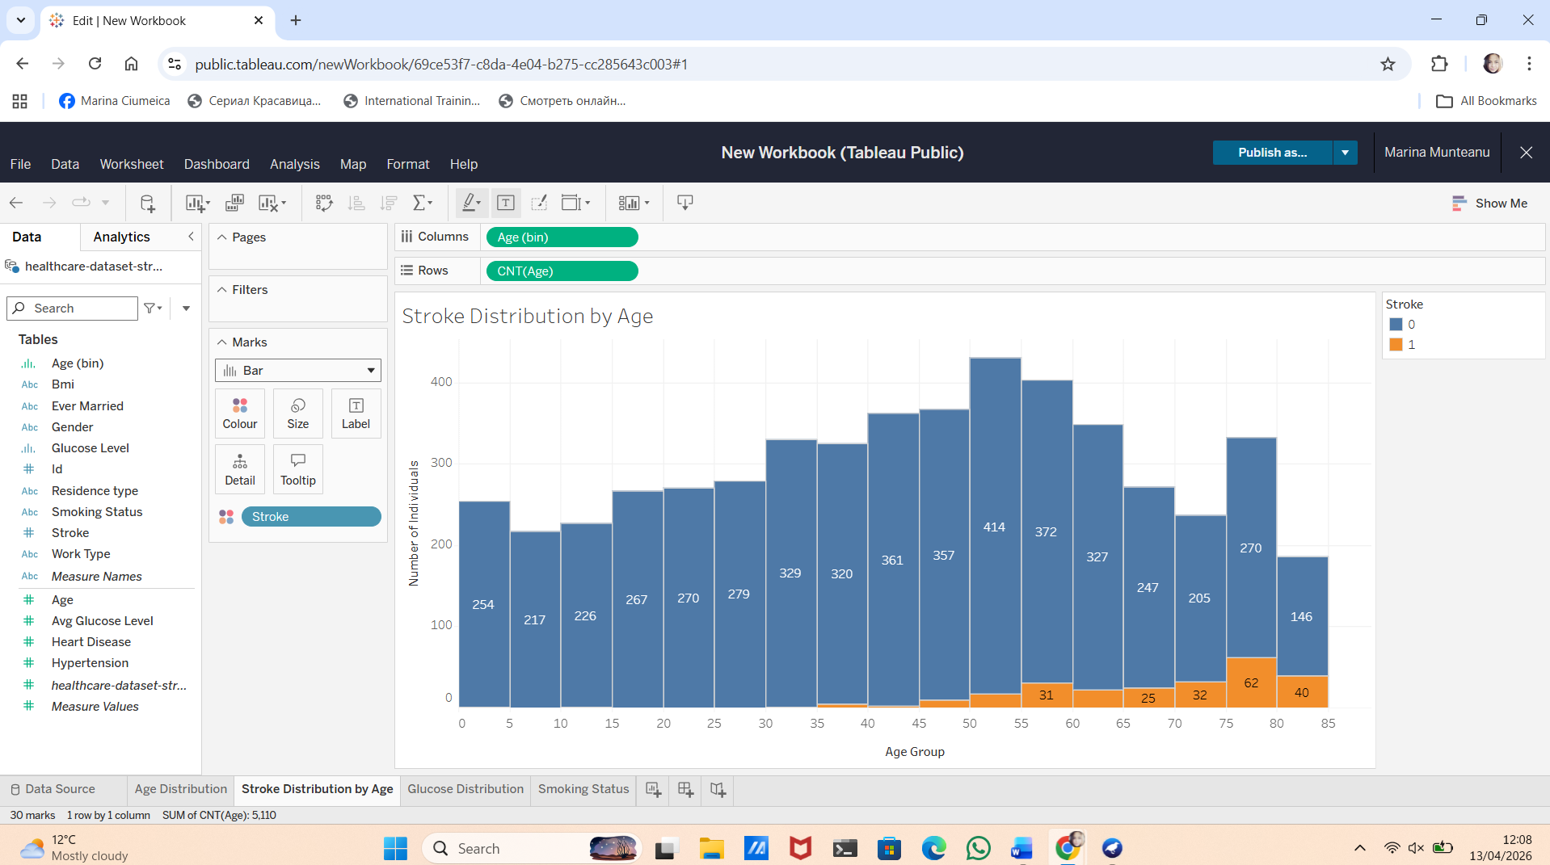
Figure 5. Stroke Distribution by Age
Figure 5 shows that stroke cases are rare at younger ages but increase after the age of 50.

Figure 6. Smoking Status Distribution
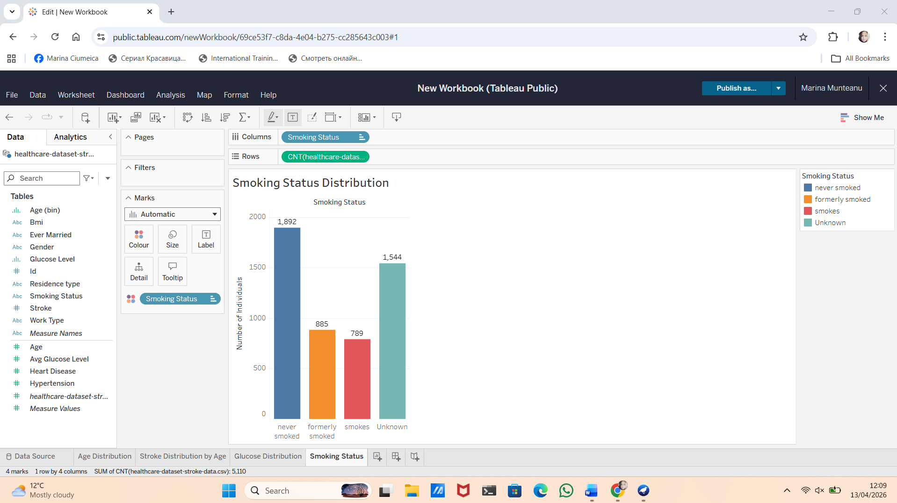
Figure 6 shows that most individuals have never smoked, while a large proportion of “Unknown” values suggests incomplete data. Overall, these visualisations highlight key patterns and support further analysis.
- Data Pre-processing and Post-processing
This section explains the steps used to clean and prepare the dataset before modelling. Data pre-processing is essential in the data mining process because it improves data quality, consistency, and the reliability of model results.

3.1 Handling Missing Values
The dataset was first analysed in Weka, where no missing values were detected at a structural level. However, a closer inspection revealed an issue with the bmi attribute, where some values were recorded as “N/A”.
Weka did not recognise these values as missing and instead treated them as strings. This caused the attribute type to become incorrect, preventing it from being used in numerical models.
To resolve this issue, the dataset was manually cleaned in Excel by replacing all “N/A” values with empty cells. After reloading the dataset into Weka, the bmi attribute was correctly recognised as numeric with missing values.
The ReplaceMissingValues filter was then applied, replacing missing values with the median (approximately 28.89). Approximately 200 missing bmi values (about 4% of the dataset) were imputed using the median, as it is less sensitive to outliers than the mean. As shown in Figure 7, this approach ensured that the dataset remained complete and consistent.
Figure 7. Applying ReplaceMissingValues filter in Weka
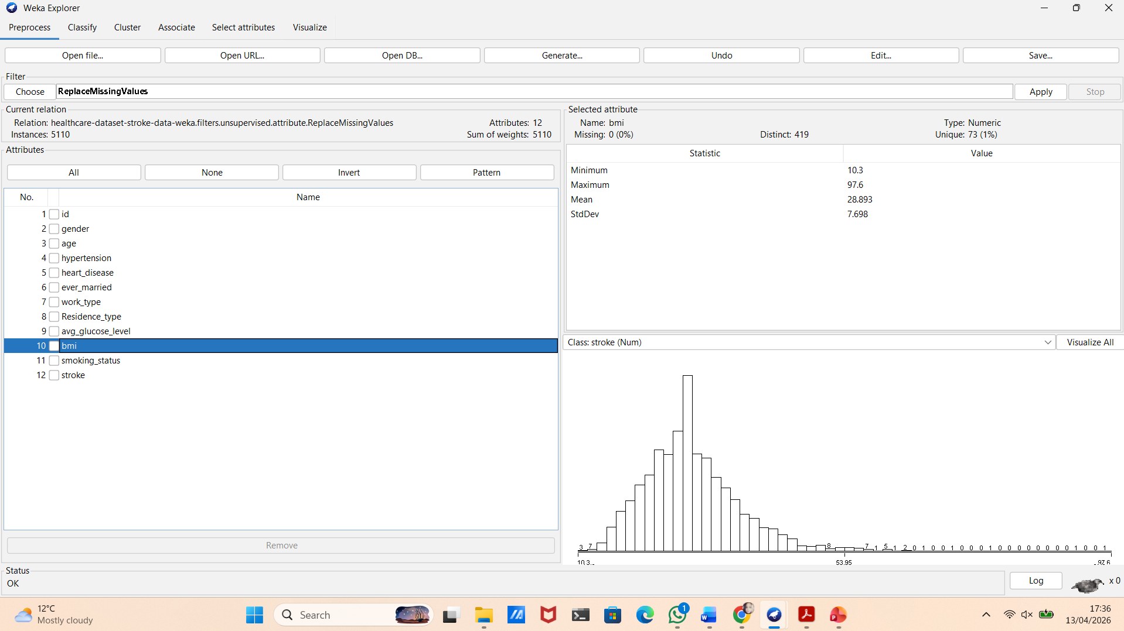
Handling missing values is essential to ensure reliable model performance and to avoid biased or incorrect predictions.

3.2 Data Type Correction ( Target Variable)
The target variable stroke was initially stored as numeric (0 and 1). However, for classification tasks in Weka, the class attribute must be nominal.
To address this, the NumericToNominal filter was applied only to the stroke attribute using the option “-R last”. As illustrated in Figure 8, this conversion ensured that the class variable was correctly interpreted by classification algorithms.
Figure 8. Converting stroke attribute from numeric to nominal
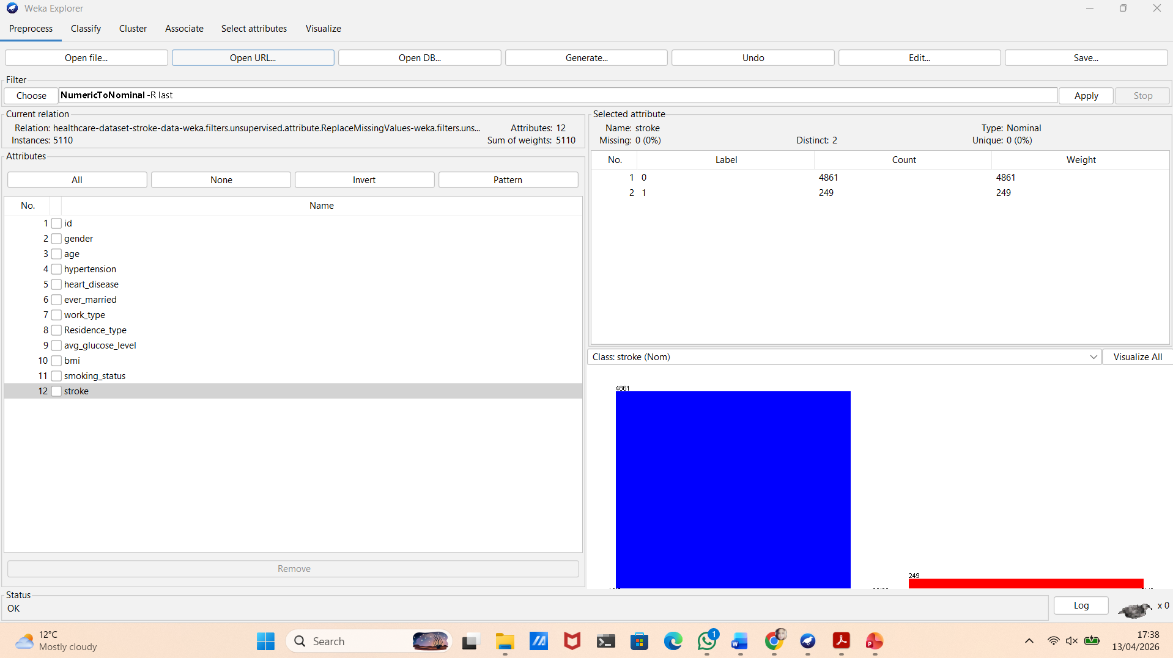
This step ensures that the target variable is correctly interpreted by classification algorithms and allows the model to produce valid predictions.

3.3 Data Balancing
The dataset is highly imbalanced, with approximately 95% of instances representing non-stroke cases and only around 5% representing stroke cases. This imbalance affected the initial model results, as the J48 algorithm predicted only the majority class. As a result, important metrics such as Precision, Recall, and F1-score for the stroke class could not be calculated.
To address this issue, the Resample filter was applied with parameters -B 1.0, -S 1, and -Z 100. This created a balanced dataset with an equal class distribution (2555 stroke and 2555 non-stroke cases), as shown in Figure 9.
Figure 9. Class distribution after applying Resample filter
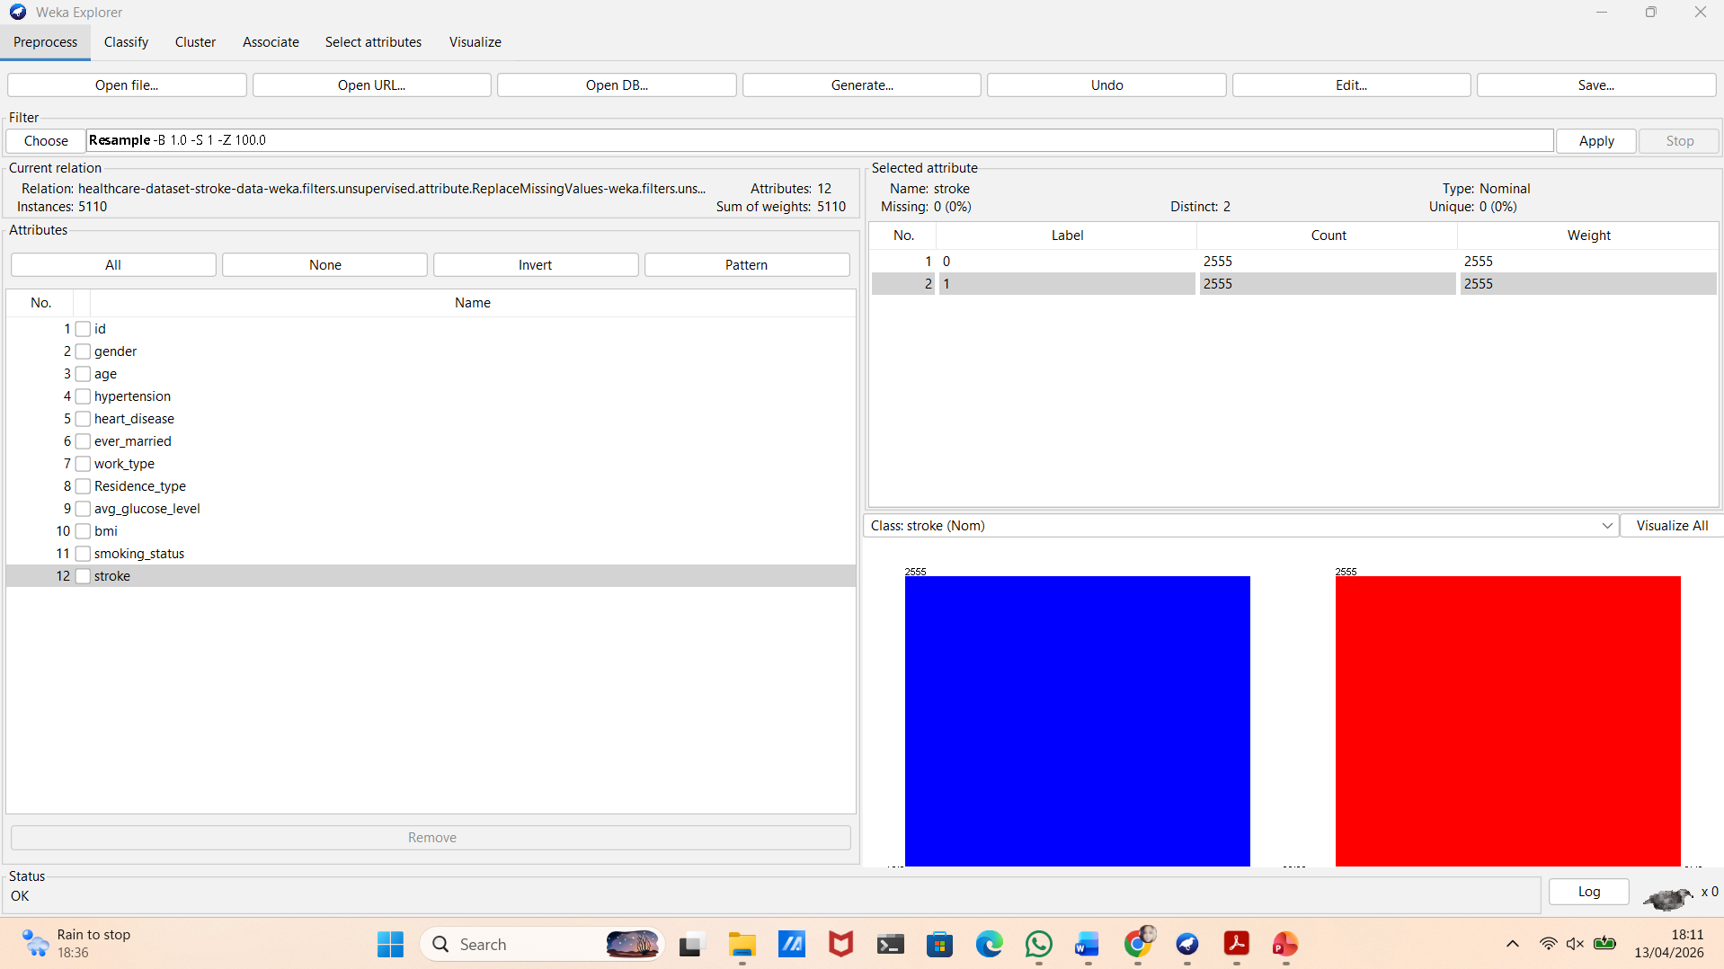
Balancing the dataset improves the model’s ability to learn patterns for both classes and is especially important in medical prediction tasks. More advanced techniques such as SMOTE could also be used, but Resample was selected for simplicity and ease of implementation [5].

3.4 Feature Selection
Feature selection identifies the most important attributes for predicting the target variable. The id attribute was removed before modelling, as it is a unique identifier and does not provide useful information for prediction.
The InfoGainAttributeEval method was applied in Weka to evaluate the importance of each attribute. The results showed that age, avg_glucose_level, hypertension, heart_disease, and bmi are the most relevant features, while gender and residence_type have a lower impact on the prediction.
Removing irrelevant attributes reduces model complexity, improves performance, and helps prevent overfitting. As a result, the model becomes more efficient and easier to interpret.

3.5 Data Transformation (Encoding Categorical Variables)
Logistic Regression requires numerical input data. However, the dataset contains categorical variables such as gender, work_type, and smoking_status, which cannot be directly used by the model.
To address this, the NominalToBinary filter was applied in Weka. This transformation converts categorical variables into binary values (0 and 1), allowing them to be processed by the algorithm. For example, the work_type attribute, which contains multiple categories, was transformed into several binary variables representing each category.
The filter was applied only to the input attributes (using the option "-R 2-11"), excluding the class attribute stroke. As shown in Figure 10, this step ensures that all variables are in a suitable format for the model.
Figure 10. Applying NominalToBinary filter in Weka
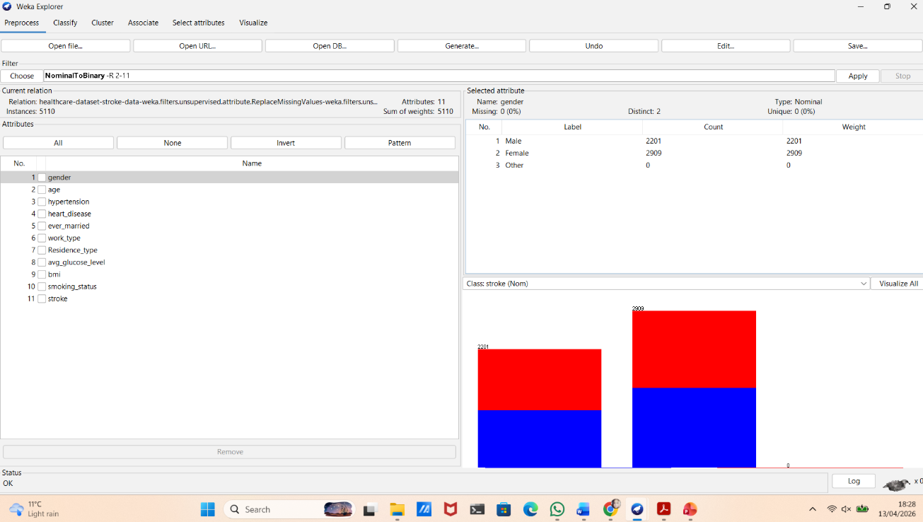
This transformation improves the model’s ability to learn relationships between variables and produce more accurate predictions.

3.6 Post-processing
After preparing the dataset, post-processing focuses on how model results are evaluated and interpreted.
To ensure reliable results, 10-fold cross-validation was used in Weka. This method divides the dataset into ten parts, allowing each instance to be used for both training and testing. As a result, it provides a more stable and less biased evaluation compared to a simple train-test split [6].
Model performance will be evaluated using key metrics such as Accuracy, Precision, Recall, F1-score, and ROC-AUC. In addition, the Confusion Matrix will be used to analyse classification results and identify possible errors.
Special attention is given to False Negatives, as failing to identify a stroke case can have serious consequences in a medical context. If the models show low recall for the stroke class, threshold adjustment may be considered to improve sensitivity.
The detailed results and visualisations of the models will be presented in the next section.
- Sample Runs and Analysis Methods
This section presents the practical application of machine learning models in Weka and analyses their performance. The aim is to evaluate how different algorithms behave on the prepared dataset and how well they can detect stroke cases.
Three models were selected for this analysis:
- J48 Decision Tree
- Random Forest
- Logistic Regression
These algorithms were chosen because they represent different approaches to classification and allow a clear comparison between interpretability and performance.
All models were evaluated using 10-fold cross-validation to ensure reliable and unbiased results.

4.1 J48 Decision Tree
The J48 decision tree was applied as a simple and interpretable classification model. When tested on the original imbalanced dataset, the model achieved high accuracy (around 95%). However, the confusion matrix showed that the model predicted only the majority class (non-stroke). This means that the model failed to identify stroke cases. Because of this, important metrics such as Precision, Recall, and F1-score for the stroke class could not be calculated. This demonstrates that accuracy alone is not a reliable metric for imbalanced datasets.
After applying the Resample filter, the dataset became more balanced, allowing the J48 model to correctly classify both classes, as shown in Figure 11.
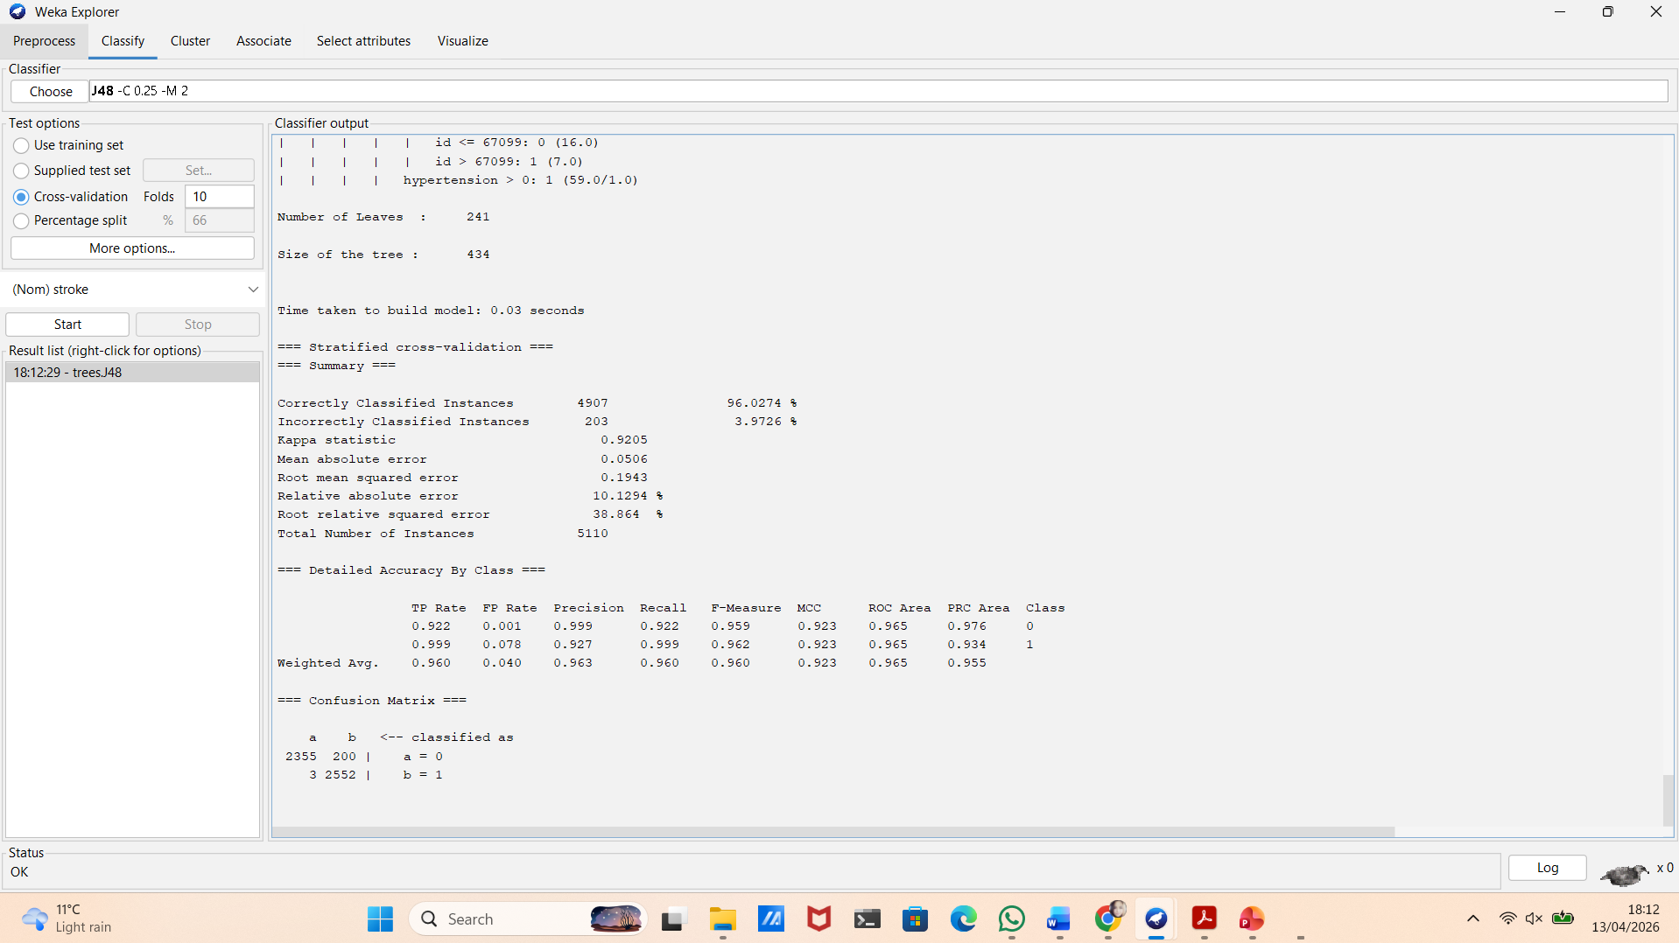
Figure 11. J48 model results in Weka
The model achieved an accuracy of approximately 96.02%, indicating good overall performance. The confusion matrix shows that:
- 2355 non-stroke cases were correctly classified
- 2552 stroke cases were correctly identified
- Only 203 cases were misclassified
The model achieved a Recall close to 0.999 for stroke cases, meaning that almost all stroke cases were correctly detected. The F1-score also improved, indicating a better balance between Precision and Recall. The ROC-AUC was 0.965, showing that the model can clearly distinguish between the two classes. This improvement is mainly due to the balanced class distribution, which allows the model to learn patterns for both classes instead of focusing on the majority class. The main advantage of J48 is its interpretability, as the decision tree clearly shows how decisions are made based on input variables. However, the model may be sensitive to changes in the data.

4.2 Random Forest
The Random Forest model was applied next as an ensemble learning method.
Figure 12. Random Forest model in Weka
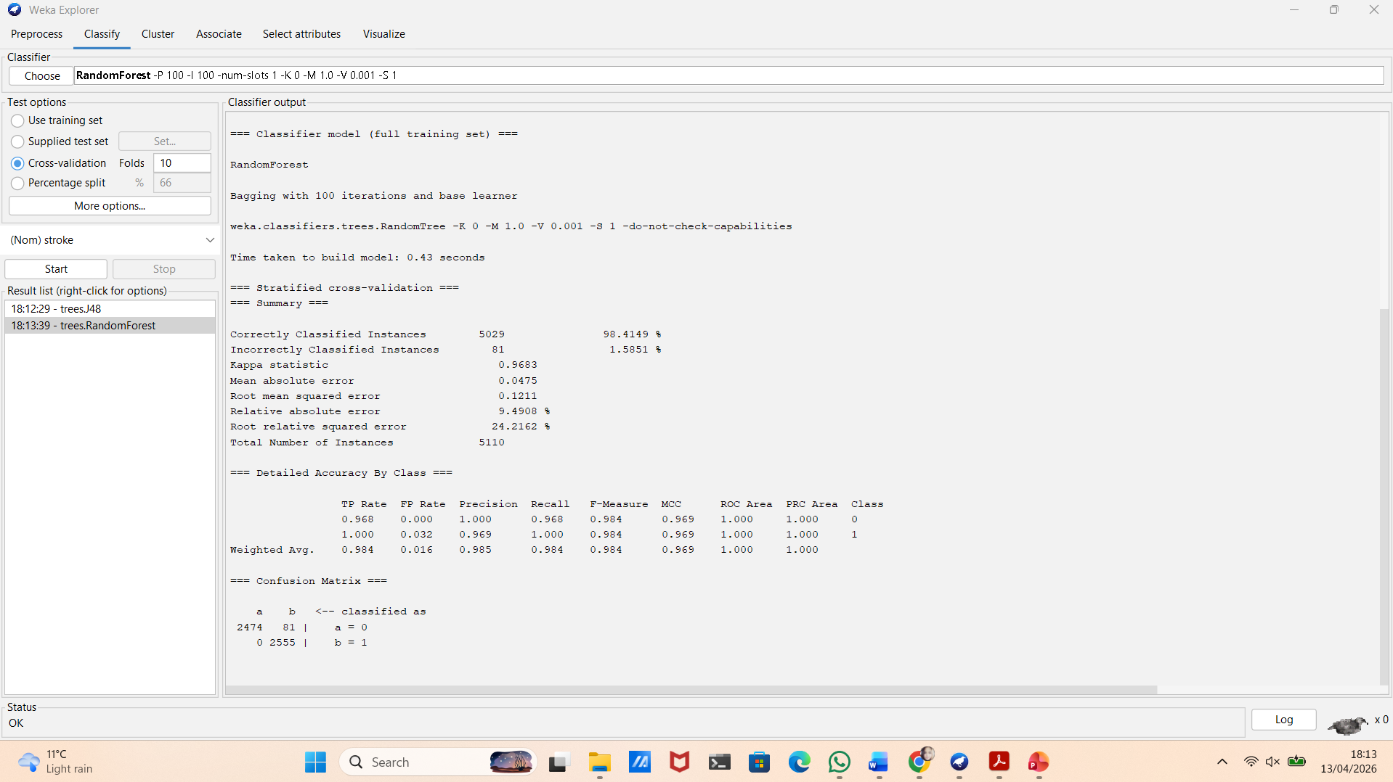
The model was evaluated using 10-fold cross-validation, as shown in Figure 12. It achieved very high performance, with an accuracy of approximately 98.41%, indicating strong overall classification ability.
The confusion matrix shows that:
- 2474 non-stroke cases were correctly classified
- 2555 stroke cases were correctly identified
- Only 81 cases were misclassified
This results in a Recall of 1.0 for stroke cases, meaning that all stroke cases were correctly detected. Precision is also very high (approximately 0.969), showing that the predictions are reliable. The ROC-AUC reached 1.000, indicating perfect class separation on the balanced dataset. These results demonstrate that the model performs extremely well after balancing the dataset, as it can learn patterns for both classes effectively. However, such high performance may indicate that the model is more complex. While Random Forest reduces overfitting compared to a single decision tree, it is less interpretable.

4.3 Logistic Regression
The Logistic Regression model was applied as a statistical classification method to predict the probability of stroke occurrence [3].
The model was evaluated using 10-fold cross-validation, as shown in Figure 13.
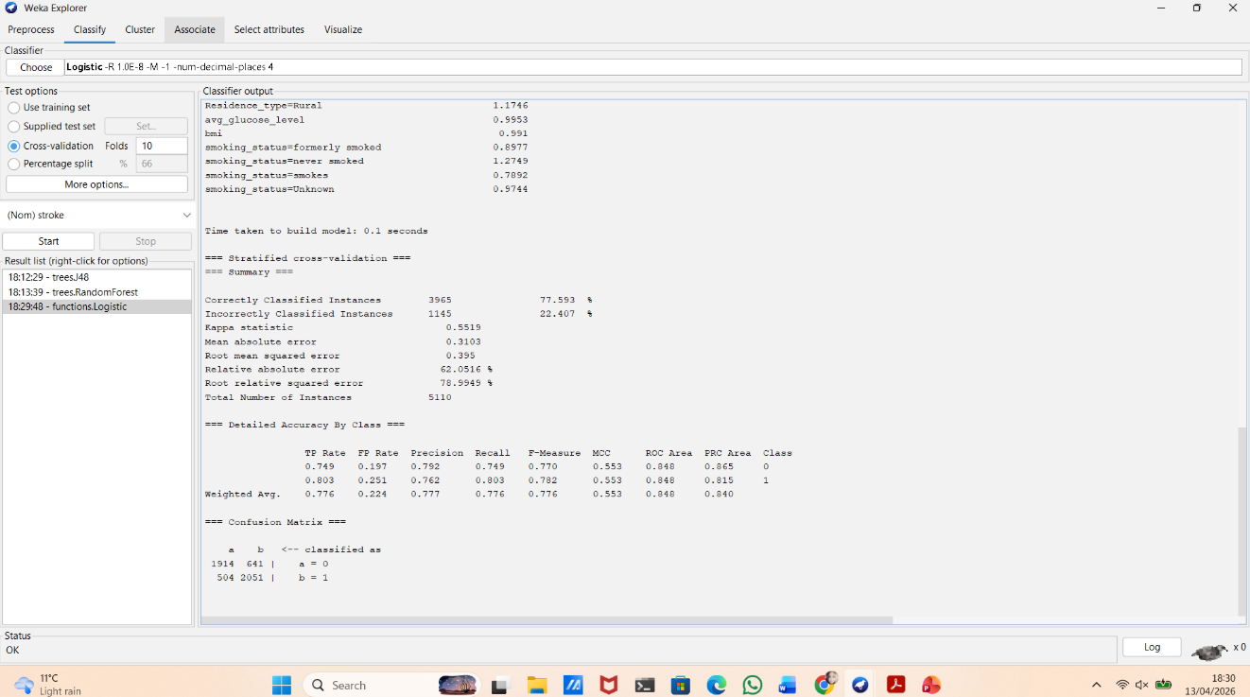
Figure 13. Logistic Regression model in Weka
The model achieved an overall accuracy of approximately 77.59%, which is lower compared to J48 and Random Forest, but still acceptable for a linear model.
The confusion matrix shows that:
- 1914 non-stroke cases were correctly classified
- 2051 stroke cases were correctly identified
- 1145 cases were misclassified
The model achieved a Recall of approximately 0.803 for stroke cases, meaning that most stroke cases were correctly detected. Precision was around 0.762, indicating a moderate level of prediction reliability. The ROC-AUC was approximately 0.848, showing good but not excellent ability to distinguish between the two classes. These results indicate that Logistic Regression performs reasonably well, but is less effective than more complex models such as Random Forest. This is because Logistic Regression assumes a linear relationship between variables, which may not fully capture the complexity of the dataset. However, the main advantage of Logistic Regression is its simplicity and interpretability. The model provides clear insights into how each variable influences the prediction, making it useful for understanding risk factors in a medical context.

4.4 Model Comparison
Table 2. Model performance comparison on balanced dataset
Model | Accuracy | Recall (stroke) | Precision | F1-score | ROC-AUC
J48 | 96.02% | 0.999 | 0.927 | 0.962 | 0.965
Random Forest | 98.41% | 1.000 | 0.969 | 0.984 | 1.000
Logistic Regression | 77.59% | 0.803 | 0.762 | 0.782 | 0.848

The three models (J48, Random Forest, and Logistic Regression) were compared based on their performance on the balanced dataset. The F1-score confirms the balance between Precision and Recall, with Random Forest achieving the highest value (0.984).
Random Forest achieved the highest overall performance, with an accuracy of approximately 98.41% and a Recall of 1.0 for stroke cases. This indicates that the model was able to correctly identify all stroke cases and minimise classification errors. The ROC-AUC of 1.000 also shows perfect separation between the two classes.
The J48 decision tree also performed well, achieving an accuracy of around 96.02% and a Recall close to 0.999. While slightly less accurate than Random Forest, J48 provides better interpretability, as the decision tree structure clearly shows how predictions are made.
In contrast, Logistic Regression achieved a lower accuracy of approximately 77.59% and a Recall of around 0.803. This suggests that the model is less effective in capturing complex patterns in the data. However, it remains useful due to its simplicity and ability to provide insights into the relationship between variables. Overall, Random Forest is the most effective model for this dataset in terms of predictive performance. However, J48 offers a good balance between accuracy and interpretability, while Logistic Regression provides a simple baseline model that is easy to understand.

4.5 Justification of Choices
The selected models (J48, Random Forest, and Logistic Regression) were chosen to represent different classification approaches and allow comparison between performance and interpretability.
- J48 was selected for its simplicity and ability to explain decision rules.
- Random Forest was chosen for its high performance and reduced overfitting.
- Logistic Regression was included as a baseline model due to its simplicity.
Accuracy, Precision, Recall, F1-score, and ROC-AUC were used to evaluate performance. Recall is important because missing a stroke case can have serious consequences. The F1-score shows the balance between Precision and Recall, while ROC-AUC measures how well the model separates the classes.

4.6 K-Means Clustering
K-Means clustering was applied to identify patterns in the dataset without using the target variable [3]. The SimpleKMeans algorithm was used in Weka with k = 2 (Figure 14).
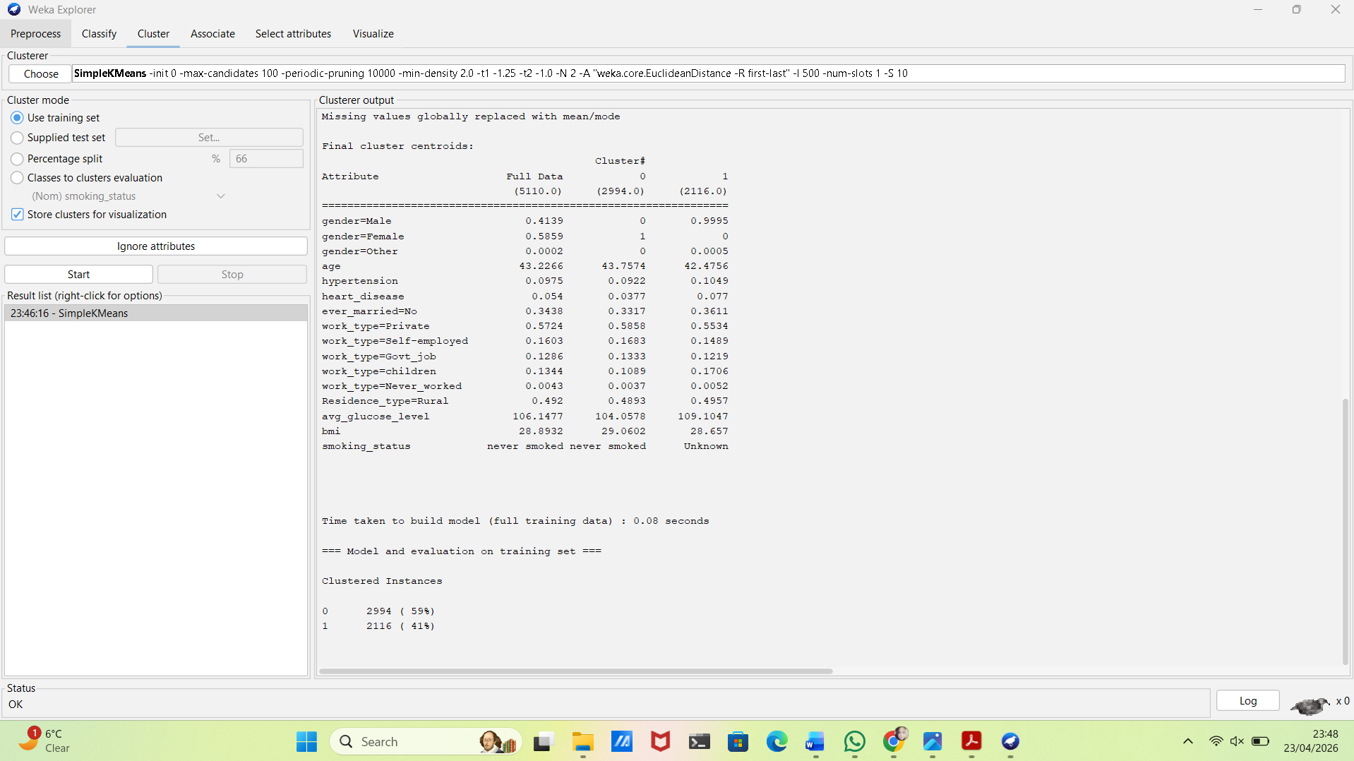
Figure 14. K-Means clustering output in Weka showing cluster centroids and distribution (k = 2)
Cluster 0 contains 2994 instances (59%), while Cluster 1 contains 2116 instances (41%). Cluster 1 shows higher average glucose levels (109.10 vs 104.06), higher hypertension (0.105 vs 0.092), and higher heart disease rates (0.077 vs 0.038), indicating a higher-risk group. In contrast, Cluster 0 represents a lower-risk group. These results support the classification findings, where glucose level, hypertension, and heart disease were key predictors of stroke risk. However, as clustering does not use the target variable, differences between groups remain moderate.
- Business Recommendations
Based on the findings from the Stroke Prediction dataset analysis, the following recommendations are proposed for healthcare providers and public health organisations.
First, healthcare organisations should implement the Random Forest model in clinical decision support systems. The model achieved 98.41% accuracy and a recall of 1.0, meaning that all stroke cases were correctly identified [7]. Key risk factors include age, average glucose level, hypertension, heart disease, and BMI. These should be prioritised in electronic health records to automatically identify high-risk patients.
Second, screening programmes should target high-risk groups identified through clustering. Cluster 1 represents 41% of the population and shows higher glucose levels (109.10), higher hypertension (10.5%), and higher heart disease rates (7.7%). This group should receive regular monitoring and early intervention, while Cluster 0 (59%) may require general prevention strategies.
Third, interpretable models such as J48 should be used alongside Random Forest. For example, a simple rule is: if age > 60 and hypertension = yes, then the patient is high risk. This improves transparency and supports clinical decisions. Fourth, data quality should be improved. Missing BMI values and incomplete smoking data reduce model performance. Ensuring accurate data collection will improve prediction reliability [5]. Finally, models should be updated regularly using new patient data. Continuous monitoring and retraining will maintain accuracy over time.
- Reflective Commentary
This project provided valuable insight into the use of machine learning techniques for healthcare data analysis. The models performed well, especially after addressing class imbalance. Initially, the J48 model showed high accuracy but failed to detect stroke cases, demonstrating that accuracy alone can be misleading. After applying data balancing, the results improved significantly.
A key strength of the analysis was the comparison of different models. Random Forest achieved the highest performance, with 98.41% accuracy and perfect recall for stroke cases. J48 provided better interpretability, while Logistic Regression offered a simple way to understand relationships between variables. This combination allowed both accurate prediction and model transparency.
In addition, clustering helped identify a higher-risk group with increased glucose levels and cardiovascular conditions, supporting the findings of the classification models.
However, the analysis had limitations. The dataset contained missing and incomplete values, particularly for BMI and smoking status. BMI values had to be converted from string to numeric format, and around 30% of smoking data was labelled as “Unknown”, which reduced data quality. If repeated, the project could be improved by enhancing data quality and applying advanced techniques such as SMOTE. External validation using a separate dataset would improve reliability. Further improvements could include parameter tuning and testing additional models.
- Conclusion
This project demonstrated the effectiveness of machine learning techniques in predicting stroke risk. Random Forest achieved the highest performance, with 98.41% accuracy and perfect recall, while J48 provided better interpretability and Logistic Regression offered a simple baseline model. The analysis highlighted the importance of data preprocessing, particularly handling class imbalance and missing values. Overall, combining accurate models with clear interpretation can support better decision-making in healthcare.

References

[1] | World Health Organization, "Stroke," World Health Organization, 2025. [Online]. Available: https://www.who.int/news-room/fact-sheets/detail/stroke. [Accessed 21 April 2026].
[2] | P. Bhatia, Data Mining and Data Warehousing: Principles and Practical Techniques, Cambridge: Cambridge University Press, 2019.
[3] | I. H. Witten, E. Frank, M. A. Hall and C. J. Pal, Data Mining: Practical Machine Learning Tools and Techniques, Amsterdam: Morgan Kaufman, 2026.
[4] | M. Meier, Mastering Tableau 2023: Implement Advanced Business Intelligence Techniques, Analytics, and Machine Learning Models with Tableau, Birmingham: Packt Publishing, 2023.
[5] | D. Tourt, "Strategic application of SMOTE and its variants to enhance AI performance in imbalanced datasets," Issues in Information Systems, vol. 26, no. 2, 2025.
[6] | N. I. K., N.-B. O. and A. J., "Performance of Machine Learning Algorithms with Different K Values in K-fold Cross-Validation," 2021. [Online]. Available: https://www.researchgate.net/publication/356914937_Performance_of_Machine_Learning_Algorithms_with_Different_K_Values_in_K-fold_Cross-Validation. [Accessed 23 April 2026].
[7] | N. Biswas, K. M. Uddin, S. T. Rikta and S. K. Dey, "A comparative analysis of machine learning classifiers for stroke prediction: A predictive analytics approach," Healthcare Analytics, vol. 2, 2022.

