MODULE CODE M4X01916
MARKETING ESSENTIALS
TUTOR DR OLU ADEGBITE
SHAHZIA AHMED
MARKETING INFORMATION SYSTEMS
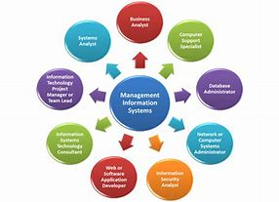
(Google images 2016)
MARKETING INFORMATION SYSTEMS (MIS)
MIS denotes the processes and persons dedicated to assessing information’s needs to develop the desired material, helping decision makers to use the generated information and validate actionable customer and market insight.
(Lecturer notes session 6, (29/01/19)
This assignment presents the use of MIS in the process of assessing and administration of data and the way it is actioned. I have chosen to look at Alton towers UK, as part of the Merlin entertainments plc.
Alton Towers Resort, often shortened to Alton Towers, is a theme park resort located in Staffordshire, England. It is near the village of Alton, in the parishes of Denstone and Farley. The resort, which is operated by Merlin Entertainments Group, incorporates a theme park, water park, spa, mini golf and hotel complex. Originally a private estate, Alton Towers grounds opened to the public in 1860 to raise funds for the estate. In the late 20th century, it was transformed into a theme park and opened a number of new rides from 1980 onwards. In 2017, it was the second most visited theme park in the UK after Legoland Windsor” (Merlin Entertainments, 2018).

Merlin group uses customer data sourced from their database to market their theme parks and hotels through the varied marketing means as devised by their marketers. The company does this various steps these are:
Defining the problem and research objectives:
Developing the Research Plan, Implementing the Research Plan; Interpreting and, Reporting the Findings. These steps are discussed below.

Step 1: Establishing the Problem and Study the Purposes
Marketing Analysis, assessing pertinent information and implement this to the target market this is the first stage of MIS systems.
Merlin Business Analysis there needs in accordance with their offerings, Alton Towers has had a huge dip in visitors attracted to the theme park since the unfortunate incident in 2015, and a ride broke down resulting in thrill seekers being stuck on the ride for several hours as well as some very unfortunate people losing their limbs.
Alton Towers reported their visitor numbers still down since Smiler crash
Merlin Entertainments were fined £5m over rollercoaster crash in 2015 The Guardian reported in 2016.
Merlin the owner of the Alton Towers theme park has seen almost £100million wiped from its value, in the week's crash and lost millions in lost bookings according to The Daily Mail 2015

Step 2: Develop a Research Plan
The Merlin group has devised this plan below to revive and reenergise the theme parks and keep the growth at a steady and constant pace.
The Shareholders and stake holders decide to Rolling out new Midway attractions – They have decided to open new Midway attractions, under one of our chainable global brands, with a focus on ‘cluster’ locations where we they can derive operating cost and use marketing and cross-selling advantages. Their 2020 milestone target is to open 40 new Midways between 2016 and 2020 according to Merlins annual report.
The strategized Introduction of a new ride in 2018 called the wicker man, a new wooden roller-coaster it boasts at being the first to be built in the UK in twenty years. This white knuckled ride gives thrill seekers the added exhilaration of adding fire to the ride heightening the experience. This ride is aimed at the younger (teens) and enthusiasts market, these are the largest demographics of visitors’ attraction.

“As stated by Nick Varney states in 2017 Merlins Long term vision and strategy, the events of 2016 strengthen their views that a varied portfolio based on strong brands with natural synergies is the best way of providing constant profit growth. Therefore they continue to track a long term vision by which the Group’s incomes are largely spread one third each across The Americas, Europe and Asia Pacific. It is worth noting that compared to 2005, when Merlin was much smaller and only operating in Europe, the 2016 revenue of £1.4 billion was already derived 27% and 14% from North America and Asia Pacific respectively.

PLANNING AND MIS SYSTEMS USED AT ALTON TOWERS
Merlin use MIS systems to regulate data, data is derived from the following sources, digital being the largest sector alongside all the conventional Marketing methods e.g. Radio, TV, promotional campaigns on chocolate bars cereal boxes, school promotions, family promotions and giveaways. As displayed in the slides below
these are the methods employed by Merlin to derive information from its customers.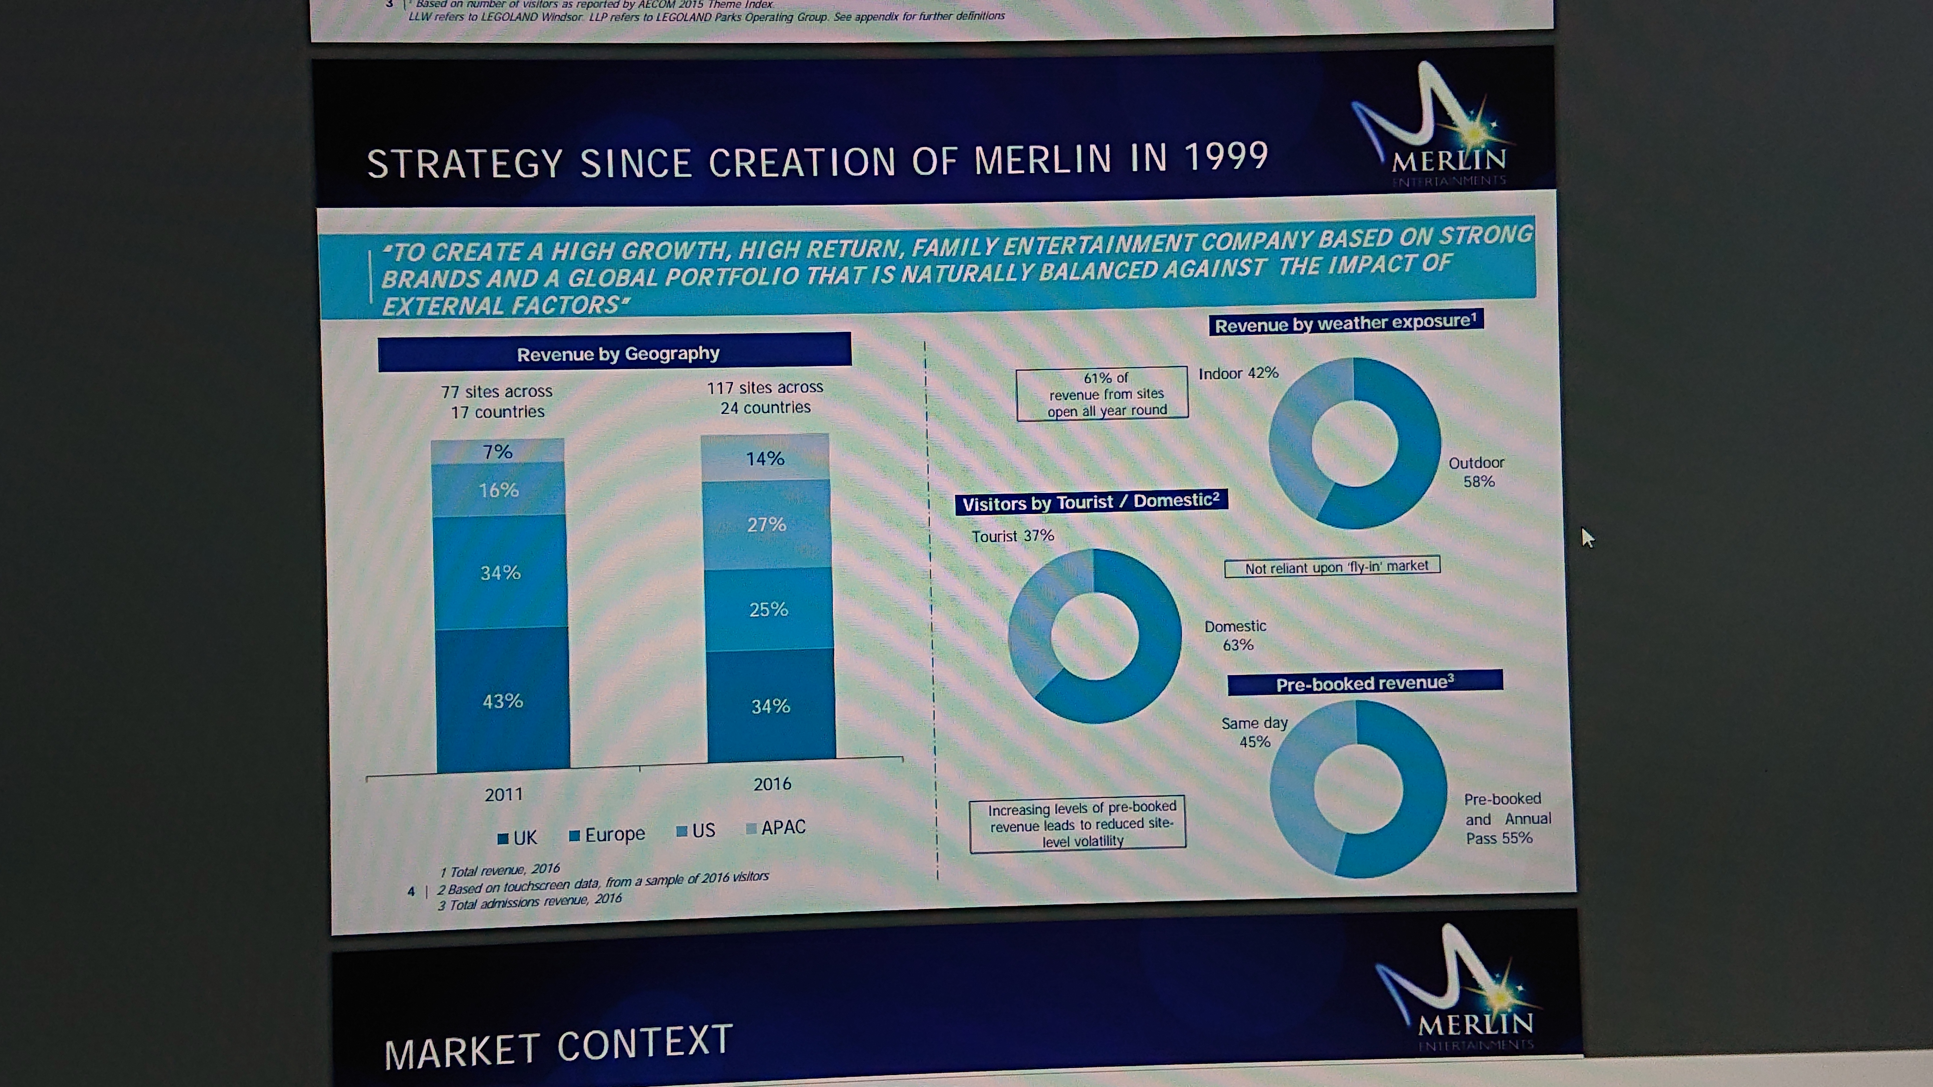
(Sourced from: Merlin website 2018)
The Marketing information systems from Merlin’s own website showing their strategies and methods implemented. However the Marketing director at Merlin realises this may not be best option, I have placed her quote below.
“The role of a marketer should be redubbed a “customer experience designer”, according to Merlin Entertainment’s group marketing director, Emma Woods, who said the ability to deliver good consumer experiences is even harder in a tech-driven world where things can easily go wrong (Merlin Entertainments, 2019).
Woods, speaking at Experian’s client summit in London today (30th September), said that the space for conveying customer experiences is tapering the correct use of data is ever more imperative.
“The world of marketing is changing and we have to think about ourselves as customer experience designers,” she said. “Part of that design responsibility is also being protectors for when things go wrong. The second thing is that… in the future your customer data will inform that customer experience and my challenge to marketers is that you have a responsibility to collect it, use it and nurture it.”(Emma Woods 30/10/17)
These points below are customer focused issues which they have placed in to action.
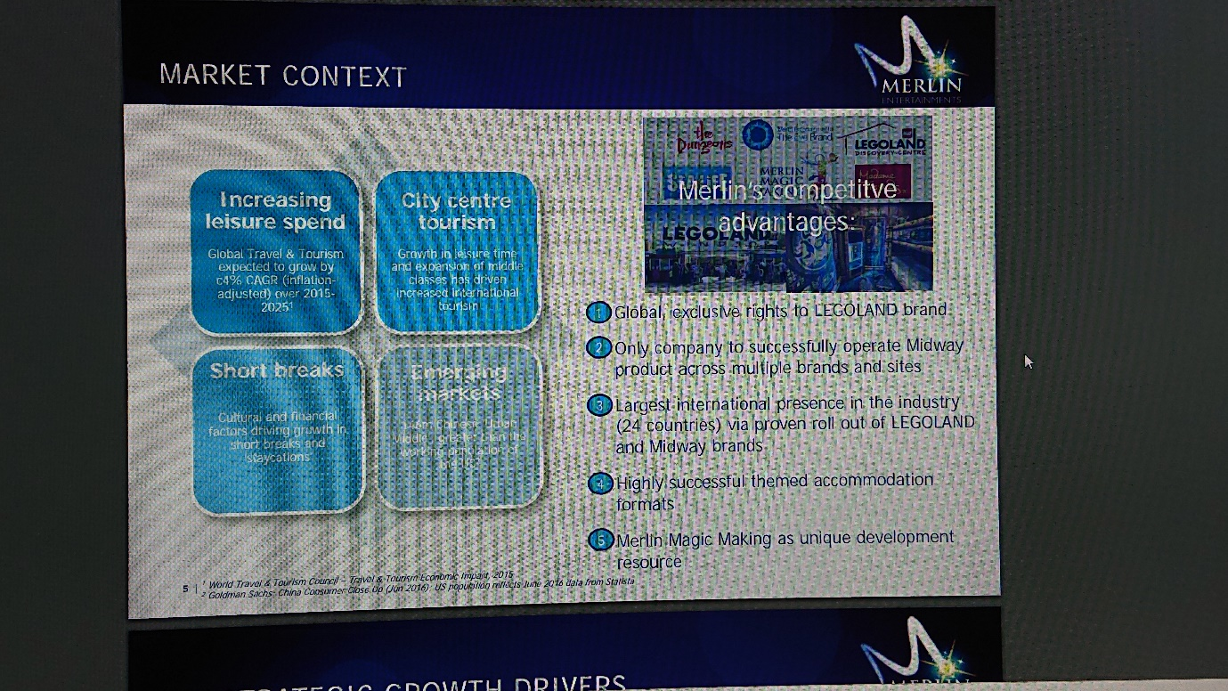
(Sourced from: Merlin website 2018)
This information was sourced the merlin group web page as it illustrates the methods and companies they have reached out to collect data. Focusing on how Alton Towers using MIS for communication through own reports shows they use all conventional methods to administer. In the report they illustrate how MIS system will administer the following,
- Increasing leisure spends through online promotions and on line advertising halfway roll out, opening new midway attraction under one of our chainable global brands, with a focus on cluster location where we can derive operating costs, marketing and cost-selling
- Increasing revenues through tourism market, strategic synergies. Balancing the scale of the group in key markets to exploit operational, marketing and buying power, including e-commerce initiatives that provide commercial benefits and better digital journeys for our guests.
- Short breaks and Developing Markets with china for example they have 146 million ‘urban Middle’ greater than the US, Merlin are developing new theme parks in to short break destinations, establishing the catchment area, create new income streams and improve guest contentment.
- Strategic acquisitions, pursuing acquisition and opportunity that tribute to Merlins objectives.

This is by use of data banks and databases and specific software’s created by Merlin to store and process very large amounts of data.
Data gathering from their own websites and search engines, promotional sites for example Groupon get a family ticket for £40, cereal boxes with buy one get one free, all social media sites Facebook, Instagram, twitter ect… all offering promotions to entice and secure bookings.

This is agreed through the – internal processes of shareholders, stakeholders, regulators, and all top management at Merlin. These decisions are all processed through these channels.
Reporting and Findings from Analysed Data:
Planning their next steps Merlin invest in an Audit from and external company and internally undergo a full Audit. The report demonstrates how they intend to grow and their growth plans, mission statements and projected areas of growth globally. They put procedures in place to create new attractions and increase foot fall and revenues, External factors are at this point of the greatest priority, merlin do a full Audit in 2017 and release these statements in a report commissioned by them self below.
“Our strategy is to create a high growth, high return, family Entertainment Company based on strong brands and a global portfolio that is naturally balanced against the impact of external factors.
CONCLUSION
Concluding the finding I have learnt that Merlin have collected, received, reviewed and implemented new systems and have dedicated money to the future growth of their companies. The MIS system has helped to deliver and implement growth externally from its micro systems increasing the volume and reach to its target customer. Merlin like any other hospitality business are learning and evolving continuously, as the digital world of marketing continuously evolves, evolution is still incomplete and the continuation of new and varied marketing techniques will emerge.

References:
Merlin Entertainments, (2018): Merlin Entertainments plc – 2017 Interim Results, available @: file:///C:/Users/1813330/Downloads/Merlin%20Entertainments%20-%202017%20Interims%20RNS%20(1).pdf, (accessed 19/02/2019)
Merlin Entertainments, (2019): MERLIN ANNUAL REPORT AND ACCOUNTS 2016 available @: file:///C:/Users/1813330/Downloads/Annual%20Report%20and%20Accounts%202016%20-%20Screen%20Viewing%20(1).pdf , (accessed on 21/02/2019)

Varney, N (2017) Chief Executive’s Report in MERLIN ANNUAL REPORT AND ACCOUNTS 2016 available @: file:///C:/Users/1813330/Downloads/Annual%20Report%20and%20Accounts%202016%20-%20Screen%20Viewing%20(1).pdf , (accessed on 21/02/2019)

The Guardian, (2016). “Alton Towers owner fined £5m over Smiler roller caster crash”, available @: https://www.theguardian.com/business/2016/sep/27/alton-towers-owner-fined-smiler-rollercaster-crash , (accessed on 22/02/2019)

King, W. R. (1977). Marketing management information systems, New York: Petrocelli/​Charter

The Daily Mail (2015). Teens among four hurt in horrific Alton Towers rollercoaster accident which cost one rider a leg were on their first date, available @: https://www.dailymail.co.uk/news/article-3108873/Alton-Towers-staff-did-not-crushed-rollercoaster-car-10-minutes.html , (accessed 22/02/2019)

Mason, R.O. (1981). Basic Concepts for Designing Management Information systems. In: Mason, R.O., & Swanson, E.B. (eds) Measurements for Management Decision. Philippines: Addison-Wesley.

