

School of Engineering

Undertaking A Green Belt Project
Six Sigma Green Belt (ACMA5005)
Paul Benbow
2014803

10/12/2022
Table of Contents
1 Introduction 1
2 Define 1
3 Measure 3
4 Analyse 5
5 Improve 6
6 Control 7
7 Bibliography 10
8 Appendix A 12
9 Appendix B 16
10 Appendix C 23
11 Appendix D 25
12 Appendix E 30
13 Appendix F 33
14 Appendix G 36

Introduction
Vale Europe LTD is a divisional region of a global conglomerate, it’s refinery, processes nickel ore to produces 40,000 metric tons of nickel products every year (Freightlinner, 2023). The products have a high nickel content of 99.9% and can be used to manufacture; electric vehicle batteries; stainless steel; aerospace alloys (Vale, 2023).
To achieve the production budget, operations are continuous therefore, equipment are required to perform their function reliably for long periods without intervention from maintenance departments that require downtime.
Ensuring equipment reliability is a function of the ‘Asset Management Department’. The ‘Asset Management department’ reports to a hierarchy external to the region and is responsible for ensuring that the risk to business and safety is mitigated by creating effective maintenance strategies and ensuring their proper completion.
The region’s ‘Engineering manager’ reports into the local hierarchy, directly to the regional manager. The ‘Engineering Manager’ is accountable for ensuring that regional systems and procedures align to the directives of the ‘Asset Management’ department.
It is the responsibility of the ‘systems supervisor’ to ensure that ‘Asset Management’ directives are integrated into regional systems and procedures. The ‘Systems Engineer’ is a direct report of the ‘System Supervisor’ and is able to design local systems and procedures that achieve the desired deliverables.
This report will use the DMIAC frame work of six sigma to design; measure; improve; analyse; control a new system which will align to the directives of the North Atlantic ‘Asset management Department’, providing the equipment owner with an efficient and effective maintenance service.

Define
The ‘General Manager’ of the ‘Asset Management Department’ for the north Atlantic division of ‘Vale Base Metals’ met the regional ‘Engineering Manager’ to discuss their concerns that current metrics suggest that UK regional maintenance departments have become overwhelmed with ‘corrective maintenance’ and do not spend sufficient time completing ‘predictive maintenance’ (Lill, 2022).
Requests which are ‘Corrective maintenance’ are considered to be unforeseen equipment failures, the types of which can cause; severe disruption to production schedules; exhaust financial budgets; degrade product quality (Bataineh, et al., 2019). Internal business reputation may also suffer (Dreyer, 1995) and as a consequence custom could be redirected to internal business competitors. At the time of writing, the price of high grade nickel was $29790.00USD per TONNE (LME, 2023), and the production budget was forecasted based on continuous operation. If operations were to shut down because of an equipment failure, the loss in revenue would be approximately $138,589.00USD per hour.
Predictive Maintenance is a combination of ‘systematic’ and ‘non-systematic’ maintenance. A definition of ‘Systematic’ could be considered as a pre-defined maintenance regime which has been created in the CMMS and has a set ‘call date’ based on a calendar frequency or a usage counter frequency. Once the ‘call date’ has been reached or the equipment has been used long enough, ;systematic maintenance’ work order will automatically generate hence, asking the required maintenance department to perform maintenance on the equipment. Completion of ‘systematic maintenance’ should identify the early signs of equipment failure. Resolving the earlier sign of a failure before it develops in to an actual failure, should be considered as ‘non-systematic’ maintenance. ‘Non-systemic maintenance’ demonstrates maintenance regimes are adequate.
Generating ‘non-systemic’ maintenance will provide enough time between identification and the actual failure occurring, for adequately planning and scheduling to take place. When a repair is adequately planned and scheduled; associated hazards are recognised, then controlled to reduce the risk of injury to personnel (HSE, 2023) and time taken to affect the repair is shorter therefore, reducing equipment downtime (Kister & Hawkins, 2006).
All Maintenance Activities (with the exception of systematic maintenance), originates from an equipment owner or maintenance technician recognising that a service is required. To inform the appropriate department of the service, a ‘notification of maintenance’ request is created in the CMMS of which, there are various types (Figure 4). The SIPOC Chart shown in Figure 6 depicts the; suppliers; inputs; outputs; customers of this process.
Information entered onto a notification, such as the ‘Required end date’ field; ‘origin of demand’ field aids the maintenance planner to determine the type of work order that should be created. Work order’s that have a YEM & YCO ‘work order type’ are classified as ‘corrective maintenance’, work orders that have YCM, YRR, YPW & YIM ‘work order type’ are classified as ‘non-systematic maintenance’ (Figure 5).
It is suggested by Stenstrom, et al., (2016), that an efficient and effective maintenance department’s time should have a ratio of 80/20 between predictive maintenance (systemic and non-systemic) and corrective maintenance respectively.
The ‘Engineer Manager’ formed a team which included the ‘System Supervisor’ and ‘System Engineer’ to; evaluate the ‘voice of the customer’ (the ‘Asset Management’ Manager); identify what is ‘critical to quality’; review current process; produce a project charter (Baynham, 2022).
A ‘Quality Function Deployment’ exercise (Figure 7), was performed by the team to identify the ‘Voice of the customer’. The team produced a ‘House of Quality’ which itemised the ‘customer requirements’, then assigned a score associated with their importance to the customer. The discussed ‘functional requirements’ which were tangible and could influence the process, a score was assigned to reflect its relationship with the ‘customers requirements’. Multiplication of both scores produced a overhaul score for each ‘functional requirement’. The ‘functional requirement’ with the highest score would receive the most attention during the design process.

Measure
A ‘time confirmation’ is a CMMS transaction that allows a maintenance technician to record accurate time that has been spent working on a maintenance activity. The “Actual hours” taken to complete a maintenance activity should be considered as the aggregate of ‘time confirmations’ made by each individual technician. The ‘Actual Hours’ field was used to establish a measurement of time spent on ‘corrective maintenance’ work order types.
An attribute dataset was taken from the CMMS, the population of which consisted of 14,126 ‘time confirmations’ which were made against ‘corrective maintenance’ work order types, for 2022. The dataset was inclusive of a “Description” data field (Figure 10), which was used to transform the dataset from nominal to binary data (Akkartal, 2021).
Verifying that the correct ‘work order type’ had been used, was made by assessing the verbs used to describe the maintenance service required. The list of common verbs used (Figure 9), were agreed by the ‘project team’ and could be associated with four of the classifications shown in Figure 5; ‘Systematic maintenance’; ‘Non-systematic maintenance’; ‘corrective maintenance’; ‘support’.
A function was used in ‘Microsoft Excel’ to test each “Description” field from every ‘time confirmation’ of the dataset, if the field contained a ‘listed verb’, it’s associated category would be populated into an additional field.
Further scrutinizing time confirmations made onto ‘corrective maintenance’ work order types was necessary to establish whether the maintenance request could have been identified by a ‘systematic maintenance’ plan and therefore, should have been classified as ‘Non-systematic maintenance’. This was achieved by analysing the ‘equipment number’ associated with each ‘time confirmation’ (Figure 10), and making a comparison to the equipment numbers of - a dataset taken from the CMMS - of available ‘maintenance plans’(Figure 11).
If a work order used for a time confirmation did not test positive when screening for specific verbs in the “Description field” therefore, maintaining it’s ‘corrective maintenance classification’ but, an available maintenance plan was associated with the same piece of equipment, the work order would have been re-classified as ‘non-systemic maintenance’
A sample was extracted from the population after treatment, to verify and ensure the capability of the measuring system. Calculation of the sample size followed two steps; first, based on the population being infinite; second, an adjustment was made for the accurate value of the population. Each step considered; a confidence level of 95% probability that the sample would reflect the results that were to be expected from the entire population; the confidence interval (margin of error), was 5% (Vanderstoep, 2008).
$$S=Sample size for infinate population$$
$Z=Confidence level$ (Z Score))
$$P=Population proportion$$
$$m=Margin of error$$
$$S_{a}=Adjusted Sample Size for specific population$$
$$S=Z^{2}×\frac{P \left(1-P\right)}{m^{2}}$$
$$S={1.96}^{2}×\frac{0.5 \left(1-0.5\right)}{{0.05}^{2}}$$
$$S=384.16$$
$$Therefore,$$
$$S_{a}= \frac{S}{1+ \left[\frac{\left(S-1\right)}{P}\right]}$$
$$S_{a}= \frac{384.16}{1+ \left[\frac{\left(384.16-1\right)}{14126}\right]}$$
$$S_{a}=374.01$$
A sample size of 375 data points where verified by the team to ensure that the measurement system had accurately assessed the “Description” field for the correct categorising of the associated work order. The actual ‘margin of error’ for the sample was 3.7% which was below the allowance of 5%.

Analyse
The defect identified by the measuring system was considered to be time confirmation’s entered on to a ‘corrective maintenance’ work order type, but should have been entered on to a ‘systematic’ or non-systematic’ work order type.
Figure 1 shows 20715 hours of the maintenance department’s time – accounting for 49% of the total - was spent on ‘corrective maintenance’ work order types which, should have been classified as either ‘systemic’ or non-systemic’.
The Pareto chart (Figure 1), categorises the causes of the defect into ‘order types’ which should have been used, to create work order’s to complete the required maintenance activity. Figure 1 shows the aggregate of hours for all time confirmations made against each cause of the defect.
The project team used Pareto’s 80/20 rule which states that; “80 % of defects in a process seemed to be accounted for by 20% of the causes” (Wilkinson, 2006), to prioritise the “causes” and concentrate their efforts.
Figure 1 shows that a ‘significant few’ of the “causes” are contributing to 80% of the defect while, an ‘insignificant many’ of the “causes” are contributing to only 20% of the defect. It can be seen that, the significant causes are shown as ‘notification of maintenance’ requests which should have been used to create ‘non-systematic’ (YCM) and ’systematic maintenance’ (YPM) but, instead used to create a ‘corrective maintenance’ order type.
To contextualise the severity of the cause; 9829 hours should have been confirmed against a ‘non-systemic maintenance’ (YCM) work order type and 7090 hours should have been confirmed against ‘systematic maintenance’ (YPM) work order type. If the correct work order types had been used, it would have reduced the total time spent on ‘corrective maintenance’ in 2022 from 67% (Lill, 2022) to 13%.
An Ishikawa diagram (Figure 2), was used by the project team to help identify root causes and understand the reasons for a YCM or a YPM work order type not being used.
Four activities were identified as “branches” on the diagram which depicted the inputs required to produce the ideal output – a maintenance request with the correct work order type - these were; ‘Maintenance Inspections’; Systems; Machine; Personnel.
Primary causes that were associated with an activity and might of affected the ‘ideal outcome’ were drawn as an “offshoot” from an ‘activity branch’. Secondary causes, tertiary causes, and so forth, were drawn in a consecutive chain until the root cause had been identified.

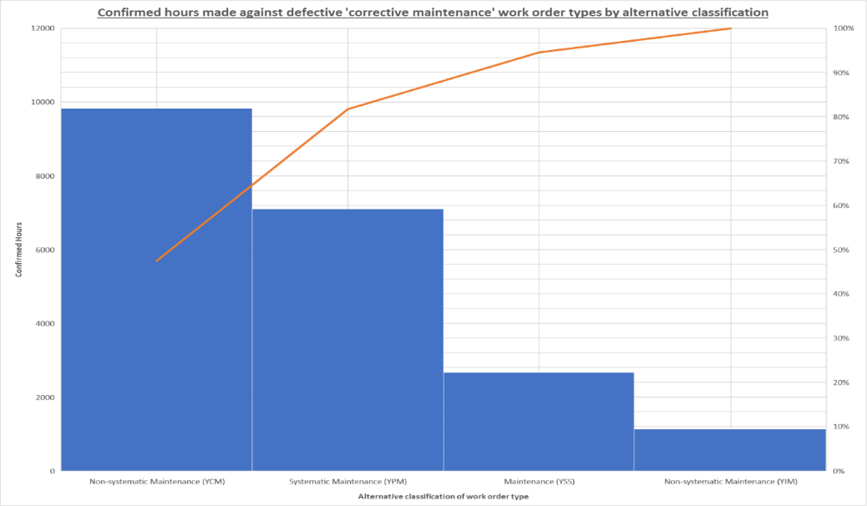
Figure 1 Confirmed hours made against defective 'corrective maintenance' work order types by alternative classification
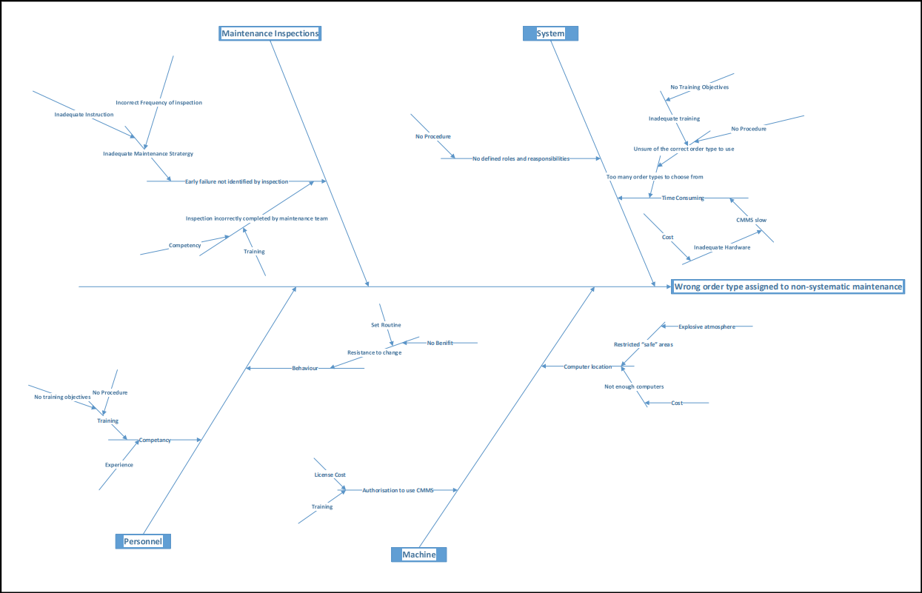
Figure 2 Ishikawa Diagram for the wrong order type assigned to non-systematic maintenance request

Improve
The project team developed a Process Failure Mode Effect Analysis (FMEA), chart (Figure 15). by reviewing the process steps identified by the ‘current state’ SIPOC (Figure 6), then associating them with root causes identified on the Ishikawa diagram (Figure 2). A ‘risk priority number’ (RPN), was calculated for each failure mode by multiplication of the severity of the failure to the customer (Figure 12); frequency the failure occurs (Figure 13); ability to detect error (Figure 14).
A ‘brainstorming meeting’ was held, which included a cross-functional team of; customer representatives; equipment owners; engineers; maintenance planners; maintenance coordinators, the purpose of which, was to create design or re-design concepts which would negate the occurrence of a ‘failure mode’.
It was recognised that completion of every concept that had been generated in the ‘brainstorming meeting’ (shown in Figure 16; Figure 17; Figure 18; Figure 19), would not be possible because of limited resources and the time allowed to complete the project so, a ‘payoff matrix’ was used to decide concept’s for focus. The ‘payoff matrix’ would evaluate each concept with regard to the ‘effort required’ versus, the benefit associated to the VOC’s requirements – this would be represented by a high ‘RPN’ value in Figure 20.
The ’pay off matrix’ in Figure 20 identified two areas of focus which would take ‘low effort’ but, would provide ‘high benefit’. The first, would be to create a procedure that would show a target audience how to create an appropriate ‘maintenance request notification’ and describe the benefits of doing so correctly. The second, to create a procedure for maintenance planners to use during the screening of ‘maintenance request notifications’ which would detail scenarios and actions to be taken. Action for both concepts were added to the FMEA (Figure 21).
A project charter was created by the team and communicated to local employees affected by the implementation of the new system (Figure 8), ensuring that the importance of the project objectives and the reasons for change were communicated effectively.

Control
Training document’s (Appendix D), for the new process stipulated that equipment owners, maintenance coordinators and maintenance planners must follow the; flow charts shown in Figure 23 and Figure 24; cheat sheets (Appendix E; Appendix F; Appendix G); RACI matrix (Figure 26) to correctly create and execute an appropriate maintenance request.
Successful implementation of the new process will depend on the roles listed on the RACI matrix, receiving the “change” and having the discipline to follow their associated ‘flow chart’, which forms the procedure, then complete their required action.
Unfortunately, because of restrictions imposed on the CMMS by Vale divisional legislation, designing a ‘Poke-yoke’ system to enforce the correct behaviour, preventing the ‘causes of the defect’ was not possible. However, a “standard” report in the CMMS was created for all maintenance planners to “screen” notifications without the requirement for them to enter subjective information into search fields. This ensured all relevant information would be visible and notifications would not be lost.
If, personnel responsible for creating a ‘notification of maintenance request’ had not followed the new procedure, it would have been difficult to ‘detect the defect’. This was because of the subjective nature of the information required to be provided would be difficult to corroborate as the individuals likely to raise a notification would be on a shift pattern and not available during a “standard” working day.
The project team would ensure that the new process is in control of inadvertent errors with a ‘detection of the defect’ philosophy. A statistical process control (SPC) chart shall be used to monitor a consistent random sample of twenty work orders that have been created on a weekly basis. Each sample shall be analysed with the measuring system which has been created. The quantity of defective items within the each sample shall be used to calculate the mean and the ‘standard deviation’
$$Mean (\bar{c})=\frac{Total number of defective items found in sample (np.c)}{Number of Samples taken (n)}$$
$$Mean \bar{(c})= \frac{50}{12}$$
Therefore,
$$Mean (\bar{c})=4.167$$
So,
$Standard Deviation (o)= \sqrt{\bar{c}(1-\frac{c ̄}{n}}$)

Therefore,
$$Standard Deviation (o)= \sqrt{4.167(1-\frac{4.167 ̄}{20}}$$
Therefore,
$$Standard Deviation (o)= 1.816$$
To ensure that defective work orders remain in control an ‘upper control limit’ and ‘lower control limit’ were calculated. Control limits must be calculated to three ‘standard deviations’ $(3o)$ above and below the calculated ‘standard deviations’ $(o)$.
Figure 3 shows the control chart for this project. Week 2 shows a trough which falls below the ‘lower control limit’ therefore, the process is considered “out of control”. Week 3 shows a peak which rises above the ‘upper control limit’ therefore, considered out of control. The process is consistent and within both control limits from week 4 onwards.
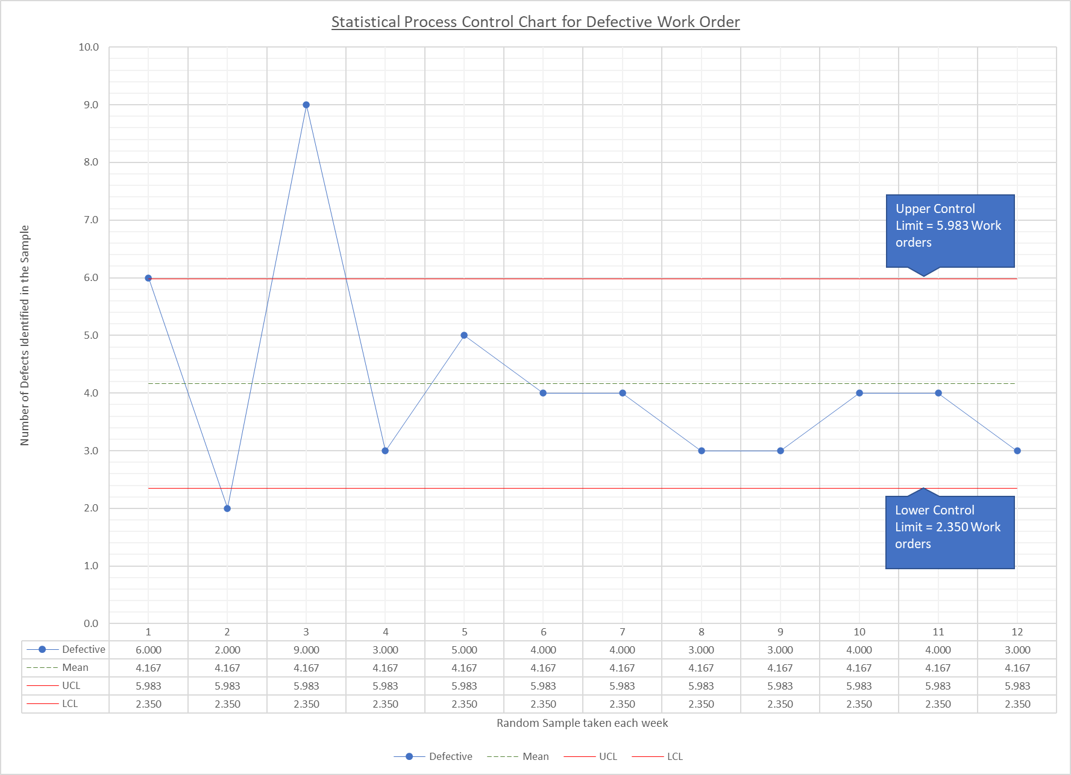
Figure 3 Statistical Process Control Chart for defective work orders
Reasons that have have contributed to non-adherence of the process during week 2 & week 3 include delays to the timeline illustrated on the project charter (Figure 8); unexpected period for embedded behaviours to broken; underestimated resistance to change; underestimated period for new behaviours to be embedded; target audience was not defined hence, requests for authorisation to use CMMS was sporadic.
Lesson’s were learnt by the team during this project. To improve the implementation of future projects the ‘voice of the process’ must be engaged. Engagement would give opportunity to those using the process to understand the ‘forces for change’ and also, would have helped the project team better understood the ‘resistance to change’. A force field analysis could have been completed to form a strategy for implementation, which would has reduced the ‘resistance to change’, accelerating the implementation phase of the project (Baulcomb, 203).

Bibliography
Akkartal, C., 2021. Six Sigma Measure Phase Data. [Online]
Available at: https://blog.masterofproject.com/six-sigma-measure-phase-data/
[Accessed 27 February 2023].
Bataineh, O., Al-Hawari, T., Alshraideh, H. & Dalalah, D., 2019. A sequential TPM-based scheme for improving production effectiveness presented with a case study. Quality in Maintenance Engineering , 25(1), pp. 144-161.
Baulcomb, S. J., 203. Management of change through force field analysis. Journal of nursing management, 11(4), pp. 275-280.
Baynham, M., 2022. AIP [Interview] (08 12 2022).
Dreyer, E., 1995. Cost-effective prevention of equipment failure in the mining industry. Pressure Vessels and Piping, 61(2-3), pp. 329-347.
Freightlinner, 2023. The largest nickel refinery in Europe. [Online]
Available at: https://www.freightliner.co.uk/case-studies/vale-europe/
[Accessed 4 Feburuary 2023].
HSE, 2023. Plant and equipment maintenance. [Online]
Available at: https://www.hse.gov.uk/toolbox/machinery/plant.htm
[Accessed 4 Feburary 2023].
Kister, T. C. & Hawkins, B., 2006. Maintenance Planning and Scheduling Handbook. 1 ed. Oxford: Elsevier Butterworth-Heinemann.
Lill, J., 2022. 2023 AIP Strategy for Clydach [Interview] (8 December 2022).
LME, 2023. LME Nickel. [Online]
Available at: https://www.lme.com/Metals/Non-ferrous/LME-Nickel#Trading+day+summary
[Accessed 4 February 2023].
Vale, 2023. Clydach Operations. [Online]
Available at: https://vale.com/clydach-operations?segmentsExperienceId=1493721&_gl=1*1fe5w1s*_ga*MTg1MTE3NzM1OS4xNjUwNzEzNDkx*_ga_BNK5C1QYMC*MTY3NTUxMTE3MC4xLjEuMTY3NTUxMTIxNC4xNi4wLjA.
[Accessed 4 Febuarury 2023].
Vanderstoep, S. W., 2008. Research methods for everyday life: blending qualitative and quantitative approaches. 1 ed. s.l.:Jossey-Bass.
Wilkinson, L., 2006. Revising the Pareto Chart. The American Statistician, 60(4), pp. 332-334.

Appendix A
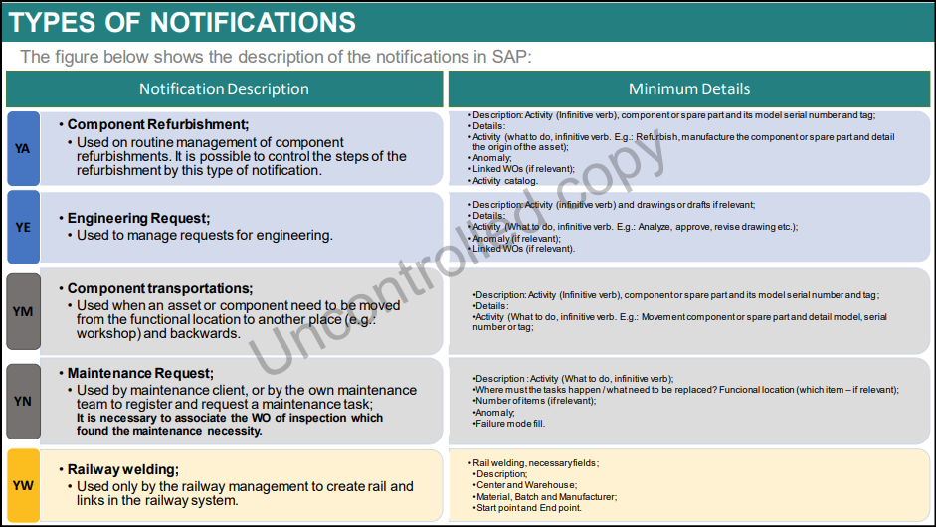
Figure 4 'Notification of Maintenance' types
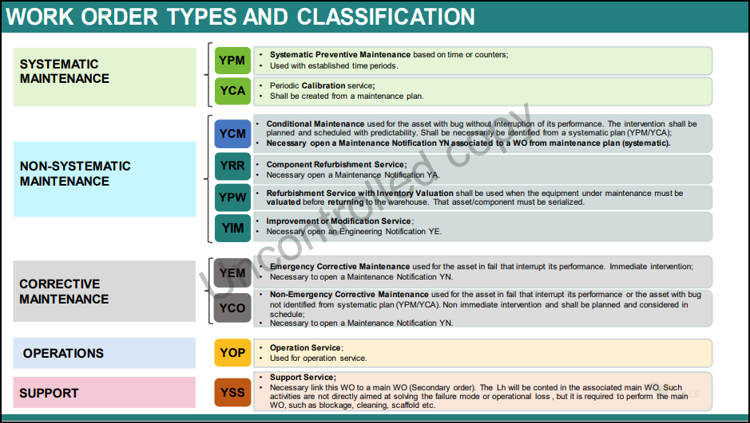
Figure 5 Work order types and their categorisation

Figure 6 SIPOC for 'Current State' of process

Figure 7 'House of quality' used to translate the VOC

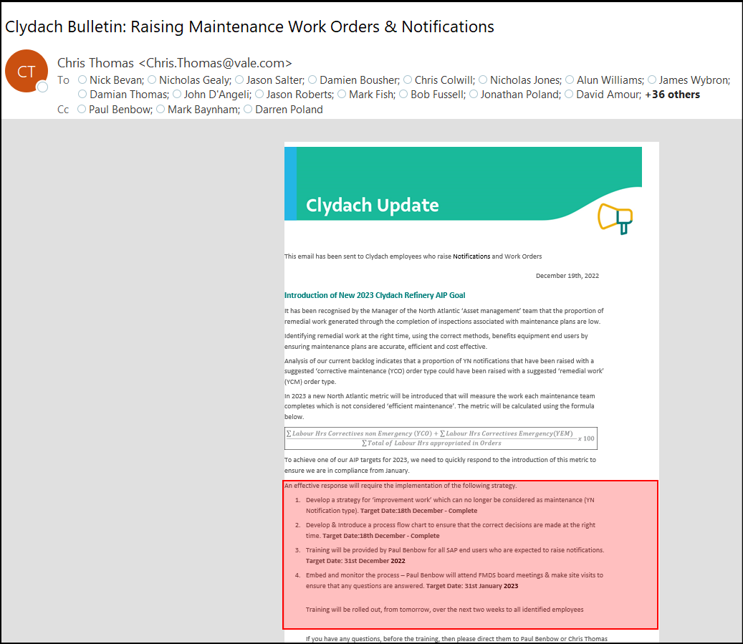
Figure 8 Clydach Update notifying users of the project charter

Appendix B
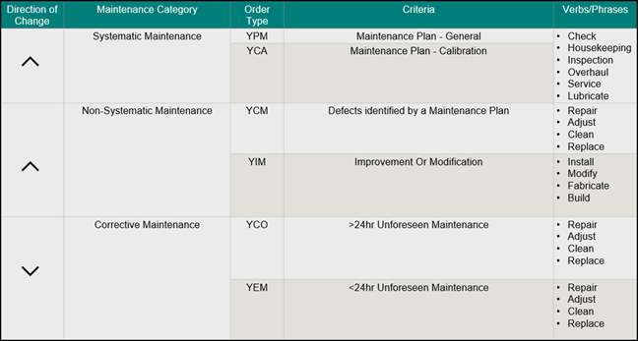
Figure 9 Verbs used to verify the 'order type' of a work order
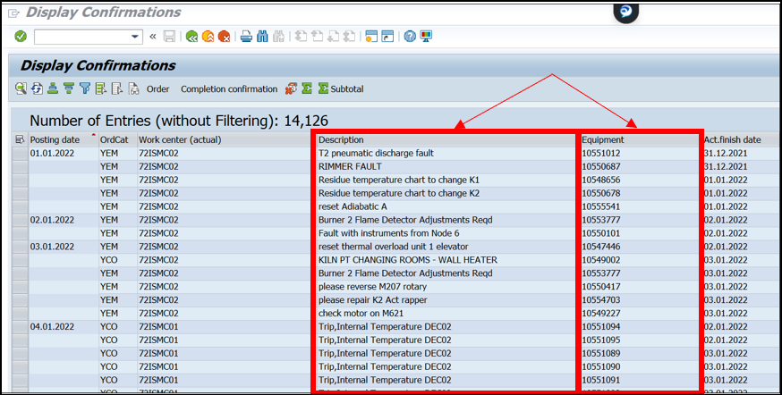
Figure 10 Examples of the "Description" & “Equipment” data point of a work order.
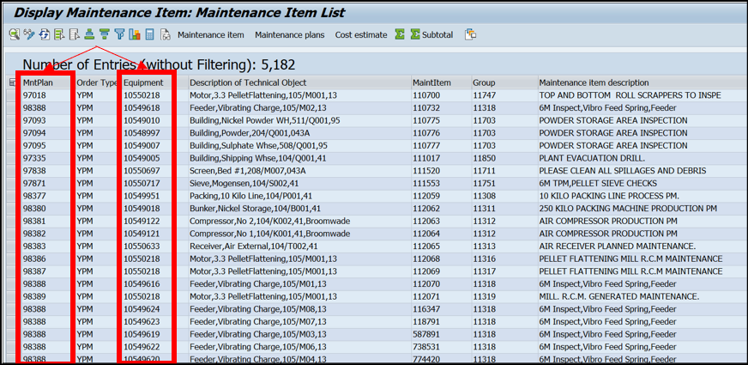
Figure 11 Available maintenance plans associated with 'equipment numbers'
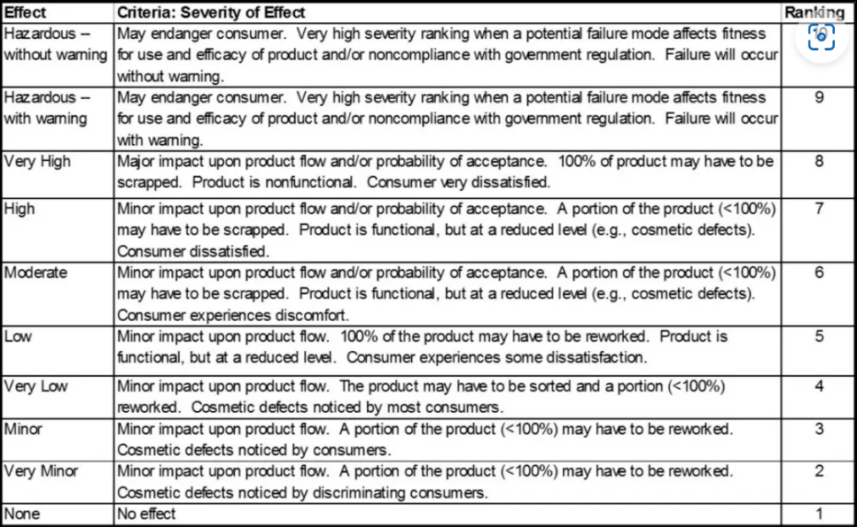
Figure 12 Severity Index used for the FMEA

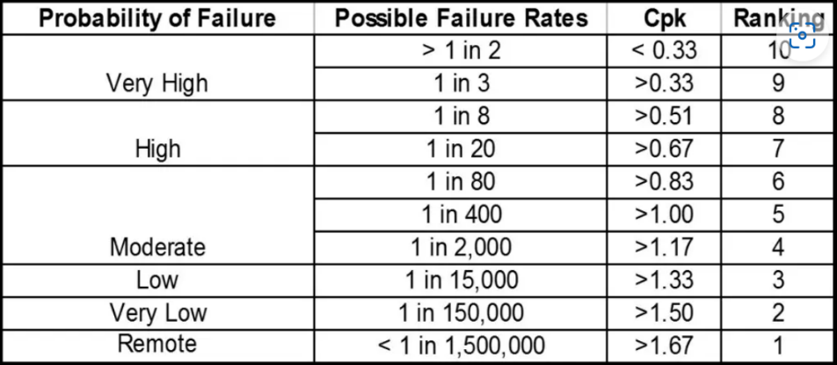
Figure 13 Probability of failure (occurrence), index used for FMEA
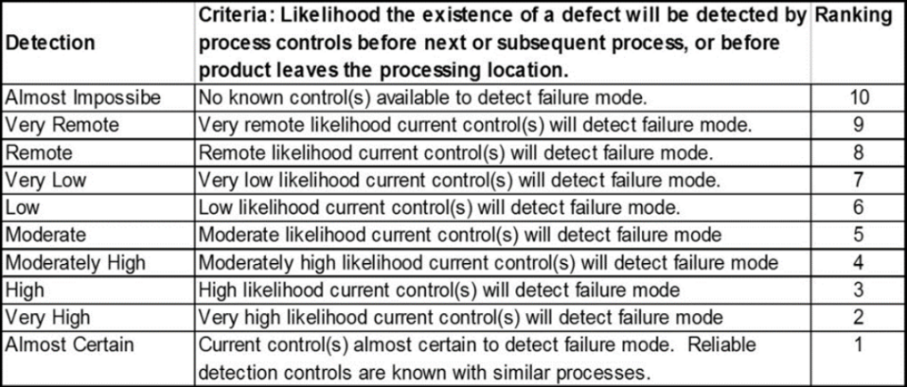
Figure 14 Detection index used for FMEA

Figure 15 Failure Mode Analysis (Rev.1)
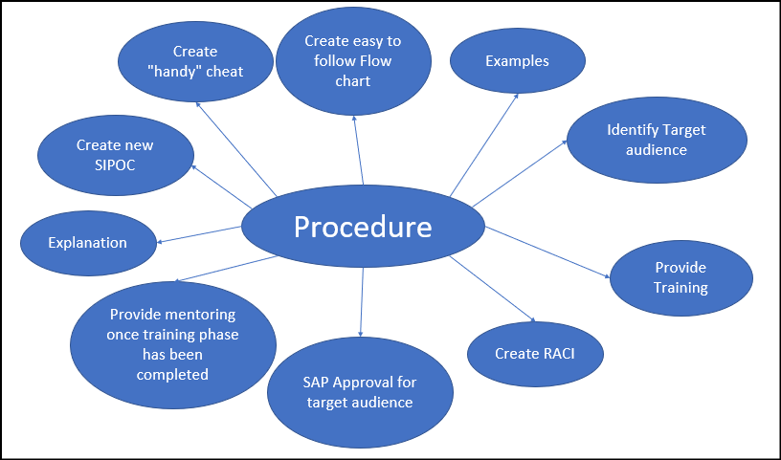
Figure 16 Brainstorm for the concept of developing a procedure

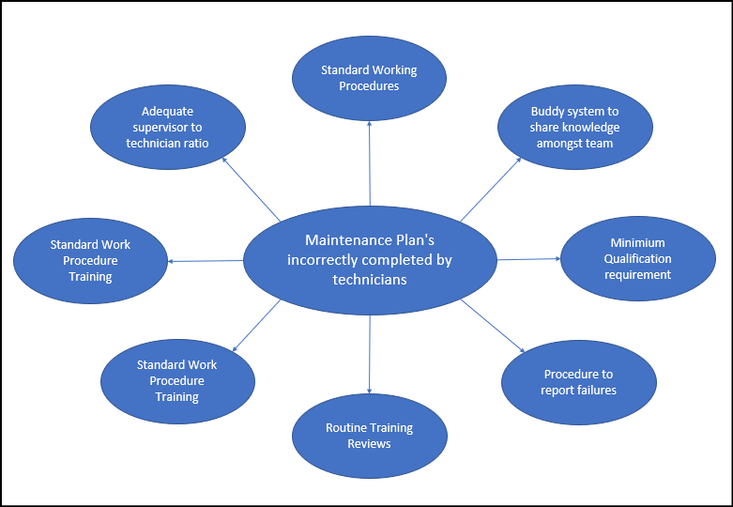
Figure 17 Brainstorm for the maintenance plans that are incorrectly completed by technicians

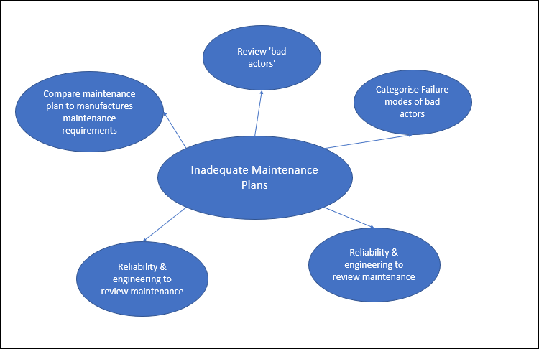
Figure 18 brainstorm for the concept of inadequate maintenance plans

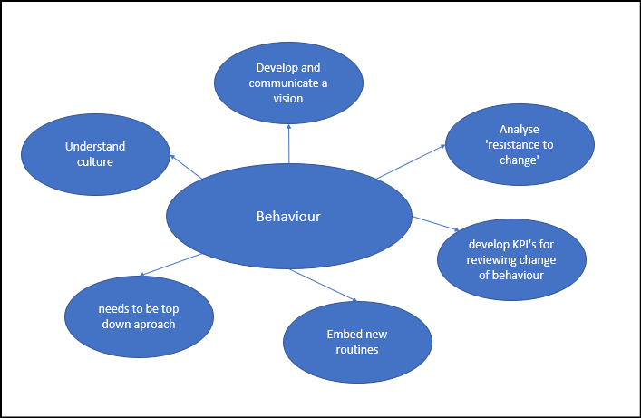
Figure 19 brainstorm for the concept of behaviour
Figure 20 Payoff Matrix

Figure 21 Actions Assigned to 'revision 2' of the FMEA

Figure 22 Final revision (3) of the FMEA

Appendix C
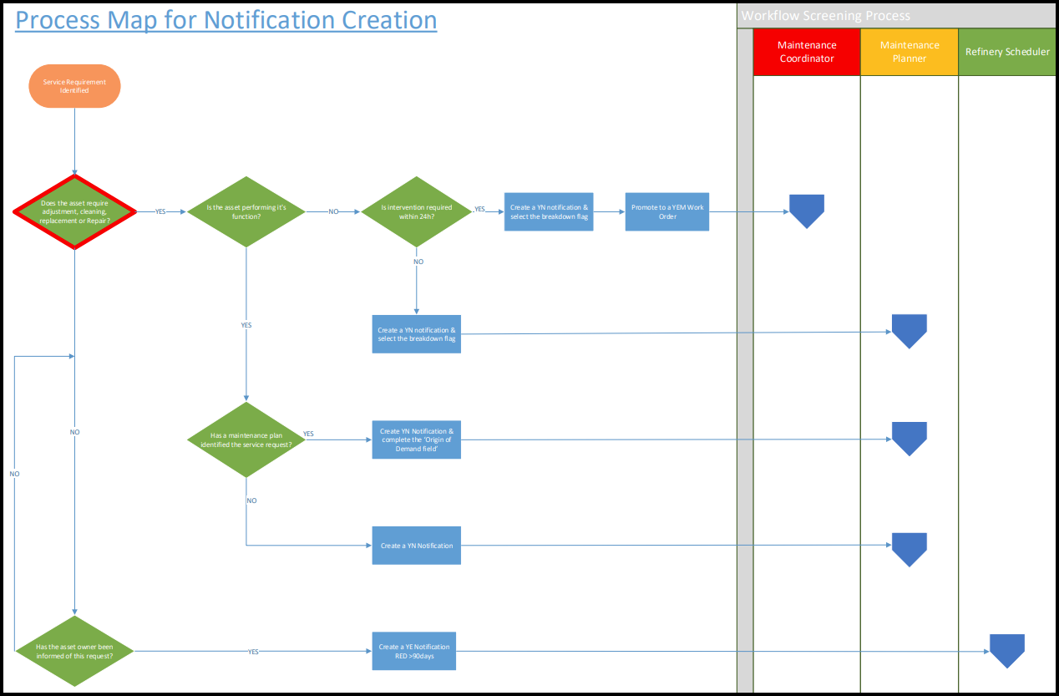
Figure 23 Flow Chart to follow for creating an appropriate notification

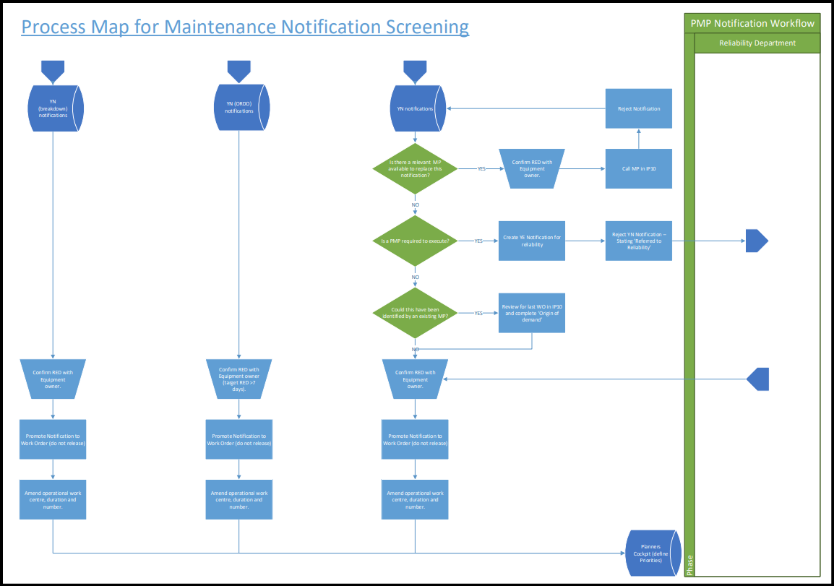
Figure 24 Flow chart to follow for screening notifications
Figure 25 'New state' SIPOC Chart
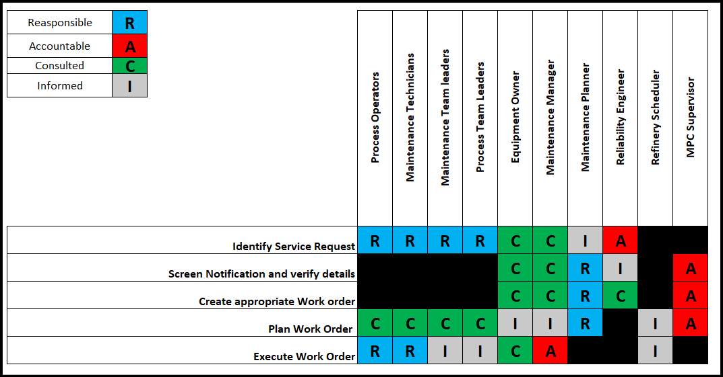
Figure 26 RACI Matrix for new process

Appendix D

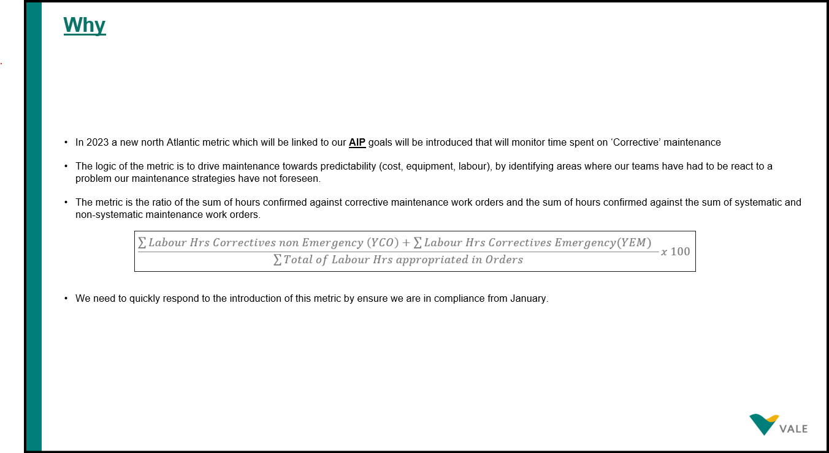
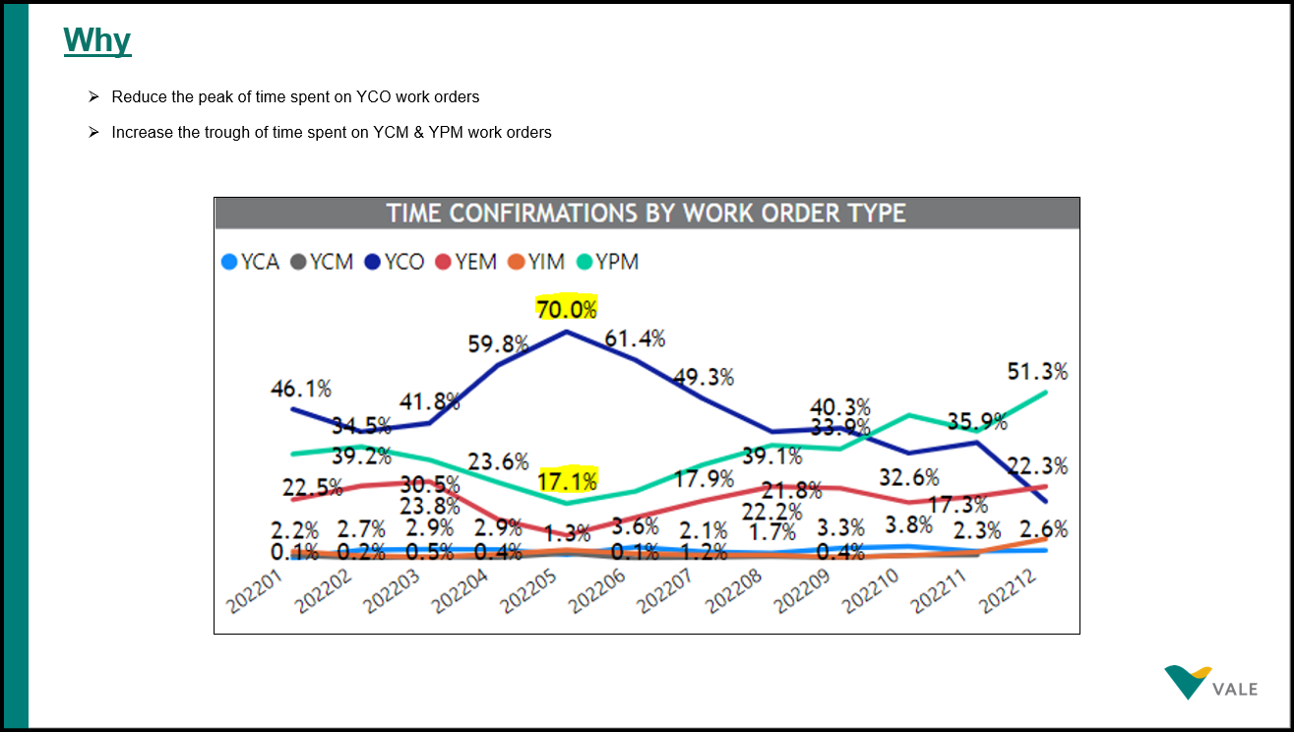
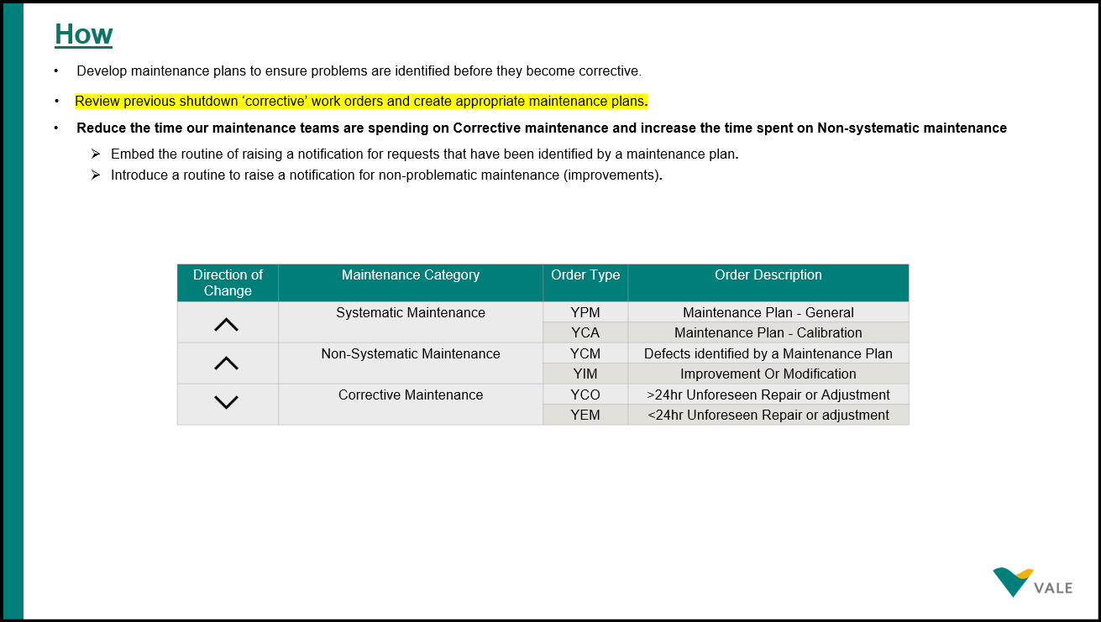
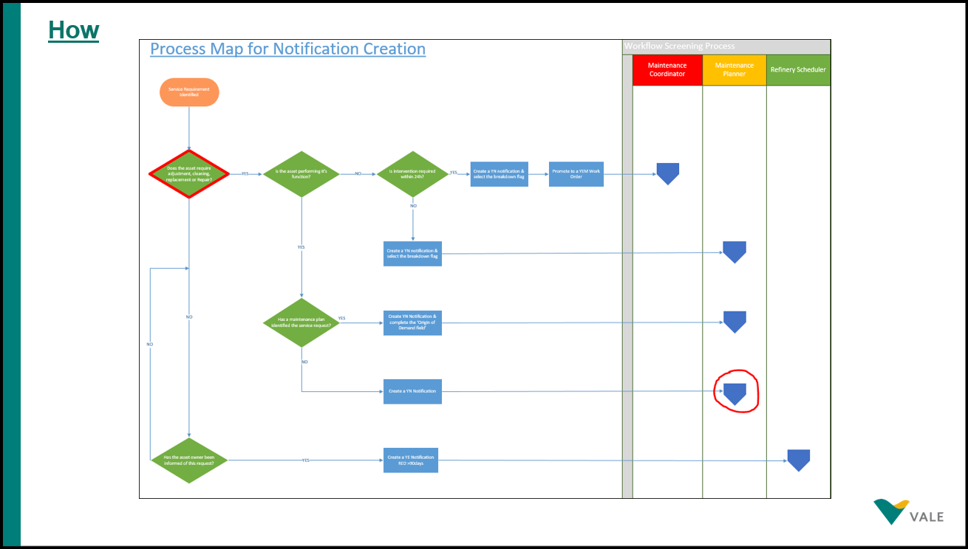
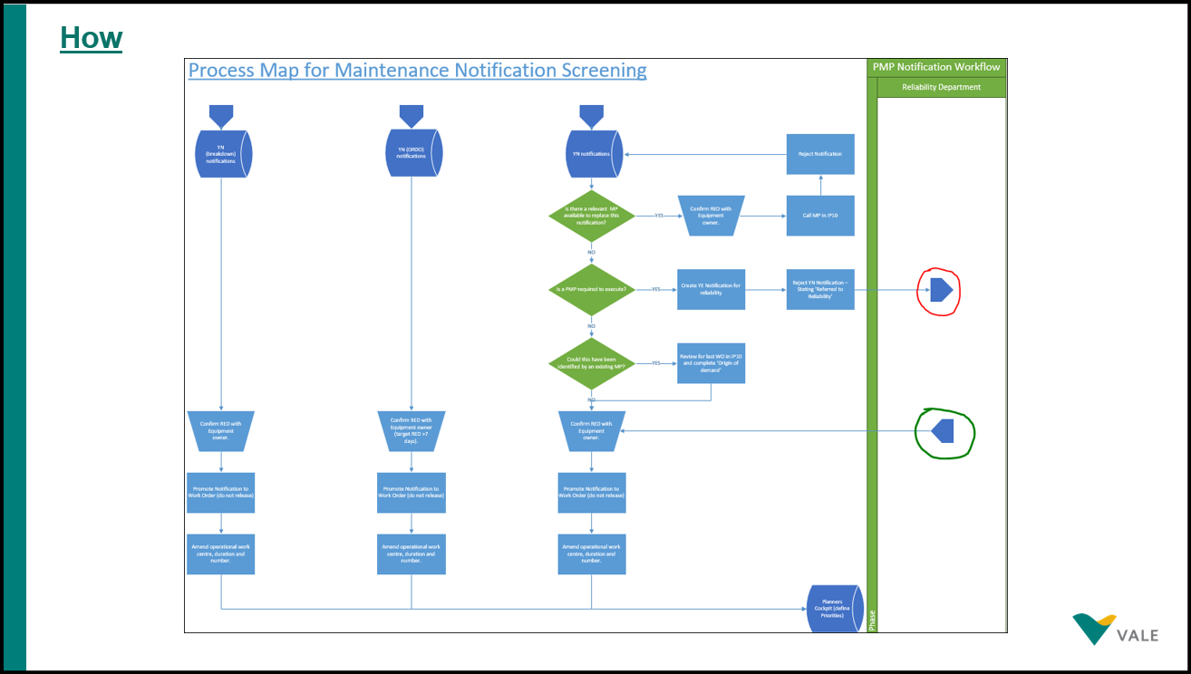
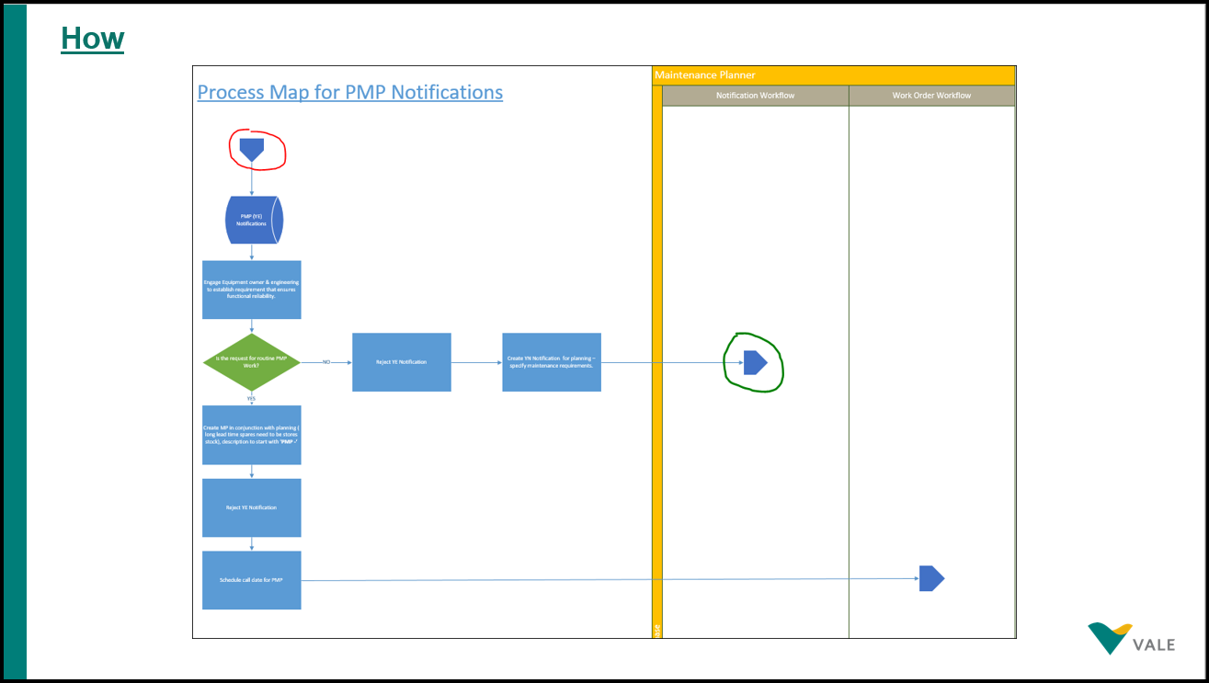
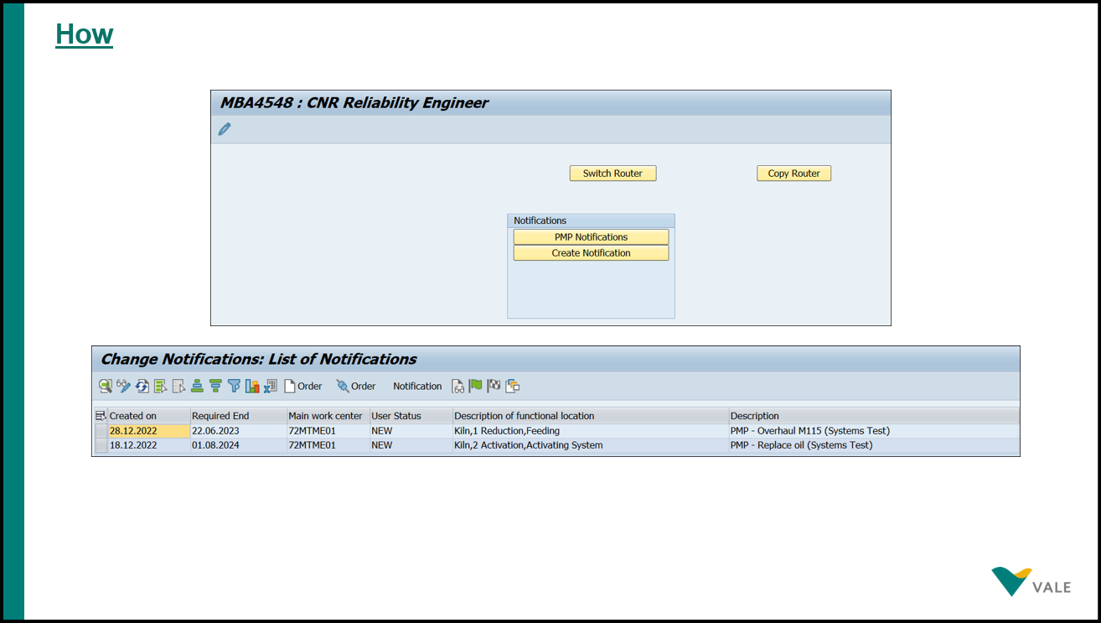



Appendix E
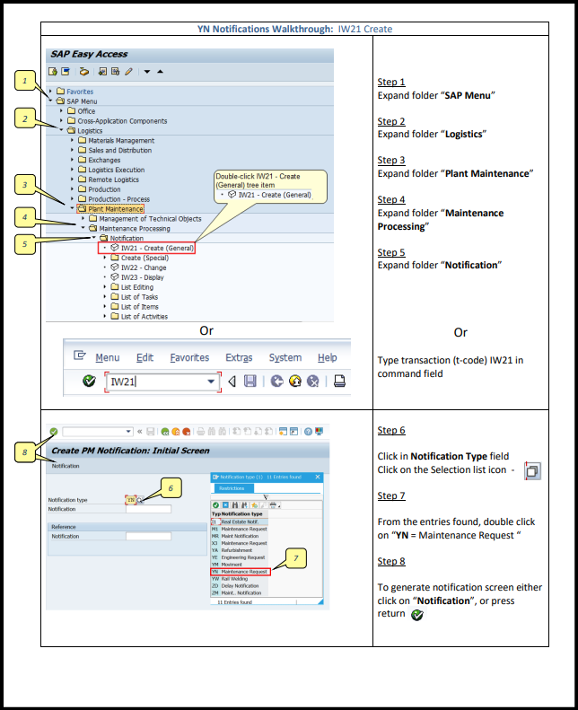
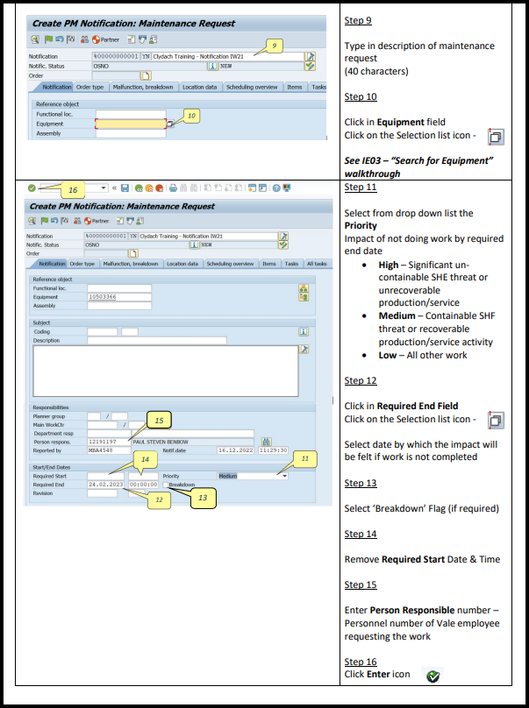
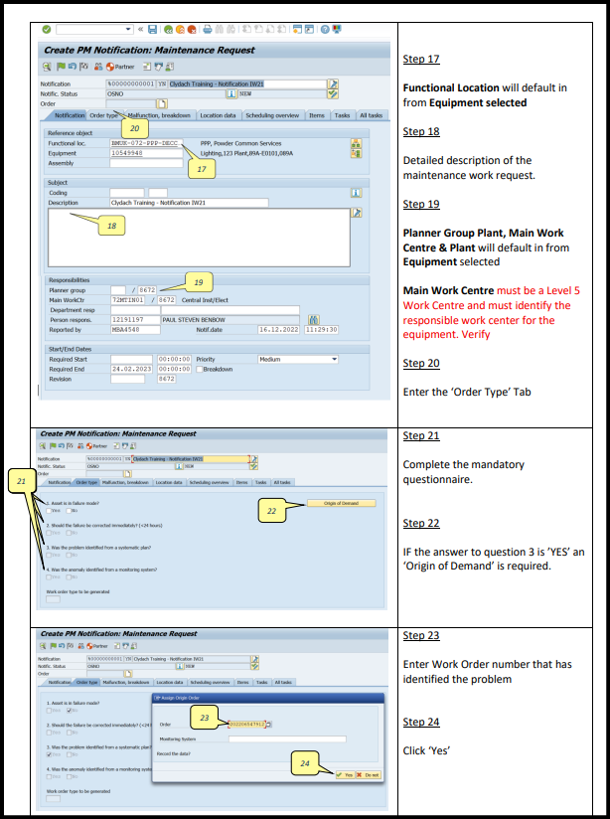
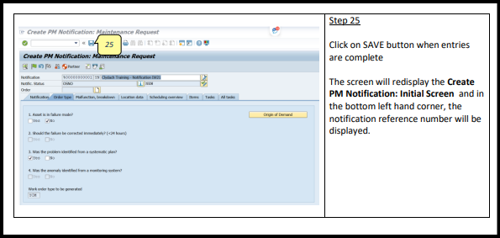

Appendix F
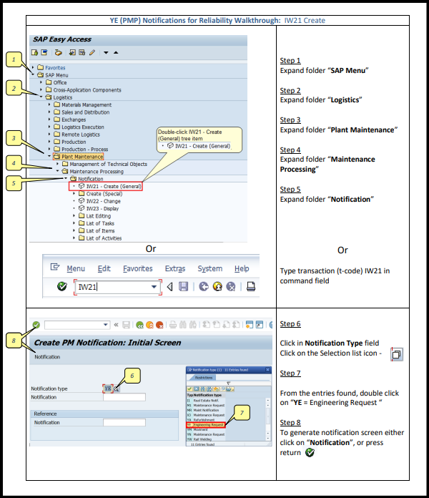
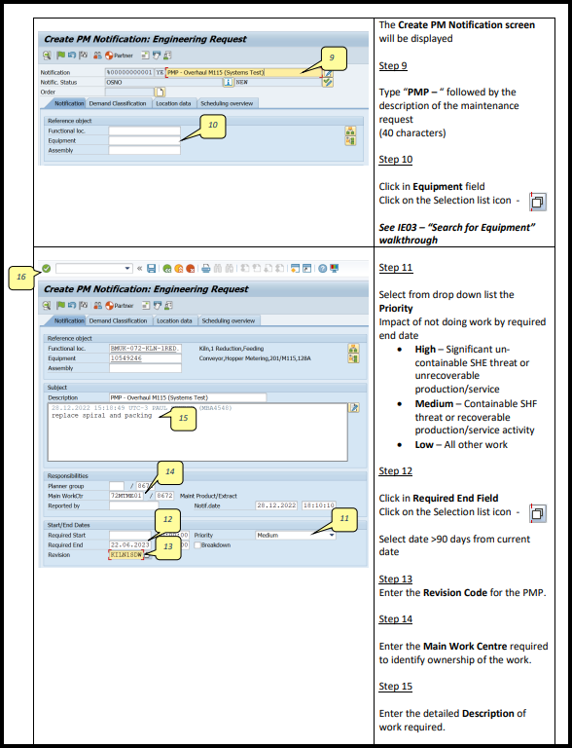
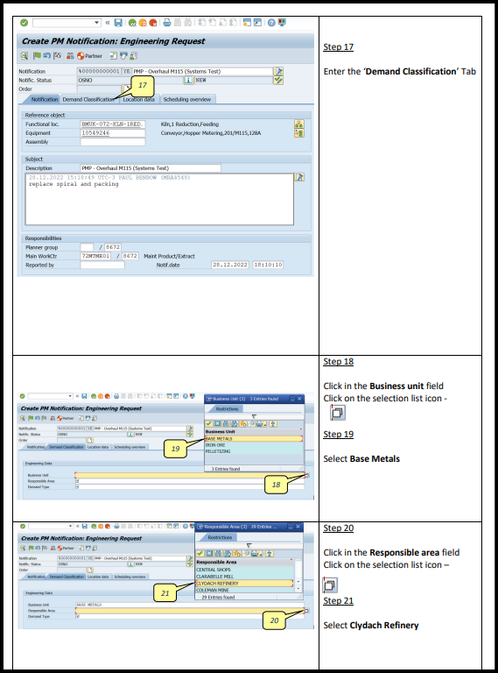
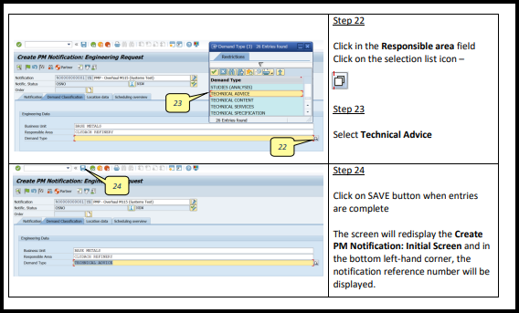

Appendix G


