Title: Academic Skills Report
Name: Usama Mushtaq
Student Number: 2414397
Module Code: LCLM 4001
Module Name: Reflective Report
Lecturer: Tim Hopkins
Date: 15/12/2024

Content
1 Introduction page 3
2.1 Note Taking page 4
2.2 Paraphrasing Skills page 5/6
2.3 Reflection Skills page 6/7
3 Conclusion page 8
4 References page 9
5 Appendices page 9/10

1 Introduction
Throughout this module, I have had the opportunity to develop three essential academic skills that are crucial for my academic growth and future success: note-taking, paraphrasing, and reflection. These skills have helped me in different ways, from understanding and organising complex information to improving the quality of my academic writing and enhancing my ability to think critically about my learning. In this report, I will reflect on how I developed each of these skills through various class activities, tools, and independent tasks. To structure my reflection, I will use Gibbs’ Reflective Cycle, a framework that allows me to analyse my experiences, evaluate what I learned, and identify strategies to continue improving in the future.

2.1 Note Taking

One of the skills I’ve improved a lot during this module is my note-taking. A task that really helped me was when we watched a video called Psychology of Motivation and Procrastination. The video had a few different speakers talking about motivation and procrastination, and we had to take notes on what they said.

At first, I found it hard to keep up with the speakers because they spoke really fast, and they mentioned a lot of names and ideas I wasn’t familiar with. I kept trying to write down everything they said, but I ended up missing important details. Sometimes I couldn’t even catch the names of the speakers, and my notes didn’t make much sense. It felt frustrating because I wanted to make sure I didn’t miss anything.

Luckily, the teacher played the video again, which gave me a chance to go over it once more. This time, I decided to try a new approach. Instead of writing everything down, I focused on the key points and main ideas the speakers were talking about. I started using shorter notes, like bullet points, and I didn’t worry too much about writing everything exactly. I just tried to capture the important things.

Looking back, I can see that my initial approach wasn’t the best. I was trying to get every single detail, and that didn’t help me understand the material. After changing my strategy, I felt much more in control. I realised that note-taking isn’t about writing everything down but about finding the key points and organising them so they make sense later. I now plan to use this method in other tasks, knowing it’s a better way to take notes that helps me remember and understand the content.

2.2 Paraphrasing
Another skill I’ve worked on throughout this module is paraphrasing. In class, we did an exercise where we were given a passage, and our job was to rewrite it in our own words without changing the meaning. At first, I found this task difficult. I wasn’t sure how to change the sentence structure or wording enough without losing the original message. I felt unsure about whether I was really paraphrasing or just copying the same ideas in a slightly different way.
During the exercise, I realised I was struggling to express the same idea in my own words without feeling like I was just rewording the original text. In the Feelings stage of Gibbs’ cycle, I felt frustrated because I wasn’t sure if I was doing it right. It felt like a challenge to make the text sound natural while still keeping the meaning intact.
After receiving feedback from the teacher and seeing examples of how to paraphrase effectively, I felt more confident. I understood that paraphrasing wasn’t just about switching a few words around. It was about understanding the core idea, then restating it in my own voice. In the Evaluation phase, I realised that paraphrasing is a skill that requires not only changing words but also restructuring the sentence to improve clarity. The teacher’s feedback and examples helped me see where I could improve.
In the Analysis phase, I thought about how paraphrasing could be helpful for writing assignments. By using paraphrasing, I can show that I understand a topic without simply copying what others have said. I now know that effective paraphrasing involves both changing the language and expressing the meaning in a new way. For Conclusion, I learned that practice is key to getting better at this skill. I will focus on reading the text carefully, understanding it, and then writing it in my own words, instead of trying to change it word-for-word.
Going forward, my Action Plan is to practice paraphrasing more by reading articles and summarising them in my own words. I will keep using the strategies I learned, like simplifying complex ideas, to improve my paraphrasing ability.

2.3 Reflection Skills
In this module, one of the most valuable skills I’ve developed is reflection. Before this, I had no idea about the different models of reflection, like Kolb’s Experiential Learning Cycle, Driscoll’s Model, or Gibbs’s Reflective Cycle. These were completely new concepts to me, and at first, I wasn’t sure how they would fit into my learning process. I thought reflection was just about thinking back on what you did, but I soon realised it was much more structured and purposeful.
The first time I learned about these models, I felt a bit overwhelmed. I didn’t understand how to apply them or why they were important. However, as we went through each one in class, I started to see how they could help me understand my learning experiences more deeply. Kolb’s model, for example, helped me understand that learning is a cycle, where experience leads to reflection, and reflection leads to new ideas or changes in behaviour. Driscoll’s model, on the other hand, made me realise how important it is to ask myself specific questions about what happened and what I learned from it. Gibbs’s cycle, which we used in our report, gave me a clear and easy way to reflect on what I had learned, how I felt, and what actions I could take next time.
At first, I felt unsure about using these models. I wasn’t sure how to break down my experiences into structured reflections. But as I practiced using them more, I began to see their value. Reflecting in a more systematic way helped me think about my learning from different perspectives.
I realised that reflection wasn’t just about looking back; it was about improving and making better choices for the future.
For Conclusion, I now understand that reflection is a vital part of learning. It’s not just about thinking back but also about critically analysing experiences and making changes to improve. In my Action Plan, I plan to continue using these models to reflect on my learning experiences. By doing so, I believe I’ll be able to better understand my strengths and areas for improvement, making me more effective in my studies and future career.

3 Conclusion
Looking back at this module, I can honestly say I’ve learned a lot and developed some important academic skills. Before this course, I never really thought about how to take notes effectively or how to paraphrase properly, let alone how to reflect on my own learning. But now, I feel much more confident in these areas.
Taking notes has become less overwhelming. I’ve learned to focus on key points, understand the material better, and structure my notes in a way that helps me process information more efficiently. Paraphrasing is still a work in progress, but now I understand it’s not just about changing words. It’s about capturing the meaning and presenting it in my own way, which has made me more comfortable with it.
Reflection has been the biggest game-changer. The different models have helped me understand that learning isn’t just about doing tasks; it’s about thinking critically and improving as I go. These skills have made me feel more in control of my learning, and I’m excited to keep using them to grow. I know that by practicing these skills regularly, I’ll continue to improve and become a more effective student.

4 References:
BBC. (2019). The psychology of motivation and procrastination.
BBC Sounds.
https://www.bbc.co.uk/sounds/play/m0005t4x

1. Kolb, D. A. (1984). Experiential learning: Experience as the source of learning and development. Prentice Hall.
2. Gibbs, G. (1988). Learning by doing: A guide to teaching and learning methods. Further Education Unit.
3. Driscoll, J. (2007). Practicing clinical supervision: A reflective approach for healthcare professionals. Wiley-Blackwell.

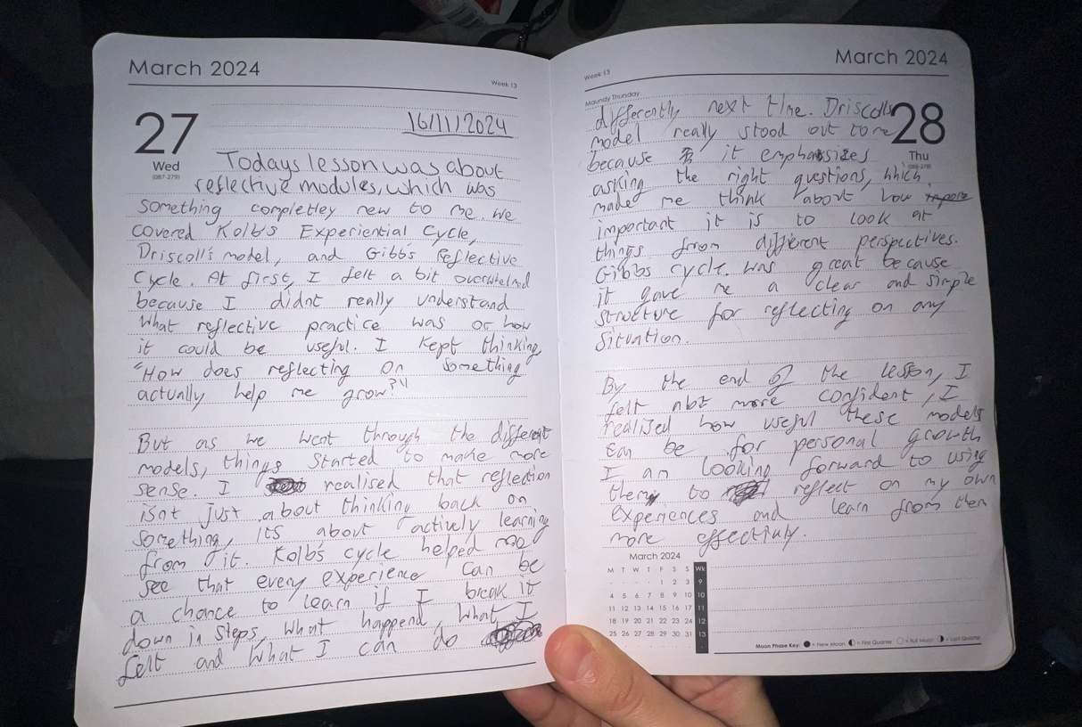
Reflection Skills 2.3
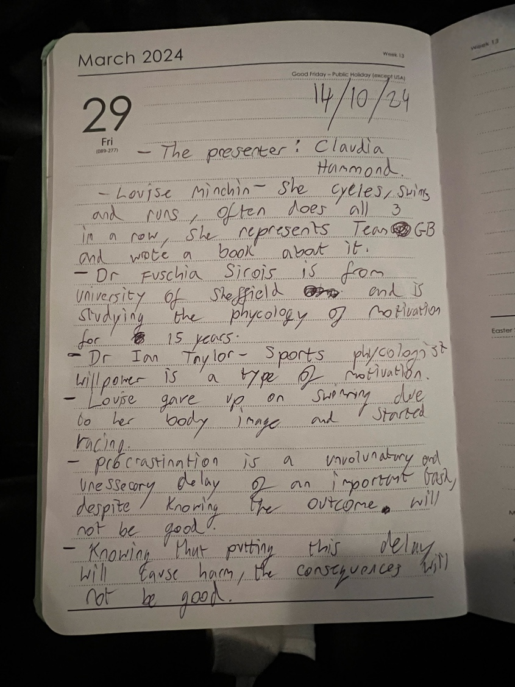
Note Taking 2.1
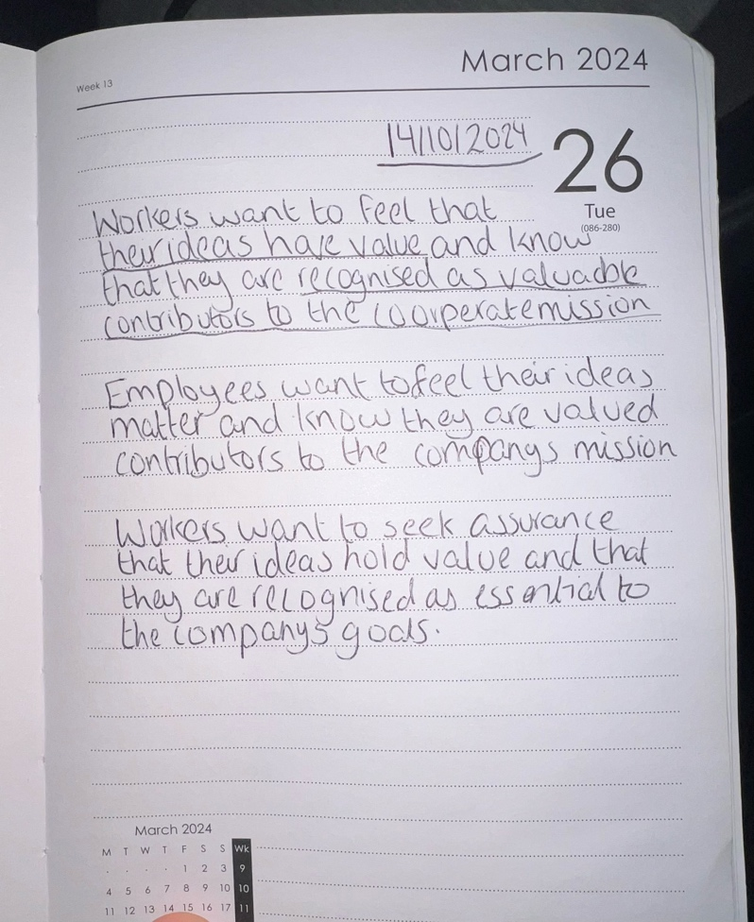
Paraphrasing 2.2

