

BSc (Hons) Health and Social Care

BMHP5014: Changemakers: Creativity and Value Creation

Student Name: Abass Bundu Kamara
Student ID: 2416734
Lecturer: Laila Surani
Module Number: BMHP5014
Submission Date: Friday 7th August 2026 (2PM)

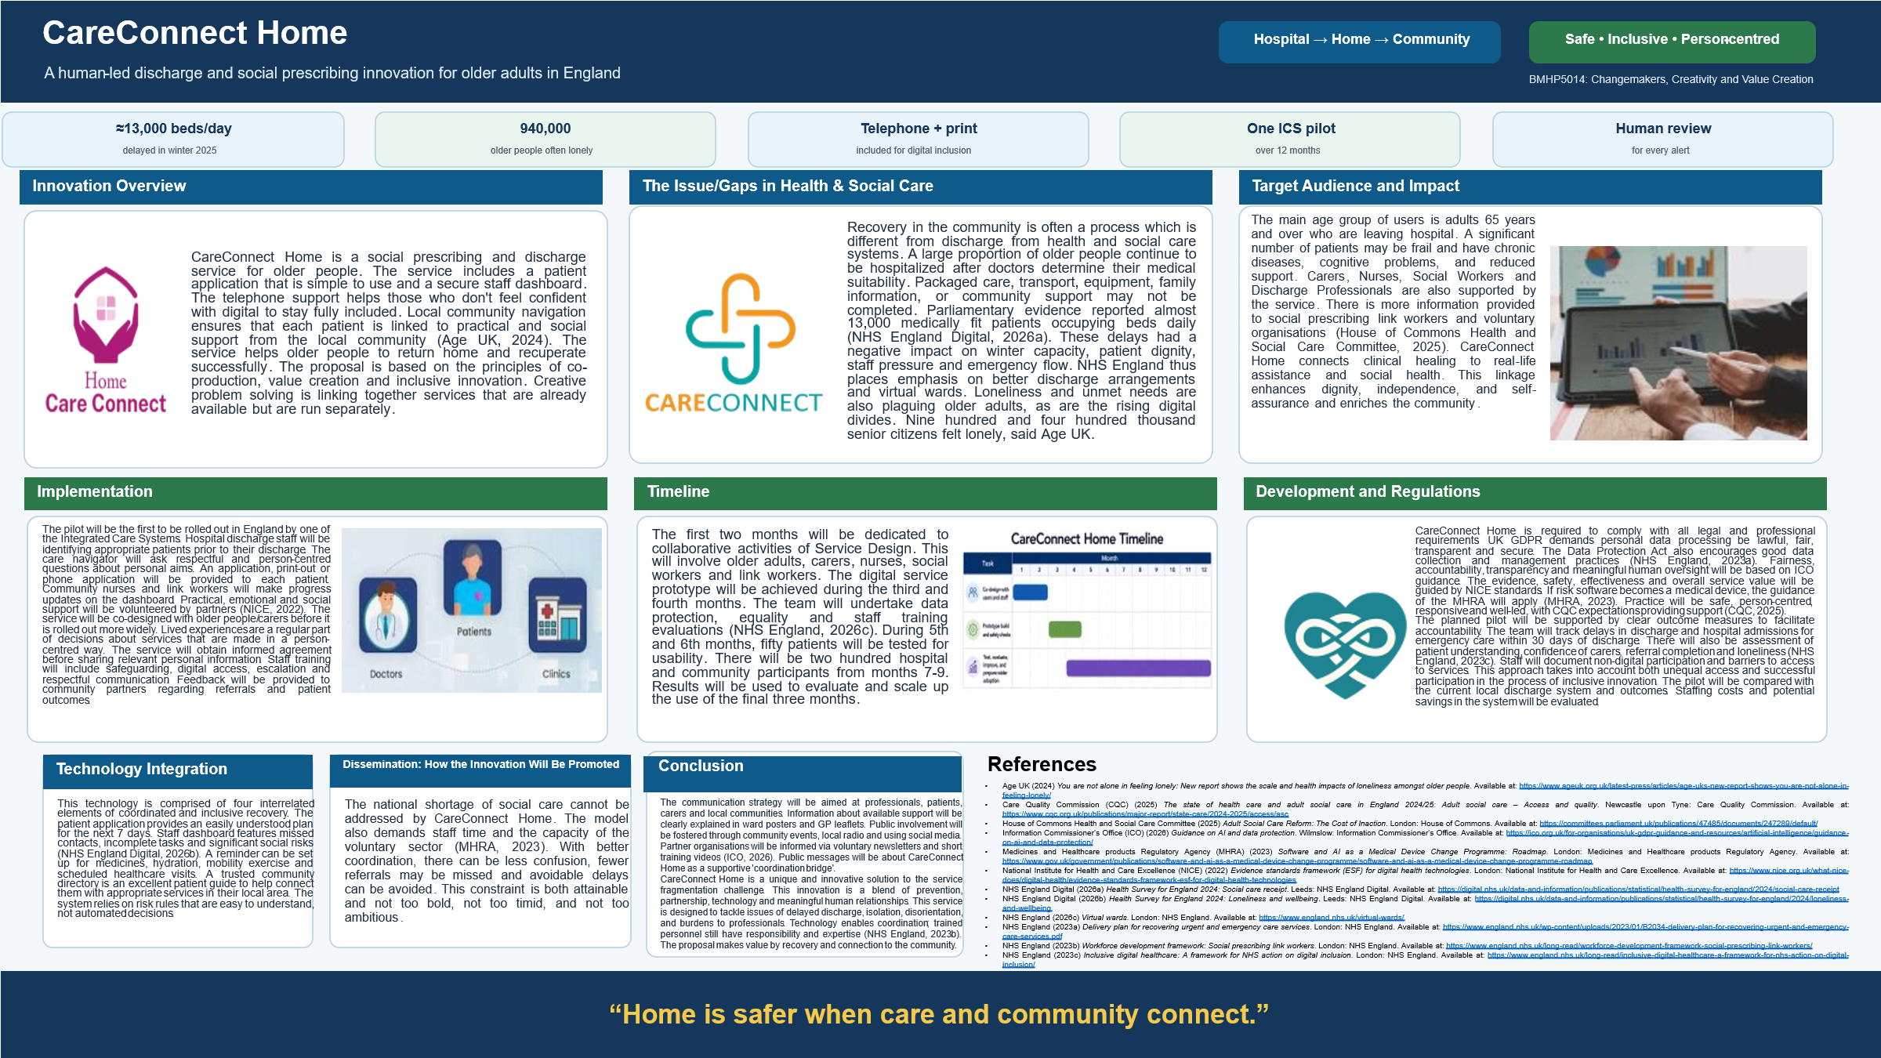

Pitch
Pitch script
1. Introduction and Rationale for CareConnect Home
CareConnect Home offers a safer discharge and more robust support in the community for the elderly. The service is a digital coordination together with trusted local partnerships and personal guidance. All older people should have a clear plan when they are returning home. All carers need accurate information on duties, contacts and support available.
The discharge from a hospital means more than just finishing therapy and moving out of a healthcare environment. Each patient has to deal with medicines, mobility, appointments, equipment and altering daily routines. Although many patients are physically healthy, they do not go to the hospital because community care is not in place. During winter, almost 13,000 beds were found to be occupied, based on Parliamentary evidence (Age UK, 2024). The unneeded postponements are demeaning and can cause distress to families. These delays also add to the strain on staff and limit emergency hospital capacity. Poor communication between health, social and community services.
Loneliness and lack of support following discharge are also common in older people. Early recovery is often a time of low confidence as a result of reduced mobility and new medications (NICE, 2022). With minimal family assistance, regular tasks can become difficult and challenging. Age UK found that 940,000 older people had a sense of loneliness often. NHS Digital evidence also highlights unmet support needs of older people.
2. CareConnect Home Service Model and Key Features
CareConnect Home offers four connected features under one bundle of service. The first feature provides a very straightforward 7-day personal recovery plan. This plan is available in the application, on the phone or via a printed document for patients. The plan describes medicines, warning signs, appointments, mobility objectives, and contact information. The second feature allows professionals to have a secure coordination dashboard. The dashboard shows all pending actions, missed contacts, referrals and follow-up requirements. Every patient has a named human care navigator in the third feature. The Navigator attentively hears and addresses individual concerns prior to discharge. The fourth feature facilitates patient linkages to trusted, local community services (House of Commons Health and Social Care Committee, 2025).
The primary target group are vulnerable patients 65 and over. There is a high likelihood of patients becoming frail, chronically ill, cognitively impaired or having poor support. This is beneficial to carers, as responsibilities and support available are clearer (NHS England Digital, 2026a). Professionals like the information, and the need to repeat communication is reduced. Better referrals to relevant and respectful personal information for voluntary organisations. The model subsequently generates common value to the individual and public services.
3. Implementation Strategy and Service Development Approach
The model will be piloted in one ICS for one year. Planned discharge teams at the hospital will review the suitability of patients before their discharge. A navigator will ask appropriately about individual purpose and possible barriers. The discussion will focus on issues of safety at home, confidence, mobility and social interaction. The service will then develop a unique discharge and connection plan. Progress will be checked by a navigator or link worker in the first week. Partners from the community will provide appropriate practical, social and emotional support (ICO, 2026).
Co-production and service testing will be applied to the development process. Early decisions will be made by older adults, carers, professionals and voluntary partners. Inclusive collaborative design and accessibility will be emphasised during the first two months. The prototype and training materials will be developed during the next two months (NHS England Digital, 2026b). The team will also carry out an equality and data protection assessment. At the end of months five and six, the usability will be tested with fifty patients. The two hundred patients will be participating for months 7-9. The last few months will be spent testing results and a broader rollout.
4. Governance, Safety, and Evaluation Framework
Safety, privacy and professional accountability are at the heart of service development. CareConnect Home will only collect personal data which is necessary and relevant. The service will communicate information clearly and accessibly about information use. Secure processing will be handled by UK GDPR and the Data Protection Act. ICO guidance will ensure fairness, transparency, accountability and human oversight. Evidence, safety, effectiveness and value will be based on NICE standards. MHRA requirements will apply if risk software becomes a medical device (MHRA, 2023). Safe, responsive, inclusive and person-centred practice will be informed by CQC expectations (CQC, 2025).
The pilot will be based on outcomes that have relevance for patients and services. The team will track the number of delayed discharge days and the number of 30-day readmissions. Patients will be assessed for the level of trust they have in the service, carer satisfaction, loneliness and completed referrals (NHS England, 2026c). Professionals to report workload changes (and experience with the dashboard). The results will be compared with current local discharge plans. Digital data for participation will provide information on patient groups which are not equally served. Meaningful non-digital access will be provided via telephone and print (NHS England, 2023b). Translation of information and digital buddy sessions will facilitate wider participation.
5. Community Engagement, Limitations, and Future Adoption
This campaign should be supported by the public as it is a community recovery process. Assistance from family and neighbours during tough times is often crucial for reassurance. Local support from charities, faith groups, libraries and community centres. GP practices, ward posters and community events will be utilised for the campaign.
The proposal acknowledges that there are real constraints and is not a promise of services that are not possible. CareConnect Home cannot create missing care workers or residential placements. The model also relies on the professional time and capacity of the community partners (NHS England, 2023a). Yet, coordination can minimise confusion, duplication, missed referrals and unnecessary delays (NHS England, 2023c). Creative problem solving is the linking together of resources along a more obvious common path. This is an entrepreneurial way of introducing value that does not substitute for the critical role of caring for humans (MHRA, 2023). CareConnect Home is the melding of technology and caring, trusted human relationships. The service promotes safe recovery and enhances dignity and independent living. The model is beneficial to the carers, professionals, communities and the wider NHS. Current evidence is supportive of a nuanced and inclusive pilot programme that is measurable.

References
Age UK (2024) You are not alone in feeling lonely: New report shows the scale and health impacts of loneliness amongst older people. Available at: https://www.ageuk.org.uk/latest-press/articles/age-uks-new-report-shows-you-are-not-alone-in-feeling-lonely/
Care Quality Commission (CQC) (2025) The state of health care and adult social care in England 2024/25: Adult social care – Access and quality. Newcastle upon Tyne: Care Quality Commission. Available at: https://www.cqc.org.uk/publications/major-report/state-care/2024-2025/access/asc
House of Commons Health and Social Care Committee (2025) Adult Social Care Reform: The Cost of Inaction. London: House of Commons. Available at: https://committees.parliament.uk/publications/47485/documents/247289/default/
Information Commissioner’s Office (ICO) (2026) Guidance on AI and data protection. Wilmslow: Information Commissioner’s Office. Available at: https://ico.org.uk/for-organisations/uk-gdpr-guidance-and-resources/artificial-intelligence/guidance-on-ai-and-data-protection/
Medicines and Healthcare products Regulatory Agency (MHRA) (2023) Software and AI as a Medical Device Change Programme: Roadmap. London: Medicines and Healthcare products Regulatory Agency. Available at: https://www.gov.uk/government/publications/software-and-ai-as-a-medical-device-change-programme/software-and-ai-as-a-medical-device-change-programme-roadmap
National Institute for Health and Care Excellence (NICE) (2022) Evidence standards framework (ESF) for digital health technologies. London: National Institute for Health and Care Excellence. Available at: https://www.nice.org.uk/what-nice-does/digital-health/evidence-standards-framework-esf-for-digital-health-technologies
NHS England Digital (2026a) Health Survey for England 2024: Social care receipt. Leeds: NHS England Digital. Available at: https://digital.nhs.uk/data-and-information/publications/statistical/health-survey-for-england/2024/social-care-receipt
NHS England Digital (2026b) Health Survey for England 2024: Loneliness and wellbeing. Leeds: NHS England Digital. Available at: https://digital.nhs.uk/data-and-information/publications/statistical/health-survey-for-england/2024/loneliness-and-wellbeing
NHS England (2026c) Virtual wards. London: NHS England. Available at: https://www.england.nhs.uk/virtual-wards/
NHS England (2023a) Delivery plan for recovering urgent and emergency care services. London: NHS England. Available at: https://www.england.nhs.uk/wp-content/uploads/2023/01/B2034-delivery-plan-for-recovering-urgent-and-emergency-care-services.pdf
NHS England (2023b) Workforce development framework: Social prescribing link workers. London: NHS England. Available at: https://www.england.nhs.uk/long-read/workforce-development-framework-social-prescribing-link-workers/
NHS England (2023c) Inclusive digital healthcare: A framework for NHS action on digital inclusion. London: NHS England. Available at: https://www.england.nhs.uk/long-read/inclusive-digital-healthcare-a-framework-for-nhs-action-on-digital-inclusion/

