
Assessment 1
Title: The Influence Of National And International Labour Markets On HRM And IHRM Strategies

Name: Shaunakkumar Patel
Student ID: 2504923
Module Name: Human Capital Management
Module Code: LCMB7023_LON
Lecturer’s Name: Dr Gladius Kulothungan
Word Count: 2513

Term 1

Executive Summary
This report provides a critical analysis of the ways in which national and international labour market dynamics shape the strategies of Human Resource Management (HRM) and International Human Resource Management (IHRM). The paper is organized around four key areas: (1) the impact of technological advancements, (2) demographic and geopolitical factors affecting global employment markets, (3) organizational strategies for addressing skills shortages, and (4) a reflective analysis of personal capabilities for operating effectively in international contexts. Based on examples like Amazon, Tesla, NHS, Apple, Samsung, TCS, Google, Marriott, and Microsoft, this report uses academic literature to explore how organizations are facing global Workforce challenges and developing their HRM strategies. In its reflective phase, the report discusses its skills in digital, communication, teamworking, leadership, and learning skills, focusing on areas needing improvement to become globally employable. In its concluding phase, this report shows that there are Immense changes happening in international labour markets due to global workforce challenges. Organisations need to focus on futuristic HRM strategies to face these changes.
Contents
1. Executive Summary 1
2. Introduction 3
3. Technological Advancements And HRM/IHRM Strategies 4
3.1. Labour Market Transformation 4
3.2. Global Talent Sourcing and IHRM 4
3.3. AI in Recruitment 4
3.4. Impact On International Mobility 5
Table 3.4. Technological Drivers of Changing Labour Demand 5
3.5. Summary 6
4. Demographics and Geopolitical Influences 6
4.1. Demographic Trends 6
4.2. Geopolitical Influences 6
4.3. Migration And Remote Work 7
Table 4.3. Key Internal Factors And HRM Challenges 7
4.4. Summary 7
5. Strategic HRM Approaches To Skills Gaps 8
5.1. Technology Sector 8
5.2. Healthcare Sector 8
5.3. Hospitality Sector 8
5.4. Employer Branding and Workforce Analytics 9
Figure 5.4. Strategic Human Resource Management 9
5.5. Summary 9
6. Reflective Report On International Capabilities 10
6.1. Digital Skills 10
6.2. Communication Skills 10
6.3. Teamwork and Leadership 11
6.4. Self-Directed Learning 11
6.5. Summary 11
7. Conclusion 12
8. References 13

Introduction
Global labour markets are facing rapid transformation in light of technological, demographic, and geopolitical changes. These changes carry important implications for how organizations recruit, manage, develop, and retain talent (CIPD, 2023, p. 12), impacting HRM and IHRM. “Automation and AI are reshaping labour demand, reducing routine tasks and increasing the need for cognitive, creative, and technical skills.” (Brynjolfsson and McAfee, 2017).
At the same time, demographic aging, migration patterns, geopolitical tensions, and global mobility restrictions shape talent flows and workforce availability (OECD, 2022; WEF, 2023). It is, therefore, of paramount importance that organizations adopt strategic and research-informed HRM practices in order to stay competitive, especially in industries with an increased talent shortage, such as technology, healthcare, and hospitality.
This report explores these factors in detail and highlights organizational strategies for adapting to global labour market challenges. The final section provides my personal opinion on working effectively in an international and technology-driven environment.

Technological Advancements And HRM/IHRM Strategies

Labour Market Transformation
Technological advancements such as AI, robotics, and digital platforms are transforming work and skill requirements. Brynjolfsson and McAfee (2017) argue that “the rise of digital labour platforms and automation is redefining what constitutes valuable human labour.”
Amazon is a key example: Its robotics integration deployment of more than 750,000 in warehouses reduces manual picking tasks but increases demand for data analysts and robotics engineers (Amazon, 2023).
Tesla’s automated Giga factories focus on robotics for battery and vehicle assembly, so they need employees with hybrid technical skills across engineering and AI (Tesla, 2022).
Companies like Microsoft, Meta, and Google are now developing in-house AI academies to train employees in cloud systems, generative AI, and cybersecurity.
HRM strategies now emphasize reskilling, digital upskilling, and strategic workforce planning.

Global Talent Sourcing and IHRM
Digital Technology helps talent sourcing across the globe. Firms nowadays use virtual teams to coordinate tasks across the globe. “TCS leverages virtual collaboration platforms to oversee its global IT talent” (TCS, 2023).
According to Dowling, Festing, & Engle, “IHRM must adapt to culturally diverse and geographically dispersed workforces, ensuring compliance and effective communication” (2017).

AI in Recruitment
AI-driven recruitment systems can be helpful for efficient candidate selection (Apple, 2023). However, Brynjolfsson and McAfee observe that “AI improves selection efficiency but poses threats to ethics if left uncontrolled” (Brynjolfsson and McAfee, 2017).
HRM techniques must implement ethical AI guidelines and some transparent recruitment governance structures.
Similarly, Google and Microsoft are utilizing AI technology for screening remote global talent, which optimizes the time-to-hire process, allowing for more impartial screening of the potential employees (Ulrich et al., 2020). Through this, the talent pool will be widened globally, yet the standard will be maintained across different geographical areas.
The implementation of an AI recruitment system will also mean that HR professionals need to specialize in AI-related ethical requirements. The technology used in these systems must comply with anti-discrimination legislation to ensure compliance with GDPR.

Impact On International Mobility
Companies such as Google and Microsoft are moving from the conventional expatriation to virtual international assignments, with lower cost but the need for highly developed virtual communication skills (Dowling, Festing, and Engle, 2017). The virtual work system saves on relocation expenditures but needs employees with highly developed electronic communication, cultural, and remote work skills. The Tata Consultancy Services (TCS) is one of the major businesses deploying their IT employees on different continents through virtual working platforms (TCS, 2023).
Technology Type | Labour Market Impact | HRM Response
Automation | Decline in routine work | Reskilling; job redesign
AI Recruitment | Faster candidate matching | Ethical AI governance
Digital Platforms | Growth of the Gig workforce | Flexible talent strategy
Virtual Work | Less physical mobility | Remote leadership training
Robotics | More tech-skilled roles | STEM-focused hiring

Table 3.4. Technological Drivers of Changing Labour Demand

Summary
Technology is transforming the labour markets, meaning that the role of HRM, or rather IHRM, is to adapt to the future of work involving re-skilling, the ethics of artificial intelligence, talent sourcing, and the adaptability of the workforce. Organizations that are strategizing effectively to adapt to the challenges brought about by technology include Amazon, Tesla, TCS, and Apple.

Demographics and Geopolitical Influences

Demographic Trends
An aging population in developed nations results in labor shortages, especially in the healthcare, engineering, and social services sectors (OECD, 2022). For example, the NHS sources massive numbers of workers from abroad due to the increasing healthcare needs (NHS, 2023). Organizations need to focus on strategies that help retain employees, develop their careers, and are culturally inclusive (Hofstede, 2011).
Conversely, countries like India and Nigeria have youthful, skilled workers who have contributed to the development of technology and manufacturing businesses (Samsung, 2023). Apple and Samsung have leveraged these demographic advantages in establishing regional hubs, demonstrating how Human Resource Management needs to integrate its strategies with the demographics of the workforce across the globe (Apple, 2023).
The labour participation rate for women increases across the globe. The GDP for the world can increase by $3 trillion if more women participate (IMF, 2023). Unilever and Deloitte engage in balancing gender inequality in leadership.

Geopolitical Influences
There have been geopolitical challenges, for instance, Brexit, that have impacted the mobility of the workforce in the UK and Europe. Airbus, for instance, was vulnerable due to the lack of mobility between the workforce within the EU and the UK (Airbus, 2021). There are also global conflicts, for instance, the Russia-Ukraine war, the influence on supply chains, the workforce, and pressure on workers' wages (WEF, 2023).
The trade tension between the US and Chinese governments causes firms such as Dell Computers, Apple Corporation, and Samsung to move to India and Vietnam (Samsung, 2023). Climate-induced migration rises, with the expected 216 million climate migrants by 2050 according to the ILO (ILO, 2021).

Migration And Remote Work
International migration is also influencing the world of work. The case of Marriott Hotels is one that draws on the skills of international workers, who then adapt their cultures to ensure work is done effectively (Marriott, 2022). Remote working also creates other challenges from the viewpoint of tax laws, the ILO starting, “Cross-border remote employment requires compliance with multiple regulatory frameworks, increasing HR complexity” (ILO, 2021).
Factor | Impact on Labour Market | HRM Implication
Ageing Workforce | Shortages In Key Sectors | Retention phased retirement
Youth Populations | High Talent Availability | High Turnover Risk
Migration Controls | Reduced Mobility | Global Sourcing Strategies
Brexit | Barriers To EU Labour | Compliance Talent Planning
Wars/Conflicts | Instability Displacement | Safety Policies Relocation
Remote Work Laws | Legal/Tax Complexity | Multi-Jurisdiction Compliance

Table 4.3. Key Internal Factors And HRM Challenges

Summary
Demographic changes, geopolitical happenings, or other uncertainties impact talent availability, talent mobility, or HRM/IHRM strategies. Organizers must develop culturally intelligent, legal, and visionary strategies to tackle the challenges of the international or global labour markets.

Strategic HRM Approaches To Skills Gaps

Technology Sector
Skills shortages in AI, cybersecurity, or software programming, face talent shortages, which necessitate effective interventions in Human Resource Management Practices. TCS’s “ION” platform enables large-scale employee reskilling, reducing external hiring dependency (TCS, 2023). Brynjolfsson and McAfee (2017) emphasize that “continuous learning is essential to address technological skill gaps.”
Many organizations are now implementing skills-first recruitment practices. IBM’s “New Collar Jobs” recruitment strategy now selects applicants based on skills acquired and not on educational qualifications. Organizations such as Google have established Career Certificates programs to facilitate a new route for individuals to enter careers related to IT Support, UX Design, and Data Analytics. All these practices illustrate how human resources management in technology involves employee development, alternative certifications, and skill selection.

Healthcare Sector
The NHS addresses shortages through international recruitment, flexible contracts, and employee wellbeing initiatives (NHS, 2023). The human resource strategies are linked to personnel development, talent, and workforce capabilities.
Healthcare HRM addresses staff shortages by broadening roles and carefully planning the workforce. Meanwhile, wellbeing programs and simulation-based training support staff in developing their skills for the long term.

Hospitality Sector
High turnover and seasonal demand in hospitality are addressed by Marriott through a career development framework, recognition programs, and automation of routine tasks (Marriott, 2022). This demonstrates strategic HRM application in labor-intensive industries.
Strategic HRM in hospitality now focuses strongly on service excellence, going beyond basic training to develop culture, enhance emotional intelligence, and improve multilingual communication skills. Leading companies like Hilton and Accor operate international mobility programs to retain their top talent. These IHRM not only aid retention but also build more robust and dynamic global talent pipelines.

Employer Branding and Workforce Analytics
Apple and Tesla use employer branding to attract highly skilled candidates, emphasizing innovation, sustainability, and professional growth (Apple, 2023; Tesla, 2022). The technology of predictive workforce analytics enables human resource managers to forecast future skill shortages to prepare for the recruitment or development of employees (Ulrich et al., 2020).
Amazon provides funding for off-site training through “Career Choice,” where Deloitte uses an internal talent mobility platform to align its staff with international projects.
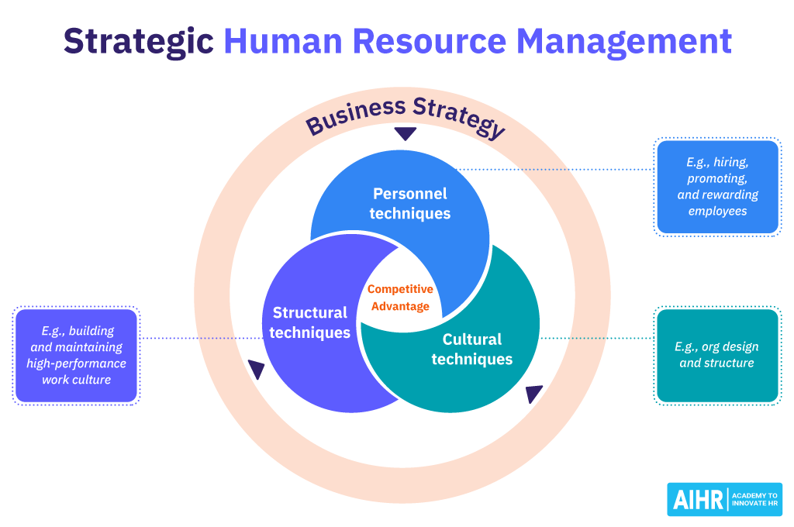

Figure 5.4. Strategic Human Resource Management

Summary
Strategic HRM integrates workforce planning, learning, employer branding, and analytics to address skill gaps effectively in the technology, healthcare, and hospitality industries.

Reflective Report On International Capabilities
This section provides a reflective evaluation of my current capabilities in relation to the competencies required for effective performance in a globalized and technologically advanced work environment. By writing this report and considering my recent academic and work experiences, I have been able to honestly assess my position, especially in digital skills, communication, teamwork, leadership, and my approach to independent learning. This reflection shows me where I’m prepared for international opportunities but also highlights where I still need to improve.

Digital Skills
Through this module and the process of compiling this report, it is become clear how essential digital skills are in international roles. I am confident using tools like Microsoft Teams, Moodle, and standard productive applications. With these, I was able to gather sources, organize, and understand that expectations are increasing. Employers are looking for abilities in data analytics, automation, and cybersecurity awareness (Ulrich et al., 2020). I have not mastered these yet. Therefore, I need to strengthen my analytical and technical skills. I am planning to take online courses and participate in university workshops to address this gap.

Communication Skills
The process of engaging with academic literature and writing this report has highlighted my strong written communication abilities. I can simplify complex information. Paraphrase effectively, and present my argument clearly. Studying international HRM has also made me more conscious of cultural differences, which is crucial in cross-border work. However, speaking in front of a group, especially in formal or unfamiliar environments, remains challenging for me. Hofstede (2011) notes that effective communication in multicultural contexts requires both clarity and confidence. This resonates with me. I need to improve my public speaking skills and participate more in presentations, seeking feedback from peers to build my confidence.

Teamwork and Leadership
I have found that I work well in teams, contribute fairly, and value different viewpoints. When faced with multiple deadlines, though, I sometimes have trouble managing everything efficiently. Regarding leadership, I am still developing, especially when it comes to making difficult decisions, delegating, and resolving conflicts. Dowling, Festing, and Engle (2017) state that international leaders need cultural intelligence, adaptability, and emotional awareness. I now see the importance of these qualities. To develop further, I intend to seek out more project work, plan my approach more carefully, and continue reflecting on what strategies are effective.

Self-Directed Learning
Completing this assignment has reinforced how important it is to take charge of my own learning. I am proactive in research and value feedback. However, maintaining a consistent learning schedule can be difficult when I am busy. Ulrich et al. (2020) emphasize that self-directed learning is key to staying employable in a rapidly changing environment. I realize I need to set clear goals and maintain consistency. Moving forward, I will establish weekly learning objectives and keep a reflective journal to monitor my development.

Summary
Overall, I have developed a solid base in digital skills, written communication, teamwork, and reflective learning. However, I recognize the need to progress further, especially in advanced digital tools, public speaking, leadership, and consistent self-directed learning. Focusing on these areas will make me more competitive and better prepared for international opportunities.

Conclusion
This report explores how national and international labour markets influence HRM and IHRM strategies today. Technological changes in AI, automation, and digital platforms are transforming what employers require. We are seeing routine roles vanish while the need for advanced technical and cognitive skills rises. Companies like Amazon, Tesla, TCS, and Apple demonstrate that HRM strategies must emphasize continuous learning, ethical AI application, and agile, adaptive workforce planning to keep up with these shifts.
The demographic and geopolitical shifts, including an ageing population, migration, and political instability, are all changing the labour supply, workforce mobility, and the makeup of teams. Practical examples from the NHS, Samsung, Airbus, and Marriott show that organizations need culturally informed approaches, strong risk management, and adaptable recruitment strategies to respond to global workforce trends. Addressing skills shortages is still a top priority. This calls for investment in reskilling, robust employer branding, workforce analytics, and a supportive organizational culture.
Reflectively, this report underscores what is essential for success in the global labour market; there are key strengths in writing, teamwork, digital skills, and reflective practice. Yet it also highlights areas for development, including advanced digital expertise, greater confidence in presenting, stronger leadership abilities, and a commitment to self-guided learning.
In summary, organizations are individuals must continuously adapt to remain competitive on a global scale. For an organization, it means strategic HRM and IHRM that anticipate future talent needs. For an individual, it requires ongoing learning and skill development, which is how to be employable in an increasingly interconnected world.

References
Airbus (2021) Annual Report 2021. Toulouse: Airbus SE. doi: https://www.airbus.com/sites/g/files/jlcbta136/files/2022-04/Airbus%20Annual%20Report%20Overview%202021.pdf
Amazon (2023) Automation and Workforce Strategy Report. Seattle: Amazon Inc. doi: https://s2.q4cdn.com/299287126/files/doc_financials/2024/ar/Amazon-com-Inc-2023-Annual-Report.pdf
Apple (2023) Human Capital Disclosure Report. Cupertino: Apple Inc. doi: https://s2.q4cdn.com/470004039/files/doc_downloads/2024/ESG/apple-disclosure-index.pdf
Brynjolfsson, E., And McAfee, A. (2017). The Second Machine Age. New York: W.W. Norton. doi: https://wwnorton.com/books/the-second-machine-age/articles
CIPD (2023) Skills and Labour Market Outlook 2023. London: CIPD. doi: https://www.cipd.org/globalassets/media/knowledge/knowledge-hub/reports/labour-market-outlook---spring-2023.pdf
Dowling, P., Festing, M., and Engle, A. (2017). International Human Resource Management. 7th edn. London: Cengage. doi: https://studylib.net/doc/25845790/peter-dowling-marion-festing-allen-engle---international
Hofstede, G. (2011). Culture and Organisations. 3rd edn. New York: McGraw-Hill. doi: https://e-edu.nbu.bg/pluginfile.php/900222/mod_resource/content/1/G.Hofstede_G.J.Hofstede_M.Minkov%20-%20Cultures%20and%20Organizations%20-%20Software%20of%20the%20Mind%203rd_edition%202010.pdf
ILO (2021) Remote Work and Cross-Border Employment Report. Geneva: ILO. doi: https://www.ilo.org/sites/default/files/wcmsp5/groups/public/@dgreports/@dcomm/@publ/documents/publication/wcms_795453.pdf
Marriott International (2022) Workforce Sustainability Report. Washington, DC: Marriott International. doi: https://serve360.marriott.com/wp-content/uploads/2022/10/Marriott-2022-Serve-360-ESG-Report-accessible_F.pdf
NHS (2023) NHS Workforce Plan 2023. London: NHS England. doi: https://www.england.nhs.uk/wp-content/uploads/2023/06/nhs-long-term-workforce-plan-v1.2.pdf
OECD (2022) Demographic Outlook 2022, Paris: OECD Publishing. doi: https://doi.org/10.1787/f6da2159-en
Samsung (2023) Global Workforce and Skills Development Report. Seoul: Samsung Electronics. doi: https://img.global.news.samsung.com/es/wp-content/uploads/2024/08/Samsung-Annual-Report-2023.pdf
Tata Consultancy Services (2023) Human Resource Development Report. Mumbai: TCS. doi: https://www.tcs.com/content/dam/tcs/investor-relations/financial-statements/2023-24/ar/annual-report-2023-2024.pdf
Tesla (2022) Giga Factory Workforce Report. Austin: Tesla Inc. doi: https://ir.tesla.com/_flysystem/s3/sec/000162828024002390/tsla-20231231-gen.pdf
Ulrich, D., Younger, J., Brockbank, W. & Ulrich, M. (2020) HR Competencies for the Future. New York: McGraw-Hill. doi: https://www.researchgate.net/publication/235295245_HR_talent_and_the_new_HR_competencies
World Economic Forum (2023) Future of Jobs Report 2023. Geneva: WEF. doi: https://www.weforum.org/publications/the-future-of-jobs-report-2023

