Establishing the Impact of the Stigma Surrounding Poor Mental Health in South Africa

Robyn Trubey
1708724

A narrative analysis was conducted on a single case study for the purpose of this assignment. The case study in question was about a South African female who was experiencing feelings of depression and anxiety. The piece of text was analysed narratively, in order to understand the significance of the sequence of events and actions that had taken place in her life. Through conducting the analysis, a number of reoccurring themes were identified, which provided a further insight into how she felt during her lifetime. The analysis found that she lived in fear of breaking the silence about her depression, due to the stigma attached to the mental illness in her culture. On finally being able to talk her struggle, she was able to encourage others in doing so.

introduction
This assignment will involve a complete analysis of a single case study regarding a South African female who suffers with feelings of depression and anxiety. The analysis will be carried out narratively, in order to recognise the significance of the story that is being told. Through conducting a narrative analysis, it will highlight the fundamental events in an individual’s life, to identify how such events reflect and reinforce social identities (Reissman, 2008).
The World Health Organisation (2018) defined depression as a common mental health condition that can lead to an individual experiencing low moods, a lack of interest or pleasure in things they once enjoyed, alongside the inability to go about their day-to-day lives as they normally would. Low self-esteem or confidence, disrupted sleep or appetite, feelings of fatigue and hopelessness, as well as poor concentration levels, are all typical symptoms of the condition. Depression is found to be the most prevalent mental health condition across the world, followed closely by anxiety. Whilst it is estimated that one in six people have experienced a common mental health problem in the last seven days, major depression is considered to be the second biggest cause of disability across the globe. The condition is also found to be one of the biggest contributing factors to rates of suicide and ischemic heart disease (Mental Health Foundation, 2019).

Method
A narrative provides us with the opportunity to establish ourselves, to clarify the sequence of events that take place in our lives and communicate this information to others (Murray, 2003). A narrative inquiry is a collection of analytic frameworks that are often adopted by researchers. This method of analysis can be used to consider a participant’s story and explore their sequence of events, in order to better understand the events and actions that have taken place in their lives (Reissman, 1993). A large number of researchers conducting a narrative analysis will ask the participant to tell a story about their experiences; either in a one-to-one interview, or in a group setting. Narratives can often be found to adopt a therapeutic function, by providing people who are suffering with an illness, such as depression in this instance, the opportunity to make sense of their emotions and thought processes (Murray, 1997).
Narrative analyses have recently become a frequently adopted method of social research. Since the introduction of this research method, it has allowed for the researcher to maintain an active role in the research process. This newly developed method grants researchers with a degree of freedom to choose what data they collect from the participant and how they go about doing so. Due to their being no specific guidelines in regard to what should be generated from an interview, it is entirely up to the researcher what information they choose to collect. Likewise, it is the choice of the researcher as to how they decide to approach the topic of interest, whether it be through the medium of story-telling, photographs or the relay of a sequence of events that have taken place (Andrews, Squire & Tamboukou, 2013).
For the purpose of this assignment, a holistic content analysis (Leiblich et al, 2008) will be conducted to analyse the case study in question. This method of narrative analysis is able to identify any major themes in texts, whilst protecting the participant’s intentions (Leiblich et al, 1998). The case study tells of how a South African female struggled with feelings of anxiety and depression throughout her lifetime. The female’s name which was mentioned in the case study will be replaced with a pseudonym (Sophie), in order to protect her identity. First of all, the case study was read through a number of times to identify any reoccurring themes or patterns within the text; before noting the initial response to Sophie’s story. Once the key themes were identified, they were then colour coded to better understanding her transition throughout the story. By adopting this method of narrative analysis it provides the opportunity to recognise any issues the participant may have experienced. Furthermore, the participant’s transition throughout the story supports the researcher in acknowledging any additional information that may have gone unnoticed in alternative methods of narrative analysis (Iyengar, 2014).

Analysis
One theme that was identified during the course of this analysis was ‘Suicidal Thoughts’. Sophie establishes that she experiences suicidal thoughts throughout different stages in her life, ‘I wanted to die so badly’ (2). She envisaged numerous ways in which she could go about killing herself, whilst contemplating which would be the easiest option to carry out, ‘an overdose’ (3). Additionally, she experienced suicidal thoughts in her teenage years, ‘plagued with thoughts of killing myself’ (25). It seems clear that she didn’t feel as though she had the same ambitions and interests compared to others her age, which made her feel like an outsider. Whilst feeling isolated from others her own age, she struggled to seek help or discuss her suicidal thoughts with anyone.
Despite moving to Canada and getting married, her suicidal thoughts continued with her into later life, ‘oh how I just wanted to die’ (48). Sophie again thought of the possible ways she could commit suicide. She considered what would happen if she somehow survived and how she could explain this to her parents. This demonstrates how despite feeling suicidal, she is still able to look to the future and consider the possibility of living beyond her attempt. Furthermore, it could be suggested that Sophie was worried about the shame and drama she would bring to her family if she was to commit suicide.
Another theme that was established throughout the text was ‘Hopelessness’. Sophie mentions how she feels hopeless and worthless, as a result of suffering with depression, ‘depression had taken over my life’ (8). It is clear that her feelings of hopelessness were long-established; even in her childhood, she felt confused and hopeless about the future. Despite experiencing a better outlook on life after moving to Canada, her feelings of hopelessness soon crept back in, ‘despair, fatigue and anxiety’ (40). The move to a new country was able to act as a distraction from her mental illness, with the new environment providing her with respite from her depression. However, once the novelty of her new environment had worn off, she again was subject to suffering with depression.
Likewise, Sophie said that she felt worthless, ‘feelings of worthlessness’ (59). Sophie mentioned how she watched a lot of reality television with celebrity hosts, where she was able to relate to people who were also suffering with mental health conditions. It is clear that through applying her own problems and feelings to individuals on these television programmes, she is hoping to gain some validation or support. Through relating to these people in this way, she feels as though she is sharing her problems with someone. She is seeking for advice and guidance from the celebrity hosts who are helping the individuals on the programme, without having to actively seek help herself.
‘Sharing With Others’ was also identified as a key theme throughout the text. On being able seek help for her depression, Sophie was able to obtain medical help to overcome her mental illness, ‘booked with a psychiatric for assessment’ (64). Through seeking professional help, it allowed her to become more open and honest about her illness. Sophie was then able to interact with other individuals experiencing the same issues, ‘address groups of people like me’ (70). Despite only sharing her struggle with a small number of people to begin with, she later valued the importance of being able to talk about her depression, ‘value of taking a vulnerable position’ (77). Through taking a vulnerable position, it gave her the courage and strength to share her struggle, ‘gave me the courage to speak openly’ (78).
Furthermore, it is apparent that through sharing, she was motivated to help others in their struggle with mental illness. As Sophie began to overcome her depression, she felt comfortable with being able to use her experiences to help others. By being open and honest, other individuals were able to open up to her, ‘friends began to share their own’ (84). It is evident that Sophie was able to better overcome her depression by seeking friendship with those individuals who were experiencing similar feelings. In aid of her recovery, sharing has motivated her to prevent others from having to suffer in silence, ‘courage to break their silence’ (94). This has been of great benefit to Sophie, as it has given her a purpose and energy to help others too.
A final theme that was determined in the latter half of the text was ‘Stigma’. Sophie states that the stigma that comes hand-in-hand with mental illness was the key factor in her struggle to discuss her depression, ‘the stigma that comes with mental health’ (88). She also mentions how growing up in her culture where mental health was never discussed, made her feel ashamed of what she was going through, ‘at first I felt ashamed’ (81). Growing up in a culture where her issues couldn’t be addressed had a substantial detrimental effect on Sophie’s mental health throughout her lifetime. Whilst understanding that many black women also suffer with mental illnesses, she still found it difficult to break the silence on discussing her issues, ‘hardly discuss them’ (88).

Discussion
In regard to the case study, the female in question has grown up, and for some part, lived in South Africa. According to statistics released by the South African Depression and Anxiety Group (SADAG), one in six people living in South Africa are living with a common mental health condition. It is has been found that fewer than 16% of those with a mental illness receive professional help, with there being only eighteen beds available for every 100,000 people in public health hospitals (SADAG, 2018). In addition to the lack of resources for those suffering with a mental illness in South Africa, the stigmas surrounding mental health pose a major obstacle when it comes to these people receiving treatment. In the country’s native language, there is no translation for ‘depression’; demonstrating how depression doesn’t have a place in South African culture. Due to the stigma attached to mental health, individuals are reluctant to admit they may be suffering. People are apprehensive to share their problems, in fear that they will shame their families, be fired from work or be discriminated against (SACAP, 2018). It is apparent from the text that Sophie has been subject to the stigma that comes with mental health in her culture. Her shame and embarrassment to talk about what she is going through is reflected in her inability to address her mental illness and receive treatment.
It is apparent that the avenues available to receive treatment for mental illness are dependent on a number of sociocultural and economic factors across the world. A study was conducted to consider the avenues to treatment that were available to individuals suffering with a mental illness in Zimbabwe. The study found that patients were significantly more likely to seek treatment from a traditional care provider, either due to their religious beliefs, based on recommendations or the provider’s reputation. In 91% of traditional consultations, a spiritual explanation was delivered about the illness (Patel, Simunyu, Epidemiol, 1996). This study highlights the cultural beliefs around mental illness in South Africa. This study demonstrates how religious groups in the country fail to recognise that mental illness is a serious condition. Instead, religious groups believe they are able to provide a spiritual explanation for the condition. In relation to the text, Sophie is afraid to break the silence about her condition and seek professional help. This study highlights how the country believes that there is a spiritual explanation, which provides a reasoning for her lack of courage to admit her struggles. This later motivated her to share with others her experience, and also help them in overcoming their battle with depression.
As mentioned previously, there is a lack of resources to treat and help those struggling with mental illness in Zimbabwe. The continuing growth of poor mental health across the globe has led to the development of evidence to suggest potentially cost-effective interventions. Despite such developments, there is still difficultly in ensuring that mental health services receive adequate funding in low and middle-income countries, such as Zimbabwe (McDaid, Knapp & Raja, 2013). A considerable 40% of low-income countries were found to have made out-of-pocket payments to fund mental health services, compared to only 3% of high-income countries (Saxena, Sharan, Cumbrera Garrido et al, 2006). If the individual is required to pay for their own mental health services, this could result in poverty or debt. In relation to the text, Sophie struggled to admit that she needed help. Furthermore, on admitting she needed professional help, the resources may not have been in place. As a result, Sophie may have experienced heightened feelings of hopelessness after seeking help which wasn’t readily available. By failure to easily access professional help in Zimbabwe, it discourages individuals to speak out about their problems and try and overcome their mental illnesses.

Conclusion
As identified throughout this assignment, conducting a narrative analysis can be an advantageous method of analysing qualitative data. A narrative analysis can allow for new avenues to be established in understanding and interpreting the stories and experiences of individuals (Clandinin & Connelly, 2000). Although deemed an effective method of analysis, this method fails to provide researchers with a standardised framework to follow. There are no clear guidelines that identify the way the research should be conducted. However, this could be argued as a strength, as it allows for each and every experience that is relayed to the researcher to be interpreted accordingly.
As a final statement, Sophie established her journey with her depression over the course of her lifetime. She was able to address when her depression started and how that made her feel. Later in the text, she was able to find a way to overcome her illness, and help others in doing so too. This conclusion was met after conducting a holistic content analysis method. Despite considering other methods of analysis beforehand, it was found that this method was best suited to analyse the text. The themes which were identified throughout the text produced great lines of enquiry into the mental health phenomenon in South Africa. A number of the themes brought about by the text resided with empirical data studies regarding depression. Furthermore, through conducting this narrative analysis it allowed for a better understanding of individual’s experience with mental health in South Africa to be established.

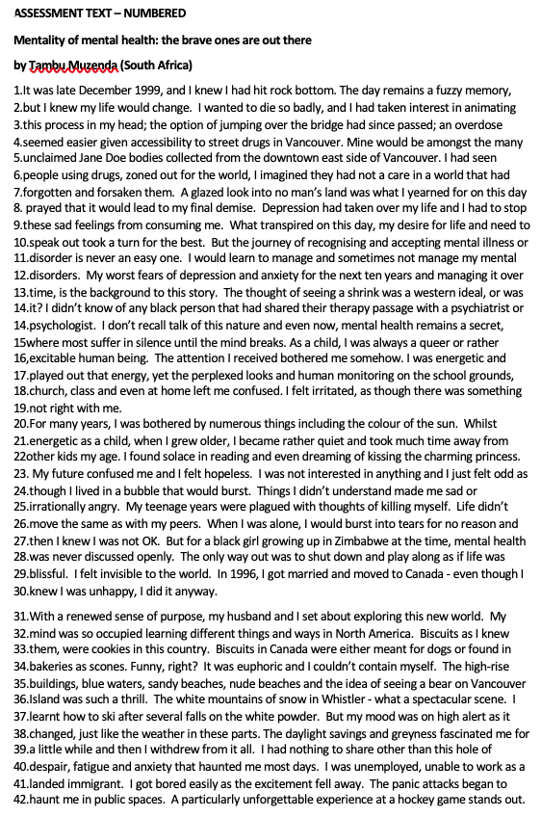
Appendix

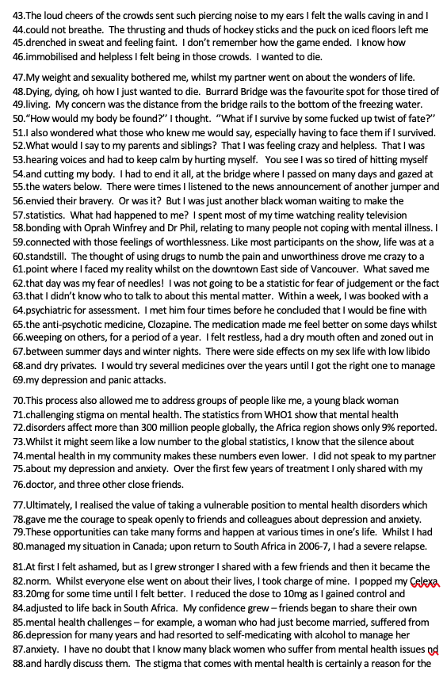

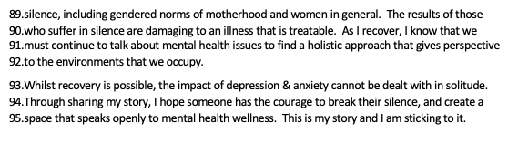

References
Andrews, M., Squire, C., & Tamboukou, M. (Eds.). (2013). Doing narrative research. Sage.

Clandinin, D. J., & Connelly, F. M. (2000). Narrative inquiry.

Iyengar, K. M. (2014). Holistic content analysis of narratives written by Asian Indian American students. European Journal of Research and Reflection in Arts and Humanities Vol, 2(2).

Jacob, K. S., Sharan, P., Mirza, I., Garrido-Cumbrera, M., Seedat, S., Mari, J. J., ... & Saxena, S. (2007). Mental health systems in countries: where are we now?. The Lancet, 370(9592), 1061-1077.

Lieblich, A., Tuval-Mashiach, R., & Zilber, T. (1998). Narrative research: Reading, analysis, and interpretation (Vol. 47). Sage.

McDaid, D., Knapp, M., & Raja, S. (2008). Barriers in the mind: promoting an economic case for mental health in low‐and middle‐income countries. World Psychiatry, 7(2), 79-86.

Mental Health Statistics: UK and Worldwide. (2019). Retrieved from https://www.mentalhealth.org.uk/statistics/mental-health-statistics-uk-and-worldwide

Murray, M. (2003). Narrative psychology and narrative analysis.

Patel, V., Simunyu, E., & Gwanzura, F. (1997). The pathways to primary mental health care in high-density suburbs in Harare, Zimbabwe. Social Psychiatry and Psychiatric Epidemiology, 32(2), 97-103.

Riessman, C. K. (1993). Narrative analysis (Vol. 30). Sage.

World Healh Organisation (2019). Depression. Retrieved from https://www.who.int/mental_health/management/depression/en/

Wyatt, G. E., Thames, A., Simbayi, L., Stein, D. J., Burns, J., & Maselesele, M. (2017). Trauma and mental health in South Africa: Overview. Psychological Trauma: Theory, Research, Practice, and Policy, 9(3), 249.

