USING THE INTERNET OF THINGS(IOT) TO MONITOR THE ENVIRONMENT OF THE TRANSMISSION LINE IN THE ELECTRICAL GRID RESEARCH PROPOSAL
Lu Han

Contents
Figures 3
1. Introduction 4
2. Background to The Proposed Research 4
2.1 Literature Review 4
2.1.1 Smart Grid 4
2.1.2 IOT 5
2.1.3 WSN 7
2.2 Application of WSN/IOT Technology in Electrical grid 7
3. Aims & Objectives 9
3.1 Want to Do 9
3.1.1 Compare Different Wireless Communication Technologies 9
3.1.2 Build A Monitoring System 9
3.1.3 Evaluation of The Monitoring System 9
3.2 expected outcomes 10
4. Research Methods 10
4.1 Philosophy 10
4.2 Strategy 10
4.3 Approaches 11
4.3.1 Document Review 11
4.3.2 Software/Hardware Development 11
4.3.3 Experiment 11
4.4 Risks & Limitations 11
4.4.1. Wrong Direction 11
4.4.2 Lack of Resources 11
4.4.3 Personal Reasons 12
4.5 Data Evaluation 12
5. Development Methods 12
5.1 Software Development Methodology 12
5.2 Hardware development methodology 12
5.3 Website development methodology 13
6. Resources & Planning 14
6.1 Resources Required 14
6.2 Gantt Chart 15
7. References 16
8. Bibliography 17
Appendix: Mind Map of Literature Review 19

Figures
Figure 1 The Application of Smart Grid [3] 5
Figure 2 Three Layer (Tier) IoT Architecture [8] 6
Figure 3 A WSN [9] 7
Figure 4 Comparison of ZigBee and Wi-Fi [18] 10
Figure 5 Project Gantt ChartCreating Citation... 17
Figure 6 Docear Mind Map 22

Introduction
Transmission lines are often distributed in complex areas with changeable environment which has a significant impact on the operation. Using Internet of Things(IOT) and Wireless sensor networks(WSN) technology can effectively monitor the environment of electrical grid.
Apply various sensor nodes in the Electrical grid, such as RFID, temperature sensor, voltage acquisition device, etc. These terminal sensing devices collect various parameters in the electrical grid and transmit them to the grid company. Nowadays, most data transmission uses wired transmission methods such as optical cables. [1] [2]
When the IoT technology is added to the smart grid, the network layer can be changed from the original fibre-optic cable transmission to wireless transmission. This information transmission saves a lot of cost and the equipment is easy to install. The data collected by the terminal sensing device is uploaded to the server to make data query and call more convenient.
Installing a number of sensors in a certain area is conducive to timely finding problems and reducing the occurrence of accidents. Through the application of WSN technology, the real-time monitoring of the transmission line can be achieved. The data is transmitted to the remote client through wireless transmission technology and displayed on the computer, which can improve work efficiency.

Background to The Proposed Research

2.1 Literature Review

2.1.1 Smart Grid
The smart grid adds intelligent features to the traditional electrical grid by using advanced transmission technology that allows for two-way communication between the utility and its customers. Like the Internet, the smart grid will consist of controls, automation, new technologies and equipment working together. In this case, these technologies will work with the electrical grid to respond digitally to our quickly changing electric demand. [3] [4]
The smart grid can greatly improve the efficiency of energy utilization and reduce the impact of the electrical grid on the surrounding environment. It can also reduce the power loss of the transmission network and provide people with reliable power supply services.
Smart grids can affect many aspects of our lives, as shown in Figure 1.
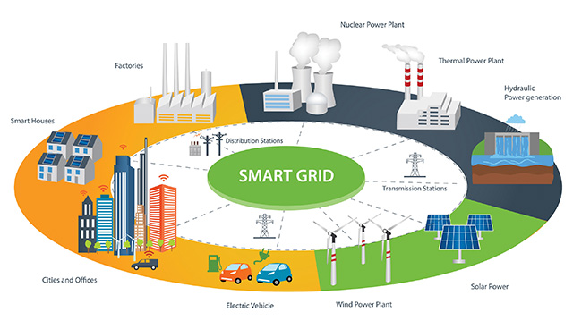
Figure 1 The Application of Smart Grid [5]
Each country will conduct corresponding research and practice according to the actual situation of the country. The Oak Ridge National Laboratory (ORNL), part of the US Department of Energy (DOE), is actively involved in the development of smart grids. Part of its work involves tracking the state of the grid at the transmission and distribution levels. [6]Germany has developed the “E-Energy” program with a total investment of 140 million euros. During the period from 2009 to 2012, it conducted intelligent grid experiments in six locations across the country. [7]China National Grid has formulated the "Strong Smart Grid Technology Standard System Plan", which clarifies the roadmap for strong smart grid technology standards. [8]
In recent years, many high-tech technologies have been fully utilized in the power grid. Smart grid will surely be the future of power grid.

2.1.2 IOT
The IOT is regarded as the most important part of the new generation of information technology. As an emerging technology, the main purpose of IOT is to realize the intelligent identification, location, tracking, monitoring and management of objects.
With IOT technology, people can achieve a large amount of information exchange with anyone and anything at anytime and anyplace. Cisco predicts that approximately 50 billion new connections will be established for the IOT over the next decade. [9] [10]
From the perspective of technology architecture, IOT has three layers: perception layer, network layer and application layer showing at figure 2.
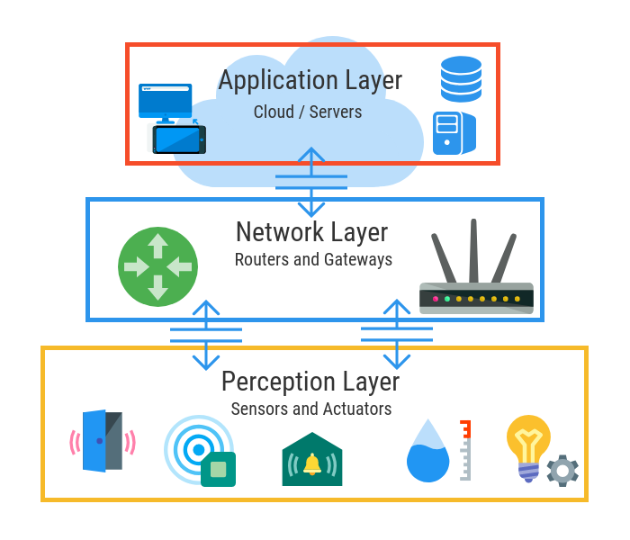
Figure 2 Three Layer (Tier) IoT Architecture [10]

- The perception layer is constructed from Sensors, actuators and edge devices that interact with the environment. These numerous sensors are important sources for identifying objects and collecting information.
- The network layer is composed of a variety of networks and cloud computing platforms. The information collected and processed by the sensing layer is the main function of the network layer.
- The application layer is the interface between the IOT and the application. It provides users with data processing and storage as well as specialized services.

2.1.3 WSN
WSN is a self-organizing network system composed of a large number of sensor nodes deployed in the monitoring area and formed by wireless transmission technology . It can be said that WSN is the technical support of the IOT.
A typical WSN system is shown in Figure 3. It contains various connected sensors , gateways, wireless communication technology and client computers.

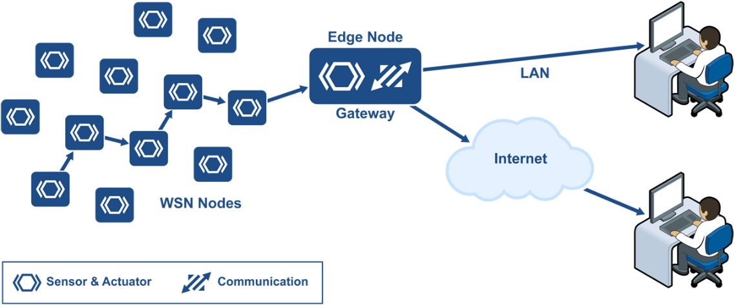
Figure 3 A WSN [11]
WSN were originally designed to promote military operations and expanded to health, transportation and industrial sectors. [12] [13]

2.2 Application of WSN/IOT Technology in Electrical grid
The environment of electrical grid is complicated and changeable, and the electrical grid is closely related to our daily life and work. Once the grid fails, the consequences are very serious . Modern power systems in various countries have suffered varying degrees of damage. In the United States, the most famous grid accident is the Northeast blackout of 2003. [14] The blackout has affected 10 million people in Ontario and 45 million in eight US states. In India, existing power systems face many problems, such as intermittent power supplies and power theft. These problems have caused huge losses to the local power grid. [15]
Artificial patrol and helicopter are important ways to detect transmission lines. But neither of these methods can achieve real time monitoring. The IOT is a network that connects people and things by using wired or wireless communication technology to realize remote management control and intellectualization.
Compared with wired communication technology, WSN have the following advantages:
(1) The data acquisition, data processing and data communication functions of the nodes in the WSN are highly integrated.
(2) The use of wireless communication mode can cancel the complex communication line wiring., WSN is undoubtedly cheaper than traditional wired network.
(3) WSN is a self-organizing and large-scale network that processes wireless sensors in a distributed manner.
(4) WSN are more suitable for use in remote areas or in harsh environments. In pastures, for example, some animals may destroy wiring.
Through the above analysis, it can be known that WSN is very suitable for monitoring the electrical grid. Transmission line status and environmental monitoring uses WSN technology to distribute a certain number of sensors to the Electrical grid. Each sensor node is aggregated into a routing node in an ad hoc network to transmit data to the monitor through wireless communication technology.

Aims & Objectives

3.1 Want to Do
The aim of the project is to investigate how to apply IOT technology to monitor the environment of transmission line in real time via the following objectives:
- To compare the applicability of different wireless communication technologies in environmental monitoring, and then choose a wireless network transmission scheme.
- To accomplish the monitoring of electrical grid environment by building monitoring system hardware and software system or using software to Perform simulation experiments.
- To evaluate the validity of the research.

3.1.1 Compare Different Wireless Communication Technologies
As the foundation of smart grid implementation, communication technology will have huge potential development space with the construction and development of smart grid. Wireless communication technologies include Zigbee, Wi-Fi, Bluetooth, ultra-wideband, and so on.
(1) ZigBee
The ZigBee device operates in the public frequency band and has transmission rates of up to 250 kb/s(global 2.4 GHz), 20 kb/s(Europe 868 MHz) and 40 kb/s (US915 MHz) . ZigBee is mainly used for data transmission between various electronic devices with short distance, low power consumption and low transmission rate. ZigBee is suitable for typical applications with periodic data transmission and is ideal for a wide range of applications in a wide range of smart grids. [16] [17] [18]
(2) Wi-Fi
IEEE 802.11 defines a set of standards to support both point-to-point and point-to-multipoint communication. The latest version of IEEE 802.ad uses Orthogonal Frequency Division Multiplexing (OFDM) and multi-antenna technology and operates in the 60 GHz band to provide maximum transmission rates of up to 7 Gb/s. [19]
- Wi-Fi can be used as an effective solution for smart grid data communication based on the following three points,
- Wi-Fi devices are widely accepted and deployed in the world for home use for Internet access;
- Wi-Fi is relatively cheapen if a new installation is required, it would not cost too much;
- the Wi-Fi card is a plug-and-play device that is easy to install.
WLANs work in the public frequency band and share the same frequency resources with other standards, so they are prone to serious interference in densely deployed areas, which makes WLAN-based smart grid systems face challenges.
A comparison of ZigBee and Wi-Fi is shown at figure 4.
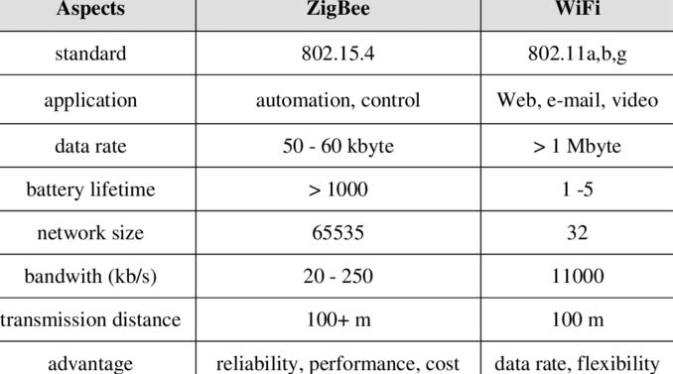
Figure 4 Comparison of ZigBee and Wi-Fi [20]

3.1.2 Build A Monitoring System
This project designs a grid monitoring system based on WSN technology and selects the appropriate technology (such as ZigBee or WIFI) to apply to the system. The system should have the advantages of low power consumption, low cost, safety, reliability, high efficiency, etc.
In the system, the sensor nodes are placed in specific area, and the camera is installed according to actual needs. The actual terrain of the electrical grid needs to be taken into account when installing the sensor nodes. A convergence node is set at a certain distance in each transmission line for summarizing the data collected by all the sensor nodes in each circuit, and intelligently detecting the parameters in the detection area through the wireless network.
The design requirements for electrical monitoring system are as follows:
1) Apply various sensors to obtain the parameters required for monitoring the transmission line, including temperature, working voltage, working current and pictures.
2) The use of wireless communication technology to achieve timely and reliable data transmission between various types of sensor nodes.
3) Through the development of software, data acquisition and processing can be performed on sensor nodes. The most important function is to achieve real-time display of the collected data, which helps employees to query data.

3.1.3 Evaluation of The Monitoring System
In order to evaluate the effectiveness of the smart grid online monitoring system based on the Internet of Things technology, it is necessary to test the system and obtain some researchable data. The data are obtained by setting different simulation parameters using appropriate simulation software.
Commonly used evaluation parameters in wireless communication technology are as follows:
(1) Packet Delivery Ratio
The packet delivery ratio is the ratio of the sum of the packets received by the destination to the sum of the packets sent by the source node (usually expressed as a percentage) over a period of time. The higher the packet delivery ratio, the better the communication quality of the network and the more complete of information .
(2) Average end-to-end delay (Average Delay)
The average delay is the ratio of the time that the number of packets sent by the source successfully reaches the destination and the total number of packets successfully received within a certain period of time. The average delay reflects the validity and speed of the routing protocol. The smaller the average delay, the faster the response of the routing protocol and the shorter the time spent on information transmission.
(3) Network throughput
Network throughput indicates the total number of packets sent by the node or unit during the continuous operation of the data state from the time the data message is sent to the time the message arrives.

3.2 Expected Outcomes
The goal of project is to build a system to achieve real-time monitoring of the Electrical grid. Corresponding to different sub-goals, there are the expected outcomes:
- Find a safe, reliable and inexpensive electrical grid wireless transmission method
- Build a smart grid online monitoring system
- Prove the effectiveness of the system

4. Research Methods

4.1 Philosophy
This project uses a quantitative research design. The philosophical assumptions in this project are positivism and objectivism, emphasizing quantification in data collection and analysis. Deductive methods are mainly used to study the relationship between theory and experiment. In order to prove whether the application of WSN technology can realize real-time monitoring of the electrical grid, establish a power grid monitoring model and conduct experiments to verify the effectiveness of the model. In the experiment, the test was carried out by selecting different parameters, and the obtained experimental data was compared with the literature to draw conclusions.

4.2 Strategy
The project strategy is to conduct quantitative research based on literature reading and experimentation.
The project is completed in three phases.
- Study the application of WSN in electrical grid monitoring by reading the literature.
- Deploy WSN design and establish grid monitoring system through experimental methods.
- Through experimental and literature research methods, systematically design simulation experiments to obtain data and evaluate system performance.

4.3 Approaches

4.3.1 Document Review
By reading the literature, It can be known that the network monitoring system needs to use Zigbee, Wi-Fi and other wireless network technologies for communication. Compare the difference of ZigBee and Wi-Fi and then design a specific network topology. Determine which modules are included in the system and what each module is to implement.

4.3.2 Software/Hardware Development
In terms of hardware, the network topology architecture, central node, and sensor nodes are mainly designed. In terms of software, the software is divided into three parts: data communication design, sensor node design, and remote monitoring website design. Use the C++ language and php language to design the software part of the remote monitoring system. The design of each part is realized by using the corresponding programming language and database system.

4.3.3 Experiment
Using development board and sensors deploys a WSN experiment. The program of the collection node and the aggregation node are respectively designed, and the collection node collects voltage, current, temperature and image information. The information is transmitted to the aggregation node by wireless transmission. The aggregation node then transmits the data to the host computer.

4.4 Risks & Limitations

4.4.1. Wrong Direction
The philosophy of the project is deduction method. The use of deductive methods for scientific research should pay attention to the purpose and direction of deduction. This is because the deductive method is mainly to test or prove whether a general feature or universal conclusion of one (or more) aspects is suitable (or exists) in a certain (or a class) scientific activity or scientific phenomenon. If the purpose and direction of deduction are not clear, it will lead to improper selection of researchers and even lead to the failure of research.

4.4.2 Lack of Resources
The literature required for research is insufficient. For the electrical grid is an important part of national infrastructure construction, many materials are not open to the public. Most of the material available on the web has not been verified.
Insufficient software and hardware equipment. The grid monitoring system experiment requires ARM development board and various sensors, which is not easy to obtain when it compares to software resources. If there is not enough equipment, this project may not be able to proceed. The solution is to change the grid monitoring system experiment to the corresponding software simulation experiment.

4.4.3 Personal Reasons
Due to the individual's point of view and ability, the analysis of the research object is not comprehensive and in-depth. The undergraduate major of author is logistics engineering. Through undergraduate courses, the theory about Internet of Things can be learned. But the author lacks practical experience. The choice of hardware and software before the experiment requires the support of practical experience. Lack of experience may lead to unsatisfactory experimental results.

4.5 Data Evaluation
The system result evaluation is divided into three parts, including communication module evaluation, software evaluation and website evaluation. The evaluation of the data is done through system testing.
The purpose of system testing is to identify defects in the system and verify whether it meets the functional requirements. It mainly tests whether the grid monitoring system can operate normally, and whether each module can complete its respective functions. The system test includes two aspects: whether the data of the acquisition end can be accurately collected and transmitted in time; whether the receiving end can receive the information uploaded by the collection end normally and accurately.

Development Methods

5.1 Software Development Methodology
The software development of the grid monitoring system chooses a modular development method. The grid monitoring system is divided into three modules by analysing the decomposability, assimilability, and comprehensibility of the module:
- transmission line sensing module
- wireless communication transmission module
- remote monitoring module
Each module is independently developed, tested, and finally assembled into the entire software system. This method can not only reduce the complexity of software system development in the decomposition process, but also facilitate modification and maintenance. And it is also easy to realize parallel development of different parts of the same system, thereby improving the production efficiency of the software.

Hardware development methodology
Hardware development is divided into schematic design, circuit diagram design, development board design, functional test and stability test. Hardware development needs to focus on the following aspects:
1. Clarify the overall hardware requirements
Such as CPU processing power, storage capacity and speed, I/O port allocation, interface requirements, level requirements, special circuit requirements, etc.
2. Develop a hardware overall plan based on demand analysis
To find key devices and their technical materials and technical approaches, technical possibilities, reliability, and cost control must be fully considered.
3. Detailed hardware design
It will include hardware schematics, single-board functional block diagrams, development board layout and production documents .
4. Board debugging
Perform commissioning on each function in the principle design and modify the schematic diagram if necessary.

5.3 Website development methodology
The remote monitoring website is implemented by PHP language programming. The system collect temperature, voltage, current and image data and display data in the computer website.
The website will mainly achieve the following functions:
(1) Real-time display of data
In the website, all sensor nodes are displayed with corresponding data in real time. If the transmission line fails during operation, the webpage will display the fault and alarm. It can display the specific location of the transmission line fault which is convenient for the staff to repair in time.
(2) Database data query
The system can query the past record data for different nodes at different time periods and display them in a specific order. It is convenient for staff or managers to perform historical data query.
(3) Remote monitoring system,
The monitoring system can connect to Ethernet via GPRS, and can realize remote login and control of received data.

Resources & Planning

6.1 Resources Required
Resources required for the experiment include：
Hardware:
- Laptop serves as a monitoring centre
- ARM Development Board as Gateway
- ZigBee Module as Communication Module
- Sensors can monitor relative parameters
- Camera record image.
Software ：
- Using PHP to build online monitoring website
- MATLAB
- N2
- Notepad++
- .net platform
The resources needed to write a thesis are:
Microsoft Office Software： Excel, Word, PowerPoint, Project.
Docear :Mind Map software
Literature resources: UWTSD Library, IEEE library, ScienceDeriect…

6.2 Gantt Chart
My project Gantt chart is shown in Figure 5.

Figure 5 Project Gantt Chart
Creating Citation...

References

[1] | S. N. H. J. M. L. Z. J. a. L. Xiaolei, “The Implementation of the Internet of Things Technology in Henan Smart Distribution Network Demonstration Project,,” China International Conference on Electricity Distribution (CICED), pp. 1-5, 2016.
[2] | P. Li, “Design of Smart Grid Monitoring System Based on Internet of Things,” 2018.
[3] | “What is the Smart Grid?,” [Online]. Available: https://www.smartgrid.gov/the_smart_grid/smart_grid.html.
[4] | S. V. a. P. Rana, “Wireless communication application in smart grid: An overview,” Innovative Applications of Computational Intelligence on Power, Energy and Controls with their impact on Humanity (CIPECH), p. 310–314, 2014.
[5] | “Smart grid evolution,” [Online]. Available: https://www.eolasmagazine.ie/smart-grid-evolution/.
[6] | D. B. Koch, “An Internet of Things approach to electrical power monitoring and outage reporting,” SoutheastCon, p. 1–3, 2017.
[7] | “E-Energy - Smart Grids made in Germany,” [Online]. Available: https://www.ppc-ag.com/projekte/e-energy/.
[8] | “Smart Grid,” [Online]. Available: https://baike.baidu.com/item/%E6%99%BA%E8%83%BD%E7%94%B5%E7%BD%91/1884275?fr=aladdin.
[9] | S. E. Collier, “The Emerging Enernet: Convergence of the Smart Grid with the Internet of Things,” IEEE Rural Electric Power Conference, p. 65–68, 2015.
[10] | “Architectures in the IoT Civilization,” [Online]. Available: https://www.netburner.com/learn/architectural-frameworks-in-the-iot-civilization/.
[11] | “How to Think about the Internet of Things (IoT),” [Online]. Available: https://www.micrium.com/iot/devices/.
[12] | A.-S. K. P. S. K. a. N. A. Alrajeh, Wireless sensor networks : current status and future trends, London:: Taylor & Francis distributor, 2012.
[13] | R. Faludi, Building Wireless Sensor Networks, O’Reilly Media, 2010.
[14] | “Northeast blackout of 2003,” [Online]. Available: https://en.wikipedia.org/wiki/Northeast_blackout_of_2003.
[15] | A. R. D. a. M. V. Ramesh, “Wireless Smart Grid Design for Monitoring and Optimizing Electric Transmission in India,” Fourth International Conference on Sensor Technologies and Applications, p. 637–640, 2010.
[16] | S. A. H. M. M. A. S. K. H. S. a. M. H. Habaebi, “Smart Zigbee/IEEE 802.15.4 MAC for wireless sensor multi-hop mesh network,,” IEEE 7th International Power Engineering and Optimization Conference (PEOCO), p. 282–287, 2013.
[17] | D. S. S. K. R. B. B. P. a. D. Hanapi, “Monitoring Connectivity of Internet of Things Device on Zigbee Protocol,” International Conference on Electrical Engineering and Computer Science (ICECOS), p. 351–356, 2018.
[18] | M. Z. X. Y. a. J. Liu, “Design of smart home control system by Internet of Things based on ZigBee,” IEEE 11th Conference on Industrial Electronics and Applications (ICIEA), p. 128–133, 2016.
[19] | “Wireless Sensor Network (WSN),” [Online]. Available: https://www.techopedia.com/definition/25651/wireless-sensor-network-wsn.
[20] | “Comparison of ZigBee, WiFi and Bluetooth,” [Online]. Available: https://www.researchgate.net/figure/Comparison-of-ZigBee-WiFi-and-Bluetooth_tbl10_287596223.

Bibliography
[1] S. Arif and S. H. Supangkat, “Simulation and analysis of ZigBee - WiFi interference,” International Conference on ICT For Smart Society (ICISS), pp. 206–210, 2014.
[2] D. S. Sharipuddin Kurniabudi R. Budiarto B. Purnama and D. Hanapi, “Monitoring Connectivity of Internet of Things Device on Zigbee Protocol,” International Conference on Electrical Engineering and Computer Science (ICECOS), pp. 351–356, 2018.
[3] S. E. Collier, “The Emerging Enernet: Convergence of the Smart Grid with the Internet of Things,” IEEE Rural Electric Power Conference, pp. 65–68, 2015.
[4] A. R. Devidas and M. V. Ramesh, “Wireless Smart Grid Design for Monitoring and Optimizing Electric Transmission in India,” Fourth International Conference on Sensor Technologies and Applications, pp. 637–640, 2010.
[5] R. Faludi, Building Wireless Sensor Networks. O’Reilly Media, 2010.
[6] E. N. Firdaus and A. Sahroni, “ZigBee and wifi network interface on Wireless Sensor Networks,” Makassar International Conference on Electrical Engineering and Informatics (MICEEI), pp. 54–58, 2014.
[7] S. A. H. M. M. Ahmed S. Khan H. Shabani and M. H. Habaebi, “Smart Zigbee/IEEE 802.15.4 MAC for wireless sensor multi-hop mesh network,” IEEE 7th International Power Engineering and Optimization Conference (PEOCO), pp. 282–287, 2013.
[8] D. B. Koch, “An Internet of Things approach to electrical power monitoring and outage reporting,” SoutheastCon, pp. 1–3, 2017.
[9] P. Li, “Design of Smart Grid Monitoring System Based on Internet of Things,” 2018.
[10] A. I. P. Yi and C. Zhou, “Developing ZigBee Deployment Guideline Under WiFi Interference for Smart Grid Applications,” IEEE Transactions on Smart Grid, pp. 110–120, 2011.
[11] S. N. S. S. H. Pramono and E. Maulana, “Internet-based monitoring and protection on PV smart grid system,” International Conference on Sustainable Information Engineering and Technology (SIET), pp. 448–453, 2017.
[12] A.-S. K. P. S. Khan and N. A. Alrajeh, Wireless sensor networks : current status and future trends. London: Taylor & Francis distributor, 2012.
[13] S. Verma and P. Rana, “Wireless communication application in smart grid: An overview,” Innovative Applications of Computational Intelligence on Power, Energy and Controls with their impact on Humanity (CIPECH), pp. 310–314, 2014.
[14] M. Z. X. Yi and J. Liu, “Design of smart home control system by Internet of Things based on ZigBee,” IEEE 11th Conference on Industrial Electronics and Applications (ICIEA), pp. 128–133, 2016.
[15] J. Xia, “Design and Implementation of ZigBee-Based WSN Experiment Platform,” International Conference on Smart Grid and Electrical Automation (ICSGEA), pp. 280–283, 2016.
[16] Z. W. S. Liou G. Qiu B. Zu Y. Kung and G. Jong, “Home monitoring system based internet of things,” IEEE International Conference on Applied System Invention (ICASI), pp. 325–327, 2018.
[17] S. N. H. Jinhua M. Linchang Z. Jingchao and L. Xiaolei, “The Implementation of the Internet of Things Technology in Henan Smart Distribution Network Demonstration Project,” China International Conference on Electricity Distribution (CICED), pp. 1–5, 2016.
[18] “Smart grid evolution,” https://www.eolasmagazine.ie/smart-grid-evolution/.
[19] “Architectures in the IoT Civilization,” https://www.netburner.com/learn/architectural-frameworks-in-the-iot-civilization.
[20] “How to Think about the Internet of Things (IoT),” https://www.micrium.com/iot/devices.
[21] “Comparison of ZigBee, WiFi and Bluetooth,” https://www.researchgate.net/figure/Comparison-of-ZigBee-WiFi-and-Bluetooth_tbl10_287596223.
[22] “What is the Smart Grid?,” https://www.smartgrid.gov/the_smart_grid/smart_grid.html.
[23] “internet of things (IoT),” https://internetofthingsagenda.techtarget.com/definition/Internet-of-Things-IoT.
[24] “Wireless Sensor Network (WSN),” https://www.techopedia.com/definition/25651/wireless-sensor-network-wsn.
[25] “Different Types of Wireless Communication with Applications,” https://www.elprocus.com/types-of-wireless-communication-applications.
[26] “List of major power outages,” https://en.wikipedia.org/wiki/List_of_major_power_outages.
[27] “Northeast blackout of 2003,” https://en.wikipedia.org/wiki/Northeast_blackout_of_2003.

Appendix: Mind Map of Literature Review
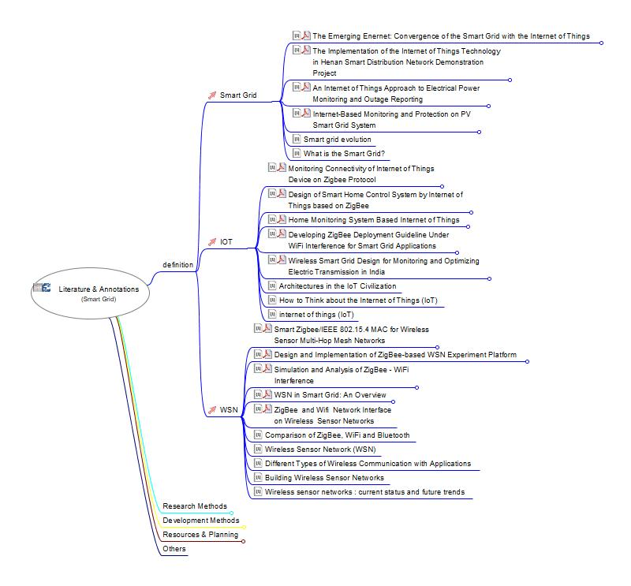
Figure 6 Docear Mind Map

