Dynamic Stress-Strain Investigation
L4 Physics acda4006
Luke Malcolm (2030773)
2022
Contents
Abstract 1
Background & Definitions 1
The Model 4
Limitations 9
Conclusion and Future Work 9
Bibliography 10

Abstract
This paper will assess a basic bullet impact modelled on Finite Element Analysis (FEA) software. The software package of choice for the purpose of this report is the Dassault Systems ABAQUS tool, using the Johnson-Cook material model for both bullet and target.

Background & Definitions
The author elected to use their own bullet design instead of the example provided. This is for several reasons:
- The bullet design provided was not appropriate, and would not have been able to be properly seated in a case due to the lack of bearing surface
- The ballistic coefficient of the bullet would have been incredibly poor (and the profile indicated a pistol-calibre bullet, which is far from the first choice to defeat an armoured target).
- The bullet was made of steel, which would result in an overly light-for-calibre bullet that wore barrels out incredibly quickly, and would likely be over-spun in standard-for-calibre twist rate barrels intended for heavier bimetallic bullets
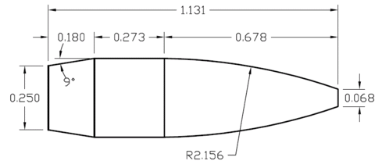
The author elected to use a bullet design based on the profile of the infamous Sierra 155gr MatchKing, one of the most common match-grade bullets for target shooting in 7.62x51mm calibre rifles. However, there is a current operational requirement for more “environmentally friendly” bullets containing no lead, in an attempt to reduce levels of battlefield contamination. As such, the author has elected to use the tried-and-tested Hollow Point Boat Tail (HPBT) bullet profile, while making the bullet out of solid copper (monolithic).
Figure 1 – 155gr .30” Sierra MatchKing Bullet Diagram. All dimensions inches. [8]

One point to note on the topic of bullet design – note the flat meplat (tip) of the bullet (measuring 0.068” across). This is a by-product of the process used to produce extremely accurate match bullets – the copper jacket is drawn over the lead core from the base to the tip, rather then being drawn from the tip to the base. This results in the HPBT profile, and ensures greater accuracy for several reasons, such as bullet weight distribution, uniformity, and base drag that will not be covered in detail in this report. For the sake of being able to use existing ballistic coefficient data should this bullet design actually be trialled, the author has elected to reproduce this meplat in the model despite the fact it could easily be eliminated on a lathe-turned monolithic bullet.
Another point of note is that the bullet would be significantly lighter (and faster) than a conventional bimetallic bullet and should possibly not be fired through “fast-for-calibre” 7.62x51mm barrels. This report will not discuss other problems with a direct switch to monolithic bullets such as barrel throating and cartridge overall length/magazine feeding issues.
Some definitions and the defeat mechanisms or armour [1] [2]:
True Stress: The ratio of a force acting on a test specimen to the cross-sectional area
True Strain: the logarithm of the ratio of the length of a test specimen to its natural length
Deformation: A thin ductile armour plate will be dished by the impact of a projectile. If the material is thicker (and therefore stiffer), deformation will occur by material being pushed aside by the projectile appearing on the back or front face as “petals”. These petals are caused by circumferential and radial stresses as the tensile limit of the plate is reached and star-shaped cracks form. These are pushed back by the motion of the projectile, forming the iconic “petals”.
Adiabatic Shear: During rapid deformation in a penetration process, heat is generated locally. If the rate of decrease of material strength is greater than the rate of increase of strength due to work hardening, the material will continue to deform locally. In a penetration simulation this is demonstrated by a discontinuous drop in the resistance of a material to the motion of the penetrator. Because of the localized high deformation rates, the heat is unable to propagate away from the plastic zone, resulting in the temperature rising further still, encouraging additional plastic flow.
Plugging: This typically occurs with blunt projectiles. Where there is insignificant penetration of the target by the projectile, at a velocity close to the ballistic limit of the target, a cylindrical “slug” of the armour is formed (of a similar or equal diameter to the projectile). This “slug” continues forward as a secondary projectile. Separation of the plug from the target is likely to occur through adiabatic shear. For strike velocities 5-10% above the minimum perforation velocity, multiple fragments rather than an intact plug may result.
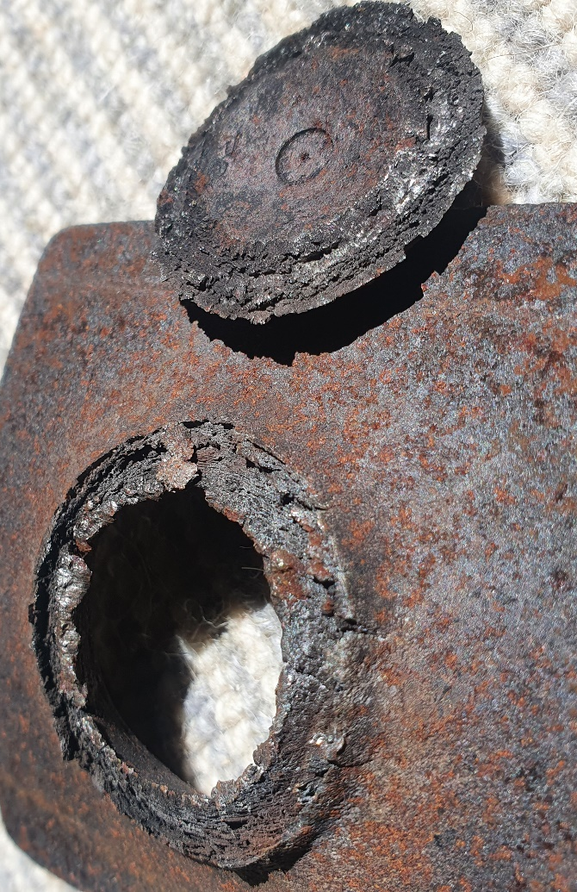
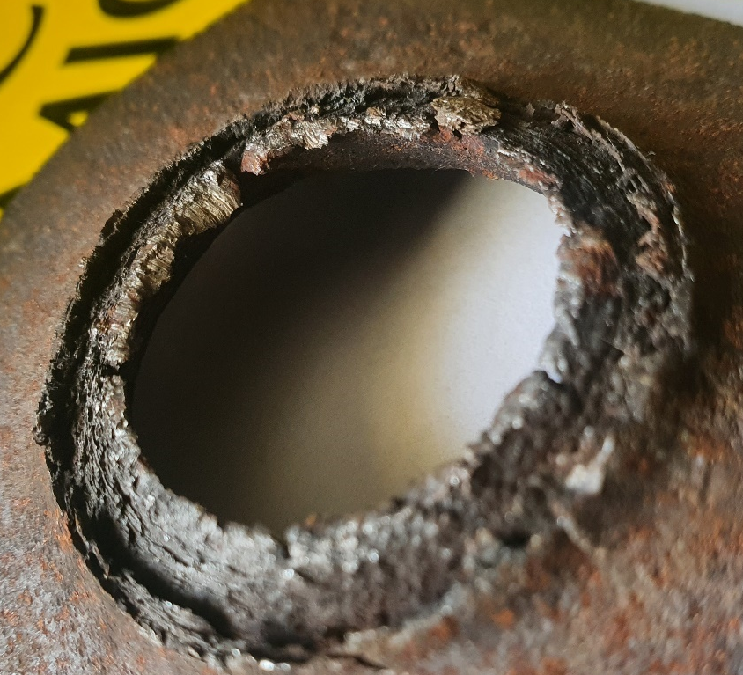
Spalling/Scabbing: Most common in blast or intense impact loadings, spalling is the detachment of a disc of material (a “scab”) from the back face of a target. This is caused by the compressive wave that travels through the target when it is struck - when the compressive wave reaches the free back face of the target, it is reflected as a tensile wave, causing the back face of the material to fail and detach. In weaker targets, this may result in fracture (as the stress wave can exceed the ultimate strength of the material. Another theory purports that the compressive stress causes lateral stress waves in the material, these lateral stresses cause the material to fracture by shear on planes of weakness – this is supported by figures 2&3 below which demonstrate a mild steel plate failure by spall and fracture, exposing “layers”. Note that mild steel plate is often cold rolled, which potentially explains the lateral nature of the layers failing as that is where the weaknesses will be.
Figure 2- Back face of a 5mm mild steel plate after 15g of PE4 has detonated on front face . Note the scab on the right of the image (which had enough velocity to damage the concrete blast chamber flooring). Credit – author.
Figure 3 – Closeup of “layers” having separated due to lateral stress waves of the plate depicted in figure 2 following failure. Credit - author

This report will not cover hydrodynamic nor hypervelocity penetration mechanics.
For the purposes of this report, the author has elected to create a composite 5-layer target structure consisting of alternating copper and plastic layers – mainly due to the fact it was the only iteration of target assembly that wouldn’t cause the simulation to crash. It isn’t fair to refer to this target as “armour”, the only thing it would adequately defend against is a craft knife. Copper is far too weak a material to make any “serious” armour out of due to its weakness and ductility. Plastic in body armour is not a new concept though, however, has only begun to take off on a commercial level recently. Ultra-High Molecular Weight Polyethylene (UHMWPE) is the plastic of choice for removable body armour inserts and will protect against NIJ L3 threats (7.62x51mm NATO Ball at 10m) [3]. UWHMPE armour is lighter than comparable ceramic and steel plates, while doing away with some of the downsides of steel (weight, spall) and ceramic (weight, fragility, inability to protect against multiple hits in the same place). [4].

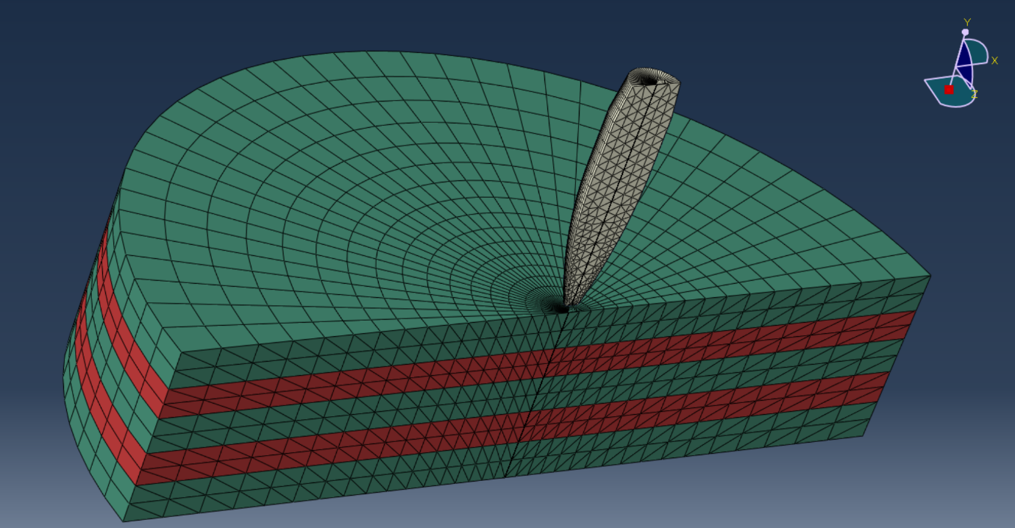
The Model
Figure 4 -The author’s model, with mesh visible
Figure 4 shows the author’s model and the mesh within. In order to stay within the 1000-node limit of the student edition of ABAQUS, the mesh could not be made particularly fine on the large target, but an effort was made to use a relatively fine mesh on the bullet.
Material data is available on request. The Johnson-Cook damage model was used, as it is ideal for high strain rate calculations. Minor modifications were made to the mesh (element degradation/deletion, enhanced distortion and hourglass control) in order to aid the simulation in running smoothly.
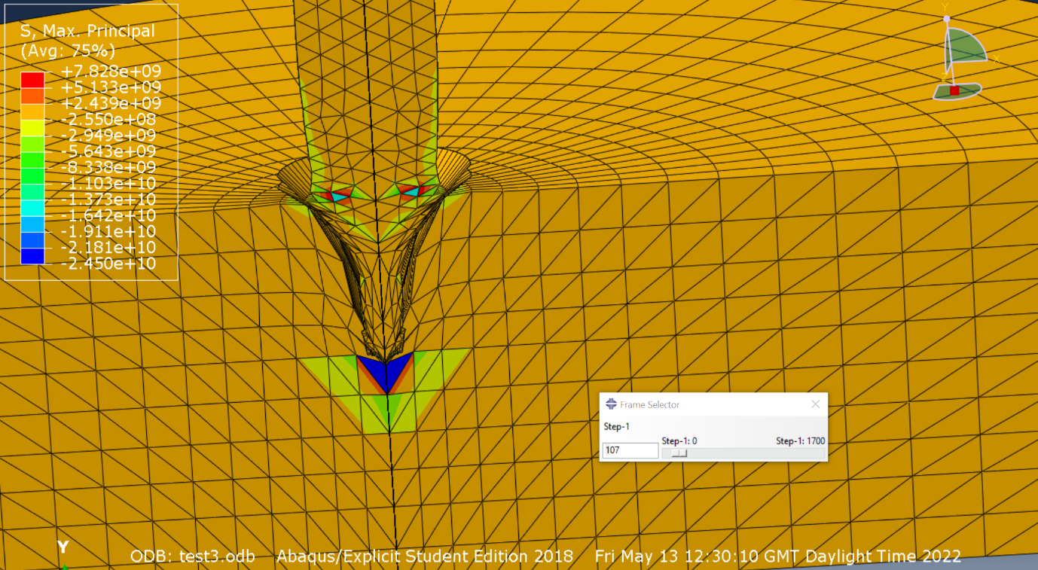
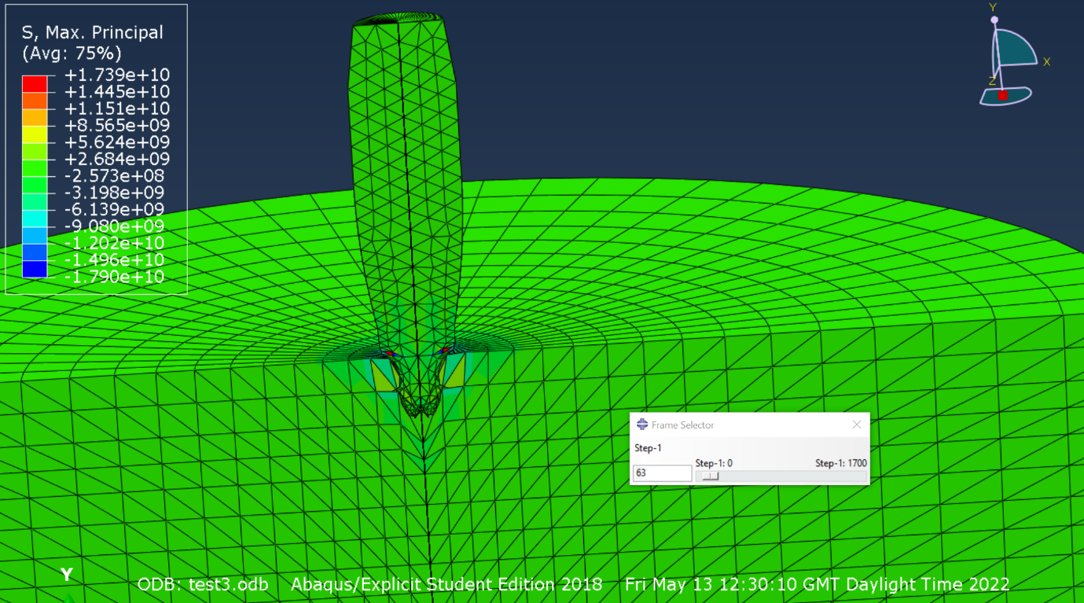
In figure 5, small areas of intense compression can be observed on the bullet as it begins to deform and penetrate the target.
Figure 6 –projectile has penetrated the first copper layer and just the first plastic layer.
Figure 5 – briefly after impact. Projectile is most of the way through the topmost copper layer
In figure 6, the projectile has been slowed and is has only just contacted the centre copper plate. The blue zone (negative stress) indicates an area of compression, while the red and green immediately outside show tensile waves. Elements have started to be deleted as they reach maximum damage.
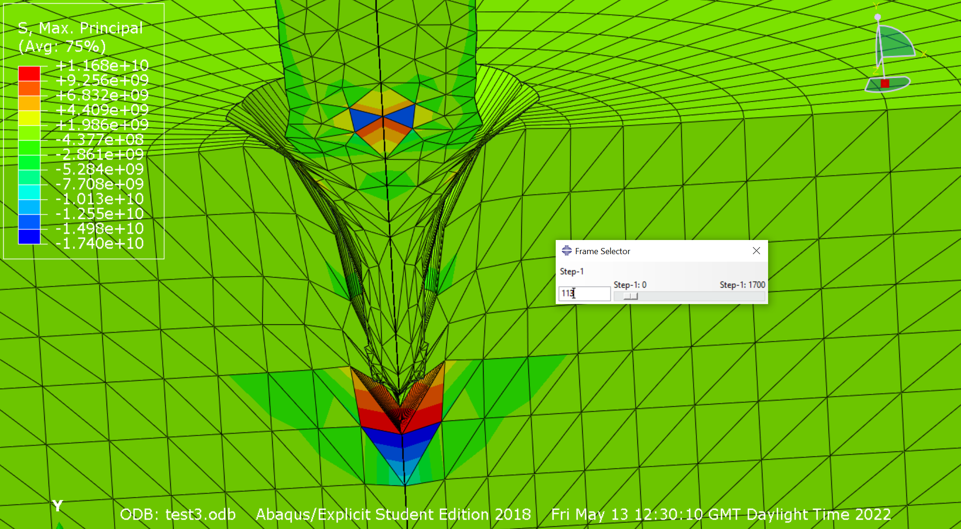
Figure 7 – note the elements being deleted as they reach maximum damage
Figure 7 further demonstrates the compressive and tension waves in the target plate. Also note the areas of compression in the core of the bullet.
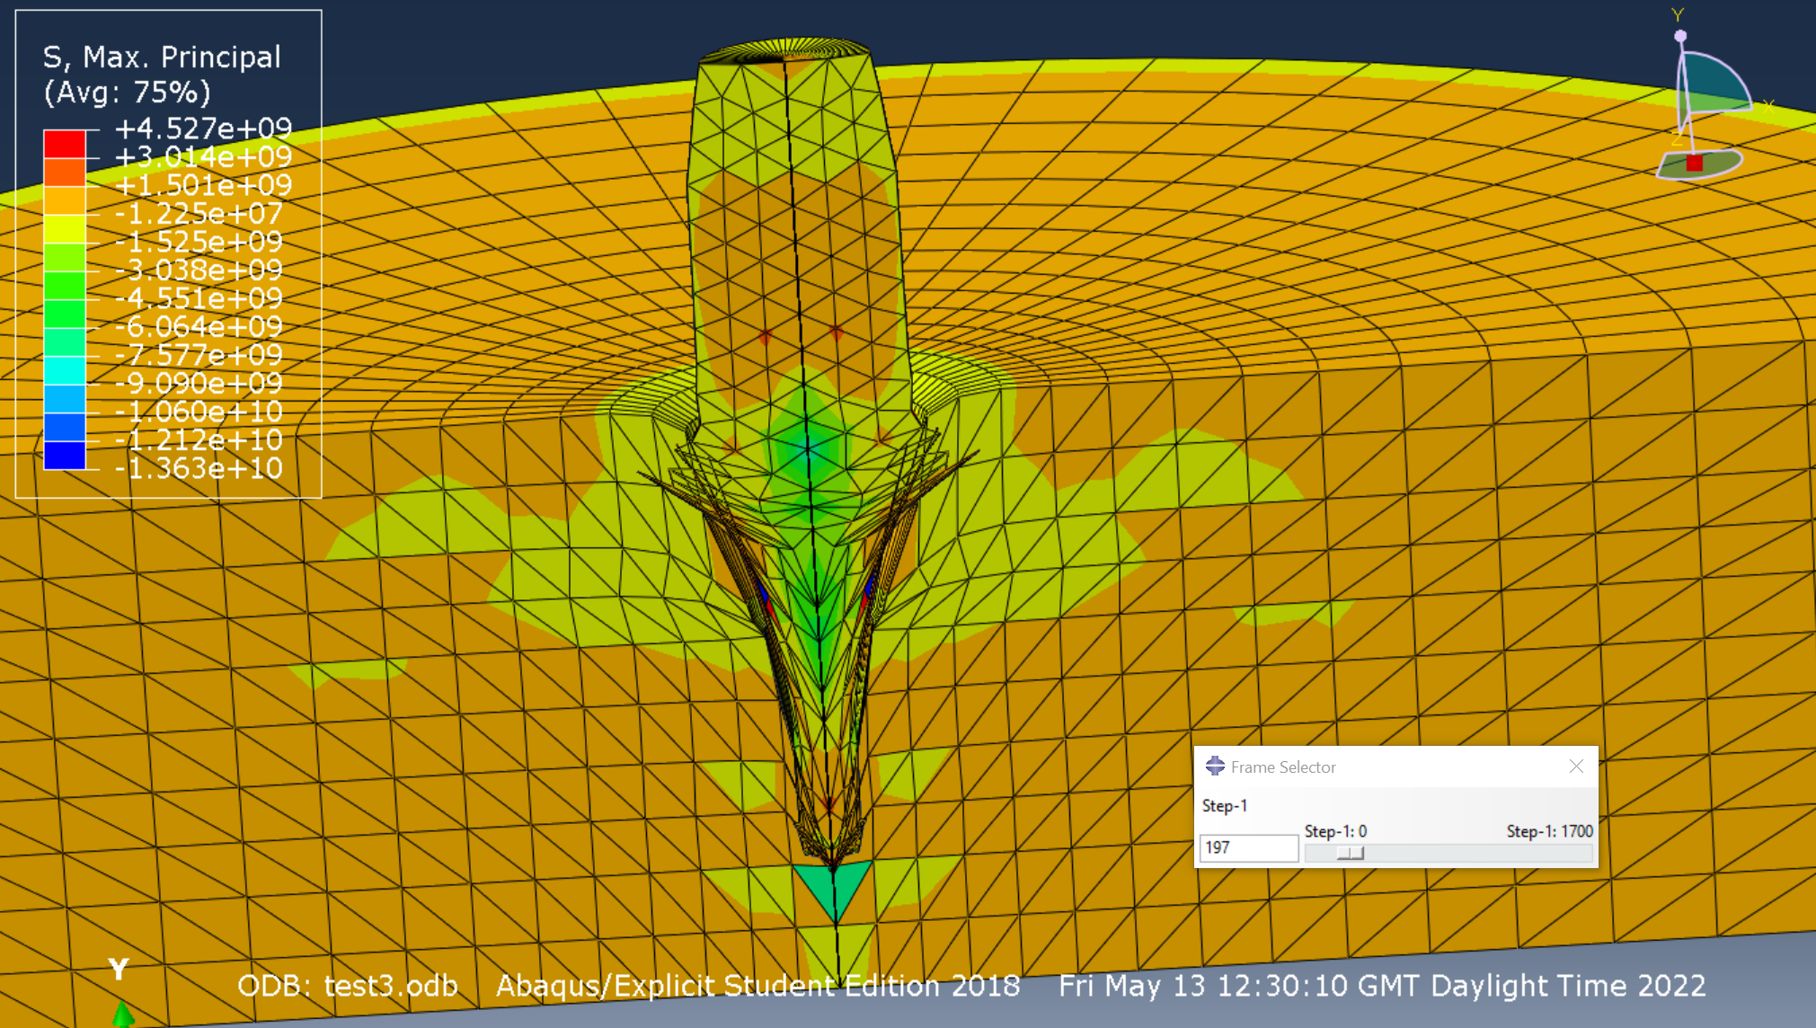
Figure 8 – element deletion further continues, note minor amounts of overclosure
Minor amounts of overclosure are present as the bullet deforms, note the small “points” of intense tensile stress. Pressure waves spread radially, element deletion continues. The projectile appears to have elongated significantly.

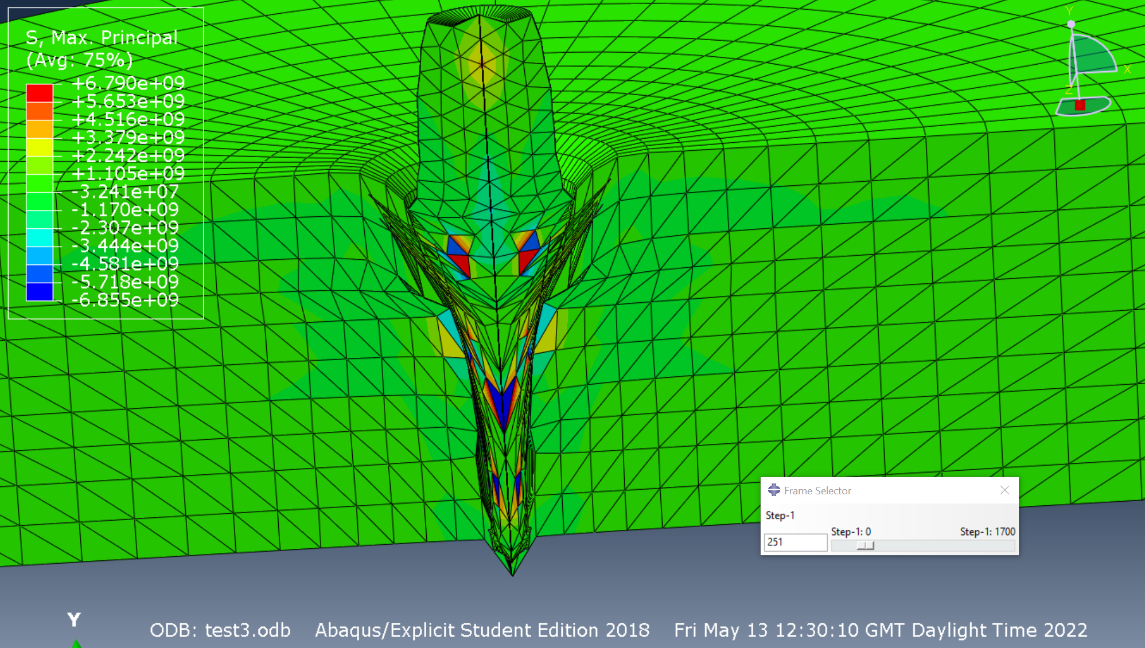
Figure 9
Areas of extreme tension and compression can be observed in the bullet – it seems that a tensile wave has been reflected to the back of the bullet and caused a small deformity in the centre of the tail.
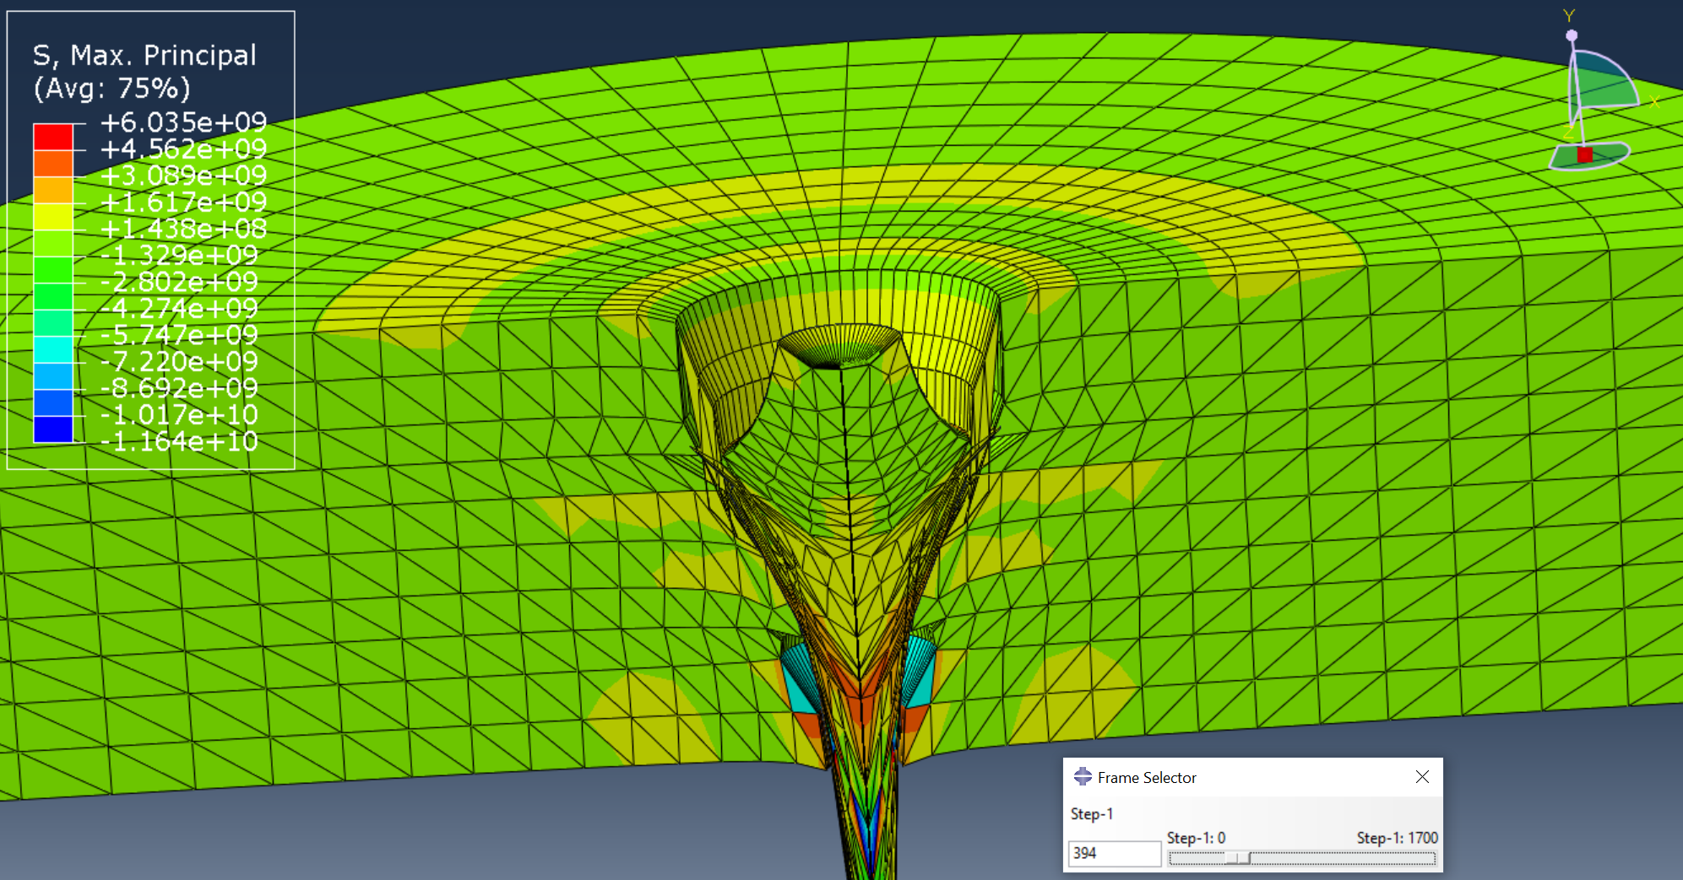
Figure 10
Tensile stress waves can be seen spreading radially from the point of impact in figure 10, also note areas of extreme tensile stress on the bullet as it is drawn out into a length longer than its original.

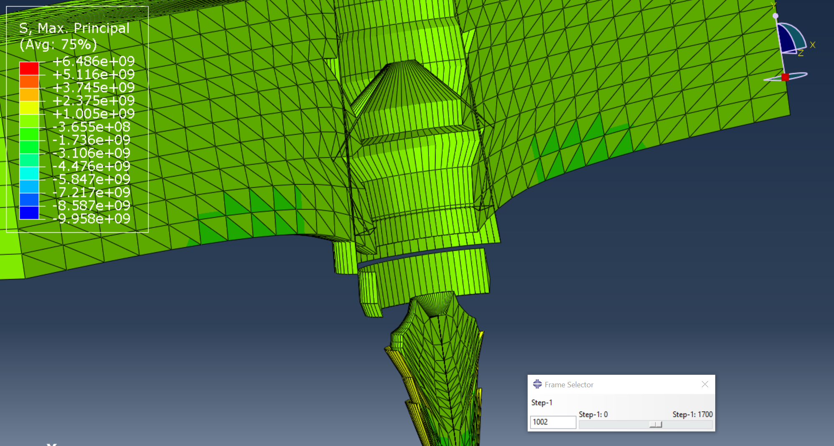
Figure 11 – target now fully penetrated
Comparatively little of interest happens between figures 10 &11. However, in figure 11, one can observe that a round piece of target material is ejected from the bottom, along with some evidence of overclosure further up. The manner it seems the material is being ejected in seems consistent with some degree of fracture failure – the back face is copper, so it’s possible the copper has been stretched to the point it has sheared. While the 180 degree sweep on the model makes the debris seem perfectly ring-like, it’s likely that in real life some degree of petal-ing or fragmentation would be evident. This would be captured well by using high-speed digital video (HSDV).
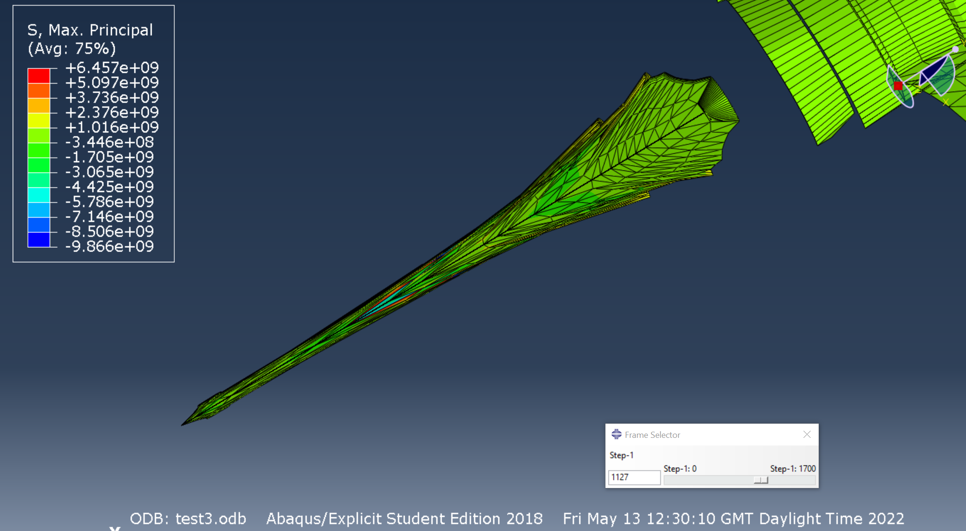
Figure 12 – what was originally the bullet after having penetrated the target
Figure 12 depicts the bullet after having penetrated the target assembly. The way it has extended and sharpened itself is extremely interesting, this is possibly due to its ductility. The flat base has inverted and the boat-tail has become significantly steeper, while remaining intact. It would be interesting to experiment with different ogive profiles and bearing surface lengths to see if that has much outcome on the final shape of the bullet, especially as in figure 8 there seems to be some stress concentration around where the bearing surface begins.

Limitations
The author had significant difficulty using the FEA software package of choice. Progress was hampered by constant errors which were not easily fixable by someone of their experience level. It seems that to master ABAQUS, one must have an excellent understanding of 3D CAD, materials science, coding, and FEA-specific tools & terminology. The plastic the author wished to use (UHMWPE) was not able to be modelled without constant errors, meaning they had to do with the basic plastic model provided to them. The target was also only modelled at a perfectly perpendicular angle to the projectile, and more interesting results would have likely been achieved by assessing the penetration at different angles. The bullet did not rotate in the model, (and in fact would have been rotating at circa. 167,000rpm at 2788fps in a 1:12” twist barrel). The student version of the software is also limited to 1000 nodes.
The author recommends that in the case of trials which would require very little cost and effort to undertake (such as this one), the trial is conducted physically rather than computer simulations prioritised.
“If you are going to be wrong, be wrong as simply and cheaply as possible!” [2]
In terms of man-hours, it would have been cheaper to do the experiment rather than run this simulation.
An attempt was made to plot the velocity of the bullet, but the graph was so chaotic (and involved elements speeding up past the impact velocity) that it was not worth including in this report. This is possibly because the bullet is a ductile material (copper) so instead of simply being slowed down and/or stopped, it was drawn out. This is likely to cause the graph to look extremely messy.

Conclusion and Future Work
To conclude, while this report and the model discussed within constitutes a start, there is much more that could be done with the appropriate knowledge and time, both with the FEA software and with access to a test/small arms range. Typically, body armour assessment is conducted to NATO Standard AEP-2920. Annex B & C of AEP-2920 details a “standard” set of projectiles, some of which are bullets (for example, the mild-steel cored SS109 5.56mm bullet and the standard 9x19mm ball round), and some of which are chisel-nosed Fragment Simulating Projectiles (FSPs) [5].
It would also be a good idea to recreate a ballistic test for which results are widely available, for the purposes of model validation. Alternatively, have several lathe-turned bullets identical to the profile in figure 1 made, and build up a simple target pack from mild steel and plastic, weigh them, and using publicly available load data for 7.62x51mm cartridges and that projectile weight, create a load to fire them out of a 7.62 rifle at the correct velocity – alternatively use an internal ballistics modelling programme such as QuickLoad. This would at least give a ballpark indication of model “correctness”, especially if the bullet were able to be recovered afterwards.
Ideally, more time and guidance would be available to further refine the simulation. The writer believes that an interesting combination to assess would be a RHA and UHMWPE sandwich. Alternatively, a model for a weave such as Kevlar could be developed and used in conjunction with a titanium plate (specifically, a 1.6mm titanium plate and 20 layers of Kevlar, as used in the NATO-standard CRISAT body armour for assessing bullet performance [6] [7]). This would provide yet another manner in which the model could be validated, as performance data against this target for a number of bullets is available.
Another interesting manner in which penetration simulations could be validated and compared to real-world test results is with the use of “flash X-ray” systems. These systems consist of large extremely high-voltage X-ray pulsers (in the megavolt region) which have very short exposure times [2]. This allows the user to see “into” a target as it is being penetrated, however due to the very short exposure time, one can only see a “snapshot” at the exact moment the X-ray source is triggered, so to understand the behaviour throughout the experiment would require at the very least several “shots” to be carried out. This comes at considerable expense, however, provides fantastic results when carried out properly.

Bibliography

[1] | J. Belk, “Properties of Materials,” in Textbook of Ballistics and Gunnery, Volume 1, Her Majesty's Stationaey Office, 1987, pp. 71-72.
[2] | e. a. Jonas Zukas, Impact Dynamics, Malabar, Florida: Krieger Publishing Company, 1992, p. 183.
[3] | Compass Armour, [Online]. Available: https://www.bodyarmour.shop/collections/uhmwpe-armor-plates/products/level-3-plates. [Accessed 13 05 2022].
[4] | ShotStop, “What Are the Different Types of Body Armor?,” [Online]. Available: https://www.shotstop.net/blogs/blog/what-different-body-armor-steel-ceramic-polyethylene-vs-duritium-body-armor. [Accessed 13 05 2022].
[5] | North Atlantic Treaty Organisation, “AEP-2920, Procedures for the Evaluation and Classification of Personal Armour, Bullet and Fragment Threats,” NATO Standardization Office, 2016.
[6] | A. G. Williams, “Addressing the body armour challenge,” Jane's International Defence Review, Derbyshire, 2017.
[7] | North Atlantic Treaty Organisation, “STANAG 4512 - Dismounted Personnel Target,” NATO Standardisation Office, 2004.
[8] | B. Litz, “Ballistic Coefficient Testing of the Sierra .308" 155gr Matchking Palma Bullet”.

Despite the term “hollow point” in HPBT, HPBT bullets are still Hague Convention compliant, as the design intent is not for them to expand on impact with a soft target. This is unlike HP bullets with a deep dished tip and a jacket containing striations to encourage consistent and reliable expansion in soft targets. Thus, HPBT bullets have useful legitimate military applications.

