

Faculty of Applied Design and Engineering/Cyfadran Dylunio Cymhwysol a Pheirianneg
School of Applied Computing/Ysgol Cyfrifiadureg Gymhwysol

IP Internetworking
BSc Computer Networks (M1X8609)
HND Computer Networks (M5X8914)

Practical Lab Assessment 2013-14

Name :

Student ID :

Date & Time :

This is an individual practical lab-test, held under examination conditions. You will be assigned three Routers; you should configure these devices based on the given specifications.

This paper is marked out of 100.

You will have 2 hours to complete this task.

TOPOLOGY DIAGRAM
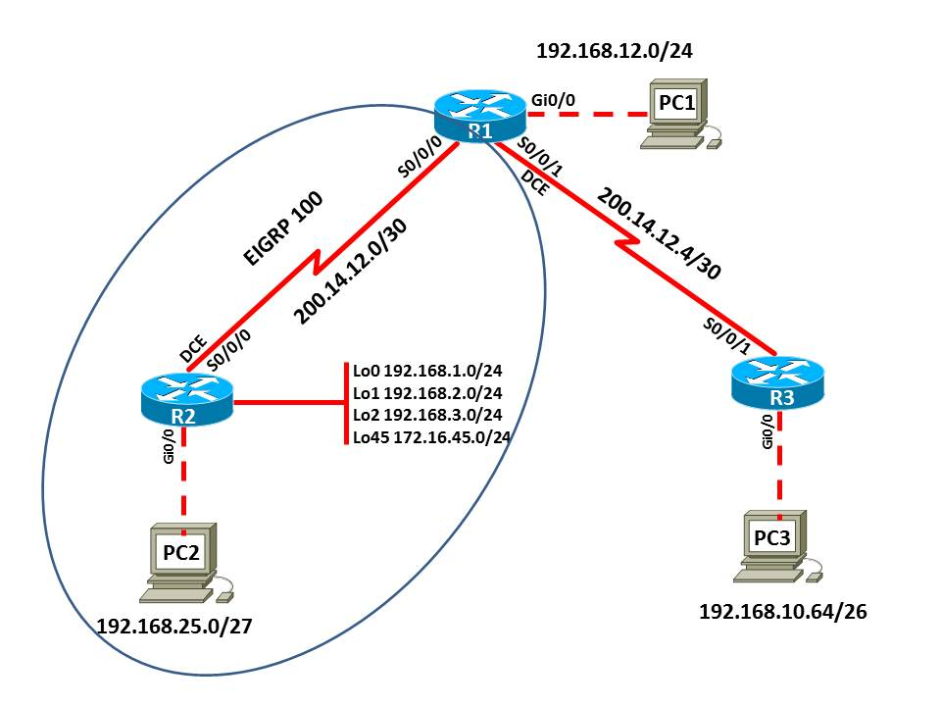

Task 1: Create an Addressing Scheme (15 marks)

Assign the first usable IP address of each subnet to each Router

Assign the last usable IP address of each subnet to each PC
Device | Interface | IP Address | Subnet Mask | Default Gateway
R1 | Gi0/0
R1 | S0/0/0
R1 | S0/0/1
R2 | Lo0
R2 | Lo1
R2 | Lo2
R2 | Lo45
R2 | S0/0/0
R2 | Gi0/0
R3 | Gi0/0
R3 | S0/0/1
PC1
PC2
PC3
Task 2: Cable and configure the network based on the diagram and the addressing scheme you created in the previous task. (20 marks)
Configure the R1, R2, and R3 according to the following guidelines:
- Configure the hostname.
- Disable DNS lookup.
- Configure an EXEC mode password.
- Configure a message-of-the-day banner.
- Configure a password for console connections.
- Configure synchronous logging.
- Configure a password for vty connections.
- Configure all interfaces with appropriate IP address.
- Configure line description.

Task 3: Configure EIGRP with Process ID 100. (30 marks)
Step 1: Configure EIGRP on the R1 router and advertise all directly connected networks.
Advertise the network along with a wildcard mask for the appropriate subnet.

Step 2: Configure EIGRP on the R2 router and advertise all directly connected networks and advertise all loopback interfaces. Disable auto summary function.

Step 3: Verify that routers R1 and R2 has a path to each network in the autonomous system.
Task 4: Static and Default Route (20 marks)
Step 1: Configure a static default route on the R1 router to R3.
Step 2: Propagate the static default route in the R1 routing update.
Step 3: Configure a static route on the R3 router using next hop address of R1.
Step 4: Verify that the static default route is received by the R1 and R2 routers.

Task 5: Verify network connectivity (10 marks)
Ping a loopback interface on the R2 router from each host.

Was PC1 successful? ___________
Was PC2 successful? ___________
Was PC3 successful? ___________

If you are not successful, troubleshoot configurations using the appropriate show and debug commands.

Task 5: Document the Configurations (5 marks)
All documentation for your solution should be submitted. Your name should be clearly printed on the documents.

At the end of the test a flash memory will be given to you, the configuration files for all routers should be copied to the media and handed in to your instructor. It is you responsibility that you copy the files correctly.

On each Router, issue the
show run
sh ip int brief
sh ip protocols
sh ip route
commands and capture the configurations. Save the file as devicename_surname_Pno.txt.

