Student name: | Ionel Oprea | Student ID number: | 2526326
Programme: | Certificate of Higher Education Skills for the Workplace (Health & Social Care)
Module: | Introduction to Health and Social Care
Module code: | LCHS4003 | Contribution to Overall Module  Assessment (%): | 50%
Lecturer: | Muhammad Aliyu (Module Leader) | Internal Verifier: | Dr Besty Jose
Assignment Title: | Component 1:  Portfolio – Two Tasks | Word count (or equivalent): | 600 words


Task 1
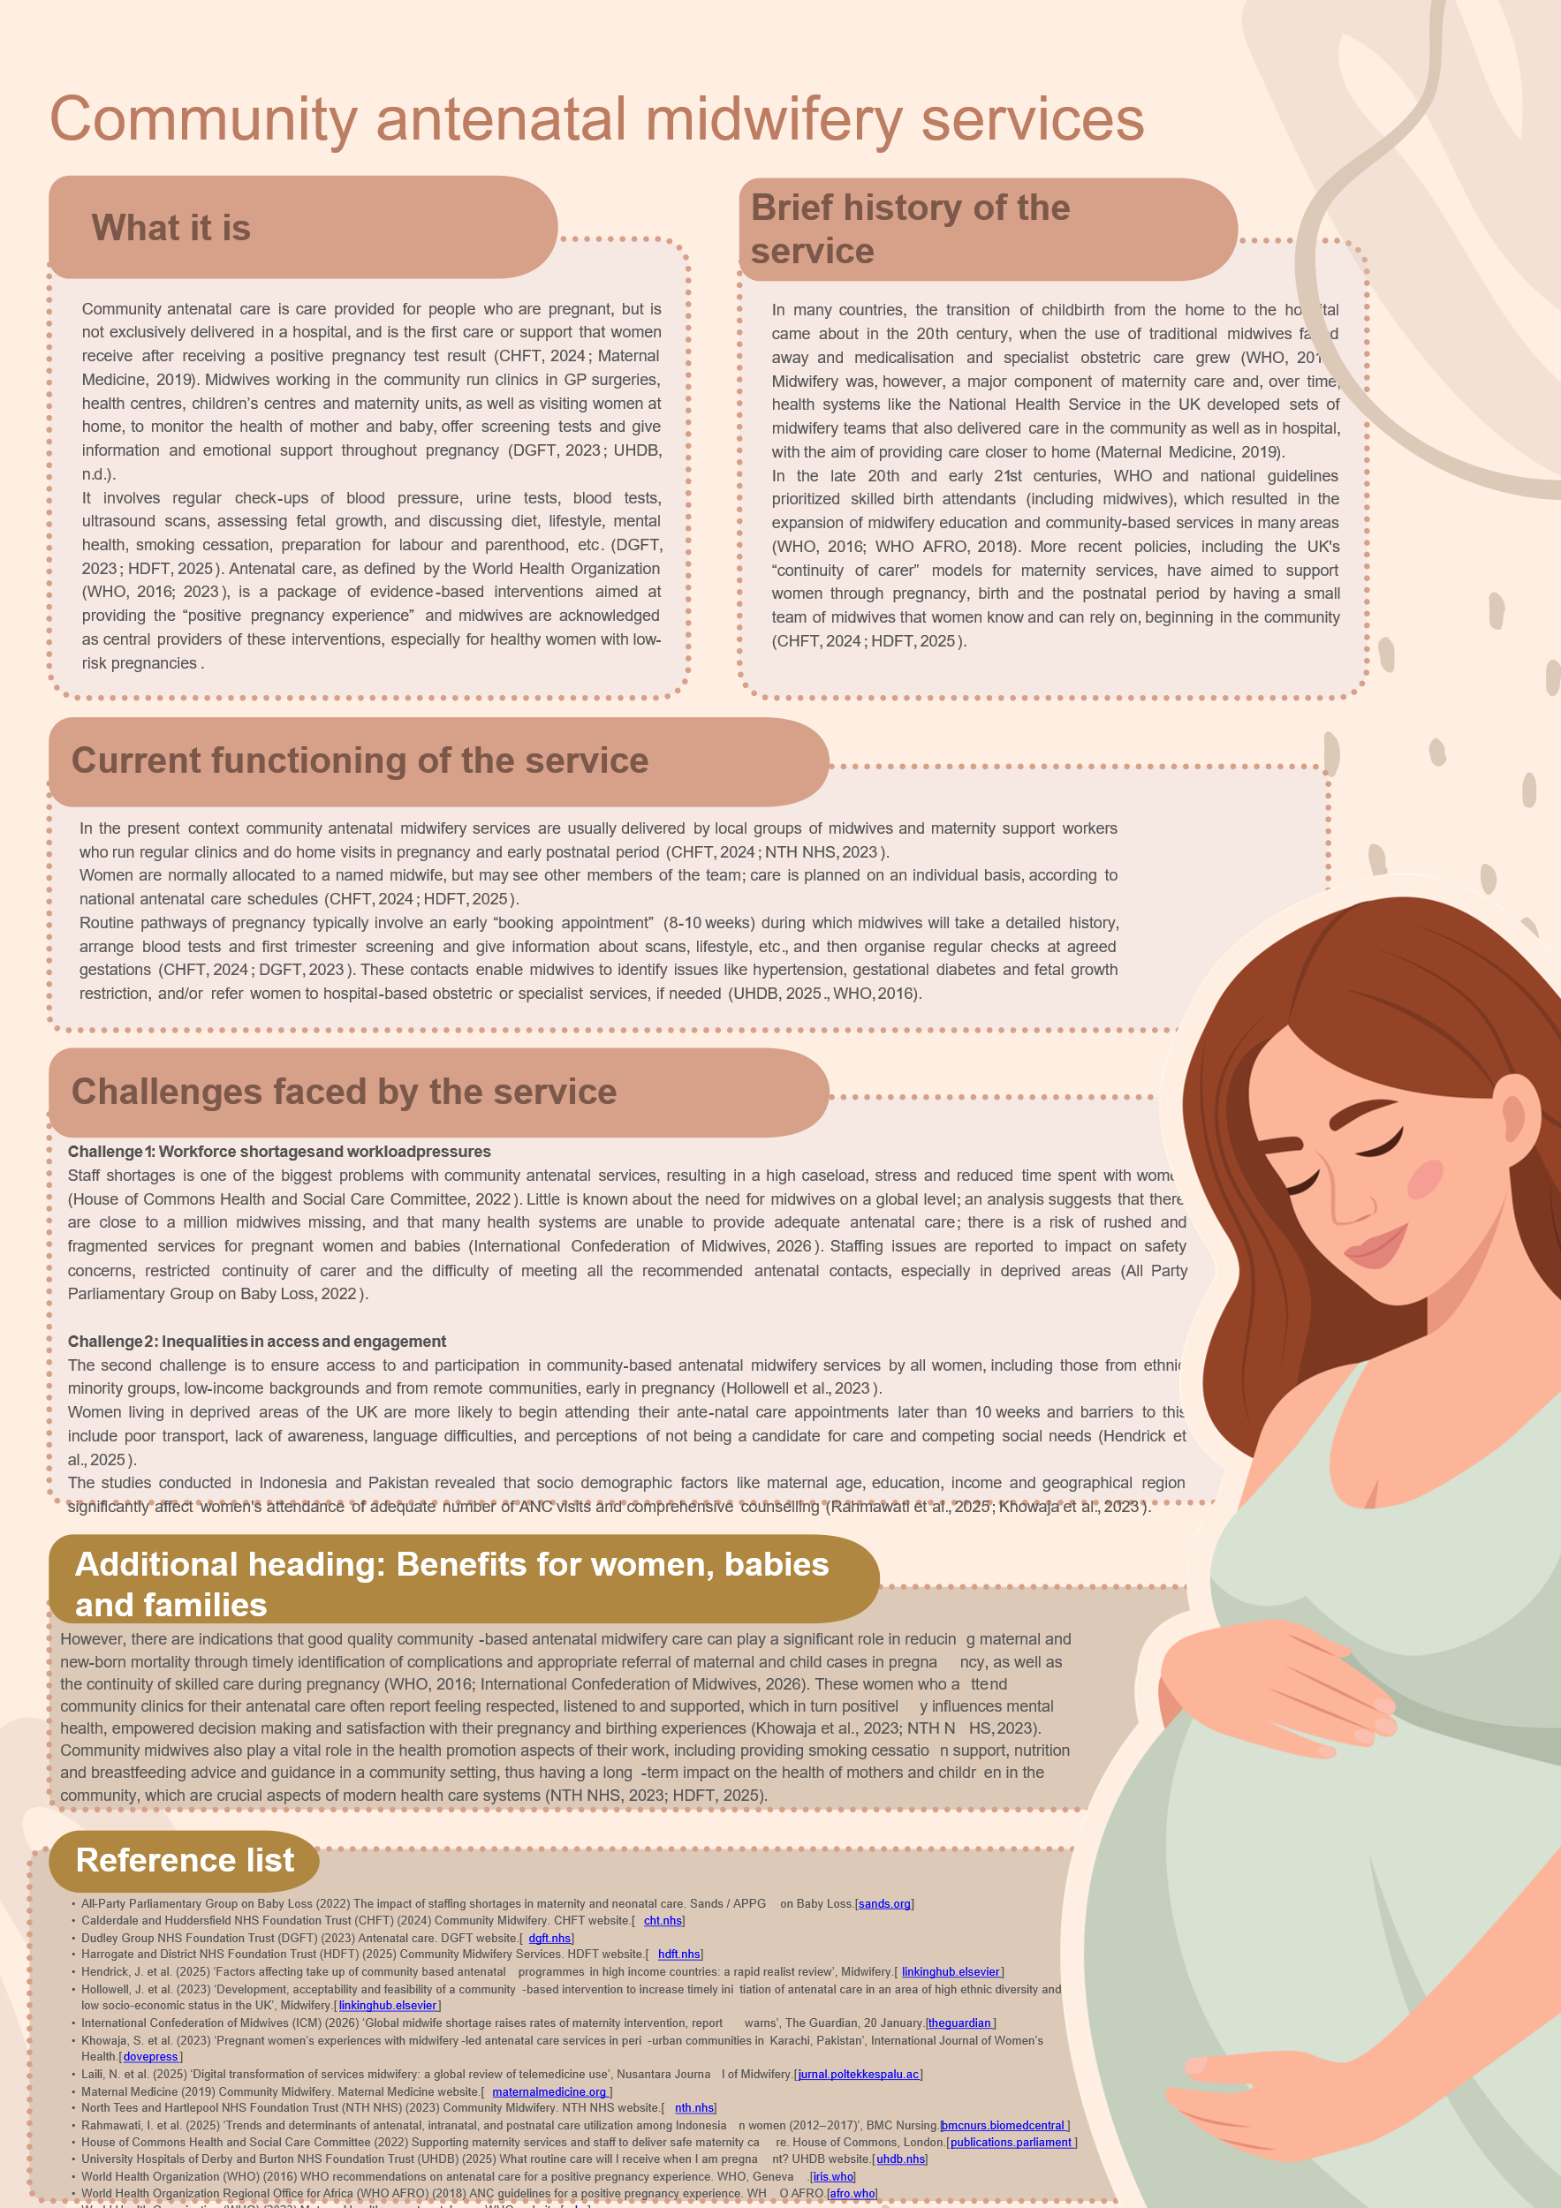

Task 2

Community Mental Health Services: Origins, Contemporary Practice and Contributions to Quality of Life
Community mental health services are a system of supports and treatments that are provided in everyday environments, like the local clinic, people's homes, schools or social care agencies, not in long stay psychiatric hospitals (World Health Organization, 2025; NHS England, n.d.).
They seek to support people with mental health issues to live as independently as possible, with the emphasis on recovery and social inclusion and protection of human rights, rather than on long-term institutionalisation (WHO, 2024).
During much of the 19th and early 20th centuries, people suffering from serious mental illness were typically treated in large asylums, often some distance from their communities, where treatment was custodial, and where there was a tendency to separate the ill from the community (Turner, 2015; Open University, 2020).
In the UK, the first Mental Health Acts in 1930 and 1959 allowed for increased voluntary admissions and fostered a relationship between hospital services and community agencies, with a view to more care in the community (Burns, 2020; Nuffield Trust, 2016).
Starting in the 1960s, improvement of treatment methods, greater concern about human rights violations in psychiatric institutions, and critiques of institutionalisation contributed to a policy focus on “deinstitutionalisation” by many countries, which aimed to replace psychiatric institutions with community mental health services (World Health Organization, 2014; World Health Organization, 2024). International agencies such as the UN Convention on the Rights of Persons with Disabilities (2006) and in South East Asia, the Paro Declaration on universal access to people centred mental health care reinforced the vision of living and receiving mental health care services in the community instead of in long stay institutions (World Health Organization, 2024; World Health Organization, 2024b).
Overall, community mental health services were found to be a reaction to the shortcomings of asylum-based services and the move towards person centred, rights based and socially integrated care (Saraceno et al., 2026; World Health Organization, 2014).
Community mental health services are now usually made up of multi-disciplinary community mental health teams (CMHTs), crisis resolution and home treatment teams, day centres, supported housing, peer support and psychological therapy services that are connected to primary care (NHS England, n.d.; World Health Organisation, 2025).
The services offer early evaluation, continuous care, rehabilitation and social support in the local context with the goal of decreasing hospitalizations and facilitates recovery “in real life” (World Health Organization, 2025; World Health Organization, 2005).
There is evidence that well developed, community-based systems can enhance access, reduce stigma and achieve better health and social outcomes than hospital-based systems alone, particularly when they integrate health care with programmes for housing, employment and social inclusion services (World Health Organization, 2025; World Health Organization, 2024).
But in most LMICs, the majority of funds are allocated to psychiatric hospitals, and substantial gaps in treatment exist: up to 95% of people with mental health conditions do not receive adequate care in some parts of the world (World Health Organization, 2014; World Health Organization, 2024b).
Other obstacles to community mental health services include under investment, staffing deficits and poor integration with social care and differing levels of coverage between urban and rural areas (Saraceno et al., 2026; World Health Organization, 2014).
Despite these deficits, with proper resource, structure and function, community mental health can play a significant role in the quality of life of people using services (World Health Organization, 2025). Living close to home supports and enables people to maintain family connections, be employed, be in education or participate in the community – these are essential for recovery and long-term wellbeing (World Health Organization, 2024b; Saraceno et al., 2026).
Community based care also contributes to the prevention of institutionalisation and helps avoid the isolation and stigma that accompany it, ensuring dignity, autonomy and the right to live independently in the community (World Health Organization, 2024; World Health Organization, 2024b).
Rather than just “surviving” with symptoms, when mental health support is combined with housing, vocational training, and peer-led initiatives, people using services will be more likely to return to a sense of purpose, rebuild social networks and attain meaningful life goals (World Health Organization, 2025; World Health Organization, 2005).

Reference list
Burns, T. (2020) ‘Community-based mental health care in Britain’, Consortium Psychiatricum.
NHS England (n.d.) Community mental health services. NHS England website.
Nuffield Trust (2016) Between the Acts: Community mental health services 1959–1983. Nuffield Trust.
Open University (2020) ‘The past: from asylum to community care?’, Mental health: a society in crisis, OpenLearn.
Saraceno, B. et al. (2026) ‘Reorganization of mental health services: from institutional to community-based care’, Eastern Mediterranean Health Journal.
Turner, J. (2015) ‘The history of mental health services in modern England: practitioner memories and the psychiatric hospital’, Social History of Medicine.
World Health Organization (2005) Mental health II: balancing institutional and community-based care. WHO Policy Brief.
World Health Organization (2014) Innovation in deinstitutionalization: a WHO expert survey. WHO, Geneva.
World Health Organization (2024) Deinstitutionalization of people with mental health conditions in WHO South-East Asia Region. WHO South-East Asia Regional Office.
World Health Organization (2024b) ‘Deinstitutionalize mental health care, strengthen community-based services’, WHO South-East Asia news release.
World Health Organization (2025) ‘From isolation to inclusion: community-based mental health care’, WHO commentary.

