Development and use of information systems in the context of passenger transport

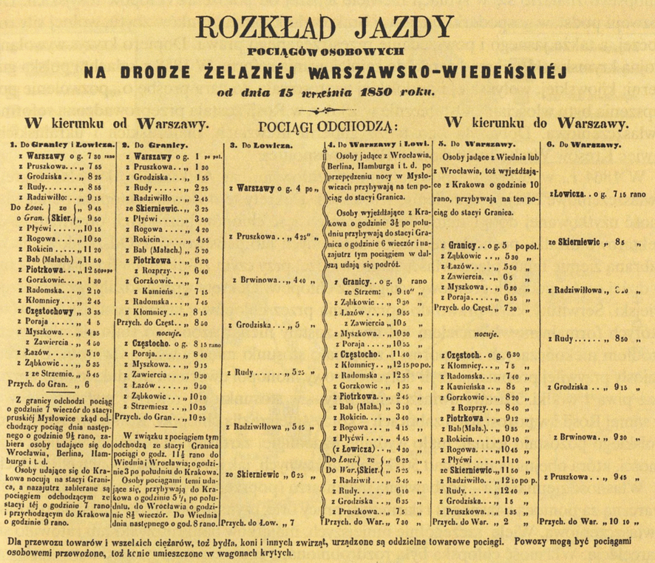
All branches of public transport rely on timetables which organise its function making it sustainable. Timetables and other related data need to be presented to customers in a clear way, making it easy to infer all the necessary information, for example: departure time, composition of trains (for long distance services with seat reservations) or the current delay. Development of technology has influenced current passenger information systems, evolving it from simple posters shown at train stations, to LCD screens on both stations and vehicles, vocal announcements and live internet feed with GPS locating service showing the current position of the vehicle on your mobile phone. Information has always been an important part in the transport industry, and development of means of presenting it goes parallel with development of all other branches of transport and logistics.

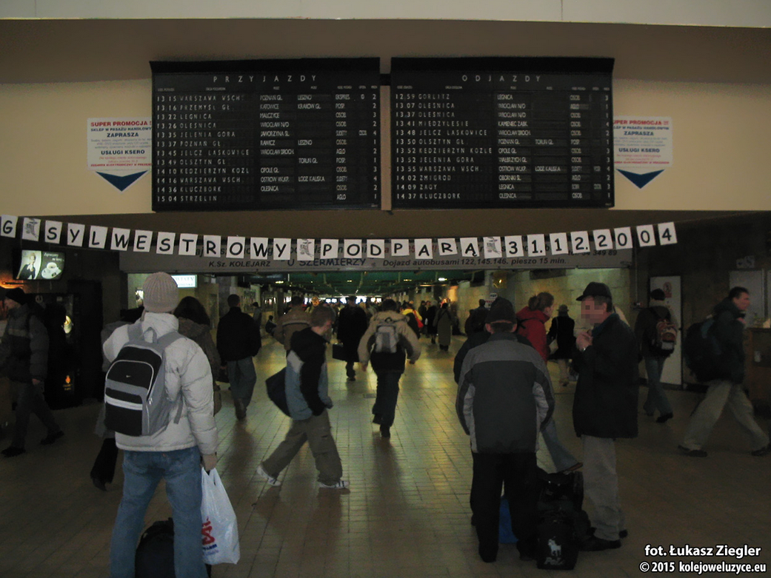
When train operations got more complicated due to broad expansion of railway lines and need for more trains to carry more and more people it was apparent that there needs to be a way to present more information without occupying so much space. The industry decided to adapt known technology from flip clocks to design split-flap displays. Split flap displays are electromechanical devices which use flaps that can present characters or full words by changing their position. This enabled airports, train operators and railway infrastructure providers to manage passenger information dynamically, which means they were now able to present data valid for a short period of time and account for real time delays or obstructions. Presented data could be telematically updated at any given time with a push of a button. This kind of passenger information system has quickly gained popularity around the world and its unique noise made while changing the layout of flaps became one of the symbols of rail travel. Two european companies have been leading in the production of these - Italian ‘Solari’ and Czechoslovakia based ‘Pragotron’.

Another important mean of passenger information system is vocal announcements. Early development of microphones and speakers allowed station masters and airport managers to announce different services as well as warn passengers about dangers, eg. due to leaving their luggages around or classic, London’s underground “Mind the gap”. Nowadays due to development of computer based voice, speech synthesis is available. Even though speech synthesis is an interesting way of announcing trains, it can sound robotic and not always come across as clear. Due to automation of announcements it also gets rid of a job place.

Nowadays passenger information systems feature top of the line display technologies such us LCDs and LEDs. It’s getting increasingly hard these days to find a split flap display in Europe. This is because LEDs and LCDs are easier and cheaper to maintain as well as more visible for passengers. Apart from that, more specific information can be acquired through GPS and internet services.
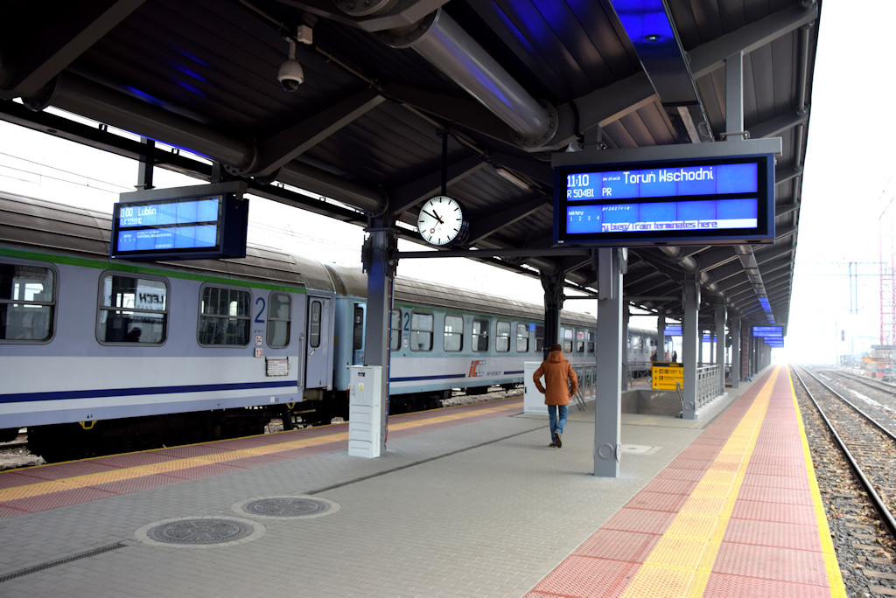
LCDs, or liquid crystal displays are “electronic displays that consist of segments of liquid crystal whose reflectivity varies according to the voltage applied” - according to merriam-webster.com. Liquid crystals were first extracted from cholesterol from a carrot in 1888. It took nearly a hundred years for the technology to be developed into a flat display, as LCDs were invented by James Fergason in 1970s. The newly invented screen technology found its application in many fields. For the next decades the patent kept evolving making it more and more applicable. Nowadays most of the screens and displays around us are LCDs - TVs, laptops, pc screens, mobile phone screens, and of course - Passenger information systems.

LEDs, or Light emitting diode is another modern technology often used to manufacture displays. According to Techopedia.com, “LED is a screen display technology that uses a panel of LEDs as the light source.” The principle is easy, and similar to lightbulbs, except diodes have no filaments and they create light purely by electricity flowing through them. Colour and intensity of electromagnetic radiation emitted by a LED depends on voltage and current put through them. The first LED display was created in 1977 by James P. Mitchell, and even though it was monochromatic it was still a major breakthrough in the display manufacturing industry. Nowadays LED displays are used broadly in mobile phones, TVs and they also gain popularity as technology for passenger information systems.

One of the most important technological breakthrough that made public transport even more appealing to potential customers is GPS technology. That, together with internet allows users to track their train, flight or bus using their phones. There are some apps that can estimate arrival and departure times, whether it’s a city bus or a long distance train should it be delayed. An example of that would be realtimetrains.co.uk that allows users to find out where their train is precisely and shows estimated arrival or departure time if the service is delayed. Another online service is flightradar24.com which allows users to track every single flight around the world providing information such as estimated arrival time, estimated departure time, type of aircraft, flight number, delay, current speed, altitude etc. This data, from the vehicle including its position is usually acquired through GPS (Global Positioning System). It features 33 satellites orbiting the Earth at approximately 20 thousand kilometres. The satellites emit radio waves at certain frequencies and devices on board receive those signals. That allows the satellites to work out the relative position of the on board receiver thus it allows them to pinpoint its position on a map. Over time, that can be used to work out the speed and direction of travel as well as the position on its own. The system was launched in 1973 and originally it was for military use only.

Passenger information systems are of course very important to maintain sustainability of transport. They allow customers to organise their itineraries, find their way around hubs and vehicles as well as get informed about safety rules and precautions. Modern LCDs and LEDs displays are bright and energy efficient which makes them good information displays either indoor, or outside on platforms. In conclusion - information and presenting it to general public plays a vital role in providing the general public with a good, sustainable mobility in the context of passenger public transport. In order to use public services customers need to know their way around and the more the information is available, the more people will be satisfied with services provided.

fig.1 - Simple passenger information poster with timetable from 1850
on the Warsaw-Vienna railway line (public domain work)

fig.2 - Pragotron display at Wroclaw Main Station in 2004, just six years before LCD replacement (photo by Lukasz Ziegler)

fig.3 - Modern LCD based visual passenger information system on a platform at Bydgoszcz main station in Poland (photo by KZL Bydgoszcz company)

Bibliography:

https://www.fastcompany.com/90157213/old-school-mechanical-displays-are-making-a-comeback
http://lodz.wyborcza.pl/lodz/1,35136,20023360,dworzec-lodz-kaliska-znika-ostatni-taki-system-w-polsce.html
https://www.merriam-webster.com/dictionary/LCD
https://www.quora.com/How-does-the-Indian-railway-train-announcement-system-work
https://www.techopedia.com/definition/14957/led-display
https://sciencing.com/led-lights-work-4588096.html
http://www.realtimetrains.co.uk/about/sources
https://www.flightradar24.com/52.24,-3.64/8
http://www.kzl.com.pl/oferta/systemy-informacji-pasazerskiej.html

