

MODULE HANDBOOK

Yr Athrofa: Centre for Education

Postgraduate Certificate in Teaching
in Higher Education (Advanced HE accredited)

UNHE7010
Advanced Teaching & Assessment in Higher Education
PSF 2023

Institute of Education and Humanities

2026-7

WELCOME

Welcome to the Post Graduate Certificate in Teaching in Higher Education (PG Cert tHE).
Whilst the Programme Handbook provides you with general University information and an introduction to the Professional Standards Framework (PSF 2023), this module handbook provides you with detailed information to support the second module of the award, namely ‘Advanced Teaching and Assessment in Higher Education UNHE7010. In addition, it contains further information about the Advance HE accreditation that is an integrated element of the PGCert (pending approval), with the Programme Learning Outcomes mapped to the PSF 2023.
Through this accreditation (pending approval) the PGCert is able to offer Advance HE recognition for those who teach or support learners in Higher Education, whether in the classroom, online or in a support role. It is essential that you fully familiarise yourself with the PSF 2023, which can be found on the Advance HE’s website: Professional Standards Framework (PSF 2023) | Advance HE (advance-he.ac.uk)
The full PGCert is aligned to Descriptor 2 of the PSF 2023 (Fellow status). The PSF 2023 is of direct relevance to academic staff, but many other staff supporting student learning will also be able to provide appropriate evidence for the various Descriptors.
The appendices included in this module handbook, all relevant to elements of your portfolio, can also be found on the Programme Moodle site.
KEY INDIVIDUALS
Assistant Dean – Caroline Lewis SFHEA, caroline.lewis@uwtsd.ac.uk
Programme Lead - Mark Flagg FHEA, mark.flagg@uwtsd.ac.uk
Professional standards lead – Katie Gardner FHEA, katie.gardner@uwtsd.ac.uk
You are very welcome to email Mark with queries that you may have concerning the module or the programme in general. Do check the information on Moodle and Teams first however, to see if the answers are already there for you. Mark will advise on the PSF 2023 and the portfolio requirements and facilitate learning throughout the programme. Two Senior Fellows also support the programme.
Practice Advisor
To support you in evidence gathering for this module and broader day-to-day practical issues relating to your teaching, a Practice Advisor will be identified, ideally at your campus. Your Practice Advisor, who will be an experienced staff member, will be chosen in discussion between the Programme Manager and your Academic Director or equivalent. Your Practice Advisor is required to be one of the individuals who observe you teaching as part of UNHE7010. Mandatory training is provided for all Practice Advisors by the Programme Manager.

UNHE7010 LEARNING OUTCOMES
Upon the successful completion of this module, participants should be able to demonstrate the ability to:
- Design, plan and critically evaluate effective and inclusive learning environments. [A1/K1,K2/V2]
- Critically apply an extensive range of teaching and learning methods to support and enhance inclusive learning. [A2,A4/K2,K4/V1
- Display an increased range of self, peer and student monitoring and evaluation techniques. [A3/K3/V3]
- Analyse and assess their own future development needs and make a plan for their own continuing professional development. [A5/K3,K5/V4,V5]
- Demonstrate competence in aligning their practice to descriptor D2 of the PSF2023.

In addition to meeting the module learning outcomes, students provide evidence to meet the requirements of D2 of the PSF 2023.
D2 is suitable for individuals whose practice with learners has depth and breadth, enabling them to evidence all criteria statements. Effectiveness of practice in teaching and /or support of high-quality learning is demonstrated through evidence of;
D2.1 Use of all five Professional Values.
D2.2 Application of all five forms of Core Knowledge.
D2.3 Effective and inclusive practise in all five Areas of Activity.

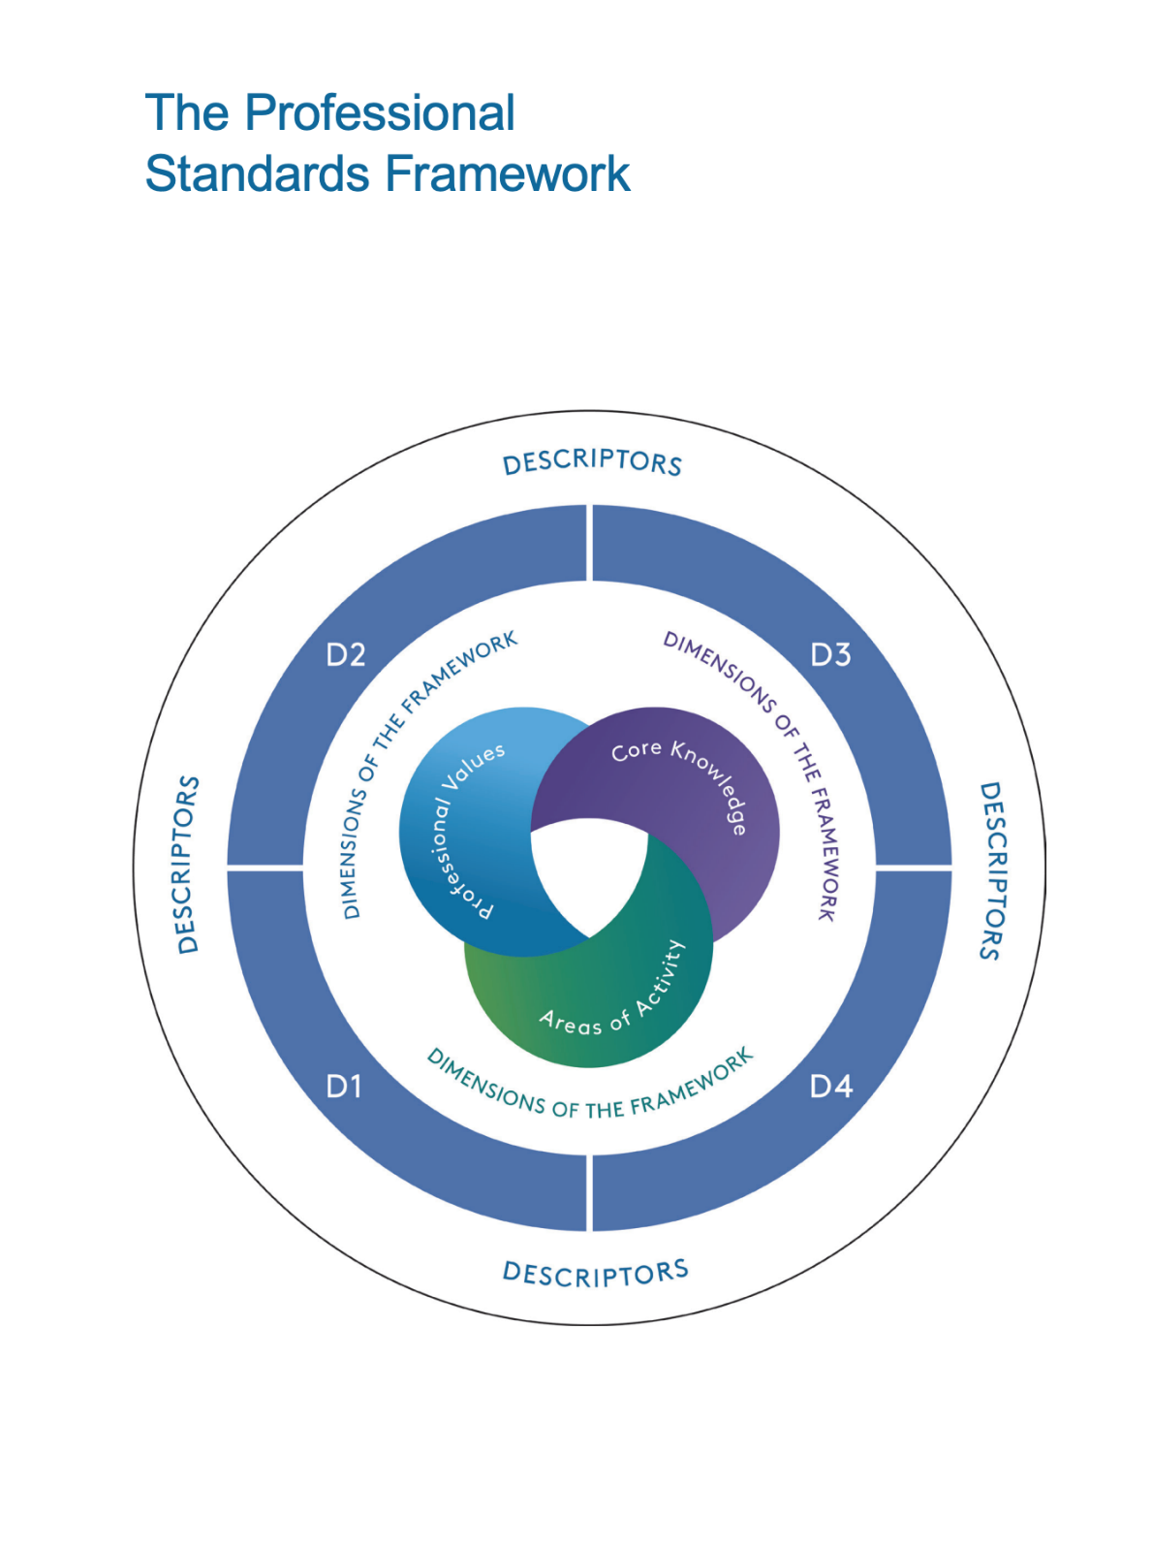

Details of the professional values, core knowledge and areas of activity are set out in the Advance HE illustration.

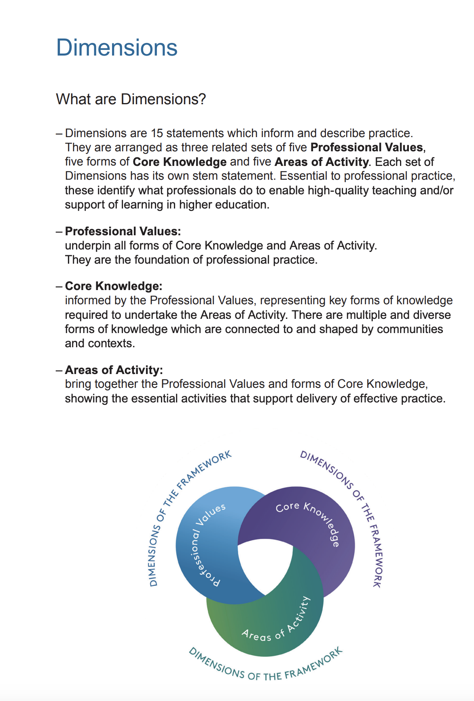

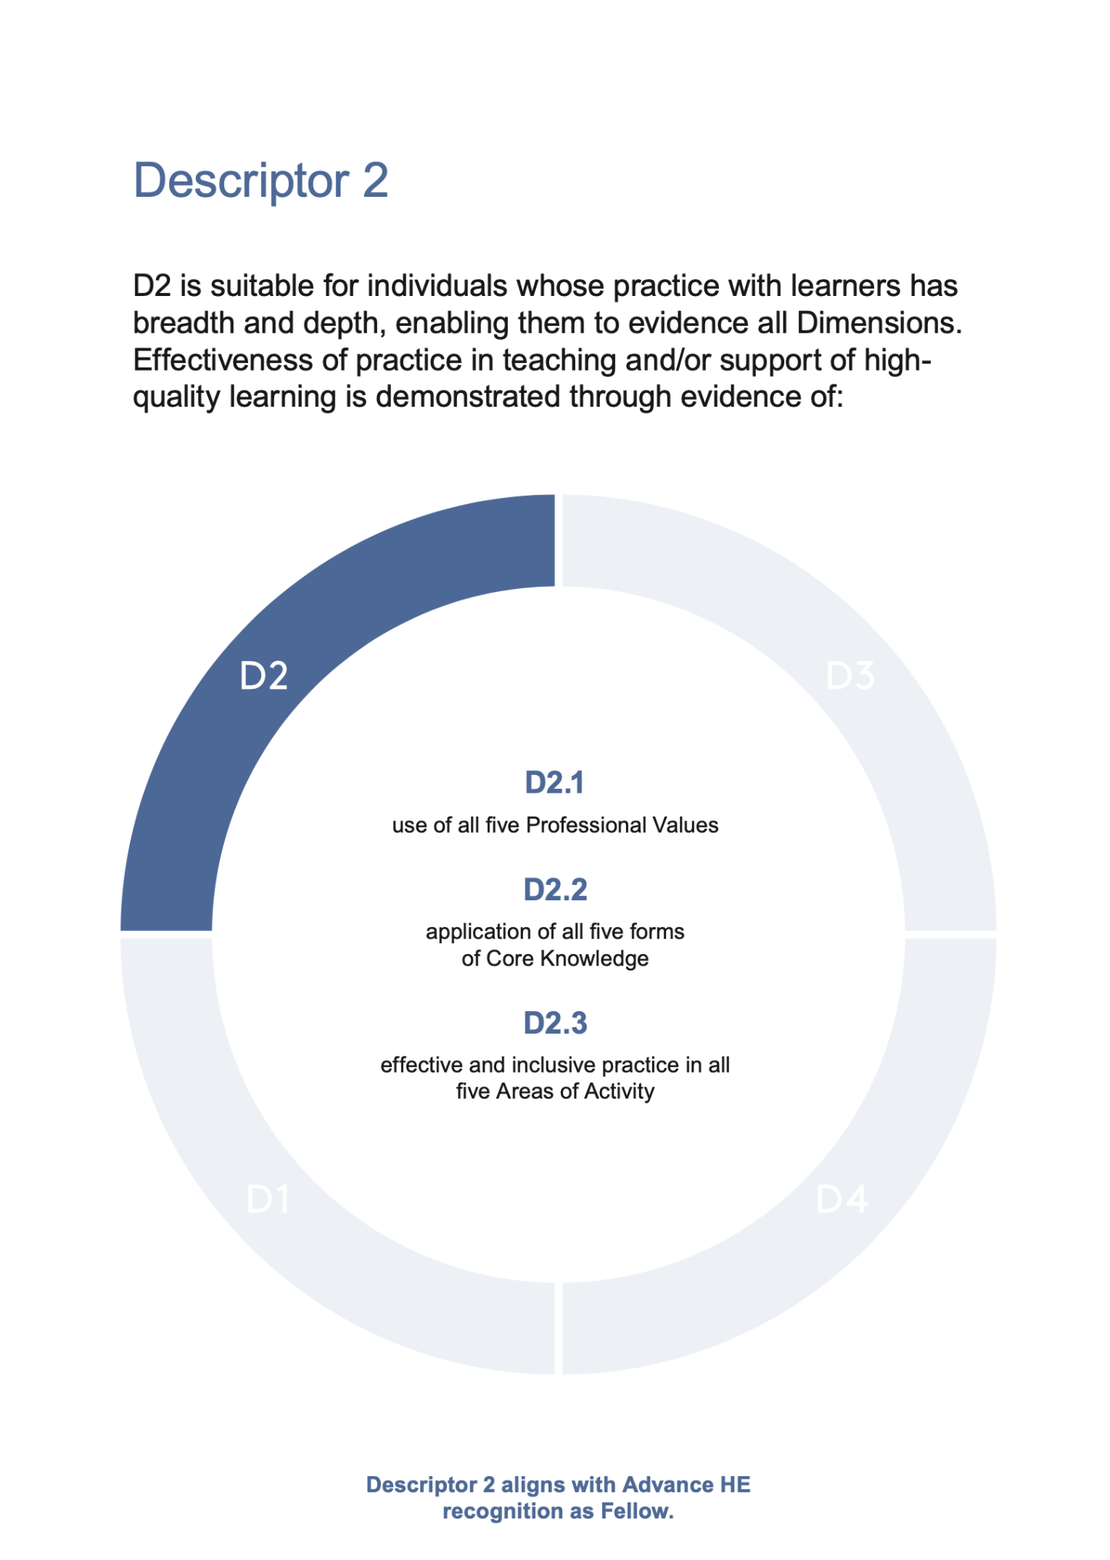

Please note, therefore, that the focus of the module is to provide evidence for all the module learning outcomes and D2 of the PSF 2023, –shown in the diagram below;
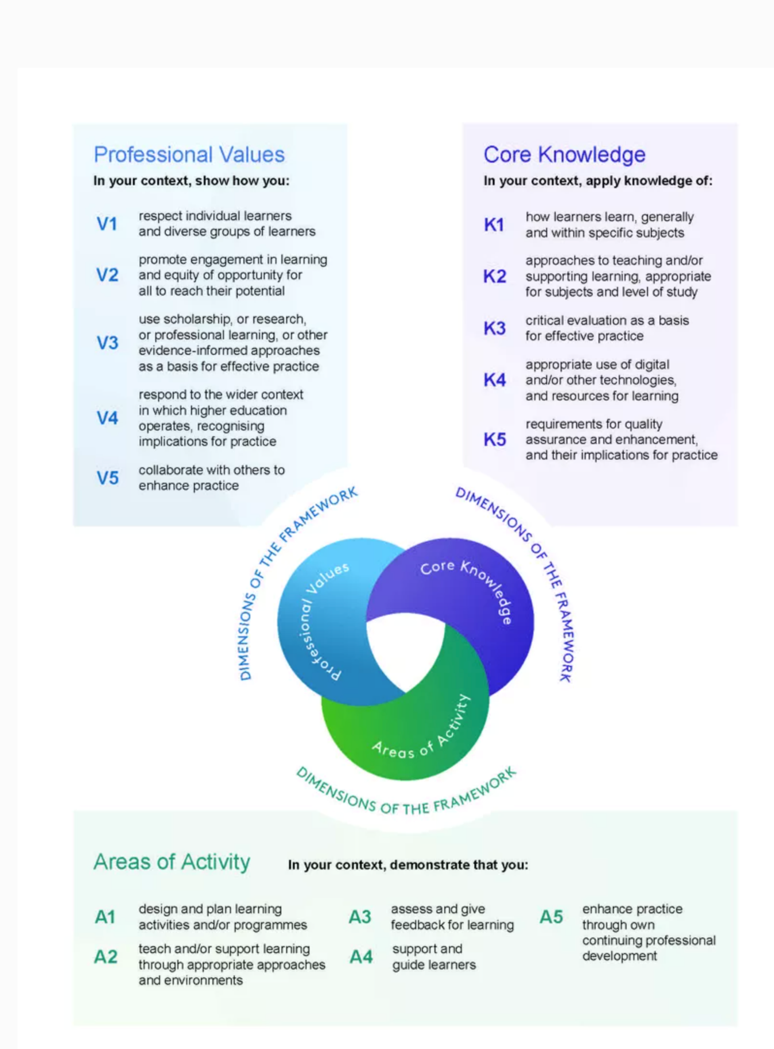

DELIVERY, CURRICULUM AND ASSESSMENT
The PGCert tHE is a distance learning programme, but those participants based at one of the UWTSD Welsh campuses, can opt for a blended learning approach, through the inclusion of teaching on campus if there are sufficient numbers. The Programme team delivers both the on campus and electronic sessions, using identical materials and content, thereby ensuring parity of opportunity for all. Further details regarding the delivery method can be found on page 12 of the Programme Handbook.
Assessment is by means of a portfolio. The diagram below represents the portfolio's key components, and you are strongly advised to read the assessment brief for the module. This is Appendix B of this handbook. The assessment brief has details of the grading criteria rubric.
UNHE7010: Portfolio Components
Registry to arrange award certificates
Summative Assessment
[Refer to Appendix C]

General Reflective Statement
CPD Reflective report 1
Teaching Observation 2 (Of you )
Teaching Intervention 1
Report
Teaching Intervention 2
Poster

Exam Board

CPD Reflective report 2
Teaching Observation 2 (Of you )
Academic Office notified to arrange FHEA certificates
CPD Reflective report 3
Teaching Observation 3 (Of you )

PSF 2023 D2 evidence is gathered and mapped by the student within these assessment tasks
As part of the assessment for this module, your tutors and the External Examiner, will look for evidence that you have demonstrated an understanding of specific aspects of effective teaching, learning support methods and student learning aligned to PSF 2023 Descriptor 2.

HOW THE CURRICULUM FOR UNHE7008 MEETS D2 OF THE PSF 2023

Topic | Area/s of Activity | Core Knowledge | Professional Values
Educational theory and effective learning environments | A1,2,3 | K1,2 | V1,2
PSF 2023 and Descriptor 2 | A5 | K3 | V3,4,5
Subject-specific pedagogies and the enhancement of teaching and learning | A1,2,3,4 &5 | K1,2,4 | V2
The use of technology in HE and the role of the on-line tutor | A1,2,4 | K4 | V2
Inclusion, equality and diversity | A1,2,3,4 | K1,2 | V1
Critical evaluation and the sharing of best practice | A5 | K5 | V5
Purposeful observations of teaching | A3& 5 | K3 | V3,5
PDP and the University’s Continuing Professional Development Scheme | A5 | K3 | V4

HOW THE ASSESSMENT FOR UNHE7010 MEETS THE D2OF THE PSF 2023
Portfolio assessment component | PSF 2023 mapping (D2 Fellow)
Teaching Intervention - report | - D2 requires evidence of effective and inclusive practice across all Areas of Activity. It additionally requires evidence of effective application of Core Knowledge in addition to effective use of Professional Values to inform and develop inclusive practice. Since this is a major piece of action research within the portfolio, should use it to satisfy all the evidence requirements for D2. It is important to be reflective and focus on the criteria statements ensuring that D2 is fully evidenced.
Teaching Intervention - poster | - Like the teaching intervention in report form, this poster will show effective engagement with the Areas of Activity as well as effective application of Core Values and effective use of Professional Values of the PSF 2023. Once again it is important to be reflective in this piece of action research.
Reports of three teaching observations  [See Appendix B for a copy of the observation form.] | - The teaching observations authenticate your practice and will be an opportunity to provide clear and effective evidence of designing learning and your current practice in teaching, assessing and supporting learners through positive learning environments. You should also show effective evidence of the application of Core Knowledge.  - Most, if not all, of the professional values will also be relevant here.
Reflective evaluations of three CPD events attended | - The CPD reports will provide evidence of effective engagement in many of the criteria statements of the PSF 2023 but particularly A5 enhance practice through own CPD.
A brief assessment of your development as a reflective practioner | - There is a strong emphasis upon personal development throughout the PGCert tHE, therefore you should aim here to show evidence of reflection and professional development in practise that addresses specific statements within the PSF 2023.

EVIDENCE OF PRACTICE
You must provide evidence of at least 100 hours of teaching in your portfolio for this module. What constitutes teaching in this respect is anything that is directly supporting or teaching a student or students addressing learning outcomes or academic study skills.
There is a form to evidence your teaching hours. This Teaching Log is included as Appendix A and can be accessed on Moodle. Your Practice Advisor is required to sign off your Teaching Log, whether you be an internal staff member, or working in one of UWTSDs collaborative partners.
When providing evidence for the assessed components of UN7010, you should make the links to the criteria statements clear, focusing on your impact as a practitioner in all of the PSF 2023 Areas of Activity, along with knowledge and understanding in all of Core knowledge and Professional Values. When portfolio building, the Programme Team and your Practice Advisor will provide guidance on how your practice can be mapped to the PSF 2023 Descriptors. Your first tutorial for module UNHE7010 will review your PSF 2023 mapping. Likewise, your meetings with your Practice Advisor, familiar with your professional setting, will further enable such discussions regarding the building of your portfolio. All Practice Advisors will receive training specifically on the PSF 2023.
TO SUMMARISE
Assessment component | PGCert Learning outcomes | PSF 2023 Relevant criteria statements to consider
Teaching Intervention-report | LO 1, 2, 3, 4 & 5 | All
Teaching Intervention-poster | LO 1, 2, 3, 4 & 5 | All
Reports of three teaching observations | LO 1, 2, 3, 4 & 5 | All
Reflective evaluations of three CPD events attended | LO 1, 2, 3, 4 & 5 | A5/K3/V3
Reflective statement | LO 1, 2, 3, 4 & 5 | All
ASSESSMENT AND AWARD
Your portfolio will be assessed by the Programme Team, who will consider - whether your work achieves the minimum Level 7 pass mark of 50%. Assessments are moderated internally by a member of the Programme Team and confirmed by the External Examiner and finally the UWTSD Exam Board. Decisions ratified in the Exam Board are then reported to the Academic Office and Associate Fellow/ Fellow numbers noted for information in the University’s Learning and Teaching Board.
Any portfolios considered by the Exam Board as not having achieved the minimum pass mark of 50%, are required to be resubmitted following a rework by a date agreed at the Board. The maximum mark achievable for a rework is 50%. One resubmission only is permitted.

UNHE7010: Pathway

Induction to part 2
Learning outcomes for
UNHE7010
PSF 2023 -D 2
Portfolio building
Supported with tutorials
Distance learning
Reading
Assessment
Level 7 assessment criteria
Accreditation
PSF 2023 -D2

MODULE KEY DATES 2026/7
Below are key dates for the module, that you should diarise

Date | Activity | Location
2nd^{h} October 2026  14.00-1700hrs | Induction to Module 2 | Online- teams
10th November 2026  10.00-15.00hrs | Retreat | TBC
8th December 2026  10.00-15.00hrs | Retreat | TBC
26th January 2027  10.00-15.00hrs | Retreat | TBC
23rd February 2027  10.00-15.00hrs | Retreat | TBC
23rd March 2027  10.00-15.00hrs | Retreat | TBC
30th April 2027  Midday | Hand in final portfolio | Via the Turnitin link on Moodle

Reading

Advance HE – PSF 2023
The PSF 2023 resources are available here at the Advance HE website
https://www.advance-he.ac.uk/guidance/teaching-and-learning/ukpsf
The website has several interesting and informative articles, for example this article discusses Advance HE accreditation
https://www.advance-he.ac.uk/news-and-views/cross-campus-teaching-coordination-new-campus-education-experience-development-and

Biggs J and Tang C (2011) ‘Teaching for quality learning at university’ OU McGraw Hill- Chapter 1 and 4 The changing scene at university
Petty G (2009) ‘Teaching today; A practical guide’ Nelson Thornes 4th Ed -Chapter 4
Reece I and Walker S (2007) ‘Teaching, training and learning : A practical guide’ Business Education Publishers – Chapter 1
Knowles et al (2015) ‘The Adult Learner : The definitive classic adult education and human resource development’ Routledge - Chapter 6
Armitage et al (2003)’Teaching and training in post compulsory education’ 2nd Ed OU McGraw Hill- Chapter 3.3 page 73
Downey and Kelly (1977) ’Theory and Practice of Education’ Harper and row Chapter VI
Teaching strategies
Petty G (2009) ‘Teaching today ; A practical guide’ Nelson Thornes 4th Ed Part 2
Davis JR and Arend BD (2013) ‘Facilitating Seven Ways of Learning : A resources for more effective and enjoyable college teaching’ Stylus
Illeris (2007) ‘How we learn ;Learning and non-learning in school and beyond’ Routledge - Chapter 4 Different types of learning
Aubrey K and Riley A (2016) ‘Understanding and using Educational Theories’ Sage
Bergman J and Sams A (2012) ‘Flip your classroom : Reach every student every day’
Gray et al (2005) ‘Training to teach in Further and Adult Education’ Chapter 2
Petty G (2009) ‘Teaching today ; A practical guide’ Nelson Thornes 4th Ed part 4 chapters 43&44
Reece I and Walker S (2007) ‘ Teaching , training and learning : A practical guide’ Business Education Publishers – Chapter 7
Armitage et al (2003) ’Teaching and training in post compulsory education’ 2nd Ed OU McGraw Hill- Chapter 7
Biggs J and Tang C (2011) ‘Teaching for quality learning at university’ OU McGraw Hill- Part 2 Chapter 10&11
Philpott C (2015) ‘Theories of professional learning; A critical guide for teacher educators’ Critical publishing
Ashwin et al (2015) ‘Reflective Practice in Higher Education’ Bloomsbury
Megginson D & Whitaker V (2009) ‘Continuous Professional Development’ CIPD
Petty G (2009) ‘Teaching today ; A practical guide’ Nelson Thornes 4th Ed Chapter 5

Appendix A

PG Cert tHE -TEACHING LOG

Candidate: | Campus:

Date | Session Details | No of Hours | Practice Advisor’s Signature
 |  | Total Hours =

Participant’s signature……………………….

Practice Advisor’s signature ………………..

Appendix B

PGCert tHE OBSERVATION FORM -PSF 2023


Details of the Observation
Observee

Practice Advisor / Expert peer observer

Date of the Observation

Campus / Location

Date, Time, Duration

Subject Speciality

Type of activity

This observation will contribute to the participant’s portfolio of evidence to satisfy the assessment of the PGCert tHE and should be undertaken by an experienced academic colleague. Observation by a fellow participant on the programme is not permissible as a means of authenticating practice.

Teaching/Support preparation [A1: Design and plan learning activities/programmes]
i.e. Preparation, selection and organisation of content. Choice of teaching/learning methods.

Comments

Teaching [A2: Teach and/or support learning.]
i.e. Beginning class, introduction, continuity with other sessions, students’ prior knowledge. Clarity of presentation. Pace. Attitude to the subject matter. Use of appropriate reinforcement. Ending the session – summary, future work etc. Technique and Aids: General apparatus – board, data projector, use of handouts. Was effective communication achieved? Was there good student–teacher rapport? Were the aims/outcomes achieved? Appropriateness of teaching/learning methods.
Comments

Effective Learning Environments [A4:Support and guide learners/V1 Respect individual learners/diverse groups of learners]
i.e General class atmosphere, level of participation, attention, and interest. Student attitude and ability to carry out classwork. Were learning problems identified and overcome? Awareness of individual needs. Attitude to students.

Comments

Assessment [A3: Assess and give learners feedback for learning]
i.e Formative/summative assessment examples , Question and answer technique. Other evaluation procedures, class management, instructions to students.
Comments
Core Knowledge
- K1 - how learners learn, generally and within specific subjects
- K2 - approaches to teaching and/or supporting learning, appropriate for subjects and level of study
- K3 - critical evaluation as a basis for effective practice
- K4 - appropriate use of digital and/or other technologies, and resources for learning
- K5 - requirements for quality assurance and enhancement, and their implications for practice
Comments

Professional values
- V1 Respect for individual learners/ Diverse groups of learners.
- V2 Promote engagement and learning and equity of opportunity for all to reach their potential.
- V3 Use scholarship, Research or professional learning? All other evidence informed approaches as a basis of effective practice.
- V4 Respond to the wider context in which higher education operates, recognising implications for practice.
- V5 Collaborate with others to enhance practice.
Comments

Examples of good practice:

Action points:
For Observee
Write a short statement to address area of activity [A5]. Describe how this observation will enhance your practice
Observer ...................................................... Date

Overservee ................................................... Date

PGCert PARTICIPANTS
On completion of the peer observation reports for each module, compose a short reflective paragraph on your observation experiences for inclusion in your portfolio along with the observation sheets.

Appendix C

ASSESSMENT BRIEF

Student name: |  | Student ID number:
Programme: | Postgraduate Certificate in teaching in Higher Education
Module: | Advanced Teaching and Assessment in Higher Education
Module code: | UNHE7010 | Contribution to Overall Module Assessment (%):
Lecturer: |  | Internal Verifier:
Assignment Title: | Professional Portfolio 2 | Word count (or equivalent):
Submission deadline: |  | Return date of provisional marks & written feedback:
Submission method: | All written assessments, where practical and possible, must be submitted via Turnitin unless otherwise instructed by the Lecturer. (Please DO NOT put this assessment specification into Turnitin or it will match many similarities with other students’ submissions.)  Alternative submission method (if applicable):  Late submission of the assessment will result in a late penalty mark. Penalties for late submission: Up to one week late, maximum mark of 50%. Over one week late, 0%. Only the Extenuating Circumstances Panel may approve a change to submission dates.
Academic honesty / referencing: | Academic honesty is required. In the main body of your submission you must give credit to authors on whose research and ideas your work is based. Append to your submission a reference list that indicates the books, articles, etc. that you have used, cited or quoted in order to complete this assessment.

Module Learning Outcomes (from module syllabus)

Aims
- To provide an opportunity for educational professionals to develop and reflect on their own personal and professional practice with reference to appropriate literature.

Learning outcomes (Mapped to Advanced Descriptors)
Upon the successful completion of this module, the student should be able to demonstrate the ability to:
- Design, plan and critically evaluate effective and inclusive learning environments;
critically apply an extensive range of teaching and learning methods to support and
enhance inclusive learning
- Display an increased range of self, peer and student monitoring and evaluation techniques to enhance own professional practice
- Analyse and assess their own future development needs and make a plan for their own continuing professional development;
- Demonstrate competence in aligning their practice to descriptor D2 of the PSF 2023
TASK DESCRIPTION
The portfolio for UNHE7010 Advanced Teaching & Assessment in Higher Education 2 should consist of the following:
- 1 reflective report of a teaching intervention cycle (4,000 words);
- 1 reflective teaching intervention cycle in the form of a poster (approx. 500 words + graphics);
- Reports of three teaching observations (500 words x 3);
- Reflective evaluations of three CPD events (500 words x 3);
- A brief assessment of your development as a reflective practioner throughout the programme together with an analysis of future developmental needs (500 words in total);
- Evidence of 100 hours teaching.

Your portfolio needs to clearly evidence how you have developed and enhanced your inclusive practice in relation to all Areas of Activity within the PSF2023. It will also require clear evidence as to how you have successfully applied Core Knowledge in your context in addition to the use of all Professional Values within your context to develop effective and inclusive practice.

GUIDANCE FOR INDIVIDUALS IN THE COMPLETION OF TASKS

NOTE: The guidance offered below is linked to the five generic assessment criteria overleaf.
- Engagement with Literature Skills
Your work must be informed and supported by scholarly material that is relevant to and focused on the task(s) set; you should make use of scholarly reviews and primary sources, as appropriate (for example, refereed research articles and/or original materials appropriate to the discipline). You should provide evidence that you have accessed a wide range of sources, which may be academic, governmental and industrial; these sources may include academic journal articles, textbooks, current news articles, organisational documents, and websites. You should consider the credibility of your sources; academic journals are normally highly credible sources while websites require careful consideration/selection and should be used sparingly. Any sources you use should be current and up-to-date, mostly published within the last five years or so, though seminal/important works in the field may be older. You must provide evidence of your research/own reading throughout your work, using correctly a suitable referencing system, including in-text citations in the main body of your work and a reference list at the end of your work.
Guidance specific to this assessment: (to filled in by the tutor in all instances where applicable)
- Knowledge and Understanding Skills
At level 7, you should be able to demonstrate a systematic understanding of knowledge, and a critical awareness of current problems and/or new insights, much of which is at, or informed by, the forefront of your academic discipline, field of study or area of professional practice, with a comprehensive understanding of techniques applicable to your own research or advanced scholarship. Your work must demonstrate your growing mastery of these concepts, principles, current challenges, innovation and insights associated with the subject area. Knowledge relates to the facts, information and skills you have acquired through your learning. You demonstrate your understanding by interpreting the meaning of the facts and information (knowledge). This means that you need to select and include in your work the contemporary concepts, techniques, models, theories, etc. appropriate to the task(s) set. You should be able to explain the theories, concepts, etc. meaningfully to show your understanding. Your mark/grade will also depend upon the extent to which you demonstrate your knowledge and understanding; ideally each should be complete and detailed, with comprehensive coverage.
Guidance specific to this assessment:

- Cognitive and Intellectual Skills
You should be able to: evaluate critically current research and advanced scholarship in the discipline; evaluate methodologies and develop critiques of them and, where appropriate, to propose new hypotheses; deal with complex issues both systematically and creatively to make sound judgements in the absence of complete data. Your work must contain evidence of logical, analytical thinking, evaluation and synthesis. For example, to examine and break information down into parts, make inferences, compile, compare and contrast information. This means not just describing what! But also justifying: Why? How? When? Who? Where? At what cost? At all times, you must provide justification for your arguments and judgements. Evidence that you have reflected upon the ideas of experts within the subject area is crucial to you providing a reasoned and informed debate within your work. Your choice of methodologies to gather data and information must be rigorously defended. Furthermore, you should provide evidence that you are able to make sound judgements and convincing arguments using data and concepts. Sound, valid, persuasive conclusions are necessary and must be derived from the content of your work. Where relevant, alternative solutions and recommendations may be proposed.
Guidance specific to this assessment:

- Practical Skills
At level 7, you should be able to demonstrate originality in the application of knowledge, together with a practical understanding of how established techniques of research and enquiry are used to create and interpret knowledge in the discipline. This includes acting autonomously in planning and implementing tasks at a professional or equivalent level, originality in tackling and solving problems, and decision-making in complex and unpredictable contexts or situations.
You should be able to demonstrate mastery of the leading edge subject-related concepts and ideas as they relate to real world situations and/or particular contexts. How do they work in practice? You will deploy models, methods, techniques, and/or theories, in those contexts or circumstances, to assess current situations, perhaps to formulate plans or plausible, justifiable recommendations to solve problems, or to propose new models, or to create artefacts, which may be innovative and creative, thereby demonstrating your understanding of how the boundaries of knowledge are advanced through research and/or application. This is likely to involve, for instance, the use of real world artefacts, examples and cases, the application of a model within an organisation and/or benchmarking one theory or organisation against others.
Guidance specific to this assessment:

- Transferable Skills for Life and Professional Practice
Your work must provide evidence of the qualities and transferable skills necessary for postgraduate-level employment in circumstances requiring sound judgement, personal responsibility and initiative in complex and unpredictable professional environments. This includes demonstrating: the independent learning ability for continuing professional development to advance existing skills and acquire new competences of a professional nature that will enable you to assume significant responsibility within organisations; that you can initiate and complete tasks, projects and procedures, whether individually and/or collaboratively, to a professional level; that you can use appropriate media to effectively communicate information, arguments and analysis in a variety of forms for a variety of audiences; fluency of expression; clarity and effectiveness in presentation and organisation. Work should be coherent and well-structured in presentation and organisation.
Guidance specific to this assessment:

- Fellowship Criteria (Appendix C)

To satisfy the assessment and accreditation requirements of the PGCert tHE, all candidates submitting the portfolio for UNHE7010 must demonstrate how they fully meet the criteria in Descriptor 2 of the PSF 2023 by completion of the full award.

APPENDIX A: FEEDBACK FORM

This section details the extent to which the assessment criteria are demonstrated by you, which in turn determines your mark. The marks available for each category of skill are shown. Lecturers will use the space provided to comment on the achievement of the task(s), including those areas in which you have performed well and areas that would benefit from development/improvement.

Generic Assessment Criteria | Marks available | Marks  awarded
1. Engagement with Literature Skills
.
2. Knowledge and Understanding Skills

3. Cognitive and Intellectual Skills

4. Practical Application Skills

5. Transferable Skills for Life and Professional Practice

Has the student provided evidence of D2 of the PSF 2023?  Effectiveness of practice in teaching and/or support of highquality learning is demonstrated through evidence of:  D2.1 use of all five Professional Values  D2.2 application of all five forms of Core Knowledge  D2.3 effective and inclusive practice in all five Areas of ActivityComments : | YES | Not Yet

Assessment Mark (Assessment marks are subject to ratification at the Exam Board. These comments and marks are to give feedback on module work and are for guidance only until they are confirmed. ) | Late Submission Penalties (tick if appropriate) |  | %
 | Up to 1 week late (50% Max) |  | %
 | Over 1 week late (0%) |  | %

First Marker (Name/Signature)  Advance HE Designation – SFHEA/FHEA [delete as appropriate] | Date

APPENDIX B
GENERIC ASSESSMENT CRITERIA

Level 7
In accordance with the Framework for Higher Education Qualifications, at the end of Level 7 students should be able to demonstrate: a systematic understanding of knowledge, and a critical awareness of current problems and/or new insights, much of which is at, or informed by, the forefront of their academic discipline or area of professional practice; a comprehensive understanding of techniques applicable to their own research or advanced scholarship; originality in the application of knowledge, together with a practical understanding of how established techniques of research and enquiry are used to create and interpret knowledge in the discipline; conceptual understanding that enables the student to evaluate critically current research and advanced scholarship in the discipline to evaluate methodologies and develop critiques of them and, where appropriate, to propose new hypotheses. They will be able to deal with complex issues both systematically and creatively, make sound judgements in the absence of complete data, and communicate their conclusions clearly to specialist and non-specialist audiences. They will demonstrate self-direction and originality in tackling and solving problems, and act autonomously in planning and implementing tasks at a professional or equivalent level to continue to advance their knowledge and understanding, and to develop new skills to a high level. They the qualities and transferable skills necessary for employment requiring the exercise of initiative and personal responsibility; decision-making in complex and unpredictable situations/professional environments; and the independent learning ability required for continuing professional development.

Level 7 | FAIL | FAIL | MARGINAL FAIL | SATISFACTORY  (Pass) | GOOD to VERY GOOD  (Merit) | EXCELLENT  (Distinction) | EXCEPTIONAL  (Distinction)
Category | 0-29% | 30-44% | 45-49% | 50-59% | 60-69% | 70-84% | 85-100%
Engagement with literature (including current research, referencing,  academic conventions and  academic honesty) | Little or no evidence of reading and/or reliance on inappropriate sources.  Views and findings mostly unsupported and non-authoritative.  Referencing conventions used incoherently or largely absent. | Poor engagement with essential reading. No evidence of wider reading. Reliance on inappropriate sources, and/or indiscriminate use of sources. Heavily reliant on information gained through class contact. Inconsistent and weak use of referencing. | Engagement with a very limited range of relevant and credible sources. Some omissions and minor errors.  Referencing conventions evident though not always applied accurately or consistently. | Engagement with an appropriate range of research-informed literature, including sources retrieved independently. Some over-reliance on texts. Referencing may show minor inaccuracies or inconsistencies. | Engagement with a wide range of research-informed literature, including sources retrieved independently.  Selection of relevant and credible sources. Very good use of referencing, with no/very few inaccuracies or inconsistencies. | Engagement with an extensive range of relevant and credible literature, informed by the latest research. Consistently accurate application of referencing. | Exceptional engagement with an extensive range of relevant and credible literature, informed by the latest research. High-level referencing skills consistently and professionally applied.
Knowledge and understanding (A systematic, conceptual understanding of knowledge, and a critical awareness of current problems and/or new insights, much of which is at, or informed by, the forefront of the discipline; a comprehensive understanding of techniques applicable to their own research) | Major gaps in knowledge and understanding of the subject matter is not systematic. Substantial inaccuracies. No awareness of current problems, insights or the latest research and/or advanced scholarship within the discipline. | Gaps in knowledge, with only superficial systematic understanding. Some significant inaccuracies and/or irrelevant material. No critical awareness of current problems, insights, or latest research within the discipline. | Limited knowledge and systematic understanding of the concepts and principles within the subject area, which to some marginal extent, is informed by current research and scholarship. Some critical awareness of current problems and/or new insights, but often under-developed. | Knowledge is accurate and reasonably detailed. A systematic understanding of the field of study informed by, to some extent, current research and scholarship, A critical awareness of current problems and/or new insights though this may be under-developed occasionally. | Knowledge has a well-defined focus, which is reasonably extensive, coherent and detailed, with a critical awareness of current problems and/or new insights. Exhibits good understanding of the breadth and depth of contemporary and established views, and the work is, at least in part, well-informed by current research and scholarship. | Excellent mastery of a complex and specialised area of knowledge. A systematic, excellent understanding of the concepts of the subject informed by current research and scholarship. Highly critical awareness of current problems and/or new insights. A critical, awareness of how the boundaries of knowledge are advanced through research. | Exceptional mastery of a complex and specialised area of knowledge. An exceptionally critical awareness of current problems and/or new insights. An outstanding understanding of the concepts of the subject, well-informed by current research and scholarship. A critical, sophisticated and nuanced awareness of how the boundaries of knowledge are advanced through research.
Cognitive and intellectual skills  (Critical evaluation of current research and methodologies and develop critiques of them and, where appropriate, to propose new hypotheses; make sound judgements in the absence of complete data.) | Wholly or almost wholly descriptive work. Little or no evaluation or critique or attempt at a systematic approach.  Failure to develop arguments, leading to illogical or invalid judgements. Unsubstantiated generalisations, made without use of credible evidence. | Largely descriptive work, with superficial use of critical evaluation of research and methodologies. Absent or weak development of hypotheses and judgements. Information accepted uncritically, uses generalised statements made with scant evidence and unsubstantiated opinions. Ideas sometimes illogical and contradictory. | Limited attempt at critical evaluation/ critique of current research and methodologies, tending towards description.  Limited attempt to propose new hypotheses. Can deal with complex issues but not systematically or creatively. Some evidence to support emerging judgements but these may be underdeveloped or with a little inconsistency / mis-interpretation.  May assert rather than argue a case. | Some critical evaluation/ critique of current research and methodologies, though slightly underdeveloped in places, Proposes adequate but limited new hypotheses, where relevant. Can deal with complex issues but not fully systematically or creatively. Ability to make judgements based on data (that may be incomplete) but with some tendency to assert/state opinion rather than argue on the basis of reason and evidence. | Sound critical evaluation/ critique of current research and methodologies, Proposes new hypotheses, where appropriate. Can deal with complex issues systematically and with some creativity. Ability to make sound judgements based on data (that may be incomplete) | Excellent critical evaluation/ critique of current research and methodologies, Proposes innovative hypotheses, where appropriate. Can synthesise complex issues systematically and creatively. Ability to investigate contradictory or incomplete information and make strong, persuasive, arguments and sophisticated judgements. | Exceptional critical evaluation/ critique of current research and methodologies, Proposes innovative hypotheses, where appropriate. Exemplary systematic and creative synthesis of complex issues.  Ability to investigate contradictory or incomplete information and make strong, persuasive, arguments and sophisticated, nuanced, judgements. Potential for journal publication or doctoral research.
Practical skills  (Originality / creativity in the application of knowledge, tools and techniques and in tackling and solving problems in complex and unpredictable professional situations; practical use of established techniques of research and enquiry to create and interpret knowledge in the discipline.) | Limited or no use of methods, materials, tools and/or techniques.  Little or no appreciation of the context of the application.  Limited understanding of the application of theory to practice or making appropriate links between the two.  Very weak problem-solving skills in complex and unpredictable contexts. | Rudimentary application of methods, materials, tools and/or techniques but without consideration and competence. Flawed appreciation of the context of the application.  Weak understanding of the application of theory to practice, with only occasional evidence of making appropriate links between the two. Weak problem-solving skills in complex and unpredictable contexts. | An awareness and mostly appropriate application of well-established methods, materials, tools and/or techniques, with occasional errors.  Basic appreciation of the context of the application. Theoretical knowledge and understanding applied in practice, but not always making logical links between the two.  Can identify problems and propose basic solutions without fully appreciating the complexity of unpredictable contexts. | An appropriate application of standard methods, materials, tools and/or techniques.  Clear appreciation of the context of the application. Mainly consistent, accurate and logical application of theory to practice, making appropriate links between the two.  Can identify problems and propose mostly appropriate solutions in complex and unpredictable contexts, with elements of originality. | A very good application of a range of methods, materials, tools and/or techniques.  Very good consideration of the context of the application, with perceptive insights. Can identify problems and propose appropriate solutions in complex and unpredictable contexts.  Evidence of originality and creativity. | An advanced application of knowledge, methods, materials, tools and/or techniques.  The context of the application is well considered, and insightful.  Can identify complex problems and propose excellent solutions. An excellent grasp of techniques applicable to own research or advanced scholarship.  Shows originality in application of knowledge and techniques, and of how established techniques of enquiry create and interpret knowledge in the discipline. | Exceptional application skills in complex, unpredictable, contexts, drawing skilfully on the latest research within the discipline. Can identify complex problems and propose sophisticated, original solutions.  An outstanding application of techniques applicable to own research or advanced scholarship.  Shows originality in application of knowledge and techniques, and of how established techniques of enquiry create and interpret knowledge in the discipline with assimilation and development of cutting edge processes and techniques.
Transferable skills for life and professional practice  (Exercise of self-direction, autonomy and personal responsibility; plan and implement tasks at a professional level; independent learning; use appropriate media to communicate effectively and professionally to a variety of audiences; fluency of expression; systematic approach; clarity and effectiveness in presentation and organisation.) | Communication medium is inappropriate or misapplied.  Work is poorly structured, disorganised and/or confusingly expressed. Very weak use of language and/or very inappropriate style. Little or no evidence of autonomy (or collaboration, where relevant) in the completion of tasks. Little or no evidence of the skills required in professional, postgraduate employment. | Communication medium is poorly designed and/or not suitable for the audience.  Work is poorly presented in a disjointed manner. It is loosely, and at times incoherently, structured, with information and ideas often poorly expressed. Weak use of language and/or inappropriate style. Weak independent initiative (or collaboration, if relevant). Limited evidence of the skills required in professional, postgraduate employment. | Can communicate in a suitable medium but with some room for improvement.  Mostly ordered presentation and structure in which relevant ideas / concepts are reasonably expressed. Work may lack coherence in places. Can work as part of a team, but with limited involvement in group activities.  Demonstrates some but not all of the basic skills required in professional, postgraduate employment, with some areas of minor weakness. | Can communicate effectively in a suitable format, but may have minor errors.  Mostly coherent, organised work, in a suitable structure and is for the most part clearly expressed. Can work effectively independently and/or as part of a team, with clear contribution to group activities.  Demonstrates the skills required in professional, postgraduate employment, with some areas of strength and some of minor weakness. | Can communicate well, confidently and consistently in a suitable format.  Work is coherent, fluent, well-structured and organised. Can work very well autonomously and/or as part of a team, with a good contribution to group activities.  Demonstrates comprehensive professional, postgraduate employment skills. | Can communicate professionally confidently and consistently in a suitable format.  Work is coherent, very fluent and is presented professionally. Can work autonomously with initiative. Where relevant can work professionally within a team, showing leadership skills as appropriate, managing conflict and meeting obligations. Demonstrates excellent professional, postgraduate employment skills and a strong appetite for further development. | Can communicate with an exceptionally high level of professionalism.  Work is remarkably coherent, very fluent and is presented professionally. Can work outstandingly well and professionally within a team, showing advanced leadership skills. Demonstrates exemplary professional, postgraduate employment skills and a strong appetite for further development.

