

Assessment 1
Title: AMAZON

Name: MOHD SAIF
Student ID: 2431762
Module Name: Strategic Management
Module Code: LCMB7003
Lecturer’s Name: DR ANDRY RAKOTOVOLOLONA
Word Count: 4977

Term 2

Table of Contents
Introduction 3
SECTION 1: Strategic Analysis Report 3
1. Organisational Context and Overview 3
1.1 Company Background and History 3
1.2 Mission, Vision, and Objectives 3
1.3 Business Model 4
1.4 Industry Overview (UK Market) 4
1.5 Key Competitors and Market Position 5
2. External and Internal Environment Analysis 6
2.1 External Environment (PESTEL Analysis) 6
2.1.1 Political Factors 6
2.1.2 Economic Factors 7
2.1.3 Social Factors 7
2.1.4 Technological Factors 7
2.1.5 Environmental Factors 7
2.1.6 Legal Factors 8
2.2 Critical Success Factors and Strategic Challenges 8
2.3 Internal Environment Analysis 9
2.3.1 Resources (Tangible & Intangible) 9
2.3.2 Capabilities 9
2.3.3 Core Competencies 10
2.4 VRIO Analysis 10
2.5 Competitive Advantage Assessment 11
3. CSR and Sustainability Objectives 12
4. Comprehensive and Holistic View (Balanced Scorecard) 13
4.1 Financial Perspective 14
4.2 Customer Perspective 14
4.3 Internal Business Process Perspective 14
4.4 Learning and Growth Perspective 15
5. Strategic Choices and Implementation 15
5.1 Business-Level Strategy (Cost Leadership / Differentiation) 15
5.2 Corporate-Level Strategy (Diversification / Expansion) 15
5.3 Change Management and Strategic Implementation 16
6. Strategic Evaluation and Recommendations 16
6.1 SWOT Analysis 16
6.2 Ansoff Matrix Analysis 17
6.3 Strategy Evaluation 18
6.4 Recommendations 18
SECTION 2: Reflective Account 19
7. Reflection Using Gibbs Cycle 19
7.1 Description 19
7.2 Feelings 20
7.3 Evaluation 20
7.4 Analysis 20
7.5 Conclusion 21
7.6 Action Plan 21
References 22

Introduction
This report gives a critical strategic analysis of Amazon, looking at how well it can gain and keep a competitive edge in a worldwide market that is always changing. The research assesses the organization's internal and external surroundings using essential strategic frameworks, such as PESTEL, VRIO, SWOT, and the Balanced Scorecard. It also looks at Amazon's commercial and corporate strategy, as well as how it handles CSR and sustainability (Ramirez, 2024). The report's goal is to evaluate Amazon's strategic success and provide ways to make it better in the future by combining theoretical ideas with real-world examples

SECTION 1: Strategic Analysis Report

1. Organisational Context and Overview

1.1 Company Background and History
Jeff Bezos started Amazon in 1994 as an online bookshop. It quickly grew into a huge technology company with operations all over the world. It grew into many other areas, including e-commerce, cloud computing (AWS), digital streaming, and artificial intelligence (Amiri and Vida, 2023). Amazon entered the UK in 1998 and quickly became a major online retailer by spending a lot of money on logistics and fulfillment centers. Over time, its marketplace model and Prime environment allowed it to grow and keep customers, making it one of the most important digital platforms in the world and a leader in the UK retail industry.

1.2 Mission, Vision, and Objectives
Amazon's goal is to be "Earth's most customer-centric company," which means they want to be the best at making things easy, being the best at prices, and coming up with new ideas. Its objective is to develop over the long run by focusing on technology and customers. Some of the key goals are to grow the number of Prime members, make logistics work better, and make AWS a stronger leader while keeping its market share and coming up with new digital services all the time.

1.3 Business Model
Amazon has a hybrid business strategy that includes first-party retail, third-party marketplace services, and subscription-based services like Prime. It makes money by selling products, taking a cut of revenues, offering cloud services (AWS), and running ads (Charles and Uford, 2023). Its platform-based ecosystem uses economies of scale, data analytics, and logistical infrastructure to provide both cost leadership and distinctiveness at the same time. This creates significant network effects and keeps customers coming back.

1.4 Industry Overview (UK Market)
The UK e-commerce industry is one of the biggest in the world. It was worth around $317 billion in 2026, and it is expected to grow at a rate of 9–10% each year over the following five years. Around 28–30% of all retail purchases in the UK happen online, thanks to around 59 million digital customers. Amazon is the most popular platform in a very competitive yet small market. Mobile commerce, digital payments, and modern logistical infrastructure are all driving growth in the UK, which is a strategically significant and mature e-commerce market.
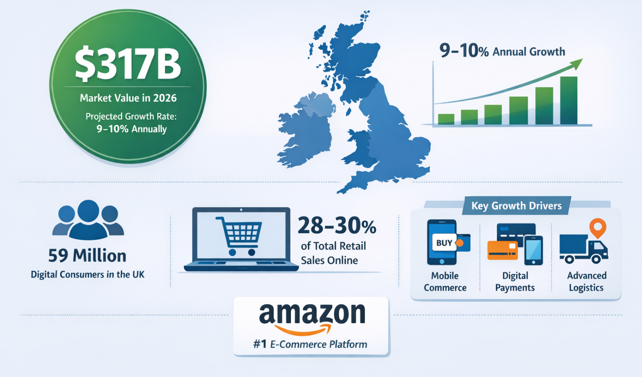
Figure: UK Ecommerce Market
(Source: Research Gate, 2026)

1.5 Key Competitors and Market Position
Amazon has more than 30% of the UK e-commerce market. This is a lot more than eBay (around 10%) and big stores like Tesco and Sainsbury's. It is the biggest online store in the UK, and it has a lot of brand awareness, modern logistics, and a wide choice of products (Amatanwezeet al., 2025). Some of the main rivals include conventional stores that are moving online, digital marketplaces, and specialist platforms. Even though competition is becoming tougher, Amazon stays on top of the market by coming up with new ideas, offering Prime membership advantages, and having efficient fulfillment networks. This strengthens its long-term competitive edge.

2. External and Internal Environment Analysis

2.1 External Environment (PESTEL Analysis)
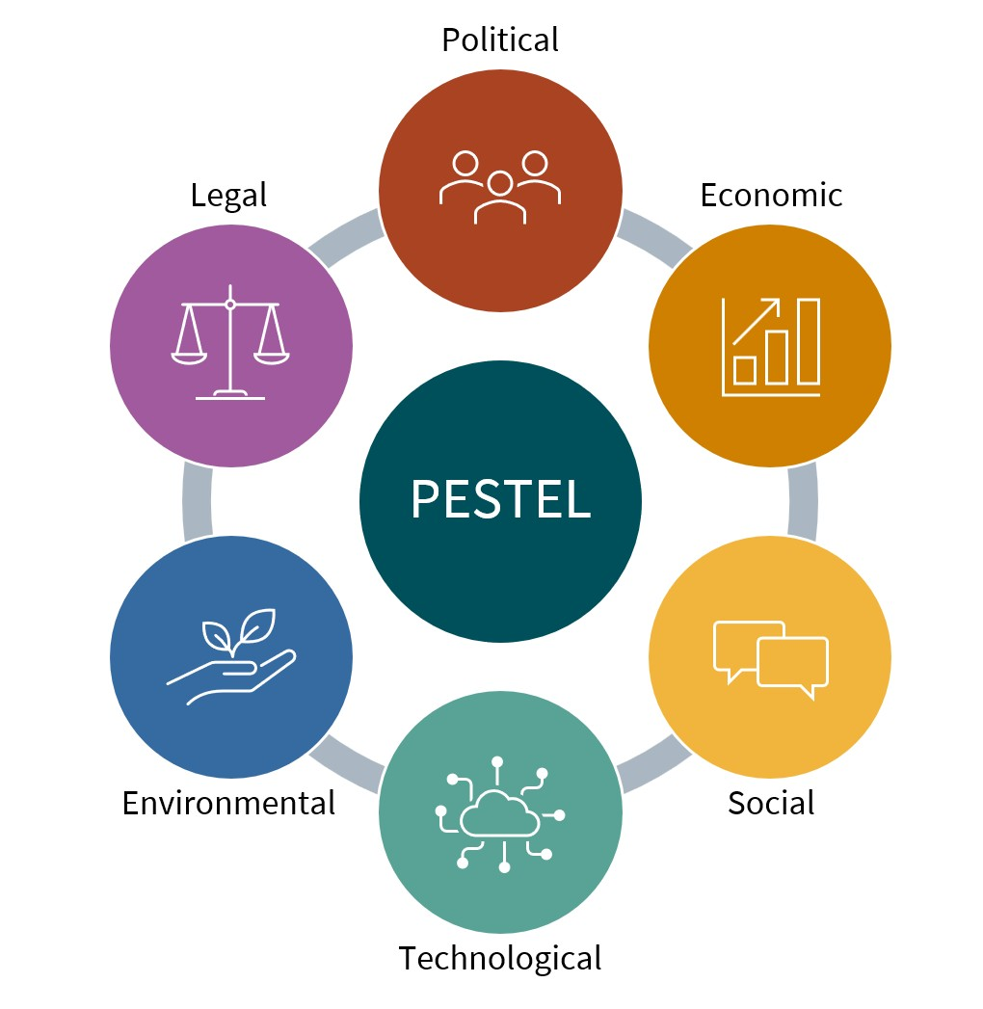
Figure: PESTEL Analysis
(Source: IoP, 2024)

2.1.1 Political Factors
The UK government sets rules on taxes, commerce, and digital regulation that affect how Amazon does business in the UK. Trade laws after Brexit have made supply chains more complicated and expensive (Korshun, 2025). Also, Amazon's strategic choices and operational transparency in the UK market are affected by government demand for fair competition regulations and examination of company tax methods.

2.1.2 Economic Factors
Amazon's sales are affected by things like inflation, changes in currency rates, and less money in people's pockets. Costs of doing business in the UK are going up because of higher logistical and labor costs. But robust e-commerce demand and trends in digital consumption help revenue rise, which lets Amazon stay strong even when the economy is shaky.

2.1.3 Social Factors
Amazon benefits from changes in how people purchase, such as their desire for ease, rapid delivery, and purchasing online. People are more likely to buy things when they want personalized experiences and ethical consumption. However, worries about working conditions and the effect on local businesses hurt Amazon's brand. This means that the company has to find a compromise between meeting consumer needs and meeting social responsibility standards.

2.1.4 Technological Factors
Amazon's competitive edge is becoming stronger because of how quickly technology is changing in areas like AI, automation, and cloud computing (Lai et al., 2022). Putting money into AWS, data analytics, and robots makes things run more smoothly and improves the customer experience. But to keep coming up with new ideas, the company need to spend a lot of money, and as technology changes quickly, the company need to stay ahead of the competition in the digital world.

2.1.5 Environmental Factors
Amazon's business is affected by environmental issues including carbon emissions, packaging waste, and sourcing that is good for the environment. Regulators and customers are putting more and more pressure on companies to do things like become carbon neutral and utilize renewable energy. But its big logistical network has a big effect on the environment, which makes it hard to reach long-term sustainability objectives.

2.1.6 Legal Factors
In the UK, Amazon has to follow tight laws on data protection (GDPR), competition, and how it treats its employees (Aniebonam, 2024). Antitrust investigations and labor rights concerns that are still going on make it more expensive and risky to follow the law. These rules affect Amazon's business choices by making it more important for the company to be open, honest, and follow changing laws.

2.2 Critical Success Factors and Strategic Challenges
Amazon's sustained dominance in the UK e-commerce sector is based on a number of key success characteristics that make it more competitive. One of the most important things is its superior logistics and fulfillment infrastructure, which makes it possible to deliver quickly and run smoothly. The company's capacity to improve inventory, storage, and last-mile delivery makes customers happier and lowers costs, which helps both cost leadership and service differentiation at the same time (Singh et al., 2026). Also, Amazon's focus on the client leads to constant improvements in the user experience, such as personalized suggestions and smooth digital interfaces. The Prime ecosystem, which improves customer loyalty and lifetime value, supports this emphasis on customer value. Amazon also has great data analytics and artificial intelligence skills, which help it predict demand, set prices, and make better operational decisions. This boosts its long-term strategic position (Rikap, 2024).

Even while Amazon has these strengths, it still has to deal with several strategic problems in the outside world that might hurt its ability to compete in the future. More government monitoring of data privacy, taxes, and antitrust issues might hurt its ability to be flexible and grow. Governments are putting more rules on digital platforms, which might make Amazon less powerful in the market and cost more to follow. Also, problems with labor, especially those connected to working conditions in warehouses and logistics networks, have drawn public criticism and might hurt the image of the brand and the relationships between employees (Hassel and Sieker, 2022). Environmental sustainability is also a big problem since Amazon's huge logistical operations cause carbon emissions and packaging waste. Prices and service quality are under even more strain because of more competition from both well-known stores and new internet platforms. So, even if Amazon's key success criteria provide them a tremendous edge over their competitors, they need to deal with these strategic problems in order to keep growing and stay on top of the market.

2.3 Internal Environment Analysis

2.3.1 Resources (Tangible & Intangible)
Amazon has a lot of physical and non-physical tools that help it be successful strategically. It has a lot of tangible resources, such a big worldwide fulfillment network, modern warehouses, transportation systems, and a lot of money, which make it possible to run massive operations and deliver goods quickly. Its investment in infrastructure makes deliveries quicker and operations more scalable, which gives it a stronger competitive edge in the UK market. Intangible resources are much more important. These include a strong brand reputation, consumer trust, proprietary algorithms, and huge data assets created from millions of transactions (Aksoy, 2023). Amazon can customize consumer experiences and make the most of its pricing tactics thanks to these intangible assets. Its intellectual property and technical know-how in cloud computing via AWS also provide it a distinct edge. By combining these resources, Amazon can provide value and keep its ecosystem running smoothly, which helps them stay on top of the digital market.

2.3.2 Capabilities
Amazon's capabilities show how well it can use its resources to reach its strategic goals. One of its most important skills is operational excellence, which is shown by its very efficient supply chain management, automated warehouses, and systems for monitoring inventories in real time. This helps Amazon deliver things quickly and reliably, which makes customers happier. Another important feature is its capacity to make decisions based on data. It uses sophisticated analytics and AI to guess how customers will act, find the best prices, and make marketing more successful. Amazon is also very good at coming up with new ideas. For example, it keeps adding new services like AWS, Alexa, and Prime, which helps the company make more money and keep customers interested. Its platform management feature also makes it easy for third-party merchants to join, which increases the diversity of products without adding to the hazards of having too much inventory. All of these skills together help Amazon be efficient, innovative, and able to grow in a competitive market (Agustian et al., 2023).

2.3.3 Core Competencies
Amazon's main strengths are in areas where it always beats its competition and gives customers something special. One of its main strengths is its focus on the consumer, which leads to constant improvements in service quality, prices, and convenience. This skill is backed up by the company's ability to use data analytics to figure out what customers want and need. Another important skill is its integrated digital ecosystem, which brings together e-commerce, cloud computing, digital streaming, and logistics into one platform that makes the user experience better and produces powerful network effects (Soni, 2026). Also, Amazon's knowledge of logistics and supply chain management lets them deliver quickly and reliably, which is hard for other companies to copy. Its capacity to keep coming up with new ideas, especially in AI and automation, makes its strategic position even stronger. These essential capabilities provide Amazon a long-term competitive edge and help it thrive in global marketplaces.

2.4 VRIO Analysis

Resource / Capability | Valuable (V) | Rare (R) | Imitable (I) | Organised (O) | Competitive Implication
Advanced Logistics Network | Yes | Yes | Difficult | Yes | Sustained Competitive Advantage
Amazon Prime Ecosystem | Yes | Yes | Difficult | Yes | Sustained Competitive Advantage
AWS (Cloud Infrastructure) | Yes | Yes | Difficult | Yes | Sustained Competitive Advantage
Brand Reputation & Customer Trust | Yes | Yes | Difficult | Yes | Sustained Competitive Advantage
Data Analytics & AI Capabilities | Yes | Yes | Difficult | Yes | Sustained Competitive Advantage
Marketplace Platform (3rd Party) | Yes | Moderate | Moderate | Yes | Temporary Competitive Advantage
Financial Resources | Yes | No | Easy | Yes | Competitive Parity
Workforce & Human Capital | Yes | No | Moderate | Yes | Competitive Parity

Amazon's main strengths are its logistical network, AWS, and Prime ecosystem, which are all valuable, unusual, and hard to copy. These skills are well-organized, which gives the company a long-term competitive edge. But things like financial strength and a large staff are more prevalent and merely provide the company a competitive edge. Overall, Amazon's ability to combine technology, growth, and customer-focused innovation gives them a long-term strategic edge in the UK market.

2.5 Competitive Advantage Assessment
By combining its resources, skills, and core competencies into a business model that is very efficient and can grow, Amazon has a long-term competitive edge. It can provide competitive prices while giving customers a better experience because it can mix cost leadership with distinctiveness (Zhou, 2023). The company's logistical system, data-driven decision-making, and constant improvements to its digital offerings make it hard for other companies to get in. Amazon's ecosystem model, which includes Prime and AWS, also helps keep customers and brings in money in a variety of ways. Network effects make it even more powerful since more users attract more merchants, which helps the platform develop. But to keep this edge, one needs to keep changing with the market and the competition.

3. CSR and Sustainability Objectives
Amazon's corporate social responsibility (CSR) and sustainability strategy has grown more and more important to its long-term commercial goals. This is mainly because stakeholders want more from the company and regulations are becoming stricter. Through projects like The Climate Pledge, which aspires to reach net-zero carbon emissions by 2040 (Etumnu, 2022), the corporation has set lofty environmental targets. This shows that Amazon is trying to make its business more environmentally friendly while also improving its brand image and consumer trust. Investments in renewable energy, electric delivery trucks, and eco-friendly packaging show that the company wants to make its large logistics network less harmful to the environment.

However, Amazon's CSR strategy also includes social and moral duties, such as taking care of employees, becoming involved in the community, and procuring materials in a responsible way (Hassel and Sieker, 2022). Even with these efforts, the firm has been criticized for the way it treats its workers and the way it runs its business, which hurts its image and shows that there is a gap between policy and practice. These problems show that CSR activities need to go beyond strategic pledges and become consistent operational practices if they want to be credible and build trust among stakeholders.

From a strategic point of view, Amazon's efforts to be more environmentally friendly fit well with its business model and competitive strategy since they lower regulatory risks, make operations more efficient, and make customers more loyal (Aksoy, 2023). Adding sustainability to innovation and supply chain management makes it possible to create long-term value and stand out in a crowded market. So, even while Amazon has made great strides in corporate social responsibility, it has to keep doing better, be more open, and have stronger ways to hold people accountable in order to properly match its sustainability aims with its overall business goals.

4. Comprehensive and Holistic View (Balanced Scorecard)

Perspective | Objectives | Key Performance Indicators (KPIs) | Targets | Strategic Initiatives
Financial | Increase revenue growth and profitability | Revenue growth rate, operating margin, AWS revenue share | 10–15% annual revenue growth | Expansion of AWS services, cost optimisation in logistics, advertising growth
Customer | Enhance customer satisfaction and loyalty | Customer retention rate, Prime membership growth, delivery time | Increase Prime users by 8–10% annually | Improve delivery speed (same-day/next-day), personalised recommendations, customer service automation
Internal Business Processes | Improve operational efficiency and supply chain effectiveness | Order fulfilment time, inventory turnover ratio, logistics cost per unit | Reduce delivery time by 20% | Warehouse automation, AI-based inventory management, last-mile delivery optimisation
Learning & Growth | Foster innovation and employee productivity | Employee productivity rate, R&D investment, number of new services launched | Increase R&D investment by 10% annually | Investment in AI, employee training programs, innovation in digital services (Alexa, AWS)

4.1 Financial Perspective
From a financial point of view, Amazon wants to keep its revenue growth going, make more money, and increase the value of its shares over the long run. The corporation does this by having many sources of revenue, like e-commerce, AWS, and advertising services. This makes it less dependent on one area. Cost-effective logistics and economies of scale improve margins even more and help the company stay ahead of the competition in terms of price. The growth rate of revenue, the operating margin, and the contribution of AWS to total revenue are all important performance measures (Ramirez, 2024). Amazon continues to spend a lot of money on new ideas and infrastructure to maintain its financial performance and competitive edge, making sure it can weather market changes.

4.2 Customer Perspective
Amazon's main goal from the customer's point of view is to provide better value via ease, cheap pricing, and personalized experiences. The firm puts client pleasure first by providing quick shipping, a large choice of products, and easy-to-use digital interfaces. Prime membership is very important for keeping customers and increasing their lifetime value (Kausar et al., 2023). Client satisfaction ratings, delivery speed, and client retention rate are all important performance factors. Amazon also uses data analytics to provide personalized suggestions, which keeps users more interested. This great focus on customers builds brand loyalty and sets Amazon apart from other online stores that are quite competitive.

4.3 Internal Business Process Perspective
Amazon's internal business procedures are all about making operations run smoothly by managing the supply chain well and using technology effectively. The firm uses automation, robots, and technologies that are based on data to make warehouse operations better and cut down on delivery times. Logistics and inventory management that are always becoming better make sure that services are reliable and costs are low (Qin and Liu, 2022). Order fulfillment time, inventory turnover, and logistics cost efficiency are all important performance factors. Amazon increases efficiency while maintaining high service standards by making internal procedures more efficient. These skills let the business swiftly adapt to market demand and keep its competitive edge.

4.4 Learning and Growth Perspective
Amazon's view on learning and growth is that innovation, staff development, and technology progress are important for long-term success. The corporation spends a lot of money on research and development, especially on technologies like AI, cloud computing, and automation (Rikap, 2024). A culture of experimentation and ongoing staff training help organizations be more flexible and innovative. Some important performance indicators include how much money is spent on research and development, how productive employees are, and how many new goods or services are released. Amazon improves its capacity to react to changing market circumstances and stay ahead in the digital economy by creating a learning-friendly atmosphere.

5. Strategic Choices and Implementation

5.1 Business-Level Strategy (Cost Leadership / Differentiation)
Amazon uses a hybrid business-level approach that combines cost leadership with differentiation to get an edge over its competitors. The corporation can provide competitive prices on a broad variety of goods because it has economies of scale, good supply chain management, and excellent logistical infrastructure (Agustian et al., 2023). Amazon sets itself apart by offering a better consumer experience, such as speedy shipping, personalized suggestions, and a smooth digital interface. Services like Prime membership provide even more value by giving one access to features like streaming and faster delivery. This two-pronged approach lets Amazon reach a wide range of customers while still being able to run its business efficiently and come up with new ideas. Combining technology, data analytics, and platform-based services makes it easier for the company to keep its expenses low while yet standing out from the competition.

5.2 Corporate-Level Strategy (Diversification / Expansion)
Amazon's corporate-level strategy is marked by a lot of diversity and growth into new markets throughout the world. This helps the company lower its risk and make money in many different ways. The firm has grown beyond e-commerce to include things like cloud computing (AWS), digital streaming, AI, and advertising services (Zhou, 2023). By diversifying, Amazon can take advantage of synergies throughout its ecosystem and improve its position in the market. Amazon is also growing worldwide by entering new countries and changing its business strategy to fit local requirements. Strategic purchases and investments help growth and new ideas even more. Amazon is less dependent on one market and more resilient in the long run since it works in many different sectors. This strategy also lets the organization take advantage of new chances and technical progress in the global digital economy.

5.3 Change Management and Strategic Implementation
Amazon has shown that it can handle change and carry out strategic plans well in a business world that is changing quickly. The firm is adaptable and focused on new ideas, which lets it swiftly adapt to changes in the market and new technologies (Soni, 2026). Leadership is very important for creating a culture of experimenting, where failure is seen as a normal part of the process of coming up with new ideas. Amazon's decentralized structure makes it easier to make decisions quickly and carry out initiatives effectively across multiple business divisions. But fast growth and constant change have also made things harder, especially when it comes to controlling the conditions of the personnel and keeping the organization together. To manage change efficiently, one need to find a balance between new ideas, stable operations, and the health and happiness of the employees. Amazon's ability to make changes effectively has been a big reason why it has been able to stay ahead of the competition and adapt to changing worldwide marketplaces.

6. Strategic Evaluation and Recommendations

6.1 SWOT Analysis
Strengths: Amazon's strong brand recognition, superior logistical network, and varied business strategy are some of its biggest assets. Its focus on customers and technology skills make it possible to run smoothly and keep customers happy (Zhou, 2023). Also, services like AWS and Prime bring in a lot of money and keep customers coming back, which gives one a long-term competitive edge (Soni, 2026).

Weaknesses: Amazon has certain limitations, including low profit margins in its retail business and high operating expenses since it has to spend a lot of money on logistics and infrastructure (Singh et al., 2026). Problems with workers and unhappy employees can hurt the company's efficiency and public image, which might hurt its reputation (Hassel and Sieker, 2022).

Opportunities: Amazon has a lot of room to grow in new technologies like AI, cloud computing, and automation (Rikap, 2024). The growth of e-commerce and digital services throughout the world also opens up new markets and ways to make money, which leads to further growth and new ideas (Aksoy, 2023).

Threats: Some of the biggest challenges include more scrutiny from regulators, more competition from both global and local companies, and more worries about data privacy and sustainability (Moreira et al., 2024). Changes in consumer behavior and economic instability are also threats to long-term growth (Reinhardt, 2022).

6.2 Ansoff Matrix Analysis
Market Penetration: Amazon solidifies its standing in current markets by boosting customer experience, accelerating delivery times, and implementing competitive price tactics (Reinhardt, 2022). More people signing up for Prime also helps the company reach more customers (Kausar et al., 2023).

Market Development: The organization grows into new geographic areas by changing its platform and logistical systems to fit the needs of each area (Zhou, 2023). Amazon can reach new customers and grow its share of the worldwide market by expanding internationally (Aksoy, 2023).

Product Development: Amazon is always coming up with new goods and services, such AWS innovations, smart gadgets, and AI-driven solutions (Houda et al., 2025). These new ideas provide value for customers and make it easier for businesses to stand out from the competition (Rikap, 2024).

Diversification: Amazon diversifies by getting into new fields including cloud computing, advertising, and artificial intelligence (Agustian et al., 2023). This technique lowers risk and opens up new ways to make money, which helps the business stay open and thrive over time (Soni, 2026).

6.3 Strategy Evaluation
Amazon's present strategy is very good at giving the company a competitive edge by using cost leadership, differentiation, and diversity (Agustian et al., 2023). Its excellent tech skills and focus on customers help it keep growing and coming up with new ideas (Rikap, 2024). But problems with regulations, labor, and the environment show that strategies need to be changed all the time. Amazon's overall strategy is still strong, but it has to be improved to deal with outside threats and make sure it lasts for a long time (Moreira et al., 2024).

6.4 Recommendations
Amazon should put more money into green logistics and cutting carbon emissions to make their sustainability efforts stronger (Etumnu, 2022). It should also make working conditions better to make employees happier and increase the company's reputation (Hassel and Sieker, 2022). Investing more in AI and digital innovation may also help maintain a competitive edge and enable long-term development in global markets (Rikap, 2024).

SECTION 2: Reflective Account

7. Reflection Using Gibbs Cycle

Figure: Gibbs Reflective Cycle
(Source: Mdpi, 2024)

7.1 Description
For this project, I did a strategic study of Amazon by looking at its internal and external environment, its position in the market, and its efforts to be environmentally friendly. I used important strategic management tools including PESTEL, VRIO, SWOT, the Ansoff Matrix, and the Balanced Scorecard to look at how Amazon gets and keeps its competitive edge. To get a full picture of the organization (Ramirez, 2024), I read academic publications, case studies, and industry reports. I had to think critically about how Amazon's strategy includes new ideas, putting customers first, and running the business efficiently. I also looked at its CSR programs and the strategic problems it faces in global marketplaces. This work required me to combine theoretical ideas with real-world examples so that I could write an organized and analytical report based on strategic management principles.

7.2 Feelings
I was sure I could comprehend Amazon as a corporation at the start of this project, but I wasn't sure I could use more than one strategic framework in a critical and integrated way. As I went along, I found the analysis to be both hard and interesting, particularly when I connected theory to how businesses really work (Soni, 2026). At first, I had trouble organizing my points and making sure that the various parts of my essay flowed logically from one to the next. But the more I learned about Amazon, the more sure I was that I could judge its techniques and figure out what it did well and what it might do better. I also felt inspired when I was able to relate ideas like digital ecosystems, innovation, and competitive advantage in a clear way. Overall, the experience made me better at thinking analytically and gave me more confidence in using strategic management methods in real life.

7.3 Evaluation
Looking back on my work, I think one of the best things about it was how well I used strategic frameworks to look at Amazon's business model. I was able to combine theory and practice well, which made the report better overall (Agustian et al., 2023). Credible academic sources backed up my study, which made my analysis more thorough and trustworthy. However, I also see several flaws, especially when it comes to keeping the critical assessment consistent throughout all parts. There were moments when my analysis was more descriptive than analytical, which made it harder to have a deeper understanding. It was also hard to keep everything clear and coherent while keeping the word count down. Even with these problems, the whole process helped me learn more about strategic management and made my academic writing better.

7.4 Analysis
By thinking about this, I learned how important it is to connect academic frameworks with real-world business situations in order to better comprehend strategy. Using models like VRIO and SWOT helped me figure out how Amazon's resources and skills provide it an edge over its competitors (Zhou, 2023). I also learned that strategic analysis involves more than just finding strengths and shortcomings; it also involves thinking critically about what they will mean in the long run. Using more than one framework showed how strategic choices are interrelated, with internal strengths and weaknesses and outside forces affecting how well an organization does. This assignment also stressed how important innovation and digital transformation are for gaining a competitive edge in today's industries. In general, this experience helped me become better at thinking critically and using what I learned in school in real-life situations.

7.5 Conclusion
In conclusion, this project has greatly enhanced my comprehension of strategic management and its practical application in the analysis of a worldwide organization such as Amazon. I have improved my research and analytical abilities, especially when it comes to using frameworks like PESTEL, VRIO, and Balanced Scorecard (Rikap, 2024). The experience also showed how important it is to use critical thinking, systematic debate, and evidence-based analysis in school. I had trouble keeping depth and consistency, but I was able to get through it by doing research and thinking about it all the time. This method has made me more sure of my ability to do strategic analysis and has given me useful information on how businesses stay ahead of the competition in changing circumstances.

7.6 Action Plan
I want to become better at critically analyzing strategic ideas instead than just describing them for future projects. To do this, I will read more academic literature and case studies. I will concentrate on being better at managing my time so that I have enough time to prepare, write, and revise my work. I also want to improve my academic writing by making sure it has a better structure, is more coherent, and has stronger argument development (Ramirez, 2024). I will also work on using citations better inside paragraphs to help with critical analysis. Additionally, I want to learn more about advanced strategic frameworks and how they may be used in real life. I want to do better work on future tests by making these changes. I want my work to be more perceptive, well-organized, and academically rigorous.

References
Aksoy, C., 2023. Digital business ecosystems: An environment of collaboration, innovation, and value creation in the digital age. Journal of business and trade, 4(2), pp.156-180.
Amatanweze, K.T., Bentil, M.A., Chibesa, M.M., Okoro, J.I. and Nyikwagh, F.T., 2025. Strategic Analysis of Competitive Business Models: A Case Study of Amazon. The EUrASEANs: Journal on Global Socio-Economic Dynamics, 2(51), pp.68-86.
Amiri, S. and Vida, V., 2023. Analysis of marketing strategic issues at Amazon. SEA: Practical Application of Science, 11(31).
Aniebonam, E.E., 2024. Strategic management in turbulent markets: A case study of the USA. International Journal of Modern Science and Research Technology, 1(8), pp.35-43.
Charles, I.I. and Uford, I.C., 2023. Comparative analysis and evaluation of business and financial performance of Amazon. Com: A three-year period critical review of exceptional success. European Journal of Business, Economics and Accountancy, 11(2), pp.69-92.
Hassel, A. and Sieker, F., 2022. The platform effect: How Amazon changed work in logistics in Germany, the United States and the United Kingdom. European Journal of Industrial Relations, 28(3), pp.363-382.
Korshun, A., 2025. Systematic Approaches to Identify and Start Profitable Products on Amazon: Key Criteria, Research Methods and Financial Analysis. Management in Review, 3(1), pp.45-55.
Lai, G., Liu, H., Xiao, W. and Zhao, X., 2022. “Fulfilled by amazon”: A strategic perspective of competition at the e-commerce platform. Manufacturing & Service Operations Management, 24(3), pp.1406-1420.
Qin, Y. and Liu, H., 2022. Application of value stream mapping in E-commerce: a case study on an Amazon retailer. Sustainability, 14(2), p.713.
Ramirez, J.G.C., 2024. The power of planning: how business plans drive effective management strategies. Integrated Journal of Science and Technology, 1(1).
Rikap, C., 2024. Varieties of corporate innovation systems and their interplay with global and national systems: Amazon, Facebook, Google and Microsoft’s strategies to produce and appropriate artificial intelligence. Review of International Political Economy, 31(6), pp.1735-1763.
Soni, S., 2026. THE AMAZON PLAYBOOK: WHAT 23 YEARS OF SHAREHOLDER LETTERS REVEAL ABOUT BUILDING ENDURING COMPANIES. SOVEREIGN HOUSE.
Singh, K., Vasudevan, A., Mohammad, S. and Raja, N., 2026. Factor Influencing Inventory Management on Minimizing Cost with Reference Through Business Analysis in Amazon India: Case Study. Architecture Image Studies, 7(1), pp.217-228.
Kausar, M.A., Fageeri, S.O. and Soosaimanickam, A., 2023. Sentiment classification based on machine learning approaches in amazon product reviews. Engineering, Technology & Applied Science Research, 13(3), pp.10849-10855.
Zhou, M., 2023, June. Model-Taking Amazon as an Example. In Proceedings of the 6th International Conference on Economic Management and Green Development (p. 247). Springer Nature.
Agustian, K., Mubarok, E.S., Zen, A., Wiwin, W. and Malik, A.J., 2023. The impact of digital transformation on business models and competitive advantage. Technology and Society Perspectives (TACIT), 1(2), pp.79-93.
Houda, B., Sabrine, B. and Wahiba, H., 2025. Strategic Analysis of Artificial Intelligence Application in Marketing: Amazon as a Model.
Moreira, F.G.P., de Souza, A.H.F., Bassalo, J.M.C. and Farias Filho, M.C., 2024. Between Laws and Trends: Unraveling the Dynamics of Vertical Housing Units’ Development under Institutional Forces in the Brazilian Amazon. Buildings, 14(3), p.727.
Etumnu, C., 2022. Does the Climate Pledge Command a Price Premium? Evidence from Amazon. Evidence from Amazon.
Reinhardt, N., 2022. Amazon market entry effects on e-commerce markets and possible future impact on Finland’s e-commerce market.
Banerjee, O., Cicowiez, M., Macedo, M.N., Malek, Ž., Verburg, P.H., Goodwin, S., Vargas, R., Rattis, L., Bagstad, K.J., Brando, P.M. and Coe, M.T., 2022. Can we avert an Amazon tipping point? The economic and environmental costs. Environmental Research Letters, 17(12), p.125005.
Zhou, M., 2023, June. Analysis of the Internet Industry Based on SWOT Model and Porter’s Five Forces Model—Taking Amazon as an Example. In Proceedings of the 6th International Conference on Economic Management and Green Development (pp. 247-254). Singapore: Springer Nature Singapore.

