Personnel Resourcing and Development
BMIH5005

Romeo Popescu
1922487

Table of Contents
Introduction and Background 3
Discussion/Literature 4
PESTLE Analysis 5
Political Factors 5
Economic 6
Social 6
Technological 7
Legal 7
Environmental 7
SWOT Analysis 8
Evaluation and Conclusion 10
Conclusion 10
Recommendations 10
References 12

Introduction and Background
In this report, the main key problems that are discussed with relevance to the topic are poor management teams, lack of motivation, staff shortage, and lack of training support for employees. It is critically discussed with help of PESTLE and SWOT analysis about different internal and external factors influencing hotel production and performance through low employee retention rates. Kurdi, and Alshurideh, (2020), observed that a decrease in employee retention rate affects customer relationships and team productivity.
This report comprise of information relating to employee retention faced by Premier Inn employees. Premier Inn is a famous hotel chain. Premier Inn is considered one of the largest hotel brands existing in the UK as it comprises 82,000 rooms. It has a chain of hotels in different regions such as Germany, the UK, and other global regions (Page, and Connell, 2020). It facilitates its customers by providing a range of rooms for which the hotel won the Best Budget Hotel Brand award in the year 2021 (Whitbread, 2022).
Moreover, it is also found losing the interest of employees in their job resulted in low performance which affects the revenue generation of the hotel. The current employee retention rate at Premier In the hotel is 72 %. Within the UK, the average annual staff retention rate observed is 70% within the hospitality industry (Park, and Min, 2020). However, the main reasons for employee turnover in the hospitality sector indicated as unsuitability of the role, lack of flexibility due to long shifts hours, and schedules, unhealthy environment, and lack of growth opportunities (López et al., 2019).
Therefore, the significance of this report is dependent on the accurate determination of employee retention barriers that can be overcome efficiently through strategic solutions. The importance of employee retention is crucial and vital to understand as it helps to attract and retain Hotel key employees and their significant contribution to the growth of the Hotel (Sansa et al., 2021). In addition, it is also reported that an increase in employee retention help in reducing turnover and its related cost which collectively increases Hotel productivity and business performance (White, 2020).
The main aspects of retaining employees can be attained by providing benefits, training, workplace environment, and alignment of values and mission for employees in the workplace (Betts, 2020). The operational model of Premier Inn hotel demonstrated its area of high significance such as digital distribution, operational control, everyday efficiency, brand strength, and scale advantage contributing to high-quality service deliverance (Whitbread, 2022).
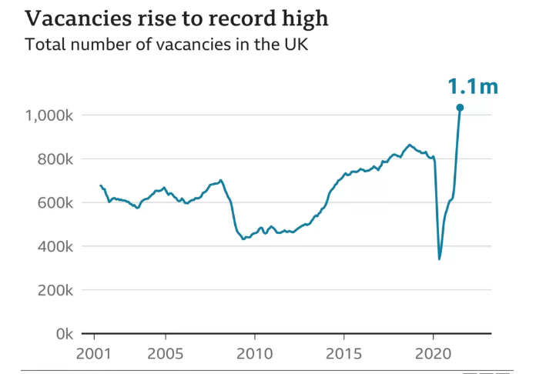
Figure 1: Vacancy Rate in the UK (Source; Office for National Statistics, 2021)
It was determined by Office for National Statistics that around 1.1 million vacant positions were reported between July and September.

Discussion/Literature
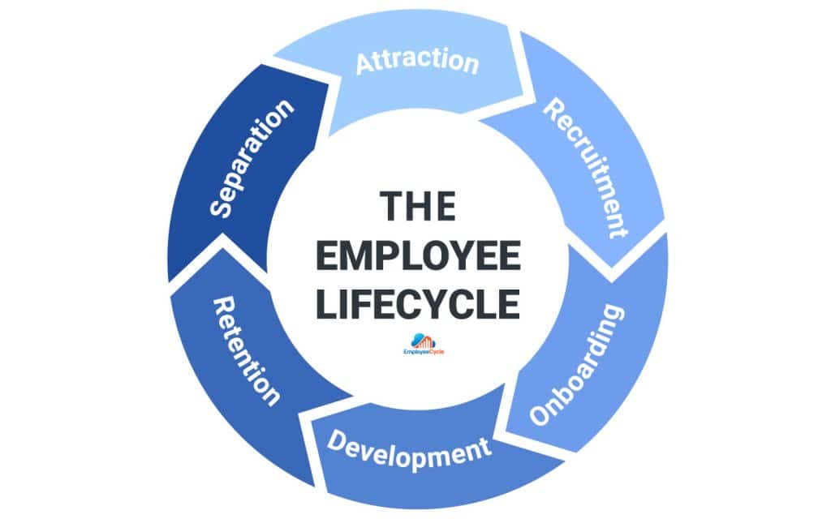
Figure 2: Employee lifecycle (Source; Kaela, 2021)
With help of the employee lifecycle, the identification and expression of different stages are discussed faced by the employee upon their engagement with a company. The main stages indicated within the lifecycle includes attraction, recruitment, onboarding, development, retention, and separation as shown in figure 2. With help of this lifecycle an evaluation of employee and their experience, associated with Premier Inn hotels, is assessed (Singh, 2019).
It is analysed through Yang et al., (2019), study that employees for the company are notified by the hotel manager of vacancies. The process of hiring employees includes training, educating, and coaching in accordance with the hotel’s regulations and policies. The manager is informed in case of any deviation in performance management about performance or activities. Therefore, the significance of the employee lifecycle is found vital in overcoming the barriers to retaining and developing talents within the company. The role of development opportunities within Premier Inn found increased over the period as it aimed to expand its hospitality services across the globe particularly expanding in Berlin, Cologne, and other cities in Germany. It focuses significantly on award-winning induction programs, management development apprenticeships, and kick-start and industry-leading training for employees. Although staff shortage and lack of motivation among staff remain challenging situations due to low wages and long working hours (Premier Inn, 2019).

PESTLE Analysis

Political Factors
Due to the COVID-19 lockdown policy, unfavorable conditions for the Premier Inn hotel resultantly impacted the employee retention rate. It was observed that in Germany city tax was employed for tourist in the year 2014. Currently only Berlin and Frankfurt impose city tax which is paid directly to tax office. The aspects of organisational politics found impacting on extra-role performance, turnover intentions and organisational commitment of employees. It is analysed that within Premier Inn, decrease in training programs caused difficulties for employees to cope with increase in demands. In addition, employee’s incapability’s effected on organisational politics. Low level of motivation among employees showed provision of unfair decision within workplace and increase in organisational politics. Similarly, increase in taxation found decreasing employment opportunities. The increase in taxes on labor income unable employee to save money (Annual reports, 2022).
It was found that the COVID-19 policy restricted the flow of work and hiring of new employees within the company. The fear of being infected with the virus distressed employee’s resulting in a shortage of staff. However, through the operational policy regulations, Premier Inn tried to manage and retain the employees. Similarly, it was found that the rise in the rate of unemployment increased along with the rise in performance expectations during the pandemic period decreased the level of flexibility rate for many employees. It was also observed that employees found themselves unsafe during the Pandemic situation resulting in job dissatisfaction and interest (Filimonau, and Magklaropoulou, 2020).

Economic
The relation of inflation, recession and economic instability effects on hotel business. An increase in labor cost, energy bills and construction cost caused immense pressure on the hotel industry during inflation period. British Hospitality Association report showed that the impact of Brexit on employee recruitment and retention was also found negative. As stated by Whitbread, 40% decrease in annual profit is reported due to Brexit uncertainties (Premier Inn, 2019). Also, around 38% of EU nationals are found working in the UK hospitality sector whereas, 43% of jobs of non-managerial or low-level positions are occupied overseas (Shin, and Hur, 2019). This report indicated that an extreme shortfall of employees over the next years can be predicted. Similarly, the shortage of working employees within Premier Inn increases employee demands to overcome and among workload. During the COVID duration decrease in UK government budget support was reported that also contributed to employee shortage. Increase in financial crisis within the company unable to pay wages and bonuses which also contributed to decreasing motivation level among employees (Aroul et al., 2022).

Social
The social apsects covers the people’s preferences as people of different age groups and classes travelling to other countries look for the hotel suitable to their budget with preferred facilities. The Premier Inn hotel found contributing on decreasing the food wastage by developing and initiating programs of waste minimisation by 2030. Moreover, around 500000 meal distributed to Great Ormond Street Children’s Hospital
by Premier Inn at time of pandemic (Whitbread plc, 2021). However, customer feedback due to the service change can result in a negative image (Tsao et al., 2015).
The increase in the COVID-19 lockdown situation resulted in social isolation and a decrease in training and engaging activities for employees which collectively contributed to a low level of interest and motivation among workers. Furthermore, customers’ negative feedback about service changes also caused dissatisfaction among employees. The increase in work pressure not only affected staff but directly impacted employees’ emotional and mental health as well. The fear of the disease and fewer interactions with other teams causes anxiety and a depressing environment for the employees to work in (López et al., 2019).

Technological
The lacking advanced training opportunities and workshops during COVID-19 were also found to affect employee retention. Web-based media technology also found adapted by the hotel to increase its promotion. Although increase in technological advancement also found causing threat of cyber security (Shabani and Munir, 2020). The lack of recognition of employees' ability to work efficiently in the workplace restricted their growth and development. The lack of support from the company during COVID-19 and at times of inflation made it difficult for employees to work in the company. The integration of technological advancements affected their performance. Although, currently Premier is focused to enhance its digital system by adapting what3words location technology to guide its customers. Also, Premier Inn found increasing its internet technologies to provide ease for employees and customers (Bas, and Sivaprasad, 2021).

Legal
On the other side, the legal aspects of Premier Inn for employees provide paid holidays and hotel discount offers. The policies of the company also included providing food or meals for on-duty employees (CPD, 2022). The hotel policies also include a pension plan for employees. Although, during COVID-19 increase in working hours causes trouble for many employees to manage and perform well. Employees were directed towards vaccination drive to minimise the health risk. Only employees with vaccination were allowed to work to minimise the risk of COVID-19 virus spread (Bas, and Sivaprasad, 2021).

Environmental
The sense of a safe and healthy working environment was found to contribute majorly to employee engagement and enhanced performance (Modau et al., 2018). The aspect of safety was found significantly considered within Premier Inn hotel for team members and guests. The hotel initiated Premier Inn Clean Protect's promise to ensure safety and a hygienic environment for employees with relevance to government guidance. This aspect helped the hotel to maintain its value and brand loyalty in the marketplace (Freeman, 2020).

SWOT Analysis
On basis of PESTLE analysis, the factors beneficial and harmful for the company are analysed to increase better understanding and channels for improving solutions as shown in Table below.

Strength  - During COVID-19 Hotels introduced health regulatory policies and standards for practices to maintain the health and safety of employees.  - By the end of the year 2022, Premier Inn introduced career development training and programs that help in increasing employee productivity and performance.  - The inclusion of technological advancements after the COVID-19 breakout made it easy for employee productivity.  - Integration of clean protect and vaccination drive during COVID-19  - Resect and valued the cultural perspectives of employees belonging to different regions (Group, N.W. et al. 2022).  - The introduction of a Pension plan for employees helps in engaging employees.  - The increase in the level of trust and transparency between the company and employees enhances productivity (Horng et al., 2022). | Weakness  - It was observed that the changes that occurred during the period of COVID-19, inflation, and Brexit affected the productivity and performance of employees dynamically.  - Moreover, it was observed that employees found the least interest in maintaining good standards of practices during the COVID-19 pandemic. Similarly, decrease in motivation levels among employees due to lack of recognition. During Inflation decrease in bonuses and salaries resulted in employee dissatisfaction. It was observed that employees found less interested to integrate or look for solutions to handle and manage challenges encountered within the Hotel setting. Moreover, an increase in working hours during the Pandemic resulted in less flexibility for employees and eventually leaving their job (Liu et al., 2022).
Threats  - The major threat analysed within Premier Inn hotel for employees is less availability of monitoring and tracking employee productivity.  - In addition, it was found that a decrease in technological knowledge and skills among employees also causes reluctance among employees to adapt to changes and work efficiently.  - Cyber-attacks threat due to technological advancement.  - Moreover, the unavailability of backups for situations like inflation causes threats to employee wages, and resources and disrupts the management network.  - The recession threat is also challenging for influencing macroeconomic trends (Hasan, 2019). | Opportunities  - Increasing investment opportunities to enhance employee wages and bonuses or rewards (Department for Business, Energy & Industrial Strategy, 2022).  - Inclusion of technological training sessions for employees to adapt skills and knowledge for handling new software relating to work management and proper documentation (CIPD, 2022).  - Implementation of data protection policies or software’s to prevent the risk of cyber-attacks and protect employee and customer’s data.  - Initiation of Waste minimisation strategies or programs.  - Moreover, establishing employee assessment tools can help to improve employee motivation and analyse challenges encountered by employees during work.  - Developing an appropriate Schedule for employees working hours or shifts electronically can be beneficial in reducing stress among employees (Cousins et al., 2019).
Table 1: SWOT Analysis

Evaluation and Conclusion

Conclusion
This report has significantly highlighted the key barriers contributing to the employee retention rate such as the strategy of staff, lack of training and career growth opportunities, and decrease in employee motivation level. The barriers identified were found caused due to COVID-19 and inflation's global impact. It was reported that an increase in inflation led to many unemployment opportunities for employees. Similarly, fear of COVID-19 causes an immense effect on employees and companies. Through internal and external factors analysis of Premier Inn hotel, it was encouraged to look upon solutions to overcome the barriers.
The importance of increasing employee retention rate impacts directly on company performance and productivity. The lack of opportunities for employees to enhance their skills, knowledge, and self-motivation impacts adversely on their performance. Similarly, the lack of rewards or awards for employees also causes hindrance the growth of employees and decreases employee trust in it company. Therefore, the challenges identified within this report can be addressed through a proposed set of recommendations in the next section. As well as, these recommended solutions can be implicated in future studies to analyse their impact on employee retention rates within the hospitality sector.

Recommendations
Armstrong, and Taylor, (2020), study focused on building strong team relationships to foster a positive and safe working environment for the employees. It is observed that increasing active listening and effective communication skills among employees can help to build trust and develop a sense of respect to value others’ cultural, religious, and spiritual beliefs. It is important to value employees’ beliefs to increase brand loyalty towards their employees. In addition, implementing continuous training programs and leave avenues for employees also showcase the concerns of the company for their employee growth and development. It is also encouraged to seek more investment opportunities to promote career development among employees. Offering competitive salaries and opportunities for promotion can help to build a sense of responsibility among employees (Torrington et al., 2020). It is also important to consider legal policies such as Data Protection Act, Individual state food safety act, Human Rights Act and Health and Safety Act within the setting to minimise the incidence of data security, safety of employees or customers (Gerke et al., 2020).
Further, it will also help to motivate, adapt changes and put their inputs for better improvement and growth of the company. Rewarding employees with bonuses or awards can help to appreciate their performance and efforts. On the other side, integrating employee assessment tools can also help to recognise and address employee needs and challenges. Therefore, challenges encountered in retaining employees can be strategically overcome through suggested recommendations (Johnston et al., 2012).

References

Annual reports (2022) Annual reports for 9,199 International Companies, AnnualReports.com. Available at: https://www.annualreports.com/ (Accessed: November 19, 2022).
Armstrong, M. and Taylor, S., 2020. Armstrong's handbook of human resource management practice. Kogan Page Publishers.
Aroul, R.R., Hodari, D., Bianchi, G. and Martignoni, G., 2022. The impact of brand affiliation on asset values: the case of UK hotels. Journal of Property Research, pp.1-31.
Bahar, A.M., Islam, M.A., Hamzah, A., Islam, S.N. and Reaz, M.D., 2022. The efficacy of work-life balance for young employee retention: a validated retention model for small private industries. International Journal of Process Management and Benchmarking, 12(3), pp.367-394.
Bas, T. and Sivaprasad, S., 2021. COVID-19 and Implications for Future Trends in the UK Travel and Tourism Sector. Available at SSRN 3623404.
Betts, B.S.H., 2020. The importance of human resource management in the Hotel industry in Sierra Leone. American Academic Scientific Research Journal for Engineering, Technology, and Sciences, 64(1), pp.96-108.
CIPD (2022) CIPD the professional body for Human Resources and People Development, CIPD. Available at: https://www.cipd.co.uk/ (Accessed: November 18, 2022).
Cousins, J., Foskett, D., Graham, D. and Hollier, A., 2019. Food and beverage operations and management.
CPD (2022) Continuing professional development (CPD), CIPD. Available at: https://www.cipd.co.uk/learn/cpd (Accessed: November 18, 2022).
Department for Business, Energy & Industrial Strategy (2022) Department for Business, Energy & Industrial Strategy, GOV.UK. Available at: https://www.gov.uk/government/organisations/department-for-business-energy-and-industrial-strategy (Accessed: November 18, 2022).
Filimonau, V. and Magklaropoulou, A., 2020. Exploring the viability of a new ‘pay-as-you-use’energy management model in budget hotels. International Journal of Hospitality Management, 89, p.102538.
Freeman, J., 2020. On Determining the Value of Online Customer Satisfaction Ratings–A Case‐based Appraisal. Data Analysis and Applications 3: Computational, Classification, Financial, Statistical and Stochastic Methods, 5, pp.195-214.
Gerke, S., Shachar, C., Chai, P.R. and Cohen, I.G., 2020. Regulatory, safety, and privacy concerns of home monitoring technologies during COVID-19. Nature medicine, 26(8), pp.1176-1182.
Group, N.W. et al. (2022) Homepage, Institute of Customer Service. Available at: https://www.instituteofcustomerservice.com/ (Accessed: November 18, 2022).
Hamouche, S., 2021. Human resource management and the COVID-19 crisis: Implications, challenges, opportunities, and future organizational directions. Journal of Management & Organization, 1, pp.1-16.
Hasan, M., 2019. The Effectiveness of e-learning in Staff Training to Gain Hospitality Organizational Excellence. AIUB Journal of Business and Economics, 16(1), pp.252-267.
Horng, J.S., Liu, C.H., Chou, S.F., Yu, T.Y. and Hu, D.C., 2022. Role of big data capabilities in enhancing competitive advantage and performance in the hospitality sector: Knowledge-based dynamic capabilities view. Journal of Hospitality and Tourism Management, 51, pp.22-38.
Itam, U., Misra, S. and Anjum, H., 2020. HRD indicators and branding practices: A viewpoint on the employer brand building process. European Journal of Training and Development, 44(6/7), pp.675-694.
Johnston, R. Clark, G. Shulver, M (2012). Service Operations Management ,Pearson, London
Kaela Blanks, 2021, https://www.employeecycle.com/hr_metrics_for_every_phase_of_the_employee_lifecycle/
Kurdi, B. and Alshurideh, M., 2020. Employee retention and organizational performance: Evidence from banking industry. Management Science Letters, 10(16), pp.3981-3990.
Liu-Lastres, B., Wen, H. and Huang, W.J., 2022. A reflection on the Great Resignation in the hospitality and tourism industry. International Journal of Contemporary Hospitality Management, (ahead-of-print).
López-Andreu, M., Papadopolous, O. and Jamalian, M., 2019. How has the UK hotels sector been affected by the fissuring of the worker–employer relationship in the last 10 years?.
López-Andreu, M., Papadopolous, O. and Jamalian, M., 2019. How has the UK hotels sector been affected by the fissuring of the worker–employer relationship in the last 10 years?
Modau, F.D., Dhanpat, N., Lugisani, P., Mabojane, R. and Phiri, M., 2018. Exploring employee retention and intention to leave within a call centre. SA Journal of Human Resource Management, 16(1), pp.1-13.
Office for National Statistics (2021) Premier Inn owner Whitbread warns of staff shortages as demand recovers, BBC News. BBC. Available at: https://www.bbc.com/news/business-59048014 (Accessed: November 18, 2022).
Page, S.J. and Connell, J., 2020. Tourism accommodation and hospitality services. In Tourism (pp. 216-241). Routledge.
Park, J. and Min, H.K., 2020. Turnover intention in the hospitality industry: A meta-analysis. International Journal of Hospitality Management, 90, p.102599.
Premier Inn (2019) Whitbread Opens Second Hotel in Germany, News stories | 2019 | Premier Inn. Available at: https://www.premierinn.com/gb/en/news/2019/whitbread-opens-second-hotel-in-germany.html (Accessed: November 19, 2022).
Sansa, M., Badreddine, A. and Romdhane, T.B., 2021. Sustainable design based on LCA and operations management methods: SWOT, PESTEL, and 7S. In Methods in Sustainability Science (pp. 345-364). Elsevier.
Shin, Y. and Hur, W.M., 2019. When do service employees suffer more from job insecurity? The moderating role of coworker and customer incivility. International journal of environmental research and public health, 16(7), p.1298.
Singh, D., 2019. A literature review on employee retention with focus on recent trends. International Journal of Scientific Research in Science and Technology, 6(1), pp.425-431.
Torrington, D, Hall, L, Atkinson, C, & Taylor, S 2020, Human Resource Management PDF EBook, Pearson Education, Limited, Harlow. Available from: ProQuest Ebook Central
Whitbread, 2022. Governance [Online] Available at: https://www.whitbread.co.uk/governance/
Whitbread, 2022. Our business model and strategy. [Online] Available at: https://www.whitbread.co.uk/about-us/our-business-model/ Accessed On [17 September 2022]
White, T., 2020. The effects of employee engagement and morale on workforce retention.
Yang, C., Guo, N., Wang, Y. and Li, C., 2019. The effects of mentoring on hotel staff turnover: Organizational and occupational embeddedness as mediators. International Journal of Contemporary Hospitality Management.

