Module: Research Methods 1
Module Code: ECPS4003
Title: Is there an association between gender and preference for working from home?

Abstract
This study was composed of a questionnaire which asked for the demographic data of a participant (age and gender) and whether the participant preferred working from home or working from a working environment. This study was an online questionnaire as it was conducted in the corona virus pandemic, so it was essential to conduct the study online to stop the spread of the infection. The data collected from this study was analysed using the chi-square formula. This study found that there is an association between gender and working from home. This report will further discuss studies in support of these findings, the methodology and procedure of this study, the results of this study as well as the strengths and weaknesses and possible future practical applications of this study to everyday life.

Introduction
The corona virus pandemic became apparent in early 2020 and to avoid the spread of the infection, it was suggested that people should stay home and work. Therefore, children and adults had to complete work at home.
According to research, men have been shown to enjoy working from home more than women. For example, the BiBB/BAuA 2018 employment survey shows that only 7.7% of employed men without children under age 13 would not work from home whereas 12% of women with children without children under 13 wouldn’t work from home. Furthermore, the survey further supports this stance as the results suggest that 8.9% of women with children under 13 wouldn’t work from home whereas only 6.6% of men with children under 13 would opt against working from home. The research study mentioned was carried out using a survey to collect demographic data such as gender as well as whether participants had a child under 13 and whether they would or wouldn’t work from home.
Another research study focusing on the impact of corona virus and working from home hypothesised that the willingness to work from home would be dependent on gender and the presence of their children in the home. The study which was conducted in 2020 and had 50 participants. It was carried out using a questionnaire and secondary data such as journals, websites, and newspaper reports. The results determined (using the chi square test) that because the participant value was 0.770 while the significance level was 0.05, that the given hypothesis could be accepted. In conjunction with this, it was concluded that the willingness to work from home would be dependent on the presence of children at home and most of the respondents who argued that they would not work from home had children. There are other studies which support this viewpoint. For example, Stevenson and Wolfers (2009) proposed that interactions between work and private life could impact ‘overall life satisfactions’ and the decrease in female happiness highlighted that these interactions are likely to vary due to parental status and gender. Also, it has been argued that flexible working times could also impact women’s enjoyment in the working environment. Moreover, Amabile and Kramer (2013) suggested that working from home allows people to balance office work and routine work as it saves time, allows for a higher rate of productivity, and enjoy their personal life.
In conjunction with this, another study conducted by Xue and McMunn showed that women complete 64% of the unpaid tasks such as childcare and housework and if working hours needed to be adapted to accommodate children and housework it would be more likely to be women to do so than men. In conjunction with this, other research has suggested that working from home may increase family conflict due to the burden on families, therefore supporting the argument that women are more likely to prefer working from a work environment to avoid stress (as it has been suggested that women partake in 64% of unpaid work within a household such as childcare and housework). During the start of lockdown, mothers carried out an average of 41.22 hours of care work a week compared to fathers, who completed an average of 21.03 hours a week of care work.
Alongside this, another study found that 36% of its participants preferred to work from home but also found that parents disputed this as they had distractors such as children so it could be argued that there is a no association between gender and preference of working from home but that preference on working from home is dependent on the presence of children in a household.
On the other hand, research has suggested that if women (mothers) are able to work from home then they are less likely to reduce working hours as they find it easier to balance the stresses of home life and working life better and are able to work after childbirth when working from home.
Moreover, ONS have implied that women completed more work at home than men, with 47.5% of women working from home during lockdown and 45.7% of men working from home during lockdown.
As well as this, women (mothers) may prefer to work from a work environment as throughout lockdown while they were productive, there was a 22% decrease in productivity for their actual job as they had other commitments at home and couldn’t find tome to complete tasks for work, meaning there could be an association between gender and preference of working from home as males (fathers) enjoyed working from home as they were able to spend more time with their children. To support this, another study conducted in Vietnam suggests that 56% of female teleworkers compared to 45% of male counterparts had a positive perception of working from home during the covid-19 pandemic.

Methods
This study was a questionnaire-based experiment whereby demographic data such as gender and age were collected alongside the preference of working from home or a preference for working in a working environment.
Participants
During this study, we had 41 participants. As the study was conducted online due to the corona virus pandemic, the participants participated in the study from their own accord. This means the sampling method used to gather participants was volunteer sampling or self-selected sampling as the participant had to sign up to the study by themselves. In this study, there were 14 males and 27 females. The age range of these participants was 33 (participants were aged 18-51) and the mean age was 27.46 to 2 decimal places (2.d.p).
Design
The IV or independent variable of this study was the gender of the participant and the DV (dependent variable) of this study was preference of working location whether it be home or in a working environment.
This study was a within-subjects study as all the participants within the study had the same conditions (they were all asked the same questions on the same questionnaire). The analysis that has been done on this study was done by using the chi-square formula as the study needed to calculate whether there was an association between gender and working from home so all preferences (working from home or working in a work environment) were calculated alongside the gender of the participant.
Materials
The materials used were the questionnaire, the information sheet, the consent form, demographic data collection sheet and the debrief form (see appendix).
Procedure
Participants were asked to read the information sheet provided to them and sign a consent form if they were happy to continue with the questionnaire. If they were happy to continue taking part in the study, they were then asked to fill out a questionnaire which asked demographic data about the participant (for example, age and gender) and whether they preferred to work from home or whether they preferred to work in a working environment. They were then debriefed and once again, informed of their right to withdraw their data if they wanted to. Before the study had finished, they were also given the contact details of the researcher in case they had any questions.

Results
The total scores for both preference of working from home and preference of working from a work environment were calculated and suggested that women had a slight preference for working from a work environment over working at home (13 of the female participants preferring to work from a working environment and 11 of the female participants preferring to work from home). If we refer back to the studies mentioned previously such as the study conducted by Stevenson and Wolfers (2009), it is possible that women prefer working from a work environment as they have less commitments due to having a tendency to do most of the housework, childcare as well as work for their career and may find it hard to balance such a hefty workload and feel that to work from a work environment may be less stressful as they have less tasks to complete. The results also show that there is more of a divide between working preferences with the male participants as only 5 of the male participants preferred to work from home whereas 12 of the male participants preferred to work from a working environment, which could contradict the significance and accuracy of the hypothesis that there is an association between gender and preference of working location (whether it be working from home or working from a work environment). This means that the hypothesis that there is an association between gender and preference for working from home as within the study, a similar number of males (12) and females (13) prefer to work from home cannot be accepted. However, as this study contains more female participants than male participants, it indicated women prefer a ‘hybrid’ working style whereas men preferred to work from a working environment. Finally, the chi-square formula was used to calculate results. The chi square value was 6.44, meaning this result is significant (as it more than 3.841 (degrees of freedom)) as the participant value was less than 0.05 (p=<0.05).

Discussion
The hypothesis that this study was trying to prove was that there was an association between gender and working from home and the results from this study show the hypothesis cannot be accepted.
As said previously, the findings from this study relate to previous literature such as the study conducted by Xue and Mcmunn (2021) implies that women may prefer working from a work environment as they may feel less stress due to the fact when they are working from home they not only need to complete work for their jobs, but also tend to partake in childcare and complete housework meaning that working from home may seem stressful to them. Furthermore, when their jobs require them to attend meetings online, it would be more difficult for them to do so at home with children who may distract them from their work whereas this wouldn’t be problematic in a working environment. Moreover, other research has shown that men tend to enjoy working from home more than women.
Potential weaknesses of this study, however, may include the fact that participants weren’t asked if they had children which could impact results due to the idea that women (mothers) could potentially prefer working from home over work environment if there is a presence of children at home. Another possible weakness of this study may include the fact that the study (while it did provide an option for non-binary/third gender) didn’t have any participants who identified as non-binary/third gender as well as the fact that it was conducted in the middle of the corona virus pandemic, which means that the sampling method used was volunteer sampling or self-selected sampling meaning that participants decided to participate in this study from their own accord. This means that our participants may have similar interests and the sample isn’t representative of all people meaning it would be difficult to generalise the findings of this study to the wider population as it isn’t inclusive to everybody, making the study lack inclusivity and difficult to generalise to the wider population.
Future considerations for similar research that may be conducted in the future would be to try and include a larger variety of participants, to conduct the study it in-person (if possible) as it is difficult to conduct a study online through a questionnaire due to the fact it is difficult to retrieve qualitative data as well as not being able to help participants understand the meaning of the questions being asked. As well as this, another consideration may be to ask why a participant may prefer to work from home or from a work environment to develop understanding as to why there may be an association between gender and working from home.
However, the findings of this study could have practical applications in jobs such as teaching, whereby teachers or lectures who are teaching online (as many teachers and lecturers did through the corona virus pandemic) may be interrupted by children or pets at home, and managerial positions, where managers would need to conduct meetings with fellow co-workers to assign shifts for example and again, may be interrupted by children or pets at home. It could useful to enforce a ‘hybrid’ working style, allowing men to work how they wish (which would help mental health) and would be significant for working mothers as it allow women to be productive at home and efficient at their job.
In conclusion, the study conducted shows that, due to the results of the study, that the hypothesis that there is an association between gender and working cannot be accepted. This means that there is not enough evidence to suggest that there is an association between gender and working from home yet. However, other research has shown that most women preferring to work from a work environment and men tend to enjoy working from home more than women and the divide between the male gender and preference of working from a work environment is more pronounced and is a lot larger in comparison to the divide between the female gender and preference for working from a work environment over working from home.

Reference list
Alexander, A., De Smet, A., Langstaff, M., Ravid, D. (2021). What employees are saying about the future of remote work. McKinsey and Company. https://www.mckinsey.com/business-functions/people-and-organizational-performance/our-insights/what-employees-are-saying-about-the-future-of-remote-work
Andrew, A., Cattan, S., Costa Dias, M., Farquharson, C., Kraftman, L., Krutikova, S., Phimister, A., Sevilla, A. (2020). How are mothers and fathers balancing work and family under lockdown? Institute for Fiscal Studies. https://ifs.org.uk/uploads/BN290-Mothers-and-fathers-balancing-work-and-life-under-lockdown.pdf
Cameron, A. (2020, July 8). Coronavirus and homeworking in the UK: April 2020. Office for National Statistics. https://www.ons.gov.uk/employmentandlabourmarket/peopleinwork/employmentandemployeetypes/bulletins/coronavirusandhomeworkingintheuk/april2020
Chung, H., Horst, M. (2017). Women’s employment patterns after childbirth and the perceived access to and use of flexitime and teleworking. Human Relations, 71(1), 47–72. https://doi.org/10.1177/0018726717713828
Chung, H., Lippe, T. (2018). Flexible Working, Work–Life Balance, and Gender Equality: Introduction. Social Indicators Research, 151(2), 365-381. https://doi.org/10.1007/s11205-018-2025-x
Chung, H., Seo, H., Forbes, S., Birkett, H. (2020). Working from home during the Covid-19 lockdown: Changing preferences and the future of work. University of Birmingham. https://www.birmingham.ac.uk/Documents/college-social-sciences/business/research/wirc/epp-working-from-home-COVID-19-lockdown.pdf
Chung, H., Seo, H., Forbes, S., Birkett, H. (2021). Covid-19, Flexible Working, and Implications for Gender Equality in the United Kingdom. Sociologists for Women in Society, 35(2), 218-232. https://doi.org/10.1177/08912432211001304
Gascoigne, C. (2020). Working from home: assessing the research evidence. CIPD. https://www.cipd.co.uk/Images/8051-working-from-home-report_tcm18-84208.pdf
Ibarra, H., Gillard, J., Chamorro-Premuzic, T. (2020, July 16). Why WFH Isn’t Necessarily Good for Women. Harvard Business Review. https://hbr.org/2020/07/why-wfh-isnt-necessarily-good-for-women?registration=success
Nguyen, M., Armoogum, J. (2021). Perception and Preference for Home-Based Telework in the COVID-19 Era: A Gender-Based Analysis in Hanoi, Vietnam. MDPI. https://www.mdpi.com/2071-1050/13/6/3179
Nicks, L., Gesiarz, F., Likki, T., Baynham-Herd, Z., Lohmann, J. (2021). Impact of changes in flexible working during lockdown on gender equality in the workplace. Government Equalities Office. https://www.bi.team/wp-content/uploads/2021/05/Covid-flexible-working-report-for-upload.pdf
OECD (2021, September 21). Teleworking in the COVID-19 pandemic: Trends and prospects. OECD.org. https://www.oecd.org/coronavirus/policy-responses/teleworking-in-the-covid-19-pandemic-trends-and-prospects-72a416b6/#figure-d1e756
Platts, K., Breckon, J., Marshall, E, (2022). Enforced home-working under lockdown and its impact on employee wellbeing: a cross-sectional study. BMC Public Health. https://bmcpublichealth.biomedcentral.com/articles/10.1186/s12889-022-12630-1
Silim, A., Stirling, A. (2014). Women and Flexible Working Improving Female Employment Outcomes in Europe. IPPR. https://www.ippr.org/files/publications/pdf/women-and-flexible-working_Dec2014.pdf
Xue, B., McMunn, A. (2021, March 4). Gender differences in unpaid care work and psychological distress in the UK Covid-19 lockdown. Plos One. https://journals.plos.org/plosone/article?id=10.1371/journal.pone.0247959

Appendices
Appendix A: Information Sheet
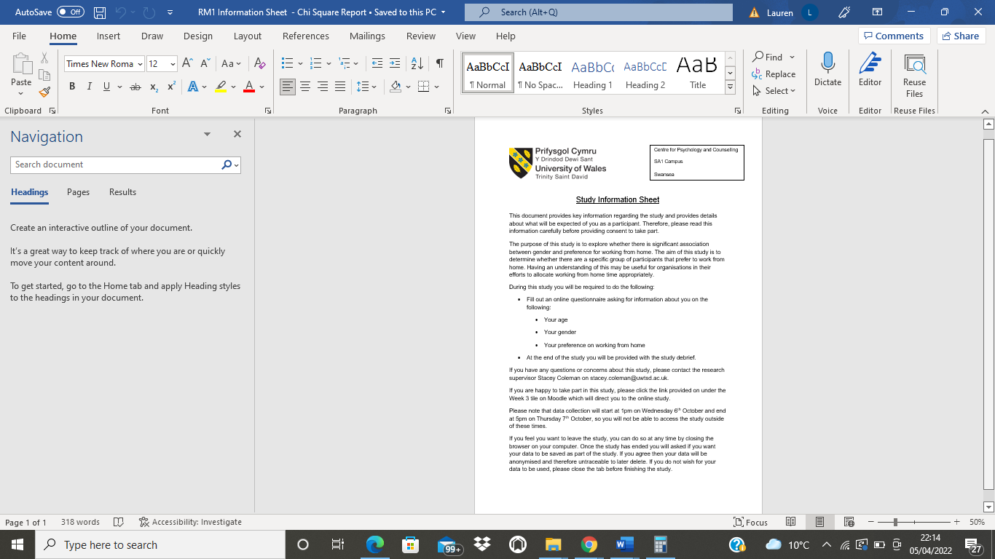
Appendix B: Consent Form
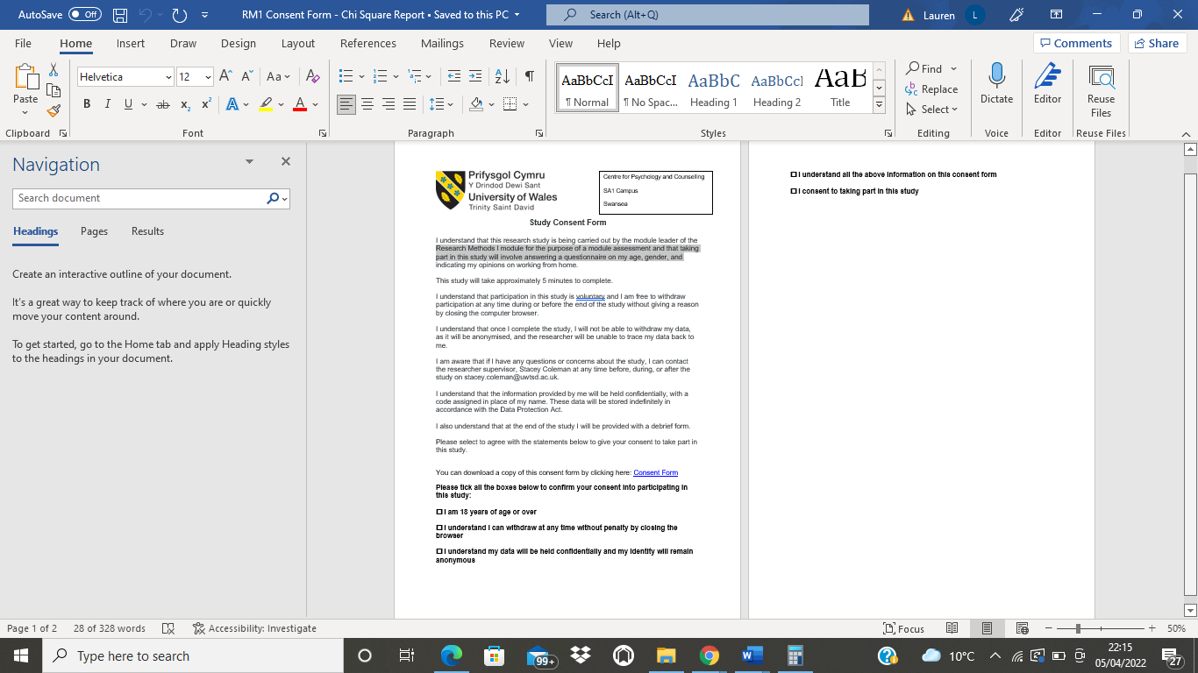
Appendix C: Questionnaire
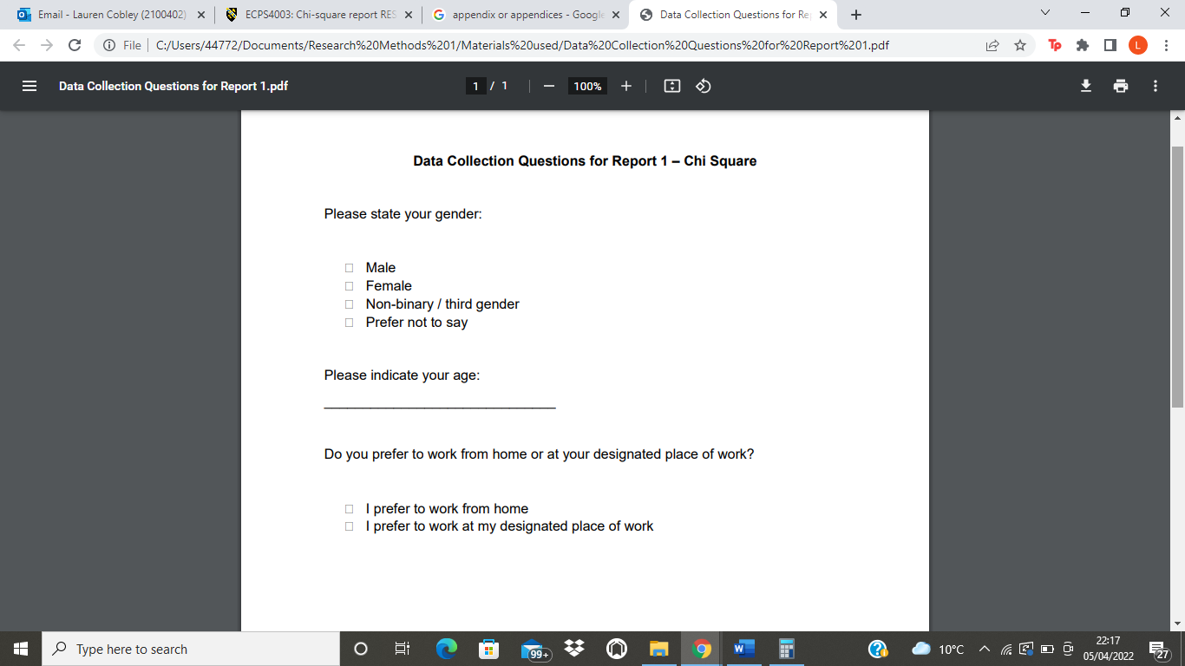
Appendix D: Debrief Form
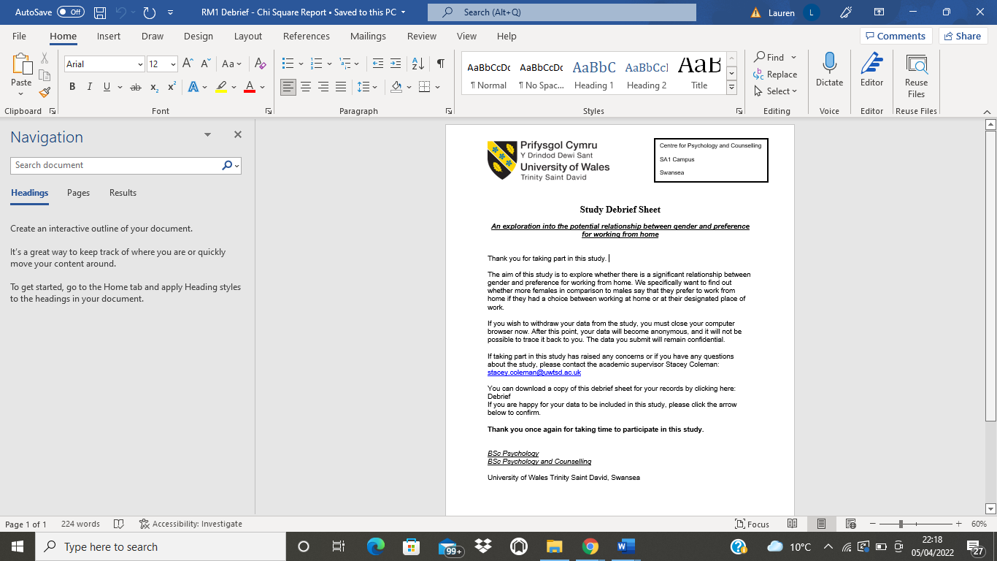
Appendix E: Chi-Square Calculation on Excel


