Workshop log book
Learning in the Digital Era
Alexander Gravatt
2217176

The circuit below is of a 741 opamp amplifier that is intended to amplify by a three.
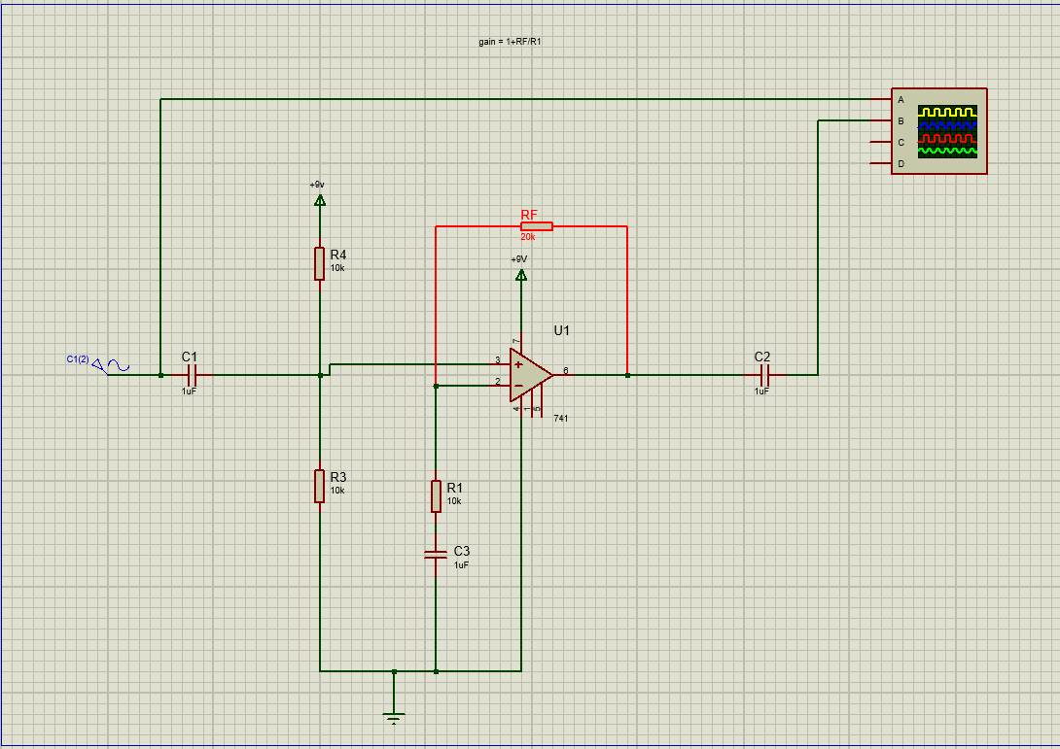
Gain = 1+rf/r1 this is a 9-volt noninverting amplifier
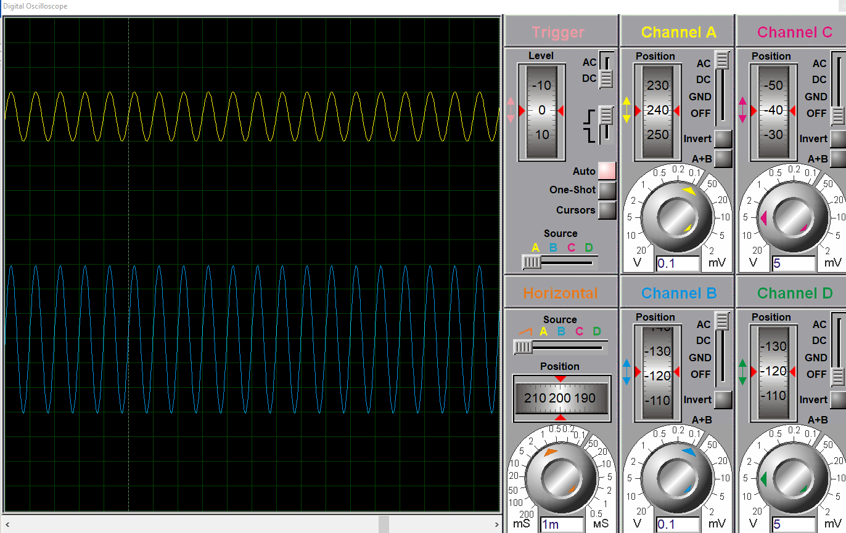
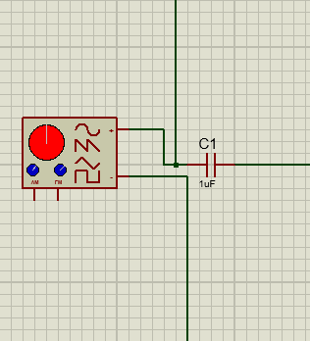
Signal generator allowing for a varied input.
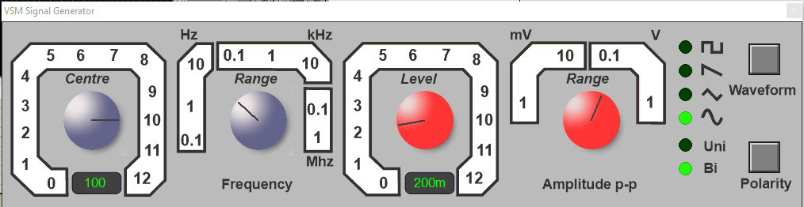
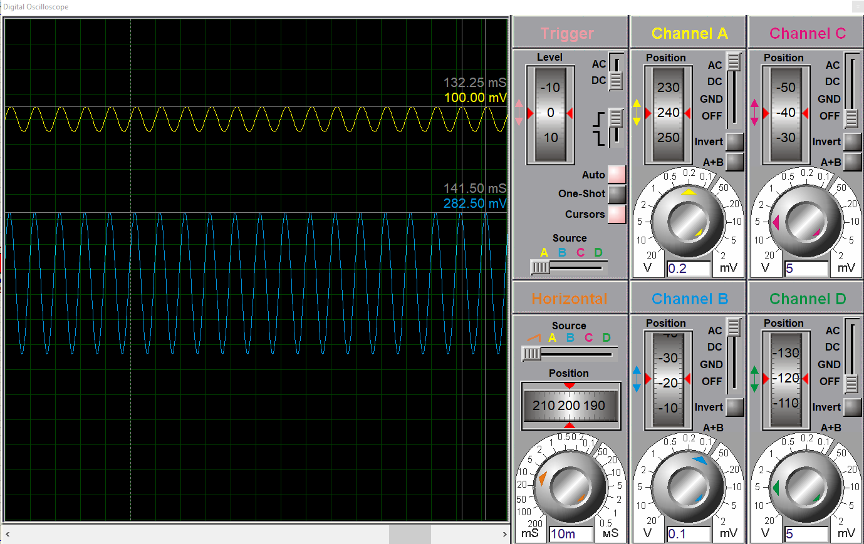
As shown the settings of 100 hertz and 200 volts.

Using the signal generator and a number of values I took readings from the oscilloscope and recorded them in excel after which using the. -3db rule using a smaller scale of changes from 250k to 450k looking for when the voltage reached close to the 212.1 value for me this was the 300k mark.
300k time the 3 in the .3db rule bring the value to 900k as such it is with in tolerance for a the opamp.
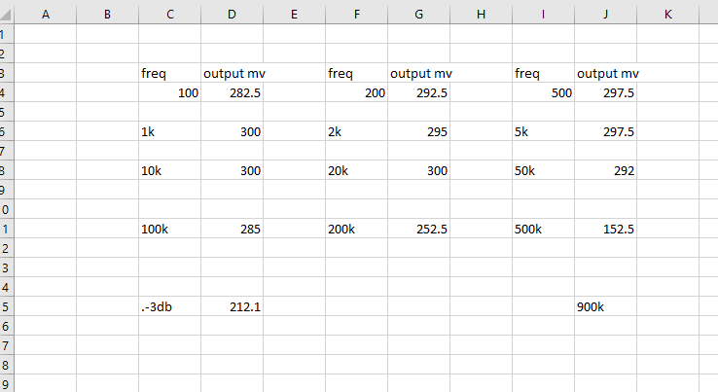

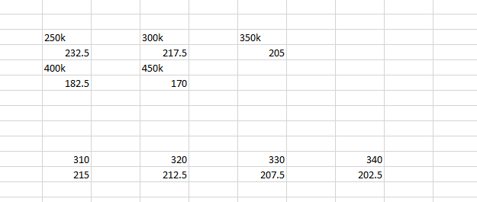
.-3db is the cutoff point of an amplifier circuit.
Normally amplifiers are 1mhs as shown below
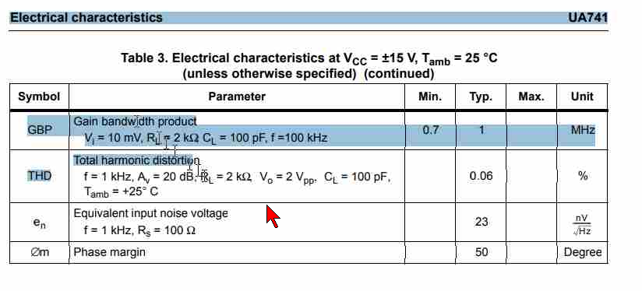

Easy pc
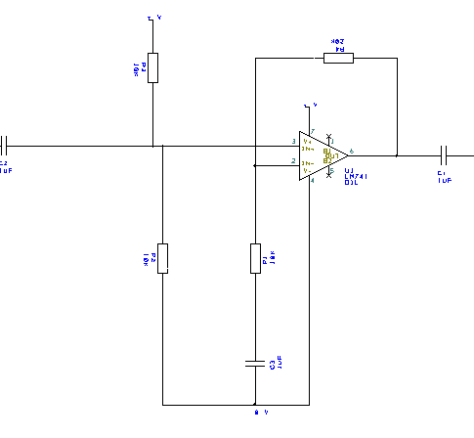

Using easy pc, I created the same circuit as in proteus allowing for the creation of the circuit board below.

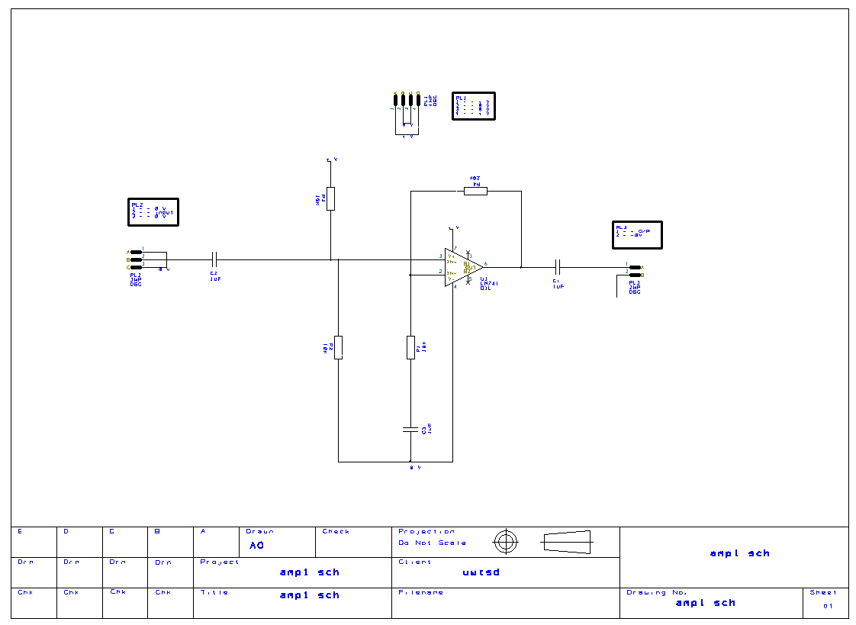
Then circuit below comes from the pcb mode allowing the program to model the pcb exactly and create a schematic for production of the pcb

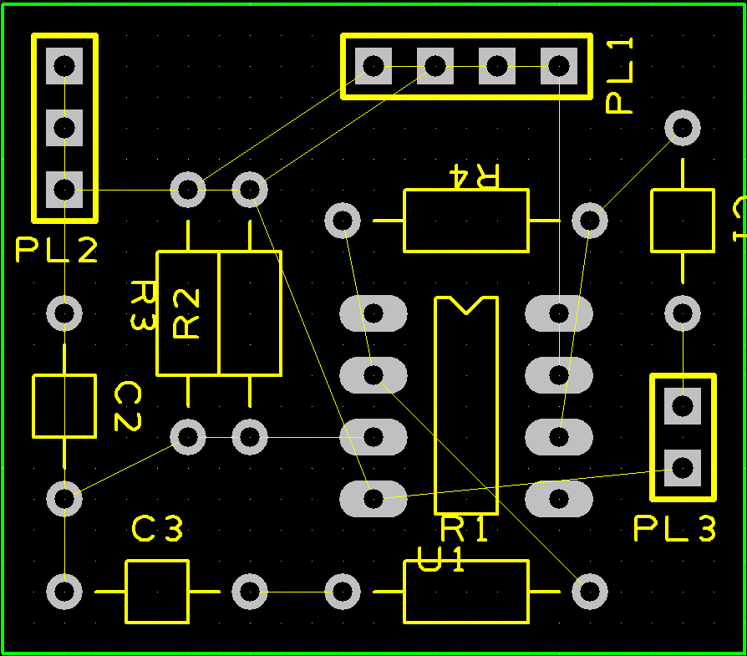
The dummy grids below are to provide a dummy version of the eventual copper plates they will form part of the circuit
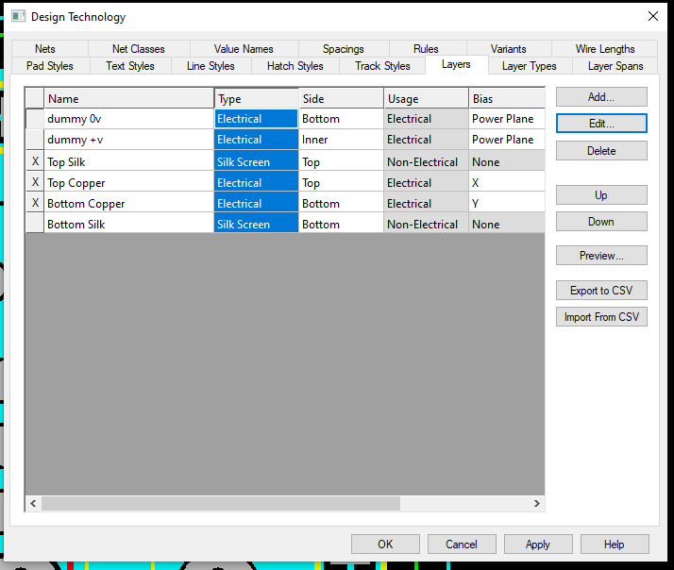
Optimize net
Using the optimize tool in the settings removed a selection of the un routed wires as shown below as they are connected to the 0 V dummy grid.
These wires would eventually be connected to the positive and negative copper on the back plate.
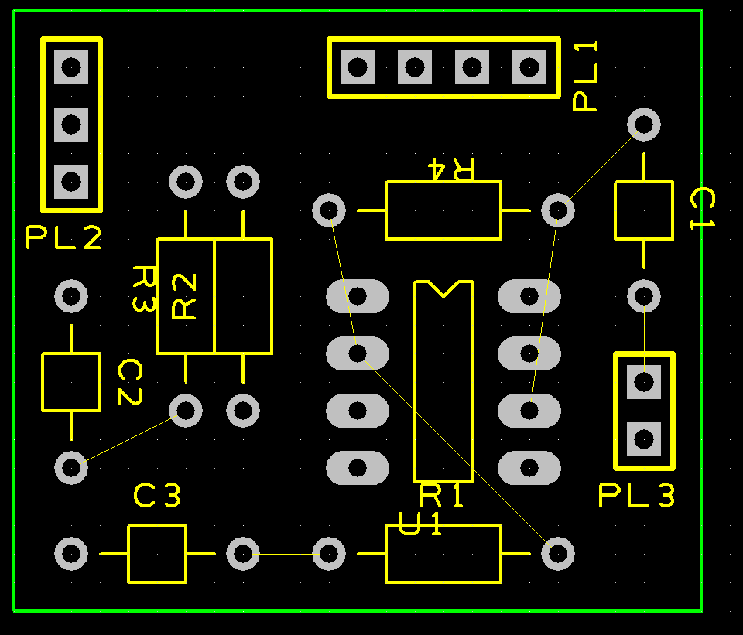

Using the copper pour area mode, I created the connected zone to be used as seen below.
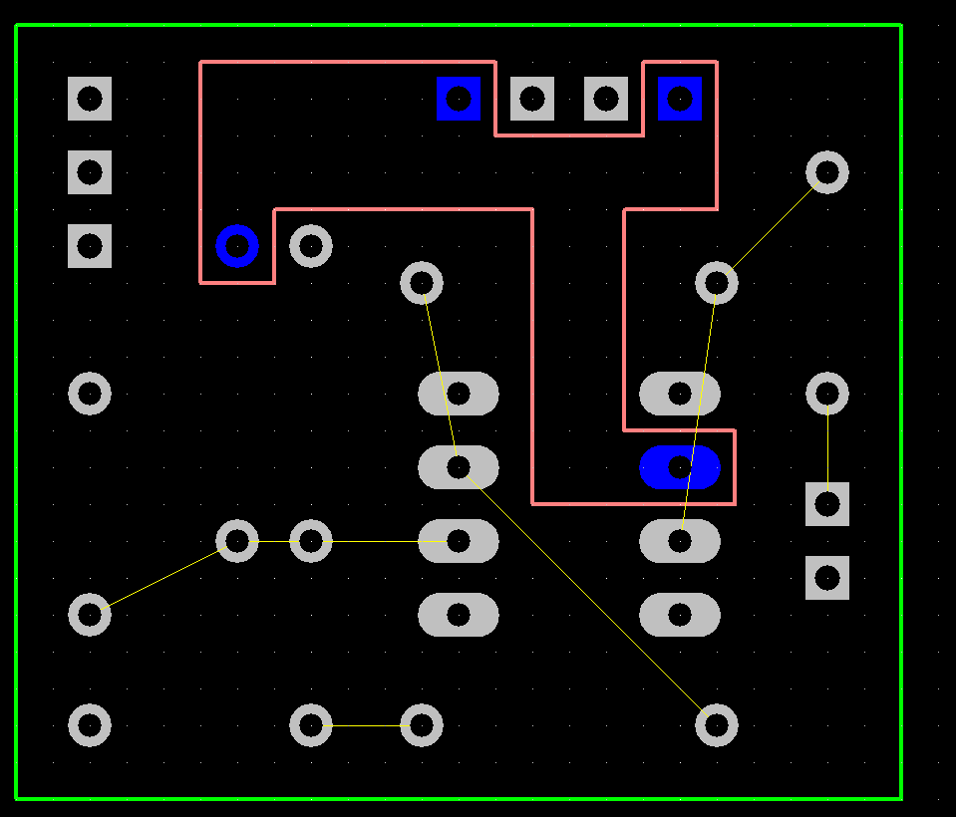
This zone was used for positive voltage. Once pored it looks as shown below.
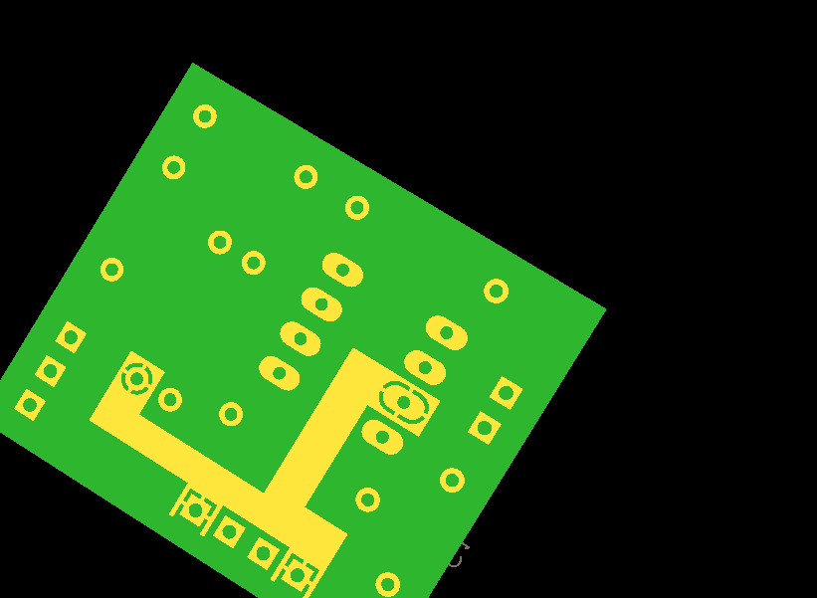
The spurs around the component's connectors are to limit the thermal movement while soldering. This can result in the glue around the board melting.
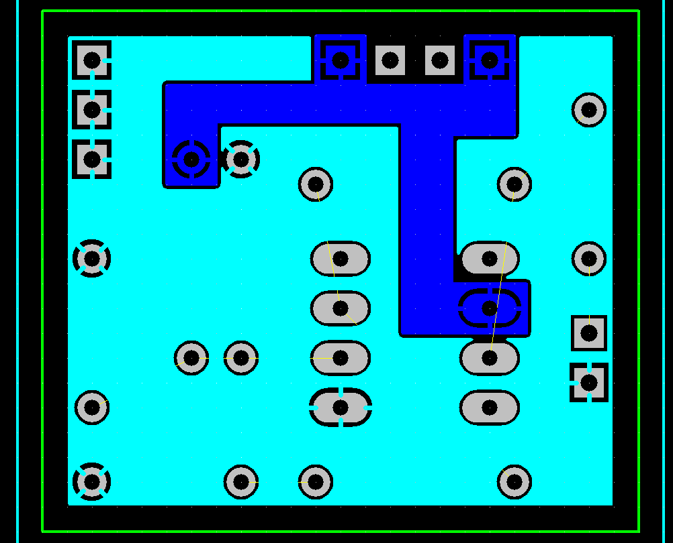
The light blue section shown above is the ground or 0V net as such it takes all final signals away from the components.
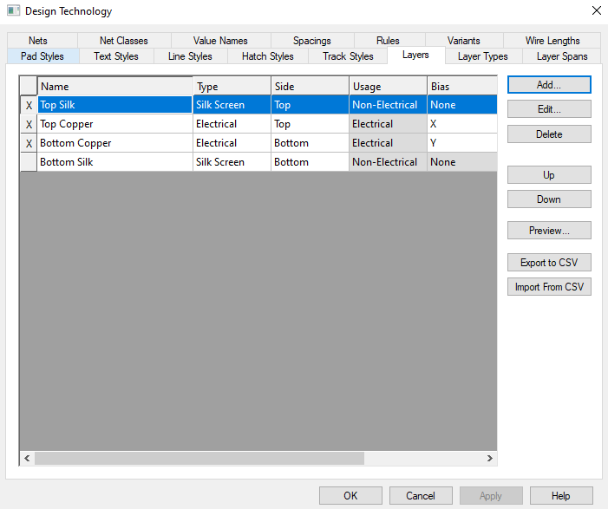
After the creation of the copper pour zones the dummy layers can be removed as they are no longer being used. And the circuit is a two-layer circuit.
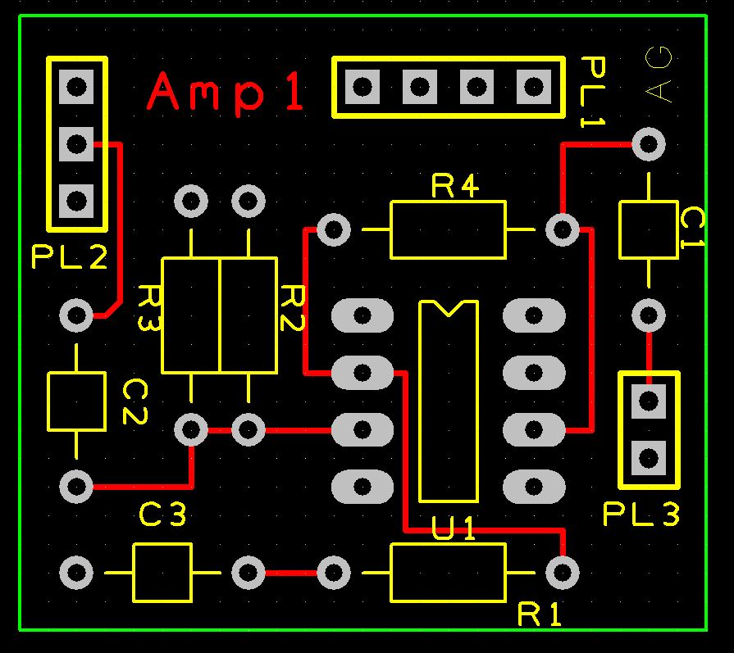
These red tack lines signify the tracks on the top layer of the circuit board. These connect directly to each component and drag the power signal across the board to the next part of the circuit.
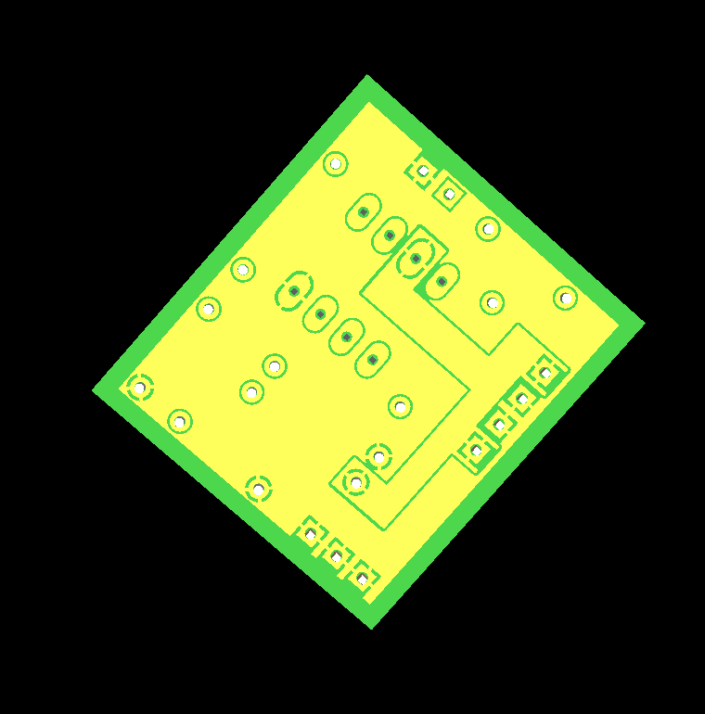
After removing the dummy grids, the circuit was complete.

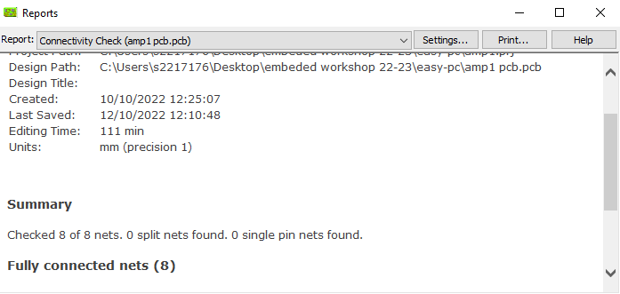
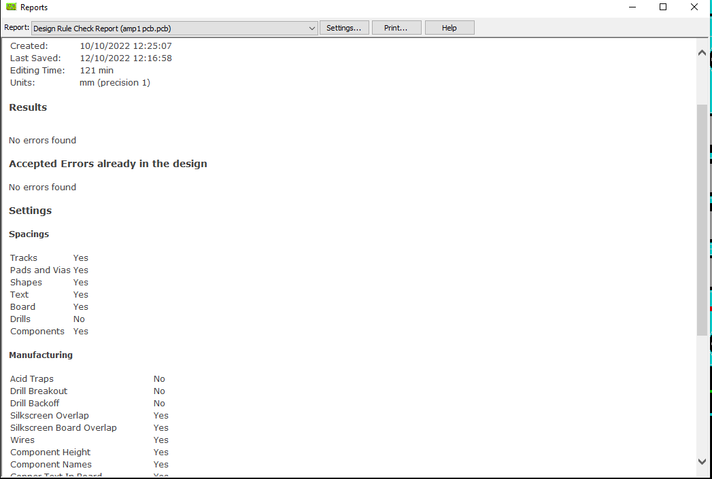
Finally, the check functions for checking connectivity and overall design quality were performed.

Checking the spacing of all the components makes sure that they do not overlap.

The manufacturing checks that during production the chip no issues will occur.

The sections turned off during this process were drilling and acid pooling. This limited the errors and was also done as I will not be producing the board on my own and as such do not need to fully understand the possible flaws.
These tests ensured that they were ready for production and conversion to the Gerber file they removed issues with the silk layer and copper layers ensuring that the names did not overlap the

Next is to produce a Gerber file of this pcb. Gerber is a file format that allows for easy transfer between computers and further easy transfer between CNC machines used for production.
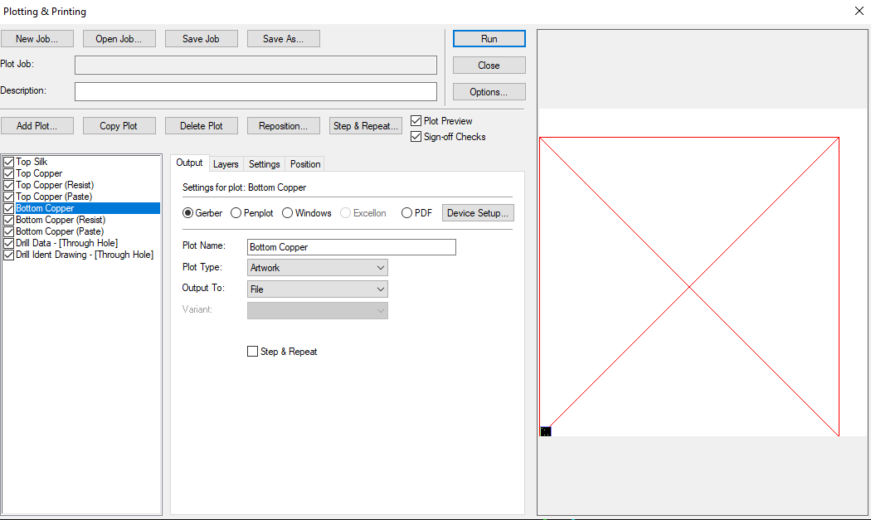
After setting top silk top copper and bottom copper to have a boarder outline, I clicked run and the system saved the Gerber file to a plots folder.
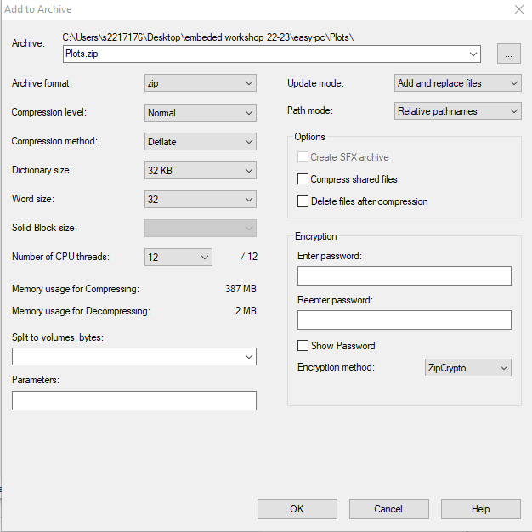
From there I zipped all the files except the report of the file creation. Making sure it was in a .zip file rather than the alternatives.
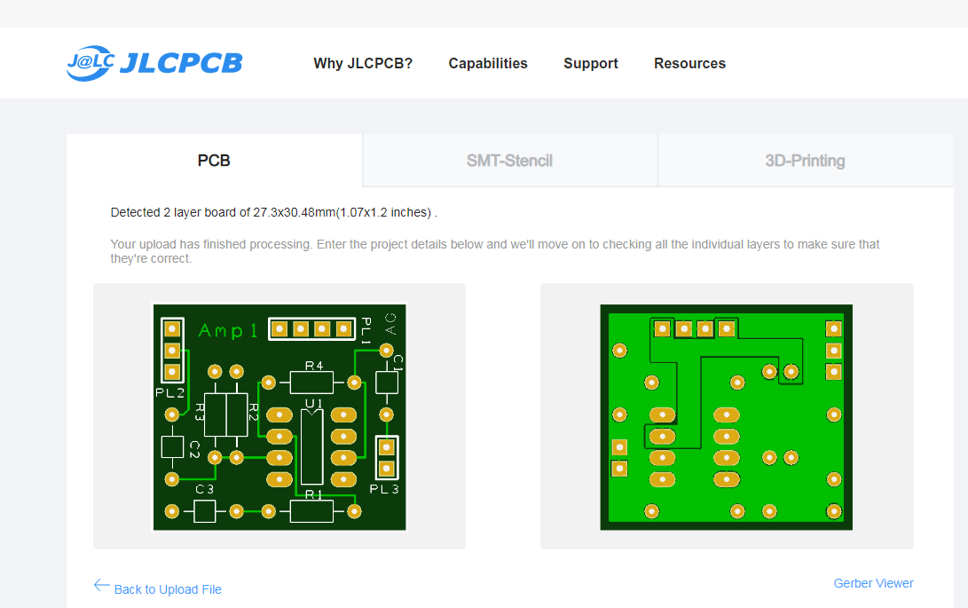
Then I placed the zip into the quote process for JLC pcb from file this allows me to see the cost of manufacturing a batch of this pcb.
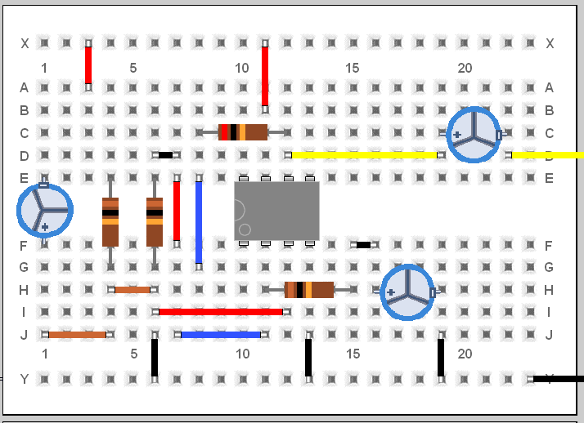
I started the bread board by creating it in pebble an online bread board program as seen above the board produced is a 741 opamp. I used the circuit diagram as a guide to produce the online board.

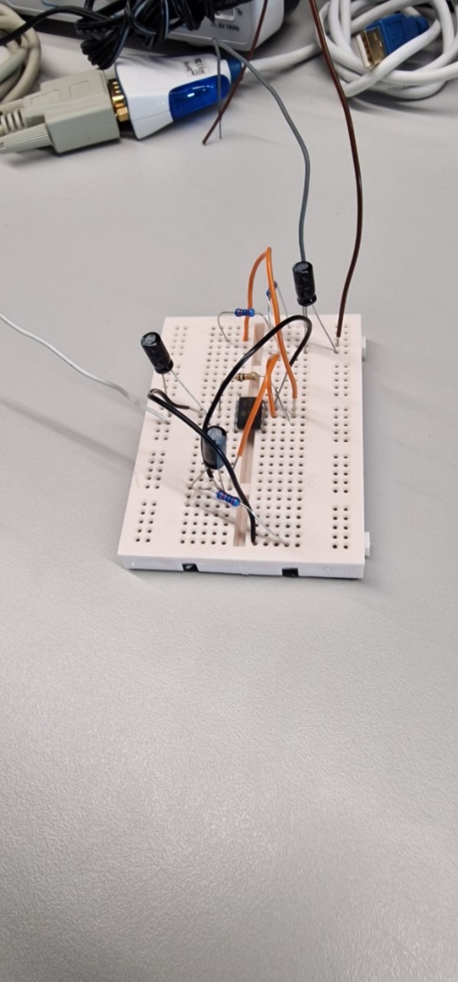
I initially placed all the parts in and circuited them together to get a rough idea of how thing needed to be positioned or where they needed to go then using the pebble diagram, I create the circuit below which focuses on keeping items neat and close to the board.
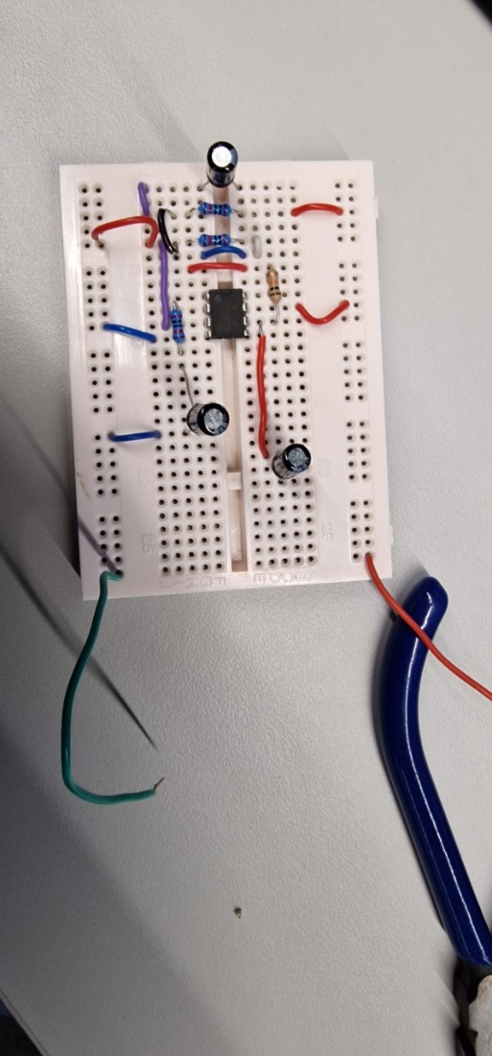
Paying close attention to the circuit diagram I connected the resistors then the capacitors and finally the wires placing all around the 741 chip as this made it easier to monitor the connections ensuring connections to each pin were correct.
During this process I kept in mind how the bread board connects components the center section moves up and down the board the top goes across allowing me to produce two rails a positive in red and a negative in blue. I intended to use black but did not have any black wires to had at the time.
This bread board worked but not to its initial intention as the resistors were the wrong strength. I had 3 20 and 1 10-ohm resistor. As such the amplifier was amplifying the signal incorrectly.
As show above the amplification level is 1.5 due to the resistor levels instead of the intended 3 that we would have got if the resistors were right.
Once the resistors were corrected the results are as below the orange line shows the input voltage and the blue shows the varying output of the amplifier.

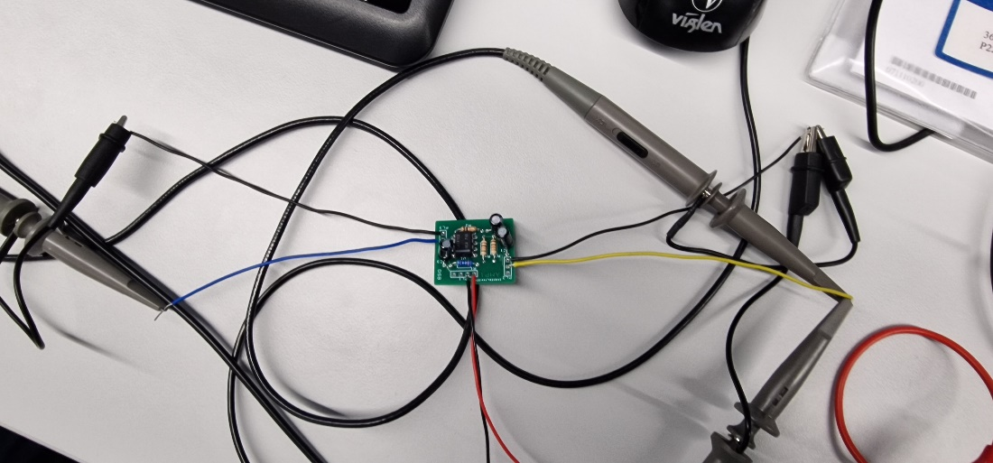

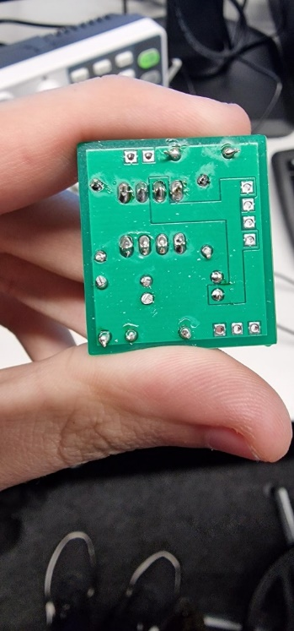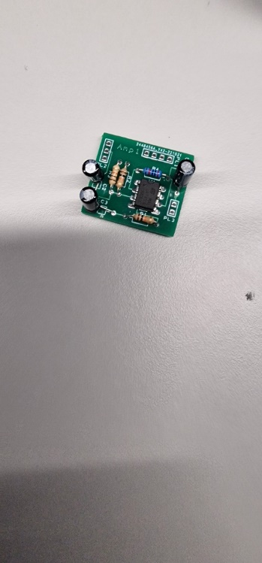
I soldered the low-lying components first finishing with the capacitors as the high components are easier to solder into the board later and the resistors and 741 chip are harder to fit into the circuit later.
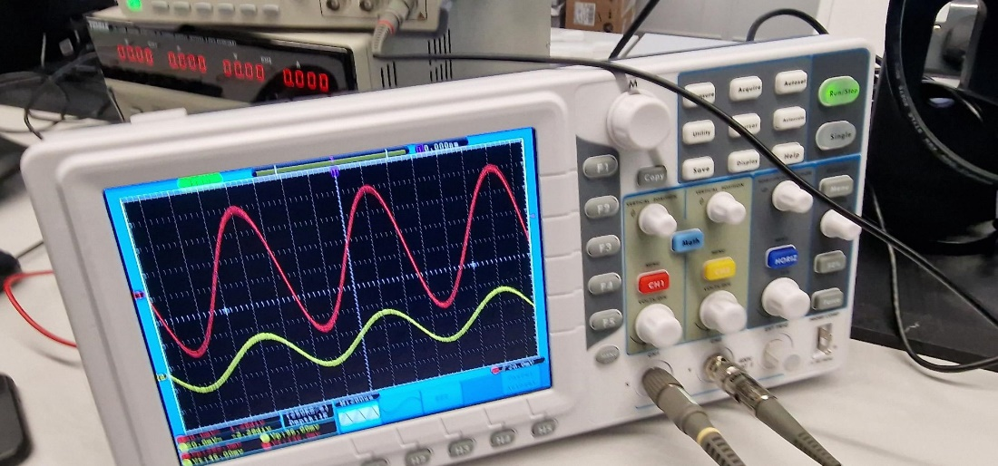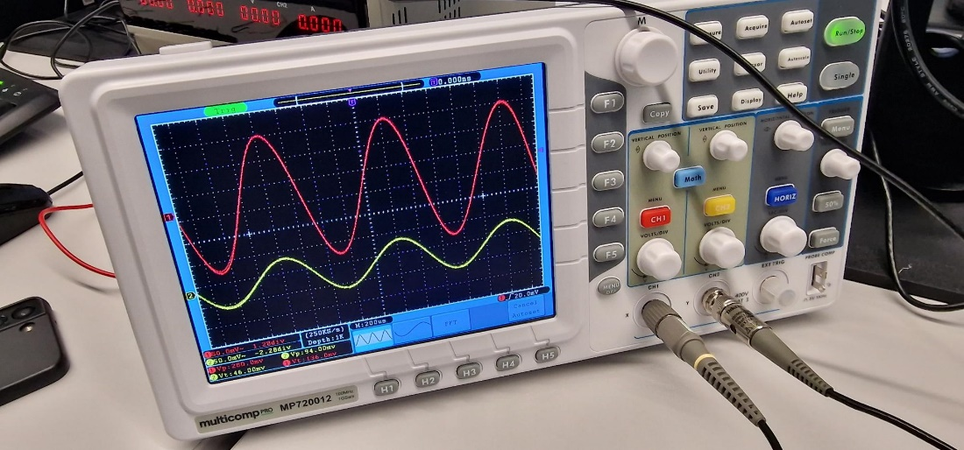
The circuit produce a gain of 3 on the initial input starting at 200 hz and outputting a 556 mv output.
Whereas at 1000 hz the board measured 228 mv

This shows the input voltage against the amplified voltage as shown the voltage

Finally, I place the bread board results against the pcb results and produced then table below the breadboard results dip and jump a bit more due to the inconsistency in the breadboards construction.

Finally I calculated the actual gain of the pcb
Using the half gain point of 0.707 x 232=164.024
64000 x 3 = 192000
192k

Overall the circuit performed as intended and the noise from the other components on the board was low and the wires like wise produced limited noise allowing for clean readings.
For future boards I would install molex cables as that will allow for cleaner connections and repeated connections with less interpretation.

