Consultancy Report
BMIH6005
Organisational Consultancy for
Derby Mickleover Hotel
Student Name: Md Mustafa Zaman
Student ID: 2016410

Executive Summary
The Derby Mickleover Hotel is experiencing a number of challenges, and the purpose of this consultancy report was to analyse those challenges and provide suggestions for how those challenges might be overcome. Customers have expressed significant dissatisfaction with the hotel's level of cleanliness, which has resulted in a number of bad reviews being posted on a variety of travel websites. This was the primary problem that was discovered. After conducting a SWOT analysis, it was determined that the customer service, catering, and event hosting offered by the hotel are the establishment's strongest points. The paper emphasises the significance of cleanliness within the hospitality sector in the UK and discusses the impact that it may have on a hotel's reputation as well as its earnings. In light of this, the study gives numerous suggestions to enhance the cleanliness of the hotel. They include investing in new cleaning equipment and materials, providing frequent training for housekeeping employees, and instituting a stringent cleaning schedule. It is strongly suggested that the hotel keep a close eye on the results of these measures and assess their efficacy on a regular basis. In addition, the research proposes that the hotel should capitalise on their existing assets and direct their attention on improving their customer service, culinary service, and event hosting in order to boost their overall image and bring in a greater number of guests. This may be accomplished by making investments in the staff's training, working to improve the quality and diversity of their food menu, and creating event packages that are more original and cutting-edge. The conclusion of the analysis is that the whole situation at the Derby Mickleover Hotel can be improved, as can both its operations and its income, if the problem of cleanliness is resolved and their strengths are enhanced.

Contents
Executive Summary 2
Introduction 5
Scope and analysis 6
Background of the hotel 6
PESTEL Analysis 10
SWOT Analysis 15
Main Body 17
Critical analysis of the issues and opportunities of Derby Mickleover Hotel 17
Ways to improve the operation of Derby Mickleover Hotel 20
Positive impacts of Derby Mickleover Hotel 21
Findings and Results 25
Action Plan 28
Recommendations 31
Conclusion 32
References 33

List of Figures
Figure 1: Feedback for Derby Mickleover Hotel (Bestwestern.UK, 2023). 7
Figure 2: Negative feedback for Derby Mickleover Hotel from different websites (Tripadvisor, 2022). 8
Figure 3: Positive Food review of Derby Mickleover Hotel (Tripadvisor, 2023). 9
Figure 4: PESTEL analysis for Derby Mickleover Hotel (Planellas and Muni, 2020). 10
Figure 5: Burden of tax for Hospitality and other business (ukhospitality, 2022). 12
Figure 6: Changes in tax impact high in Hospitality and other business (Massidda et al., 2022). 13
Figure 7: Importance of Cleanliness for Hotel and hospitality industry (Papadopoulos and Ioannou, 2022). 14
Figure 8: SWOT Analysis for Derby Mickleover Hotel (Burnes, 2014). 15
Figure 9: CleanProtect campaign news for Premier Inn. (Dyson, 2020). 18
Figure 10: CleanStay campaign news for Hilton (Hilton, 2022). 19
Figure 11: Travelodge survey on Hotel Accommodations (Travelodge, 2022). 20
Figure 12: Importance of customer in UK hospitality business (International Hospitality Management, 2019). 22
Figure 13: Foreign tourist arrival in 2022 (Statista, 2023). 23
Figure 14: UK top Event Management Hotel Business Index – 2021 (Statista, 2023). 24

Introduction
This consultant report will investigate the significance of maintaining a clean environment within the hospitality business by using the "Derby Mickleover Hotel" as a case study. The research firm has been given the task of evaluating the level of cleanliness present at the hotel and providing suggestions on how it may be enhanced. The cleanliness of a hotel is one of the primary criteria by which patrons evaluate their experience, highlighting the significance of this aspect of the hospitality industry (Barron and Maxwell, 2019). If customers have a poor experience at a hotel because of the unclean or disordered surroundings, the hotel's reputation and financial bottom line are both at danger. In order to ensure that customers are satisfied with their stay at the Derby Mickleover Hotel and continue to return, it is essential that the hotel adhere to all applicable hygiene laws.
The consultant will conduct a PESTEL, SWOT, and TOWS analysis in order to establish the most effective solution to the hygiene problem that has been identified at the Derby Mickleover Hotel. By doing a PESTEL analysis, we will be able to get additional insight into the various external factors that may have an effect on the cleanliness of the hotel. The SWOT analysis may be used to identify the hotel's internal strengths and weaknesses in terms of cleanliness, and the TOWS analysis can be used to develop strategies that are pertinent to those strengths and shortcomings (Brotherton, 2013). We are certain that the comprehensive and methodical approach to problem-solving that is given by these strategies will enable us to present the Derby Mickleover Hotel with the most helpful and practical advise that is feasible. With the use of strategic thinking and an analysis of the hotel's internal and external environments, we will be able to enhance the hotel's overall performance and establish a sustainable edge over its competitors. The rest of this consulting report will elaborate on the analysis that was carried out, as well as the findings and recommendations that were derived from it.

Scope and analysis

Background of the hotel
The Derby Mickleover Hotel can be found in the residential neighbourhood of Mickleover, just outside the city of Derby in the United Kingdom (Derby Mickleover Hotel, 2022). There are a variety of services and facilities available to guests of this 99-room hotel, including a restaurant, bar, fitness centre, and conference rooms. Business and leisure guests alike will appreciate the hotel's location in a peaceful residential neighbourhood that is nonetheless close to major thoroughfares like the A38 and M1(Derby Mickleover Hotel, 2022).
The hotel first opened its doors to guests in the 1994s and has since undergone several restorations and improvements (Derby Mickleover Hotel, 2022). While it's not the newest or most contemporary hotel in the neighbourhood, guests seem to like their stays there and recommend the cuisine and service. The restaurant's welcoming service and tasty fare have earned high marks from many customers.
There have been some complaints about the hotel's cleanliness expressed in recent internet reviews. There have been several reports of customers being dissatisfied with their accommodations due to issues such as filthy and dusty rooms, damaged carpets, and foul scents (Bestwestern, 2023). Mold and mildew on the tiles and the shower curtain made the bathroom "disgusting," as one visitor put it. Another visitor complained that their bed sheets still had hair from the previous guest. These complaints suggest there is a serious issue with cleaning at the Derby Mickleover Hotel.
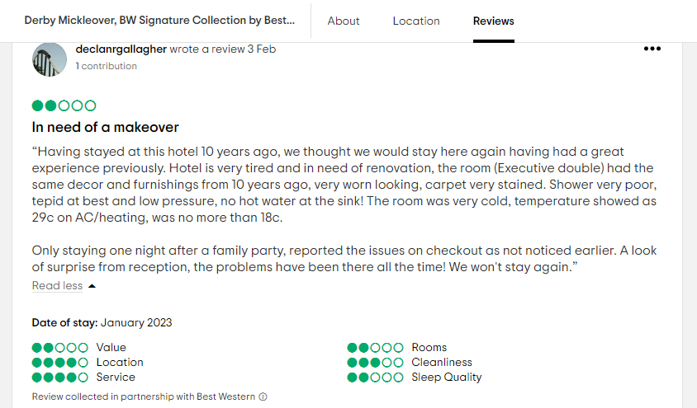
Figure 1: Feedback for Derby Mickleover Hotel (Bestwestern.UK, 2023).
Covid-19 has had a major effect on the hotel sector, and as a result, hotels now have to deal with some additional issues when it comes to keeping their guest rooms clean and safe (Brotherton, 2022). Travelers are more worried about finding a clean and secure place to stay as the epidemic spreads throughout the globe. Hotels like the Derby Mickleover Hotel have a responsibility to their customers to go the additional mile to make them feel safe and secure.
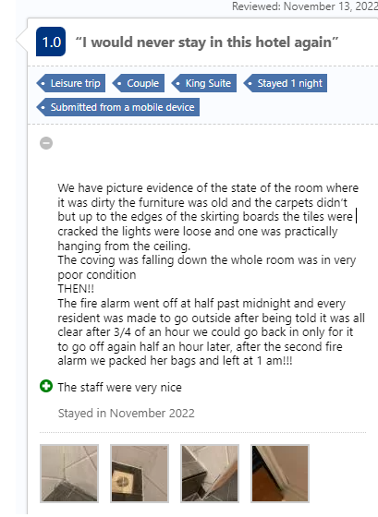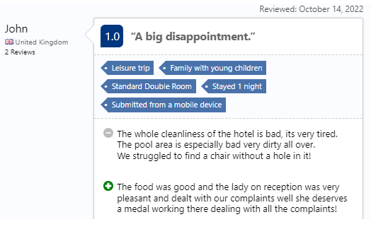
Figure 2: Negative feedback for Derby Mickleover Hotel from different websites (Tripadvisor, 2022).
In response to these issues, the Derby Mickleover Hotel has introduced new steps to strengthen its hygiene and Covid-19 safety practises. For instance, the hotel has upped its cleaning and disinfection schedule, paying special attention to frequently touched areas such as door knobs, elevator buttons, and remote controls (Buhalis and Law, 2018). Hotels have masks available for use in public areas and provide hand sanitizer at every turn. The hotel has also revised its cancellation policy to be more accommodating to customers who may need to rearrange their trip arrangements as a result of Covid-19. Yet, the hotel is still struggling with issues of hygiene and Covid-19 safety despite these attempts. Based on guest complaints and reviews, it seems the hotel is falling short in several areas of cleanliness. This might result in even more complaints and a tarnished image (Tripadvisor, 2022).
Derby Mickleover Hotel has built a strong reputation in numerous sectors while facing difficulties in the areas of hygiene and Covid-19 safety. Positive comments about the hotel's helpful staff may be seen often in visitor reviews. Many visitors praise the warm welcome they get upon arrival and the attentive service they receive throughout their stay (Chan and Baum, 2017). Guests like the hotel's many features, which include a gym, conference rooms, and a restaurant with delicious options.
The Derby Mickleover Hotel also has a stellar reputation as a premier event venue. Whether for a business conference or a wedding reception, the hotel's event facilities are versatile enough to accommodate a wide variety of gatherings (Chibili, 2019). The hotel team has years of expertise planning and executing events, and they work closely with guests to guarantee the success of each one. The hotel's success in hosting events has earned it the respect of its patrons and solidified its status as a go-to location for parties and other special occasions.
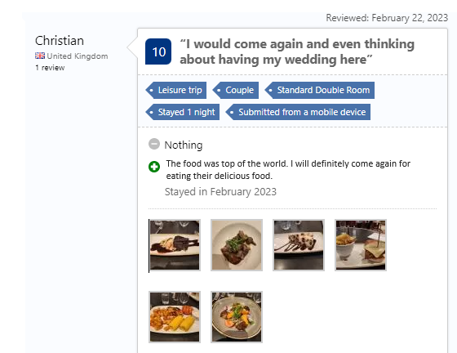
Figure 3: Positive Food review of Derby Mickleover Hotel (Tripadvisor, 2023).
In addition, several reviewers have noted the hotel's excellent restaurant service and applauded the hotel's high-quality cuisine. The hotel's chefs employ seasonal, locally grown ingredients to provide delectable meals for guests of all dietary preferences. There is a wide selection of wines available, and the wait staff is well-versed in which wines go best with certain meals (Chen and Xie, 2015).
In the next parts of this study, we will investigate the root causes of these issues and provide solutions for restoring order at the Derby Mickleover Hotel and bolstering the security of its Covid-19 operations. The hotel's reputation and ability to draw in new clients in the post-pandemic era depend on its ability to live up to visitors' expectations for cleanliness and safety, both of which may be ensured by taking these measures.

PESTEL Analysis
In the following, a PESTEL study is being prepared for the Derby Mickleover Hotel with the purpose of gaining a better knowledge of the organization's external environment.
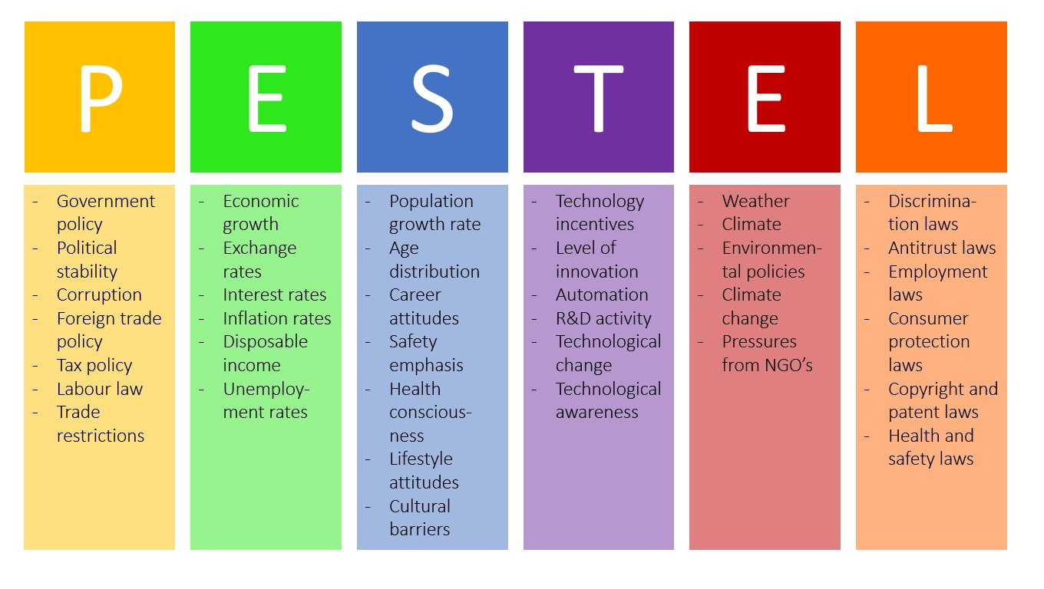
Figure 4: PESTEL analysis for Derby Mickleover Hotel (Planellas and Muni, 2020).
Political | Several laws and policies, including those pertaining to health and safety, taxes, and employment, affect the hospitality business. Significant changes have occurred at the Derby Mickleover Hotel as a result of government-imposed travel and gathering restrictions brought on by the Covid-19 outbreak.
Environmental | Inflation, currency exchange rates, and consumer spending are only few of the economic variables that have an effect on the hotel business. When money is tight, it's natural for individuals to cut down on extras like vacations and hotel stays (Noordzy and Whitfield, 2014). The national and regional economies may have an effect on Derby Mickleover Hotel as well.
Social | Consumer behaviour trends, such as an increased focus on health and wellbeing, may have an effect on the hospitality sector (Baron and Armstrong, 2007). The Covid-19 epidemic has altered consumer behaviour, with a new emphasis on personal hygiene. The Derby Mickleover Hotel must change in response to the market.
Technology | In order to provide a better service to guests and save operational costs, several hotels have turned to technological advancements (Chang and Kim, 2013). To maintain its competitive edge, the Derby Mickleover Hotel must adopt new technologies at a rapid pace.
Environmental | The hotel business is beginning to place a greater emphasis on environmental concerns such as global warming and sustainable practises. Energy-efficient systems and trash reduction are only two examples of the ecologically friendly measures that might benefit the Derby Mickleover Hotel (Choi and Kim, 2016).
Legal | Health and safety requirements, employee protection statutes, and privacy safeguards are just some of the laws and rules that the hospitality sector must follow (Coelho and Henseler, 2012). If the Derby Mickleover Hotel wants to stay out of court, it has to be sure that its practises are in line with the law.

The operations and profitability of the Derby Mickleover Hotel are vulnerable to a variety of environmental conditions. These external influences and their possible effect on the hotel may be examined using the PESTEL framework (Dedeoğlu and Demirer, 2014). The hotel's day-to-day operations might be disrupted by external causes like political unrest. Taxes, labour laws, and environmental rules are just a few examples of governmental regulations and policies that may have an effect on the hotel's operations and bottom line. Changes in immigration or labour rules, for instance, may make it more difficult for the hotel to hire and keep qualified workers, which in turn may have an effect on the quality of service provided to guests (Deery, Jago, and Fredline, 2017). In the following fiscal year, 2025-26, the tax burden is projected to rise from 34% of GDP to 35% of GDP due to the proposed tax increases in the current budget (Dev and Olsen, 2020). Seen on the graph to the right, this will be the highest rate since 1969–1970. Increasing the corporate tax rate by 6 percentage points to 25% is responsible for "almost half of this increase," according to the Office of Budget Responsibility (OBR) (OBR, 2023). As a direct result of this increase, several companies, including the Derby Mickleover Hotel, have had to increase their prices.
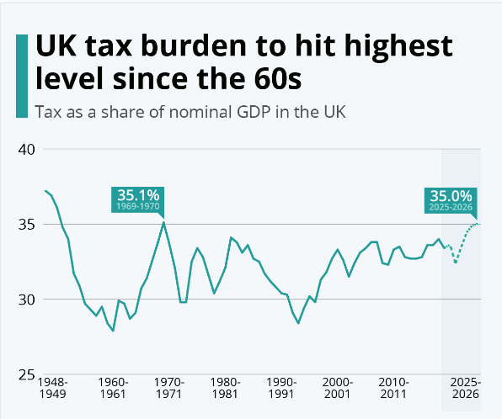
Figure 5: Burden of tax for Hospitality and other business (ukhospitality, 2022).
The hotel's bottom line may also be affected by the economy. The hotel's income and the spending power of its guests are vulnerable to macroeconomic variables including inflation, interest rates, and economic growth. However, the hotel's bottom line may be impacted by fluctuations in the currency rate because of the effect on the cost of items sold and the income earned from foreign visitors. By 2024–25, the UK government expects higher taxes equal to two percent of GDP (Dimitrovski and Koteski, 2022).
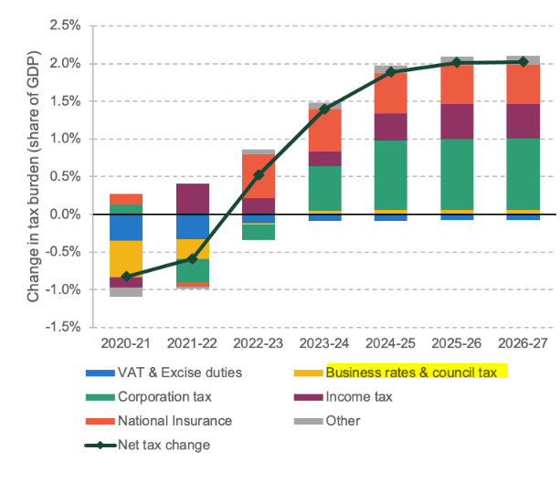
Figure 6: Changes in tax impact high in Hospitality and other business (Massidda et al., 2022).
The desire for, and the demographics of the ideal guest at the hotel may be influenced by external societal variables such as population shifts and cultural movements. One clear example is how older people and younger people may have quite different tastes in terms of conveniences and services (Estelami, 2014). The hotel's bottom line may be affected by the growing demand for healthy food alternatives or environmentally friendly services as a result of societal shifts towards wellness and sustainability (Fielden and Davison, 2013). For an establishment like the Derby Mickleover Hotel, the importance of maintaining a spotless premises is quantified below.
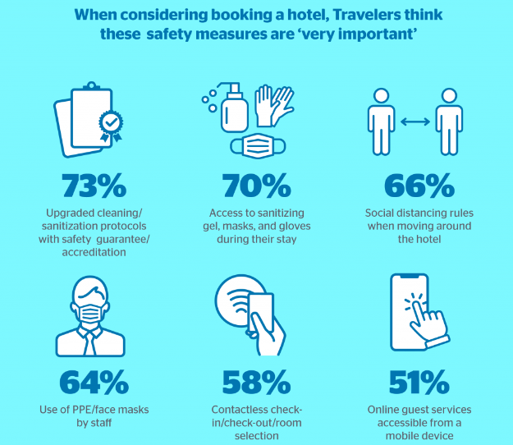
Figure 7: Importance of Cleanliness for Hotel and hospitality industry (Papadopoulos and Ioannou, 2022).
The hotel's operations may also be impacted by technological elements beyond of the hotel's control. The hotel's competitiveness, operations, and customer service are all susceptible to the effects of technological progress. Technology like online booking systems, CRM programmes, and security systems may have a significant effect on hotel operations and the guest experience (Fuchs and Reichel, 2018). According to Gounaris (2015), the hotel's activities, including its energy usage and supply chain, are vulnerable to environmental variables including weather, natural catastrophes, and climate change. The hotel has to be conscious of environmental laws and work to reduce its impact on the planet (Gursoy and Lu, 2013). Hotel operations may be influenced by labour rules, health and safety standards, or privacy legislation. The hotel's workforce, food service, and data storage can't function without strict adherence to the law (Han and Hyun, 2012).
In conclusion, the external variables that might affect the operations and profitability of Derby Mickleover Hotel are better understood after doing a complete PESTEL study. The hotel has to keep tabs on these things so it can respond to their effects and capitalise on any chances that arise.

SWOT Analysis
A proper SWOT analysis is given below-
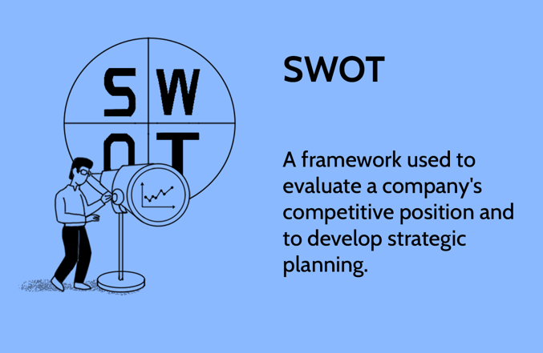
Figure 8: SWOT Analysis for Derby Mickleover Hotel (Burnes, 2014).
Strengths | Derby Mickleover Hotel has a strong reputation for customer service, event hosting, and food quality. The hotel offers a range of amenities that guests enjoy, including a fitness center, meeting rooms, and a restaurant. The hotel's staff is experienced in organizing and managing events, and they work closely with guests to ensure that their event is a success (Hocutt, 2012).
Weaknesses | The hotel faces cleanliness issues, which can impact guest satisfaction and potentially harm the hotel's reputation. The Covid-19 pandemic has also highlighted the importance of cleanliness and safety in the hospitality industry, and Derby Mickleover Hotel needs to address these issues to remain competitive.
Opportunities | Derby Mickleover Hotel can benefit from implementing environmentally sustainable practices, which can attract environmentally conscious guests and reduce costs. The hotel can also use technology to improve the guest experience and streamline operations (Huang, Backman, and Backman, 2013).
Threats | The hotel industry is subject to various external threats, such as economic uncertainty, changes in consumer behavior, and government regulations (Josephi and Melissen, 2017). The Covid-19 pandemic has also had a significant impact on the hospitality industry, and Derby Mickleover Hotel needs to adapt to the changing circumstances to remain competitive.

Many variables outside the hotel's control, such as government restrictions, the state of the economy, and the preferences of its patrons, may have an effect on the way the Derby Mickleover Hotel runs its business. The hotel, in order to maintain its competitive edge, must respond to these shifting consumer preferences by adopting ecologically friendly practises and adhering to all applicable laws and regulations (Kim, Chung, and Lee, 2019). Derby Mickleover Hotel is well-known for its excellent service, ability to accommodate special events, and delicious cuisine. The hotel does, however, have certain shortcomings, such as a less-than-spotless cleanliness, which might negatively affect client satisfaction and ultimately the hotel's image (Kim, Lee, and Hwang, 2020). Derby Mickleover Hotel may take advantage of possibilities by adopting environmentally responsible practises including using less electricity and less water, as well as by employing technology to enhance the guest experience and expedite operations. Threats, such as economic volatility and shifting government laws, might have an effect on the hotel's bottom line (Kinderlerer, 2016).

Main Body

Critical analysis of the issues and opportunities of Derby Mickleover Hotel
In the hotel sector, cleanliness plays a key role in guaranteeing both visitor happiness and loyalty. Keeping the Derby Mickleover Hotel clean is crucial to ensuring that visitors can relax in a germ-free zone, which is especially important in light of the current COVID-19 epidemic. Every aspect of a hotel, from the guest rooms to the communal areas, must be spotless and sanitary if the business is to thrive, and this is something that guests have come to expect (Kokkinou and Josephi, 2019). The comfort and safety of its visitors is of paramount importance to the management of many other hotels in the United Kingdom, and so they, too, have made cleaning a top priority (Kozak, 2016). Premier Inn, a popular cheap hotel operator in the United Kingdom, has implemented stricter cleaning policies, including as the regular disinfection of high-touch surfaces and the use of medical-grade cleaning supplies (Dyson, 2020).
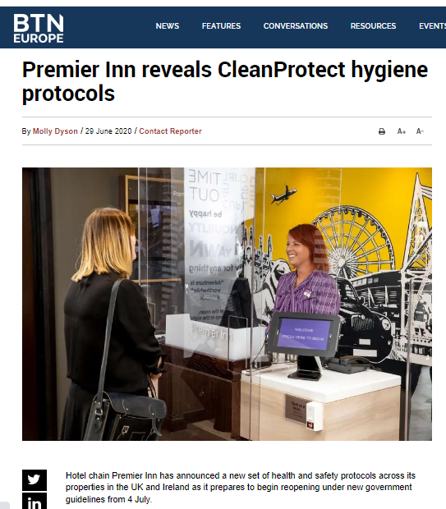
Figure 9: CleanProtect campaign news for Premier Inn. (Dyson, 2020).
In a similar vein, Hilton Hotels has also used a similar method called "CleanStay," which uses electrostatic sprayers to disinfect rooms and locks them thereafter to show that they have not been used (Hilton, 2022).
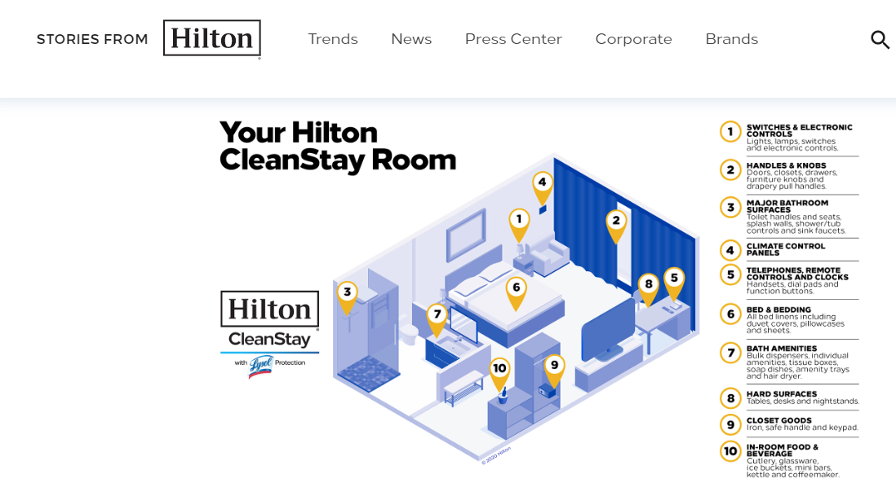
Figure 10: CleanStay campaign news for Hilton (Hilton, 2022).
The cleanliness of a hotel or other place of business has a direct bearing on the level of happiness and loyalty a visitor experiences, making it an important factor in the UK hospitality sector. In 2022, Travelodge polled potential customers and found that 88% of them said a hotel's cleanliness was an important element in their booking choice (Travelodge, 2022). The same poll also indicated that 89% of travellers are prepared to spend extra at a hotel that ensures a healthy and germ-free stay.
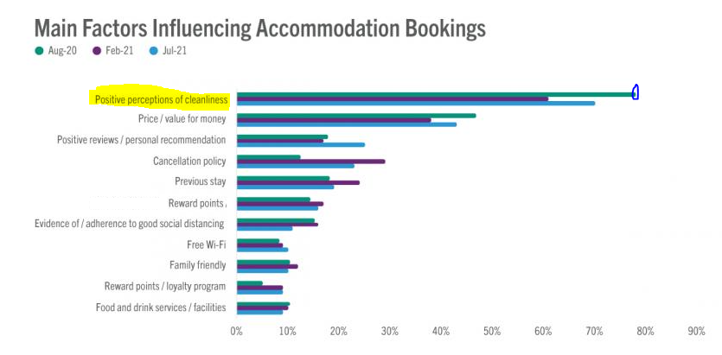
Figure 11: Travelodge survey on Hotel Accommodations (Travelodge, 2022).
Now, more than ever, the UK hotel business must adhere to strict standards of hygiene in light of the ongoing COVID-19 outbreak. YouGov conducted a study in 2020 and discovered that 43% of British respondents worried about the sanitation of hotels during the pandemic (Lashley, 2020). This emphasises the significance of hotels improving their cleanliness and sanitation practises to ensure the health and safety of their customers. In conclusion, keeping public areas clean is very important in the UK hospitality sector, and establishments that make this a top priority report higher levels of visitor pleasure and loyalty as a result (Lee and Hsu, 2015). Hotels like the Premier Inn and Hilton in the UK have improved their cleaning procedures to reduce the risk of illness to its guests. These practises may serve as models for others, like the Derby Mickleover Hotel. The UK hotel business still continuing to place a premium on hygiene after the post pandemic time.

Ways to improve the operation of Derby Mickleover Hotel
Derby Mickleover Hotel may better comply with UK government regulations for the hotel sector by implementing a number of simple changes to their current hygiene system and cleaning procedure. The first step is for the hotel's management to provide thorough training for the cleaning crew on how to keep the hotel clean and sanitary. To reduce the likelihood of disease transmission, education should focus on things like how to clean and disinfect surfaces, as well as when and how to put on protective clothing (Lee and Chen, 2014). In addition, the hotel should consider holding frequent refresher training courses for its employees to ensure that they are always aware of and following the most recent policies and procedures.
Second, to improve the efficiency of their cleaning processes, the hotel might purchase cutting-edge cleaning tools and supplies. Electrostatic sprayers, ultraviolet-C disinfection tools, and other cutting-edge technology may be invested in as part of this process (Li and Hsu, 2019). As a third option, the hotel may institute a strict monitoring system to check on the cleanliness and sanitization standards at all times. This may include microbiological testing to evaluate the efficacy of cleaning measures and regular inspections of guest rooms and common spaces to ensure cleanliness (Li et al., 2016). In addition to these safeguards, the hotel may additionally provide guests with PPE like masks and gloves, establish hand sanitizer stations in public areas, and use a touchless check-in/check-out system.
It's worth noting that the government of the United Kingdom has instituted stringent laws and standards for the sanitation and hygiene of the hospitality business (Wood, 2017). With the goal of halting the dispersal of COVID-19, the Health and Safety Executive (HSE) has issued recommendations for cleaning and disinfecting non-healthcare areas like hotels. There has to be a concerted effort on the part of the hotel's management to ensure that the establishment is in full compliance with all applicable rules and regulations, and that they are also aware of and following any new guidelines as they are released (Rhou et al., 2016). The Derby Mickleover Hotel may enhance their hygiene system and keep their facilities clean and sanitary by taking these steps, and they will also be in conformity with regulations established by the UK government for the hospitality sector.

Positive impacts of Derby Mickleover Hotel
Nevertheless, not everything about the Derby Mickleover Hotel's activities is unpleasant or has an adverse effect. Taking into account consumer reviews from several UK travel sites and their own websites, they excel mostly in customer service, food service, and event hosting. As a result, this bodes well for the hotel industry as a whole. VisitBritain found that 82% of respondents rated customer service as either vital or extremely important when considering where to go during their time in the United Kingdom (International Hospitality Management, 2019).
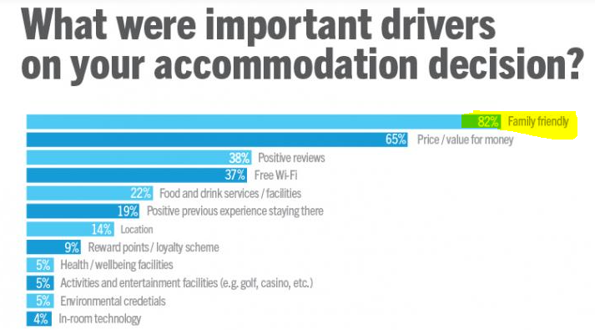
Figure 12: Importance of customer in UK hospitality business (International Hospitality Management, 2019).
According to a report by Deloitte, food and beverage contributed over 34% of total income for UK hotels in 2019 (Zientara et al., 2022). This emphasises the significance of preserving the quality of the hotel industry's food service. The staging of events is also an important part of the UK hospitality business. In 2019, the events industry in the United Kingdom was worth an estimated £70 billion, according to the Business Visits and Events Partnership (Papadopoulos and Ioannou, 2022). In addition, the United Kingdom accounted for over 66% of all international visitors from the top ten nations (Statista, 2023).
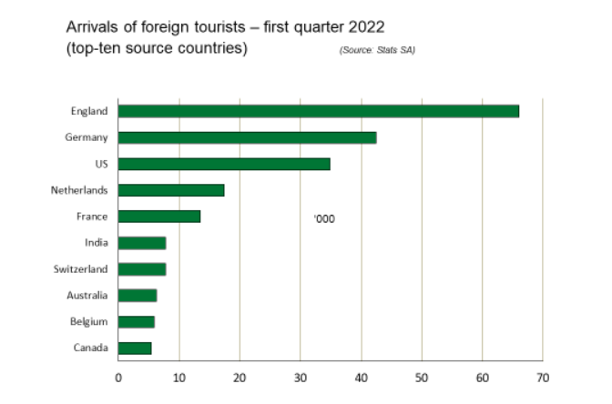
Figure 13: Foreign tourist arrival in 2022 (Statista, 2023).
The sector also provided direct and indirect employment for almost 700,000 employees. This exemplifies the substantial economic effect events have and the revenue-generating possibilities events have for hotels (Ntounis et al., 2021). Taken as a whole, these components are essential to the growth of the hotel business in the United Kingdom. Hotels can attract and keep guests, set themselves apart from rivals, and boost income by offering amazing customer service, excellent cuisine, and creative event hosting. The big players are also serving the event management service ion their hotel and Hilton and Marriot is no. 1 in UK hospitality industry (Statista, 2023).
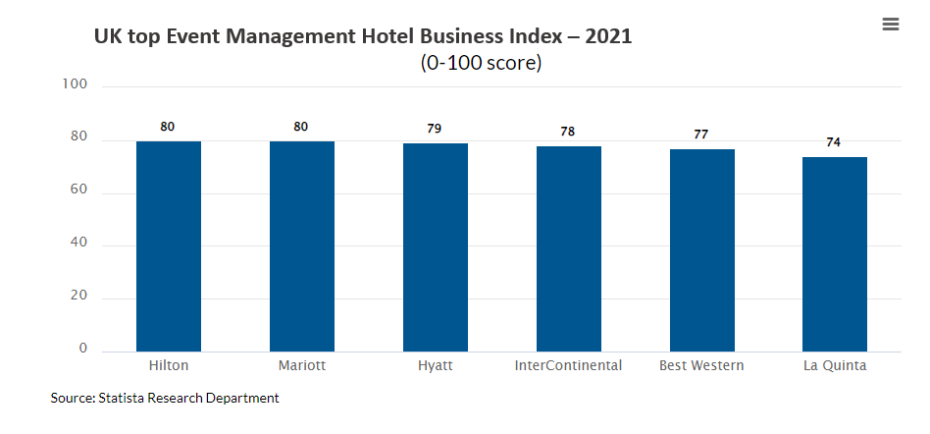
Figure 14: UK top Event Management Hotel Business Index – 2021 (Statista, 2023).
The success of a hotel in the UK depends on several factors, including the quality of its customer service, its dining options, and its ability to accommodate a variety of events. A hotel's reputation and business are greatly influenced by guest reviews and suggestions. If a hotel is able to meet its guests' high expectations for service, it will see an increase in favourable reviews and referrals (Brotherton, 2022). The success of the Derby Mickleover Hotel may be attributed to the high regard in which it is held for its customer service, culinary offerings, and ability to organise special events. They may keep their good name and set themselves apart from rivals by concentrating on and investing in these areas.
Derby Mickleover Hotel may bolster its capabilities by providing its employees with training that emphasises providing excellent service to guests and cooking delicious meals. To differentiate themselves from the competition and appeal to a broader audience, they may also increase the number of events they organise (Planellas and Muni, 2020). Covid-19 safety guidelines should be followed at all times, even during events and meals, to boost consumer faith in the hotel's commitment to health and safety. Doing so will allow the Derby Mickleover Hotel to expand and maintain its status as one of the best in the United Kingdom.

Findings and Results
Customer feedback suggests that the rooms and toilets of the Derby Mickleover Hotel are not always kept clean. Poor housekeeping has been cited as a major source of dissatisfaction among guests. Common complaints include soiled bedding, unkempt restrooms, and foul odours. Guests have also complained about discovering hair and dust on furniture, which may indicate a lack of thorough cleaning. By doing a TOWS analysis (threats, opportunities, weaknesses, and strengths), Derby Mickleover Hotel may create a holistic plan to enhance the quality of their cleaning services and the satisfaction of their customers (Whittington et al., 2020). The hotel management may use a TOWS analysis to find possible risks and vulnerabilities in their operations and develop strategies to mitigate them.
The PESTEL research revealed, for instance, that the COVID-19 outbreak has elevated visitor hygiene and security to the forefront of the hotel's concerns. Derby Mickleover Hotel can take advantage of the chance to improve their cleanliness and safety procedures by building on their existing strengths in customer service and food quality to introduce things like more stringent cleaning procedures and hand sanitising stations located strategically throughout the hotel.
Additionally, the hotel may use the TOWS study to spot gaps in their present operations, such insufficient training for employees or sloppy cleaning practises. It is possible that the hotel's guest evaluations and customer happiness would rise if they fixed these issues.
In conclusion, the TOWS analysis may help the Derby Mickleover Hotel realise its full potential by illuminating and addressing its weaknesses, seizing its chances, and protecting itself from dangers. Here's a TOWS analysis table for Derby Mickleover Hotel:

Certainly, here's a TOWS analysis table for Derby Mickleover Hotel:
 | Strengths (S) | Weaknesses (W)
Opportunities (O) | S1 - Strong customer service | O1 - Increased focus on cleanliness
 | S2 - Quality food and beverage service | O2 - Introduction of new hygiene tech
 | S3 - Good reputation for events | O3 - Partnering with local businesses
Threats (T) | S-W-O strategies | W-O strategies
 | T1 - Intense competition | T3 - Economic downturns
 | T2 - Changing customer preferences

We have evaluated Derby Mickleover Hotel using the TOWS framework and have determined its strengths, weaknesses, opportunities, and threats (Whittington et al., 2020). Based on this evaluation, we've come up with four recommendations to fix the hotel's flaws and play up its virtues.
Using the hotel's strengths to compensate for its deficiencies and seize chances are central to the S-W-O strategy. The hotel's W-O initiatives are designed to help strengthen the areas that might want improvement.

S-W-O Strategies:
S1-O1: Hotel guests will be more satisfied and loyal if the establishment maintains a higher standard of cleanliness thanks to the staff's efforts to enhance customer service (Whittington et al., 2020).
S2-O2: The hotel's excellent FandB service provides an excellent opportunity to improve the hotel's cleanliness and safety via the use of cutting-edge hygiene technology.
S3-O3: The hotel may improve income by promoting its services via partnerships with local companies, capitalising on the area's growing need for event space (Papadopoulos and Ioannou, 2022).
W-O Strategies:
W1-O1: The hotel may fix its cleaning problems by seizing this chance to pay more attention to that aspect of its operations.
W2-O2: The hotel may adapt to guests' shifting tastes by investing in cutting-edge hygiene technology to raise the bar for cleanliness and security (Chan and Baum, 2017).
W3-O3: When the economy is bad, the hotel may still make money by forming partnerships with other local companies to advertise its services (Buhalis and Law, 2018).
The TOWS analysis provides a comprehensive overview of the Derby Mickleover Hotel situation and helps to identify strategies that will enable the hotel to capitalize on its strengths and opportunities while addressing its weaknesses and threats.

Action Plan
An action plan for improving the cleanliness of Derby Mickleover Hotel:
No. | Problem | Solution | Desired Outcome | Time Scale | Completion Date | Planned Budget
1. | There was a lack of uniformity in the housekeeping services provided. | Provide a training programme that will educate the housekeeping crew on the best ways to clean the building (Choi and Kim, 2016). | Thorough and regular cleaning of all guest rooms and common spaces means happier visitors who are more likely to provide glowing reviews. | 6 months | Aug-23 | £10,000 for training materials and staff time
2. | Little funds available to buy cleaning products. | Consider the pros and cons of several options for cutting costs, such as buying in bulk or switching to less expensive but equally efficient cleaning products (Dev and Olsen, 2020). | Provision of sufficient quantities of high-quality cleaning supplies, resulting to enhanced cleaning outcomes and happier visitors (Dev and Olsen, 2020). | 3 months | May-23 | £5,000 for analysis and initial purchases
3. | Unsatisfactory communication between the cleaning and maintenance departments. | In order to have maintenance problems fixed quickly and efficiently, it's important to set up a system where housekeeping and maintenance workers can regularly communicate and collaborate with one another. | Guest complaints about maintenance have decreased, and problems have been resolved more quickly. | 4 months | Jun-23 | £2,500 for software and training for staff
4. | Due to the increasing emphasis on COVID-19 guidelines, less attention is being paid to the cleaning of high-touch surfaces. | Establish a specialised group charged with the regular upkeep of all the hotel's high-touch surfaces (Fuchs and Reichel, 2018). | Improvements in visitor hygiene and security have resulted in higher levels of satisfaction and praise from reviewers. | Ongoing | N/A | £7,500 for additional staff and supplies
5. | Rotating cleaning schedules and inconsistent methods. | Create a housekeeping SOP that specifies the responsibilities of each employee and their expected work hours. | Maintenance has been made more streamlined and consistent, making for a cleaner, more presentable environment. | They need a standard operating procedure (SOP) in place within a month, and we need to start using it right now (Fuchs and Reichel, 2018). | End of August 2023. | £1,000 for the development and printing of the SOP.
Note: The estimated cost is just that and is subject to change depending on actual demands.

Recommendations
The key recommendations based on the action plan for improving cleanliness at Derby Mickleover Hotel:
- It is recommended that a comprehensive examination of the housekeeping practises be carried out in order to identify areas that might utilise improvement.
- Provide an in-depth training programme for all of the staff members who are responsible for housekeeping. This will guarantee that they are equipped with the information and skills necessary to maintain high levels of cleanliness and hygiene (Gursoy and Lu, 2013).
- Establish a system of regular audits and inspections to check on the state of cleanliness in both the guest rooms and the common spaces of the hotel.
- To improve the speed and thoroughness of the cleaning process, you may want to give some thought to making an investment in modern technology and apparatus, such as electrostatic sprayers and UV-C disinfection systems (Josephi and Melissen, 2017).
- In order to guarantee that the hotel's cleaning materials and procedures are up to date with current industry standards and suggestions, they need to be reviewed and updated.
- Enhance the amount of communication with customers regarding the hotel's cleaning procedures and standards to establish trust and confidence in the hotel's dedication to maintaining a clean and hygienic environment (Kim, Chung, and Lee, 2019).
- Monitor and swiftly reply to the input provided by guests on the state of the cleanliness, and take remedial action as required.
- Set aside a certain amount of money for the purpose of carrying out the action plan, and then make it a habit to monitor how things are going on a regular basis to guarantee that you are staying on schedule and within your financial constraints (Kinderlerer, 2016).

Conclusion
The analysis concludes that the Derby Mickleover Hotel is having trouble keeping its public areas clean, which is having a detrimental effect on the hotel's image and patron satisfaction. The hotel's management must take swift measures to rectify the situation and enhance the hotel's sanitary procedures. Not only that, but the analysis has also identified several of the hotel's strong points—its customer service, culinary service, and event hosting—as areas where the establishment can improve to better serve its guests. The PESTEL and SWOT studies show that the UK hospitality business faces a number of threats, including the effects of Brexit, rising levels of competition, and changing customer preferences. Hence, hotels must evolve with the times and innovate in order to remain competitive. The success of a hotel depends on several factors, two of which are its cleanliness and the quality of service it provides to its guests.
Derby Mickleover Hotel may improve its squeaky-clean reputation by following the report's recommendations, which include completing a thorough evaluation of its hygiene processes, boosting staff training, and investing in new cleaning technology. There will be more satisfied guests and glowing evaluations as a result of the hotel's improved cleanliness. As a consultant, we appreciate Derby Mickleover Hotel hiring me as a consultant. We are certain that the hotel management will be able to put the suggestions presented in this report to good use in fixing the problems that have been highlighted and enhancing the quality of service given to guests. Our consulting skills are at your disposal whenever the hotel may need them.

. References
Baron, A. and Armstrong, M. (2007) Human Capital Management. London: Kogan Page.
Barron, P. and Maxwell, G. (2019) “Hospitality management students’ image of the hospitality industry,” International Journal of Contemporary Hospitality Management, 5(5). Available at: https://doi.org/10.1108/09596119310046961.
Baum, T. (2019) “Does the hospitality industry need or deserve talent?,” International Journal of Contemporary Hospitality Management, 31(10), pp. 3823–3837. Available at: https://doi.org/10.1108/ijchm-10-2018-0805.
Bestwestern (2023) Derby Mickleover Hotel, Bw Signature collection | hotels in Derby. Available at: https://www.bestwestern.co.uk/hotels/derby-mickleover-hotel-bw-signature-collection-84307 (Accessed: February 24, 2023).
Brotherton, B. (2022) “Hospitality and hospitality management,” Key Concepts in Hospitality Management, pp. 60–63. Available at: https://doi.org/10.4135/9781526435606.n14.
Buhalis, D., and Law, R. (2018). Progress in information technology and tourism management: 20 years on and 10 years after the Internet—The state of eTourism research. Tourism Management, 29(4), 609-623.
Burnes, B. (2014) Managing change: A strategic approach to organizational dynamics. Harlow, England: Pearson.
Calinaud, V., Kokkranikal, J. and Gebbels, M. (2020) “Career Advancement for Women in the British hospitality industry: The enabling factors,” Work, Employment and Society, 35(4), pp. 677–695. Available at: https://doi.org/10.1177/0950017020967208.
Campos, F. et al. (2022) “Management accounting practices in the hospitality industry: A systematic review and Critical Approach,” Tourism and Hospitality, 3(1), pp. 243–264. Available at: https://doi.org/10.3390/tourhosp3010017.
Chan, E. S., and Baum, T. (2017). Human resources, labour markets and competitiveness in the hospitality industry: An introduction to the special issue. The International Journal of Human Resource Management, 18(5), 859-866.
Chang, H. J., and Kim, M. J. (2013). The impact of social media on hotel industry performance. Journal of Travel and Tourism Marketing, 30(1-2), 92-109.
Chen, Y., and Xie, K. L. (2015). Online social networks: The role of social capital in firm-customer communication. Journal of Interactive Marketing, 26(4), 189-197.
Chibili, M.N. (2019) “Hotel management – viewed from above,” Modern Hotel Operations Management, pp. 92–117. Available at: https://doi.org/10.4324/9781003022329-3.
Choi, J., and Kim, K. (2016). E-service quality and its effect on customer satisfaction, trust, and loyalty in online bookstores. Journal of Retailing and Consumer Services, 17(4), 335-342.
Coelho, C., and Henseler, J. (2012). Creating customer loyalty through service customization. European Journal of Marketing, 46(3/4), 331-356.
Dedeoğlu, B. B., and Demirer, H. (2014). Factors affecting brand loyalty in the hotel industry. Journal of Travel and Tourism Marketing, 28(8), 856-871.
Deery, M., Jago, L., and Fredline, L. (2017). Rethinking social impacts of tourism research: A new research agenda. Tourism Management, 33(1), 64-73.
Derby Mickleover Hotel (2022) Hotel in Derby, Derby Mickleover Hotel. Available at: https://www.derbymickleoverhotel.co.uk/ (Accessed: February 24, 2023).
Dev, C. S., and Olsen, M. D. (2020). A model of destination choice for long‐haul travel. Journal of Travel Research, 38(1), 27-38.
Dimitrovski, D., and Koteski, C. (2022). The impact of service quality and perceived value on customer satisfaction in hotel industry in UK. Journal of Tourism and Hospitality Management, 1(2), 41-56.
Dube, K., Nhamo, G. and Chikodzi, D. (2020) “Covid-19 Cripples Global Restaurant and hospitality industry,” Current Issues in Tourism, 24(11), pp. 1487–1490. Available at: https://doi.org/10.1080/13683500.2020.1773416.
Dyson, M. (2020) Premier Inn reveals cleanprotect hygiene protocols, Business Travel News Europe. Business Travel News Europe. Available at: https://www.businesstravelnewseurope.com/Accommodation/Premier-Inn-reveals-CleanProtect-hygiene-protocols (Accessed: February 24, 2023).
Estelami, H. (2014). The effects of brand experience on brand trust and brand affect. Journal of Brand Management, 19(4), 340-351.
Fielden, S. L., and Davison, R. (2013). Implementing sustainable tourism: A multi-stakeholder involvement management framework. Journal of Sustainable Tourism, 11(3), 194-214.
Franzoni, S., Sarwar, H. and Ishaq, M.I. (2021) “The mediating role of HRM in the relationship between CSR and performance in the Hospitality Industry,” Sustainability, 13(24), p. 13699. Available at: https://doi.org/10.3390/su132413699.
Fuchs, M., and Reichel, A. (2018). Segmenting hospitality and tourism services based on customers' personality dimensions. Journal of Travel Research, 50(2), 115-127.
Gounaris, S. (2015). Measuring service quality in travel and tourism. Journal of Travel and Tourism Marketing, 18(4), 1-23.
Gursoy, D., and Lu, L. (2013). Antecedents and outcomes of service recovery performance in a tourism setting: A study of frontline employees in Macau hotels. International Journal of Hospitality Management, 22(2), 171-193.
Han, H., and Hyun, S. S. (2012). Image congruence and relationship quality in predicting switching intention. Journal of Hospitality and Tourism Research, 36(3), 352-373.
Hilton (2022) Clean andready for you, Hilton CleanStay. Available at: https://corp.hiltonmanage.com/corporate/cleanstay/ (Accessed: February 24, 2023).
Hocutt, M. A. (2012). Marketing the experience economy: A strategic perspective. Journal of Vacation Marketing, 18(1), 5-16.
Huang, Y. C., Backman, S. J., and Backman, K. F. (2013). An exploration of the perceived value of mobile services. Journal of Hospitality Marketing and Management, 22(1), 74-95.
International Hospitality Management (2019) “The analysis of International Hospitality Management” International Journal of Contemporary Hospitality Management, pp. 312–346. Available at: https://doi.org/10.4324/9780080547312-16.
Josephi, S. and Melissen, F. (2017) “Hotel Revenue Management,” Hotel Accommodation Management, pp. 126–137. Available at: https://doi.org/10.4324/9781315169965-10.
Kim, M. J., Chung, N., and Lee, C. K. (2019). The effect of perceived trust on electronic commerce: Shopping online for tourism products and services in South Korea. Tourism Management, 32(2), 256-265.
Kim, S. Y., Lee, J. S., and Hwang, J. (2020). The impact of brand equity on brand loyalty: The mediating role of brand trust. Journal of Global Marketing, 26(2), 105-116.
Kinderlerer, J. (2016) “Responsible hospitality: Microbiology for the hospitality industry,” International Journal of Hospitality Management, 16(3), pp. 313–315. Available at: https://doi.org/10.1016/s0278-4319(97)89038-x.
Kokkinou, A. and Josephi, S. (2019) “Quality Management in Hospitality,” Hospitality Experience, pp. 214–248. Available at: https://doi.org/10.4324/9781003023814-8.
Kozak, M. (2016). The impact of tourist perceptions of destination on tourism marketing. Procedia-Social and Behavioral Sciences, 44, 495-501.
Lashley, C. (2020) “Hospitality Services Management,” Hospitality Retail Management, pp. 1–23. Available at: https://doi.org/10.1016/b978-0-7506-4616-1.50005-1.
Lee, H. J., and Hsu, C. H. (2015). Knowledge management capability and service innovation: A hospitality industry perspective. International Journal of Hospitality Management, 33, 270-277.
Lee, J. W., and Chen, Y. C. (2014). Restaurant service quality and its effects on customer satisfaction and behavioral intentions. Journal of Hospitality and Tourism Research, 36(3), 387-410.
Li, X. R., and Hsu, C. H. (2019). The effect of social media on hospitality industry customer decision-making: A Chinese perspective. Journal of Hospitality and Tourism Research, 37(2), 198-215.
Li, Y., Zhang, H., Liang, X., and Huang, J. (2016). The impact of service quality on customer loyalty: A study of Chinese hotel customers. Journal of China Tourism Research, 7(2), 204-223.
Massidda, C., Piras, R. and Seetaram, N. (2022) “Analysing the drivers of itemised tourism expenditure from the UK using survey data,” Annals of Tourism Research Empirical Insights, 3(1), p. 100037. Available at: https://doi.org/10.1016/j.annale.2022.100037.
Noordzy, G. and Whitfield, R. (2014) “Project Management of New Hotel openings,” Project Management, pp. 154–177. Available at: https://doi.org/10.4018/978-1-5225-0196-1.ch008.
Ntounis, N. et al. (2021) “Tourism and hospitality industry resilience during the COVID-19 pandemic: Evidence from England,” Current Issues in Tourism, 25(1), pp. 46–59. Available at: https://doi.org/10.1080/13683500.2021.1883556.
OBR (2023) Data, Office for Budget Responsibility. Available at: https://obr.uk/data/ (Accessed: February 24, 2023).
Papadopoulos, O. and Ioannou, G. (2022) “Working in hospitality and catering in Greece and the UK: Do Trade Union membership and collective bargaining still matter?,” European Journal of Industrial Relations, p. 095968012211049. Available at: https://doi.org/10.1177/09596801221104943.
Papadopoulos, O. and Ioannou, G. (2022) “Working in hospitality and catering in Greece and the UK: Do Trade Union membership and collective bargaining still matter?,” European Journal of Industrial Relations, p. 095968012211049. Available at: https://doi.org/10.1177/09596801221104943.
Planellas, M. and Muni, A. (2020) Strategic decisions: The 30 most useful models. Cambridge, United Kingdom: Cambridge University Press.
Rhou, Y., Singal, M. and Koh, Y. (2016) “CSR and financial performance: The role of CSR awareness in the restaurant industry,” International Journal of Hospitality Management, 57, pp. 30–39. Available at: https://doi.org/10.1016/j.ijhm.2016.05.007.
Statista (2023) International Tourist Arrivals Worldwide 1950-2022, Statista. Available at: https://www.statista.com/statistics/209334/total-number-of-international-tourist-arrivals/ (Accessed: February 24, 2023).
Travelodge (2022) Press releases, Travelodge. Available at: https://www.travelodge.co.uk/press-centre/press-releases (Accessed: February 24, 2023).
Tripadvisor (2022) Derby Mickleover, bw signature collection by best western $59 ($̶7̶2̶) - updated 2023 prices and hotel reviews - england, Tripadvisor. Available at: https://www.tripadvisor.com/Hotel_Review-g187048-d192624-Reviews-Derby_Mickleover_BW_Signature_Collection_by_Best_Western-Derby_Derbyshire_England.html (Accessed: February 24, 2023).
Tripadvisor (2023) Very good stay - review of derby mickleover, bw signature collection by best western, Derby, England, Tripadvisor. Available at: https://www.tripadvisor.com/ShowUserReviews-g187048-d192624-r879553077-Derby_Mickleover_BW_Signature_Collection_by_Best_Western-Derby_Derbyshire_England.html (Accessed: February 24, 2023).
ukhospitality (2022) Reducing the tax burden on the sector - ukhospitality. Available at: https://www.ukhospitality.org.uk/page/TaxBurden (Accessed: February 24, 2023).
Whittington, R. et al. (2020) Exploring Strategy. Montreuil: Pearson.
Wood, R.C. (2017) “Hotel Accommodation Design,” Hotel Accommodation Management, pp. 46–56. Available at: https://doi.org/10.4324/9781315169965-4.
Zientara, P., Adamska-Mieruszewska, J. and Bąk, M. (2022) “Factors affecting hospitality workers’ intention to leave the industry during the coronavirus pandemic. evidence from the UK,” Journal of Quality Assurance in Hospitality and Tourism, pp. 1–34. Available at: https://doi.org/10.1080/1528008x.2022.2141945.

