.

Student Name: Chene Davis
Student Number: 1914509
Module Code: BMSW4005
Lecturer: Charles Nimoh
Assignment Title: Portfolio of Work.

Context page

PAGE – 3 – Introduction

PAGE 4-5 – Personal Development Plan.

PAGE 5-8– Theory

PAGE 9-10 – Self Refection.

PAGE 11 – References

Introduction.

This report is going to be based entirely on the benefits of the outcome of the whole course in general, the theory that’s best to describe which training would be ideal for certain individuals and how a pdp works and how to make one.
This course has helped me in so many ways in building my confidences up, made me believe in myself much more to beilive I can do anything I put my mind to which is the keys thing in the matter.
There is many benefits you can take from making a dpd or even having a pdp one being “goals” you can set yourself and many goals as you want alongside a time frame in when you want these goals to be set to achieved. Having a dpd can also be helpful in serval many ways. Where you won’t need to keep setting yourself new goals, to get where you need to. At the start of the pdp you there to make them goals as well as setting yourself targets to achieve and develop yourself further along journey or path you want. Helping you to never lose track in your progress.
GOAL | ACTION | SKILLS REQUIRED | SKILLS I NEED TO DEVELOP | TARGET DATE
Fully understand everything electrical | - Go back to college.  - Read More books.  - Ask collages for help.  - Use internet. | - NVQ Level 3 In electrical installation  - AM2  - BS7671:2018 18th Edition of Electrical Wiring Regulations  - City & Guilds 2391 | - Inspecting and testing  - Fault Finding and Diagnosis  - Damage and malfunctions  - Working Solo | 2021-2022
Fully Qualify as an electrician. | - Study  - Practice  - Join & Pass college.  - Join a new electrical company | - The ability to use, repair and maintain machines and tools.  - Knowledge of building and construction.  - Maths knowledge for understanding technical plans.  - To be thorough and pay attention to detail. | - Independent problem solving  - Time management  - Maintain a positive attuite.  - Never Stop Learning. | 2021-2022
Become an electrical supervisor. | - Find a company.  - Train and Practice  - Go for the course | - Previous leadership experience.  - Excellent communication skills.  - Eye for detail and accuracy.  - Reliable, with high integrity and strong work ethic | - Multitask  - Learning quickly  - Reading Comprehension  - Training | 2021-2022
Run my own electrical business | - Do research  - Make a business plan  - Read and understand my step by step guild.  - Put plan to action | - Communication and negotiation.  - Leadership.  - Project management and planning.  - Delegation and time management. | - Networking.  - Problem solving  - Marketing, sales and customers  - Business Skills | 2021-2022
PERSONAL DEVELOPMENT PLAN.

(2016). Guidance On Developing Personal Development Plan. [online] Available at: <http://www.docs.csg.ed.ac.uk> [Accessed 28 March 2016].

Pdp.albany.edu. (2020). The Professional Development Program—PDP. [online] Available at: <https://www.pdp.albany.edu/> [Accessed 29 November 2020].

This is my Personal development planning which is the process of my goals I want to achieve and the time period that I want to complete them in. With this I have established aims and objectives mainly would say my goals. The ones I want to achieve and how and where i want to go, in the short, medium or long-term in my life. I am doing this by; assessing current realities, identifying needs for skills, knowledge or competence and selecting appropriate development activities to meet those perceived needs. For each of the goals I have set myself I have listed a set of the skills and knowledge that I will need to obtain to help me get these goals I want to achieve. With setting myself these goals I am able to development objectives that will help me overcome these setbacks and help me to concern the goals I have set. These need to be SMART: Specific, Measurable, Achievable, Realistic and Timely.
To achieve my goals I have set and to get where I need to go I am going to have to pay close attention to my pdp and follow it step by step and make it for informal so I can have it there so I can check up on it now and again.
To achieve these goals and to become a fully qualified electrician I would need; Ability to understand technical plans, Attention to detail, Communication, Numeracy, Organisation, People management, Problem solving, Teamwork and Technical ability. Following the qualifications of Level 3 C&G equivalent NVQ or SVQ qualification in Electrical Installation Theory & Practice, C&G 2381/2 17th Edition IEE Wiring Regulations and test and inspect electrical installation works and complete the relevant certification.
My goal to open my own business up would be ideal now that I have set up my pdp as this is there to help me keep track and note of where I am the skills I need the skills I need to improve on and how I am going to get there and the things I need to do to get me there. Also knowing that I have set a time limit that I can change at any given time it will help me keep more on track because I know I have a target and an end goal to get to. Knowing that when I get to the there the plan has fallen into place and many more benefits can come through knowing when I have finished this one pdp I can always make another one to help more one with my life and get further where I need to be in my life as the pdp will always be there and the more I use it the more it in benefiting me in the long term as well as the short term

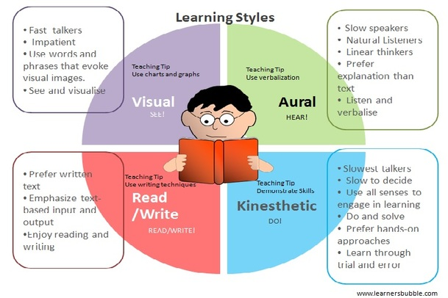
Neil Fleming Learning Style Theory.

As an assistant manager I would like to assess the learning and development training methods for my new employees the theory that I am going to use to back up my argument and for the reason why I have chosen this theory “Neil Fleming Learning Style Theory.
“ is because in a way it highlights every individual in their own way starting with the visual learners

As the assistant manager I will be identifying all new employees as; visual, auditory, reading/writing, kinaesthetic, learners. Which will then give me the information aligning my overall outcome and how certain training will benefit each individual based on this kind of learning style
Sometimes you may come across and find that it’s a combination of all three sensory modalities that may result of being the best option. Allowing each employee to access information in terms they are comfortable with will increase their training practice that builds up their knowledge and understanding of the job and the roles it requires them to take part during their workday.

Being a visual learner, is ideally someone that prefer the use of images, maps, and graphic organizers to understand new information, which tends to make it a lot easier for them to remember and come to terms with the new information.
Listening and speaking are the way auditory learners are at their best understanding when new content in situations. Being part of lectures and group discussions are used repetition as a study technique and benefit from the use of this technic
The strong reading/writing learner’s preference learn best through words. Leaving these students show better understanding when they are learning through reading and writing which results to them to be; copious note takers or avid readers and are able to translate abstract concepts into words and essays.
The learners who are kinaesthetic learners best understand information through tactile representations of information. Kinaesthetic learners learn best from hands-on learners and learn best through figuring things out by hand.

Prithishkumar, and Michael (2014). Understanding your student: using the VARK model. Journal of postgraduate medicine, 60(2), p.183.

This would fit into my training style as I am training induvial up to become an electriaian. To be fair in this industry it wouldn’t real matter what kind of learning style you are in the Neil Flemming as all of these learning skills are going to be very beneficial as in if you are a visual learner something that prefers images and them sort of things this would be ideally a really good thing for you as there is many different symbols you have to remember in your day to day and having a good memory for images will definitely come In handy
If you are person that loving reading and writing and tend to find it a lot easier for you to understand and follow new information through test this is a good thigs for you also as the 18th edition book has serval different pages and to become and electrical you do need to have a good understand of English and reading and everything is based around reading. As these people have a good habit of taking notes and jotting things now this would definitely be helpful when going through the books needs to read to help your learning future.
People that tend to work well when in a group from listening and speaking will benefit as well as to become and electrician you need to be able to work within a team and support others around you this learning skill with give you the ability to commutate with each other while listening to their points then could potentially help them out as other people bring new ideas. Together combining the two will bring a bigger and better picture.
Being an kinaesthetic learning in this industry is a really good out come as the more hands on you are the more it will benefit you in the long run as this job is hands on mostly and the best way to learn new things in the industry is to be hands on and get your head around all the little things you need to know and understand and take note of when doing certain things.
Electricians work across homes, businesses and in industry.
- installation electrician – fitting power systems, lighting, fire protection, security and data-network systems around the home and in businesses
- maintenance electrician - checking systems are running efficiently and safely
- electro-technical panel builders – assembling and fitting control panels that run electrical systems.
- machine repair and rewind electrician - repairing and servicing electrical motors and machinery.
- highway systems electrician – building and repairing street lighting and traffic management systems.
Each of these jobs would be the role of the new employees so relating back to the Neil Flemning’s theory each learner with benefit in many ways if they at least have one of these learning strategies. It will be even more beneficial if the individuals have more than one of these learning skills has it will help them sore through all the learning obstacles, very much beneficial.
Learning Theories. 2020. Summaries Of Learning Theories And Models - Learning Theories. [online] Available at: <https://www.learning-theories.com/> [Accessed 29 November 2020].

Othman, and Amiruddin, (2010). Different perspectives of learning styles from VARK model. Procedia-Social and Behavioral Sciences, 7, pp.652-660.

Hawk, and Shah, (2007). Using learning style instruments to enhance student learning. Decision Sciences Journal of Innovative Education, 5(1), pp.1-19.

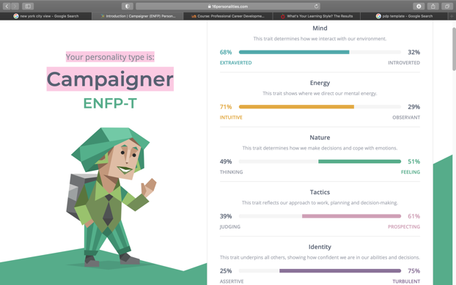
Self-Reflection

I believe that at the start of this whole module I knew a bit about myself, the things that motivate me. On that note doing things module has helped me and opened my eyes up to new possibilities, for example: I now know my skill set and my abilities along with strategies to help me to do and learn new things in ways I didn’t think was possible. I have taken a learning style test which then gave me the feedback of Auditory: 30% Visual: 35%, Tactile: 35% which makes me a visual and tactile learning meaning I find reading or seeing pictures, learn by touching and doing. As the best method of learning things easy and fast. Doing this test showed be that I was right, I prefer hands on things. I also did a personality and the type I got was a Campaigner which I like to think that it means; my mind is more on an extraverted than introverted my energy is more intuitive the observant. Nature is more feeling than thinking. Tactics would be more on the prospecting side more than the judging side. Last but not least my identity would be more turbulent than assertive.
However on a whole I have learnt serval new things that I can bring away with me after this course, for example I didn’t know how to reference before now I believe I am not 100% there yet but I am way better now than back at the start of the year when I started. I have even learnt that some of the aggression that is built up inside it partly somewhat got my past to blame and the way I was brought up that got all carried in the subconscious mind.
Before starting this course I didn’t really understand my surrounding was in a way the reason for some of my behaviour has the environment you put yourself in can often have an positive or negative effect on you depending who you are with and what you are doing.
I have also learnt and found out the skills I have and the skills I need to achieve what I want to achieve for example learning about the pdp and actually being able to do one has opened up my eyes to new possibility’s and new path I can go down which is also leads and helps me follow process by having a guild that I can also go back to and check up on to make sure I am on track and still heading to my targets. With the pdp it is a key help as it helps you understand what skills you need and what skills you need to develop on which in ideally is a really good things as you will never get stuck and you can always go back to have a look at to keep tabs on yourself. Which is then helping to achieve the goals you have set in place. Setting a time frame along with the goals is key help as we can all fall victim to sloppiness/ laziness.

Sciortino, (2013). Self Reflection. Trafford Publishing.

On the note of self-reflection I can tell I have benefited at lot from this course from many ways as at the start I did find myself an confident person but now I find myself a more confident person as having to do prestation Infront of loads of people has helped that and made me feel like this as before I would feel a bit shy talking Infront of a larger group of people but now has the year has gone on I have benefited from taking part in group actives and talking Infront of the group I have also come away with listening more as people have different ways of seeing things which has made me realise if I take a second to listen to someone’s opinion or point it could potentially save me time and energy.
I have also come away with more knowledge of how to use Microsoft word, PowerPoint and excel.
I never knew how to refence before I may still don’t know how to fully do it but this course has helped to be able to give it ago and to actually understand parts and ways to do it. Which is a good things as now instead of getting done for copy write or plagiarism you can just add someone’s work with a name and date and it will no longer be classed as that.
References

- HELENA, M.T.C., 2017. Styles of Learning Based on the Research of Fernald, Keller, Orton, Gillingham, Stillman, Montessori and Neil D Fleming.
- Hawk, T.F. and Shah, A.J., 2007. Using learning style instruments to enhance student learning. Decision Sciences Journal of Innovative Education, 5(1), pp.1-19.
- Learning Theories. 2020. Summaries Of Learning Theories And Models - Learning Theories. [online] Available at: <https://www.learning-theories.com/> [Accessed 29 November 2020].
- Othman, N. and Amiruddin, M.H., 2010. Different perspectives of learning styles from VARK model. Procedia-Social and Behavioral Sciences, 7, pp.652-660.
- Prithishkumar, and Michael (2014). Understanding your student: using the VARK model. Journal of postgraduate medicine, 60(2), p.183.
- Sciortino, J., 2013. Self Reflection. Trafford Publishing.
- (2016). Guidance On Developing Personal Development Plan. [online] Available at: <http://www.docs.csg.ed.ac.uk> [Accessed 28 March 2016].
- Pdp.albany.edu. (2020). The Professional Development Program—PDP. [online] Available at: <https://www.pdp.albany.edu/> [Accessed 29 November 2020].

