

University of Wales Trinity Saint David Birmingham
Module: Personal Development in Health and Social Care
Module Code: LCHS4009
Component 2 Personal Development Profile
Submitted by
Name of the student: Shabinah Nargas
ID number: 2418906
Submitted to
Name of the lecturer: Wafa Nasir
Submitted on Date:24/07/2026

TABLE OF CONTENT;
CV
Personal statement
SWOT analysis
Personal Development Plan
Critical reflection – Gibbs model
References

Task 1
Nargas Shabinah
| shabsnabs@outlook.com
PROFILE
I am a dedicated and compassionate individual with experience in supporting children with SEND. Currently studying towards Level 4 Diploma in Health and Social Care to further develop my knowledge and skills. Committed to promoting inclusion, well-being and independence for every individual. In my personal time I enjoy swimming and exploring new places, which helps me bring energy and a positive outlook to my work.
EDUCATION & QUALIFICATIONS
UCB College-Birmingham - CERT Level 2 and 3 Teaching Assistant Children and Young People, (A-Level or equivalent) 2020
UWTSD University of Wales Trinity Saint David – CertHE Health and Social Care Level 4
2025 - Ongoing.
WORK EXPERIENCE
Teaching Assistant/ Dinner Supervisor | Aspire People/ Clifton Primary School Sep 2024 to Present
- I have worked 1-to-1 with a SEN child from 2023 to present. I supported the child to meet his targets set by the EHCP plan. My role includes following expectations of a personalised curriculum to support the child daily. Special education needs demand me to be an active listener, and this involves asking thoughtful questions to get information and showing signs of body language that demonstrate I am paying attention.
- I have been a dinner supervisor at a primary school from 2024 to current I demonstrate skills such as patience and empathy by listening to each child, staying calm in challenging situations, and responding to their individual needs with kindness and understanding. I create a safe and supportive environment where every child feels valued and respected and employ good teamwork and organisational skills.
Volunteering Teaching Assistant | Oasis Academy Hob Moor Sep 2018 to Jul 2020
While volunteering as a teaching assistant at Oasis Academy, I supported pupils from a range of various backgrounds and abilities to learn and participate with positive behaviour in the classroom while assisting teachers with delivering lessons and all kinds of daily classroom activities. I provided 1 to 1 support to help students achieve their individual learning goals. Recognising that all pupils have different learning abilities and needs. I have also used sensory aids and adaptive technologies to support children with cognitive and physical difficulties, helping to create an inclusive, safe and supportive learning environment where all pupils could advance in their individual learning skills and to help them both emotionally and socially.
ADDITIONAL INFORMATION
Training – Basic classroom support
Caring for the needs of others
1-2-1 support as well as small group support
Meeting and greeting parents and giving back feedback to parents.
Languages – Urdu and English
Technical skills
- HGV Class 2 December 2022 to Present I have gained my CPC licence as a Class 2 HGV driver.
INTERESTS
Swimming
Spending time with family and friends
REFERENCES
Joseph Middleton | Joseph Middleton joe@wildfi.co.uk
Wafa Nasir | Lecturer at UWTSD w.nasir@uwtsd.ac.uk
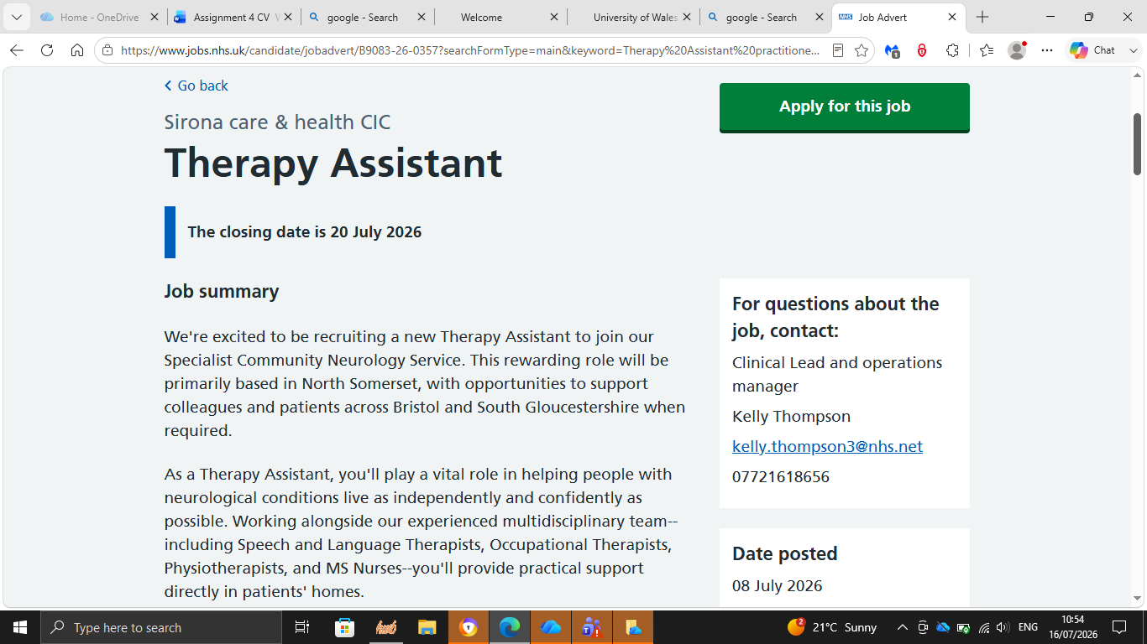
Task 2

PERSONAL STATEMENT
I am a compassionate and motivated teaching assistant in special educational needs. I plan and deliver instruction to children with behavioural and learning difficulties and physical challenges at a range of various levels.

Currently studying towards a CertHE level 4 diploma in health and social care. I am committed to promoting independence, dignity and well-being through person-centred support. During my university course, I developed digital skills using Microsoft Office and collaboration tools. I regularly use Microsoft PowerPoint to design and deliver presentations incorporating visuals, animations and speaker notes to communicate information clearly to my peers and tutors. I gained confidence in structuring content for different audiences and presenting professionally.

I used Microsoft Word to produce academic reports and essays, developing my skills for formatting, proofreading and editing documents to a high standard. Through Microsoft Teams, I participated in online lectures and meetings and shared resources, learning to share files, co-edit documents and communicate effectively in a virtual environment.
For example, during a 10-minute presentation on child development theory when using PowerPoint, which received positive feedback for clarity and design from my tutor, I managed good eye contact throughout and showed that I appreciate how psychology theory can be used to explain human behaviour. I have used in-text citations on my slides and have a long reference list at the end of my slides; my references included some peer-reviewed journal articles.

My experience has developed my ability to adapt to individual needs and work effectively as part of a multidisciplinary team. I understand the importance of following therapy plans accurately, monitoring progress and providing encouragement to help patients achieve their goals.

I am reliable and patient. I continue learning under the guidance of qualified therapists to make a positive difference to people's recovery and daily lives. I am particularly interested in supporting speech and language therapy. For this I will use communication techniques to support patients to carry out therapy programmes safely. Encourage independence and improve quality of life. Monitor progress, provide emotional support and motivation during rehabilitation and maintain a safe and supportive environment for my patients.

I enjoy swimming because it simultaneously gives me a sense of freedom, peace, and energy. The world above appears to vanish as soon as I jump into the water, leaving just the calming sound of my own motions. It helps me relax and relieve tension. I always feel like I have accomplished something. Swimming is one of my favourite activities since it provides me strength and serenity. (NHS, 2015).

Task 3

PERSONAL SWOT ANALYSIS
When SWOT analysis is applied for an individual, it is possible to assess their prospects and current threats, as well as their internal and external resources for accomplishing their goals. These actions focus on using an individual's strengths, strengthening their shortcomings, taking advantage of external resources, avoiding risks, and—above all—developing a personal development vision and a strategic plan for achieving their personal objectives. The objectives of a personal SWOT analysis are to assess the individual's critical success elements in relation to each goal, find ways to accomplish personal goals within the next few years, and create a strategy. Knowledge, skills, competencies, job experience, finances, company resources, brand power (loyalty, reputation), individual credentials, technological opportunities, and other internal factors of the individual are considered in the analysis, depending on the objectives

A senior student may use it as an internal tool to define personal resources and assess opportunities and potential risks in the social context when thinking about their future career. When evaluating their position inside the organization, a CEO could use it. When assessing possibilities and resources associated with a job, a candidate may utilise it as a means of self-reflection. (Jurevicius, 2021)

Everyone has their own life goals and aspirations. Some people try to accomplish them in accordance with their own standard. Certain individuals don't have a plan; they just act for "some reason." Others fulfil their aims. Many people can consciously determine what their life's purpose is, but most of the time it is a disorganised vision that is determined by their surroundings, family, close, friends and society. (Leigh, 2009)

STRENGTHS
- I am hard-working and strive to do my best
- Experience in supporting children with SEND
- I demonstrate skills such as patience and empathy by listening to others
- I am compassionate, supportive and caring
- I can work with a team

WEAKNESSES
- I am dyslexic and suffer from anxiety
- I find it difficult to pronounce new words
- Easily distracted
- Lack of experience in certain areas
OPPERTUNITIES
- Learn new skills/courses
- To gain specialised training
- AI and computer knowledge

THREATS
- I fear emotional burnout
- Overworked and not enough time to complete my task
- Not appreciated for the effort I put in
- Increasing competition amongst teachers and therapists

Task 4

PERSONAL DEVELOPMENT PLAN - SPEECH AND LANGUAGE THERAPY

A personal development plan PDP is a structured, systematic process by which an individual reflects on their skills, knowledge and experiences, identifies areas for development, set specific goals and outlines actions to achieve them. PDPS are widely used in health professions, education and practices to foster lifelong learning and professional accountability (Health Education England, 2021). (Cottrell, 2015)
Personal SWOTs are often included in personal development plans (PDPs) or professional portfolios, aligning with the drive towards reflective, evidence-based practitioners. (NMC, 2018).

Personal Development Plan Template
Goals | List the actions to complete to achieve the goal | Support/resources needed | Target date | Review date
Complete my level 5/6 Health and Social Care | Register and enrol on a course | Apply for funding  Tuition fees  Invest in a good laptop | Sept 2027/2028 | 2027/2028
learn digital and AI literacy | Register and enrol on a course | Apply for funding  pay for my tuition fees | Sept 2027 | 2027
Learning new clinical skills in therapy techniques | Register and enrol on a course | Apply for funding  pay for tuition fees | Sept 2028 | 2028

PDP TEMPLATE (Cottrell, 2015)

My long-term professional vision is to become a skilled, knowledgeable practitioner within speech and language therapy, supporting children and adults with communication and swallowing needs to achieve their full potential. I aim to work as part of a multidisciplinary team. Delivering high-quality interventions that promote independence, confidence and quality of life. My current Strengths are empathy and compassion. To build trust with clients and their families. I am naturally supportive and caring, with experience in working with children with SEN, which has developed my patience, active listening and the ability to adapt communication to an individual's needs. I understand the importance of person-centred care and maintain dignity in all aspects of support. My current Level 4 health and social care studies are strengthening my theoretical knowledge of development, safeguarding and professional practice. Opportunities for growth and committing to continuous professional development to meet the evolving demands of speech and language therapy. Learning new clinical skills in therapy techniques. AAC device and observational recordings of clients' progression under qualified supervision, and to learn digital and AI literacy. Building on my computer knowledge and understanding of AI tools that can support me in this journey of therapy. SMART goals: I would like to take specialist training, accessing CPD in areas such as autism, Makaton or early language intervention to broaden my scope of practice. Within the next two years, I would like to apply for an accredited specialist course such; as Supporting children with speech, language and communication needs to enhance my practice.

Task 5

REFLECTIVE MODEL (GIBBS MODEL), REFLECTION ON COMPONENT 1 PRESENTATION ASSESSMENT

Professor Graham Gibbs created the theoretical model known as Gibbs' Reflective Cycle in 1988. It provides an organised framework for experiential learning through a six-stage reflection process. (Communication Theory, 2024)

The model consists of six stages: description, feelings, evaluation, analysis, conclusion and action plan, encouraging individuals to reflect on an event and identify opportunities for improvement systematically. Gibbs’ Reflective Cycle is widely used within various HSE sectors because it helps to promote reflective practice, critical thinking and continuous professional development. It helps health and social care workers to acknowledge capabilities and pinpoint growth opportunities and apply learning to future practices, resulting in superior patient care provided. Reflecting on this experience using Gibbs’ Reflective Cycle is important to me because it helps me to evaluate my actions and recognise what I did well and pinpoint which areas I need to improve on. By reflecting on my personal experiences, I can help myself to improve my knowledge, skills and confidence, helping me to provide safe, effective and Individualised support in my future practices. This process will also help support my ongoing professional development and enable me to improve as a future healthcare therapist.
(Gibbs and Andrew, 2001)

Feelings
Receiving the feedback, “You did well to try and show eye contact. You spoke at a good pace and with a clear tone, at times you were mispronouncing words, you answered the questions well. Your presentation design was good,” this made me feel encouraged and confident about my presentation skills. I was pleased that I was able to maintain eye contact during my presentation, speak clearly and answer all questions. I was happy that my efforts were effectively recognised I value the criticism about my miss pronunciation. I try to communicate as effectively and clearly as I possibly can. I am aware that my dyslexia affects how I pronounce words. However, I'm still dedicated to improving my communication abilities and making sure that I speak clearly and professionally.

Evaluation
Overall, the feedback I received was positive and highlighted several of my strengths in my presentation, including my ability to maintain eye contact, my pace of speech, ability to answer the questions and the design of my presentation. These comments showed that I was able to engage with my audience and communicate my ideas successfully. However, my pronunciation affected the clarity at some parts of my presentation, demonstrating that there is still room for improvement.

Analysis
The feedback suggested that I had prepared myself well and used effective communication techniques, such as speaking at an appropriate pace and completing my presentation within the given time. These skills are important for engaging with an audience and delivering information confidently. However, mispronouncing words may have reduced the overall clarity of my presentation making it harder for the audience to understand this, emphasises how crucial it is to practise vocabulary.

Conclusion
Reflecting on this feedback has helped me recognise both my strengths and the areas that require further development. While I am encouraged by the positive aspects of the feedback, I understand that improving my pronunciation will enhance my communication skills and make my presentations more effective.

Action Plan
For future presentations, I will practise pronouncing technical and unfamiliar words before presenting by reading my presentation aloud and using online pronunciation resources where necessary. I will also continue to maintain good eye contact, speak at a clear pace and design engaging presentations, while seeking further feedback to monitor my progress and continue developing my presentation skills.

REFERENCES
•Cottrell, S. (2015) Skills for success: Personal development and employability. 3rd ed. London: Palgrave.

Communication Theory. (2024). Journalism – Definition, Types and Examples. [online] Available at: https://www.communicationtheory.org/journalism-definition-types-and-examples/ (Accessed 20 July 2026).

Eurich, T. (2018) Insight: The Surprising Truth About How Others See Us, How We See Ourselves, and Why the Answers Matter More Than We Think. London: Macmillan. (Accessed 02 July 2026).

Gibbs, G. (1988) Learning by Doing: A Guide to Teaching and Learning Methods. Oxford: Oxford Polytechnic. (Accessed 23 July 2026).

How to Conduct a SWOT Analysis for Therapist: 10 Examples. (2025). [online] PlaniBusiness. Available at: https://planibusiness.com/therapist-swot-analysis/ (Accessed 22 July 2026).

Jurevicius, O. (2021). SWOT Analysis - How to Do It Properly - SM Insight. [online] Strategic Management Insight. Available at: https://strategicmanagementinsight.com/tools/swot-analysis-how-to-do-it/ (Accessed 23 July 2026).

Leigh, D. (2009). SWOT Analysis. Handbook of Improving Performance in the Workplace: Volumes 1-3, [online] 1–3(2), pp.115–140. doi:https://doi.org/10.1002/9780470592663.ch24. (Accessed 21 July 2026).

NHS (2015). Speech and language therapy assistant. [online] Health Careers. Available at: https://www.healthcareers.nhs.uk/explore-roles/healthcare-support-worker/roles-healthcare-support-worker/speech-and-language-therapy-assistant (Accessed 23 July 2026).
Watkins, R. and Leigh, D. eds., (2009). Handbook of Improving Performance in the Workplace: Selecting and Implementing Performance Interventions. Hoboken, NJ, USA: John Wiley & Sons, Inc. doi:10.1002/9780470587102. (Accessed 23 July 2026).

