The topic of: preparing for higher education

Summary of 300 words with one supporting image on the topic of preparing for higher education.

Preparing for higher education for many is an exciting time, learning in an environment that promotes; high independence of learning, introducing key life skills such as time management, development of study skills, organisation in addition to resilience. Resilience is a concept that encompasses a variety of skills, qualities, and attitudes Cottrell, s, (2019), P.21. Moreover the fundamental understandings of skills allow a student to focus on the important rather than the unimportant such as managing your learning environment by minimizing distractions such as turning your mobile phone on do not disturb, keeping your study space neat and suitable for keeping focus as well as choosing an area suitable to avoid distractions from studying. These areas may include a library or a private living space area that minimises distractions.
Time management is a significant aspect of preparation for higher studies. As shown in the journal Adams, R. V., & Blair, E. (2019) studies suggest that effective time management is associated with higher academic achievement (McKenzie & Gow, 2004; Trueman & Hartley, 1996). In preparation for higher studies, implementing resources to achieve effective time management could be: creating a timetable to organise studying, assignments and breaks. Utilising your time effectively will improve your work, mental well being and produce successful work.
Implementing the use of digital skills in the evolving modern world of social media is vital as established in the digital competence theory, and exploring the various ways of studying is another essential part of preparing for higher education, Ala-Mutka, K., Punie, Y., & Redecker, C. (2008) :
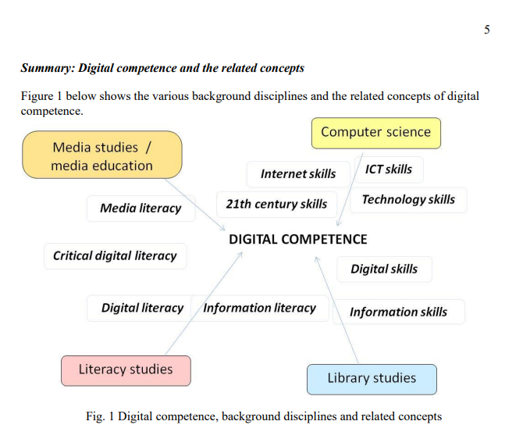

The above figure encompasses all of the essential skills that help certain courses. The concepts connect how places of study such as libraries can develop digital skills for instance using computers to facilitate learning, internet skills as basic digital skills involving literacy. For instance adapting to online sites that help with grammar punctuation and wording of essay writing; Grammarly and khan academy. In addition to this, learning to reference in all aspects of work is significant as is avoids plagiarism, adds academic credibility to your arguments, acknowledges authors work as well as proving your work as credible such as Harvard or APA referencing, referencing using technology develops students ability to create credible work, develop knowledge, as well as avoid plagiarism particularly by using the library as a main source as librarians can help student learn more about referencing work, O’Donnell, R.O, et al. (2006).

- Citation: text book- The study skills handbook
Citation: Cottrell, S. (2019) The study skills handbook. Fifth edition. London: Red Globe Press.
Put the name, page and year of the book for cite
Citation: Adams, R. V., & Blair, E. (2019). Impact of Time Management Behaviours on Undergraduate Engineering Students’ Performance. SAGE Open, 9(1).
https://doi.org/10.1177/2158244018824506
Citation research article from the website : core.ac.uk

Image: Ala-Mutka, K., Punie, Y., & Redecker, C. (2008). Digital competence for Lifelong Learning. Luxemburg: Office for Official Publications of the European Communities. Retrieved August 20, 2010 from http://ftp.jrc.es/EURdoc/JRC48708.TN.pdf

Journal article: O’Donnell, R., Maloney, K., Masters, K. and Liu, D., 2020. Library-faculty referencing and plagiarism pilot using technology-mediated feedback for change. Journal of the Australian Library and Information Association, 69(4), pp.523-539.

