
Student Name: Prashant Gajera
Student ID: 2428140
Teacher Name: Brian and Muhammad
Topic Name: Diabetes
MODULE CODE AND TITLE: LCHS7003 AND COMMUNITY CARE AND MANAGEMENT OF LONGER-TERM CONDITIONS
ASSIGNMENT TITLE: COMPONENT 1 INFORMATION BOOKLET OF LONG-TERM CONDITION MANAGEMENT
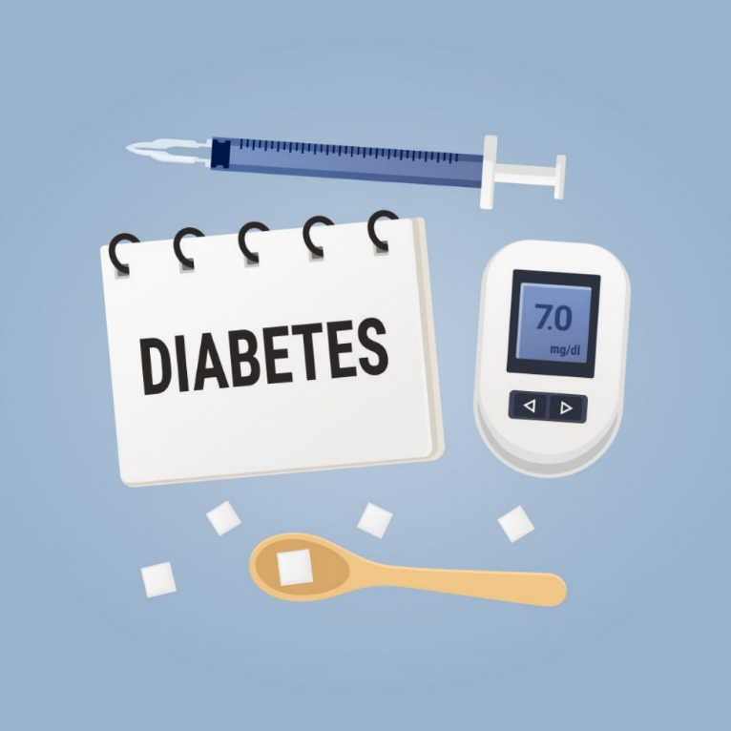

LCHS7003 AND COMMUNITY CARE AND MANAGEMENT OF LONGER-TERM CONDITIONS
INDEX
Introduction 3
1. Explanation and evaluation of the focused long-term condition 3
1.1 Definition of the long-term condition 3
1.2 Prevalence of the condition 3
1.3 Risk factors of the health-condition 5
2. Critical evaluation of the impact of the long-term condition 5
2.1 Physical impact 5
2.2 Psychological impact 6
2.3 Social impact 6
2.4 Evidence-based treatments in the UK 6
3. Identification and evaluation of the theoretical perspectives 7
3.1 UK model: House of care model 7
3.2 International model: The chronic care model (CCM) 8
4. Implementation of local and national political-health and social-care agendas 9
4.1 Local and national political health 9
4.2 Social care agendas 10
5.Facilitation of recommendations for improvement into person-centred care approaches 11
5.1 Person-centred care 11
5.2 Self-management 12
5.3 End-of-life care 12
Conclusion 13
References 15

Introduction

Diabetes is one of the chronic metabolic disorders identified by the high blood glucose level due to impaired insulin secretion or utilisations. This shows major public health issues globally and across the UK by contributing to significant morbidity, mortality and healthcare expenditures. The growing incidence of Type 2 diabetes is largely influenced by obesity and lifestyle factors (Chakraborty, 2025). This booklet focuses on assessing diabetes as long–term conditions, evidence-based treatments considering several theoretical perspectives for diabetes management. This will also develop the evidence-based recommendations for person-centred practices across the UK community settings in promoting holistic, co-ordinated and compassionate long-term condition management.

1. Explanation and evaluation of the focused long-term condition

1.1 Definition of the long-term condition
Diabetes can be defined as a health condition in which the body-glucose level gets too high due to the inability of the body to produce enough insulin or incapability in using the glucose (Saha et al. 2024). This can be referred to as a chronic condition, which can deteriorate the overall health of the patient if, remain untreated for a long time. Diabetes can be categorised into different stages among the patients such as Type 1 and Type 2 diabetes, Gestational diabetes, Prediabetes, and Type 3 diabetes (Clevelandclinic, 2025). This categorisation of diabetes assists the doctors in treating the patients in an accurate manner and improving the health of the patients. Glucose comes in the body by eating carbohydrates, which can be referred to as a primary source of energy of the body; however, the excess of glucose in the body can be dangerous for the health of the people causing diabetes.

1.2 Prevalence of the condition

UK prevalence
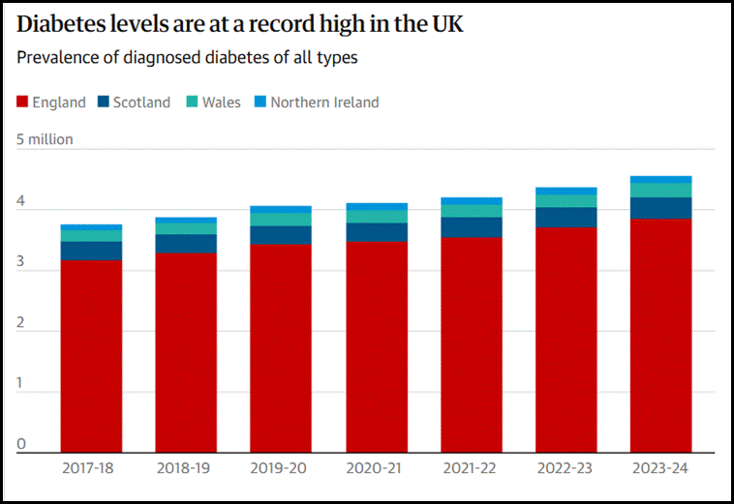
Figure 1: Diabetes prevalence in the UK
(Source: Gregory, 2025)
It is evident from the above figure that nearly one in five people in the UK have diabetes due to the modern lifestyle of late-night sleep and increase in eating fast-foods (Gregory, 2025). The number of diabetes patients in the UK is alarming as it has an increasing trend and type 2 diabetes is most prevalent among the patients. Almost 12.2 million people in the UK are affected by diabetes and 6.3 million people have non-diabetic hyperglycaemia (Gregory, 2025). In this situation, direct government intervention can be beneficial in making the people aware of the threat of diabetes and improve their health conditions through lifestyle changes. Over 35,000 children and young people, under 19 years of age are diagnosed with Type 1 diabetes in the UK, which is a shocking statistic for the health authorities (Diabetes, 2025). An increase in diabetes among the UK population can also negatively affect the social wellbeing of the people in the country.
Worldwide prevalence
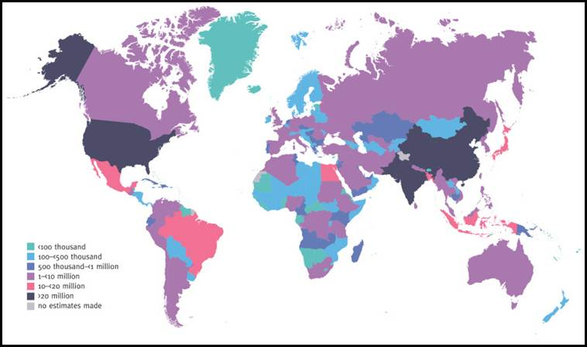
Figure 2: Global prevalence of diabetes
(Source: Ncbi, 2021)
The figure above shows that the Indian subcontinent, China and North American region have the higher number of people living with diabetes (Ncbi, 2021). The primary reason behind this increase in diabetes is the poor food habits of people and eating carbohydrate-rich foods frequently. Almost 589 million people between 20 to 79 years of age globally are diagnosed with diabetes and 853 million people will have diabetes by 2050 (Idf, 2025). Data further suggests that almost 4 in 5 people in the low and the middle-income countries live with diabetes. Due to the consideration of this information, diabetes can be listed as a global health-hazard, which requires immediate attention.

1.3 Risk factors of the health-condition

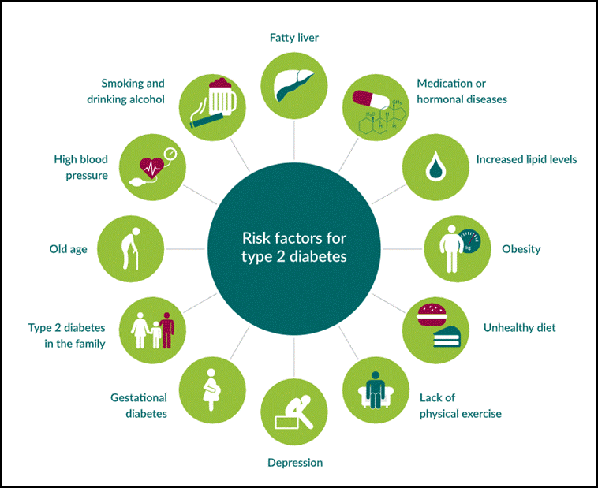
Figure 3: Risk factors associated with diabetes
(Source: Diabinfo, 2025)
The risk factors related to diabetes are obesity, old age, fatty liver, gastronomical conditions and unhealthy diet (Diabinfo, 2025). A lack of sleep among the people and depression can also cause diabetes that needs to be considered by the patients and required steps need to be taken to prevent diabetes. The family history of having diabetes can act as aetiology to develop diabetes among the people that need to be identified by the people (Mayoclinic, 2025). These risk factors are needed to be evaluated effectively to prevent the possibility of developing diabetes by modifying lifestyle and positively changing food habits.

2. Critical evaluation of the impact of the long-term condition

2.1 Physical impact

There are devastating physical impacts of diabetes among the people including heart attack, kidney failure, complications in eyes and foot and even nerve damage if the disease is not treated timely (Healthline, 2024). Degradation of the physical health of the patients with diabetes can also cause depression and anxiety for the family members involved in the care provisions due to emotional attachments. The size of the blood vessels can be increased among the patients with diabetes that can increase the risk of high blood pressure. Slow digestion and loss of vision can be observed among the people having Type 2 diabetes if the condition remains untreated for a long time (CDC, 2024). These are the severe physical impacts of diabetes on the patients that need to be understood and thereby necessary healthcare measures are needed to be taken to improve health.

2.2 Psychological impact

Psychological impacts of diabetes include depression, anxiety, stress and emotional breakdown, these impacts can further damage the diabetes condition of the patients as well (CDC, 2024). Constant thinking of one's own health due to diabetes is the primary reason behind the increase in stress among the patients. Required emotional support is needed to be given to the patients dealing with diabetes in order to boost their morale and cope with the health conditions.

2.3 Social impact

People having diabetes can face social isolation, challenges in managing relationships; observe social stigma and difficulty in going to office and educational institutes (Korsah and Agyeman‐Yeboah, 2023). The family members involved in the care provisions of the patients with diabetes can face social stigma due to diabetes of one family member. The constant requirements of self-care of the diabetic patients make them isolated from the other people in the society and they can also face social stigma of maintaining an unhealthy lifestyle. The family dynamics of the diabetic patients can be changed due to the difficulty of the diabetic patients in earning money (Mphasha et al. 2022). Understanding these impacts can be beneficial for the people in taking precautionary measures to prevent the development of diabetes. Social inclusion of the diabetic patients is required to increase their motivation and thereby develop the capability to tackle the treatments.

2.4 Evidence-based treatments in the UK

The evidence-based treatments of diabetes as per the NHS guidelines include bringing significant modification in the lifestyle of the patients and eating only healthy foods (Nhs, 2025). Along with the required medications, the patients with diabetes are advised to walk nearly 2.5 hours every week and get involved in certain physical activities. Diabetic patients with obesity are also required to reduce their body weight in order to increase the effectiveness of the treatment. As per the 2020 /2021, NHS data nearly 470,000 diabetic patients in the country are receiving ketone testing strips and lancets that are beneficial in improving the health condition of the patients (Nhs, 2021). Improvement in the eating habits of the patients can further be beneficial in enhancing the health condition and keeping blood-glucose level under control. Reduction in depression and improving sleep-cycle is also suggested by the NHS authorities to improve the patient’s health condition and reduce the possibility of developing diabetes.

3. Identification and evaluation of the theoretical perspectives

The management of diabetes across the UK healthcare system enhancing relies on the integrated models which promotes shared decision-making, co-production and proactive support. The two major frameworks such as House of care model for UK and Chronic care (CCM) for international are as follows:

3.1 UK model: House of care model

The House of care model has been introduced by NHS England by providing the comprehensive framework for delivering person-centred care to individuals living with long-term conditions such as diabetes (NHS, 2023). The model is structured around four interdependent components such as commissioning, engagement of patients, collaborative healthcare professionals and organisational systems. Their foundation depends on supporting informed people by empowering professionals to co-design personalised care plannings. The model can show partnership working between diabetes nurses, general practitioners, dietitians and social care teams in diabetes care. This multidisciplinary strategy improves self-management by reducing complications such as neuropathy and retinopathy. The NHS Personalised care model complements this by implementing six principles such as shared decision-making, personal health budgets, social prescribing and supported self-management into care delivery.
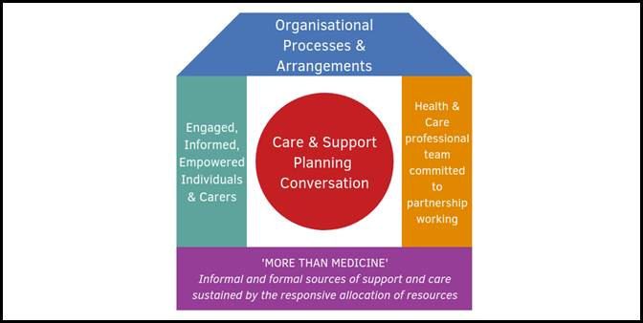
Figure 4: House of Care model
(Source: Health and Social Care Alliance Scotland, 2025)
The empirical evidence recommends that application of House of care with diabetes management can improve the adherence, glycaemic control and patient satisfactions (Sim and Lee, 2021). This can be beneficial to the healthcare providers to move from a reactive, biomedical approach to a holistic one that recognises patient’s emotional, social and behavioural assistance. However, the challenges remain in their implementation across under-resourced or ethnically diverse areas. The variations in commissioning capacity and digital literacy can limit equitable access to personalised services. The continuous staff training and inter-organisational collaborations are significant for consistency and sustainability.

3.2 International model: The chronic care model (CCM)

The chronic care model is an international recognised framework aiming to enhance the quality of chronic disease management by proactive, planned care (Grudniewicz et al. 2023). This contains six components such as community resources, healthcare system organisational, self-management support, delivery system design, decision support and clinical information systems.
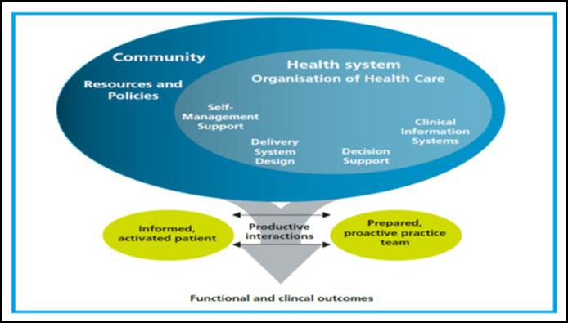
Figure 5: Chronic care model (CCM)
(Source: Ansari et al. 2022)
The CCM focuses on patient empowerment and collaborative goal-settings. Europe and North America have shown that adopting the CCM reduces HbA1c levels and diabetes-related hospital admission in order to meet diabetes care (Boye et al. 2022). The integration of self-monitoring applications and data-driven consultations enhances patient autonomy by improving engagement with healthcare providers. On the other hand, the CCM focuses more on systemic and technological integration while the House of Care implements person-centredness across the national social care framework. These both frameworks control the multidisciplinary coordination, however, the CCM places stronger focus on population-level improvement and outcome measurements (Ansari et al. 2022). The hybrid model has combined the CCM’s structured system design and the House of Care’s personalisation approaches offering an optimal framework.
Therefore, the both models align with NICE NG17 which suggests structured education, personalised planning and psychological support for the people having diabetes (NICE, 2021). The evaluation of these perspectives shows that effective diabetes management needs coordination systems empowering patients and policy-driven integration between health and social care sectors to assure equal and holistic care in diabetes management.

4. Implementation of local and national political-health and social-care agendas

4.1 Local and national political health

Diabetes has a long-term significant impact over the people who have faced severe health conditions in the UK. Considering the data of 2022-23, 5.8 million people in the UK have faced the issue of diabetes all time (diabetes.org, 2025). The government of the UK in collaboration with the NHS has taken diversified approaches to deal with the consequences of diabetes. The local body of the NHS has taken approaches of 10 year long term programs that could deal with the issue of Type 2 diabetes by integrating new technologies that can deal with it (england.nhs, 2025). NHS has also taken care of digital management programs that are oriented with better health transformation and managerial context to enhance quality of life. As per the opinion of Riddle et al. (2022), Diabetes is responsible for changing day to day routine activity among people that reflects on physical and psychological health conditions. Diagnosis remissions for managing glucose section from individuals become effective for dealing with supportive and better health conditions. Thus, persistent medications and awareness creation among patients would be a better approach for enhancing the quality of life.
In International level WHO has taken initiatives of Global diabetes compact forum by taking collective vision for dealing diabetes and its related immature death numbers (who.int, 2025). Along with that, 14th November has been considered as World Diabetes day for creating public health initiatives for creating awareness among people. According to Pillon et al. (2021), an early detection and diagnosis of type 2 diabetes would help in preventing long term complications of this disease. On the other hand, lack of systematic care processes can cause a severe damage for people facing such health issues.
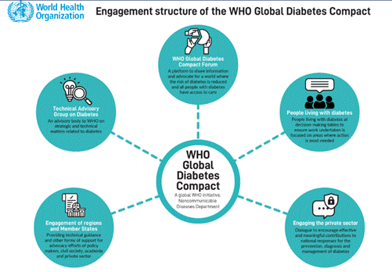
Figure 6: Approaches of Global diabetes compact forum
(Source: who.int, 2025)

4.2 Social care agendas

Restructuring of the Primary Care Networks (PCNs) would be an essential aspect of providing holistic diabetes care to the patients (diabetes.org, 2025). PCNs help in dealing with different group populations, which are facing the same issue and ensure in taking long term aspects that deal with diabetes. As per the analysis of Levidow et al. (2024), voluntary services deal with giving primary approaches that are dealing with team-based collaboration along with more attachment with grassroots level people. A proper training and knowledge enhancement are required for dealing with the aspects of social care and managerial approaches. Awareness creation among people from the primary level would take the opportunity that can deal with the consequences of dealing with that health issue (Preiksaitis and Rose, 2023). In addition to that, NHS has taken initiatives for Diabetes Weight Management Service for integrating behavioural and lifestyle management programs for people dealing with diabetes (england.nhs, 2025). This is a digital technology so people can easily connect with their handsets or PCs with internet connections. Thus, technological integration would become a positive aspect that deals with better life development and management respectively.

5.Facilitation of recommendations for improvement into person-centred care approaches

5.1 Person-centred care

The person-cantered care to treat diabetes include ‘communication and education’ which focuses on making the people aware of the procedures to prevent diabetes and taking precautionary measures ( Chen et al. 2024). Recognising the individuality of the patient can be beneficial in providing enough autonomy and supporting the self-management efforts of the patients. On the other hand, providing emotional support to the patients with diabetes can be beneficial in eliminating the challenges faced due to diabetes (Mangoulia et al. 2024). The personalised goals of the patients are required to be fulfilled in order to increase the motivation of the patients to cope with the health conditions. Understanding the individual needs related to treatment can make the treatment procedure highly personalised for the diabetic patients. The medical authorities to understand the health condition of the patients from remote places can use ‘Remote patient monitoring (RPM) technology and thereby required treatments can be facilitated (Shaik et al. 2023). The support for self-care of the patients’ needs to be maintained by the healthcare authorities to address the different co-morbidities among the patients in an accurate manner and reduce the severity caused by diabetes.

5.2 Self-management

Patients having a family history of diabetes are required to check their blood-glucose level as per the advice of the healthcare-professionals in order to understand the sudden changes in the glucose-level (Ihnaini et al. 2021). This can be recommended as a self-management approach to prevent the development of diabetes among the patients and thereby improving their health conditions. People are needed to practice healthy eating and maintain a balanced diet by reducing the amount of excessive carbohydrates from the diet. The sugary drinks are required to be avoided by people and leafy greens need to be included in the diet to get extra nutrients. Maintenance of a regular physical activity can assist the people in preventing the sudden spike in blood-glucose level in the body and thereby reducing the chances of diabetes (Hartigan, 2023). Managing stress and avoiding tobacco products can additionally help in the prevention of diabetes among the people. Getting enough sleep is also a part of the self-management approach that needs to be practiced by the people to maintain the hormonal balance in the body and keep the blood-glucose level under control.

5.3 End-of-life care

The people eventually face challenges in comorbidities, frailty and organ failure requiring palliative and end-of-life support; however, diabetes is sometimes managed as a chronic but controllable condition. NICE NG19 and the NHS Long Term Plan address early recognition of deterioration and proactive planning for end-of-life care in diabetes cases (Rayman and Kar, 2021). This strategy assures the symptoms of control, psychological comforts and dignity.
The effective end-of-life management engages collaborative planning across diabetologists, primary care teams and palliative care nurses (Seim et al. 2024). This maintains optimal glucose levels without overburdening patients with insulin regimes sometimes simplified as required. Moreover, the family and carer engagement are integral to continuity of care by minimising emotional distress and decision-making conflicts. The cultural sensitivity and spiritual support needed to show the end-of-life services respecting patient’s beliefs and values. The integrated palliative care for diabetic patients minimises the unplanned hospital admissions by improving quality of life in the final stages (Johnston et al. 2024). Hence, the implementation of compassionate, anticipatory care into diabetes pathways upholds both person-centred and ethical principles of the healthcare practices.

Conclusion

This booklet has described diabetes which is one of the most significant long-term conditions in the UK by showing cohesive, person-centred and interdisciplinary management strategies. The evaluation of theoretical perspectives shows that both House of care and chronic care models provided strong frameworks for integrating clinical, behavioural and social dimensions of the care. The House of care model has prompted personalised planning and co-production between patients and healthcare professionals while the CCM has enhanced systemic efficacy with patient’s self-management by structured coordination and data utilisations. Combinedly, these models will provide the holistic community-based management outlined in the NHS Long Term Plan. Although, the consistent application needs to address the inequality in resource allocation, digital access and cultural competencies in the diverse populations for both UK and International context.
Therefore, the implementation of early palliative planning across diabetes management will enhance the strengths of the continuum of care by ensuring dignity and autonomy in advanced illness stages. Likewise, the service development needs to be prioritised by workforce training, shared decision-making and the integration of the digital health tools. Moreover, the empowerment of the people to self-management while receiving compassionate, coordinated and person-centred care will align with the national priority for enhancing long-term conditional outcomes by improving quality of life for people and families with diabetes.

References
Ansari, R.M., Harris, M.F., Hosseinzadeh, H. and Zwar, N. (2022). Implementation of Chronic Care Model for Diabetes Self-Management: A Quantitative Analysis. Diabetology, 3(3), pp.407–422.
Boye, K.S., Thieu, V.T., Lage, M.J., Miller, H. and Paczkowski, R. (2022). The Association Between Sustained HbA1c Control and Long-Term Complications Among Individuals with Type 2 Diabetes: A Retrospective Study. Advances in Therapy, 39(5), pp.2208–2221.
CDC (2024). Diabetes and Mental Health. Available at: https://www.cdc.gov/diabetes/living-with/mental-health.html (Accessed on: 11 November 2025)
CDC (2024). How Diabetes Can Affect Your Body Infographic. Available at: https://www.cdc.gov/diabetes/communication-resources/how-diabetes-can-affect-your-body.html (Accessed on: 11 November 2025)
Chakraborty, A. (2025). Systematic Review: Risk Factors for Developing Type 2 Diabetes Mellitus. European Journal of Cardiovascular Medicine, 15(1), pp.382–390.
Chen, T.T., Su, W.C. and Liu, M.I., (2024). Patient-centered care in diabetes care-concepts, relationships and practice. World Journal of Diabetes, 15(7), p.1417.
Clevelandclinic (2025). Diabetes. Available at: https://my.clevelandclinic.org/health/diseases/7104-diabetes (Accessed on: 11 November 2025)
Diabetes (2025). High Quality Care for Children and Young People with Type 1 Diabetes. Available at: https://www.diabetes.org.uk/about-us/about-the-charity/our-strategy/position-statements/high-quality-care-for-children-and-young-people-with-type-1-diabetes-in-the-uk (Accessed on: 11 November 2025)
diabetes.org (2025) How many people in the UK have diabetes? Available at:https://www.diabetes.org.uk/about-us/about-the-charity/our-strategy/statistics (Accessed on: 11 November, 2025)
diabetes.org (2025) How to deliver best practice in diabetes care across Primary Care Networks Available at:https://www.diabetes.org.uk/for-professionals/improving-care/good-practice/primary-and-community-care/pcn-delivery-of-care (Accessed on: 11 November, 2025)
Diabinfo (2025). These factors may be part of why someone develops type 2 diabetes. Available at: https://www.diabinfo.de/en/prevention/diabetes/am-i-at-risk/what-increases-the-risk-of-type-2-diabetes.html (Accessed on: 11 November 2025)
England.nhs (2025) Diabetes treatment and care programme Available at:https://www.england.nhs.uk/diabetes/treatment-care/ (Accessed on: 11 November, 2025)
england.nhs (2025) Diabetes treatment and care programme Available at: https://www.england.nhs.uk/diabetes/treatment-care/ (Accessed on: 11 November, 2025)
Gregory, A., (2025). One in five UK adults have diabetes or pre-diabetes, analysis shows. Available at: https://www.theguardian.com/society/2025/feb/06/one-in-five-uk-adults-have-diabetes-or-pre-diabetes-analysis-shows (Accessed on: 11 November 2025)
Grudniewicz, A., Gray, C.S., Boeckxstaens, P., De Maeseneer, J. and Mold, J., (2023). Operationalizing the chronic care model with goal-oriented care. The Patient-Patient-Centered Outcomes Research, 16(6), pp.569-578.
Hartigan, P., (2023). Diabetic diet essentials for preventing and managing chronic diseases. Clinical Journal for Medicine, Health and Pharmacy, 1(1), pp.16-31.
Health and Social Care Alliance Scotland (2025). The House of Care Model. Available at: https://www.alliance-scotland.org.uk/past-work-and-projects/scotlands-house-of-care/the-house-of-care-model/ (Accessed on: 11 November 2025)
Healthline (2024). The Effects of Diabetes on Your Body. Available at: https://www.healthline.com/health/diabetes/effects-on-body (Accessed on: 11 November 2025)
Idf (2025). Facts & figures. Available at: https://idf.org/about-diabetes/diabetes-facts-figures/ (Accessed on: 11 November 2025)
Ihnaini, B., Khan, M.A., Khan, T.A., Abbas, S., Daoud, M.S., Ahmad, M. and Khan, M.A., (2021). A smart healthcare recommendation system for multidisciplinary diabetes patients with data fusion based on deep ensemble learning. Computational Intelligence and Neuroscience, 2021(1), p.4243700.
Johnston, B.M., Miller, M., Normand, C., Cardona, M., May, P. and Lowney, A.C., (2024). Primary data on symptom burden and quality of life among elderly patients at risk of dying during unplanned admissions to an NHS hospital: a cohort study using EuroQoL and the integrated palliative care outcome scale. BMC palliative Care, 23(1), p.46.
Korsah, K.A. and Agyeman‐Yeboah, J., (2023). Narratives of type 2 diabetes mellitus patients regarding the influence of social issues on diabetes self‐management: implications for patient care. Nursing open, 10(8), pp.5741-5748.
Levidow, L., Berardi, A. and Jung, J., (2024). How does community food growing build community bonds? Insights from grassroots visual storytelling. Local Environment, 29(1), pp.1-20.
Mangoulia, P., Milionis, C., Vlachou, E. and Ilias, I., (2024), July. The interrelationship between diabetes mellitus and emotional well-being: Current concepts and future prospects. In Healthcare (Vol. 12, No. 14, p. 1457). MDPI.
Mayoclinic (2025). Overview. Available at: https://www.mayoclinic.org/diseases-conditions/diabetes/symptoms-causes/syc-20371444 (Accessed on: 11 November 2025)
Mphasha, M.H., Mothiba, T.M. and Skaal, L., (2022). Family support in the management of diabetes patients’ perspectives from Limpopo province in South Africa. BMC Public Health, 22(1), p.2421.
Ncbi (2021). Chapter 3Global picture. Available at: https://www.ncbi.nlm.nih.gov/books/NBK581940/ (Accessed on: 11 November 2025)
Nhs (2021). Diabetes treatment and care programme. Available at: https://www.england.nhs.uk/diabetes/treatment-care/ (Accessed on: 11 November 2025)
NHS (2023). House of Care. Available at: https://www.whittington.nhs.uk/default.asp?c=31000 (Accessed on: 11 November 2025)
Nhs (2025). Treatment for type 2 diabetes. Available at: https://www.nhs.uk/conditions/type-2-diabetes/treatment/ (Accessed on: 11 November 2025)
NICE (2021). NG17 Type 1 diabetes in adults: diagnosis and management. Available at: https://www.nice.org.uk/guidance/ng17/update/ng17-update-1/documents/draft-guideline (Accessed on: 11 November 2025)
Pillon, N.J., Loos, R.J., Marshall, S.M. and Zierath, J.R., (2021). Metabolic consequences of obesity and type 2 diabetes: Balancing genes and environment for personalized care. Cell, 184(6), pp.1530-1544.
Preiksaitis, C. and Rose, C., (2023). Opportunities, challenges, and future directions of generative artificial intelligence in medical education: scoping review. JMIR medical education, 9, p.e48785.
Rayman, G. and Kar, P. (2021). Diabetes GIRFT Programme National Specialty Report. Available at: https://www.gettingitrightfirsttime.co.uk/wp-content/uploads/2020/11/GIRFT-diabetes-report.pdf (Accessed on: 11 November 2025)
Riddle, M.C., Cefalu, W.T., Evans, P.H., Gerstein, H.C., Nauck, M.A., Oh, W.K., Rothberg, A.E., le Roux, C.W., Rubino, F., Schauer, P. and Taylor, R., (2022). Consensus report: definition and interpretation of remission in type 2 diabetes. The Journal of Clinical Endocrinology & Metabolism, 107(1), pp.1-9.
Saha, T., Khan, M.I., Sandhu, S.S., Yin, L., Earney, S., Zhang, C., Djassemi, O., Wang, Z., Han, J., Abdal, A. and Srivatsa, S., (2024). A passive perspiration inspired wearable platform for continuous glucose monitoring. Advanced Science, 11(41), p.2405518.
Seim, S., Monsen, R.E., Kolltveit, B.C.H. and Graue, M., (2024). Healthcare professionals’ experiences of providing palliative care for patients with diabetes–a qualitative study. BMC Palliative Care, 23(1), p.241.
Shaik, T., Tao, X., Higgins, N., Li, L., Gururajan, R., Zhou, X. and Acharya, U.R., (2023). Remote patient monitoring using artificial intelligence: Current state, applications, and challenges. Wiley Interdisciplinary Reviews: Data Mining and Knowledge Discovery, 13(2), p.e1485.
Sim, R. and Lee, S.W.H., (2021). Patient preference and satisfaction with the use of telemedicine for glycemic control in patients with type 2 diabetes: a review. Patient preference and adherence, pp.283-298.
who.int (2025) The Global Diabetes Compact Forum Available at:https://www.who.int/initiatives/the-who-global-diabetes-compact/the-global-diabetes-compact-forum (Accessed on: 11 November, 2025)

