

BMSW5106
Module: Knowledge and Information Management Skills or the Workplace
Assignment Title: Knowledge and Information Management of Amazon.com
Task 1 (75%)- Individual Report of 3,500 (+) 10% words
Task 2 (25%)- Evaluation of Proposed Knowledge Management Framework Individual Poster Submission
Lecture name: REJWAN BIN SULAIMAN
Student name: Maria Vitoroi 2023024

TABLE OF CONTENTS:
Task 1 3
INTRODUCTION: 3
KNOWLEDGE AND INFORMATION MANAGEMENT: 4
EVALUATION OF KNOWLEDGE AND INFORMATION MANAGEMENT: 6
INVESTIGATING OF KM TECHNIQUES USED BY AMAZON.COM: 8
CONCLUSIONS AND RECOMMENDATIONS: 10
Task 2 POSTER: 12
REFERENCES: 13

Task 1

INTRODUCTION:
Covid-19 had a considerable impact on the economy, technology, business travel, and e-commerce. Worldwide trends have been significantly altered in every industry and change has happened quickly. More specifically, it has altered human behaviour, the environment of commerce, trading, as well as even the manner of life (Beckers et al. 2021). In today's globalized world, having the capacity to manage knowledge is progressively important. It becomes essential to operate businesses actually and competitively, and knowledge management, if properly understood and applied, could be a helpful instrument for organizational change as well as the secret to useful advantage There et al., 2011).
-Knowledge management theory
As many businesses struggled to survive both during and after the Covid-19 outbreak, some companies not only weren't affected negatively but instead saw an increase in their profits. The main goal of this report is to identify the knowledge management strategies that Amazon.com utilized to succeed as one of the top businesses during the worst economic time.
Amazon.com is a worldwide technology firm that specializes in e-commerce, data storage, digital streaming, and artificial intelligence. It was established by JeffBezosz in 1994 and started as an online bookstore before growing into a multi-service/multi-product e-commerce platform. The main reason for Amazon. Om’s popularity is that it consistently has the lowest prices on millions of products. To develop into many unexplored markets, the organization is currently working to be a creative force and discover different concepts.
- Effective creation, storing, sharing, and application
The company's foundation is built on strong leadership values. This entails accepting concern for getting short-term sacrifices for long-term gains, as well as understanding to be interested in constantly enhancing oneself and those around one. What distinguishes Amazon.com is not only how it handles content, but also how it adapts to users' needs and interests, as well as how it connects users with information offered by others (Flamand et al., 2020).
This paper will be examined the definition of knowledge management, its significance for every organization, and how it aids in obtaining a competitive advantage. The evaluation of Knowledge and Information Management theory will be followed, with a focus on Nonaka's tacit and clear conversion and decision-making model (SECI model) and how management evidence systems assist organizations in communicating and exchanging their knowledge headquarters across the organization.
Additionally, methods of knowledge management that Amazon.com uses will be analysed. This section will examine the significance of understanding Amazon.com's Standard Operating Processes, the primary results that Amazon has achieved via the implementation of these procedures, and the areas Amazon.com can yet develop in the opportunity to face problems.
Finally, a knowledge management framework will be made available for Amazon.com to adopt in the future to improve the quality and efficiency of its knowledge management culture.
The result of this paper is to understand the importance of learning and information management in a corporation, to investigate what sort of strategies may be applied in practice from Amazon.com, and to identify future ways of improvements.

KNOWLEDGE AND INFORMATION MANAGEMENT:
Amazon.com had a major shock on the economy and the lives of its consumers before the Covid-19 disaster, but now its range and consequence are virtually incomprehensible. According to the first figure, it is a company that not only didn’t face negative impacts from the Covid-19 virus but instead experienced a significant increase.
Sr.no | Retail website | Millions
1 | Amazon.com | 4059M
2 | Ebay.com | 1227M
3 | Rakuten.co.jp | 804M

Figure 1: Desk of top retail e-market sites during the epidemic (Andrienko, 2020)
According to Charan and Yang (2019), Amazon.com is always changing, expanding both in size and in its product offers, moving from straightforward business models to ones with far wider ranges. What began as an online bookshop has evolved into a platform, both first-party and third-party, that combines online and offline and aims to offer nearly the lot to virtually everyone. Moreover, Amazon has evolved into a provider of infrastructure for many kinds of industries in the numeral age thanks to its logistics and cloud customer services.
Flamand et al. (2020) point out that Amazon.com gathers enough data based on previous orders to identify the customer's lifestyle, personality, and viewpoints and then matches them with similar products with the expectation that they will make another purchase. The interest of Amazon.com is in learning what the client purchased and why and utilising it as a method of enhancing itself and identifying what the public will find most appealing.
Customers can rate and review products, as a result, other customers may relate and make purchasing decisions based on other opinions. From this perspective, Amazon has perfected the skill of client tracking using cookies stored on a customer's hard disk. Based on previous product views and transactions, this integrated marketing function tailors each customer's purchasing experience. Rosenberg (2014) explains that Amazon.com applies knowledge management techniques and ideas to significantly enhance the user experience.
Experience has always been a valuable resource for people and, by extension, organizations. According to Hulse et al. (2012) in the information era, knowledge is the most precious asset, and effective knowledge management is crucial to the success of any company. The main goal of knowledge management (KM) is to create a culture that is conducive to knowledge in a social context. This culture must be fostered by the right procedures and tools. The knowledge itself that is produced by the people themselves is the most vital resource of a company, according to the KM framework.
The development of knowledge management approaches and beliefs was driven by the idea that information is a valuable resource that must be managed carefully (There et al. 2011). Shujahat et al. (2017) explain that knowledge management is a managerial function and discipline that is designed to develop, put into practice, and assess the methods that guarantee the correct flow of information to the appropriate individual at the appropriate time and in the appropriate place. In addition, technology tools such as workstations, systems, the internet, synthetic intelligence, data mining, big data, cloud computing, and book learning machines are some that have revolutionized business management, particularly knowledge management, in organizations (Oliva and Kotabe, 2019).
According to Nuruzzaman et al. (2018), knowledge is a cognitive activity that involves people the level of organizational innovation is directly impacted by the effective participation of important employees in knowledge management processes within organizations. Knowledge creation, acquisition, sharing, codification, and utilization are all part of knowledge management, which aims to boost corporate performance and creativity, point out Andreeva and Kanto (2011), as a result, this procedure enables companies to acquire a competitive advantage and to be more adaptable to changes in the business environment (There et al., 2011). An industry's abilities and methods for enhancing profitability can be improved with the use of effective knowledge management techniques (Majed et al., 2018).
Khalilabad et al. (2006) clarify that the ability of a company to recognize relevant knowledge and capitalize on its value is one of the key success elements for knowledge management in companies. Nowadays, an efficient knowledge management strategy involves the processing of data in real time, allowing organizations to respond to consumers more quickly and resulting in better decision-making.
The three major components of knowledge management are gathering knowledge, storing knowledge, and sharing knowledge.
Gaviria-Marin et al. (2019) support that the three major components of knowledge management are accruing knowledge, keeping knowledge, and distributing knowledge. Companies protect their execution by assembling and storing the knowledge of their workers. As well, by distributing this knowledge through the company, staff members are created aware of previous methods that have improved performance or better-informed new plans. Organisations should encourage and foster a background of learning and growth to accomplish the goals of knowledge management, fostering an environment where employees are motivated to interchange knowledge to expand the workforce.
Amazon.com manages consumer knowledge fruitfully through gift book reviews, the client's order history, the order information of other customers, and personalised submissions based on prior purchases. In essence, Amazon.com is a business that has evolved into a population of book lovers eager to share their knowledge on their favourite topics.
Information about the customer is regarded as a crucial organizational resource in the current business environment which is now controlled by consumer wants and preferences. This knowledge can give businesses a competitive advantage and assist them in developing a customer-focused strategy. Organizations work to strengthen their bonds with their valuable consumers with the support of knowledge management, which gives them a competitive edge by fostering close and devoted clients who won't immediately move to competitors.

EVALUATION OF KNOWLEDGE AND INFORMATION MANAGEMENT:
Knowledge generation, agreeing to Nonaka and Takeuchi (1995), is a rotating process of interconnections between tacit and specific knowledge, and these interactions create different knowledge. According to Nonaka and Takeuchi, tacit knowledge includes both technical skills such as know-how and cognitive abilities such as beliefs, intuition, and mental models. Also because the SECI model of knowledge generation places tacit knowledge at its core and advises organizations to create a methodology of sharing and capturing tacit information, it is important to connect tacit knowledge to this model. To transform tacit information into explicit knowledge and the opposite, four knowledge processes interact in the SECI model: socialization, externalization, combination, and internalization. 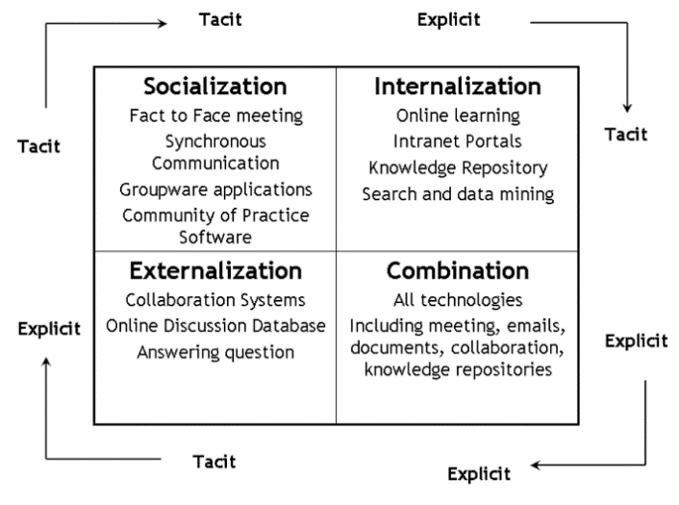
Figure 2: The Theory of Knowledge creation (Nonaka and Takeuchi, 1995)
According to Mathew and Varia (20140 when it comes to knowledge management within the business, the SECI version can be applied to illustrate the tactics the organization employs in the marketplace. It is essential to examine the version's scope and define how intangible it is for controlling knowledge inside an organization.
The primary step is socialization, which is the haggle of tacit awareness through experience, observation, imitation, and interest in both informal and formal organizational procedures. Amazon.com has used the SECI model successfully in the past, which has aided the organization in useful data management.
The second feature of the model is externalisation, which is the process of making tacit knowledge explicit in the form of ideas, pictures, and textual materials. Through conversation, metaphors, and team conflicts, people successfully codify tacit information here (Farnese et al., 2019). An organisation must develop strategic plans that will allow it to externalise information to improve communication management (Majed, Nuraddin and Hama, 2018).
The third step is to incorporate information into the knowledge system (Correll et al., 2016). This type of knowledge change could be aided by the inventive use of computerised email networks and large databases. Several previous studies, for example, have focused on the use of ICT, such as groupware, online databases, private networks, and virtual communities, to speak and swap information. Higher-order knowledge is generated because of these information-sharing procedures, such as models, best practices, guides, and information systems, which can then be shared even in the lack of human interaction (Farnese et al., 2019).
The approach concludes with internalization, where individuals assimilate explicit knowledge, enhancing their understood knowledge base. The correct information is linked to personal skills to be later transmitted and utilized in real-world situations, making the basis of employees' modernized routines. For example, during training, participants can assume a different position by reading and commenting on materials about their workplace or company.
In general, these learning exercises assist participants in expanding their professional knowledge and incorporating new information into their mental models, which allows for the creation of new tacit knowledge. This newly internalised knowledge is then recirculated by the information cycle, initiating additional conversion processes (Farnese et al. 2019). The methodology assists Amazon in gathering relevant data and effectively managing its knowledge
Communication management methods help organizations, and their systems work together successfully and professionally to maximize the contact between people and information systems. At both the calculated and effective levels of a business, a management information system makes straightforward management choices (Demir, 2017).
The Amazon.com example demonstrates how information systems can be successfully aligned with an organization's overarching strategic goals. More specifically, amazon manipulates management information systems to transform data into information that can be used to make decisions. By maintaining its technical and application system and efficiently running its information system, the company succeeds in implementing an integrated system over the web. Moreover, by preserving its website operations distinct and apart from its order processes, Amazon.com has been improving its e-strategy. Management information system has been essential to the company's growth on a global scale (Weber, 2010). In addition, Amazon.com has optimized its management processes using management information systems, and at the same time, has made sure that customers are offered a variety of services through its management information system (Demir, 2017).

INVESTIGATING OF KM TECHNIQUES USED BY AMAZON.COM:
According to Rosenberg (2014), Amazon.com adds considerable benefit to its consumers in a variety of ways by developing the principles and techniques of knowledge management.
First of all, Amazon.com utilizes only one portal and user interface. Through this procedure, users are comfortable and relaxed, which reduces their fear as they discover different parts of the website. In addition, the employees have also common, comfortable, and simple-to-use access to workplace information in all formats due to the one portal and interface. For instance, course materials, e-Learning, websites, videos, and workplace tools all appear in the same location.
Moreover, correct to their brilliant subject matter management, in which they compile information and then distribute it to users, they provide information for every item in the same method and order, from product details to reviews. There is no need for employees to learn how to read or analyse content because of the way it appears. The worth of different organizing structures is severely reduced and users may become baffled if each site has its unique presentation technique. One factor that Amazon.com takes seriously into consideration is consistency (Rosenberg, 2014).
Another knowledge management technique that utilizes Amazon.com is the way the website seems to know its users, which makes him very remarkable to its users. More specifically, the more the user utilizes the website, the more information gathers the website about the user. Consequently, it can bring back old memories, provide suggestions for items he might like, and direct him to further information that he is aware he is seeking. When a system can recognize users and deliver the most important content to them at the right time, productivity and efficiency are improved (Rosenberg, 2014).
Furthermore, another Amazon.com innovative technique is 1-Click Shopping, which enables users to make online purchases of things with just one mouse click using data collected from the customers' prior purchases. Another significant fact is that users are prevented from making purchases by the shopping cart. Listmania and Wish List are two further innovations offered by Amazon.com that assist shoppers in finding new products and making informed decisions (Rosenberg, 2014).
Amazon.com is considered one of the best online marketplaces for encouraging consumers to leave useful reviews. The business appreciates client opinion because it understands how valuable it is to customers. It delivers many options for separating and sorting the information to suit their preferences and places references right on the result's home page. Potential consumers are not the only ones, who can profit from this information, but also Amazon.com may utilize it to increase its services and producers can increase their goods. One of the best methods to evaluate knowledge management effectiveness for determining the worth of material is through user feedback and in comparison to downloads or page visits it has a more significant impact. Based on comments from other users, it also enables users in distinguishing significant and valuable content fast (Rosenberg, 2014).
Despite the impression that Amazon controls what we see, most material is created by product firms with genuine expertise. The information is more useful because it seems like it was produced in the same location thanks to Amazon's design guidelines, writing guidelines, and other practices and procedures. The burden of content completion, relevance, and correctness is likewise transferred to the most responsible entity by transferring content generation to the source. In, addition, every page on Amazon is divided into manageable sections by the corporation. This frees up employees from misusing time reading lengthy documents or indices in search of the information they require by allowing them to quickly access only the content they require (Rosenberg, 2014).
Amazon.com's purpose is the creation of a platform as friendly and detailed as possible for its users. This procedure supports the business save a lot of money and increases client satisfaction. Most of the product information on Amazon is so thorough. Even a small decrease in email or call centre requests has the potential to save a lot of money. On the other hand, Amazon.com has invested in the online help. The user can learn how simple it is to use, read, and follow by choosing "Help". This technique improves the users' experience, boosts their satisfaction and efficiency, and lowers Amazon's expenses. Actually "Help" is knowledge management pointed out by Rosenberg (2014). Employees’ productivity would benefit from anything that enhances the help feature of any application or software.
A knowledge management system is influenced by a variety of significant aspects, including corporate culture, leadership, knowledge flow and process, technological infrastructure, organizational structure, and mission (Albers, 2009). Appropriate knowledge management implementation strategies must be adopted to provide a framework for knowledge management and integration that makes it simple for employees to access and share knowledge. A knowledge management system must have significant leadership backing to be implemented successfully Denizhan (2008).

CONCLUSIONS AND RECOMMENDATIONS:
Although one of Amazon's greatest useful benefits is the way they organize, classify, and control their enormous amounts of data, this does not mean that there isn't still potential for development. A proposal for the organization is to arrange leadership training sessions for all employees and managers. It's critical to remember that education may foster professionalism and skills in dealing with clients in the marketplace (Vakulenko et al., 2019). Much work needs to be done to enhance service delivery to guarantee that each employee is properly trained and equipped for the position. Digital systems for acquiring and distributing information shouldn't be neglected because they can progress business operations.
Furthermore, Amazon ought to think about constructing a robotic sorting facility that would use programmed robots to automatically identify products and packing boxes. The packing list might be computerized as part of this program, reducing the need for paper and the risk of privacy breaches. Errors are less likely to occur, and labour expenses might go down. Additionally, security problems would decrease with the use of electronic or robotic devices.
Moreover, another recommendation is to enhance people management strategies because they affect information flow. The company has recently been able to gather information on both an internal and external level using a variety of models (Dixit et al., 2019). Implementing a bottom-up strategy enables the business to gather data that may be relevant for decision-making in the future. Ineffective leadership in the company has drawn criticism in the past due to the unfair treatment of some employees (Vakulenko et al., 2019). For example, it should be honest and encouraging of moral standards while employing new staff and collaborating with suppliers. Training and developing initiatives can enhance employee leadership skills (Majed et al., 2018). Additionally, it must expand its coverage of other markets to increase the number of ways to learn about how the sector is operating. Enhancing methods for handling information and preserving that knowledge could be useful in fostering performance at Amazon.
Challenges and possibilities for transformation are both brought on by the pandemic. A reputable knowledge management system, like that of Amazon.com, was examined for a company that obtained a significant revenue boost throughout the pandemic.
A crucial factor that should be taken into account to boost performance is knowledge management in a business. Knowledge management is a systematic method for developing, managing, and exploiting organisational knowledge to maximize the use of knowledge, establish a long-term competitive state, and improve organizational performance and production. Knowledge management is a combination of people, procedures, and technologies (Albers, 2009).
Making decisions requires the use of information, and poor information management can hurt efforts to promote operations. Amazon employs a variety of tactics for handling information both internally and externally, including the integration of analogue and digital communication channels. For instance, implementing innovative methods within the business has significantly enhanced operations. Being inventive has also resulted in the creation of unique purchasing tactics that have influenced the experiences of numerous customers on a global scale.
It has been demonstrated that knowledge management programs have numerous advantages, including evolving organizational strategies, resolving issues quickly, disseminating best practices, cultivating knowledge of goods and services, enabling organizations to compete better, reducing redundancy, improving internal procedures, reducing errors, increasing staff participation levels in decision-making, and retaining organizational rational capital.

Task 2 POSTER:

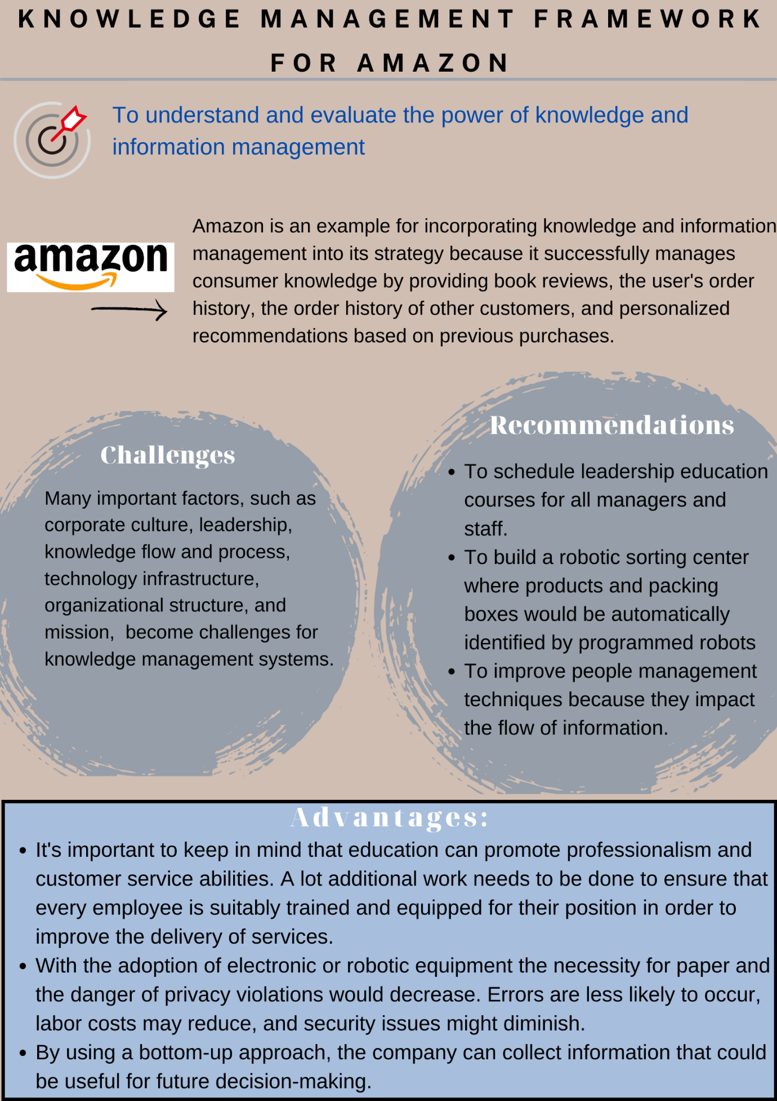

REFERENCES:
Albers, J. A. (2009). A practical approach to implementing knowledge management. Journal of Knowledge Management Practice, 10, 1-14.
Andreeva, T. & Kianto, A. (2011). Knowledge processes, knowledge-intensity and innovation: A moderated mediation analysis. Journal of Knowledge Management, 15(6), 1016–1034.
Beckers, J., Weekx, S., Beutels, P. & Verhetsel, A. (2021). COVID-19 and retail: The catalyst for e-commerce in Belgium? Journal of Retailing and Consumer Services, 62, 102645.
Charan, R. & Yang, J. (2019). The Amazon Management System: The Ultimate Digital Business Engine That Creates Extraordinary Value for Both Customers and Shareholders. Ideapress Publishing.
Correll, N., Bekris, K.E., Berenson, D., Brock, O., Causo, A., Hauser, K., Okada, K., Rodriguez, A., Romano, J.M. and Wurman, P.R. (2016). Analysis and observations from the first amazon picking challenge. IEEE Transactions on Automation Science and Engineering, 15(1), 172-188.
Dixit, A., Clouse, C. and Turken, N. (2019). Strategic business location decisions: Importance of economic factors and place image. Rutgers Business Review, 4(1).
Demir A. (2017). Management Information System: Case Study of Amazon.Com. Journal of Research in Business and Management, 4 (11), 11-17.
Denizhan Kalkan, V. (2008), "An overall view of knowledge management challenges for global business", Business Process Management Journal, Vol. 14 No. 3, pp. 390-400.
Farnese, M. L., Barbieri, B., Chirumbolo, A., & Patriotta, G. (2019). Managing knowledge in organizations: A Nonaka’s SECI model operationalization. Frontiers in Psychology, 10, 2730.
Flamand, O. J., Wisher, A. & Riley, S. (2020). Strategic Plan: Amazon". Undergraduate Theses, Professional Papers and Capstone Artifacts. 309.
Gaviria-Marin, M., Merigó, J. M., & Baier-Fuentes, H. (2019). Knowledge management: A global examination based on bibliometric analysis. Technological Forecasting and Social Change, 140, 194-220.
Hulse, N. C., Galland, J. and Borsato, E. P. (2012). Evolution in Clinical Knowledge Management Strategy at Intermountain Healthcare. In: AMIA Annual Symposium Proceedings, American Medical Informatics Association, 390.
Khalilabad, H. N., Mazandarani, O. N., Sentosa, I., & Piaralal, S. K. (2006). The impact of knowledge management on customer relationship management. Journal of American Academy of Business, 9(2), 2-21.
Mathew, S. and Varia, J. (2014). Overview of amazon web services. Amazon Whitepapers.
Majed, S.Z., Nuraddin, S.H. and Hama, S.V.S., 2018. Analysing Amazon’s success strategies. Journal of process management. New Technologies, 6(4), 65-69.
Nonaka, I., and Takeuchi, K. (1995). The Knowledge-Creating Company. New York, NY: Oxford University Press.
Nuruzzaman, N., Gaur, A.S. and Sambharya, R. (2018). A micro-foundations approach to studying innovation in multinational subsidiaries, Global Strategy Journal, 1-25.
Oliva, F. L. & Kotabe, M. (2019). Barriers, practices, methods and knowledge management tools in startups. Journal of Knowledge Management.
Shujahat, M., Sousa, M. J., Hussain, S., Nawaz, F., Wang, M., & Umer, M. (2017). Translating the impact of knowledge management processes into knowledge-based innovation: The neglected and mediating role of knowledge-worker productivity. Journal of Business Research. Studies, 14(2), 97-134.
There, N., Maditinos, D. & There, G. (2011). Knowledge Management Enabler Factors and Firm Performance: An Empirical Research of the Greek Medium and Large Firms. European Research Vakulenko, Y., Shams, P., Hellström, D. and Hjort, K. (2019). Service innovation in e-commerce last mile delivery: Mapping the e-customer journey. Journal of Business Research, 101, 461-468.
Weber, S. (2010). Sell on Amazon: A Guide to Amazon's Marketplace, Seller Central, and Fulfillment by Amazon Programs (Seventh Edition) SAGE, 33 - 37.
INTERNET SOURCES:
Andrienko, O., (2020). E-commerce and Consumer Trends during Coronavirus. [Online]. (Accessed 27/11/2022). Available at: https://www.semrush.com/blog/ecommerce-covid-19
Rosenberg, M. (2014). The Knowledge Management Genius of Amazon.com. Learning Solutions. [Online]. (Accessed 28/11/2022). Available at: https://learningsolutionsmag.com/articles/1480/the-knowledge-management-genius-of-amazoncom

