
Assignment 2: Practical & professional development
Changemakers: Creativity and Value Creation

Miguel Richards
2515293

Table of Contents
Introduction 1
Task1: Practical development / implementation 1
Initial feedback 1
Implementation 3
Task 2: Enterprise 7
Q1 7
Name and Logo 7
Legal Classification 7
Business strategy 8
Funding 8
Q2 – Pest analysis 9
Political and Legal Factors 9
Economic and Competition Factors 9
Social and Customer Factors 9
Technological Factors 10
Ethical Considerations 10
Task 3: project reflection 10
Practical feedback 10
Project Progress diary 10
Skills 11
Positive social impact 11
Conclusion 11
References 12
Appendices 12

Introduction
This assignment explores the development of the dietary meal planning application. That is designed to help use a safe time of money while encouraging a healthier eating habit. This assignment covers how improvements can be made to design the initial implementation of the application and the potential business strategy for the development of the application.

Task1: Practical development / implementation

Initial feedback
Too collect feedback on the project a question was created and given to 5 different potential users. The questionnaire included a description of the application, a link to a prototype and 6 questions as shown below.
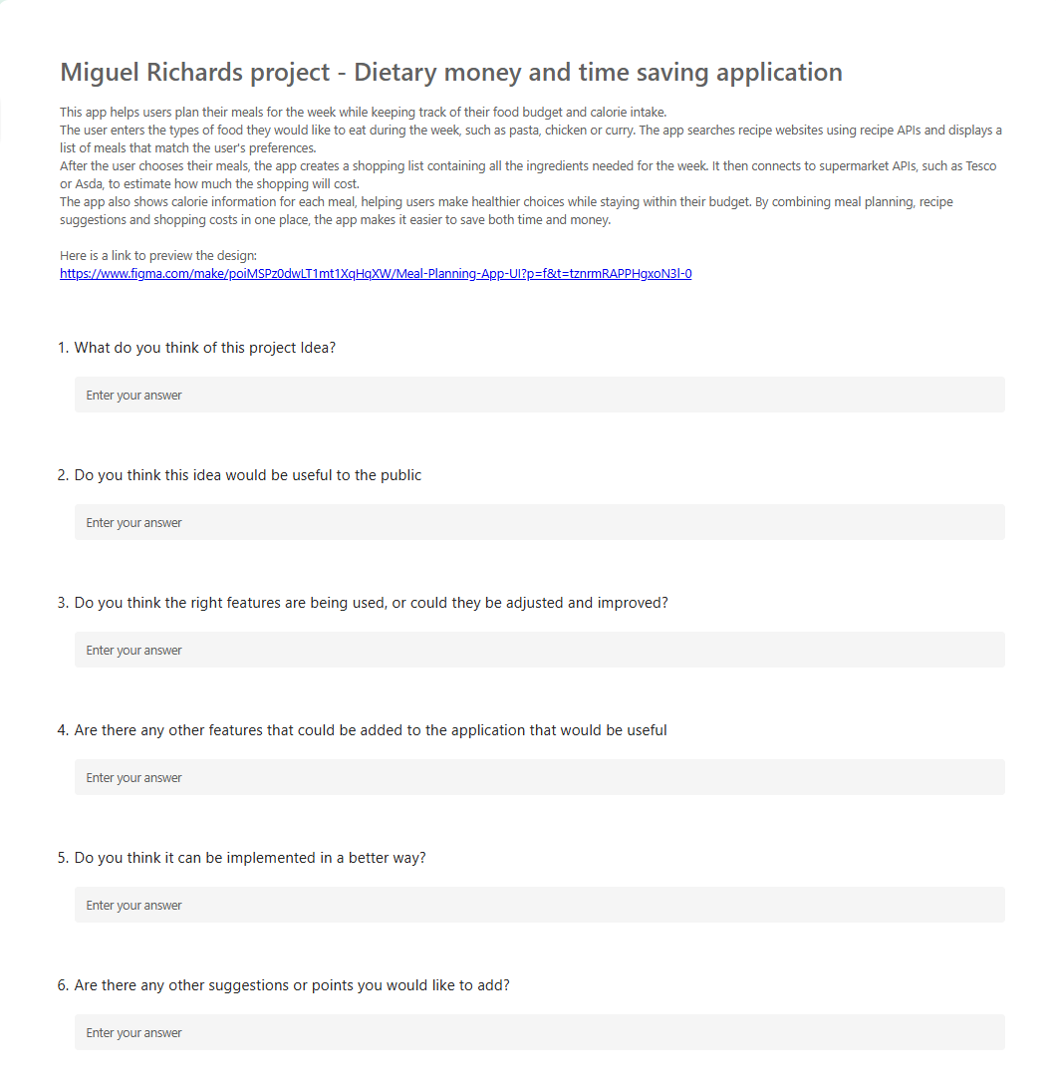

The feedback received was very positive, the participates agreed that the application has potential to be of great use to the public. The main benefits that the participants identified were helping users simplify meal planning, maintain healthier eating habits and manage their food budget more effectively. The current feature ideas such as recipe recommendations, calorie tracking, shopping lists and cost estimation were considered well suited to achieving project aims. However, some potential improvements were suggested. Some of the suggestions were adding more detailed national information, allowing users to order food directly through the application, and creating a web version to improve the accessibility.
One of the responses identified a potential implementation challenge and that was the difficulty of connecting to multiple supermarket APIs, meaning careful consideration would be required when choosing supermarket data sources. Fortunately, API research has been undertaken to mitigate that potential challenge, so only APIs that suit the requirements will be used.
Based on the feedback that was received the project will be making a few changes. The project will be adding more detail to the nutritional information such as protein, vitamins and nutrients this will improve the health tracking features. A website version will also be created so that the project is more accessible. The feature allowing food to be ordered directly through the application will also be considered as this feature would improve the user experience, but only as a future improvement due to the projected scope and current timeframe.

Implementation
Practical implementation of the application has started, the initial development focuses on the homepage and applying design ideas to the actual application. The images below show the early stages of implementation by presenting code screenshots and what the homepage looks like and some of the progress. These images help to show how some of the code works and how the styling works also.
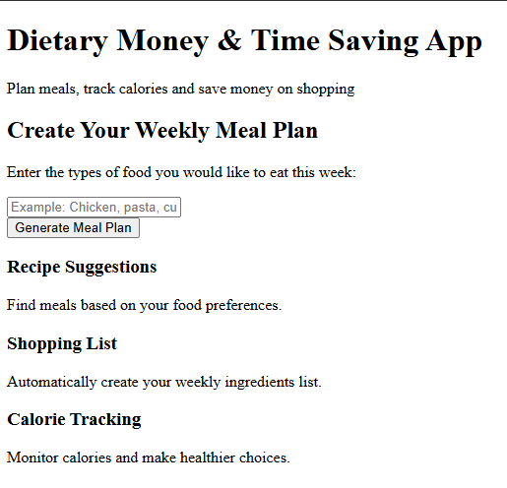
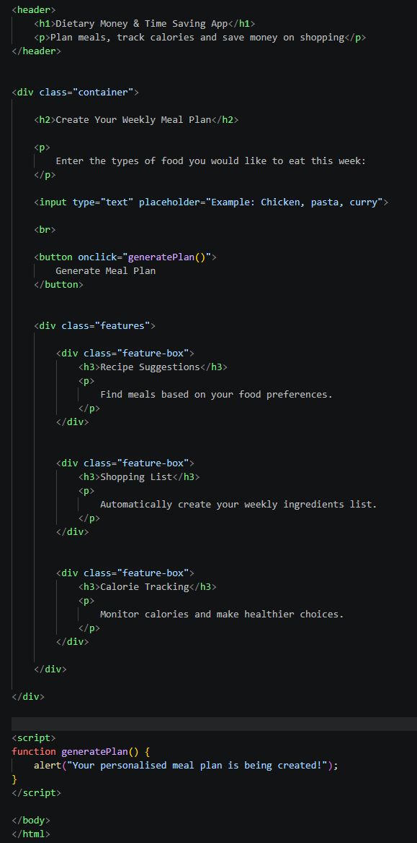
This screenshot above shows the homepage after the HTML structure was created. At this stage in the development all of the content that is required and user interface elements (e.g. buttons, text box, etc) are there but, no styling has been applied which makes the page look basic, unorganized and not engaging.

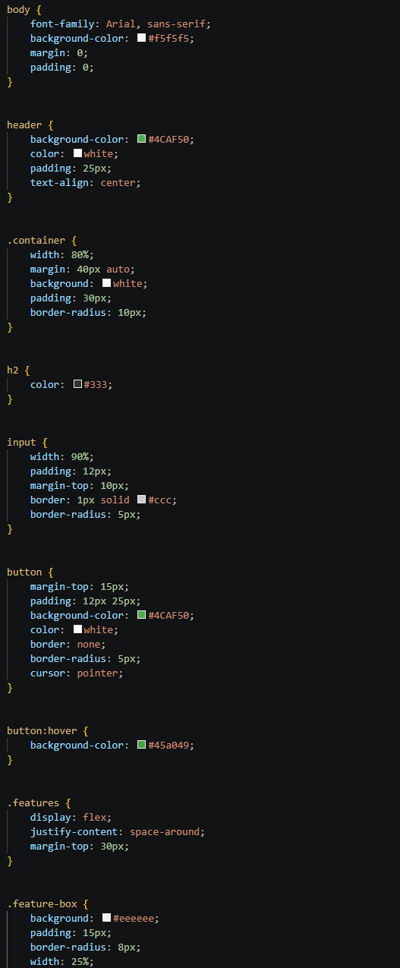
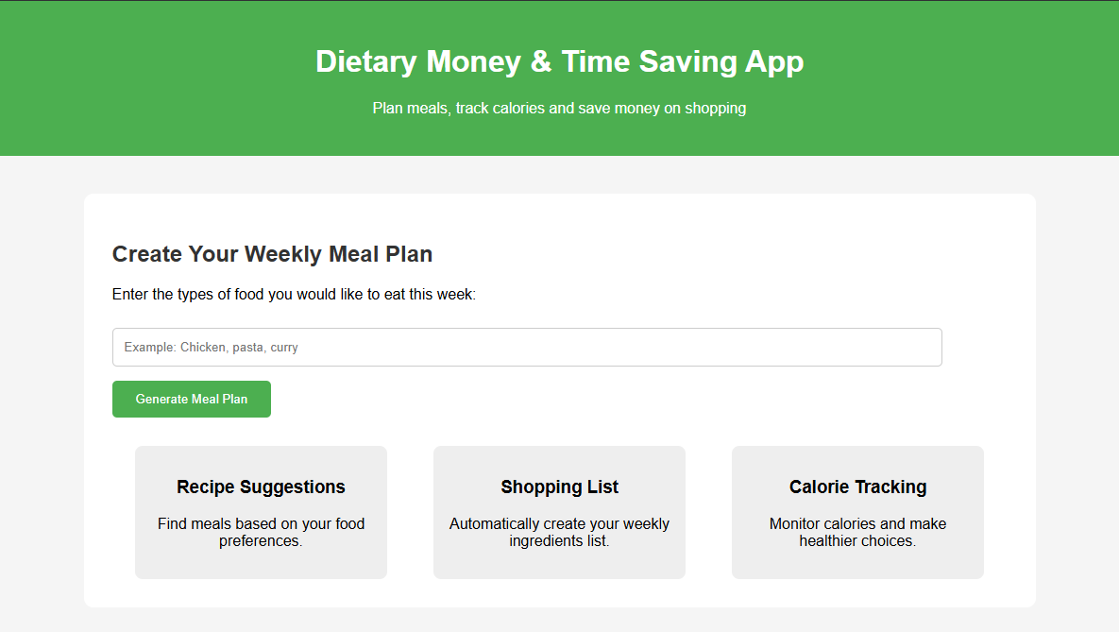
This screenshot shows the initial homepage After the CSS stylesheet that is show on the right is applied. The stylesheet improves the overall appearance of the application by improving the layout, colours and spacing, this creates a more appealing and user-friendly interface. Comparing the homepage before and after the CSS, all the elements such as text, textboxes and buttons are in both homepages but clearly the CSS makes the homepage look better.

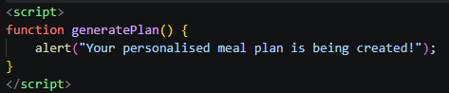
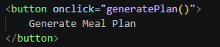
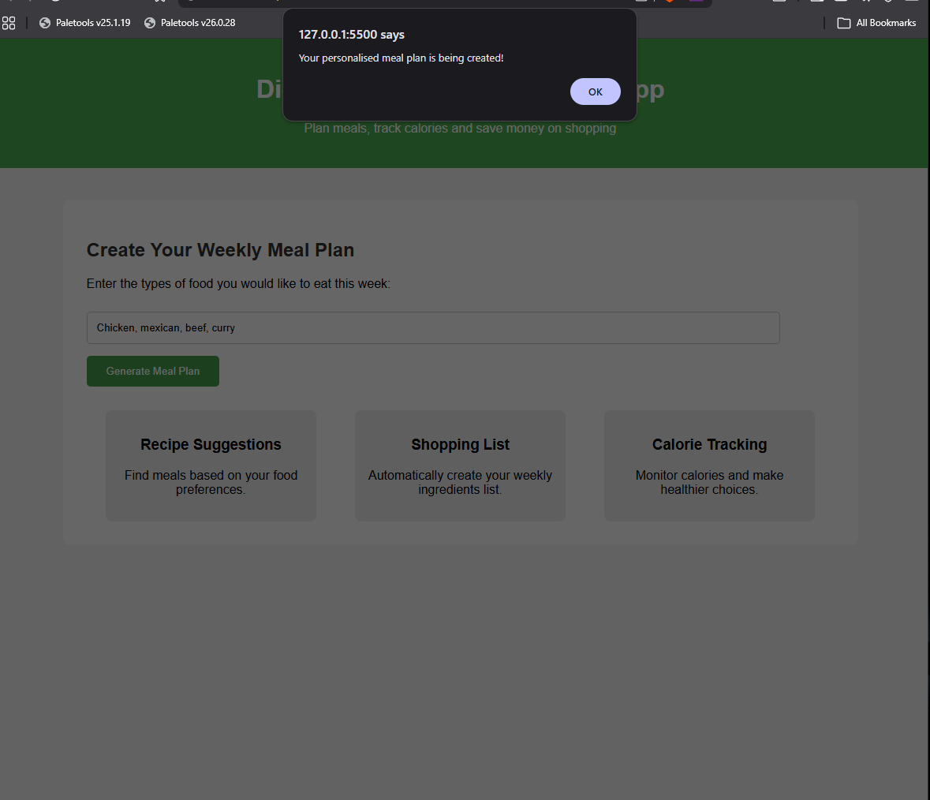
These three screenshots show the implementation of the generate meal plan button and the JavaScript function that is called when the button is clicked. At this current stag, the function displays an alert message to show that the button is working correctly and that the user can successfully interact with the button. This current alert represents the principle behind the feature to be implemented and in the future the function will be replace with a more complex function that will include the logic needed to process the user’s food preferences, retrieve recipe suggestions and even to make the waiting time message prettier.

During the creation of the home page two problems had to be troubleshooted. First, the homepage elements were not aligned correctly, making the feature boxes loom uneven. This was resolved by using CSS flexbox to evenly distribute the sections across the page. The second problem encountered was the styling, the colour scheme made some of the text difficult to read with the background behind it. The colours and the spacing were adjusted to improve the readability and create a more user friendly and accessible interface.

Task 2: Enterprise

Q1

Name and Logo
The proposed name for the business is MealWise. This name was chosen because it reflects the applications purpose of users making smarter decisions about their meals. A logo has also been designed to create a recognisable brand identity and support the marketing of the application. It includes cutlery and a salad bowl to represent healthy food and nutrition. 3 characteristics of a good logo are simplicity, memorable and distinctive[1], The MealWise logo covers these 3 characteristics


Legal Classification
Meal wise will operate as a private limited company. This structure was chosen because of limited liability, meaning all the owners’ personal assets are protected if the business face financial difficulties [2]. It also presents a more professional image and makes it easier to secure investments and expand the business.

Business strategy

Mission statement
To help individuals and families save time and money while encouraging healthier eating through an easy-to-use meal planning application.

Objectives
- Developing a functional prototype.
- Gather user feedback to improve the applications usability and features
- Identify potential funding to help start up the business.
- Create a market plan to encourage users
- Introduce additional features, such as direct food ordering from the application, in future versions of the application

Values
Innovation – Continuously improving the application with new features.
Accessibility – Ensure that the application is inclusive and allows for all users to navigate it.
Reliability – Providing accurate recipes, accurate calories and accurate shopping information.
Health and Wellbeing – Encouraging healthier eating habits by providing calorie and nutritional information.
Convenience – Simplifying meal planning and shopping to save users time and effort.

Funding
The Uk government offers funding opportunities to support start-up businesses and encourage innovation in the technology area. One example of this is an Innovate UK grant, this grant provides financial support to businesses developing innovative products, services or technologies. Innovate UK grants can range from smaller awards to larger innovation projects, funding opportunities vary depending on the specific competition [3]. This funding option is suitable for MealWise because the application is a service that helps with food planning, budgeting and healthier eating. To apply for this funding the business would need to identify a suitable innovate UK grant opportunity and submit an application explaining the purpose of the application the technology involved the expected benefits and how the funding will be used. Evidence like a prototype, user feedback and market research would help to show the potential value of the project. If successful the funding could be used to support software development, user testing and marketing for the expansion of the application.
However, innovate UK funding opportunities require the business to already be established and have evidence of previous development or trading experience [3]. For this reason, during the initial stages of the application, the development of the prototype, early research and even the deployment of MealWise will all be self-funded. Once the business has been established and has gained sufficient evidence of progress, innovate UK funding could be considered to support further development and Marketing.

Q2 – Pest analysis
Using the help of OpenAI’s ChatGPT I was able to generate a pest analysis. The analysis considers political, economic, social and technology factors[4]. Additional resources are used to help support the analysis.

Political and Legal Factors
MealWise will need to comply with legal requirements such as the UK GDPR and Data Protection Act 2018, as the application may collect user information including dietary preferences and account details. The business must ensure user data is securely stored and users are informed about how their information is used [5]. Intellectual property protection should also be considered to protect the MealWise name, logo and software from being copied. [6]

Economic and Competition Factors
The rising cost of food and the cost-of-living crisis may increase demand for applications that help users manage their spending. MealWise can provide value by helping users plan meals, estimate shopping costs and reduce unnecessary purchases. However, the business will face competition from existing applications such as MyFitnessPal and Mealime. Development costs, including software tools, API access and potential employee costs, may also affect the business.

Social and Customer Factors
MealWise targets users who want to save time, reduce food costs and maintain healthier eating habits. Increased awareness of nutrition and meal planning creates an opportunity for the application. However, users must trust the accuracy of the nutritional information and recommendations provided.

Technological Factors
MealWise relies on technologies such as recipe APIs, supermarket APIs, databases and software development tools. Future technologies, such as artificial intelligence, could improve personalised meal recommendations. However, challenges such as API reliability, security and data accuracy must be managed.

Ethical Considerations
MealWise must handle user data responsibly and avoid promoting unhealthy attitudes towards food. The application should provide accurate nutritional information and remain accessible for different users.

Task 3: project reflection

Practical feedback
A Microsoft form was created to collect feedback. Three responses were received.
The feedback from the three participants showed that the project prototype clearly communicates its purpose. Each respondent understood the main features such as recipe generation, shopping list and calorie tracking. The main improvement suggested we’re making the design more engaging, making the colour scheme better and making interactive elements clearer.
Based on the feedback, the design for the homepage will be improved by using a more professional colour scheme, improving the page title, including the logo and making the interactive features clearer. Additional information could also be considered in future versions such as calorie summaries.

Project Progress diary
The project progress sheets were completed to track and document progress made each week. This progress tracker helped to keep on track and understand what actions are next required to continue development. If the project was to be undertaken again an improvement that could be made is completing tasks earlier and creating a more detailed schedule to allow additional time for testing feedback and further improvements.

Skills
This module helped to develop technical and professional skills. Knowledge of UI and UX design was improved through creating a Figma prototype and considering how users interact with an application. Web development skills were also strengthened by completing initial implementation of the application using HTML CSS and JavaScript. Additional research and skills were improved having to research APIs. Using the skill of being able to receive feedback and use that to improve. Will help with any projects taken place in the future. These skills will be valuable for future software development projects by improving the ability to design develop and evaluate effective software solutions.

Positive social impact
Meal wise could have a positive impact on society by helping others save money, time, reduce food waste and make their food healthier. The project supports individuals and families by simplifying meal planning and helping them manage their food budgets. The skills developed during this project including software development research and problem-solving can contribute to create in future technology solutions that improve people’s everyday lives such as MealWise.

Conclusion
In conclusion, the development of meal wise has demonstrated the potential for technology to address every day challenges relating to meal plan budgeting and healthy eating. Through research in the market developing the prototype design analysing business opportunities and collecting user feedback key areas for improvement have been identified. The project has also supported the development of technical research and project management skills. These skills can support future software development work. Overall, this project has provided a solution that can create value for users and contribute positively to society.

References
[1] | Trisha, “What Makes a Good Logo? 14 Dos and Don’ts of Logo Design,” Nov. 2025. Accessed: Jul. 19, 2026. [Online]. Available: https://imagebox.co.uk/graphic-design/what-makes-a-good-logo/
[2] | Government of UK, “Set up a Private Limited Company,” 2024. Accessed: Jul. 19, 2026. [Online]. Available: https://www.gov.uk/limited-company-formation
[3] | D. for, “Innovate UK - Grant Funding, Innovation Loans and Expert Support,” Dec. 2017. Accessed: Jul. 23, 2026. [Online]. Available: https://www.gov.uk/business-finance-support/innovate-uk-grant-funding-innovation-loans-and-expert-support?
[4] | ChatGPT, “ChatGPT discussion on PEST annalysis,” Jul. 23, 2026.
[5] | ICO, “UK GDPR Guidance and Resources,” 2023. Accessed: Jul. 27, 2026. [Online]. Available: https://ico.org.uk/for-organisations/uk-gdpr-guidance-and-resources/
[6] | GOV.UK, “Intellectual Property and Your Work,” GOV.UK, Jul. 2022. Accessed: Jul. 27, 2026. [Online]. Available: https://www.gov.uk/intellectual-property-an-overview

Appendices

Project progress form

Name: Miguel Richards(2515293)
Programme: Practical and professional development

Project Aim: To design and develop a meal planning application that helps users save time and money while encouraging healthier eating. Through recipe recommendations, calorie tracking and shopping cost estimates.
Project Objectives:
- Design a functional prototype of the MealWise application using wireframes, flowcharts and a Figma interface.
- Research and integrate suitable recipe and supermarket APIs to support meal planning, calorie tracking and shopping cost estimation.
- Gather user feedback on the prototype and use the results to identify improvements for future development.

<< WEEKLY UPDATE: NEW FORM EACH WEEK >>
Weekly Project progress forms:

Date: -7/07/2026

Progress:
A MS for was created and sent out to other students to gather feedback on the design of the project.
Actions:
State priority actions to undertake over the next week below.
- Consider and summaries feedback
- Consider ways in which initial implementation can take place
- Start initial implementation

Next review date: 14/07/2026

Date: -14/07/2026

Progress:
Feedback Has been analysed and summarised. And initial implementation of the application has taken place.

This is the homepage so far, css still needs to be added to make it look like a home page.

The enterprise route has been taken for this project so, a name has now been given to the project and a logo has been created also.

Actions:
State priority actions to undertake over the next week below.
- Complete initial implementation of the home page.
- Use chatGPT and extra resources to create a PEST analysis
- Find funding for project

Next review date: 21/07/2026

Date: -21/07/2026

Progress:
This week great progress has been made.
initial implementation is complete:

Pest analysis is also complete, along with finding how the project will be funded and creating a business strategy

Actions:
State priority actions to undertake over the next week below.
- Create an ms form to receive feedback on initial implementation
- Summaries feedback
- Reflect on the project
Next review date: 28/07/2026

Date: -28/07/2026

Progress:
Final progress sheet, all work has been complete, ms form was created and sent out for feedback. Feedback was summaries and reflection on the project took place.

.

I also completed the figma course which helped me create the prototype of the app.


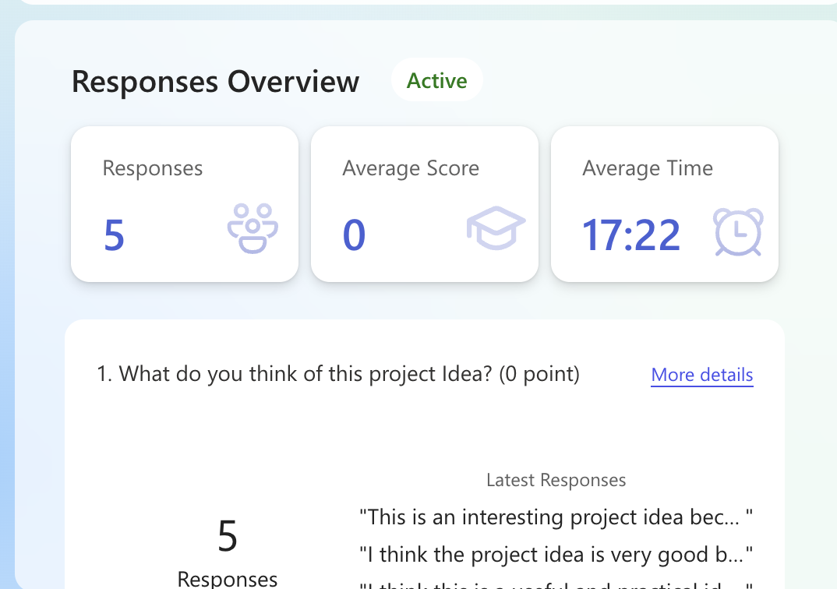
Proof of 5 responses to first ms form

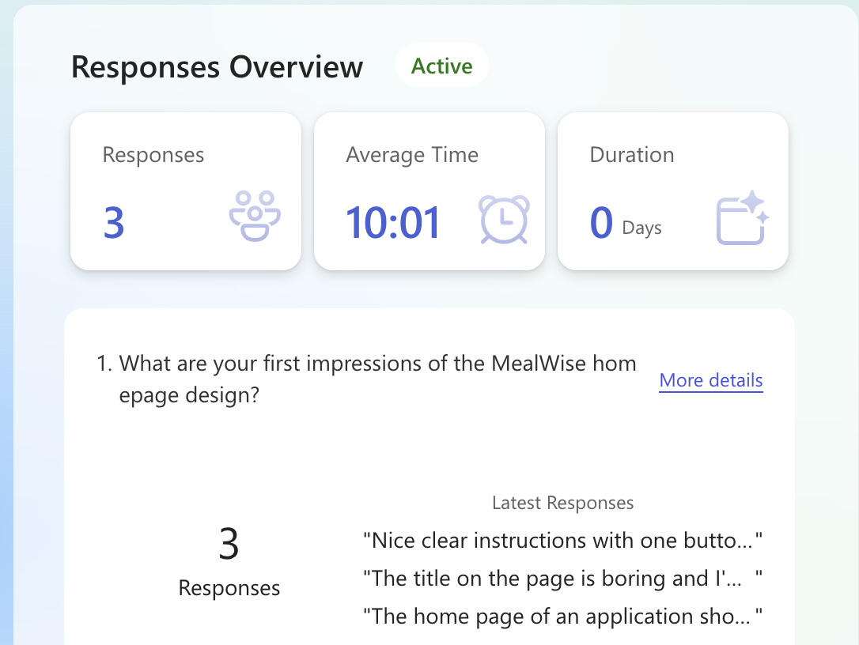
Proof of 3 responses to 2nd ms form

