How I can use the DIKW and CRAAP frameworks to confirm or refute my collected Academic GRIT test result (Primary Data) compared to the UWTSD GRIT Result (secondary Data) based on the work of Angela Duckworth TED Talk lecture

Module: Digital skills and research methods
Module code: BMSW4003_BIRM
Name: Angela Petkova Chongarova

Student number: 2106951

Introduction
What is DIKW
How I can use DIKW
What is GRIT test
Academic GRIT test result (Primary Data) compared to the UWTSD GRIT Result (secondary Data) based on the work of Angela Duckworth TED Talk lecture

The DIKW Pyramid represents the relationships between data, information, knowledge and wisdom. Each building block is a step towards a higher level - first comes data, then is information, next is knowledge and finally comes wisdom. Each step answers different questions about the initial data and adds value to it. The more we enrich our data with meaning and context, the more knowledge and insights we get out of it so we can take better, informed and data-based decisions.
Knowledge Pyramid, Wisdom Hierarchy and Information Hierarchy are some of the names referring to the popular representation of the relationships between data, information, knowledge and wisdom in the Data, Information, Knowledge, Wisdom (DIKW) Pyramid.
Like other hierarchy models, the Knowledge Pyramid has rigidly set building blocks – data comes first, information is next, then knowledge follows and finally wisdom is on the top.
Each step up the pyramid answers questions about the initial data and adds value to it. The more questions we answer, the higher we move up the pyramid. In other words, the more we enrich our data with meaning and context, the more knowledge and insights we get out of it. At the top of the pyramid, we have turned the knowledge and insights into a learning experience that guides our actions.

How to Scale Data Up the Knowledge Pyramid
So, let’s have a look at the individual components of the Knowledge Pyramid and how we move from one to the next.

Data

Data is a collection of facts in a raw or unorganized form such as numbers or characters.
However, without context, data can mean little. For example, 12012012 is just a sequence of numbers without apparent importance. But if we view it in the context of ‘this is a date’, we can easily recognize 12th of January, 2012. By adding context and value to the numbers, they now have more meaning.
In this way, we have transformed the raw sequence of numbers into

Information

Information is the next building block of the DIKW Pyramid. This is data that has been “cleaned” of errors and further processed in a way that makes it easier to measure, visualize and analyze for a specific purpose.
Depending on this purpose, data processing can involve different operations such as combining different sets of data (aggregation), ensuring that the collected data is relevant and accurate (validation), etc. For example, we can organize our data in a way that exposes relationships between various seemingly disparate and disconnected data points. More specifically, we can analyze the Dow Jones index performance by creating a graph of data points for a particular period of time, based on the data at each day’s closing.
By asking relevant questions about ‘who’, ‘what’, ‘when’, ‘where’, etc., we can derive valuable information from the data and make it more useful for us.
But when we get to the question of ‘how’, this is what makes the leap from information to

Knowledge

“How” is the information, derived from the collected data, relevant to our goals? “How” are the pieces of this information connected to other pieces to add more meaning and value? And, maybe most importantly, “how” can we apply the information to achieve our goal?
When we don’t just view information as a description of collected facts, but also understand how to apply it to achieve our goals, we turn it into knowledge. This knowledge is often the edge that enterprises have over their competitors. As we uncover relationships that are not explicitly stated as information, we get deeper insights that take us higher up the DIKW pyramid.
But only when we use the knowledge and insights gained from the information to take proactive decisions, we can say that we have reached the final – ‘wisdom’ – step of the Knowledge Pyramid.

Wisdom

Wisdom is the top of the DIKW hierarchy and to get there, we must answer questions such as ‘why do something’ and ‘what is best’. In other words, wisdom is knowledge applied in action.
We can also say that, if data and information are like a look back to the past, knowledge and wisdom are associated with what we do now and what we want to achieve in the future.
What is GRIT?

The Grit Scale measures the extent to which individuals are able to maintain focus and interest, and persevere in obtaining long-term goals. ... Authors advise against using the measure to assess within-individual changes (pre-post administrations) or in high-stakes environments (such as hiring or evaluation).

5 Characteristics Of Grit -- How Many Do You Have?

1) Courage

Hard to measure, but directly proportional to your level of grit.
Relates to your ability to manage fear of failure.
The supremely gritty are not afraid to tank, but rather embrace it as part of a process.
The supremely gritty understand that there are valuable lessons in defeat and that the vulnerability of perseverance is requisite for high achievement.

2) Conscientiousness: Achievement Oriented vs. Dependable

Five core character traits from which human personalities stem are: Openness, Conscientiousness, Extroversion, Agreeableness, and Neurotic. Conscientiousness is most connected to GRIT.
The achievement-oriented individual is one who works tirelessly, tries to do a good job, and completes the task at hand.
The dependable person is more notably self-controlled and conventional.
Achievement orientated traits predicted job proficiency and educational success far better than dependability.
In the context of conscientious, grit, and success, it is important to commit to go for the gold rather than just show up for practice.

3) Long-Term Goals and Endurance: Follow Through

Long-term goals are achieved when practice has purpose. This is the difference between someone who succeeds and someone who is just spending a lot of time doing something.
Long-term goals provide the context and framework in which to find the meaning and value of your long-term efforts, which helps cultivate drive, sustainability, passion, courage, stamina…grit.

4) Resilience = Optimism, Confidence, and Creativity

A key component of grit is resilience.
Resilience is the powering mechanism that draws your head up, moves you forward, and helps you persevere despite whatever obstacles you face along the way.
Gritty people believe, “everything will be alright in the end, and if it is not alright, it is not the end.”

5) Excellence (not perfection)

Excellence is an attitude.
The word excellence is derived from the Greek word Arête, which is bound with the notion of fulfilment of purpose or function and is closely associated with virtue.
Excellence is far more forgiving, allowing and embracing failure and vulnerability on the ongoing quest for improvement.
Excellence allows for disappointment, and prioritises progress over perfection.
Perfection is someone else’s perception of an ideal, and ultimately unattainable. Anxiety, low self-esteem, obsessive compulsive disorder, substance abuse, and clinical depression are only a few of the conditions ascribed to “perfectionism.

Academic GRIT test result (Primary Data) compared to the UWTSD GRIT Result (secondary Data) based on the work of Angela Duckworth TED Talk lecture

Angela Duckworth, a professor at the University of Pennsylvania, was teaching seventh grade math in New York City public schools when she noticed that her best students were not necessarily her smartest students. The realization prompted her to leave her middle school classroom and become a research psychologist so she could better understand the role that foundational skills like self-control and perseverance play in achievement.
Duckworth gave a TED Talk in 2013 explaining how grit—i.e., perseverance and passion for long-term goals—is a significant predictor of success. We’ll take a deeper dive into her research and consider the role of grit in the classroom in 2019, nearly six years after Duckworth delivered her TED Talk.

An Overview of Angela Duckworth’s Research on Grit
Since her 2013 TED Talk, Duckworth’s theory of grit has received a lot of attention and discussion, both good and bad. While many recognize grit as crucial to the learning process, some hold that focusing solely on grit means losing track of other important factors that impact student learning. And even those who believe in the power of grit aren’t always sure how to encourage it in their students.
We’ll discuss how Angela Duckworth came to her conclusions about grit, what her thoughts are now nearly six years after her wildly popular TED Talk went live, and how you can foster grit in your students.

Why are students successful?
Duckworth studied children and adults in challenging environments, including West Point military cadets, national spelling bee contestants, and rookie teachers in difficult schools. In each study, she and her research team asked the same question: “Who is successful here and why?”
Across numerous contexts, one characteristic emerged as a significant predictor of success: grit. Grit is the quality that allows an individual to work hard and maintain focus—not just for weeks or months, but for years.

Measuring grit
To measure grit, Duckworth and her team developed the Grit Scale, a self-reported questionnaire used to evaluate focused effort and interest over time with questions such as, “I have overcome setbacks to conquer an important challenge.” Respondents answer on a scale of one to five, with one being “Not at all like me,” and five being “Very much like me.”
Once an individual completes the survey, his or her grit score can be calculated and used to determine how grit relates to other measures of success.
Duckworth and her team studied students at Chicago Public Schools to determine whether a student’s grit, measured during junior year, predicted graduation the following year.
Students completed a survey that included four items from the Grit Scale, as well as questions used to measure various factors known to predict high school graduation, such as school safety, teacher support, peer support, parental support, conscientiousness, and school motivation.
Duckworth and her team found that juniors with the most grit were more likely to graduate from high school than their less gritty peers, even after accounting for these predictive factors, in addition to standardized test scores and demographics.

Is Grit the Only Characteristic You Should Focus On?
While it is clear that grit matters for success in school and in life, little is known about how best to foster grit in students. But research published since Duckworth’s TED Talk—and Digital Promise’s own research in the learning sciences—show that a number of factors influence student learning.

There are many factors that influence student learning
While fostering grit is beneficial when it comes to facets of student learning, such as encouraging students to correct mistakes, establish high expectations, and take ownership over their learning experience, details as seemingly small as the temperature or layout of a room can also impact student motivation and perseverance.
Since her 2013 TED Talk, Duckworth herself has revisited the role of grit in student success and acknowledged in an interview with EdSurge in 2018 that “when we are talking about what kids need to grow up and live lives that are happy and healthy and good for other people, it’s a long list of things. Grit is on that list, but it is not the only thing on the list.”
Duckworth co-founded a nonprofit, Character Lab, which seeks to demonstrate the plethora of factors that impact student learning. The site gives teachers actionable insights into multiple classroom issues with “playbooks.” One playbook is dedicated to grit, but others focus on personal qualities such as purpose, gratitude, and curiosity.

Fostering grit (and other admirable qualities) in the classroom
We still have a lot to learn about how best to foster grit in students, and answering the question will require strong collaboration between researchers and educators. It will also require determination and perseverance.
“We need to take our best ideas, our strongest intuitions, and we need to test them,” Duckworth said during her TED Talk. “We need to measure whether we’ve been successful, and we have to be willing to fail, to be wrong, to start over again with lessons learned. In other words, we need to be gritty about getting our kids grittier.”
However, after reflecting on some of the backlash she received after her TED Talk, Duckworth has clarified that a “no excuses” or shame-based approach to grit isn’t the way to go. “It is a natural human instinct to shy away from mistake-making, from confusion, from challenge,” Duckworth told EdSurge. “And it is therefore the responsibility of the classroom teacher or school or community to make sure that kids understand that when they don’t want to do something that’s hard, when they don’t want to do something that will maybe not work out, and when they don’t want to quit things, that the first and most important thing is start from understanding and accepting that that is part of the struggle.”
Duckworth encourages teachers who want to start fostering grit in the classroom to “provide a ritual and an opportunity” for students to learn from and correct their mistakes. In her EdSurge interview, she mentions as an example a teacher who kept all students’ tests in a binder they could easily access to rework the problems they got wrong. Creating the time, space, and opportunities for students to be gritty could be a great first step in encouraging gritty mindsets in the classroom.
Are you taking steps to foster grit in your students? Tell us how you’re doing it in the comments below.
Angela Duckworth, a professor at the University of Pennsylvania, was teaching seventh grade math in New York City public schools when she noticed that her best students were not necessarily her smartest students. The realization prompted her to leave her middle school classroom and become a research psychologist so she could better understand the role that foundational skills like self-control and perseverance play in achievement.
Duckworth gave a TED Talk in 2013 explaining how grit—i.e., perseverance and passion for long-term goals—is a significant predictor of success. We’ll take a deeper dive into her research and consider the role of grit in the classroom in 2019, nearly six years after Duckworth delivered her TED Talk.

An Overview of Angela Duckworth’s Research on Grit
Since her 2013 TED Talk, Duckworth’s theory of grit has received a lot of attention and discussion, both good and bad. While many recognize grit as crucial to the learning process, some hold that focusing solely on grit means losing track of other important factors that impact student learning. And even those who believe in the power of grit aren’t always sure how to encourage it in their students.
We’ll discuss how Angela Duckworth came to her conclusions about grit, what her thoughts are now nearly six years after her wildly popular TED Talk went live, and how you can foster grit in your students.

Why are students successful?
Duckworth studied children and adults in challenging environments, including West Point military cadets, national spelling bee contestants, and rookie teachers in difficult schools. In each study, she and her research team asked the same question: “Who is successful here and why?”
Across numerous contexts, one characteristic emerged as a significant predictor of success: grit. Grit is the quality that allows an individual to work hard and maintain focus—not just for weeks or months, but for years.

Measuring grit
To measure grit, Duckworth and her team developed the Grit Scale, a self-reported questionnaire used to evaluate focused effort and interest over time with questions such as, “I have overcome setbacks to conquer an important challenge.” Respondents answer on a scale of one to five, with one being “Not at all like me,” and five being “Very much like me.”
Once an individual completes the survey, his or her grit score can be calculated and used to determine how grit relates to other measures of success.
Duckworth and her team studied students at Chicago Public Schools to determine whether a student’s grit, measured during junior year, predicted graduation the following year.
Students completed a survey that included four items from the Grit Scale, as well as questions used to measure various factors known to predict high school graduation, such as school safety, teacher support, peer support, parental support, conscientiousness, and school motivation.
Duckworth and her team found that juniors with the most grit were more likely to graduate from high school than their less gritty peers, even after accounting for these predictive factors, in addition to standardized test scores and demographics.

Is Grit the Only Characteristic You Should Focus On?
While it is clear that grit matters for success in school and in life, little is known about how best to foster grit in students. But research published since Duckworth’s TED Talk—and Digital Promise’s own research in the learning sciences—show that a number of factors influence student learning.
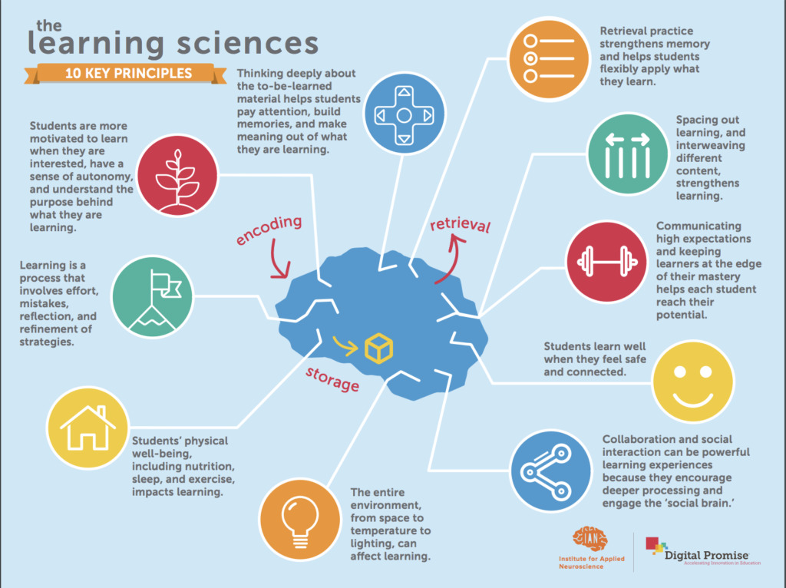
There are many factors that influence student learning
While fostering grit is beneficial when it comes to facets of student learning, such as encouraging students to correct mistakes, establish high expectations, and take ownership over their learning experience, details as seemingly small as the temperature or layout of a room can also impact student motivation and perseverance.
Since her 2013 TED Talk, Duckworth herself has revisited the role of grit in student success and acknowledged in an interview with EdSurge in 2018 that “when we are talking about what kids need to grow up and live lives that are happy and healthy and good for other people, it’s a long list of things. Grit is on that list, but it is not the only thing on the list.”
Duckworth co-founded a nonprofit, Character Lab, which seeks to demonstrate the plethora of factors that impact student learning. The site gives teachers actionable insights into multiple classroom issues with “playbooks.” One playbook is dedicated to grit, but others focus on personal qualities such as purpose, gratitude, and curiosity.

Fostering grit (and other admirable qualities) in the classroom
We still have a lot to learn about how best to foster grit in students, and answering the question will require strong collaboration between researchers and educators. It will also require determination and perseverance.
“We need to take our best ideas, our strongest intuitions, and we need to test them,” Duckworth said during her TED Talk. “We need to measure whether we’ve been successful, and we have to be willing to fail, to be wrong, to start over again with lessons learned. In other words, we need to be gritty about getting our kids grittier.”
However, after reflecting on some of the backlash she received after her TED Talk, Duckworth has clarified that a “no excuses” or shame-based approach to grit isn’t the way to go. “It is a natural human instinct to shy away from mistake-making, from confusion, from challenge,” Duckworth told EdSurge. “And it is therefore the responsibility of the classroom teacher or school or community to make sure that kids understand that when they don’t want to do something that’s hard, when they don’t want to do something that will maybe not work out, and when they don’t want to quit things, that the first and most important thing is start from understanding and accepting that that is part of the struggle.”
Duckworth encourages teachers who want to start fostering grit in the classroom to “provide a ritual and an opportunity” for students to learn from and correct their mistakes. In her EdSurge interview, she mentions as an example a teacher who kept all students’ tests in a binder they could easily access to rework the problems they got wrong. Creating the time, space, and opportunities for students to be gritty could be a great first step in encouraging gritty mindsets in the classroom.
Are you taking steps to foster grit in your students? Tell us how you’re doing it in the comments below!

