

Module code and name: LCLM4005 Employability and Career
Lecturer: Dr Lizeta Demetriou
Name: Anastasija Jevstafjeva

Submitted on: 14/07/2026

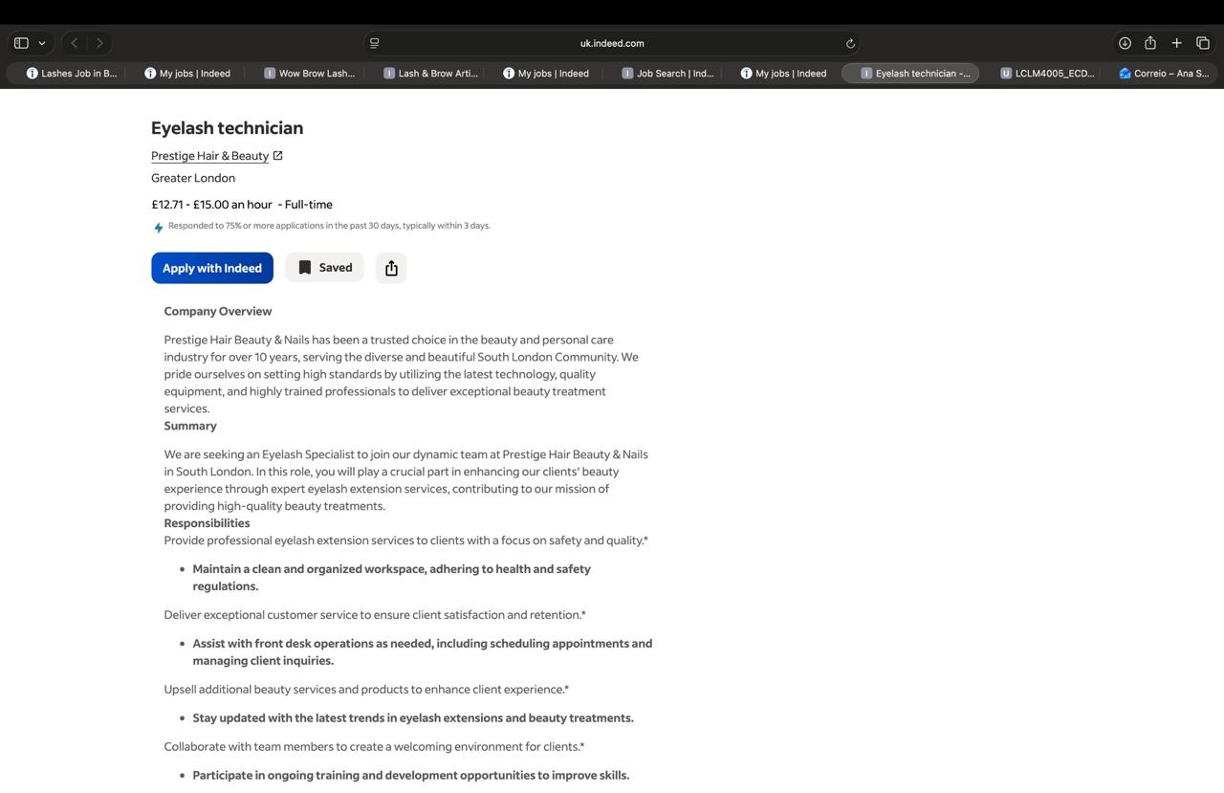

CV

ANASTASIJA JEVSTAFJEVA
19 Houghton Avenue, Gillingham, Kent ME7 3RY
+44 7834 488321 | Jevstafjevaa@myyahoo.com
Professional Profile
Friendly, professional customer service specialist with over 15 years of experience in the beauty industry in London. Experienced in welcoming clients, managing appointments, answering telephone enquiries, processing payments and providing exceptional customer care. In 2013 I completed a professional Magic Smile Teeth Whitening Course in Kyiv, Ukraine, and have experience providing cosmetic teeth whitening treatments. I am now looking to bring my customer service and client care skills to a Dental Receptionist position.
Key Skills
* Customer Service • Reception • Appointment Booking • Telephone Skills • Microsoft Office • Cash Handling • Teamwork • Time Management • Confidentiality • Attention to Detail
Employment History
Beauty Therapist – Sasyla Beauty Salon Ltd, Thamesmead, London (2010–Present)
* Welcoming clients and managing appointments
* Answering telephone and email enquiries
* Processing payments and maintaining client records
* Performing beauty treatments and cosmetic teeth whitening
* Delivering outstanding customer service
Waitress – Restaurant Zebra, Old Town, Riga, Latvia (2005–2008)
* Customer service
* Cash handling
* Working in a busy restaurant environment
Certification
* Permanent Make Up Master “BEAUTEK STUDIO” (16.02.2018)
* Eyelash Extensions “BEAUTEK STUDIO” (15.02.2018)
* Volume Eyelash Extension “Mary LASH ” (24.03.2019)
* Master of Permanent Make UP “CARTER STUDIO “ (12.12.2021)

Education
CertHE Business Skills in Higher Education
University of Wales Trinity Saint Davids – October 2025 - Present
Riga Secondary School No. 74, Riga, Latvia
Completed Secondary Education
Languages
English • Russian • Latvian
References
Available upon request.

Cover Letter
Dear Hiring Manager,
I am writing to apply for the Eyelash Technician position at Prestige Hair Beauty & Nails, as advertised on Indeed.
I am a qualified Eyelash Extension Technician with over 15 years of experience in the beauty industry in London. Throughout my career, I have provided high-quality eyelash extension treatments, building a loyal client base through excellent results, professionalism and outstanding customer care.
I am experienced in applying eyelash extensions with precision and attention to detail while maintaining the highest standards of hygiene and safety. I am confident in consulting with clients, understanding their individual preferences and creating natural or glamorous looks to suit their needs.
In addition to my technical skills, I have extensive experience managing appointments, handling payments, recommending beauty treatments and products, and ensuring every client enjoys a welcoming and relaxing salon experience. I am friendly, reliable, hardworking and work well both independently and as part of a team.
I would be delighted to bring my skills, experience and passion for the beauty industry to Prestige Hair Beauty & Nails. I am confident that I would make a valuable contribution to your team and look forward to the opportunity to discuss my application further.
Thank you for your time and consideration.
Kind regards,
Anastasija Jevstafjeva

