Digital Signal Processing and Communications Assignment
(ACDA5008)

University of Wales Trinity Saint David
Owain Plant (1910280)
Table of Contents
Table of Figures and Tables 1
1. Introduction 2
2. Background information 2
3. Simulation models 3
3.1. Amplitude Shift Keying (ASK) 3
3.2. Phase Shift Keying (PSK) 3
3.3. Quadrature Phase Shift Keying (QPSK) 3
4. Results 4
5. Discussion 5
6. Conclusion 5
7. References 6
8. Bibliography 7
9. Appendix 7

Table of Figures and Tables
Table 1- ASK Simulated results table 8
Table 2- PSK Simulated results table 9
Table 3- QPSK Simulated results table 10

Figure 1- ASK Circuit 3
Figure 2- PSK Circuit 3
Figure 3- QPSK Circuit 4
Figure 4- ASK, PSK and QPSK Signal to Noise vs Bit Error Rate Graph 4
Figure 5- Image of ASK, PSK and QPSK constellation diagrams [9] 5
Figure 6- ASK Signal to Noise vs Bit Error Rate Graph 8
Figure 7- PSK Signal to Noise vs Bit Error Rate Graph 9
Figure 8- QPSK Signal to Noise vs Bit Error Rate Graph 10

Introduction
This assignment will discuss the difference in performance between ASK (Amplitude Shift Keying), PSK (Phase Shift Keying), QPSK (Quadrature Phase Shift Keying) and QAM (Quadrature Amplitude Modulation) modulating and de-modulating systems when there is background noise present. [1] The assignment will do this by firstly discussing the background information of this explaining how the circuits will work and how the comparison will be carried out. It will then go on to discuss the simulation models, firstly looking at the amplitude shift keying model then the phase shift keying model then finally the quadrature phase shift keying model and the quadrature amplitude modulation. The results will then be given in the form of a graph to visually represent them and discuss the shown results. These results will then be discussed as well as additional research done and discussed for comparison before coming to a conclusion. The assignment will also have an appendix with additional relevant information included at the end.

Background information
The comparison of each of these circuits will be carried out by running a series of simulations and readings taken with different levels of background noise. Each of the circuits for this assignment were created and run using SIMULINK, using the software package MATLAB R2020b. [2] Each of the circuits followed a sequence of having a random system generator producing a randomised signal form this signal was then modulated to be transferred. The circuits once the signal has been modulated and is being transferred will add background noise to the signal by using a AWGN (Add White Gaussian Noise) generator. This signal was then demodulated and the error rate between the transmitted signals from the random generators and the signals after it is been filtered and demodulated calculated using a BER (Bit Error Rate) calculator. This was done by looking at both signals and comparing the differences between them.
Once the circuit was built and running without any errors the levels of background noise in the AWGN (Additive White Gaussian Noise) generator was altered and recorded for each circuit until a system failure occurs. The level at which the system fails will be when the error rate is 0.5 meaning that 50% of the data is lost, at this point the data will be too difficult to recover. Recordings of the error rate for each circuit at various background noise levels will be recorded in a table, for each level of noise 6 readings will be taken and an average gained. The data from each circuit will be put into a graph for a visual representation of the results gained and for ease of comparison. The gained information will have the standard deviation for all 6 readings calculated and added to the graph in the form of error bars.
The carrier signal wave for each circuit was kept the same for each and made to be 5 times that of the source data rate. The length of simulation was decided by weighing up the processing time and having enough data for valid results. Increasing the length of simulation increases accuracy of results and reduces variation in results for this reason the stop time was set at 30 seconds. The bit error rate will change each time but is dependent on the dependant variable the signal to noise ratio.

Simulation models

Amplitude Shift Keying (ASK)
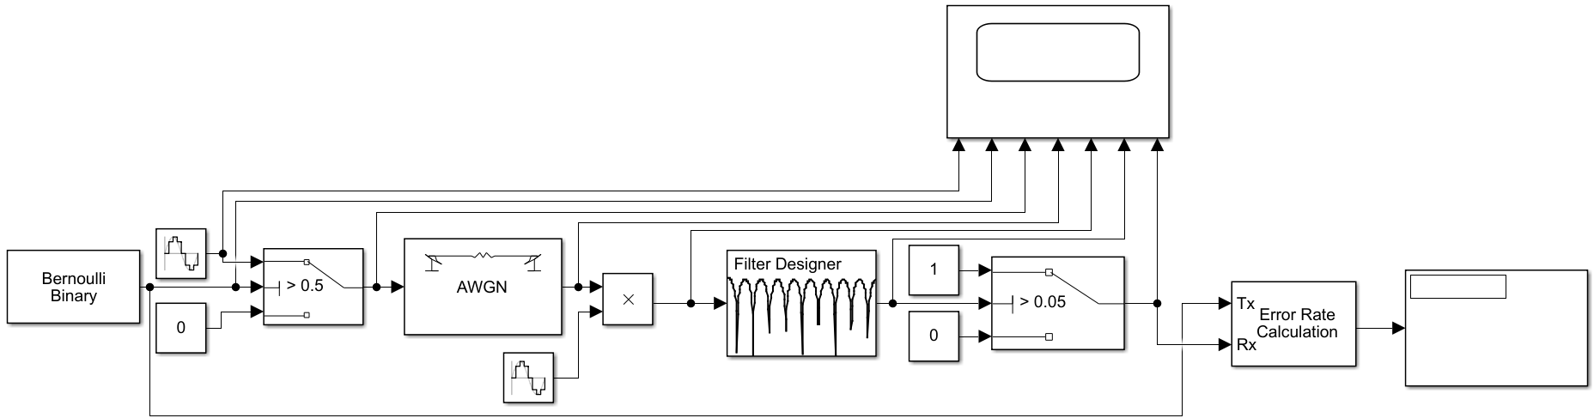
Figure 1- ASK Circuit
The image above shown in figure 1 is the simulated ASK circuit that was built and used for the exercise. The main parts of all the circuits are discussed in the background information but the main difference with the way this circuit works is the way it deals with the signal. This system has two inputs one of the signals is a binary signal and the other with a higher amplitude is the carrier signal, these signals get multiplied together with the time intervals where hence the name the amplitude is increased. [3] One example of where this modulating system is used is in systems which require low frequency radio frequency transmission such as RC (Radio Controlled) Planes and cars. Another is for devices that are used for home automation and in the automotive industry in tyres for transmitting data regarding the tyres pressure. [4]

Phase Shift Keying (PSK)
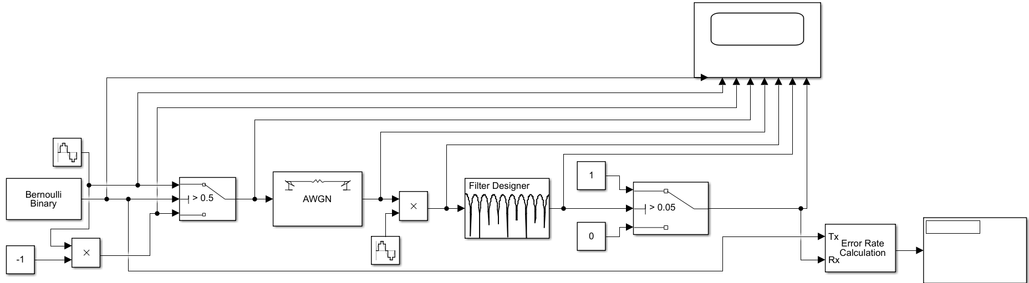
Figure 2- PSK Circuit
Figure 2 above is an image of the PSK circuit that was designed and used for the exercise in MATLAB. This system works similarly to ask because it has 2 inputs that get multiplied together but this one uses different sine inputs at particular times to change the phase of the carrier signal instead of the amplitude. [3] Examples of where this modulating system is used is for various transmitting systems such as a satellite and also in aircraft for pilots’ equalization and estimation during flight. [5]

Quadrature Phase Shift Keying (QPSK)
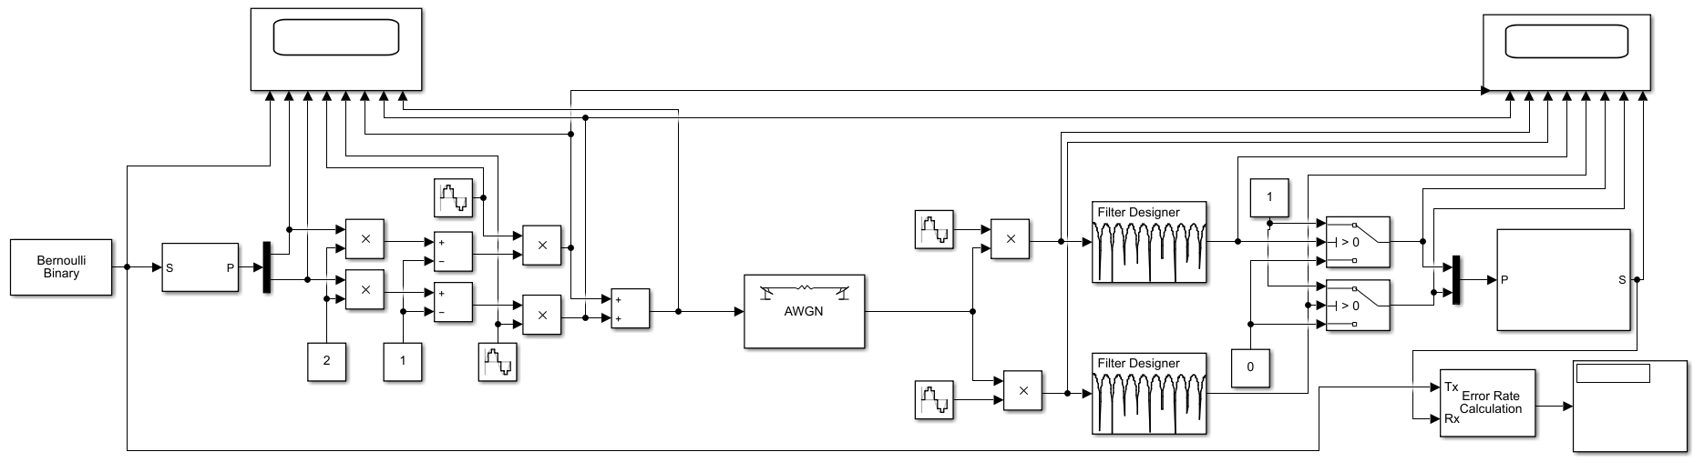
Figure 3- QPSK Circuit
The image above in figure 3 shows the QPSK circuit that was made and used for the conducted exercise. The system works by two phase shift keying signals as described above being added together after the carrier frequency phase shift 90 degrees from the other within quadrature which generate one of the four signal elements. The system consists of four different phase states where each phase is at 90 degrees to the other. [6] This system is used in various communication system such as mobile, satellite and wireless. [7]
There was no circuit built for the quadrature amplitude modulation (QAM) system due to 4 QAM and QPSK being the same. This system is used in similar applications to QPSK modulating systems but is also used frequently in AM (Amplitude Modulation) radio transmission. [8]

Results
The simulated models shown above were all set to run at different signal to noise ratios and recordings taken as previously stated in the background information. The results that were gained were put into tables and this information then put into graphical form as a visual representation of the results, this information can be seen later in the appendix. These results were also put into a graph together for comparison this can be seen in figure 4 below.

Figure 4- ASK, PSK and QPSK Signal to Noise vs Bit Error Rate Graph
The results shown in the graph in figure 4 show that the system which performed best in the simulated exercise was the QPSK circuit followed by the PSK circuit and the worst being the ASK circuit. This is shown on the graph by the lines that are lowest on the graph being the best at dealing with background noise with the lowest bit error rate. The graph has error bars for each mean result plotted on the graph, these bars show the standard deviation of the results gained. Although the error bars for the PSK and ASK models are not visible they were added to the graph, however they were not visible due to the standard deviation for these two circuits being so small as can be seen in the data tables in the appendix. The standard deviation for the QPSK circuit was much higher and this is the reason that the error bars are visible and clearly show its standard deviation.

Discussion
The modulation and de modulation of signals play an important role in various forms of communication systems. The difficulty with modulating systems is having the correct one for the correct use, this is due to each system having its own advantages and disadvantages. The images shown below in figure 5 show constellation diagrams for ASK, PSK and QPSK systems, these diagrams were gained from the website Instrumentation Forum on their page Digital Modulation. [9]
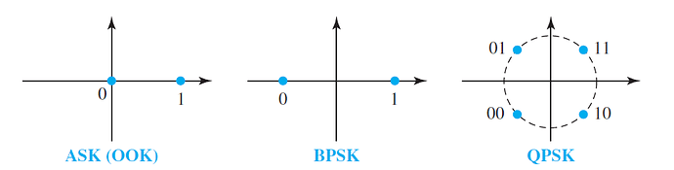
Figure 5- Image of ASK, PSK and QPSK constellation diagrams [9]
The images that are shown above show the difference between each system due to the distance between points being related to their noise immunity. The image of BPSK (Binary Phase Shift Keying) circuit above is the same as PSK previously discussed but is a different name for it. The image of the PSKs’ constellation diagram shows the benefit of the PSK circuit over the ASK circuit this is due to the PSK circuit having 180 degrees difference between each constellation point. This means that the signal can withstand fading with less bit errors being present. Another advantage the PSK circuit has over the ASK circuit is that the ASK circuit signal is either on or off, unlike the PSK circuit which continuously transmits. This means that the power that’s required to run the PSK circuit is less than the ASK circuit.
The problem with the PSK circuits is that it is difficult for the receiver to know if there is a mark or space condition, this is due to it being unaware of the exact phase of the signal that’s been transmitted. Another problem with the PSK circuit is that it can only handle modulating one bit per symbol, thus making PSK unsuitable for applications that require a high data rate. [10]
The best system as shown by the simulated results is the QPSK circuit due to it having the lowest bit error rate as can be seen in figure 4. The system also benefits from having four potential positions spaced out on the constellation diagram as can be seen in figure 5. This circuit is also beneficial due to it having an efficient high performing bandwidth as well as the low bit error rate. [7]
The experiment has also shown when originally setting up the circuits that the error rate increases when the sine wave frequency and the data frequency become closer together. Therefore, the way in which to improve the efficiency of the system is to increase the distance between the sine wave frequency and data frequency thus reducing the error rate. The error rate can also be improved by having an efficiently designed filter for the desired transmitted signal.

Conclusion
This assignment discussed the differences between different forms of modulating and de modulating systems. The different systems were all simulated with results gained being shown and described above, there was also information gathering exercise conducted during lectures and additional research done into the subject area to support the results. The results that were gained with the information gathered looked at which of the systems had the least errors when transmitting a signal in the presence of background noise. The information gathered showed that the results from the test were like the expected performance. This showed the best circuit was QPSK followed by PSK and then finally the ASK circuit.
If this exercise was to be completed again then more measurements would be taken at each signal to noise ratio to gain a better mean result. There would also be more signal to noise readings taken between the ones taken for further accuracy on the curve of the graph. The sample time would also be increased to improve the accuracy of the simulation. Carrying out all these changes would improve the accuracy of the overall results giving a better comparison of the systems. This assignment has shown the usefulness and importance of using the correct system and the difference in performance between each system. The assignment has also shown the ways in which different modulating and de-modulating systems works.

References

[1] | D. S. Mosey, Level 5 Assessment Specification Simulation of Digital Modulation Techniques, Swansea: UWTSD, 2020.
[2] | Maths Works , “Simulink,” Maths Works , 2021. [Online]. Available: https://uk.mathworks.com/products/simulink.html. [Accessed 22 March 2021].
[3] | NI, “Amplitude-Shift Keying, Frequency-Shift Keying, and Phase-Shift Keying,” NI, 02 October 2020. [Online]. Available: https://www.ni.com/en-gb/innovations/white-papers/08/amplitude-shift-keying--frequency-shift-keying--and-phase-shift-.html . [Accessed 21 March 2020].
[4] | Elprocus, “Amplitude Shift Keying (ASK) Working and Applications,” Elprocus, [Online]. Available: https://www.elprocus.com/amplitude-shift-keying-ask-working-and-applications/. [Accessed 21 March 2021].
[5] | RFWireless, “BPSK-Binary Phase Shift Keying,” R F Wireless, [Online]. Available: https://www.rfwireless-world.com/Terminology/BPSK.html. [Accessed 21 March 2021].
[6] | Electronics Projects Focus, “Phase Shift Keying (PSK) : Types and Its Applications,” Electronics Projects Focus, 2021. [Online]. Available: https://www.elprocus.com/phase-shift-keying-psk-types-and-its-applications/. [Accessed 23 March 2021].
[7] | N. G. J. P. a. P. B. N. Birla, “A novel QPSK Modulator,” IEEE International Conference on Advanced Communications, pp. 653-656, 2014.
[8] | Electronics Notes, “What is QAM: quadrature amplitude modulation,” Electronics Notes, 2021. [Online]. Available: https://www.electronics-notes.com/articles/radio/modulation/quadrature-amplitude-modulation-what-is-qam-basics.php . [Accessed 23 March 2021].
[9] | Instrumentation Forum, “Digital Modulation,” July 2017. [Online]. Available: https://instrumentationforum.com/t/digital-modulation/5621. [Accessed March 2020].
[10] | Electronics notes, “What is PSK, Phase Shift Keying,” Electronics notes, [Online]. Available: https://www.electronics-notes.com/articles/radio/modulation/phase-modulation-shift-keying-what-is-psk.php. [Accessed 21 March 2021].

Bibliography
- Parker, M. (2017) Digital Signal Processing 101: A Practical Guide, Newnes.
- Haykin, S. (2013) Digital Communication Systems: A Modern Introduction, John Wiley

Appendix
Shown in table 1 below is the results gained, the mean and the standard deviation from the ASK circuit simulations:
ASK | BER (Bit Error Rate) Readings
Signal to noise ratio (Db) | R1 | R2 | R3 | R4 | R5 | R6 | Mean | Standard Deviation
5 | 0.253 | 0.2544 | 0.2538 | 0.2535 | 0.2525 | 0.2534 | 0.253433 | 0.000653197
2.5 | 0.2657 | 0.2602 | 0.2602 | 0.2598 | 0.2601 | 0.2601 | 0.261017 | 0.002299058
0 | 0.2728 | 0.272 | 0.2721 | 0.272 | 0.2714 | 0.2729 | 0.2722 | 0.000562139
-2.5 | 0.2869 | 0.2865 | 0.2864 | 0.2888 | 0.2869 | 0.2875 | 0.287167 | 0.000889194
-5 | 0.3143 | 0.3148 | 0.3143 | 0.315 | 0.3149 | 0.3146 | 0.31465 | 0.000301662
-7.5 | 0.3407 | 0.3409 | 0.3403 | 0.3394 | 0.3403 | 0.3415 | 0.340517 | 0.000705455
-10 | 0.3685 | 0.3682 | 0.3676 | 0.3683 | 0.3695 | 0.3675 | 0.368267 | 0.000722957
-12.5 | 0.3934 | 0.3958 | 0.394 | 0.3928 | 0.3943 | 0.3945 | 0.394133 | 0.00102697
-15 | 0.419 | 0.4188 | 0.4185 | 0.4173 | 0.4183 | 0.4175 | 0.418233 | 0.000691857
-17.5 | 0.4349 | 0.4349 | 0.438 | 0.4367 | 0.4366 | 0.4359 | 0.436167 | 0.001192756
-20 | 0.4521 | 0.4517 | 0.4511 | 0.4525 | 0.4507 | 0.4519 | 0.451667 | 0.000662319
-22.5 | 0.464 | 0.4627 | 0.4643 | 0.4656 | 0.4628 | 0.4644 | 0.463967 | 0.001089342
-25 | 0.4721 | 0.4741 | 0.4711 | 0.4738 | 0.4727 | 0.4725 | 0.472717 | 0.001107098
-30 | 0.4857 | 0.484 | 0.4839 | 0.483 | 0.4839 | 0.4863 | 0.484467 | 0.00125645
-35 | 0.4909 | 0.492 | 0.4915 | 0.4913 | 0.4912 | 0.4914 | 0.491383 | 0.000365605
-40 | 0.4954 | 0.4966 | 0.4962 | 0.4957 | 0.4951 | 0.4955 | 0.49575 | 0.000554076
Table 1- ASK Simulated results table
Shown in figure 6 below is the mean of the bit error rate of the results gained at various Signal to noise ratios in a graph for the ASK circuit simulations with bit error bars showing the standard deviation:

Figure 6- ASK Signal to Noise vs Bit Error Rate Graph
Shown in table 2 below is the results gained, the mean and the standard deviation from the PSK circuit simulations:
PSK | BER (Bit Error Rate) Readings
Signal to noise ratio (Db) | R1 | R2 | R3 | R4 | R5 | R6 | Mean |  | Standard Deviation
5 | 0.2512 | 0.2495 | 0.2506 | 0.2509 | 0.2501 | 0.2494 | 0.250283 |  | 0.000741395
2.5 | 0.2515 | 0.2517 | 0.2531 | 0.2513 | 0.2513 | 0.2514 | 0.251717 |  | 0.000694022
0 | 0.2538 | 0.2546 | 0.2549 | 0.255 | 0.2543 | 0.2547 | 0.25455 |  | 0.000441588
-2.5 | 0.26 | 0.2604 | 0.2601 | 0.26 | 0.2613 | 0.2598 | 0.260267 |  | 0.000542832
-5 | 0.2694 | 0.2679 | 0.2693 | 0.2691 | 0.2705 | 0.2705 | 0.26945 |  | 0.000975192
-7.5 | 0.2831 | 0.2815 | 0.2821 | 0.2821 | 0.2828 | 0.2824 | 0.282333 |  | 0.000568038
-10 | 0.301 | 0.3005 | 0.3004 | 0.3016 | 0.3006 | 0.3008 | 0.300817 |  | 0.000440076
-12.5 | 0.325 | 0.3242 | 0.3246 | 0.3241 | 0.3235 | 0.3234 | 0.324133 |  | 0.000618601
-15 | 0.3545 | 0.3524 | 0.3545 | 0.3531 | 0.3524 | 0.3538 | 0.35345 |  | 0.000964883
-17.5 | 0.3837 | 0.3817 | 0.3827 | 0.382 | 0.382 | 0.3824 | 0.382417 |  | 0.000719491
-20 | 0.4069 | 0.4076 | 0.4062 | 0.4067 | 0.4072 | 0.4066 | 0.406867 |  | 0.000488535
-22.5 | 0.4287 | 0.4275 | 0.4299 | 0.4282 | 0.4296 | 0.4284 | 0.428717 |  | 0.000897589
-25 | 0.4469 | 0.4461 | 0.4467 | 0.4466 | 0.446 | 0.4466 | 0.446483 |  | 0.000354495
-30 | 0.47 | 0.4691 | 0.4677 | 0.4698 | 0.4684 | 0.4687 | 0.46895 |  | 0.000868907
-35 | 0.4814 | 0.4836 | 0.4828 | 0.4812 | 0.4826 | 0.482 | 0.482267 |  | 0.000909212
-40 | 0.4904 | 0.4906 | 0.4896 | 0.4904 | 0.4902 | 0.4898 | 0.490167 |  | 0.000388158
Table 2- PSK Simulated results table
Shown in figure 7 below is the mean of the bit error rate of the results gained at various Signal to noise ratios in a graph for the PSK circuit simulations with bit error bars showing the standard deviation:

Figure 7- PSK Signal to Noise vs Bit Error Rate Graph

Shown in table 4 below is the results gained, the mean and the standard deviation from the QPSK circuit simulations:
QPSK | BER (Bit Error Rate) Readings
Signal to noise ratio (Db) | R1 | R2 | R3 | R4 | R5 | R6 | Mean | Standard Deviation
5 | 0.1034 | 0.2414 | 0.2069 | 0.1724 | 0.2069 | 0.1379 | 0.17815 | 0.050782625
2.5 | 0.2759 | 0.1736 | 0.2414 | 0.2759 | 0.1724 | 0.2103 | 0.224917 | 0.047064527
0 | 0.3448 | 0.2414 | 0.2414 | 0.2414 | 0.2069 | 0.3014 | 0.262883 | 0.050423424
-2.5 | 0.3448 | 0.2759 | 0.2414 | 0.2759 | 0.3103 | 0.2414 | 0.281617 | 0.040286445
-5 | 0.2759 | 0.3103 | 0.2759 | 0.2759 | 0.1724 | 0.1034 | 0.235633 | 0.079904234
-7.5 | 0.3448 | 0.4138 | 0.1724 | 0.1724 | 0.2069 | 0.1724 | 0.247117 | 0.105537186
-10 | 0.1724 | 0.3793 | 0.2069 | 0.4138 | 0.1379 | 0.2759 | 0.264367 | 0.112629582
-12.5 | 0.3103 | 0.2414 | 0.4828 | 0.2759 | 0.3103 | 0.2414 | 0.31035 | 0.089926653
-15 | 0.2414 | 0.2069 | 0.3448 | 0.3103 | 0.4483 | 0.4828 | 0.339083 | 0.109962165
-17.5 | 0.3448 | 0.3448 | 0.2069 | 0.4138 | 0.3793 | 0.3793 | 0.344817 | 0.072329673
-20 | 0.3793 | 0.4483 | 0.3448 | 0.4828 | 0.2759 | 0.3448 | 0.379317 | 0.075558333
-22.5 | 0.4138 | 0.4828 | 0.5517 | 0.3103 | 0.4138 | 0.3793 | 0.425283 | 0.083532878
-25 | 0.4828 | 0.3793 | 0.4138 | 0.4828 | 0.4138 | 0.4138 | 0.43105 | 0.042253698
-30 | 0.4828 | 0.4138 | 0.4828 | 0.4138 | 0.4138 | 0.5172 | 0.454033 | 0.045828448
-35 | 0.3103 | 0.5862 | 0.4138 | 0.5172 | 0.5862 | 0.4828 | 0.48275 | 0.10684916
-40 | 0.5517 | 0.5862 | 0.5172 | 0.4483 | 0.4828 | 0.3793 | 0.49425 | 0.074482233
Table 3- QPSK Simulated results table
Shown in figure 8 below is the mean of the bit error rate of the results gained at various Signal to noise ratios in a graph for the QPSK circuit simulations with bit error bars showing the standard deviation:

Figure 8- QPSK Signal to Noise vs Bit Error Rate Graph

