
Online shop product finder and stock counter
by
Jericho Uzzell
Supervisor: Gaynor Thomas
Second Marker: ____

Project submitted as part of the requirements for the award of BSc (Hons) Computing (Computer Networks and Web development)
April 2023

Abstract
The aim is to understand whether customers or end-users require more information and assistance when shopping in-store. The objectives are to collect survey results and implement changes, research supermarkets and what they currently do, research current technologies, and lastly, implement an application for users to give feedback on the system. Survey responses will be sought from University students, University staff, and individuals from online forums and others.
Some major findings are the current technologies being used and the technologies being planned to be implemented. Current technologies include smart scanning, which is to purchase items faster and to track how much you are spending. This is done by scanning items as you shop. Technologies being planned and tested include those where you pick items up and walk out, where you will pay automatically from exiting.
There are two methodologies being used, one being surveyed, owing to the quick and large number of individuals being able to respond and develop. The other methodology is development based, as this report implements a website application.
This report only tests the online element so further research into in-store testing with this system should be considered. This report discovers there is a need for an application like this as it will help those who have mobility or other concerns. This application will also support those who are new to a shop or are struggling to find items, this has been sourced from data received by respondents.
The survey results were conclusive that more customers want more information and support whilst shopping, it was also concluded that more research on a wider scale would be required to gather more concrete and conclusive results. A lot of survey responses stated that customers never use the assisted shopping technologies out there already, and a majority of the respondents stated they would try this purposed system out. With that said, when the application was implemented, it was noticeable that there was a divide on whether they would use this system again. There was a majority of those who would however, the responses from those between yes and no were quite close. Whether this was due to the way the application was implemented or others is yet to be known.

Table of Contents
Abstract 1
1. Introduction 5
2. Research & Review of Literature 7
2.1. How are shops designed? 7
2.1.1. Environment 7
2.1.2. Shop layouts 7
2.1.3. Product placement 11
2.2. What technology is out there? 11
2.1.1. Current technologies 11
2.1.2. Longevity 12
2.1.3. Why does this not exist already? 12
2.3. Stock tracking 12
2.3.1. Online and physical store tracking 12
2.4. Product information 13
2.5. Product location 14
2.6. Product stock tracking 14
2.7. Data input 15
2.7. Usability 16
3. Research methods 17
3.1. Survey Methodology 17
3.2. Development Methodology 22
4. Design & Implementation 24
4.1. Design 24
4.1.1. Background 24
4.1.2. Planning diagrams 25
4.2. Implementation 33
4.2.1. Domains and web server 33
4.2.2. Javascript successful implementation 34
4.2.3. Barcode API successful implementation 36
4.2.4. Product mapping API successful implementation 37
4.2.5. Htaccess unsuccessful implementation 38
4.2.6. Design changes 40
4.2.7. Git repository 42
4.2.8. Focus group testing 43
4.2.9. Website feedback 50
5. Results 57
6. Evaluation 58
7. Conclusion and recommendations 60
8. Reflection 61
9. Reference 63
10. Figures 64
11. Bibliography 67

DECLARATION

I, JERICHO UZZELL, declare that I am the sole author of this Project; that all references cited have been consulted; that I have conducted all work of which this is a record, and that the finished work lies within the prescribed word limits.

This work has not previously been accepted as part of any other degree submission.

Date: 23/04/2023

FORM OF CONSENT

I JERICHO UZZELL, hereby consent that my Project, submitted in candidature for the B.Sc.(Hons) Computing (stream) degree, if successful, may be made available for inter-library loan or photocopying (subject to the law of copyright), and that the title and abstract may be made available to outside organisations.

Date: 23/04/2023

1. Introduction
Whenever someone wants a question asked, they simply ask their chosen search engine; where they will be given an answer straight away with ease. Whenever a customer enters a shop that they have never been in before or want an item they are not sure about, and would like to know more about the item and where the item is located; they are required to ask a member of staff.
This may worry the customer as they are bothering the staff with a request, or that there are no staff available to assist the customer, so this project is looking at assisting customers to find, locate and be present with more information regarding items that they wish to shop for.
There are countless shops across the country, from small corner shops to big supermarkets, and a problem is present for the customer and staff that go there. The problem is locating products, finding out information regarding products, how much stock is available on the shelves and are these items restricted, requiring identification.
This information is likely known to staff but is not shared with customers, likely to stores operating separately, such as they are written down on paper. If done correctly, customers and staff can use a system to find products faster, to find out if the product is available and requires restocking and, crucial information about it. This may then encourage customers to shop in another store, it may make it so staff can provide accurate information and directions to customers. This can also be expanded for the customer to allow them to have a shopping list that marks items off as they shop, giving them a positive experience whilst shopping.
The aim of the project is to focus on a way to track and locate stock in a physical store. This will include the ability to inform customers about stock information such as food allergies, and product weight and allow customers to know where the product is located in-store. This project will cover the use of a user-friendly user interface, the software required to track stock, the ability to get product information and the ability to store where a product is located in the store, so the user can locate it.

This project will define the needs of the end users from a customer and staff perspective. Development of the project will proceed to build the basic functions that will be required, during development, surveys will be completed from customers, these surveys will surround physical in-store shopping and expectations from customers.
This project will not focus on how long it takes customers to locate products, nor will this literature review consider any factor like age, gender and others. This project will only assess the viability of presenting more information to customers.
If so, then more investigation and development should be put into it, this may then include gender, age and mobility for example; currently, the customer will be given a general area of where the product is located, and no GPS tracking or other will be provided.
To satisfy the project's aim, surveys will need to be frequent and more development will need to be put into ensuring the user interface is understandable and the correct information is being shown.
Lastly, this literature review will discuss physical shop designs, the lifetime of the application, how the application itself will be coded and current technologies.

2. Research & Review of Literature

2.1. How are shops designed?

2.1.1. Environment
The question this project would like to answer is, are shops designed a certain way and, if so can this project take advantage of this?
Several factors are considered whilst creating supermarkets, these can be boiled down to visual merchandising, slowing down the customer, the music played in shops and lighting. According to [3], they state that having certain lighting in areas like spotlights, studio lighting and industrial lighting creates a blank ambience to the store, making it feel impersonal to be there and making most experiences exclusive.

2.1.2. Shop layouts
This project would like to investigate whether the layout of shops impacts the customer experience and whether product placement in the store compliments this experience. If this is the case, it will allow this project to develop its application, giving the best directions for the end user to shop.
According to [4], shops will be formatted into several designs, four of note are grid, herringbone, loop and lastly free flow (detailed below). All these designs, according to [4], state that the likely path the customer will choose will be to go right, which is where the ‘power wall’ will be placed. [5] states a power wall will attract the shopper's attention by standing out, meaning it will be taller, bigger and with more lighting focused on it.

2.1.2.1 Grid design
[4] shows that the grid design will have promotions at the end of each aisle, the aisle will be a certain width, and impulsive purchases will be near the checkout. Shops that use this format are Asda, Sainsburys and others.
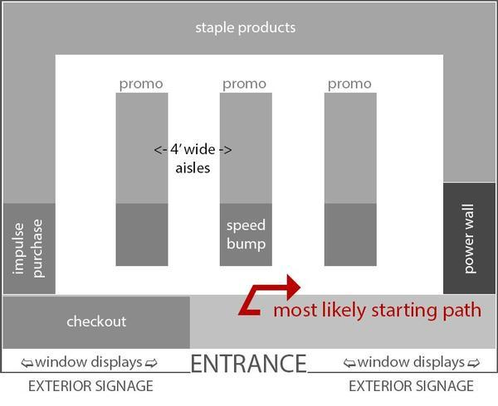
Figure 2

2.1.2.2.Herringbone Design
[4] states the herringbone has a checkout usually at the far end of the checkout with several aisles on either side, this design has been seen this design in B&Q.

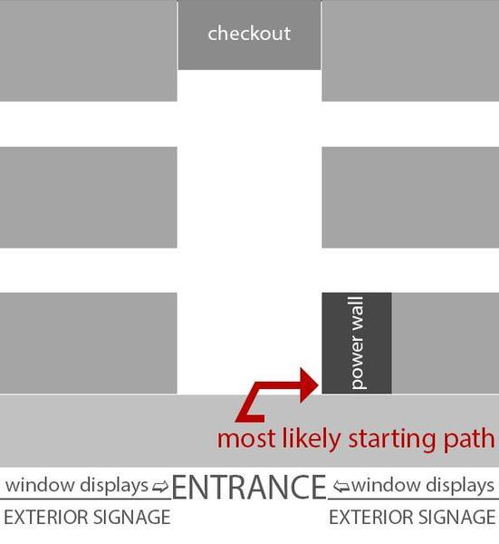
Figure 3

2.1.2.3 Loop Design
The next design there according to [4] is the loop design, this style of design has been seen in B&M.
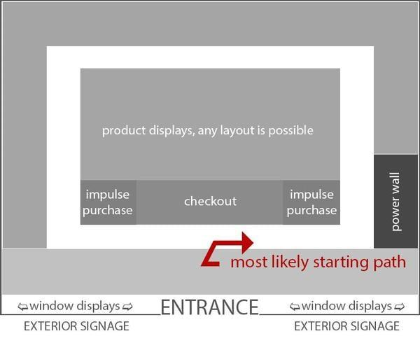
Figure 4

2.1.2.4 Loop Design
The last design according to [4] is free-flow, this style has seen this style of design in charity shops.
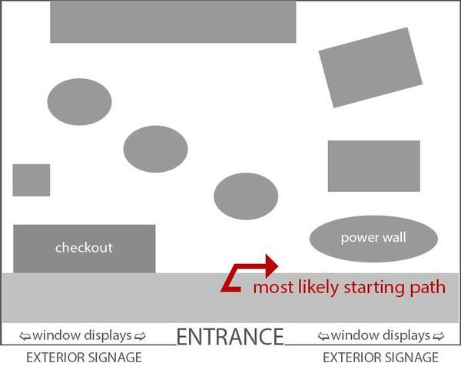
Figure 5

2.1.3. Product placement
[6] states that product placement is a game in itself as companies want their products to be eye-catching, in locations where customers are likely to pick them up. Finding information on whether fresh products are usually at the front of the store, with frozen being at the back of the store; appears to be a supermarket decision.

2.2. What technology is out there?

2.1.1. Current technologies
Currently, going into selected shops around the United Kingdom you may see technologies currently being used, similar to ‘scan as you go’. In most instances, process involves the customer registering an account with the shop, you will then utilise a phone number or email address to use the system.
Then, the customer will enter their phone number or email address and they will be assigned a smart shop scanner, to scan the products they intend to purchase. The benefit for this in most cases, if that you can scan and then bag your item into your own shopping bags. Once done, customers go to a specialised checkout to pay for their items.
Some shops only require a mobile phone application however scanning and specialised checkouts are still required. According to [7], when scanning products using their phone, customers can use their credit card on a SmartShop checkout. [7] states that Smartshop should work on all the latest devices, if however, their phone does not work some shops have dedicated Smart Shop scanners.

Some shops are trailing the ‘just walk out’ created by Amazon where customers pick up items and automatically add them to their shopping basket. Once the customer walks out, they pay from their Amazon account for the items they have picked up. According to [8], this system is accurate with proven reliability, this system is scalable and more. [8] state that this is not limited to Amazon itself, it is designed for other stores with the capability for them to just walk out. [8] states that the customer only requires a credit card, to the shop and then just walks out.

2.1.2. Longevity
Currently, other methods of the use of physical stores are being updated, the use of paying for products, the ease of scanning products and even ordering shopping online makes the process of shopping easier.
So how does this product scale and last? If there are still physical shops around then there will be a need for customers to use this product -- the product's information, and quantity in stock are something that will not disappear.

2.1.3. Why does this not exist already?
After a lot of research into big supermarkets and other miscellaneous stores, this is unknown. Some elements of this application like the products’ contents and calories are in some supermarkets' online stores. Elements like what aisle the product will be on, what shelve, and how many are in stock are not something seen.

2.3. Stock tracking

2.3.1. Online and physical store tracking
This application from the outset will be quite complex as it will need to track the barcode of the product, potentially caching certain information, determining the closest store with the ability to track products and an ability to view products online with smart tracking.
The online store tracking would consist of basic information about what aisle the product is on, the shelf number, a static image pinpointing the product's location if the product is in stock and product information. Physical store information would consist of the same information as the online view with an additional option to scan the barcodes. Lastly, an option to have a shopping basket, marking the quantity in the cart, it will show what has been scanned and what has not.

2.4. Product information
Product information will be gathered from an application programming interface (API) request, this will be done utilising the barcode of the product. The API will be able to gather the information that will be given to the end user relating to calories, product weight and other items which might be relevant.

The API being used will be barcode lookup, [9] stating that they have a large array of products that get updated by individuals using the system. So for that reason, the barcode lookup API will be used due to the amount of data stored. Below, is an example of the application and how it shows data.
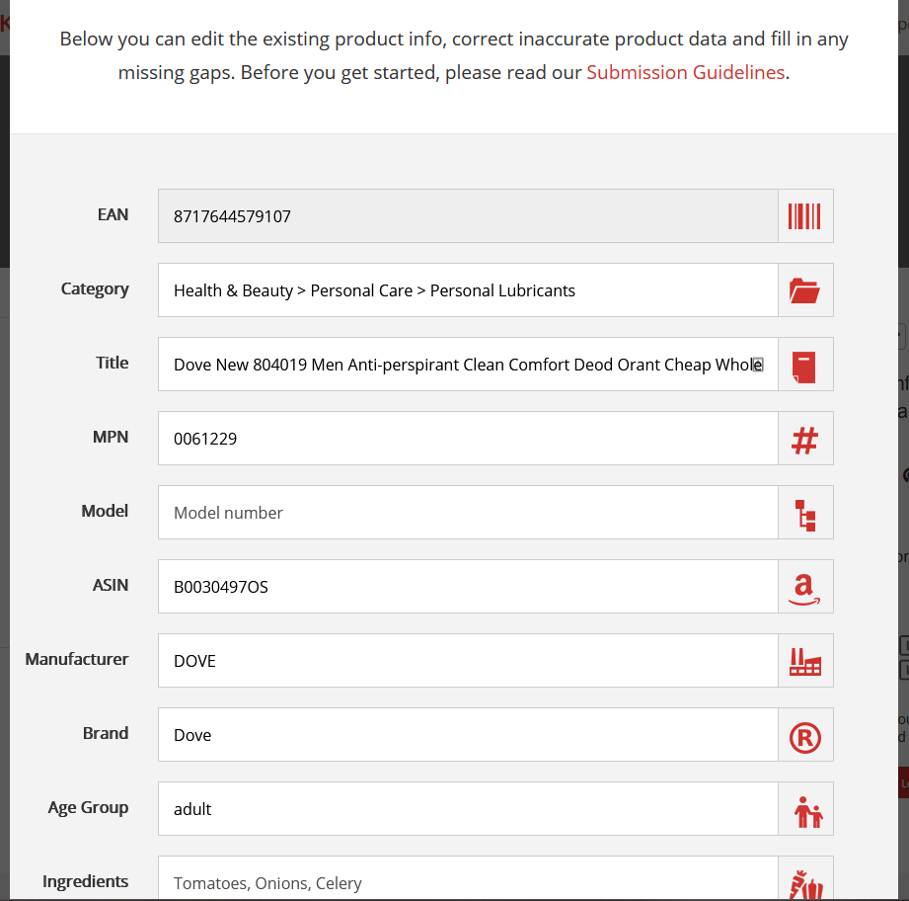
Figure 6

2.5. Product location
Product locations will be associated with the barcode, and the location itself will be inputted by store staff. The barcodes will use generated data from barcode lookup, it should be noted however some information might be incorrect and may need updating by shop staff.

2.6. Product stock tracking
A main feature is to show users whether the product they are looking for is in stock in-store, how will this be done? An idea is to track products being paid for at checkouts as the system will know the barcode being scanned and how many are being purchased.

According to [10], there are over one hundred self-checkout companies globally, a couple of notes from their list is Shopic. [11] shows their product which is a device that sits on top of a shopping trolley, customers scan products as they go around and pay for their shopping using the device. Shopic appears to be based in America and Israel.

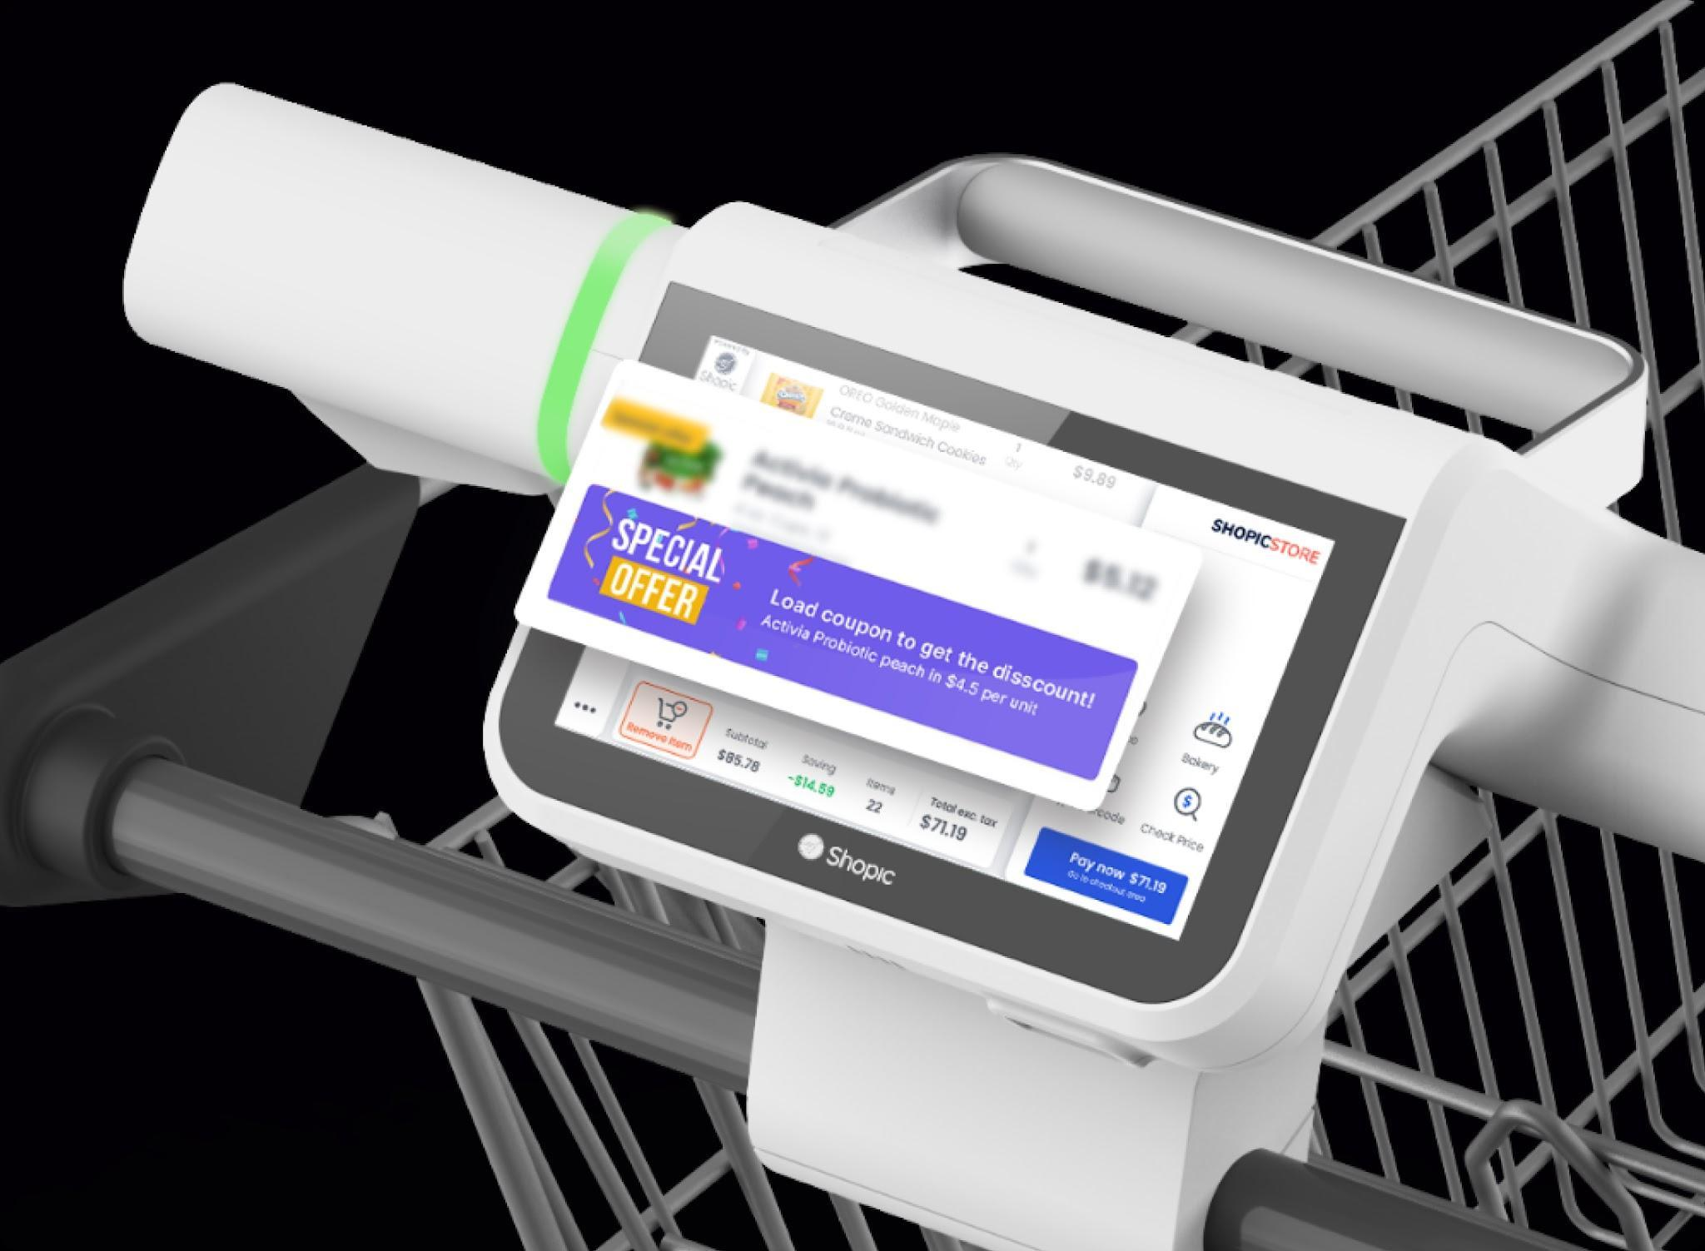
Figure 7

In the United Kingdom, all most everyone are used to kiosks, so a new style of product not using barcodes but instead using artificial intelligence to scan products and add the sum to the total and pay is available in America, according to [12].
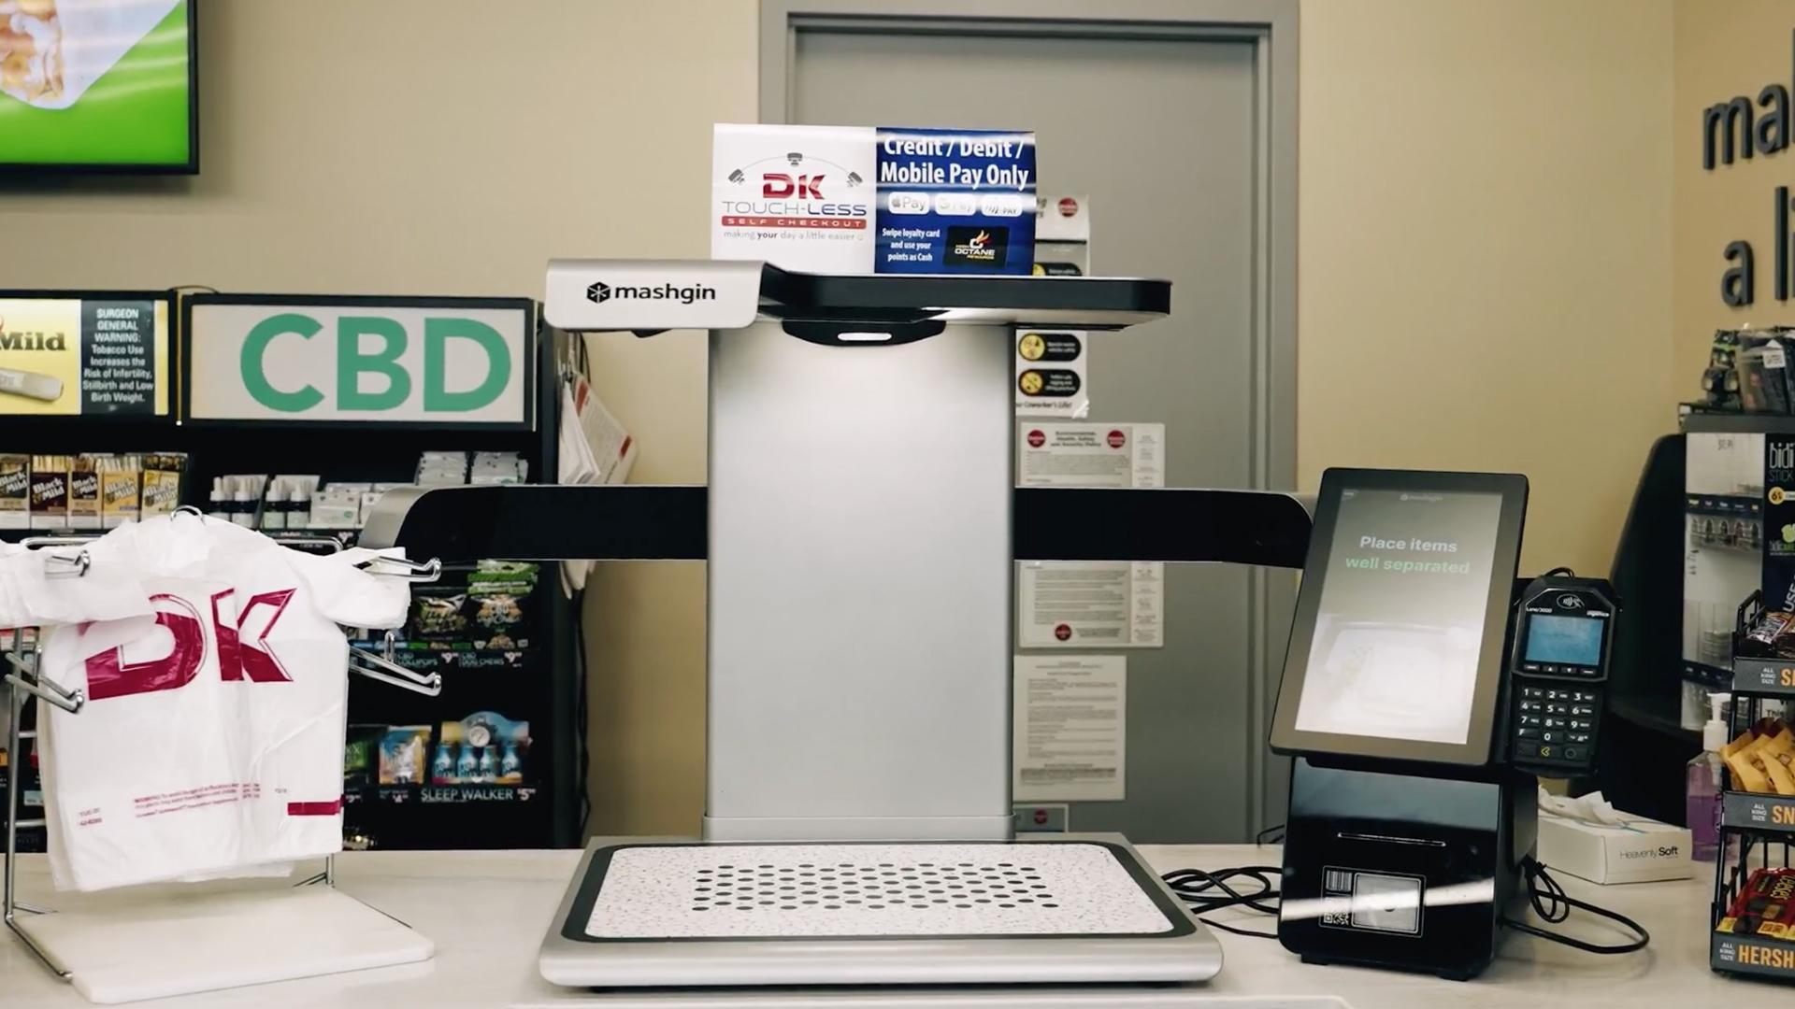
Figure 8
The above technologies are not available in the United Kingdom however, it is noteworthy to mention that amending kiosks to track product stock is not a guarantee kiosk companies will do. With this in mind, an open-source checkout kiosk may need to be considered.
If the code cannot be amended or in some way for the system to track stock levels, a fallback feature may include staff counting or estimating stock levels actively on shelves.

2.7. Data input
Data will be inputted in several ways, in the staff section products may need to be added to the store database, and information might need to be edited like product weight, size etc; other stock levels and more.
From a customer's view, they will be adding products to a cart, creating shopping baskets, checking stock levels, checking product information and others.

2.7. Usability
When designing anything that has users from any and all backgrounds using it, accessibility for those who may require further assistance, be it for disabilities, colour deficiency, inputting information, receiving information and others should be implemented.
These can be by allowing colour-assisted modes, changing fonts to a more readable one, text-to-speech options, accurate translations and more.
According to [14], they state that accessibility to websites for those with disabilities is to equally perceive, understand and navigate the website without barriers.
When implementing a website, the audience can be wide, meaning you cannot have every tool and feature implemented to support users with certain disabilities; you should instead implement features that are standard such as themes like dark mode and light mode, the ability to change fonts and text to speech. Then, assess whether you need to have or support alternative input methods, for example, allowing the user to read braille and then implement it.
A willingness to implement changes and to have feedback will enable users that require more support to provide comments on how the website can support them further.
An example of a website doing this can be Twitter, they list on their website what they support and how to get into contact with them to add more. According to [15], they state that everyone has the power to create and share their thought without barriers.

3. Research methods

3.1. Survey Methodology
One of the research methods used will be a survey, this will allow participants to give their opinion on a question, be it an open or closed question. This will allow the development of the end product to be more in line with participants' expectations. A disadvantage of surveys would be a lack of responses, lack of detail in response to open questions, the individuals being surveyed, opinions which counteract others and the questions themselves.
In response to the disadvantages, mitigations can be made, such as ensuring a broad range of individuals are being surveyed from age, sex and other, limiting the number of open questions, if an open question is used ensuring it is refined and can have a direct response and lastly, have questions which may limit countering opinions.
The targeted group that this literature review is looking at affects almost everyone, all persons of gender, age, sex and others are the target group as the activity is basic and can be done day in and day out.
Interviewing individuals were ruled out as they take too long to produce results whereas surveys can be done faster with closed questions being asked that will allow for statistical data. Interviewing individuals would be beneficial for open questions which is something that is not needed for this project.
A survey was issued asking respondents their views on in-store shopping, how would get hold of extra product information online to assist them whilst shopping, and whether they use the technology available already such as smart scanners and more.

These questions are relevant as they relate to shopping, current technologies available and some surrounding the application being developed. Analysing the results will be done by using graphs on closed-ended questions, no open-ended questions were asked.

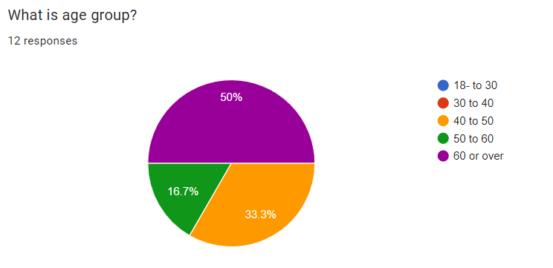
Figure 17 shows the age group of the respondent
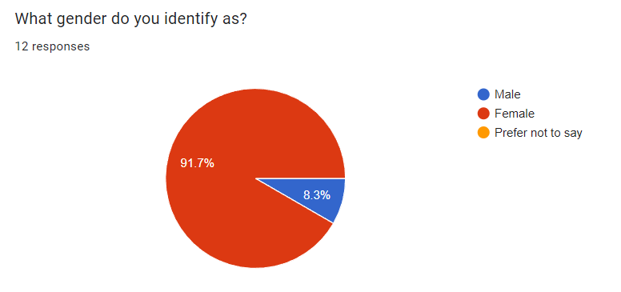
Figure 18 shows the gender of the respondent
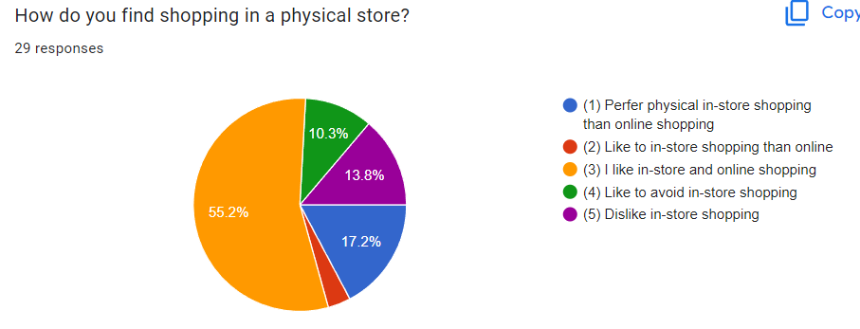
Figure 19 shows hows the respondent find shopping in-store
Upon reviewing the above results, it is apparent that respondents like both in-store and online shopping; however, this question should have had that option removed to entice respondents to choose online or in-store as a more preferred option. This is because respondents may feel that opting for the middle choice is the better one.
With this in mind, the next biggest response was that the respondents preferred in-store shopping with the next biggest one being that they did not like in-store shopping. These are complete polar opposites but yet quite close together in responses.

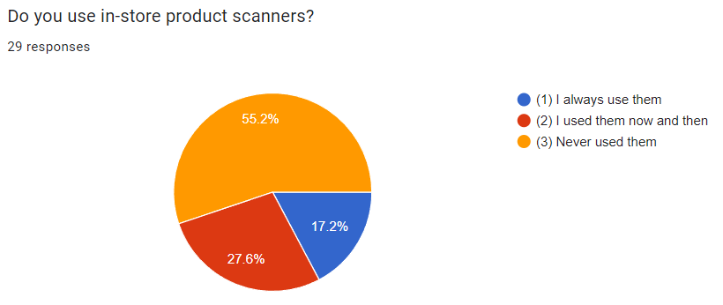
Figure 20 shows how the respondent uses already available scanners to assist with shopping

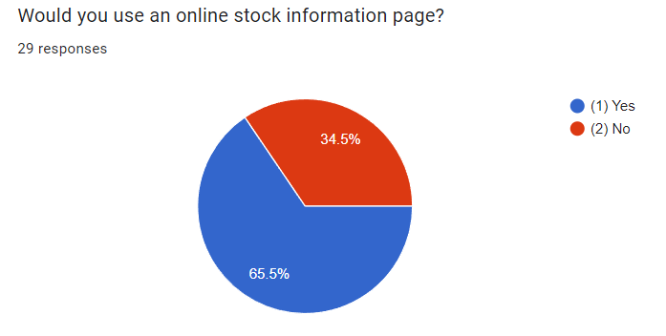
Figure 21 shows if the respondent would use online stock information web page
Noting the above chart, a vast number of respondents would use an online stock tracking webpage, this cements that customers are in need of more information so providing it should be a priority for shops.
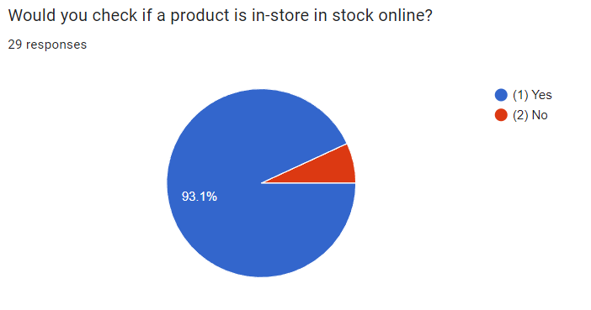
Figure 22 shows if a respondent would use online shop stock checking if they knew it was available
As stated above, the number of customers willing to use a system to check stock levels are ultimately apparent.
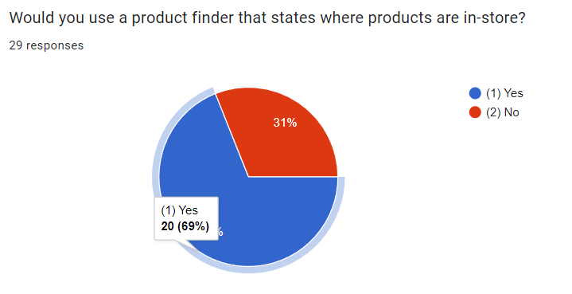
Figure 23 shows if the respondent would use a product finder in store if available
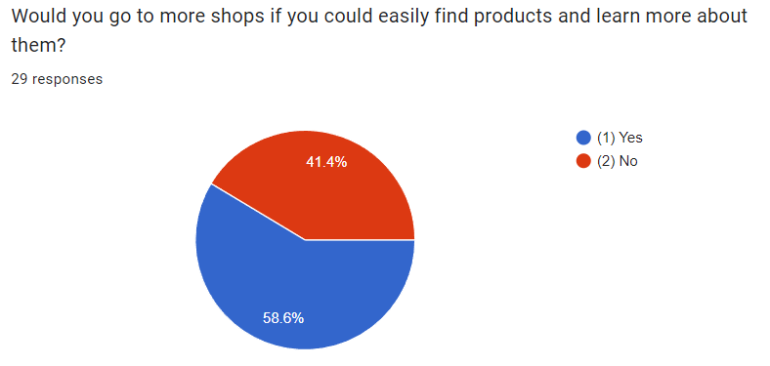
Figure 24 shows if a respondent would use technology if it assists them finding a product in-store

3.2. Development Methodology
This project will be using the XAMPP application which has WAMP (Windows, Apache, MariaDB, PHP) applications for hosting the website, this is purely down to the ability to use the system as it is easy to use and, it is easy to develop conformably.
According to XAMPP [1], they are a source project that runs MariaDB, PHP and Perl. Their aim is to allow the easy installation of Apache, distributions range from Windows WAMP Server, Linux LAMP Server and OS X.
Programming this application will be done within Visual Studio Code (VS Code), this is based on personal use of other integrated development environments (IDE) such as NotePad++, Sublime, Atom and more. VS Code has a lot of features which include altering themes, having others join you while coding in a workspace, vast amounts of extensions and more. VS Code will be used as it is popular and, due to the familiarity with this program.
Chrome will be used whilst developing, according to [2] 66% of browsers used worldwide from August 2022 to November 2022 was Chrome, whereas Mozilla Firefox is ranked 3% which was common for website developers to use.

This project will utilise agile coding as according to [13], this will allow for increased project control, production quality will be good, and changes can be made faster and more. Other methodologies like waterfall, lean, and rapid development were all considered however agile was suitable.
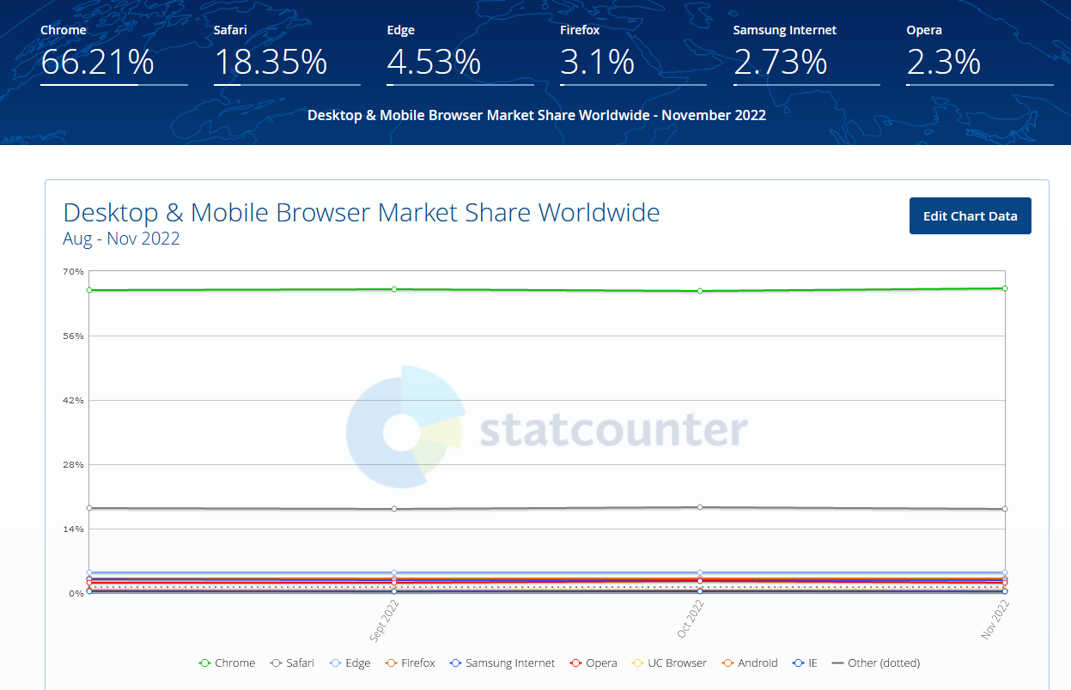
Figure 1 shows the ratio of browsers being used in 2022

The project will require hardware to run a web server, the hardware needed will not be severe, but instead low-end requirements. This application will utilise PHP, CSS, HTML, Javascript (JS) and JS Libraries such as JQuery to work.

4. Design & Implementation

4.1. Design

4.1.1. Background
This section of the literature review will discuss the project requirements and how they were discovered. The application that will be developed for this project will be created in PHP using a LAMP/WAMP server. This application will be designed for a shop, meaning the ability to shop will need to be implemented and planned, and then the next part of the application can include the features this project is testing (mapping, stock levels and others).

4.1.2. Planning diagrams
The below design is a use case which demonstrates the intended basic behaviour of users. The centre shape known as the “actor” is the user, this demonstrates the in-store, and online store and development features.
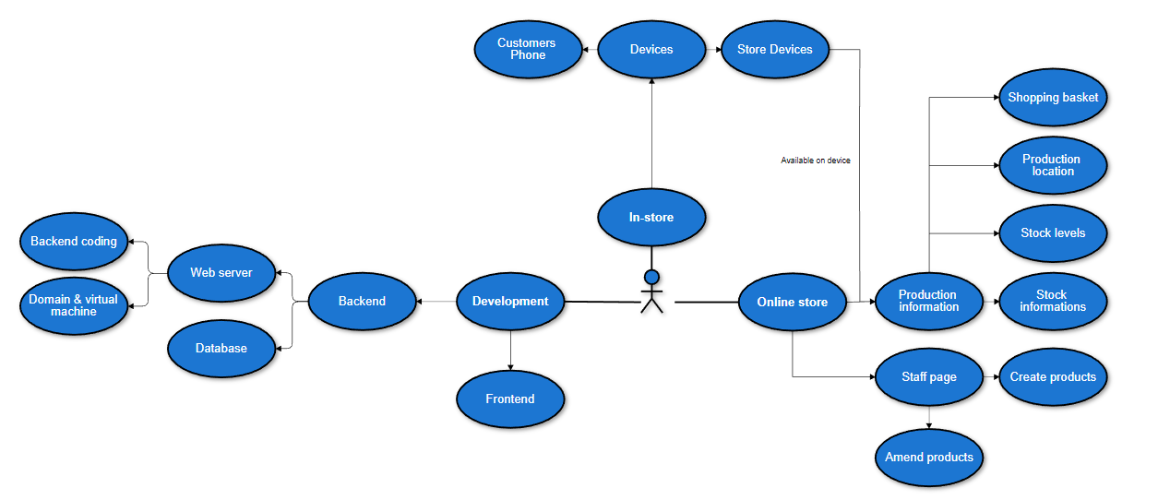
Figure 9 shows the use case diagram for the web application
The above three sections were identified by identifying the main elements needed, these being the development of the application, shopping in-store and lastly, online shopping; each has its own sections.
The design will only look at the online implementation, actual testing in a physical shop with a physical device is not the scope being investigated currently. A flow chart has been developed going into the features on the main home page and what the application is expected to do.

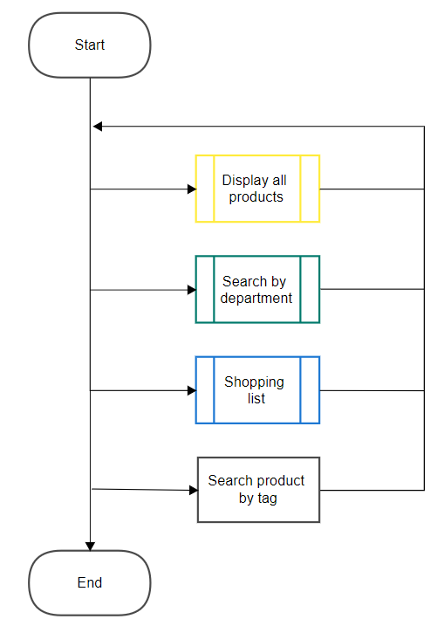
Figure 10 shows the main home page procedure and processes

The main home page can be simply put into four sections, three of which are pages that require subprocesses with corresponding colours. Displaying all products is as it states, all products on the site will be displayed in pages with a defined limit per page.
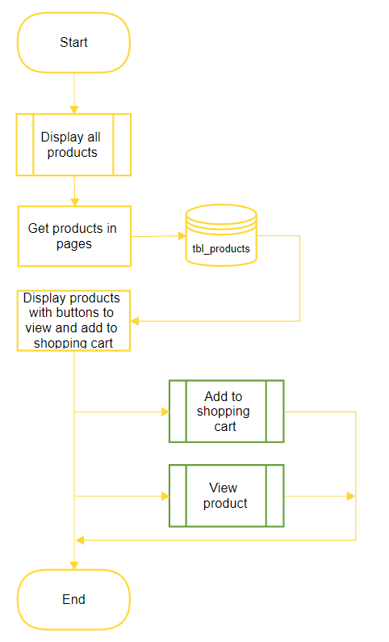
Figure 11 shows displaying all products on the home page

When getting all products, each product should follow a certain template by displaying the name, price, image and other; with additional options to view the product and to add the product to a shopping list.

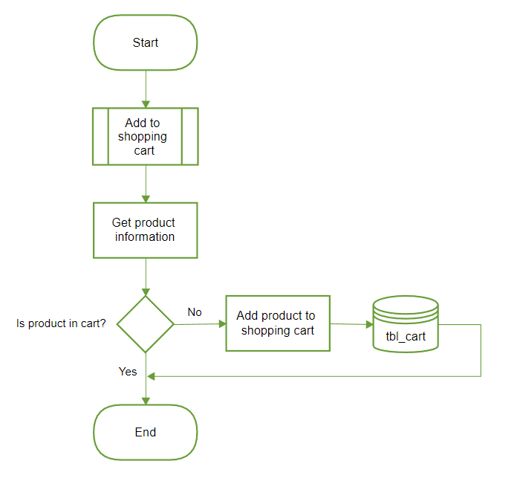
Figure 12 shows adding products to a shopping list
A shopping list is intended to be a reminder for the user. This feature removes the need to have paper or separate notes on a phone to track your shopping list. The current design would allow the user to view the product on their list with ease; this then can be designed later on where scanning products in-store can check off the item on your shopping list.
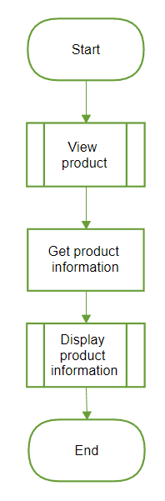
Figure 13 shows getting product information
A key element to this website is that it feels real and the data presented to you is necessary for making decisions. The process of getting product information can be tracked throughout the site which would have been gotten from live store sites.
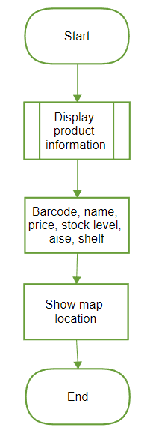
Figure 14 shows what information is gather when getting product information

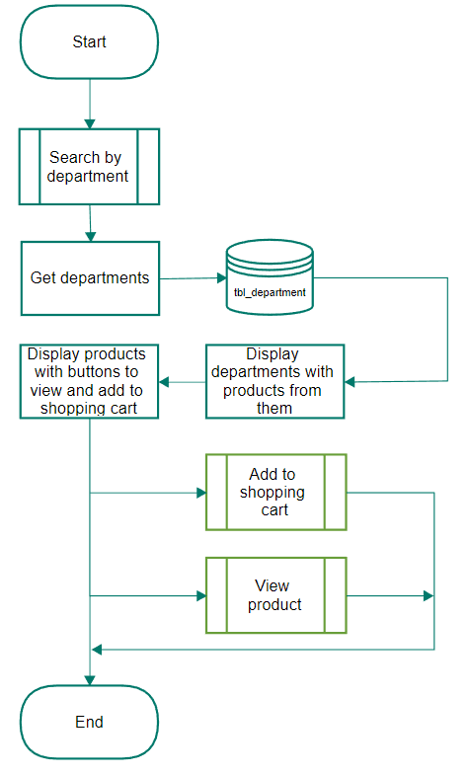
Figure 15 shows the process when searching by department

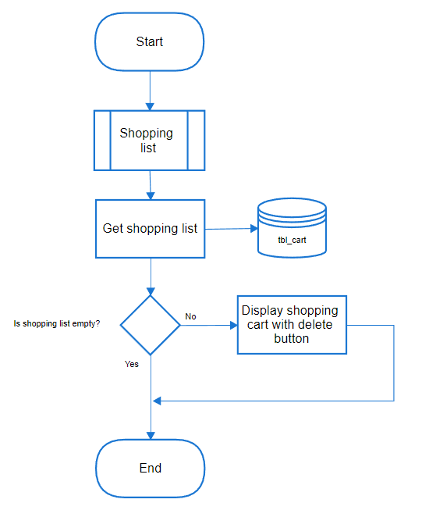
Figure 16 shows adding products to a shopping cart

4.2. Implementation

4.2.1. Domains and web server
A key element for this investigation were, users should be able to access the website from any computer at any time without having direct access to a development computer, or a computer setup specifically for the website.
To do this, a domain was opted, so the user was not required to remember the internet protocol (I.P) address; this also meant that traffic being sent from the website to the user had to be encrypted using HTTPS, even with the knowledge that personal information was not being sent.
The web server that is being used, was utilising Linux, which is different to Windows; this means configuring took a long time as the exposure to Linux was brief. With this in mind, the use of Linux is more rewarding as it is cheaper to run.
After three weeks, the web server was set up with a domain and secure socket layer (SSL) encryption in use. Some problems occurred when the domain did not point to the I.P address, the database would not allow logins and GitHub was throwing permission errors.
This was all resolved after consulting the website hosting providers' manuals.

4.2.2. Javascript successful implementation
When developing the website, it was clear that reusing code was to be avoided as much as possible. This is a clear example of that, the below code checks if the result from the web server is readable and correct. Some of these functions are used within the website over eighteen times, this shows that if the website repeated these in those functions, it would have been the repetitive and bad practice.
The below has been copied from the validator javascript file.
function isJSON(string) {
if($.isPlainObject(string)) return true;
return (string.substring(0,1)=='{'?true:false);
}
function isJSONSuccess(string) {
if(!isJSON(string)) return false;
if(string.result==undefined||string.result!=1) return false;
return true;
}
function isDataValid(string) {
if(!isJSON(string)) return false;
if(!isJSONSuccess(string)) return false;
if(string.data==undefined) return false;
return true;
}
function isJSONDataValid(string) {
if(!isDataValid(string)) return false;
string=string.data;
if(!$.isArray(string)&&!$.isPlainObject(string)) return false;
return true;
}
Implementing the code can be seen in a function to start a session.
if(!isJSON(data)) {error_cannotread();return;}
data=JSON.parse(data);
if(!isJSONSuccess(data)) {error_erroroccured(data);return;}
if(!isDataValid(data)) {error_errordatanotval(data);return;}
let result=data.data;

With that said, you could go further into preventing the repetitiveness and make the above three functions one function with the three main functions being subfunctions. In this instance, however, having more subfunctions was not necessary and may have the opposite effect it is trying to assist with.

4.2.3. Barcode API successful implementation
To increase the development, a barcode system that stores a lot of product information, images and other useful information was devised to be used. Barcode lookup API was found, and it had a free plan, the service had prewritten code for this project to use and an example is below.
$url='https://api.barcodelookup.com/v3/products?barcode='.$barcode.'&formatted=y&key='.$GLOBALS['creds']['barcode_key'];
$ch = curl_init();
curl_setopt_array($ch, array(
CURLOPT_URL=>$url,
CURLOPT_HTTPHEADER=>array('Content-Type: application/json'),
CURLOPT_RETURNTRANSFER => 1,
CURLOPT_FOLLOWLOCATION => 1,
CURLOPT_VERBOSE => 1,
CURLOPT_POST => 0,
CURLOPT_SSL_VERIFYPEER => 0,
CURLOPT_SSL_VERIFYHOST => 0,
CURLOPT_CUSTOMREQUEST => "GET"
));
$responses=curl_exec($ch);
curl_close($ch);
if($responses=='') return array('result'=>0,'message'=>'Cannot create file, error: cannot_create_with_class_02; barcode expired?');
The use of Barcode API was brief as it was only ever used to gather and then insert product information when adding products to the site. This data was stored via cached files, and the data used to simulate a real working store website.

4.2.4. Product mapping API successful implementation
A core element of this website was being able to find the product(s) you wanted in the store. Initially, an image of the store was going to be used with the website creating a shape around the product you were trying to locate. Whilst planning this, it appeared that if you upscaled to allow multiple factors like showing all products, showing certain products etc, this would result in a bad design and negative user experience.
Not only that, but it would also result in the maintaining of bad code which may take some time to resolve issues brought up.
A software called Map tiler which uses a library from JavaScript called Leaflet was chosen. The benefit of this is, you can zoom in on the map, you can move the map, can place dynamic markers, can draw shapes, upscaling the map to larger sizes (if paid for) and more.

4.2.5. Htaccess unsuccessful implementation
Whilst coding the website, strange behaviours were observed when navigating to certain parts of the site. This was noticed when implementing the product mapping feature where it would fail to load the relevant images at certain zooms.
The htaccess file that sets rules for the directory did not enable indexing and rewrites. Furthermore, the Apache file error document was set to the index page so when the server did not find the website page, it errored to the index page making it appear the website was working.
Below is the htaccess file.
RewriteCond %{REQUEST_FILENAME} !-f
RewriteCond %{REQUEST_FILENAME} !-d
RewriteRule ^(.*)$ /index.php?path=$1 [NC,L,QSA]
The below is the apache virtual host file.
<VirtualHost *:80>
ServerName uni.uzzell.dev
ServerAlias uni.uzzell.dev
ServerAdmin 1702201@student.uwtsd.ac.uk
DocumentRoot /var/www/uni_project/public
ErrorDocument /index.php
</VirtualHost>
This was fixed by removing the error document from the Apache file, enabling indexing, and redoing the htaccess file.

Below is the Apache virtual host file.
<VirtualHost *:80>
ServerName uni.uzzell.dev
ServerAlias uni.uzzell.dev
ServerAdmin 1702201@student.uwtsd.ac.uk
DocumentRoot /var/www/uni_project/public
<Directory /var/www/uni_project/public/>
Options Indexes FollowSymLinks Includes ExecCGI
Require all granted
</Directory>
ErrorLog ${APACHE_LOG_DIR}/error.log
CustomLog ${APACHE_LOG_DIR}/access.log combined
<IfModule mod_dir.c>
DirectoryIndex index.php index.html
</IfModule>
</VirtualHost>
The below is the htaccess file.
DirectoryIndex index.php
Options +Index +FollowSymLinks -MultiViews
RewriteEngine on
RewriteCond ${REQUEST_FILENAME} !-f !-d
RewriteBase /
RewriteRule ^(.*)$ index.php?path=$1 [NC,L,QSA]
This is noteworthy as simply adjustments in code without thinking about the consequence can impact later in the future.

4.2.6. Design changes
During development, a lot of design changes were made. These changes were small and some large, the first change being the change from a shopping cart to a shopping list; this was referenced a lot on the website to the user, this needed changing as a cart would imply you can purchase there and then.
A lot of the code still refers to the shopping list as a cart however, that is a backend and frontend coding concern; developers may become confused because of this so it should be changed however, it is a low priority and comments are in place.
Another design change was the main homepage, previously this would show all products from the website. This was not helpful to users browsing so four random products were chosen each time for that user upon refresh, these products were listed as featured. In the live website, the website would log what products users are browsing and purchasing, then show them as featured to other users. This could also be expanded to the users featured products, where it could find products they are most likely to purchase or find useful.
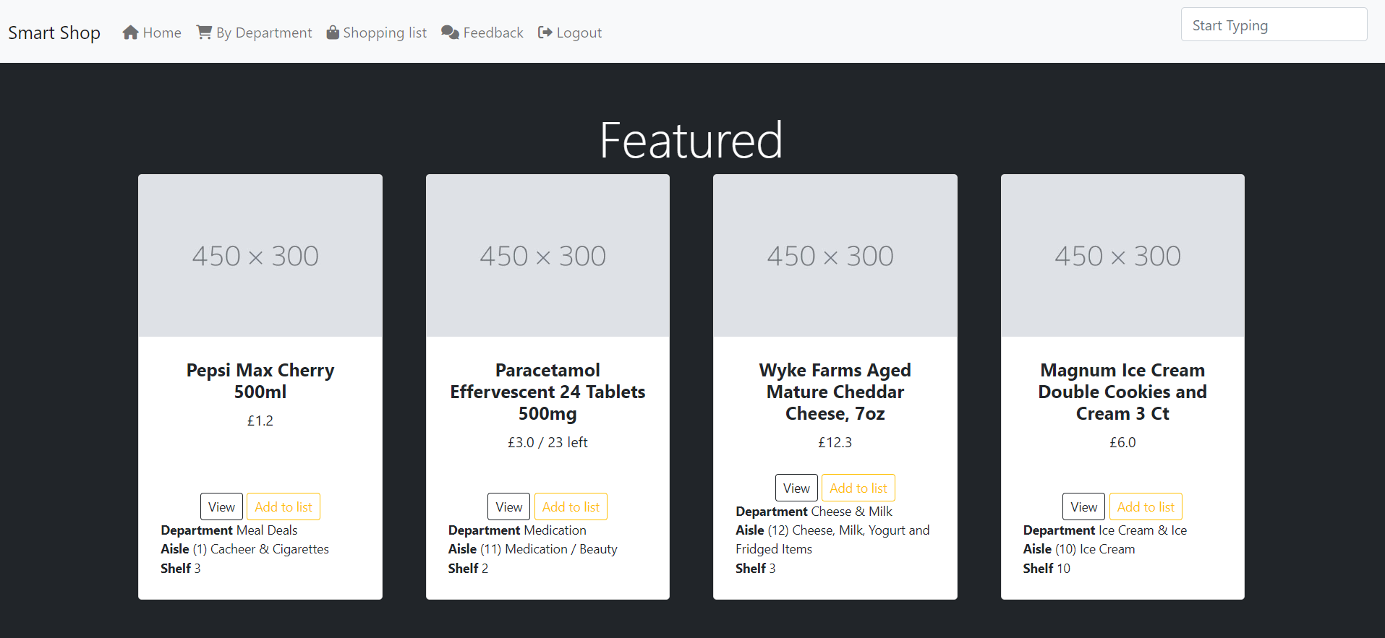
Figure 42 shows the featured four items from the home page

The main page where users would land on was also changed. Previously the page would show a password field with a login button and an about the website link. The about us webpage was moved to the main landing page with a carousel design transitioning through what the website does; accompanied by text stating what the user is looking at, making the landing page feel more knowledgeable. The login button functionality removed, instead, it now transitions you to the main homepage.
The last main change was to the mapping feature, previously the mapping page would only show the location of a product given, using its barcode. This was done by having a question mark, a key named barcode and then the barcode, for example “?barcode=number”.
The change was to show all products in store if no barcode was provided, furthermore, a change was suggested that if you had items in your shopping list, for example “?shoppinglist=true” to show you all your items from the list. If no question mark was present, then it should show you all products on the site.
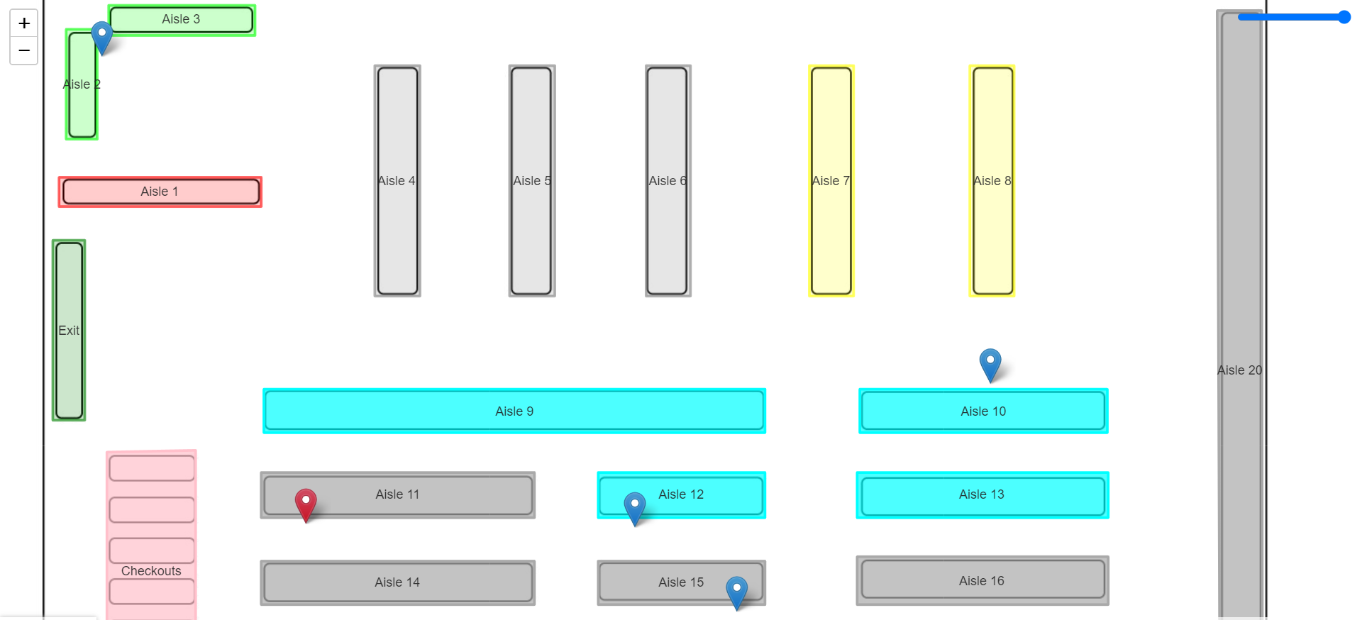
Figure 43 shows the mapped items for the shopping list
Different URL get requests are in use for all these three features, one for barcode, one for showing the shopping list only and lastly, if none are provided, show all products.

4.2.7. Git repository
This project used GitHub to track changes being made. All changes to the main website go through the repository so if something happens, the code is safe and commits can be reverted if bugs are found. A full version history is also available so developers can review amendments throughout the cycle of each file.
Using Git is extremely helpful; coding on separate computers such as a desktop computer, to commit a push of changes and amendments to then go onto a separate computer such as a laptop and then pick up from there - without the need to download each file separately from the main server using programs like Filezila on FTP.
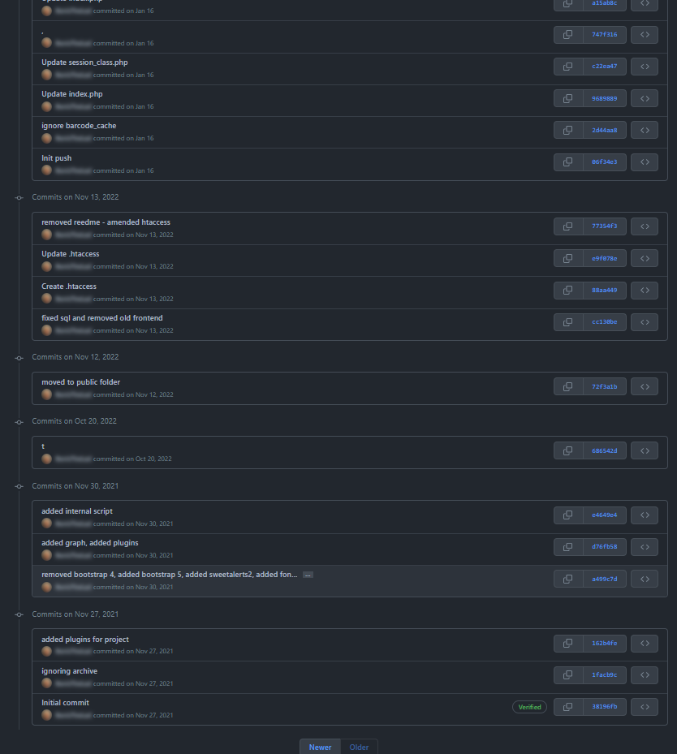
Figure 46 - Shows GitHub version control

4.2.8. Focus group testing
A focus group was decided to be used to assess the implementation of the website for this project. A five-person focus group was decided and this will be to assess in a brief investigation the site itself and whether users who know nothing about the site can use it.
With the focus group being so small, it is an acknowledgement that participants will not represent the entire audience this application might be used by; ideally, a wide range of ages, genders and users from different backgrounds should be used.
What was required from participants? Six total tasks were set out and, the participants were timed on how long it took them to complete each of them; they could pass by completing the task in full or fail by running out of time or asking for help. The average response time of all tasks was 36 seconds, the tasks were the following:
- Task one, was to find the fish and add it to the shopping list;
- Task two was to find the fish on the map;
- Task three was to find the Pepsi Max bottle and add it to the shopping list;
- Task four was to find the Pepsi Max bottle on the map;
- Task five was to find the shopping list page;
- Task six, the final task, was to view all the products in the shopping list on the map;

Whilst conducting the focus group, some of the participants looked confused as the way some of the features they expected to work like, did not work the way they expected. For one, searching in the search box was not clear enough that this was for products only, some participants tried searching for pages. A feature that was missing and confused some was that there was no button to search for what you wanted, which would bring you to a separate page - instead the products were returned after the user stopped typing after around four seconds.
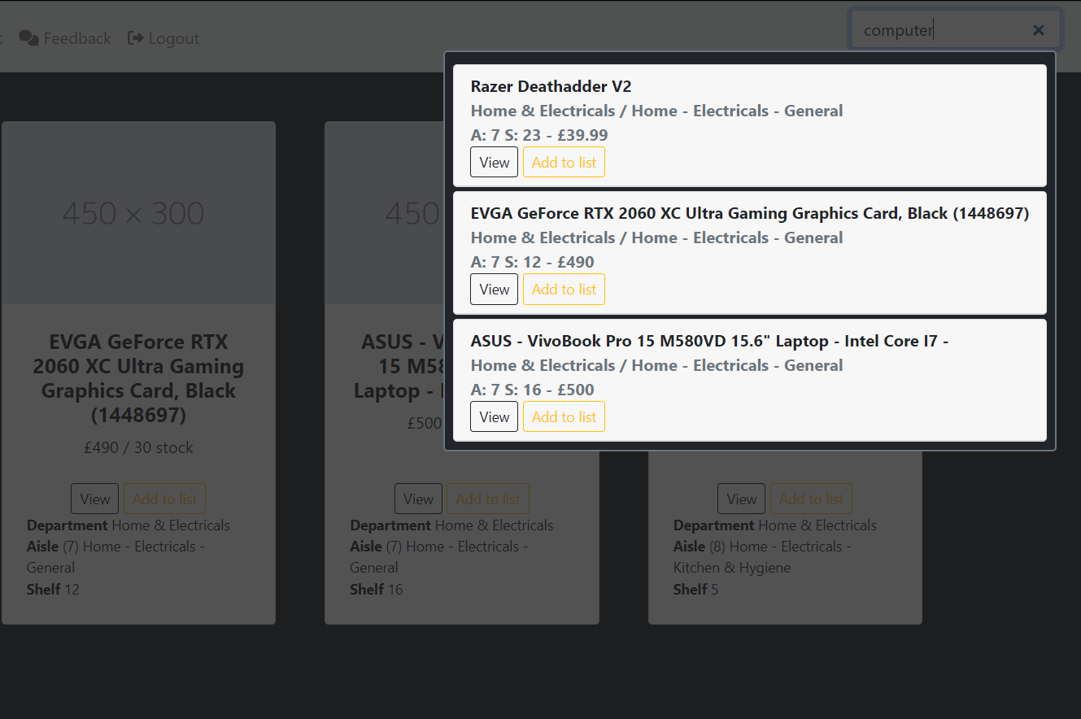
Figure 44 shows the user interface for the search box
Although all tasks (except for one participant) were successful and the task completed, a member of the focus group stated that this is the wrong area to look into, instead working on the online element for shops that make online shopping easier was mentioned. The participant stated their frustration in regard to the substitution system for products.
With that stated, a large amount of the group stated their support for the locating system but noted that this was not for them, but instead for those who are not able-bodied.

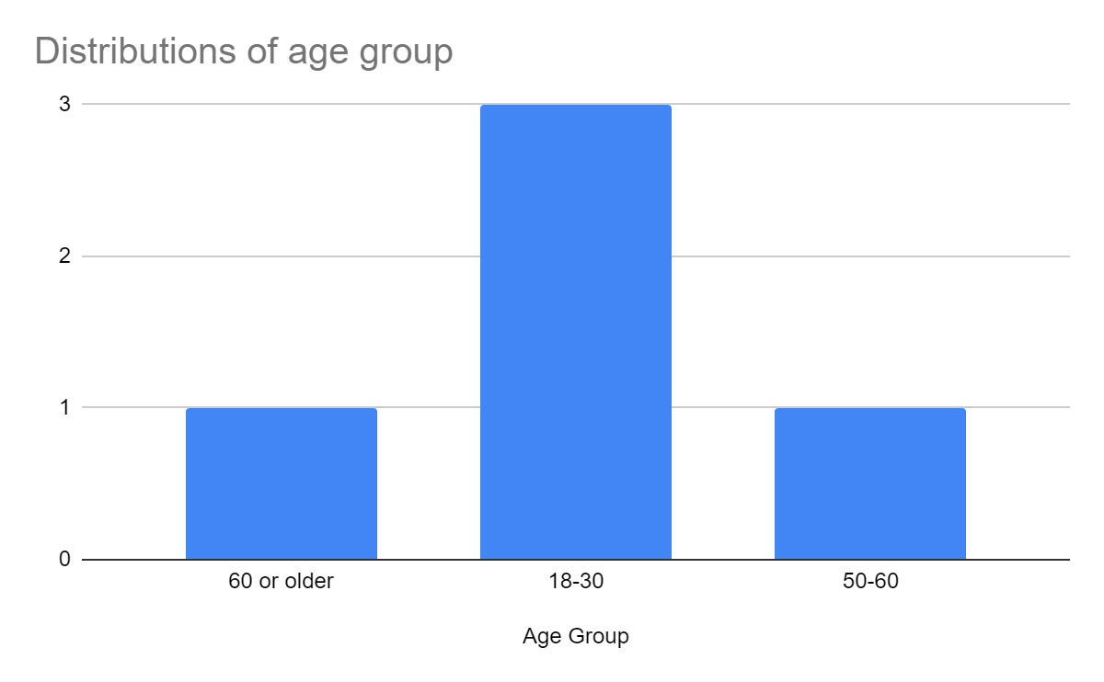
Figure 25 - Graph showing age distribution from focus group
The distribution of age was as equal as it could have been.
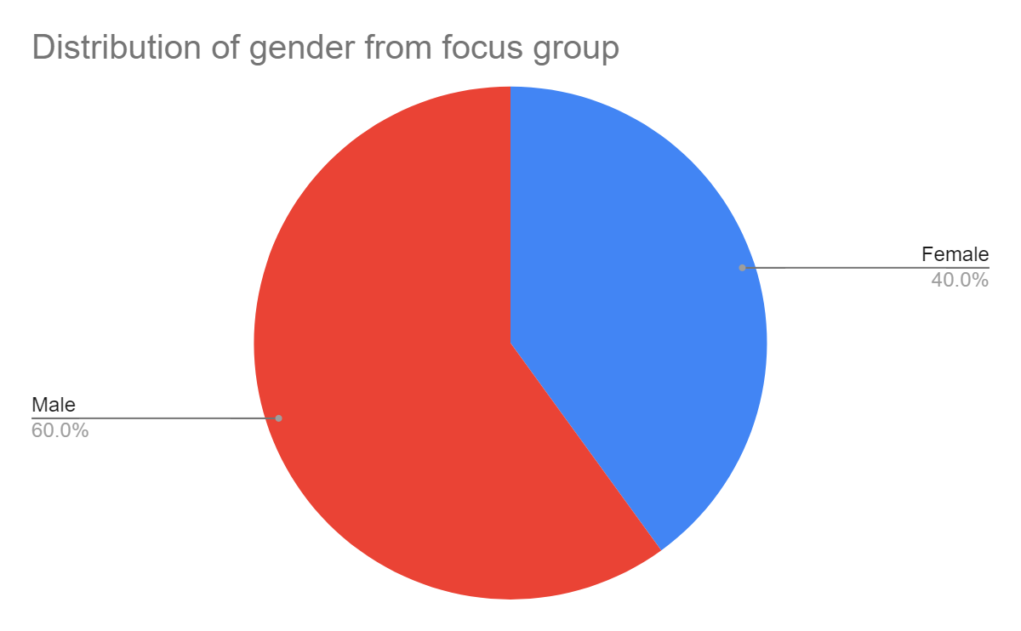
Figure 26 - Graph showing gender distribution from focus group
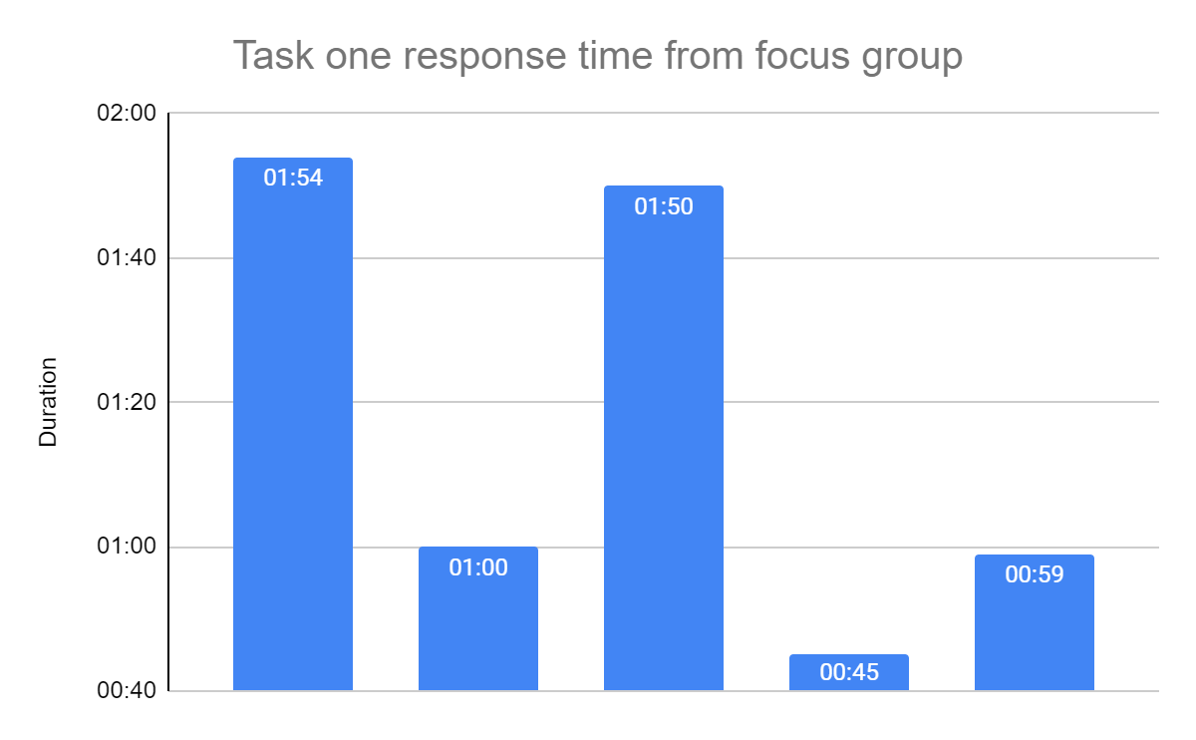Figure 27 - Graph showing task one response time from focus group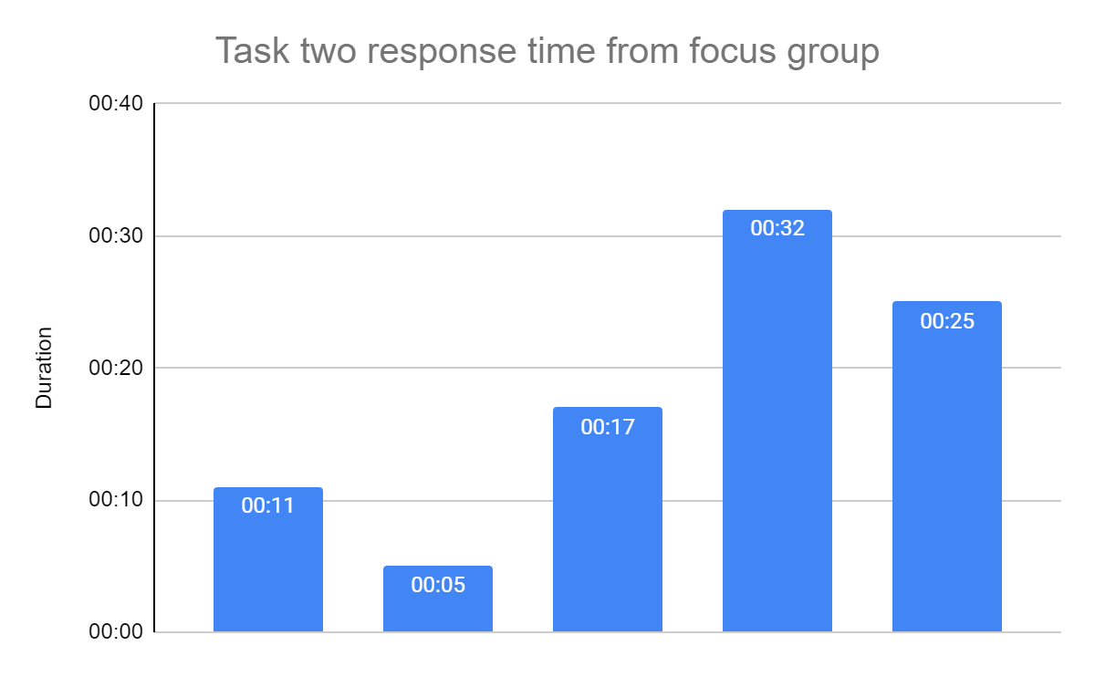
Figure 28 - Graph showing task two response time from focus group
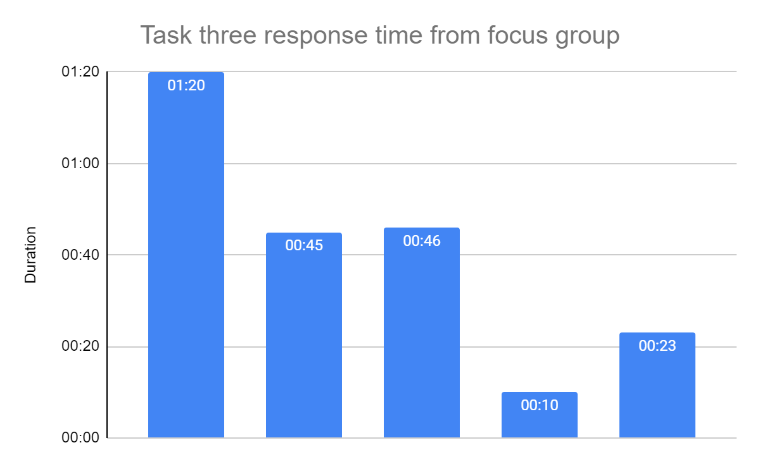
Figure 29 - Graph showing task three response time from focus group
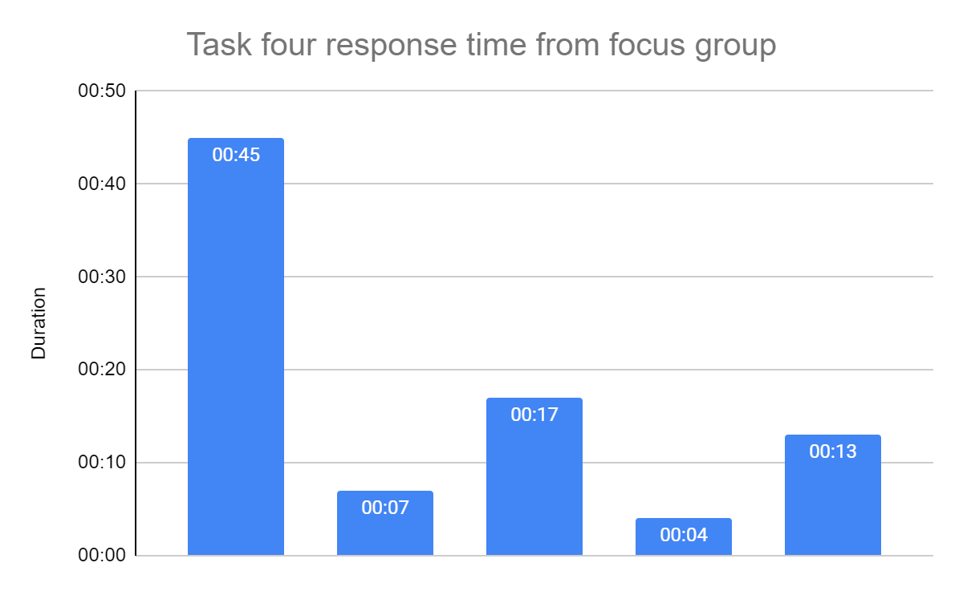
Figure 30 Graph showing task four response time from focus group
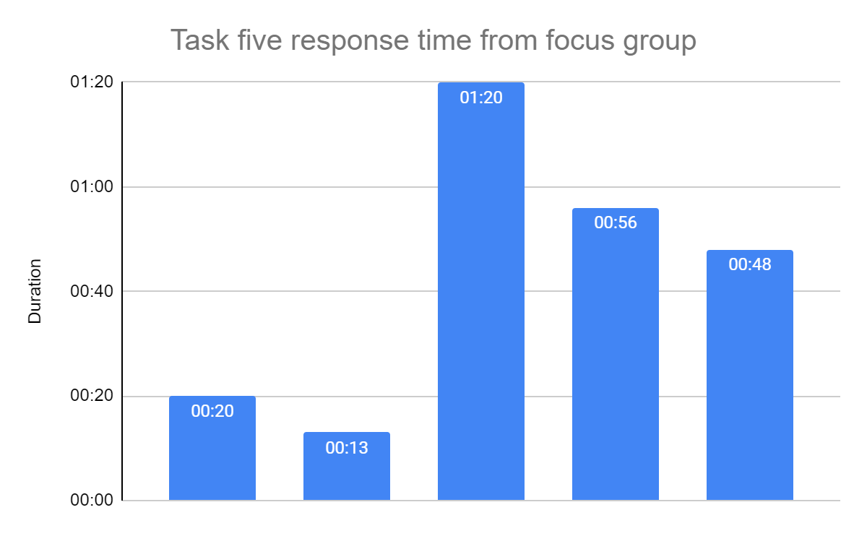
Figure 31 - Graph showing task five response time from focus group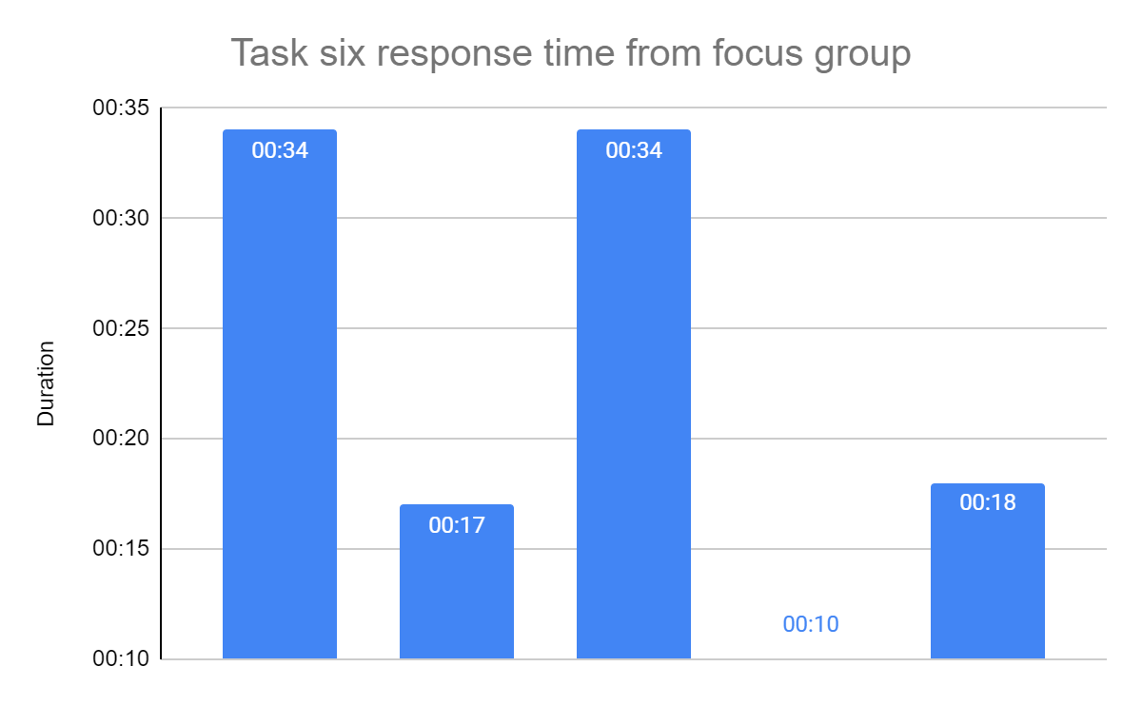
Figure 32 - Graph showing task six response time from focus group

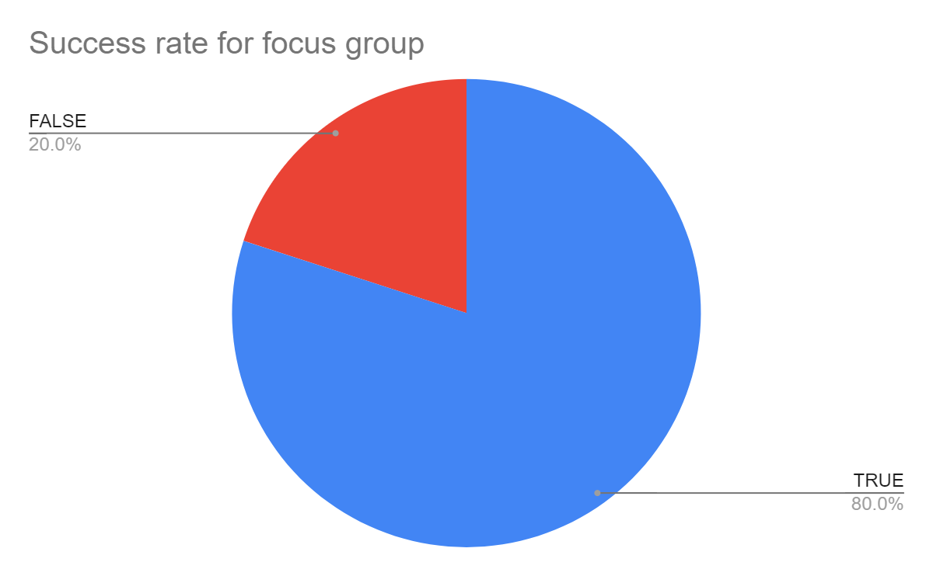
Figure 33 - Graph showing success rate from focus group tasks
The above shows if the user was successful at completing a task set out. This is ideal to note how difficult the site is to use.

4.2.9. Website feedback
Alongside the focus group, feedback using a Google form was also given out to people who were willing to give feedback - data collected was their age, gender, how long they used the site for (roughly), how they rated the website on a scale if they liked the application (one to five) if they had any problems using the application and any other comments from them.
Reviewing the survey, several sections allowed respondents to comment in their own words regarding the website; these sections explained why they chose that rating for the design, explained bugs they may have had and lastly, if they had any other comments.
A lot of the comments from respondents who chose their respected rating stated that the design of the website appeared basic and lacked colour, images and more. Many stated the site did what it needed to and was not overly complex but, with this said it is apparent that the site uses five colours and lacks personality.
A respondent went into detail on rating the website, stating that transitions were too fast, knowledge of the mapping feature was not clear, and some buttons were not clear, for example, the login button was there but there was no form to fill in, mobile view for some pages were difficult to navigate and lastly, the use of pictures notably for the shopping list was not there which it should be.
Moving onto bugs, respondents mostly said searching for products was difficult as a black pane that appears behind the input field would not work and disabled the ability to interact with the input field using the cursor. The problems that respondents replied with are mainly UX issues.
Lastly, respondents were able to give other comments regarding this application, this could be if they thought the website was a good or bad idea etc. Eight comments were given, several asked for this application to be introduced in some way currently to shops, for online shopping to be incorporated into the site, for supermarkets to use this application and lastly, for better and well-structured implementation.

4.2.9.1. Website Graphs
The following section will cover the data from respondents. Moving onto graphs that have been developed from the responses.
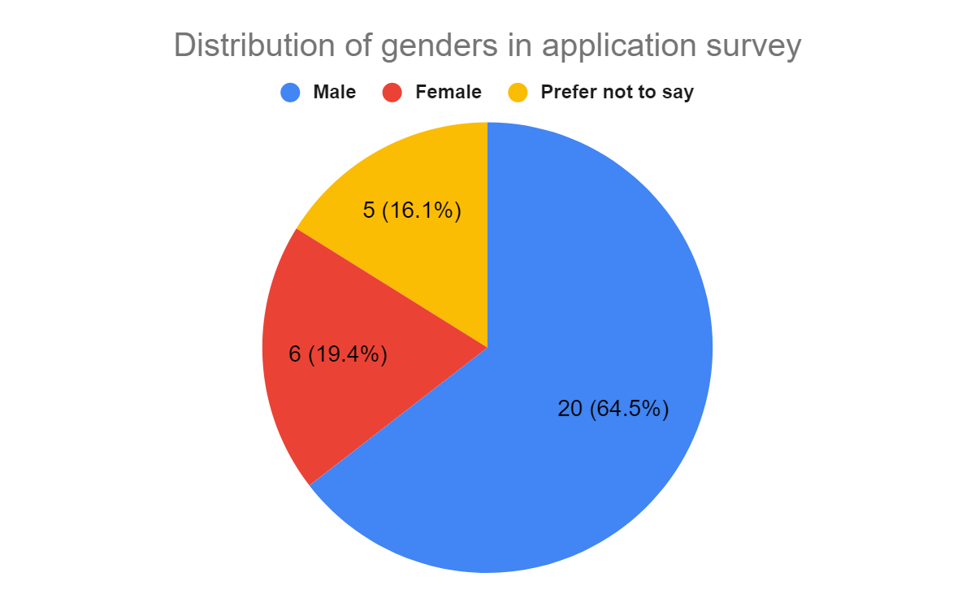
Figure 34 - Graph showing the distribution of genders from application survey
The above graph shows that a majority, of twenty people who identified as males responded to this survey, with the next being six females and then lastly, five people who preferred not to say.

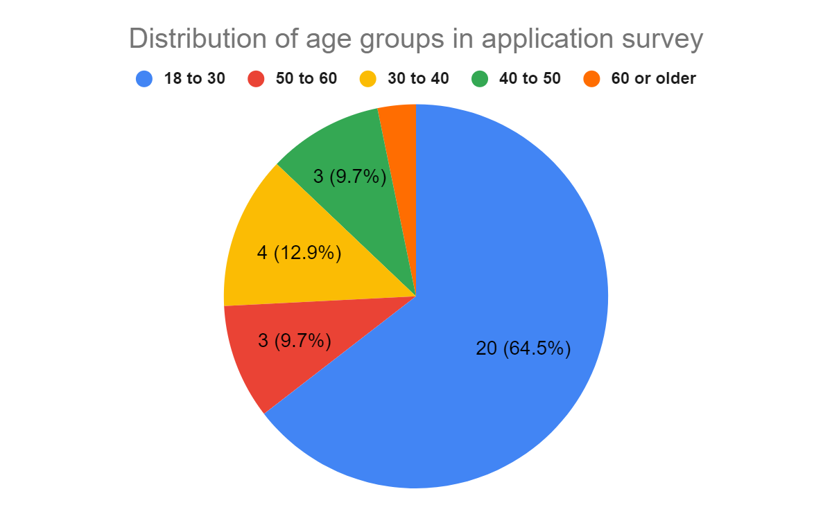
Figure 35 - Graph showing distribution of age group from application survey
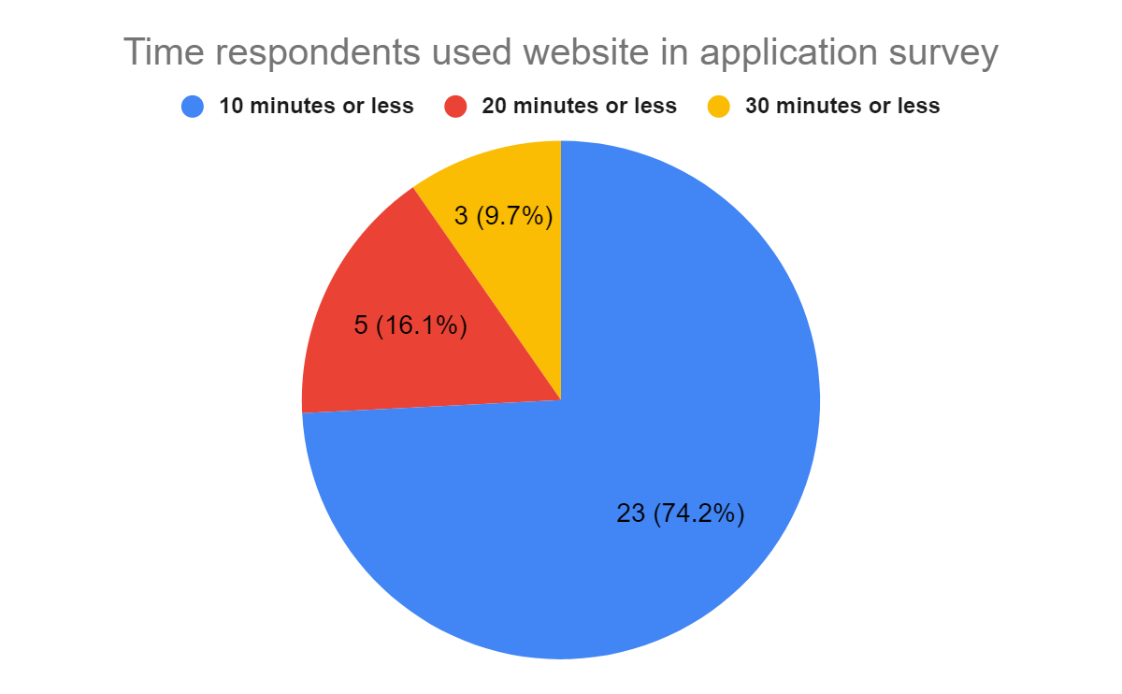
Figure 36 - Graph showing the time respondents use the website from application survey
The above graph shows that a lot of people stopped using the application before ten minutes. One hour and two hours or more were never selected which shows that users made their decision or completed everything that there is to do and see on the application within thirty minutes.
It was expected that at least one person would use the site for an hour.

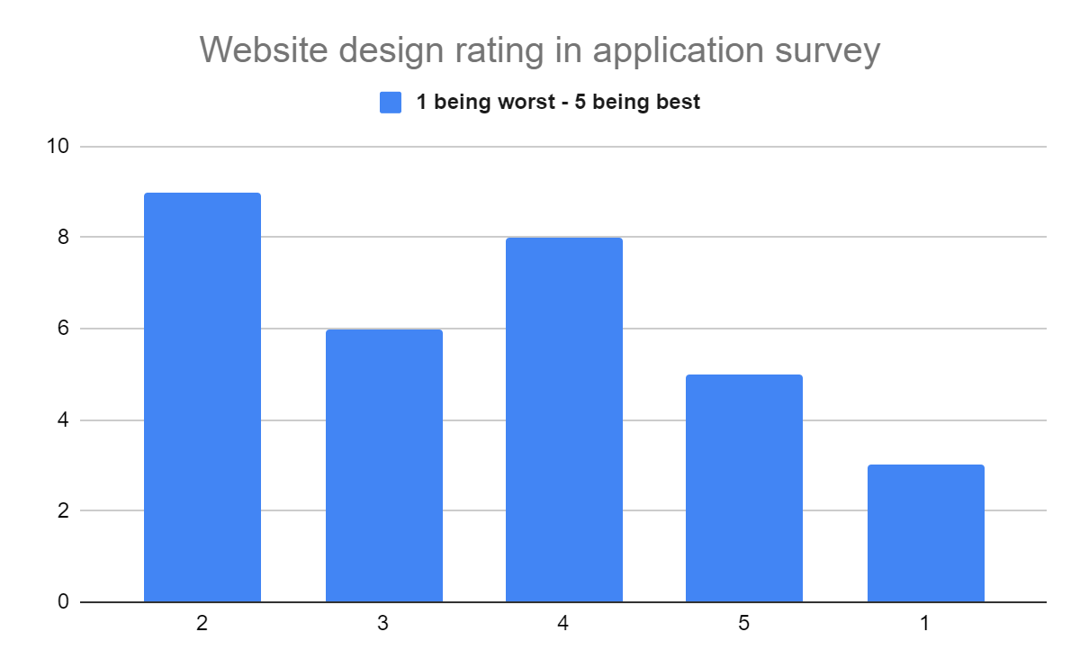
Figure 37 - Graph showing how respondents rating the website from application survey
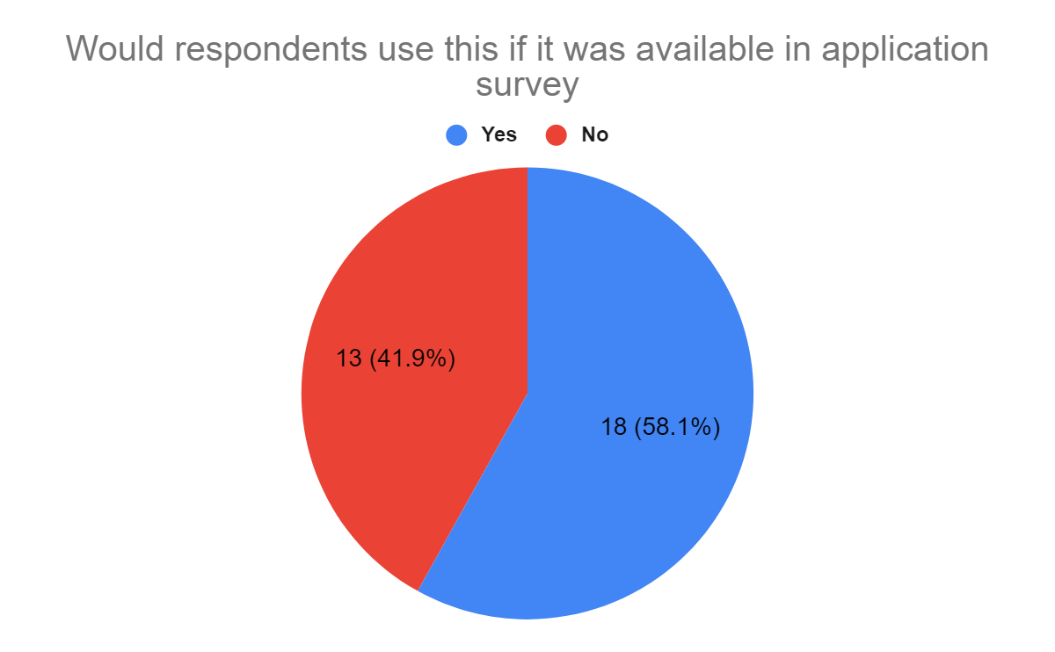
Figure 38 - Graph showing if respondents would use this application if it was available from application survey

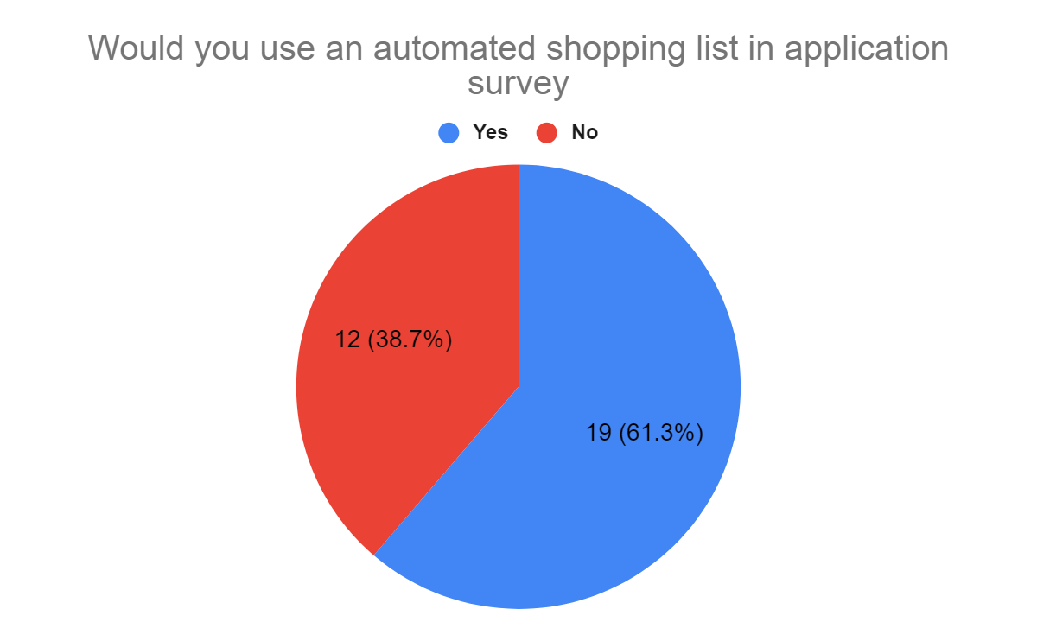
Figure 39 - Graph showing if respondents would use an automated shopping list from application survey
The automated shopping list, which is the feature to show where products are in store on a map, that is on your shopping list and also. This feature was expected to be popular with little to no one not wanting it however, from the above data it is clear it is almost divided.

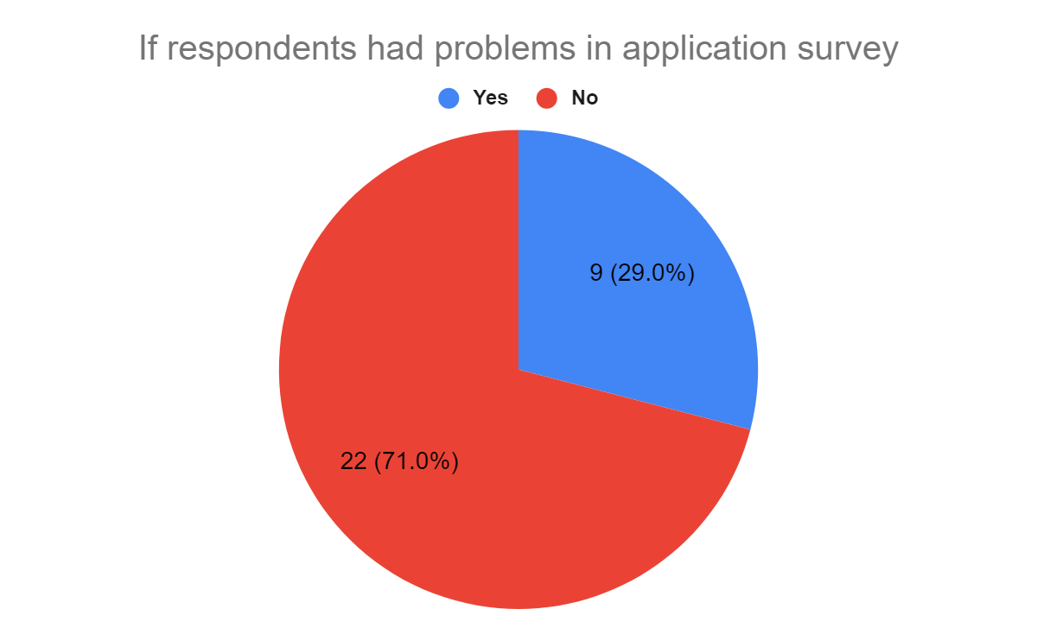
Figure 40 - Graph showing if respondents had problems from application survey

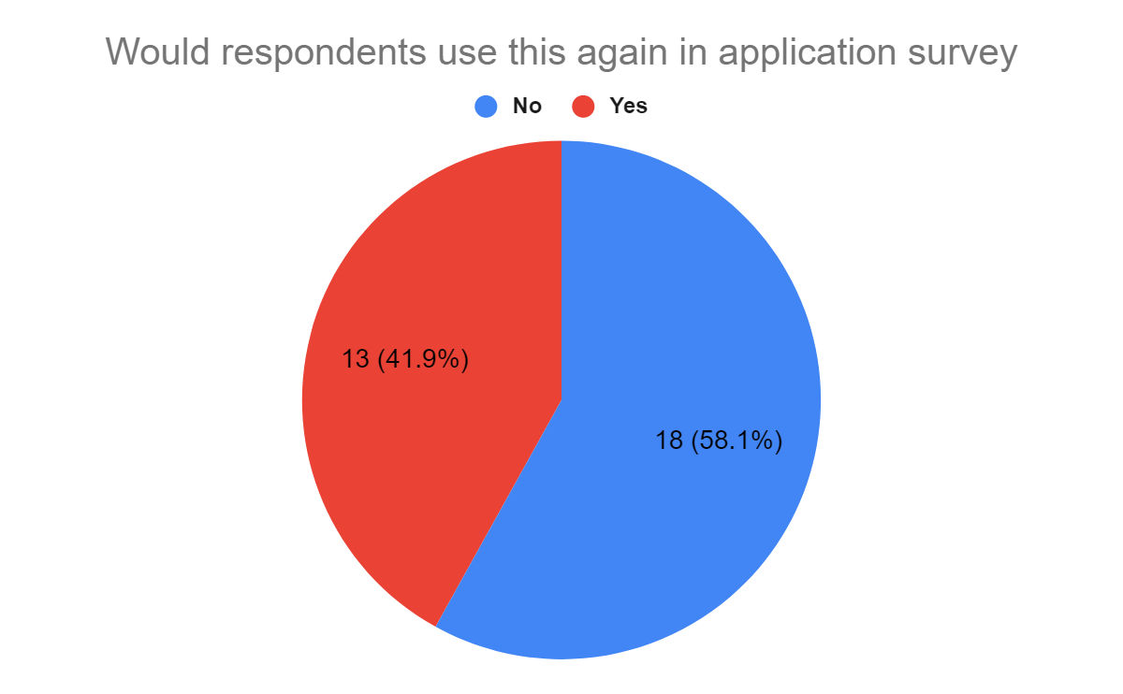
Figure 41 - Graph showing if respondents would use the application again from application survey

5. Results
After reviewing all the survey results, respondents chose that they prefer online and in-store shopping and a lot of those who go in-store shopping never use the assisted scanning tools. Comparing these results to the website feedback, the results show that there is a need for this product or something similar. The overall responses from the general survey were twenty-nine and for the website feedback, there were thirty-one.
With this in mind, from the general survey, a lot of respondents stated that they would use an online stock information page however, a lot of respondents from the website survey stated they would not use this application.
From this, it can devise that the implementation of this website was sufficient to know that there is a demand and a keen interest in looking further into this area but, the implementation will need improving as the site itself may not have been sufficient enough. Physical testing with physical store technologies assesses if everything can keep up to date with each from stock levels, to information being given, to location and lastly, the know-how level of using the technology.

6. Evaluation
Wrapping everything up from this report, this section will cover the data from the literature review, whether the objectives and aims were met, if the result is what was expected and lastly, what would be done differently.
The literature review covered shop designs, product placement, current technologies, longevity, stock information currently available and the usability practices out there currently. This information it is believed was correctly brought into the implementation of the application, from the way the shop was designed and, to where products were placed.
Unfortunately, the application did not have many usability design practices for individuals who need assistance whilst using the site.
Moving onto the aims, only one aim was set and it was to understand whether customers or end-users require more information and assistance when shopping in-store. After reviewing the data given in a survey and focus group, customers would like further assistance and information such as where the product is whilst shopping in-store.
Four objectives were established, one being to collect survey results and implement changes. The next was to research supermarkets, assessing what they currently do. The third was to research current technologies and lastly, the fourth was to implement an application for users to give feedback on the system devised from the above findings.
Objective one is believed to have been moderately successful, as the minimum amount of responses was met on both occasions, thirty being the number. Ideally, more responses would have been given to establish more of a pattern and present those findings.
Objective two has been successfully met as current shop designs and ways they operate have been mentioned. It is believed that objective three was met and all current technologies discovered and mentioned. Lastly, objective four was moderately successful as a segment of that criteria, for users to provide feedback and implement changes was never actioned. Other segments of objective four where feedback from the site would be presented were successfully done.

Covering the last item on this, would anything change if this was redone? Yes, but only some things. Firstly, the structure and progress of this report have been fine, the way it is designed and staged looks right.
The progress of the surveys was slow and it was rather difficult to get responses, it was a challenge to ask individuals to give their own feedback on the site which delay a lot of the progress. Done differently, instead of going to a group of individuals, to send out emails to the university, messaging groups of individuals once and then asking friends to submit feedback (in person if needed). The concern that has been thought of, is if asking multiple times for feedback, may give the respondent a negative outlook even before reviewing the website (which sets out skewed data).
The implementation of the website was slow, the webserver and backend components were sourced early on during this report however not much content was on the site which made it unusable. The API used to get product information had a month's free trial, which meant each month a new free trial would need to be sourced again to add more products. Ideally, a week should have been spent adding an array of products, (twenty-five) instead of stagnating these over months.
The design of the website was boring and did not encourage users to use it, not much help was given to those who did not know what was going on. Moving forward, time should be dedicated to designing the website and features planned out. A help wizard on the website should have been available pointing users to pages and features, a video may have also helped users understand more if they were not following.
The website did not offer any accessibility modes, this is not good as the survey was given to individuals of different age groups, genders and disabilities. This may have meant some respondents did not respond for this reason alone and, there is no way of knowing. Moving forward, the website feedback should be overhauled with a feedback option on site, with a ‘how are you currently feeling’, from one to five - from that, information from the page and current actions would be sent and it would allow for faster and quicker responses from respondents. This could be expanded with a page to view what the respondent has submitted and then the ability to add a comment.
Perhaps, a tasks options can be implemented and then a popup would appear after the user completed certain tasks. This could allow for results to be more direct. Whatever is chosen, these were a couple of ideas that may change the end result for the positive.

7. Conclusion and recommendations
Concluding this report, the data collected from surveys and focus groups demonstrates that there is a need for making in-store shopping simpler, be it locating products, checking stock levels, information regarding the product and others.
As stated above, users had usability issues whilst using the website implemented for this report with other concerns noted which surrounded the information given, the way the website was designed and others. Another concern that was noted whilst creating this report was the assumption that users would be able to clearly understand what the project is; although a minority, this is concerning so in future something clearly stating what this project is and what the user's job is should be devices (this was mostly noted in the website survey feedback).
It was found locating products and having information available to users was useful and sometimes needed for allergy notices; there is a need for more research into this area and more specifically, a physical device that would allow you to walk around a real shop locating items chosen at random.

8. Reflection
I found working with Linux was great as a lot of web servers use it as it's cheaper. Learning the different commands needed to navigate, edit and create files and folders is great - the same server I host the project on will host my personal about me page which may be useful in the future - this project has pushed me to do that!
My coding ability is strong and I feel this has reinforced it however, this has opened me up to adding more UX and design choices to websites and projects I create - having a bland design is boring for a lot of people and they will simply click off it. Further to this, I need to approach the site not as a developer but, as a user and try and use the site - I know where to look in almost all circumstances.
I have realised that I need to plan for eventualities, for example, if I just wanted a relaxed day, what I could work on, breaking problems and other things into groups then stating how complex I think they might be. Managing this project has been difficult as I never truly understood the time frames things needed to be completed. This is evident in the website where a lot of features were scaled back and simplified - as I took too long, believing I had more time on small and less significant problems.
I never understood why I needed to put things down as a due date, and exactly what was due. Simply put, ‘website completed’, ‘survey starts’, ‘survey ends’ etc does not detail things I need to know. Moving forward, I believe in placing checkpoints across the timeframe that I have to complete items within, by detailing what is required to be completed and how or what I believe should be completed. Applications like Trello perform this well and, I only took note of it in the final weeks of this project.
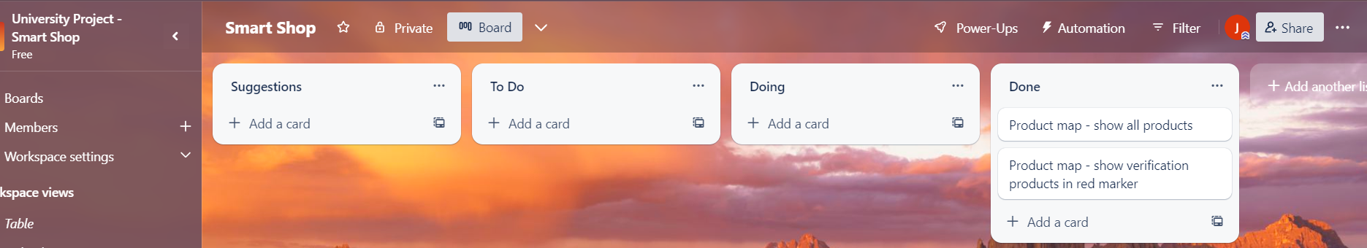
Figure 45 - Trello project board set up weeks before the due date

I believe could have used utility programs out there that could have helped me manage myself and my time, things like Trello, Google Reminders and others would have been handy; visualising when things are required is great.
Lastly, writing down ideas and what I plan things should turn out like because on several occasions have forgotten where I was going with certain things and, I have also forgotten where I left off; this was true with the surveys and coding.

9. Reference
[1] apachefriends, “About”, apachefriends, 2023, [Online.], Available: https://www.apachefriends.org/about.html, Accessed 10 Oct 2022
[2] statcounter, “Desktop & Mobile Browser Market Share Worldwide”, statcounter, 2022, [Online.], Available: https://gs.statcounter.com/browser-market-share/desktop-mobile/worldwide/#monthly-202208-202211, Accessed 10 Oct 2022
[3] lsh, “How store design affects shopping behaviour - LSH investigates”, lsh, 2022, [Online.], Available: https://www.lsh.co.uk/explore/research-and-views/news/2015/04/how-store-design-affects-shopping-behaviour, Accessed 10 Oct 2022
[4] dominionprint, “4 types of store layout you need to know about”, dominionprint, 2022, [Online.], Available: https://www.dominionprint.com/4-types-of-store-layout-you-need-to-know-about/, Accessed 10 Oct 2022
[5] K.Abbamote, “Unify online and in-person sales today”, shopify, 2022, [Online.], Available: https://www.shopify.com/uk/retail/how-to-optimize-your-stores-power-wall-to-spike-sales, Accessed 10 Oct 2022
[6] C.Chiakpo, “The Ultimate Guide to In-Store Product Placement in 2020”, repsly, 2022, [Online.], Available: https://www.repsly.com/blog/the-ultimate-guide-to-in-store-product-placement, Accessed 10 Oct 2022
[7] smartshop, “SmartShop is the new way to shop at Sainsbury's. Just scan, bag and go, it couldn't be easier!”, smartshop, 2022, [Online.], Available: https://smartshop.sainsburys.co.uk/, Accessed 10 Oct 2022
[8] justwalkout, “A new shopping experience with Just Walk Out technology by Amazon”, justwalkout, 2022, [Online.], Available: https://justwalkout.com/, Available 20 Oct 2022
[9] barcodelookup, “Integrate your app with our UPC, EAN and ISBN database.”, barcodelookup, 2022, [Online.], Available: https://www.barcodelookup.com/api, Accessed 20 Oct 2022
[10] tracxn, “Top Self Checkout Solutions Startups”, tracxn, 2022, [Online.], Available: https://tracxn.com/d/trending-themes/Startups-in-Self-Checkout-Solutions, Accessed: 20 Oct 2022
[11] shopic, “Intelligent Retail with the World's Smartest Shopping Cart”, shopic, 2023, [Online.], Available: https://www.shopic.co/home/, Accessed 7 Jan 2023
[12] mashgin, “No More Lines”, mashgin, 2023, [Online.], Available: https://www.mashgin.com/, Accessed 7 Jan 2023
[13] wrike, “Why Use Agile Project Management?”, wrike, 2023, [Online.], Available: https://www.wrike.com/project-management-guide/faq/why-use-agile-project-management/, Accessed 6 Feb 2023
[14] w3, “Accessibility, Usability, and Inclusion”, w3, 2023, [Online.], Available: https://www.w3.org/WAI/fundamentals/accessibility-usability-inclusion/, Accessed 19 Apr 2023
[15] twitter, “Accessibility at Twitter”, twitter, 2023, [Online.], Available: https://help.twitter.com/en/resources/accessibility, Accessed 23 Apr 2023

10. Figures
[Figure 1] statcounter, “Desktop & Mobile Browser Market Share Worldwide”, statcounter, 2022, [Online.], Available: https://gs.statcounter.com/browser-market-share/desktop-mobile/worldwide/#monthly-202208-202211, Accessed 10 Oct 2022
[Figure 2] dominionprint, “4 types of store layout you need to know about”, dominionprint, 2022, [Online.], Available: https://www.dominionprint.com/4-types-of-store-layout-you-need-to-know-about/, Accessed 10 Oct 2022
[Figure 3] dominionprint, “4 types of store layout you need to know about”, dominionprint, 2022, [Online.], Available: https://www.dominionprint.com/4-types-of-store-layout-you-need-to-know-about/, Accessed 10 Oct 2022
[Figure 4] dominionprint, “4 types of store layout you need to know about”, dominionprint, 2022, [Online.], Available: https://www.dominionprint.com/4-types-of-store-layout-you-need-to-know-about/, Accessed 10 Oct 2022
[Figure 5] dominionprint, “4 types of store layout you need to know about”, dominionprint, 2022, [Online.], Available: https://www.dominionprint.com/4-types-of-store-layout-you-need-to-know-about/, Accessed 10 Oct 2022
[Figure 6] barcodelookup, “Integrate your app with our UPC, EAN and ISBN database.”, barcodelookup, 2022, [Online.], Available: https://www.barcodelookup.com/api, Accessed 20 Oct 2022
[Figure 7] K.Abbamote, “Unify online and in-person sales today”, shopify, 2022, [Online.], Available: https://www.shopify.com/uk/retail/how-to-optimize-your-stores-power-wall-to-spike-sales, Accessed 10 Oct 2022
[Figure 8] mashgin, “No More Lines”, mashgin, 2023, [Online.], Available: https://www.mashgin.com/, Accessed 7 Jan 2023
[Figure 9] shows the use case diagram for the web application
[Figure 10] shows the main home page procedure and processes
[Figure 11] shows displaying all products on the home page
[Figure 12] shows adding products to a shopping cart
[Figure 13] shows getting product information
[Figure 14] shows what information is gather when getting product information
[Figure 15] shows the process when searching by department
[Figure 16] shows adding products to a shopping cart
[Figure 17] show the age group of the respondent
[Figure 18] shows the gender of the respondent
[Figure 19] shows hows the respondent find shopping in-store
[Figure 20] shows how the respondent uses already available scanners to assist with shopping
[Figure 21] shows if the respondent would use online stock information web page
[Figure 22] shows if a respondent would use online shop stock checking if they knew it was available
[Figure 23] shows if the respondent would use a product finder in store if available
[Figure 24] shows if a respondent would use technology if it assists them finding a product in-store
[Figure 25] Graph showing age distribution from focus group
[Figure 26] Graph showing gender distribution from focus group
[Figure 27] Graph showing task one response time from focus group
[Figure 28] Graph showing task two response time from focus group
[Figure 29] Graph showing task three response time from focus group
[Figure 30] Graph showing task four response time from focus group
[Figure 31] Graph showing task five response time from focus group
[Figure 32] Graph showing task six response time from focus group
[Figure 33] Graph showing success rate from focus group tasks
[Figure 34] Graph showing distribution of genders from application survey
[Figure 35] Graph showing distribution of age group from application survey
[Figure 36] Graph showing the time respondents use the website from application survey
[Figure 37] Graph showing how respondents rating the website from application survey
[Figure 38] Graph showing if respondents would use this application if it was available from application survey
[Figure 39] Graph showing if respondents would use an automated shopping list from application survey
[Figure 40] Graph showing if respondents had problems from application survey
[Figure 41] Graph showing if respondents would use the application again from application survey
[Figure 42] Shows the featured four items from the home page
[Figure 43] Shows the mapped items for the shopping list
[Figure 44] Shows the user interface for the search box
[Figure 45] Trello project board set up weeks before the due date
[Figure 46] Shows GitHub version control

11. Bibliography
https://smartshop.sainsburys.co.uk/
Sainsburys have an app where you scan products at selected shops and pay at a smart shop checkout. Sainsbury's seems to only use this for their app.
https://justwalkout.com/
Just walk out technology is by Amazon where you can pick items up and you automatically get billed when you walk out. This seems to only be Amazon doing this.

https://www.asda.com/about/instore/scan-and-go
Asda scan and go options to scan items and then pay for it at the till. Many shops use this feature.
https://greenroomdesign.com/blog/7-retail-interior-design-principles/
Retail interior design blog - some useful information.
https://agility.im/frequent-agile-question/difference-incremental-iterative-development/#:~:text=Incremental%20Incremental%20development%20is%20a,these%20is%20complete%20before%20releasing.
Was looked into whilst considering the development process.
https://www.maptiler.com/ was Used to create the map on the website.
https://leafletjs.com/ Used to create markers, create the map in the website and others.

