Digital Skills and Research Methods
Module: BMSW4003
Module leader: Paul Ranson
Student Name: Alexandru Dragomir
Student ID: 2007576

Table of Content

BBC News Pitch 3
DIKW Research Method 3
Data 3
Data presentation – grit experiment 4
Gender information 4
Highest qualification level 4
Grit average and Qualification level 5
Information 5
Information based on primary data 6
Average grit score 6
Mode of the qualification level 6
Median of the qualification level 6
Gender and Average grit 6
Knowledge 7
Knowledge- a comparative study 7
Wisdom 8
Conclusion 8
References 9

Digital Skills and Research Methods

BBC TV News Report
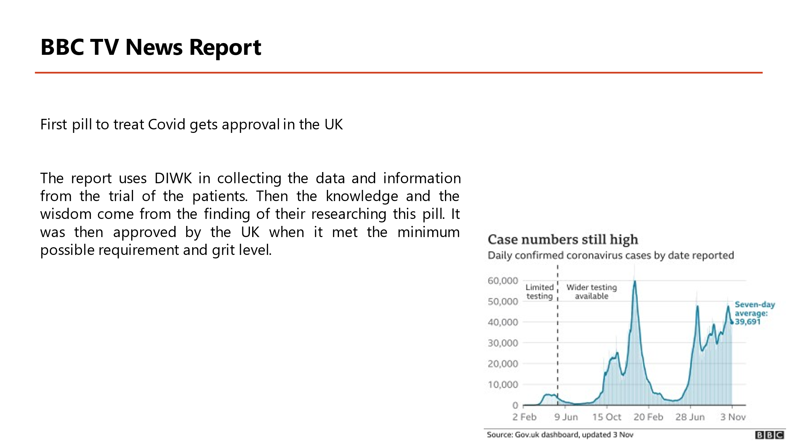
The news was titled “First pill to treat Covid gets approval in the UK”. This news report shows patients who received Molnupiravir were less likely to be hospitalised than those who were given a lower dose or dummy pill in previous clinical trials of the drug, which involved 775 people who had just been diagnosed with Covid. No one in the Molnupiravir group died from the virus; however, eight people in the placebo group did. Released in a press, they have yet to be peer-reviewed. However, research indicates that for Molnupiravir to be effective, it must be given as soon as symptoms arise. Previous research in patients with severe Covid was terminated due to unsatisfactory findings in patients who were already treated (BBC News, 2021).
The report uses DIWK in collecting the data and information from the trial of the patients. Then the knowledge and the wisdom come from the finding of their researching this pill. It was then approved by the UK when it met the minimum possible requirement and grit level.

DIKW Research Method
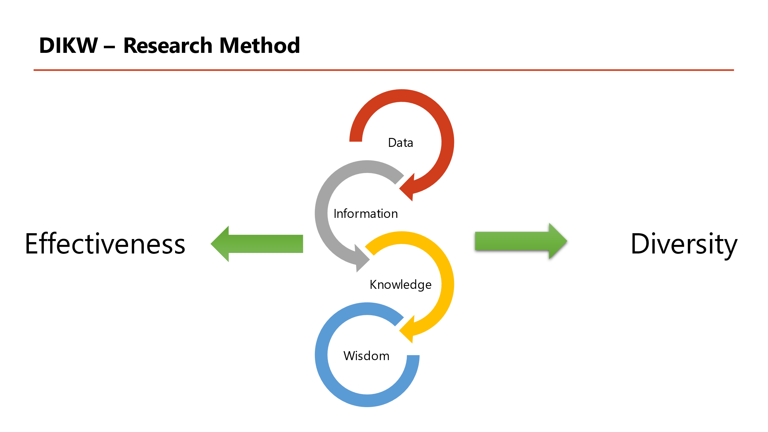
Data, Information, Knowledge and Wisdom is the abbreviation for DIKW. As the name suggests, DIKW represents a logical evolution of IT procedures (Dmitriy, 2020). Using a pyramid-like structure, the four most important components are shown to be interdependent.
In the context of DIKW, data are the indicators and characters that indicate the characteristics of a group, information is the analysis of the gathered data, and knowledge is the capacity to put the information in context. In this context, wisdom refers to the evaluation of the information that was received. Many academics believe that this technique uses a pyramidal method to mastery (Frické, 2019).
The DIKW method allows for a wide range of research projects to be organised. Researchers may utilise the DIKW framework to perform their study's research methodologies. Students that use the DIKW approach get a firm grip on the material (Aukett, 2019).
When employing the DIKW research approach, it is advantageous to have a thorough understanding of any subject matter since it aids in the explanation of the problem systematically. Researchers collect data, identify significance in the information, utilize information to understand the issue and confirm the knowledge they have gained from their research.

Data
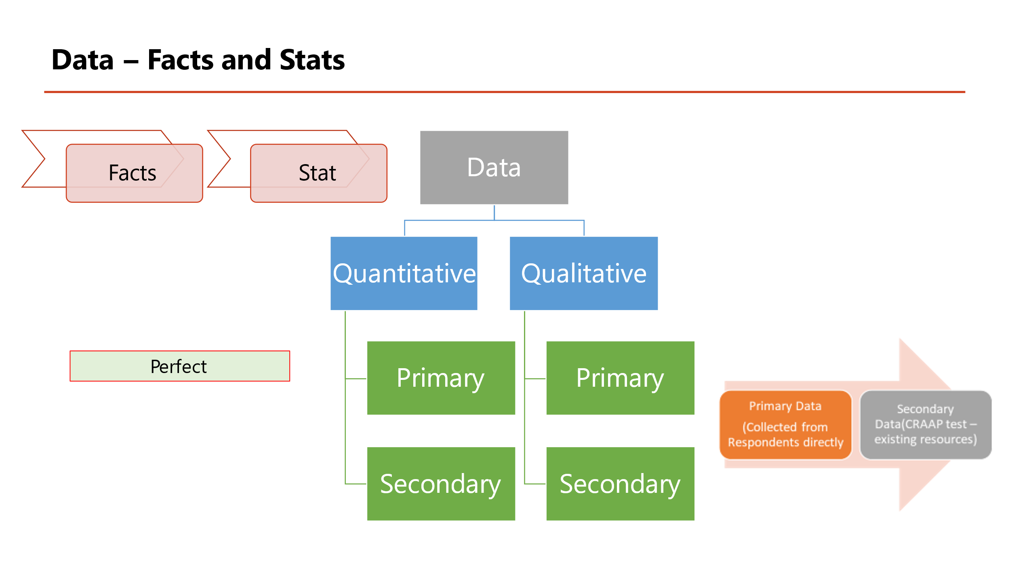
The concept of "data" encompasses a wide range of concepts, including but not limited to facts, figures, signs, symbols, individuality, and numerical values (Van Meter, 2020). Data may be divided into two major groups. It may be used to both qualitative and quantitative data. A person's blood type or ethnic group is an example of qualitative data, which is not numerical. A+ and B-blood groups are two examples of separate blood types. Also included in the quantitative data is information on the circumstances in which it was collected. Students' academic grit scores are an excellent example of measurable data that can be measured.
Based on where the data originated, it may be categorised. These are the primary and secondary sources of information that I have access to. Primary data refers to data obtained by fieldwork, surveys, and investigations. Secondary data may be accessed in several venues, including scholarly publications and websites (Willis and Smith, 2021).
Given the magnitude of secondary data sources, several issues arise about the data's accuracy, legitimacy, and use. Secondary data may be made better using the CRAAP test. CRAAP is an acronym for currency, relevance, authority, accuracy and purpose (Fielding, 2019). It serves a specific objective.
To communicate the results of their work, scientists use a wide range of visual representations. These tools will make it simpler for the study's participants to understand the study's results.

Data presentation – grit experiment
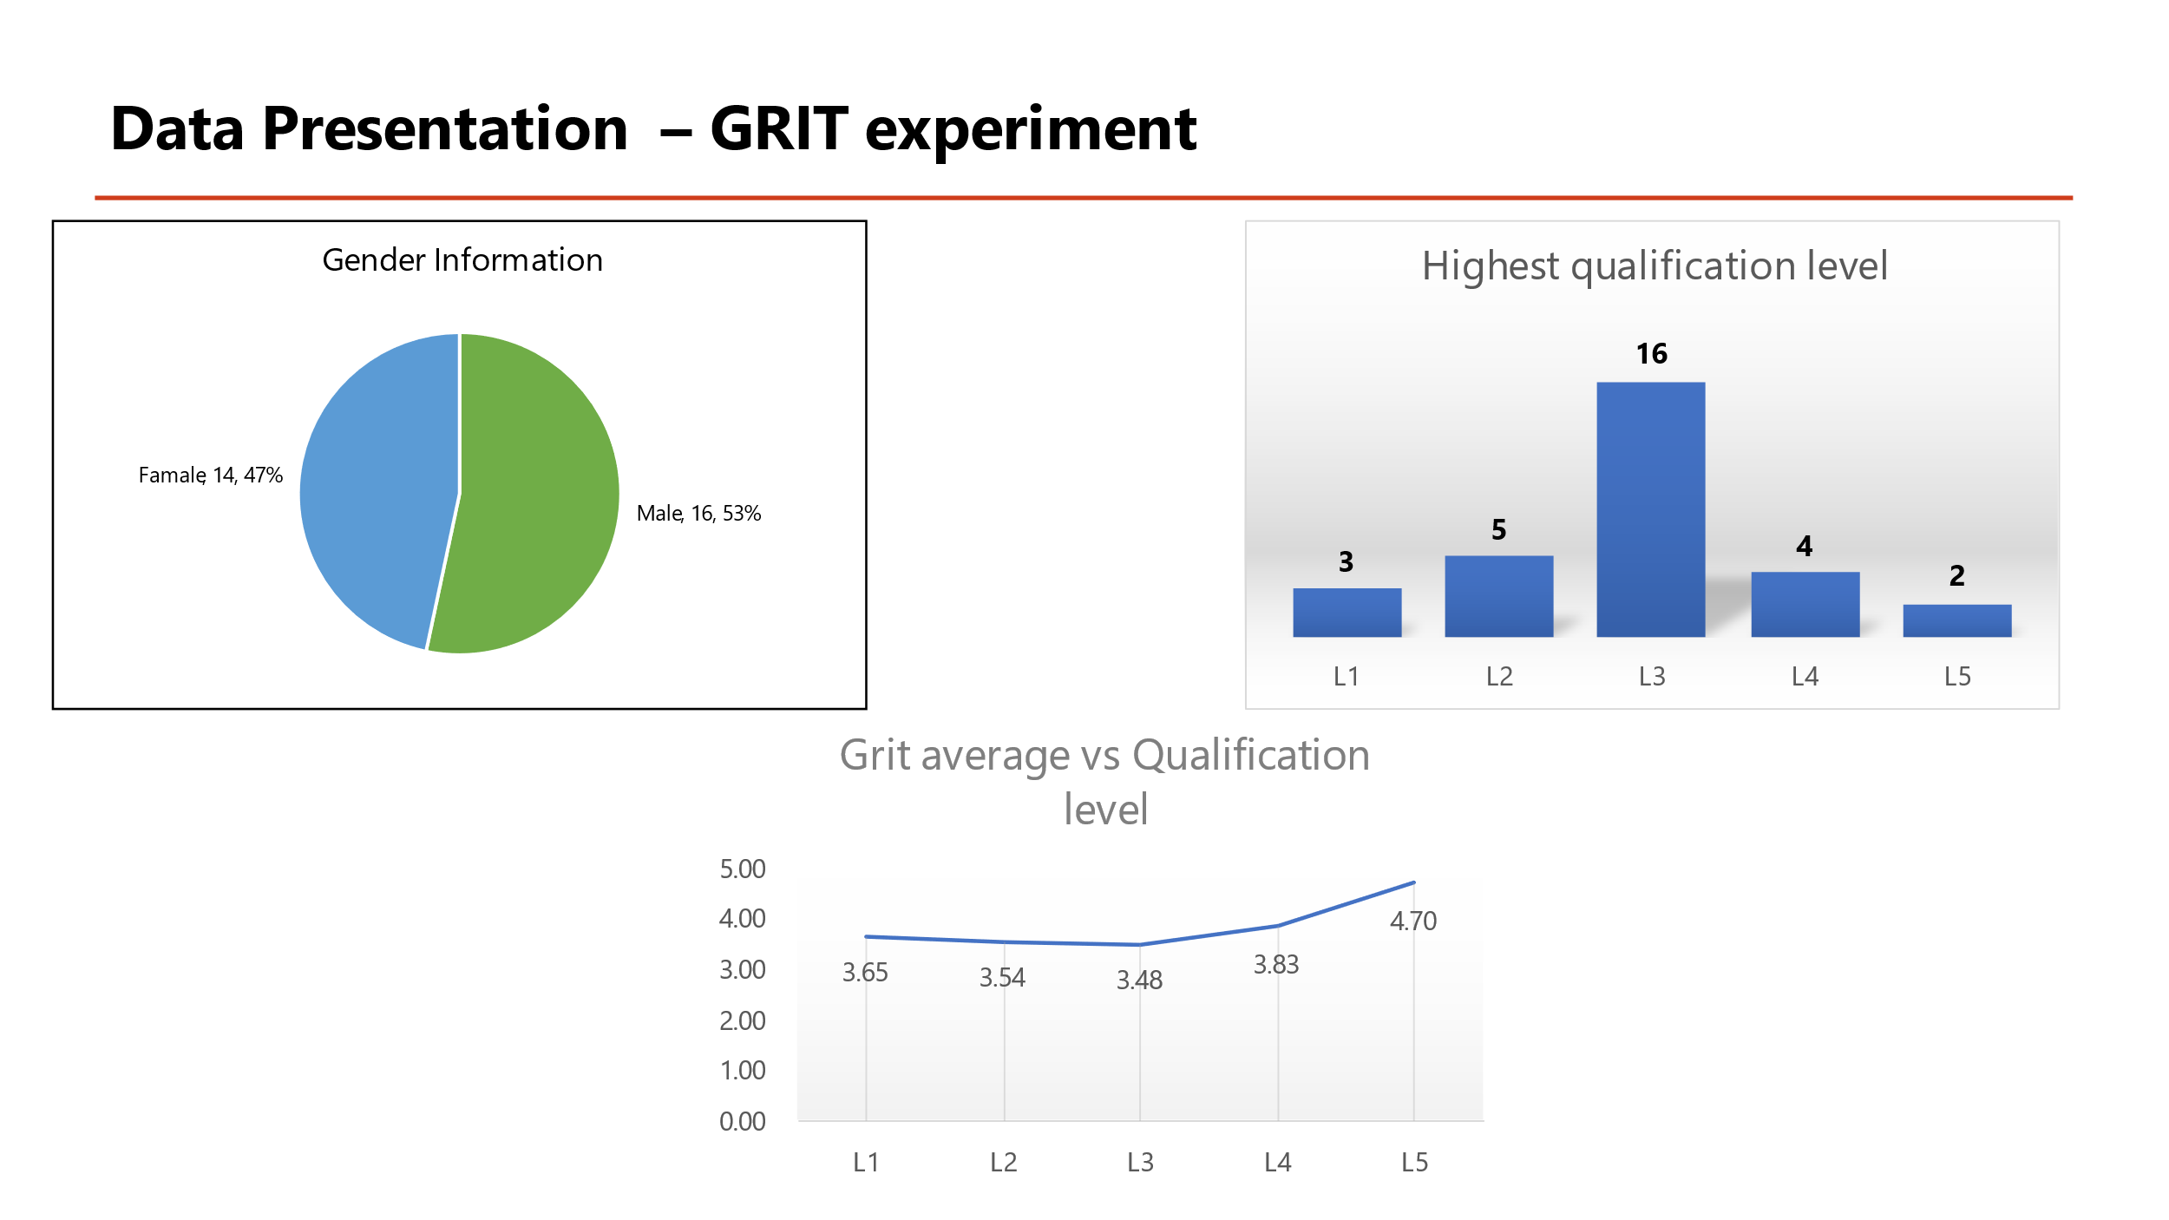
In the following charts and graphs, key sources for grit experiments are shown.

Gender information
A total of 30 samples were utilised, 16 of which were male and 14 of which were female, with a male-to-female ratio of 53% to 47%. As a consequence, there are 6 percent more males than women participating in the study. A pie chart depicting the percentages of each component is shown in the graph given.
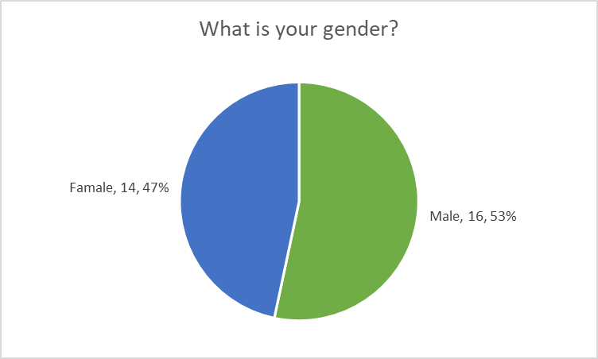

Highest qualification level
It has been determined by research that an academic area has five degrees of certification, from level 1 up to level 5. As previously mentioned, the sample size for this research is 30 people. There were 16 high school graduates in this group that earned a level 3 on the following bar graph. In addition, there were five levels 2, three levels 4, two levels 1, and one level 1 sample.
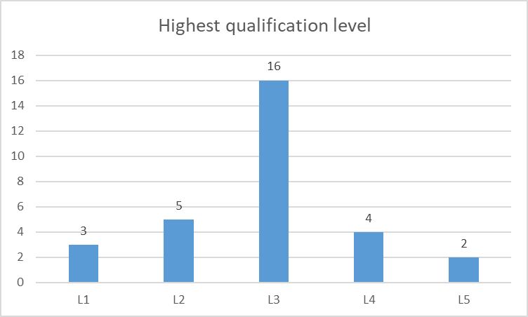

Grit average and Qualification level
The graph above shows the relationship between grit and qualification on a scale of one to ten. The average for levels 5 and 3 is the highest and the lowest, respectively. Levels 4, 1, and 2 have 3.83, 3.65, and 3.54, respectively. A line graph shows the data's evolution through time.
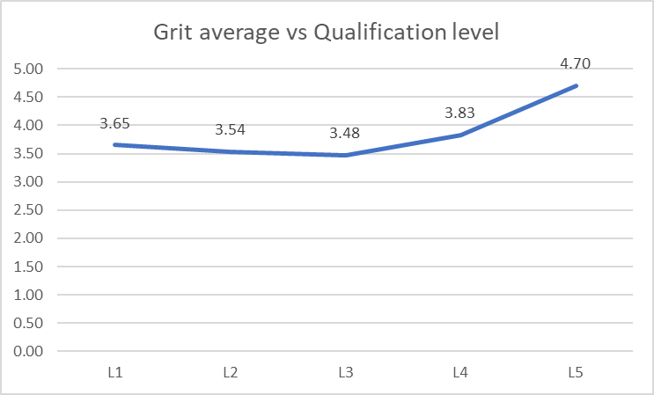

Information
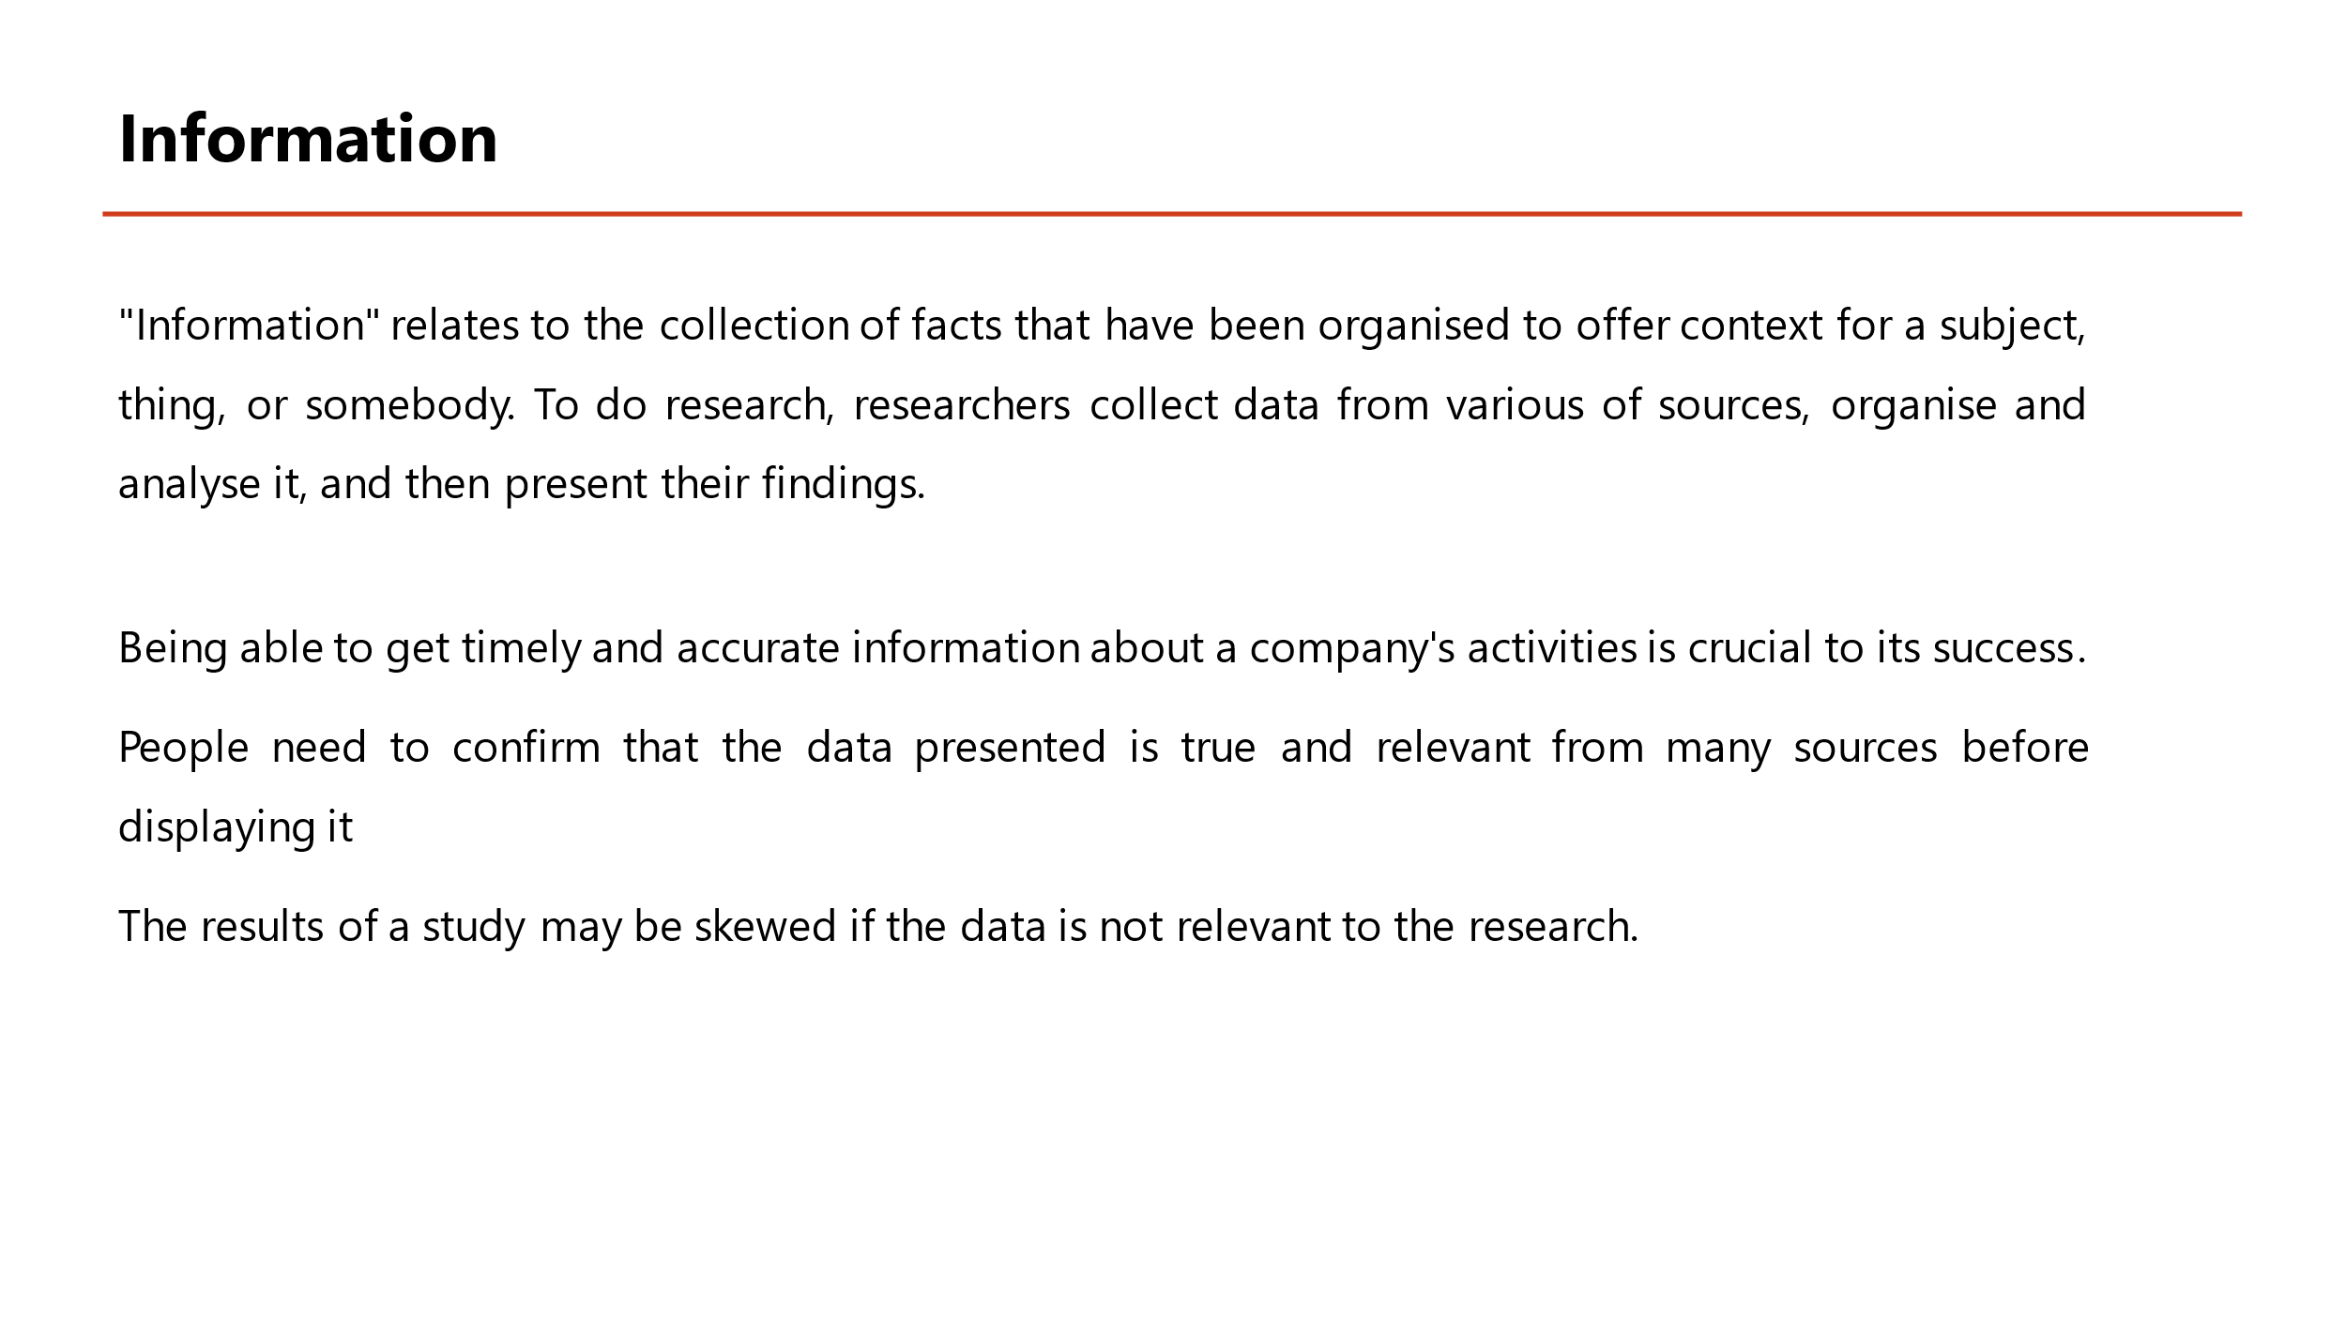
"Information" relates to the collection of facts that have been organised to offer context for a subject, thing, or somebody. To do research, researchers collect data from a variety of sources, organise and analyse it, and then present their findings (Deepu and Ravi, 2021).
Being able to get timely and accurate information about a company's activities is crucial to its success. A new company's initial step is to acquire information about the business's potential. In order to launch a new product, entrepreneurs need to gather information about a customer's desire to purchase it as well as their choice of products as well as their financial status before launching the product. Business owners need to understand how pleased their clients are even after the selling of the product if they want to develop their business.
People need to confirm that the data presented is true and relevant from many sources before displaying it. The extent to which the information obtained is pertinent to the subject at hand is described as "relevant" by the phrase. If the study's start and finish dates are known, it is feasible to apply chronological significance, which takes into consideration how long it took for the data to be collected. If the information is not appropriate for this research, the study's findings may be distorted (Ross, Perkins and Bodey, 2016).

Information based on primary data
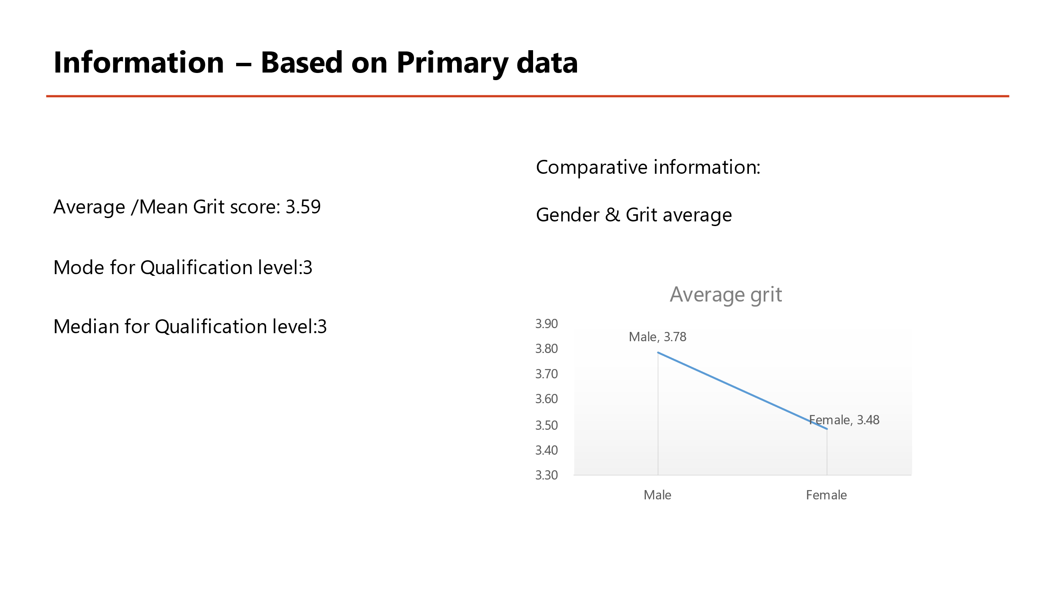
Using the main data obtained, the following information has been compiled. There is a list of them here:

Average grit score
Grit is rated on a scale of one to five. On a 5-point scale, data with an average grit score of 3.59 scores higher than moderate, indicating that the average grit level for all 30 samples is higher than moderate.

Mode of the qualification level
The number of times a sample includes data that is nearly identical to another value is what we call the dataset's mode. It is the most common degree of certification that appears in the sample, with a mode of 3.

Median of the qualification level
The median is the average of the sample's values, which are arranged logically. Regardless of whether the data are ordered ascending or descending, the median value is 3.

Gender and Average grit
Alternatively, it is a study that compares two separate subjects. Men's grit was 3.78, while women's ranged from 3.48 to 3.78, according to the findings of the study. As a result of this, investigators may infer that female populations have a lower mean value.

Knowledge
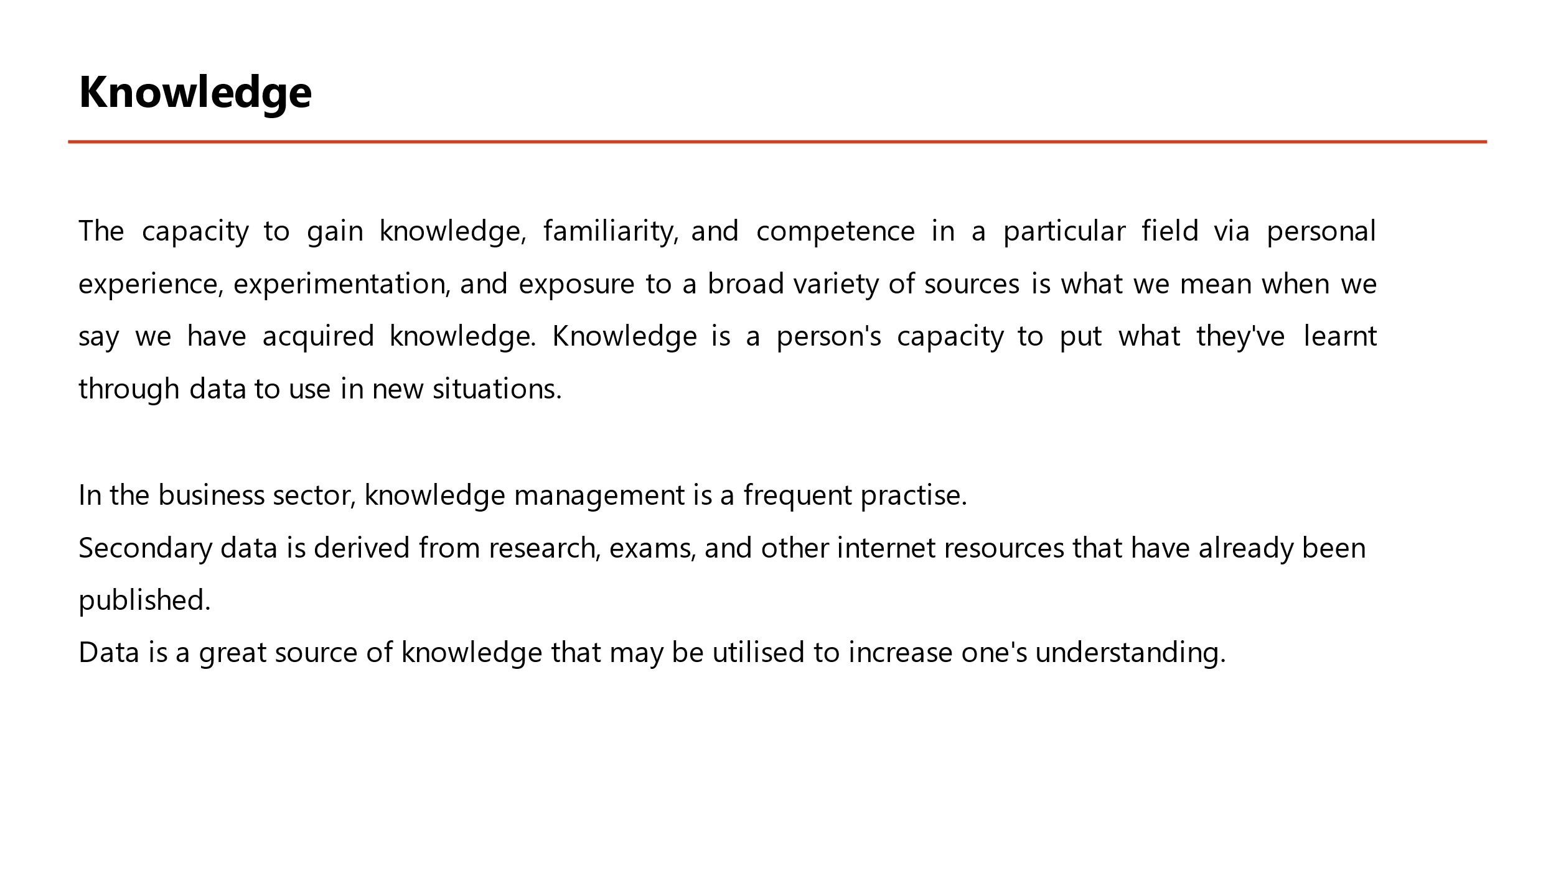
The capacity to gain knowledge, familiarity and competence in a particular field via personal experience, experimentation, and exposure to a broad variety of sources is what we mean when we say we have acquired knowledge. Knowledge is a person's capacity to put what they've learnt through data to use in new situations (Yusof, Zakaria and Zainol, 2018).
In the business sector, knowledge management is a frequent practice. Knowledge management is the process of gathering, organising, sharing, and managing knowledge. You must acquire information from various sources, do research, and experiment for your company to prosper. Investing in human capital may be done using this information management strategy.
Secondary data is derived from research, exams, and other internet resources that have already been published. The use of previously studied information referred to as secondary data facilitates the researchers' comprehension and mastery of new material. Using secondary data, we may also get insight into the study's methodology, the methods used to gather data, and the reasoning behind the findings.
Data is a great source of knowledge that may be utilised to increase one's understanding. With the help of primary and secondary sources, we may get a deeper understanding of any subject.

Knowledge- a comparative study
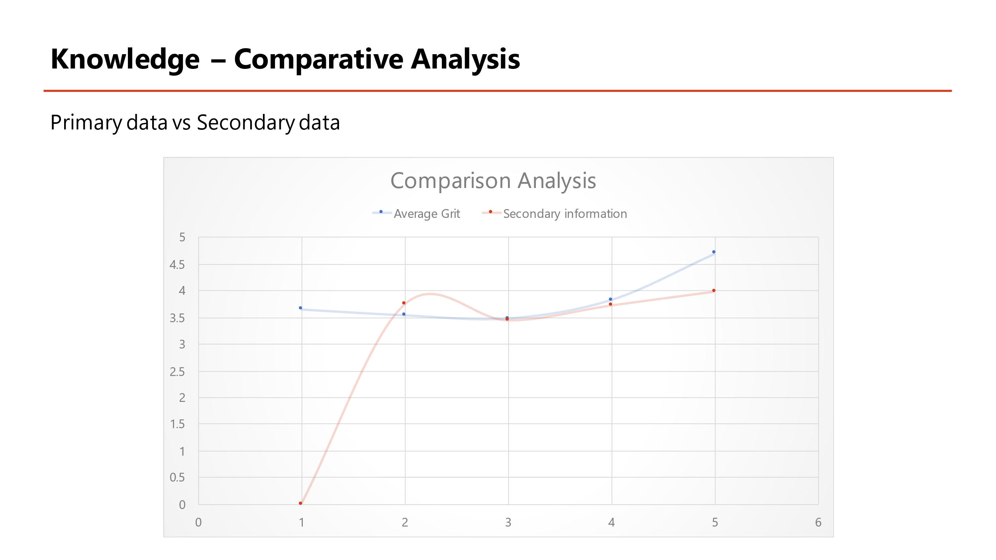
The highest qualification score and grit mean are shown in this scatter plot, which contrasts primary and secondary data. The green line on the line chart depicts the primary data, while the blue line depicts the secondary data. The mean grit score and the highest degree of success in both the main and secondary data sets may be shown inline diagrams. Level 1 secondary data has a greater average grit than level 1 primary data. Secondary data levels 3 and 4 are almost comparable in both groups, except the primary data level 2 has a higher average. At level 5, primary data consistently outperform secondary data in terms of average quality. As a consequence, the grit average for primary data is greater (4.7) than the grit average for secondary data (3.99) However, the minimal quantity for primary data is 3.45, which applies to both main and secondary data. Secondary data appears to be more reliable in this inquiry when compared to the source data.

Wisdom
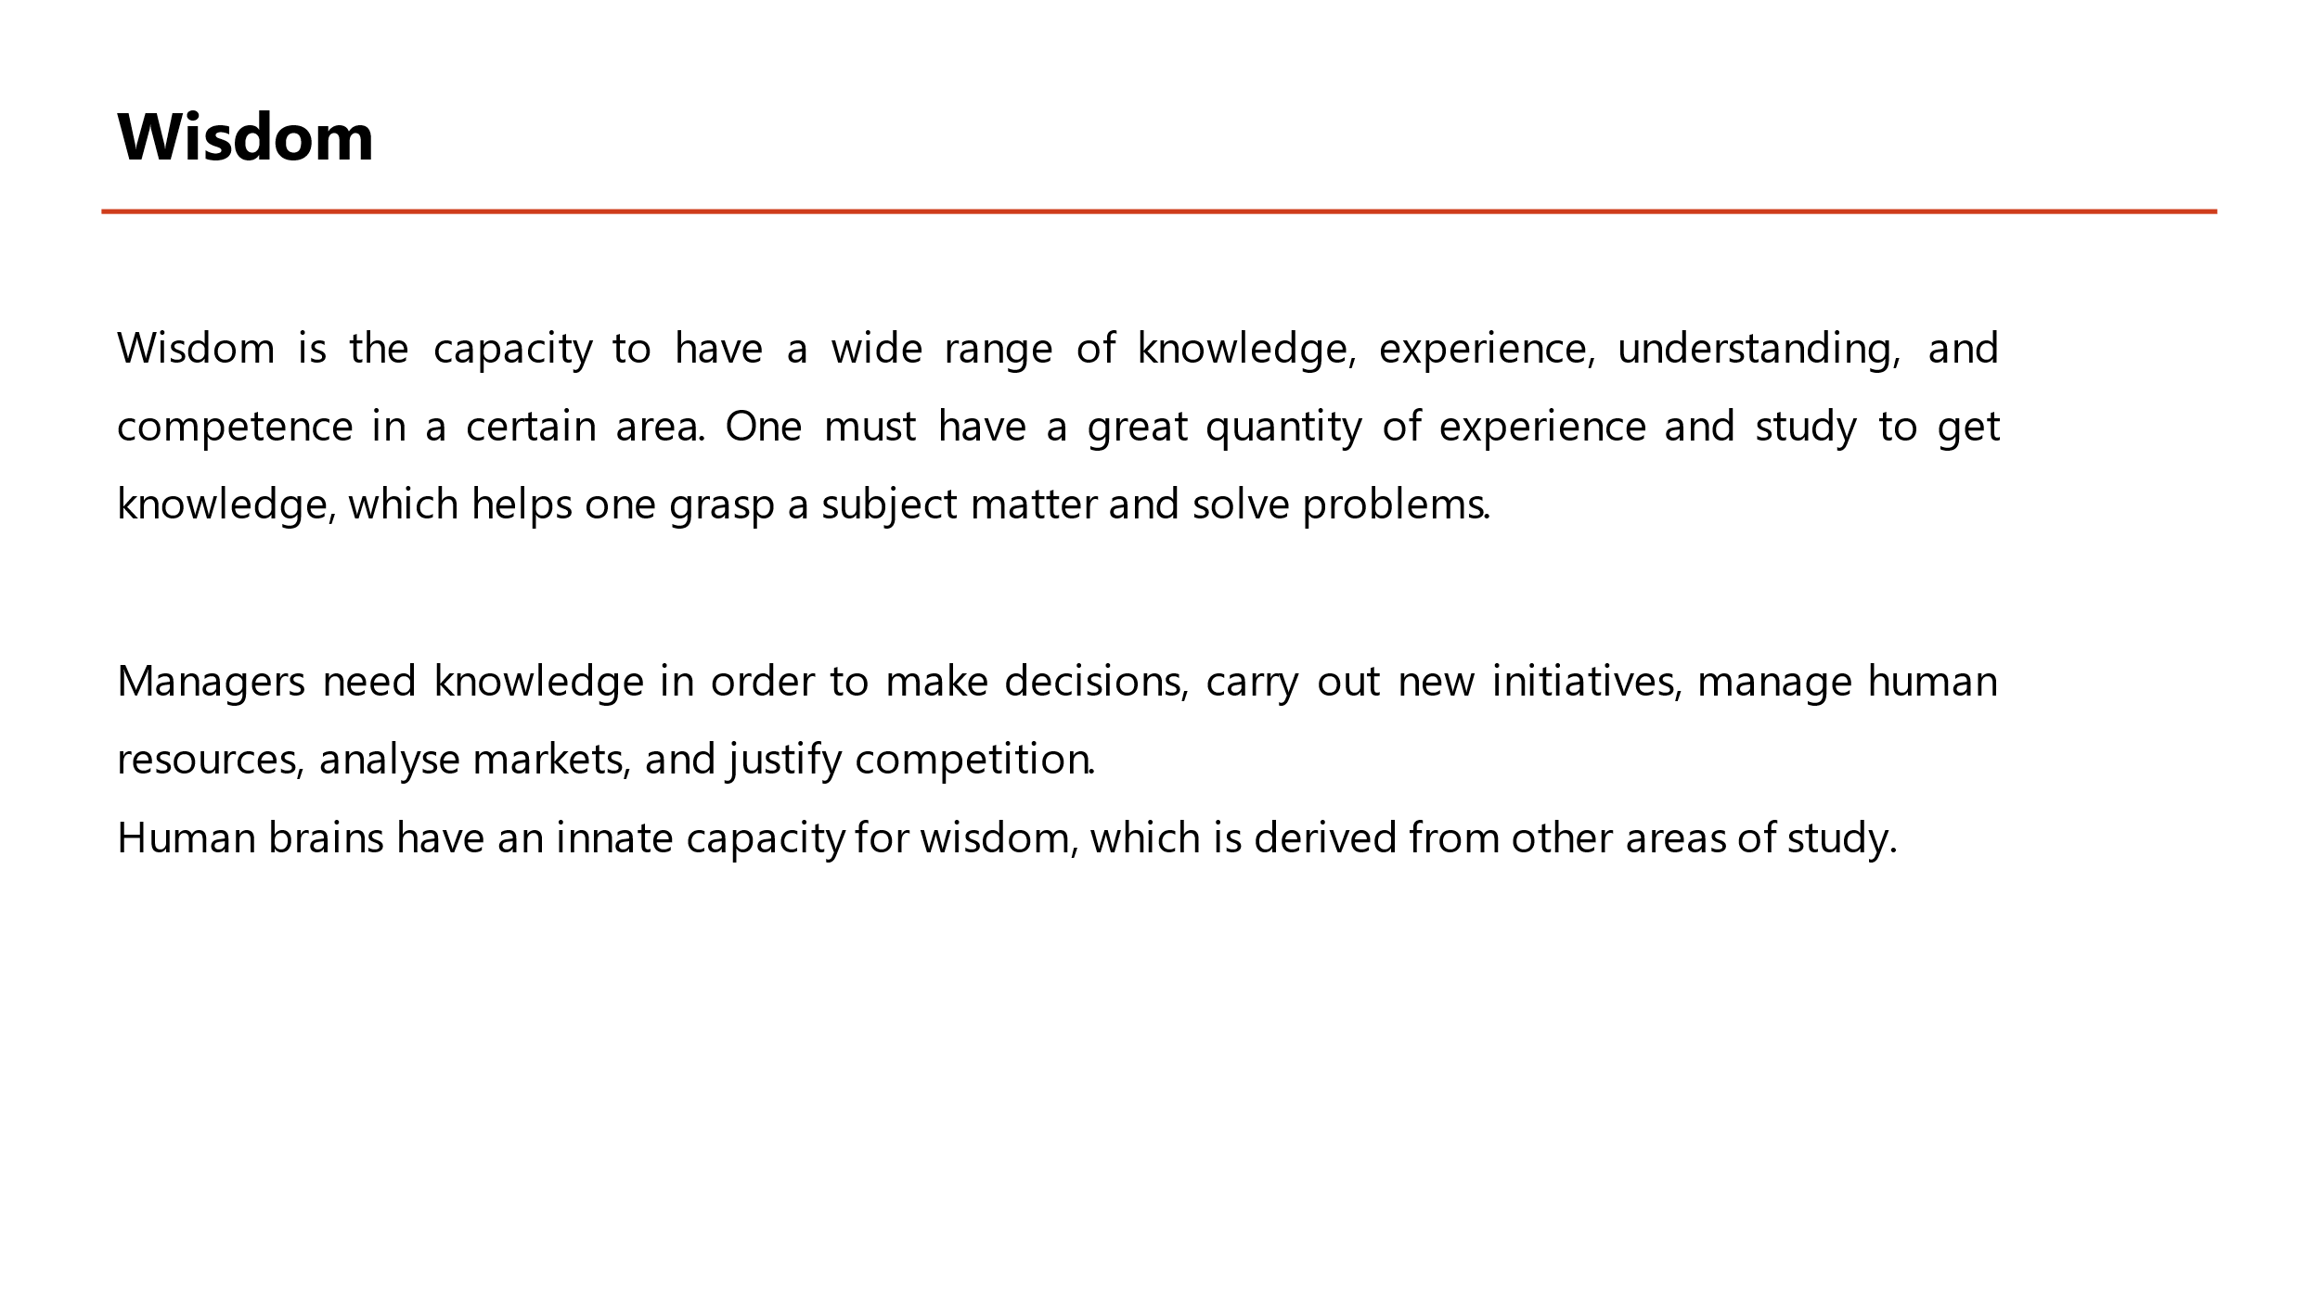
Wisdom is the capacity to have a wide range of knowledge, experience, understanding, and competence in a certain area. One must have a great quantity of experience and study to get knowledge, which helps one grasp a subject matter and solve problems (Grataridarga, 2019).
The leaders and managers of a business must have a significant level of wisdom in order to cope with a large number of difficult challenges. Managers need the wisdom to make decisions, carry out new initiatives, manage human resources, analyse markets, and justify competition. Customers, suppliers, and other stakeholders may all benefit from a wise manager's ability to negotiate effectively. Experts in the field of investment are also available. To get to the top, a corporation must have a well-informed board of directors.
Wisdom is inherent in the human brain, although it is developed from other fields of study. As previously mentioned, all of the DIKW hierarchy's components are directly linked to each other. If you want to learn anything new, you have to do a lot of studies and put in a lot of effort over time.

Conclusion
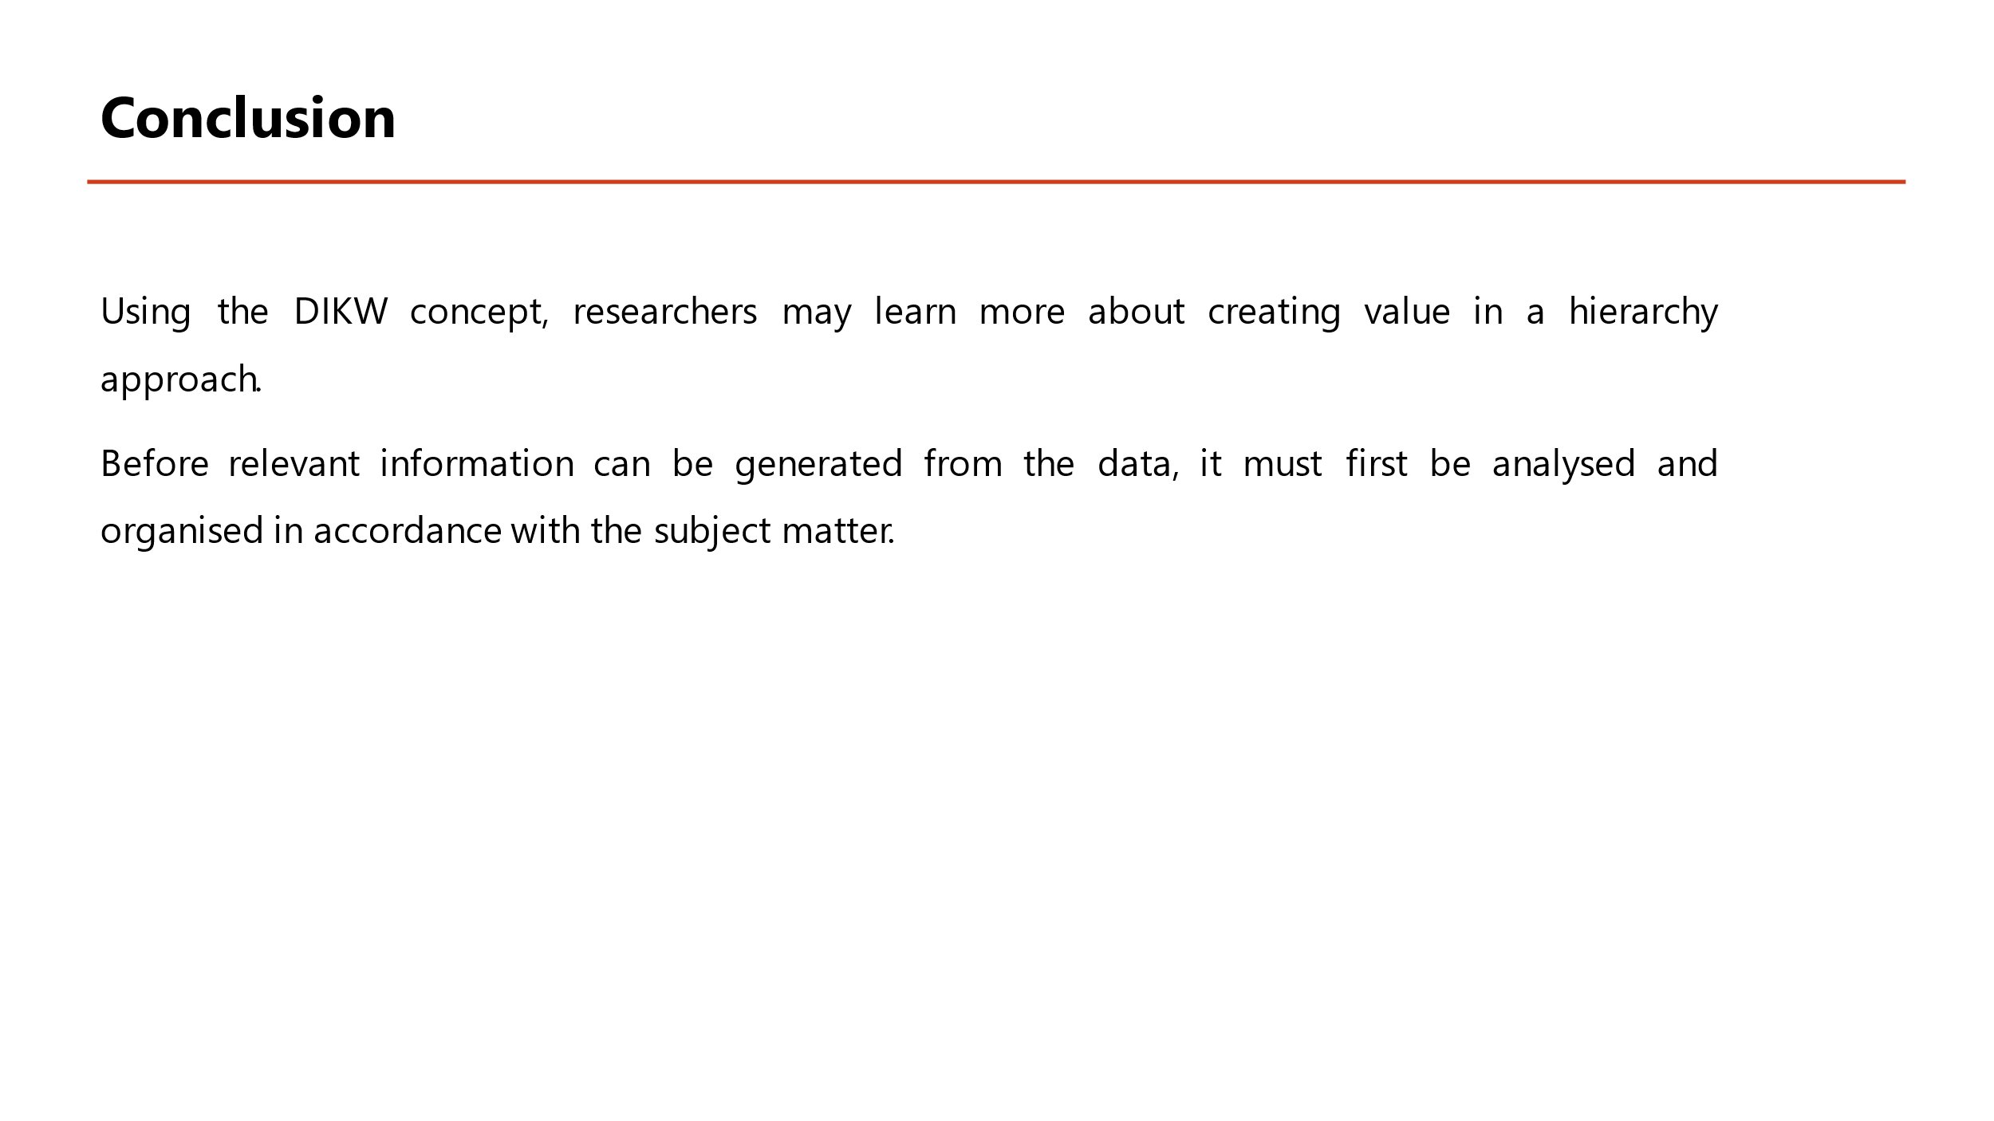
The ability to do effective digital research requires knowledge of a wide range of methods and approaches. They employ a range of scientific or technical techniques and methodologies to make the study relevant and practical to the community. Having a good influence on society is the only way to measure the worth of your research efforts. In comparison, the DIKW research framework is a regularly utilised research technique that aids researchers in understanding how to get value from a hierarchical process. As a result of this DIKW technique, data is collected and then turned into information by organising and analysing it according to the subject matter's demands. In the actual world, knowledge is converted into wisdom by applying it to the situation in which it is learnt. That's why researchers think this study will help them better understand how wisdom is developed, and why it's necessary for all elements of human existence—from the workplace to family life, from the community and the international arena—to make the most crucial choices for all stakeholders. The talents that have been learned through hard effort and trial and error are put to good use by those who are wise.

References
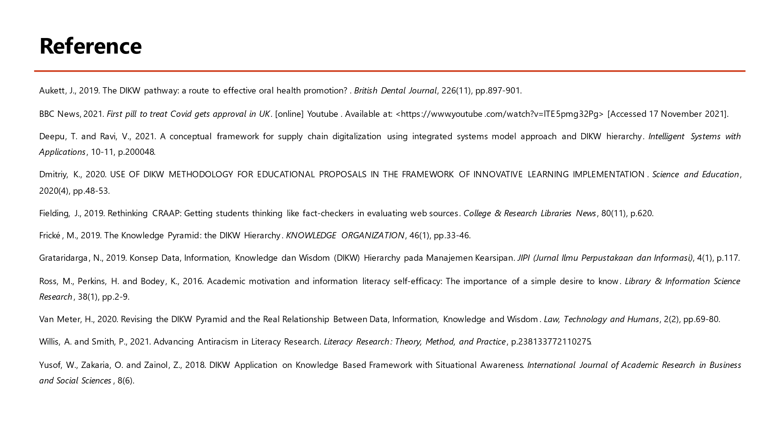
Aukett, J., 2019. The DIKW pathway: a route to effective oral health promotion?. British Dental Journal, 226(11), pp.897-901.
BBC News, 2021. First pill to treat Covid gets approval in UK. [online] Youtube. Available at: <https://www.youtube.com/watch?v=lTE5pmg32Pg> [Accessed 17 November 2021].
Deepu, T. and Ravi, V., 2021. A conceptual framework for supply chain digitalization using integrated systems model approach and DIKW hierarchy. Intelligent Systems with Applications, 10-11, p.200048.
Dmitriy, K., 2020. USE OF DIKW METHODOLOGY FOR EDUCATIONAL PROPOSALS IN THE FRAMEWORK OF INNOVATIVE LEARNING IMPLEMENTATION. Science and Education, 2020(4), pp.48-53.
Fielding, J., 2019. Rethinking CRAAP: Getting students thinking like fact-checkers in evaluating web sources. College & Research Libraries News, 80(11), p.620.
Frické, M., 2019. The Knowledge Pyramid: the DIKW Hierarchy. KNOWLEDGE ORGANIZATION, 46(1), pp.33-46.
Grataridarga, N., 2019. Konsep Data, Information, Knowledge dan Wisdom (DIKW) Hierarchy pada Manajemen Kearsipan. JIPI (Jurnal Ilmu Perpustakaan dan Informasi), 4(1), p.117.
Ross, M., Perkins, H. and Bodey, K., 2016. Academic motivation and information literacy self-efficacy: The importance of a simple desire to know. Library & Information Science Research, 38(1), pp.2-9.
Van Meter, H., 2020. Revising the DIKW Pyramid and the Real Relationship Between Data, Information, Knowledge and Wisdom. Law, Technology and Humans, 2(2), pp.69-80.
Willis, A. and Smith, P., 2021. Advancing Antiracism in Literacy Research. Literacy Research: Theory, Method, and Practice, p.238133772110275.
Yusof, W., Zakaria, O. and Zainol, Z., 2018. DIKW Application on Knowledge Based Framework with Situational Awareness. International Journal of Academic Research in Business and Social Sciences, 8(6).

