

Research Methods and Professional Development
(ACFA7004)

In Bot We Trust:
A Thorough Study & Development of Chatbot and Its Impact on Industry 4.0

TABLE OF CONTENT
- ACKNOWLEDMENT 4
- ABSTRACT 5
- INTRODUCTION 6
- BACKGROUND 7
- PROBLEM STATEMENT 11
- AIM & OBJECTIVES 13
- METHODOLOGY 14
- LITERATURE REVIEW 15
- ETHICAL ISSUES 18
- PLAN OF WORK 20
- EVALUATION AND RESULT 26
- FLOW CHART 33
- CONCLUSION 38

TABLE OF FIGURES

Figure 1 9
Figure 2 10
Figure 3 14
Figure 4 21
Figure 5 24
Figure 6 25
Figure 7 28
Figure 8 29
Figure 9 30
Figure 10 31
Figure 11 32
Figure 12 34
Figure 13 35
Figure 14 36

ACKNOWLEDMENT

I would like to thank Dr. Terry Walcott at UWTSD for his valuable input and contribution to the paper. This study and the research underlying it would not have been feasible without his outstanding help. His passion, expertise, and meticulous attention to detail have inspired me and kept my work on track. Furthermore, I would like to thank the Director of studies, Dr. Tim Bashford for his valuable cooperation in the process. Finally, I would also like to acknowledge the help I got from my colleagues and friends who helped me in the process and provided me with their necessary inputs.

ABSTRACT
A Chatbot which sometimes can also be termed as conversational AI, is an instant way to answer users’ questions. For instance, the robot to whom you ask questions about a product in the tiny popup window at the bottom-right corner of your screen when doing online shopping, is a chatbot.
Chatbots are poised to revolutionize User Interface design. The idea of using them is to make the human interaction with machine a little interactive and easy to adapt. Chatbots have many more use cases and are very versatile. They can be used in Digital Platforms, Business, Human Resources management, schools’ administrations and in many other contexts.
By using algorithms, chatbots can handle simple tasks. The idea is to automate communication and streamline customer service by providing users with quick and convenient access to information and services. They can be programmed to handle a variety of tasks, including answering frequently asked questions, providing product recommendations, scheduling appointments, and even conducting transactions. Chatbots can be integrated into a variety of platforms, including websites, messaging apps, and social media platforms, and they are becoming increasingly popular as businesses seek to enhance their customer experience and improve operational efficiency.

INTRODUCTION

The focal point of this research and assignment is to project a detailed study on how a chatbot can be created by using simple code and algorithms and how pivotal they can be when implemented in business, healthcare or technology. Although there is many other complex AI based chatbots like Alexa and Siri which uses higher level of coding, instances and programming, but we will be discussing the roots of how simple it is to create a simple chatbot and how effective it can be in booming the business and advancing the digital revolution.

BACKGROUND
Alan Turing questioned if a computer programme could communicate with a group of people in 1950 without the participants realising that their interlocutor was artificial. Many people believe that this query, known as the Turing test, is where chatbots first got their start (Turing, 1950). In 1966, the first chatbot with the name ELIZA was created. By returning the user's phrases in the interrogative form, ELIZA mimicked the actions of a psychotherapist, according to Weizenbaum (1966). Despite its limited communication capabilities, it served as an inspiration for the creation of various chatbots in the years that followed (Klopfenstein et al., 2017). According to Brandtzaeg and Flstad (2017), ELIZA makes use of pattern matching and a response selection method based on templates. Eliza's knowledge is limited, therefore it can only debate topics within a specific field, which is a downside.

A patient with schizophrenia first appeared in 1972 under the name PARRY. Since PARRY is thought to have a "personality" and a better governing framework than ELIZA, it is seen as being more advanced than ELIZA. According to a set of presumptions and "emotional responses" that are triggered by the user's utterances changing in weight, it defines his replies. Five psychiatrist judges used PARRY in an experiment to determine whether a patient was a computer programme or a real patient with schizophrenia in 1979. Thus, ten diagnoses were provided by psychiatrists. The first psychiatrist made two accurate diagnoses, whereas the second made two mistakes. Both subjects were thought to be actual patients by the third, and the other two made the diagnosis that chatbots made up both subjects. However, the sample of only five doctors is tiny, and the findings' significance is unclear because patients with schizophrenia occasionally speak incoherently. In general, PARRY is regarded as a chatbot with limited language comprehension and emotional expression skills. Additionally, it responds slowly and is unable to pick up on conversational cues.
Artificial Intelligence is firstly used in the domain of the chatbots with the construction of Jabberwacky in 1988. Jabberwacky was written in CleverScript, a language based on spreadsheets that facilitated the development of chatbots, and it used contextual pattern matching to respond based on previous discussions. Still, Jabberwacky cannot reply to high speed and work with a massive number of users.

The term Chatterbot was first mentioned in 1991. It was a TINYMUD (multiplayer real-time virtual world) artificial player, whose primary function was to chat. Many real human players seemed to prefer talking to Chatterbot than a real player. The Chatterbot succeeded because, in the TINYMUD world, players assumed that everybody was a human and might cause doubts only if it made a significant mistake. Dr. Sbaitso (Sound Blaster Artificial Intelligent Text to Speech Operator) (Dr. Sbaitso, 2019), a chatbot created in 1992, was designed to display the digitized voices the sound cards were able to produce. It played the role of a psychologist without any sort of complicated interaction.
Another step forward in the history of chatbots was the creation, in 1995, of ALICE (Artificial Linguistic Internet Computer Entity), the first online chatbot inspired by ELIZA. ALICE was based on pattern-matching, without any actual perception of the whole conversation. But with a discussion ability on the web that allowed longitude and included any topic. However, a few years had to pass before it was improved to win the title of the Loebner Prize of the best human-like computer program. ALICE was developed with a new language created for this purpose, Artificial Intelligence Markup Language (AIML), which is the most critical difference between ALICE and ELIZA. ALICE’s Knowledge Base consisted of about 41,000 templates and related patterns, a vast number comparing to ELIZA that had only 200 keywords and rules. However, ALICE did not have intelligent features and could not generate human-like answers expressing emotions or attitudes.
In 2001, there was a real evolution in chatbot technology with the development of SmarterChild, which was available on Messengers like America Online (AOL) and Microsoft (MSN). It was the first time that a chatbot could help people with practical daily tasks as it could retrieve information from databases about movie times, sports scores, stock prices, news, and weather. This ability marked a significant development in both the machine intelligence and human–computer interaction trajectories as information systems could be accessed through discussion with a chatbot. [13][14]
The way chatbots nowadays engage in a discussion is entirely different from their predecessor Eliza. They can share personal thoughts and family drama events, be relevant but also confusing, and deceive just as humans do.
A growing increase in the use of chatbots was observed, especially after 2016 (Fig. 1). According to Fig. 2, the country that has shown more research interest in chatbots is the USA, while the United Kingdom and Japan follow with less than one-third of the number of papers published in the USA. [1]

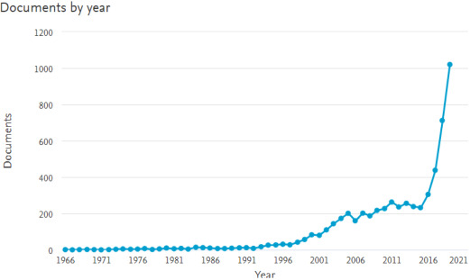
Figure 1

Fig.1 Search Results in Scopus (Scopus preview—Scopus—Welcome to Scopus, 2020), from 1966 to 2019 for the keywords “chatbot” or “conversation agent” or “conversational interface”.
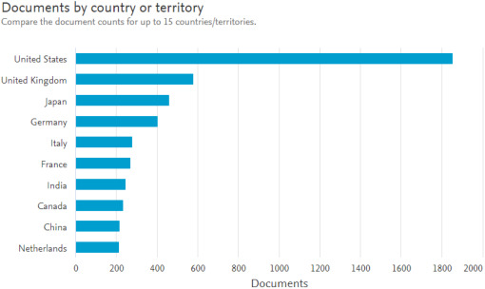
Figure 2
Fig 2. Search results in Scopus (Scopus preview—Scopus—Welcome to Scopus, 2020) from 1966 to 2019 for the keywords “chatbot” or “conversation agent” or “conversational interface” by country or territory.

PROBLEM STATEMENT
Any firm must be able to provide good customer support services. However, conventional customer care techniques like phone calls and emails can take time and cannot always result in prompt responses. We suggest creating a chatbot that can help clients in real-time to solve this problem. The chatbot will be programmed to comprehend client inquiries, give pertinent information, and, if necessary, escalate complex issues to human employees. The chatbot will be accessible around-the-clock, giving users quick support and cutting down on response time. The project's goal is to develop a customer assistance system that is affordable, effective, and practical for both consumers and companies. By offering quick and convenient customer service, the chatbot will assist businesses in increasing their customer satisfaction ratings and decreasing customer churn.
The other problems it can solve are:
- Eliminating the added costs to meet global customer demands.
We can engage with customers without having to hire additional people by using a chatbot. Chatbots are always available and may be designed to communicate with clients in whatever language we want. They can deliver such front-line assistance without making us hire more permanent or temporary employees than we can afford.
- Automating repeat customer support enquiries.
Since chatbot respond to repetitive menial tasks with any degree of dissatisfaction. They’re simply programmed to do the job and provide the level of support that buyers need. Most importantly, they can automate many of these tasks, thereby speeding up response times and reducing employee dissatisfaction and/or turnover.

- Ending sales activity and only taking place during working hours.
We can engage with customers without having to hire additional people by using a chatbot. Chatbots are always available and may be designed to communicate with clients in whatever language we want. They can deliver such front-line assistance without making us hire more permanent or temporary employees than we can afford.

- Giving customers an accessible channel to find answers to their questions.

Customers can access chatbots at any time, and they can be coloured to stand out on the website while not in use. Customers can easily initiate a conversation with the chatbot by clicking on its pop-up window and interacting with it as needed. They can do this while browsing a variety of pages and acquire answers to urgent queries without having to conduct independent research to find those solutions. [11]

AIM & OBJECTIVES

Even though the concept of chatbots is fresh, it is revolutionising digital marketing and B2B marketing. Almost all significant digital platforms and companies currently use chatbots in some capacity. This suggests that creating a chatbot is not a difficult undertaking, but it remains to be seen if it can be utilised for purposes beyond just offering an interactive user interface.
Aim:
The Aim of the project is to understand the purpose and use of chatbots and to develop and integrate a simple chatbot on any website.
Objectives:
- To understand the use of chatbots in modern industry and its various sectors.

- To study its impact on various industry sectors and how it has helped the business and sectors to grow.

- To create a chatbot and demonstrate its ease of access and use.

- Determine the requirements needed to create the chatbot and the website.

- To demonstrate each step to create a simple working chatbot and evaluate the developed scenario and help making it accessible.

METHODOLOGY
To explain the data, usage and efficiency of a modern day chatbot, we must use a quantitative approach which helps us to evaluate the exact numbers, observe results, and study the flaws (if any), which can be useful to improve the backend, user interface and working of the bot.
We will be using a quantitative user data from a chatbot developed for health sector. The purpose of this approach is to find out what information people look for in a chatbot that offers support for their issues. The questions which the chatbot was unable to answer are categorised and then it must be investigated when and how the chatbot is utilised based on time of day and the number of questions in each discussion. The main objective is to examine quantitative user data in the chatbot's log in order to advance the chatbot's development.

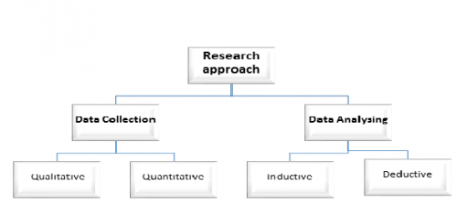
Figure 3

This figure shows the research approach which is used to create and analyse a simple working chatbot. Since AI based chatbots are based more on data collection and usage, this is the reason the quantitative research is used.

LITERATURE REVIEW

This study highlights the traits of recent empirical investigations on the interaction between humans and chatbots. It's interesting to note that most of the study on users engaging with them is very recent—more than two thirds of the publications we analysed were published in 2017. This reflects the recent growth of commercial chatbots and indicates the rising interest in this technology among academics. In terms of methodology, articles typically examine how people engage with chatbots.
Text-based chatbots (or simply chatbots), which allow human-machine contact using natural written language, have proliferated in a range of application fields during the last ten years. This phenomenon has been referred to as a "chatbot tsunami". The ability for them to be seamlessly integrated into already-existing websites and applications, as well as flexible platforms that facilitate their creation, are what are driving this proliferation. Developers can create new chatbots quickly and simply by teaching the AI to react to questions with specific purpose that are posed in natural language using cloud-based cognitive services of composable Artificial Intelligence (AI) building blocks, such as the IBM Watson Developer Cloud.
Given this technical advancement, it is not surprising that chatbot investments have skyrocketed. According to Boiteux (2018), there were more than 300,000 chatbots operating solely on Facebook Messenger in 2018. By 2022, 85% of customer support interactions, according to Gasson et al. (2009) and Gartner (2017), will be driven by chatbots. Scholars started investigating how people use this technology after noticing these tendencies. Despite the early buzz and the optimistic market expectations, talking to artificial agents creates challenges that go beyond their existing technology limitations, instead involving the human side of contact. This is why such study has been deemed significant. Chatbots may not live up to users' high expectations for, say, language proficiency. They may also provoke a range of (bad) emotions, such as irritation at not being understood, and they may promote the development of biases in users' perceptions of the technology.

The modern increase in chatbot usage
The beginning of the chatbot tsunami may be dated back to 2014, when investments in chatbots that could go into greater detail about particular topics began to soar. The general public just began to become familiar with conversational agent technology in the early 2010s, though. Social bots, which broadcast, follow, or relay messages created by other bots or actual users, were overrun on Twitter by 2010. Siri introduced language-based interaction into the mainstream of the consumer market in 2010, despite being speech-based. While IBM's Watson was competing on the game show Jeopardy in 2011, Rollo Carpenter's chatbot Cleverbot became the first AI programme to pass the "Modified Turing Test".
To identify relevant themes related to human-chatbot interaction in current research we used the Grounded Theory Literature Review method. This method is rooted in Grounded Theory, an approach developed in social sciences that aims to build theories and identify themes across data through an inductive process of data gathering and analysis. What distinguishes Grounded Theory from other approaches is an inductive, rather than a hypothetical-deductive stance. Grounded Theory has been used either as a way for developing theoretical models emerging from the data, or as a strategy to make sense of a large amount of data, namely a coding method. In this article, Grounded Theory is taken mainly as a method for analyzing data, in order to add rigor to the process of searching, selecting, and analyzing studies in a review.
In April 2020, the papers included in this systematic review were gathered. We used the Association for Computing Machinery Digital Library (ACM DL), Scopus, and EBSCO APA PsycInfo to look for pertinent publications on human-chatbot interaction. The ACM DL gathers computer science publications, PsycInfo gathers psychology papers, and SCOPUS is a more generic collection, thus we chose them to potentially capture any article addressing pertinent topics in human-chatbot interaction. [5]

(chatbot* OR “chat bot*” OR “virtual assistant*” OR chatterbot* OR “conversational agent*” OR “natural language interface*” OR talkbot* OR “talk bot*”) AND (experience* OR user* OR expectation* OR usability OR understanding* OR misunderstanding* OR bias* OR emotion* OR attitude* OR psycholog* OR interact* OR conversation* OR pragmatics OR cooperat* OR cognit* OR evaluation OR assessment OR social*)

The first part of the query relates to the notion of chatbot including synonyms that could point to text-based conversational agents. The second part refers, instead, to the human aspects of interaction: they combine general and more specific terms that may capture a wide range of topics that may be relevant for exploring the human side of interaction with chatbots. The list of search terms was composed after several iterations and refinement by all the three authors, in line with other HCI research reviews.

FUTURE GENERATION
Future generation is the following undertaking that we need to consider. In the wake of cleaning the information, it ought to be changed over in to such a way a machine can comprehend.
Here the idea of Bag of Words (BOW) is considered for producing feature from the input text. In this model, a content like a sentence or even a document is addressed as the pack (multiset) of its relating words, without thinking about the syntax and even word request yet keeping variety.
The output from this feature generator will be given as the input to the deep learning Model to foresee the response. [6][7]

ETHICAL ISSUES
Chatbots access a new fascinating area in the field of machine learning, user interaction, and information distribution. But in order to ensure that this technology is applied responsibly and effectively, there are ethical issues and ramifications that need to be considered.
This is especially true for technologies that use a "set it and forget it" strategy, like the majority of chatbots. If the businesses that use them are not attentive, advances in machine learning, particularly as it relates to bots, might confuse things even more and have much worse effects.
There are some ethical issues that needs to be addressed here.

User transparency
Transparency is a key ethical issue for technology from the user's point of view. In other words, is the user aware of all chatbot-related details and the repercussions of using one? The privacy and protection of user data is a widespread concern, as was previously mentioned. Any information that users provide to the bot during their conversation may, depending on the regulations in place, be collected, used, or sold without the users' consent. In addition, the business or organisation that owns the bot would eventually amass a growing amount of information, leading to a significant power imbalance. Being open and transparent about data usage, ownership, and protection is crucial. Implementing a system of data regulation like the GDPR of the European Union, which allows people more control over their personal data, is one method to maximise openness.

Trust and Transparency
Giving users discretion over their preferred method of interaction with an agent is a crucial first step in putting their needs and welfare first. Transparency regarding an agent's position as automatic (non-human) and the boundaries of its powers, for instance, is crucial to enable users to make knowledgeable decisions, which furthers user trust. Recent research has demonstrated that while communicating with an artificial agent as opposed to a human, people respond and interact differently. Users may be better able to control their own actions, particularly about information disclosure, if they are aware of whether they are conversing to an automated or human agent. [12]

Privacy
The gathering of user data generates a variety of privacy issues, some of which have a legal foundation and are handled by regionally distinct data protection legislation, such as the GDPR in Europe. Depending on the domain in which the agent is deployed and the degree of vulnerability of the user group, the nature of these ethical dilemmas changes dramatically. We do, however, suggest that in this area, where the default strategy should be to only collect and preserve user data if necessary for the delivery of the specified service and to do so in a transparent manner, clear legal requirements should be considered as a baseline, not a target. User privacy is crucial and becoming more crucial as AI systems are implemented in more spheres of society and are used to make judgements that are more significant and far-reaching. As a result, the idea of privacy should be seen as a larger social issue rather than solely a problem affecting the individual user. The individual user is frequently denied the chance to negotiate terms and conditions that are drafted by businesses in a way that applies to everyone, or they lack the resources to do so. Therefore, it is important to consider how the introduction of AI systems may affect society when deciding how to think about and govern privacy. With the support of this viewpoint, privacy can be rethought in a way that connects it to broader societal objectives and concerns.

4. Plurality of approaches

Depending on the application domain, intended user demographic, and goal(s) of the agent, conversational AI raises a variety of ethical issues. As a result, the identification of potential ethical concerns and solutions should be guided by an understanding of the domain and the problem that the agent seeks to solve. A customer- or public-facing agent who may be required to respond to general or unrestricted questions will have a very different set of considerations than a chatbot used within an organisation by staff for a specified purpose. A thorough awareness of the user group's traits, situations, and interests is essential for responsible system design. [2]

PLAN OF WORK
CHATBOT APPROACHES
Pattern matching and machine learning approaches are the two ways to construct a chatbot, depending on the algorithms and methods used.

1. Pattern Matching Approach
Pattern Matching algorithms are used by rule-based chatbots to compare user input to a rule pattern and choose one prepared response from a range of alternatives. Since the knowledge employed is pre-written in the form of conversational patterns by the developer, rule-based systems often do not provide new replies. A chatbot's ability to respond to user questions increases with the size of the rules database. Grammatical and syntactic problems in user responses are challenging to handle because this form of chatbot requires hundreds of rules to function properly. Some rule-based chatbots are Cleverbot, Chatfuel, and Watson.
The automated, repetitive nature of the answers and lack of creativity and spontaneity compared to human responses are disadvantages of the pattern matching approach. The supplied text is not given a more thorough syntactic or semantic analysis, which results in a quick response time.

- Artificial Intelligence Markup Language (AIML)
To build the Knowledge Base for chatbots that use the Pattern Matching technique, engineers built the Artificial Intelligence Markup Language (AIML) between 1995 and 2000. It has an XML foundation and is open source. The first chatbot with an AIML-based knowledge base was called ALICE. AIML is the most popular chatbot language due to its usefulness, simplicity of learning and using, and the availability of pre-authored AIML collections. Up to a point, context awareness exists in an AIML-implemented chatbot. It can react to input from users in a variety of ways, either randomly or according to the value of variables that are updated during the dialogue.
A part of a Knowledge Base written in AIML is demonstrated in the below figure.
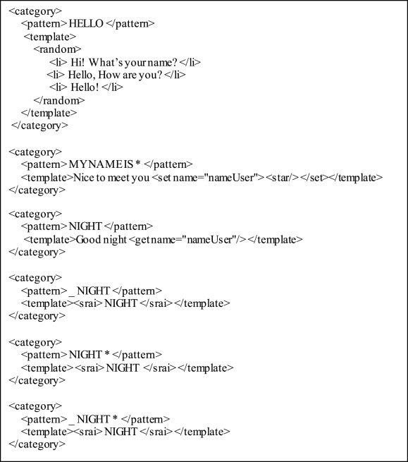
Figure 4

It is important to note that Latent Semantic Analysis (LSA) and other techniques may occasionally be used in conjunction with AIML and other pattern-matching languages. For instance, AIML can respond to queries using predefined templates, while LSA can produce answers to queries that cannot be answered in this fashion. [3]

2. Machine Learning Approach

The capacity to learn from conversations is lost in chatbots that employ Machine Learning Approaches rather than Pattern Matching to extract the information from user input using Natural Language Processing (NLP). They don't demand a predefined response for every potential user input and instead consider the entire dialogue context, not just the current turn. They often require a large training set and finding one might be problematic because the datasets that are currently accessible may not be sufficient. A movie scripts corpus, for instance, can be too general, or an IT helpline might be too specialised.
Artificial neural networks (ANNs) are frequently employed in the development of these chatbots. In retrieval-based models, the most likely response is chosen from a group of responses by assigning scores using a neural network. Generative models, in contrast, combine the response, typically utilising deep learning methods.

- Natural Language Processing (NLP)

The study of how computer systems can comprehend and manipulate natural language in text or speech is known as natural language processing, or NLP. To develop the right methods for computer systems to handle human language and perform a variety of activities, information is gathered on the comprehension and usage of human language. Most NLP methods rely on machine learning. They are made up of Natural Language Understanding, which develops the responsibility to comprehend a text, and Natural Language Generation, which adds the duty to produce the text typically carried out by ANNs.

- Natural Language Understanding (NLU)

In order to answer appropriately based on the current user's purpose, chatbots use Natural Language Understanding (NLU) to extract context from unstructured user input in human language. The three main issues brought up by the NLU process are the user's general knowledge, the user's mental processes, and the interpretation.

STEPS TO CREATE CHATBOT MODEL

In this chatbot model, we follow the following steps to develop full working chatbot system.
- Creation of dataset or loading of dataset
- Pre-processing of data
- Feature generation and creation of training data
- Building of Deep Learning model
- Predicting the response

- CREATION AND LOADING OF DATASET
Information is considered as the fundamental key to a chatbot model. On the off chance that we need our chatbot to be conversational, we ought to consider its dataset as an essential component. To fabricate a conversational framework with moderate knowledge is extremely difficult as it requires bountiful exchange data and interdisciplinary strategies. Here ais made physically to get more precision. As the model is a retrieval based one, it works for the most part on a closed domain.
Dataset which is utilized here is a collection of JavaScript objects that rundowns various tags that relate to various kinds of word patterns and is stored as a JSON file which contains the intents.

- PREPROCESSING OF DATA
After dataset creation, different pre-processing tasks are done for cleaning the data. Pre-processing task is named as a significant job while we are managing any NLP job.
- BUILDING OF DEEP LEARNING MODEL
A DL based retrieval chatbot model is implemented here in the project definition, we already stated that our number one purpose is to build a chatbot which accepts input as a set of queries that are being queried by the user with a couple of personas and gives the maximum accurate responses and to carry on the communication in a more significant manner.
- IMPLEMENTATION AND WORKING
To run this chatbot model, we have two important file named as train_chatbot.py for training the model and chatgui.py for interacting with chatbot with the help of GUI.
- Training the chatbot model
First we are going to train the model with the help of command in the terminal window:
Python train_chatbot.py

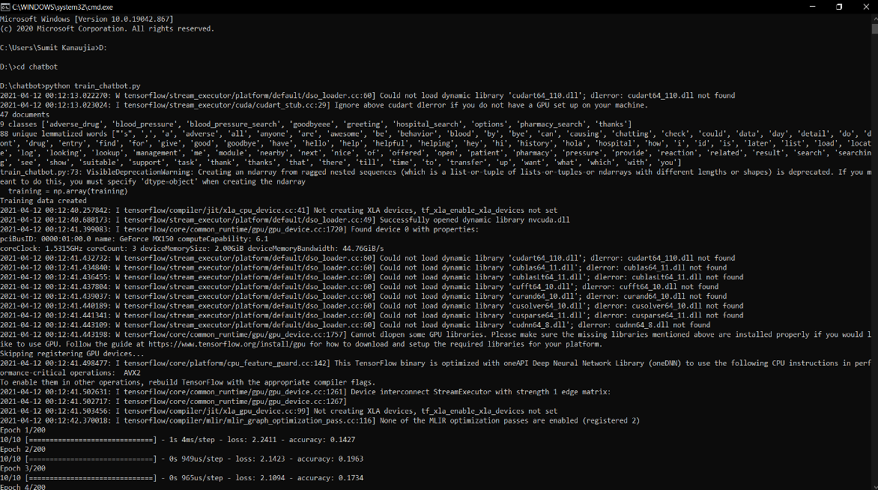
Figure 5

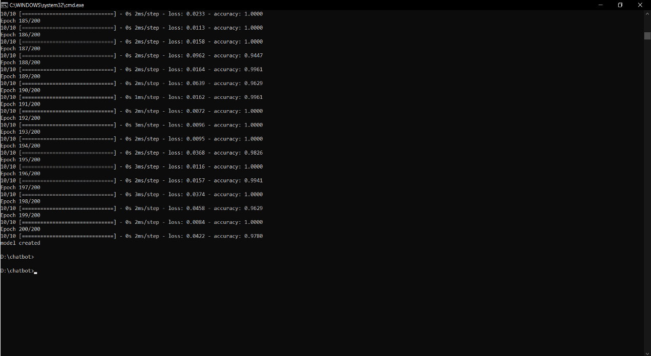
Figure 6

[8][9]

EVALUATION AND RESULT
The result and analytics can be divided into two categories: measuring the users and measuring the conversions that occur. A top-notch user experience is the ultimate goal because chatbots are set up to assist your customers. Therefore, it makes sense to look at your user base first. How would you describe the overall user experience? They're interacting with the chatbot in what way? Analysis of each is crucial because they all have a big impact on the user experience.

- Conversation Length: It is one thing that users interact with the chatbot, but whether they remain engaged is another part of the story. What is the length of interaction between your chatbot and its users? If increased efficiency is one of your goals, this may be a key metric on which to concentrate. This metric varies from case to case and is dependent upon the situation. Longer conversation times would be considered advantageous for marketing chatbots that prioritise user involvement. Yet for support chatbots aimed at resolving issues and queries in a timely manner, seeing a decrease in conversation length over time is favourable.
- Bounce Rate: This metric shows how beneficial visitors found the chatbot, much like when they leave a website after seeing just one page. Who is leaving, at what point in the conversation are they dropping off, and why? If a customer ends a session prematurely upon finding it not of use to them, for instance, this will constitute a high bounce rate.
- New Users: The users growth. During the COVID-19 pandemic, for instance, airline West Jet saw a 45X spike in new users and customer requests, with a slew of questions regarding cancellations and flying restrictions. Leveraging Netomi’s AI-powered chatbot, Juliet, the company was able to scale its support team and deflect tens of thousands of calls from human agents.
- Return Users: Aside from new users, are there customers enjoying it enough and finding it useful enough to come back?
- Customer Satisfaction: How useful or helpful was the chatbot, in the eyes of the customer? Sent immediately following an interaction, customer satisfaction (CSAT) surveys allow you to understand if you’re meeting customer expectations, enabling you to pinpoint where things go wrong in the customer journey and optimize the experience as necessary. Such customer service tools allow customers to feel appreciated and that their voices and concerns are being heard.
- Escalation Rate: There are some situations in which a chatbot will need to escalate a conversation to a human agent. This could be for several reasons: it does not understand a user’s input, has not been trained on a specific topic or a user explicitly asks for a human agent. If experiencing a high escalation rate, it might be worth conducting additional training and increasing the chatbot’s scope to deliver a boost in performance.

PREDICTING THE RESPONSE
The response Prediction is the last assignment of the framework model. The DL model provide us with the list of intents subsequent to separating it with threshold limit alongside their comparing probabilities. It is the responsibility of response generation module to select the one from that list that is most appropriate for the inputted inquiry.
This module takes the output from the Deep Learning module as it's input. At that point these lists of intents are checked with the repository (here JSON file of intents) & the one with most noteworthy likelihood that matches totally well for the input is delivered as the final output.
We use graphical user interface for predicting the response from the bot. [15][16]

1. Importing and Loading of data file
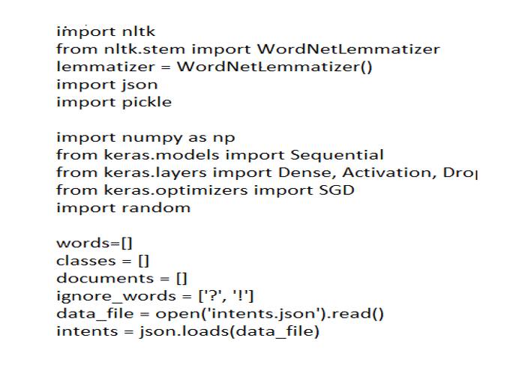
Figure 7

2. Pre-processing of Data

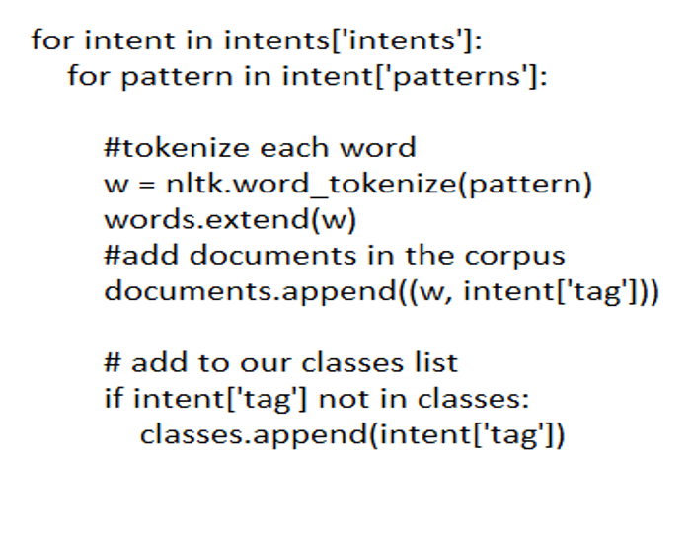
Figure 8
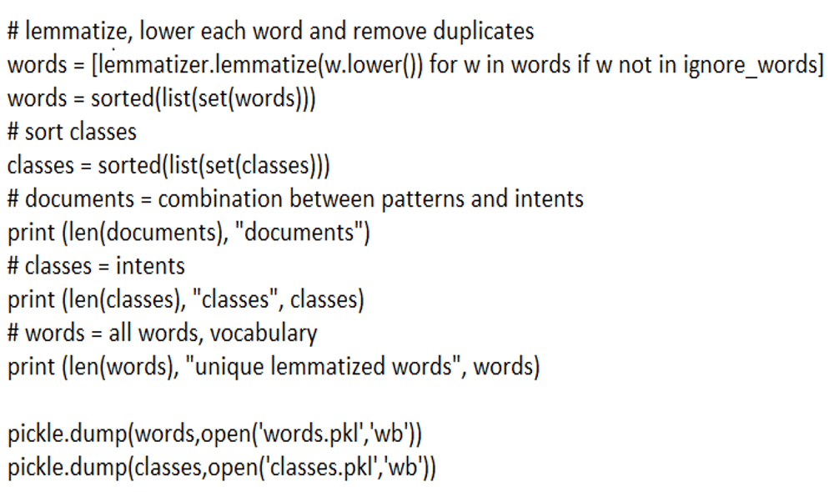
Figure 9

3. Creation of Data

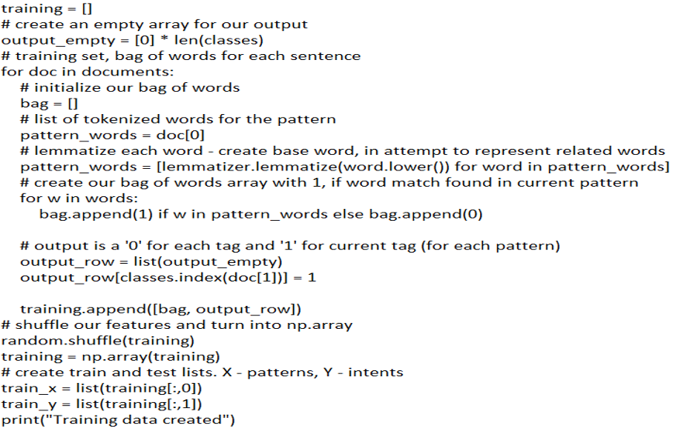
Figure 10

- Response Prediction

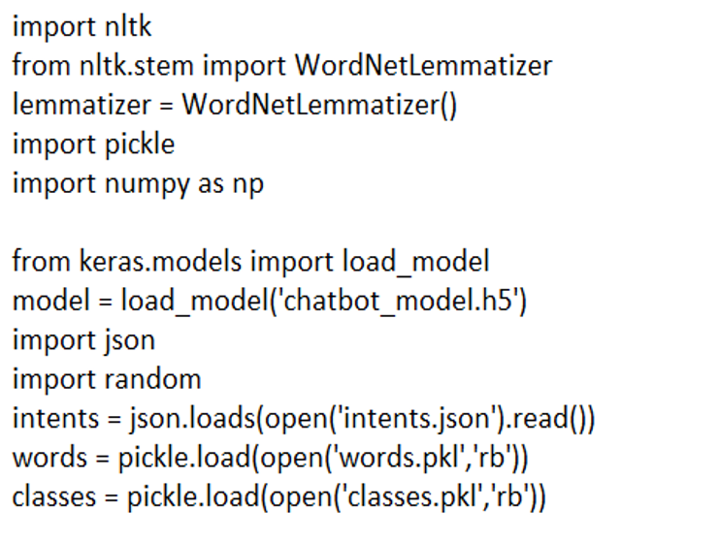
Figure 11

INTERACTING WITH THE CHATBOT MODEL
Since we have created the model successfully and trained it for 200 Epochs and achieved 100% accuracy.
Now we are going to interact with chatbot with the help of command in the terminal window:
Python chatgui.py
After the program run successfully, it will pop up a GUI window in a little time. Now user can easily interact with the chatbot and chatbot will give response to user query.

FLOW CHART
We can demonstrate the successful working of a chatbot via a flow chart which shows us steps on how the chatbot works. By using the dialog flows we can create flow diagrams for each intent. Creating flows helps us articulate and critique the interaction early on.
It turns out to be a multi-step process with a lot of back-and-forth communication. This also means added complexity, uncertainty and increased chances of error at each step.
For updating reminders, we have to augment the conversational UI with a graphical UI interaction where set reminders are always visible with edit and cancel options next to them — see UI sketch below.
A little help from Graphical UI helped to reduce additional back and forth communication and simplify the flow significantly. It also enhanced the user experience by giving visibility of existing reminders.
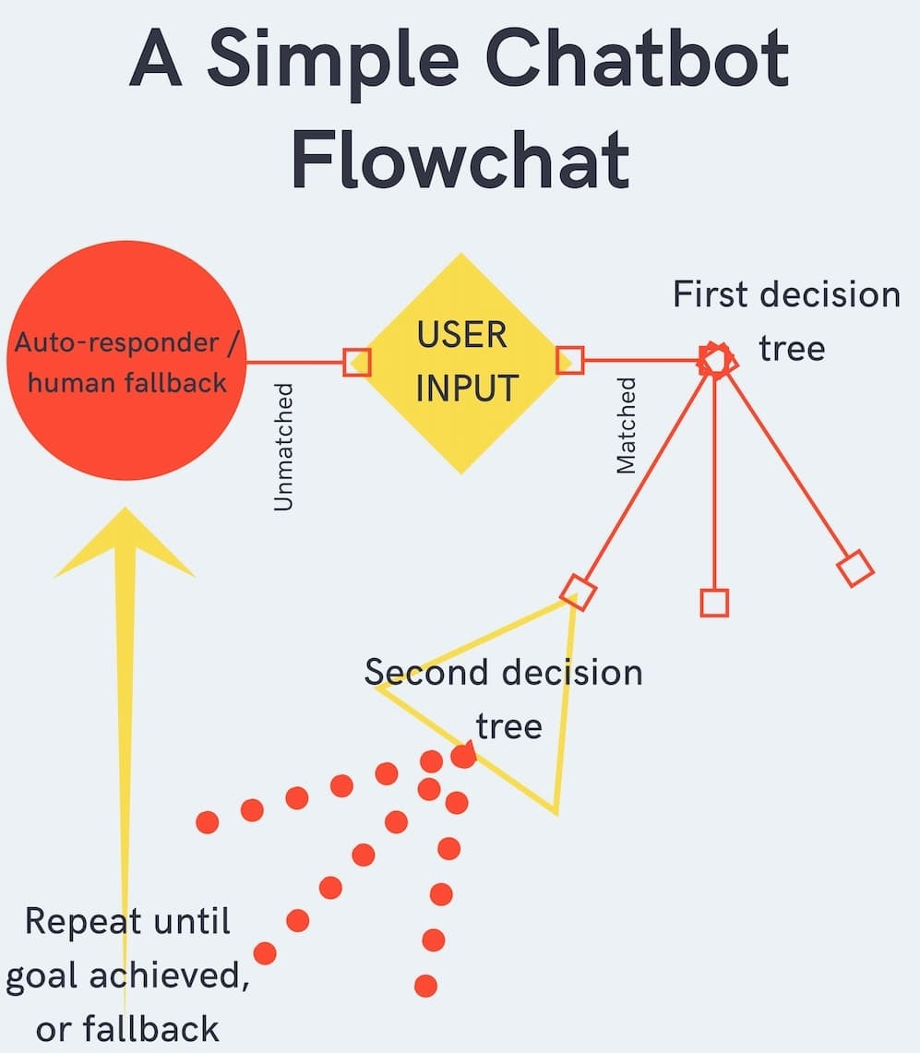
Figure 12
The above diagram shows the simple background and pre-processing of an ordinary chatbot. We can find a more interactive working of the working in the below figure. [4]
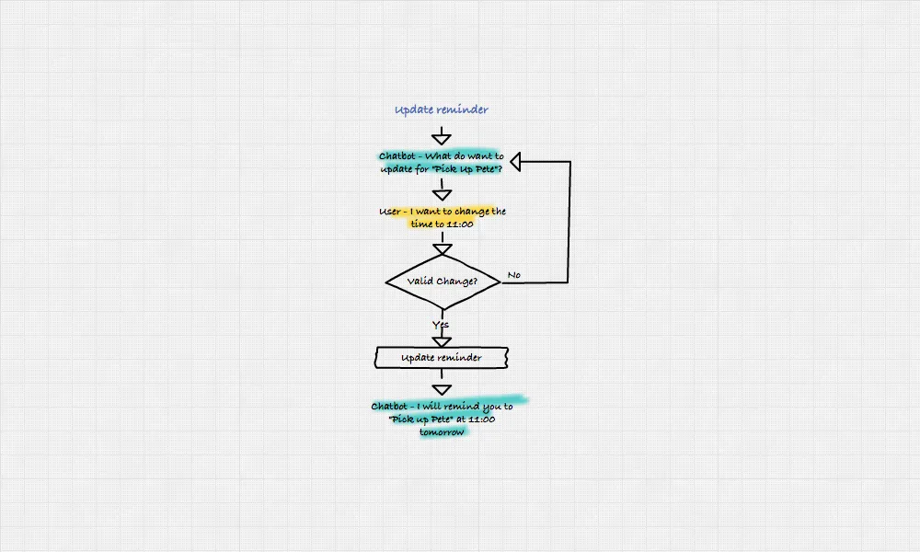
Figure 13
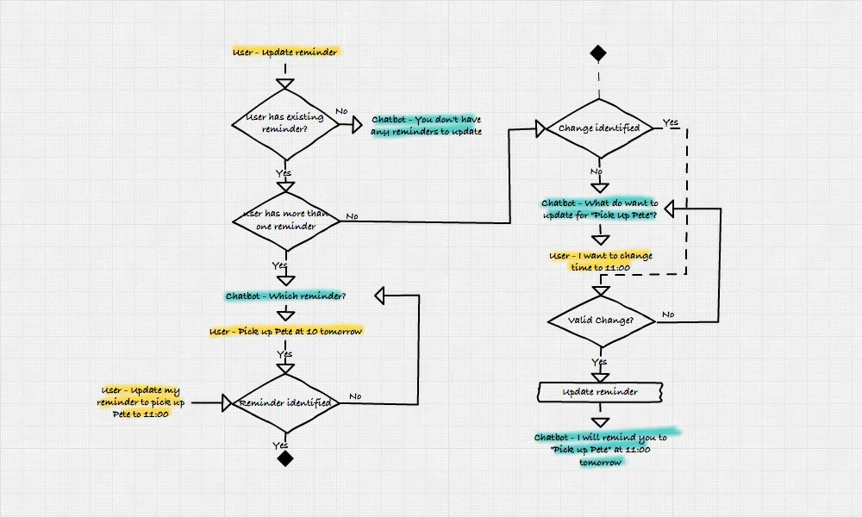
Figure 14

A user has provided input. When a user provides a keyword, the chatbot is triggered at this point.

As an illustration, we demonstrated an idea to one of the clients using a flow chatbot that used the keyword "SEO" as a trigger. When the keyword "SEO" is sent, the chatbot's initial message transforms into a comprehensive SEO course that is provided over Facebook Messenger.

A message is therefore sent by the user.

If the chatbot is unable to recognise the message, we take the left-side branch and fall back to using an autoresponder or human.

Typically, we include autoresponders, fallbacks, and finally a human fallback in every chatbot we design. A simple welcome message and a list of keywords or commands that new users might utilise make up an autoresponder.

When a user sends numerous unidentifiable inputs in a row, a fallback is typically triggered, reminding the user of the instructions they can use.

A human fallback is precisely what it sounds like, to sum up. The chatbot notifies a human to step in after several user inputs that are unrecognisable in order to encourage them to take over.

If there is a keyword in the message, the flow takes the right-side branch. Here, you may observe how the bot and its user communicate in a decision-driven manner. The user selects one of the possibilities the bot presents before presenting the next set, and so on.

At some point, the user will have either arrived at the user’s destination and discovered what they were seeking for, or the bot's fallbacks will have been used.

There it is—a flowchart showing the most basic chatbot design!

CONCLUSION
We have added fresh knowledge about the development of interactions between people and social chatbots. This research has shown that even a normal working chatbot has huge impact and benefits across various industries like economically available 24/7 service, customer satisfaction, reaching a younger demographic, reduce costs and increasing revenue.
A chatbot can be used anywhere where a human is interacting with a computer system. The whole idea of a virtual assistant and “live agent” has help is to help increasing the efficiency and decreasing the workload. Chatbots have proved to be beneficial across various industries like Sales and Marketing, Human Resources, IT, Digital and Social Platforms.
This study, in my opinion, may help us better understand a phenomenon that will become more and more important in the future: the emergence of human-AI social chatbot relationships.

‌ REFERENCE LIST
- Adamopoulou, E. and Moussiades, L. (2020). Chatbots: History, technology, and applications. Machine Learning with Applications, [online] 2. doi:https://doi.org/10.1016/j.mlwa.2020.100006. [1]
- Amditis, J. (2017). What are some ethical considerations that chatbots raise, and how should they be addressed? [online] Medium. Available at: https://medium.com/mobilenewslab/what-are-some-ethical-considerations-that-chatbots-raise-and-how-can-those-be-best-be-addressed-7f7fed23557. [2]
- Bruno Marietto, M. das G., Aguiar, R.V., Barbosa, G. de O., Botelho, W.T., Pimentel, E., Franca, R. dos S. and da Silva, V.L. (2013). Artificial Intelligence Markup Language: A Brief Tutorial. International Journal of Computer Science & Engineering Survey, [online] 4(3), pp.1–20. doi:https://doi.org/10.5121/ijcses.2013.4301. [3]
- Debecker, A. (2017). A Simple Chatbot Flowchart. [online] blog.ubisend.com. Available at: https://blog.ubisend.com/optimise-chatbots/simple-chatbot-flowchart. [4]
- Gasson, S. (2009). Employing a Grounded Theory Approach for MIS Research. Handbook of Research on Contemporary Theoretical Models in Information Systems, pp.34–56. doi:https://doi.org/10.4018/978-1-60566-659-4.ch003. [5]
- Gentner, T., Neitzel, T., Schulze, J. and Buettner, R. (2020). A Systematic Literature Review of Medical Chatbot Research from a Behavior Change Perspective. 2020 IEEE 44th Annual Computers, Software, and Applications Conference (COMPSAC). doi:https://doi.org/10.1109/compsac48688.2020.0-172. [6]
- Grudin, J. and Jacques, R. (2019). Chatbots, Humbots, and the Quest for Artificial General Intelligence. Proceedings of the 2019 CHI Conference on Human Factors in Computing Systems. doi:https://doi.org/10.1145/3290605.3300439. [7]
- Moorjani, Y. (2017). Designing chatbots. [online] Medium. Available at: https://uxdesign.cc/how-to-design-a-robust-chatbot-interaction-8bb6dfae34fb.
[8]

- Ramesh, K., Ravishankaran, S., Joshi, A. and Chandrasekaran, K. (2017). A Survey of Design Techniques for Conversational Agents. Communications in Computer and Information Science, [online] pp.336–350. doi:https://doi.org/10.1007/978-981-10-6544-6_31.
[9]

- Ranoliya, B.R., Raghuwanshi, N. and Singh, S. (2017). Chatbot for university related FAQs. 2017 International Conference on Advances in Computing, Communications and Informatics (ICACCI). doi:https://doi.org/10.1109/icacci.2017.8126057.
[10]

- Rice Mcaulay, J. (2022). What Problems Does A Chatbot Solve? | Kindly. [online] www.kindly.ai. Available at: https://www.kindly.ai/blog/what-problem-does-a-chatbot-solve.
[11]

- Ruane, E., Birhane, A. and Ventresque, A. (2019). Conversational AI: Social and Ethical Considerations. [online] Available at: https://ceur-ws.org/Vol-2563/aics_12.pdf. [12]

- Sagstad, M.H., Morken, N.-H., Lund, A., Dingsør, L.J., Nilsen, A.B.V. and Sorbye, L.M. (2022). Quantitative User Data From a Chatbot Developed for Women With Gestational Diabetes Mellitus: Observational Study. JMIR Formative Research, 6(4), p.e28091. doi:https://doi.org/10.2196/28091. [13]
- Tucker, K. (2017). A Chatbot Abstract. [online] Medium. Available at: https://chatbotslife.com/a-chatbot-abstract-1cd002e7a480. [14]
- Wallace, A. (2021). The Top 10 Chatbot Evaluation Metrics. [online] Netomi. Available at: https://www.netomi.com/chatbot-evaluation-metrics [Accessed 25 Apr. 2023]. [15]
- Wolfswinkel, J.F., Furtmueller, E. and Wilderom, C.P.M. (2013). Using grounded theory as a method for rigorously reviewing literature. European Journal of Information Systems, 22(1), pp.45–55. doi:https://doi.org/10.1057/ejis.2011.51. [16]
‌

