Human Resources Management
LCMB7000 Assessment 1
Noussayba Bendjazia
Student Number: 2121854

Contents
Introduction 3
Labour market definition 3
Microeconomic Theory of the Labour Market 4
The macroeconomic theory of the labour market 4
The impact of the covid on the labour market 5
Summary of jobs availability and unemployment 5
Brexit’s impact on the labour market 6
Industries most affected by the Brexit 7
Innovative measures to be introduced to attract and retain new entrants from the labour market 7
Measures to attract new jobs seekers from the employment market 7
Measures to retain employees 9
Further measures to be taken to incentivise the already existing employees in the company 9
Conclusion 10
References 11

Introduction
The labour market is an essential key to evaluating and measuring the stability of the economy of any country, and numerous variables and circumstances can easily affect it. The economic, political and even world health factors can play an important role and lead to multiple changes in the labour market.
In the past three years, the UK faced two crucial historical events that had a significant impact on the economy and especially created a disproportion in the element of the labour market.
The UK was and still is an attractive destination for many people who are looking to immigrate for reasons of work or even study and make their living conditions better, so the immigration has an essential role in the composition of the workforce in the country, especially in an elderly society in 2016 the population voted for a Brexit referendum. The UK will officially leave the European Union and the single market. The negotiation of the Brexit wasn’t smooth. It was surrounded by a lot of uncertainty which led to many European citizens leaving the country and causing a shortage in the workforce in numerous industries.
In early 2020 the world was heated by an unexpected pandemic. The government had to make an immediate response by imposing a national lockdown and travel restrictions to control the spreading of the virus.
In this report, we are going to analyse the impact of both the Brexit and Covid Pandemic on the UK employment market and any changes accruing in the conditions of the labour market, how the organisations were affected,
Furthermore, explaining how Human Resources Management could take any measures to adapt and attract people to the current situation.

Labour market definition
The terminology market means any place where there are offers and demands. The labour market is defined as the employment market; it refers to the availability and needs for labour forces; it is where employees and employers exchange services. The employees represent the buyer, and the seller is the employer.
The structure of the labour market and the availability of people for work will influence how companies establish and implement recruitment programmes. Recruitment issues develop due to skill shortages or a decrease in the number of workers from other countries. (Armstrong, 2020)
The labour market should be examined at either the macroeconomic or microeconomic aspects.

Microeconomic Theory of the Labour Market
The microeconomic theory examines labour supply and demand at the individual firm and worker levels and the number of hours an employee is willing to work initially. Supply rises as wages rise. No workers will work for free (unpaid interns are, in theory, working to gain experience and move to well-paid jobs). Demand is determined by two factors at the microeconomic level: the marginal cost of production and marginal revenue product. Suppose the marginal cost of recruiting new employees or requiring existing staff to work longer hours surpasses the marginal revenue product. In that case, earnings will be reduced, and the firm will theoretically reject that option. If the opposite is true, it makes logical sense to hire more people. (Kenton, 2020)

The macroeconomic theory of the labour market
According to macroeconomic theory, wage growth lags productivity growth, suggesting that labour supply has surpassed demand. As people compete for a limited number of jobs and businesses pick and choose from the labour force, salaries fall. When demand exceeds supply, wages rise because workers have more negotiating power and are more likely to be able to switch to a better-paying job while businesses battle for labour. Some factors play a significant role in labour supply and demand; for example, an increase in immigration in a country raises the labour supply, potentially driving down wages, especially if newly arrived workers are willing to accept lower pay. An older population can reduce the labour supply and potentially drive-up wages.
However, those factors do not always have such apparent consequences; in an elderly society, demand for many goods and services will fall, while demand for healthcare will rise. Not every employee who loses their job can switch to a healthcare sector, especially if the jobs in order are highly skilled and specialised, such as doctors and nurses. As a result, even if supply exceeds demand in the labour market, demand in specific sectors may exceed supply.
The economic environment serves as the base for the day-to-day operations of human resources. What happens in the macroeconomy and individual product and labour markets determines how many employees an organisation must hire, retain, and develop to satisfy customer needs. Therefore, companies and experts must monitor the state of the labour market and potential economic developments. (Davies, 2021)

The impact of the covid on the labour market
The outbreak of the coronavirus pandemic and its consequences will have a long-term impact on the economy, companies and working live; organisations need to adopt rapid changes, including how and where the jobs are taking place, along with planning for returning employees to the site safely, on other hand employees must adapt to new modes of working.
In March 2020, the World Health Organization WHO declared the coronavirus (covid 19) a pandemic; same as in other countries, the public health response to the covid caused a dramatic drop in labour demand. As a result of the government's early response to the pandemic, entire economy sections were forced to shut down, including non-essential retail, because the people were prevented from socialising, hospitality and leisure industries and air traffic were essentially suspended due to travel restrictions. On the eve of the crisis, these industries alone employed over 5 million people in the UK, and many of them were laid off after the lockdown on March 23. However, sectors like communication and information where people could work from home experienced small changes compared to the industries mentioned above.
A considerable number of sector employees most damaged by the pandemic lost their jobs during the lockdown imposed by the government to stop the spreading of the virus.
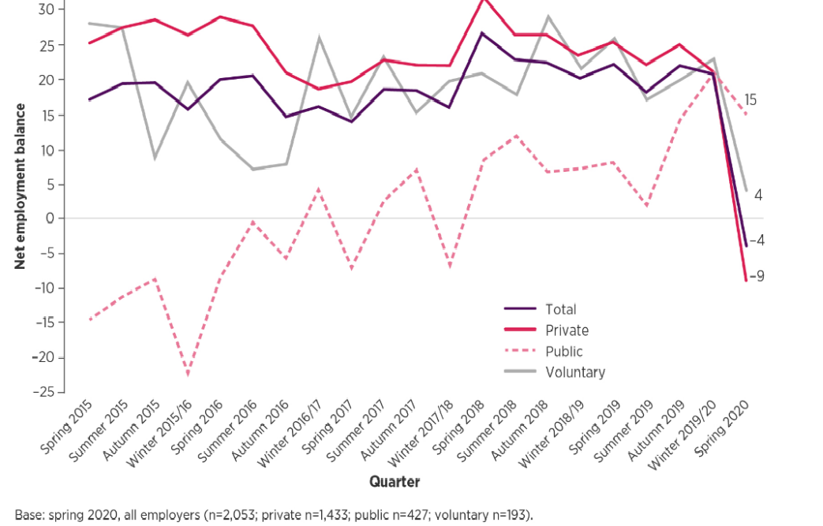
Figure 1: shows the net employment balance in the UK, source: (Anon., 2020)

Summary of jobs availability and unemployment
According to an analysis published by the office for national statistics(ONS), the UK labour market has hugely changed from the one in pre-pandemic. Between January and April 2020, the ratio of labour supply and labour demand increased, which indicates the rise in the gap between them was caused more by the failing in demand for labour for the closure of businesses and covid travel restrictions. The ratio was at its lowest (1.5) from January to May, indicating how tight the labour market was before the coronavirus. The balance has been generally stable since the beginning of 2019. The most recent increase in the ratio of ( 23.5 %) to 2.1 from November to January 2020 and February to April 2020 was related to the pandemic's impact on jobs availability, which dropped by 166,000 (or 21 %) to 641,000, while unemployment fell by 8,000 to 1.34 million. (Abby, et al., 2020)
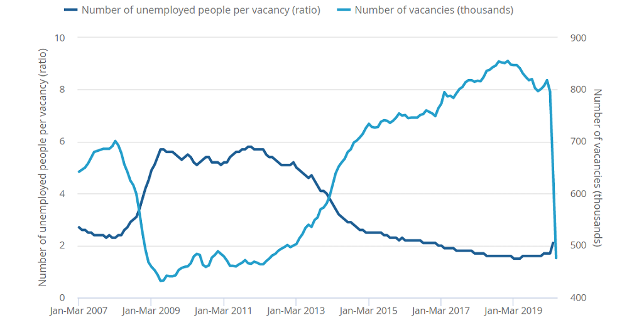

Source: Office for National Statistics – Labour Force Survey and Vacancy Survey

the government launched a Job Retention scheme to alleviate the impact of the covid pandemic on the people who lost their job temporarily during the first and second lockdown. Since the project began, 11.7 million jobs have been furloughed, and 1.3 million employers claimed under the coronavirus Job Retention Scheme (CJRS). Also, 2.9 million individuals claim under the self-employment support scheme (S (Abby, et al., 2020)EISS). Both plans ended on September 30, 2021.

( Hutton & Keep, 2022).

One of the first signs of the pandemic's impact on the labour market was a record drop in job openings in April-June 2020. During those three months, jobs reached a new low of 340,000. This was 445,000 fewer than in the January-March 2020 period. Since then, job openings have increased significantly and have risen rapidly in recent months. (Powell, Andrew; Francis, Brigid; Harriet Clark, Devine, 2022)

Brexit’s impact on the labour market

four years after the referendum, On Christmas eve, a week before the end of the Brexit transitionary period, that was until the 31 of December of 2020, the UK announced its divorce from the European Union with the agreement to leave the European single market. (O'carroll, Lisa; Boffey, Daniel, 2020)

This news left an enormous uncertainty on European individuals who have been living and working in the UK for many years. Many of them decided to leave the country because of Brexit, mainly because it parallels the pandemic and the ongoing travel restriction. Many European migrants came back home due to concern about not being able to see beloved ones for a while.

Industries most affected by the Brexit

UK food manufacturers and suppliers warn of shortage in the merchandise caused by the staff and lorry drivers shortage caused by the Brexit and the pandemic.

Another consequence of the Brexit is the recruitment difficulty of the employees; the new immigration regulation, currently, employees need to recruit individuals who already o hold presettlement or settlement; otherwise, if they are travelling from the EU to the UK, they need to be highly skilled workers who speak English, having a job offer from home office licenced sponsor. They will be paid more than £25,600 a year or more. This shortage of staff could create difficulty in recruiting workers in sectors such as Hospitality, health and social care, construction and food manufacturing, where a significant proportion of European workers used to work. This situation will put a barrier in front of the recovery from the damage caused by the pandemic for those industries.

According to Partington, Richard a journalist for the Guardian that employers are having difficulty recruiting workers because of the labour shortage that the UK didn’t experience for decades. Several numbers of 100 000 lorry drivers are estimated to be short, and hauliers entered a war by offering a high salary and a £1000 bonus. (Partington, 2021)

Innovative measures to be introduced to attract and retain new entrants from the labour market

as a result of Brexit and a lack of the available working force in the UK, businesses will face challenges through the recruitment procedure and job applications; therefore, they should analyse the labour market closely to find out the number of candidates who meet the jobs roles and create innovative strategies to attract new individuals from the labour market as well as retain them.

Measures to attract new jobs seekers from the employment market

the way of hiring new employees is supposed to attract as many skilled and qualified candidates who are actively looking for a job or considering doing it in the nearest future. All recruitment methods have advantages and disadvantages, and the method chosen must be based on the specific vacancy and the type of labour market in which the job is located. (Torrington, et al., 2020).

Today’s organisations use online job advertising or traditional and innovative methods such as websites and social media.
- Develop a strong brand: the organisation should create a strategy to fortify its company image by identifying tangible qualities that allow it to be more distinctive than other competitors (Holbeche, 2009).

The company can use the brand image to attract more talent. Today, with the internet, people can easily find information, so the organisation needs to be confident that the candidate considers the adequate information that the company wants to transmit.

The newest trends that companies today are using for their jobs advertising are using social media channels such as LinkedIn by sharing content that reflects the organisation’s culture and goals to promote its brand reputation (von Rosen, 2020)

The organisation should be present and provides updated information about the company and its mission and vision through its website. Moreover, the company could dedicate a section of its website to job opportunities.

The advantage of using the online recruitment method is to reach a substantial number of candidates, either looking for work or not, in a short period and in the cheapest way.

- create employee value proposition: the company must examine what they will offer the workers to establish an employee
- the safe work environment: the company should implement safety measures in the workplace, especially during this pandemic, for example: applying social distance measures, cleaning and sanitising by increasing the frequency of cleaning, even offering the possibility to work from home when it is possible. When making the workers feel safe, the company is enhancing their productivity.
- diversity: offering a diverse workplace in gender diversity and cultural and racial diversity, and age discrimination to enhance the organisation’s attractiveness.
- employee well-being and work-life balance: taking measures to support employees’ well-being as the covid pandemic negatively impacted the employees' physical and mental health.
- opportunities for career development: the company can offer induction training and learning new skills for the candidates and promise the possibility of a career development program within the organisation to establish the expectation.
- payments and benefits: offering a high and fair wage and bonus, transport allowance, health insurance, gym.

Measures to retain employees

Employers can use integrated measures to maintain the existing staff in the organisation, prevent them from leaving the job, and enhance the feeling of belonging. (Torrington, et al., 2020)
- controlling expectation: the organisation needs to reassure that job was well explained to the employees and met their expectations; accordingly, job dissatisfaction is the primary factor that causes turnover.
- training and development: to stop the staff turnover and influence the engagement, the company, implements ongoing training; the employees can feel their recognition and the faith that the company has made in them by funding their courses and training events.
- Arrangement of flexible work: discuss with the worker the options of the work delivery onsite, remote work or a combination of both. This offer attracts many people, particularly individuals who have a family to cope with between work and family.
- pay: payment increase to improve the job satisfaction for the employees and not to use it only as a unique method for retention when other factors in the work environment are pushing the employee to leave. Therefore, the organisation can use this measure to fortify the relationship between the company and the employee.

Further measures to be taken to incentivise the already existing employees in the company
any organisation needs to work forward and set several approaches to retain the employees, improve the worker’s engagement and satisfaction, and decrease its labour turnover rate.
There is no difference between the retention measures taken for new entrants from the labour market and the already existing workers, so the company can incentivise their retention by providing career progression, more flexibility when it is convenient, increased wages; however, the old staff needs to feel more recognised and valuable to the organisation. Therefore the organisation can take other incentives and rewards to enhance its staff engagement and satisfaction as part of an influential people management.
Bonus and incentive:
- Financial incentives: Incentives are used to influence future employee performance and are usually based on targets: if specified objectives were met, the workers are given a payment, usually of a certain quantity.
- Bonus: Bonuses can be discretionary or non-discretionary and can be used for various purposes. They can influence employee behaviour to reach pre-set targets like incentives, but they can be used to reward the worker’s well-done job.
- Employee recognition programmes are backwards-looking, as they honour past accomplishments rather than encourage new initiatives. They could be spontaneous and private.
- Non-cash incentives: their purpose is to influence future employee performance by awarding prizes, travel, gifts and recognition award. (CIPD, 2022)

Conclusion
In the conclusion of this report, we analyse the changes in the human resources management and the challenges they are facing in adapting to the external circumstances that the organisation is facing and suggest introducing new measures to be taken as part of the response to those circumstances. The UK labour market faces considerable changes post-Brexit and through the Covid pandemic. The HRM needed to consider those two factors and look for innovative strategies to fulfil the attractiveness and maintain the new workforce entering the labour market, especially with the shortage of labour force and high level of competition hiring new talents using different techniques of recruitment modern and traditional one. Moreover, the human resources management should take further steps to stimulate the existing employees, fortify their engagement and increase their job satisfaction and the feeling of belonging to the company. Wich reflects maintaining the employees and minimising jobs turnover.
In closing, the labour market component varies depending on the political, economic, demographical and even social factors that affect the business environment and especially the supply of the workforce and their management. The employment market is indeed experiencing difficulties. The business environment is hard to predict; however, this turbulent moment will conduct in new solutions and development prospects looking forward to creating innovative practices to end stronger and overcome the challenges.

References
Hutton, G. & Keep, M., 2022. Coronavirus business support, London: House of Commons Library.
Abby, L., Romiti, M., Denisson, E. & Chiripanhura, B., 2020. Labour Force Survey and Vacancy Survey. [Online]
Available at: https://www.ons.gov.uk
Anon., 2020. CIPD Coronavirus webinar series. [Online]
Available at: https://www.cipd.co.uk/Images/impact-of-covid-19-on-the-labour-market-webinar-slides1_tcm18-79454.pdf
Anon., 2022. CIPD. [Online]
Available at: https://www.cipd.co.uk/knowledge/fundamentals/people/pay/bonuses-factsheet
Armstrong, M., 2020. Armstrong's handbook of human resource management practice. Fifteen edition ed. s.l.:Kogan Page.
Davies, G., 2021. Understanding the economy and labour market. [Online]
Available at: https://www.cipd.co.uk/knowledge/work/trends/economy-labour-market-factsheet
Holbeche, L., 2009. Aligning human resources and business strategy. 2nd ed. s.l.:Butterworth-Heinemann.
Kenton, W., 2020. Labour Market. [Online]
Available at: https://www.investopedia.com/terms/l/labor-market.asp#toc-the-labor-market-in-macroeconomic-theory
O'carroll, Lisa; Boffey, Daniel, 2020. UK and EU agree Brexit trade deal. The Guardian.
Partington, R., 2021. ‘It’s a seller’s market for workers’: how Covid and Brexit have shaken up UK jobs. The Guardian, 16 September.
Powell, Andrew; Francis, Brigid; Harriet Clark, Devine, 2022. coronavirus: Impact on the labour Market, s.l.: House of Common Library.
Torrington, D., Hall, L., Atkinson, C. & Taylor, S., 2020. Human Resource Management. 11 ed. s.l.:Pearson Education, Limited.
von Rosen, V., 2020. LinkedIn Learning. [Online]
Available at: https://www.linkedin.com/learning/employer-branding-on-linkedin/introduction-to-employer-branding-on-linkedin?au

