Introduction:
Network security has emerged as a primary issue in the current age of information technology as a direct consequence of the proliferation of cybercrime and the rising complexity of online assaults. Cybercrime and the growing expertise of online attacks. Malware, viruses, attacks on the network, vulnerabilities, and other security concerns are only some of the challenges that must be overcome by the modern network architecture. It is necessary to have a strong grasp not just of these threats but also of the tools, techniques, and tactics that may be employed to eradicate them.
Part one covers a wide range of network security topics, such as the basics of network security, how to keep Cisco routers safe, how to set up AAA, how to minimise risks using ACLs, and how to set up VPNs. This part goes into detail about the Cisco Network Foundation Protection (NFP) framework and also talks about different ways to keep Layer 2 infrastructure and configurations for firewalls safe.
From the knowledge gained in part one of this assignment, the understanding of network security fundamentals can be applied to the given scenario of A2Z Technologies Ltd. As a company that designs and manufactures high-tech electronic equipment sold globally, A2Z Technologies Ltd understands the need for a proactive approach to network infrastructure cybersecurity. With the impact of cyber-attacks on organisations , including the shift to remote work and the use of personal devices to access company resources, A2Z Technologies Ltd requires a secure network infrastructure to protect their assets and data. In this report, a blueprint design for a secure network infrastructure will be provided to be implemented within the next 3 months, including a proposal explaining the choices and security measures, cost analysis, project plan timeline, and recommendations for tests to ensure the network infrastructure is secure. As a Network Security Engineer, professional and consultancy services will be provided to support A2Z Technologies Ltd in achieving their network security goals.
1.a
The specialized area of cybersecurity known as network security is primarily concerned with the protection of computer networks against attacks from the internet. Its purpose is to block unauthorized access, identify and halt cyberattacks, and guarantee that authorized users have safe access to network resources. NAC solutions are used in the enforcement of RBAC rules, the conduct of risk assessments, and the correction of non-compliant endpoints. IDPSs, VPNs, and zero trust network access (ZTNA) are some of the tools that are used to ensure the safety of remote users and to stop data leaks. Application security protections protect applications and APIs from being attacked by network attackers, while email security solutions assist prevent phishing attempts from occurring.Protection against hackers is provided through data loss prevention (DLP), endpoint security solutions, and online security solutions. Streamlining security administration and protecting an organization's network from cyberattacks are two goals that may be accomplished with the aid of network segmentation, corporate network security solutions, and cloud security solutions. Granular access controls, constant validation, and data obtained from a variety of sources are used by zero-trust network security systems in order to guarantee that only authorized users have access to the appropriate resources. [1]

2.b
Many threats and attacks that may damage systems, data, and networks. Common threats and assaults include:
Malware disrupts computer systems or damages them. It contains viruses, worms, and Trojan horses. These can potentially enter a system through a variety of entry points, downloads, email attachments, and hijacked websites may let them in. [2]
Phishing is an internet attack that uses social engineering to try to get passwords and credit card information from victims. [3]
Spear phishing is email phishing. Attackers employ phishing emails and bogus websites to trick victims into giving them information. [4]
Denial of Service (DDoS) is an attack that floods a network or website with traffic, making it difficult for genuine users to access it. The attackers use botnets in Distributed DOS attacks to infected networks of devices. [5]
Man in the Middle (MitM) attacks enable attackers to intercept or change conversations between two parties when they are positioned between two parties. MitM attacks are used by hackers to steal data or install malware on compromised machines. [6]
Social engineering attacks exploit human contact to trick users into divulging critical information or compromising security. These assaults constitute "social engineering." Some call social engineering "social hacking." These attacks include phishing, pretexting, and baiting. [7]
These are just a few examples of the wide variety of threats and attacks that the networking industry has to deal with on a daily basis.
2.c
Antivirus software is a kind of software that performs scans on your computer to look for harmful code and then either deletes or quarantines the code if it is discovered. It is very necessary to keep the antivirus software on your computer up to date in order for it to be able to recognize new varieties of harmful malware. [8]
Firewalls: Firewalls help prevent unauthorized users from accessing your network. It is possible for them to be based on either hardware or software, but either way, they are an essential component of the first line of protection against attacks. [9]
Intrusion detection systems(IDS) are computer software that monitors your network in order to discover and thwart any efforts that are made to break in. They are able to identify potentially harmful behaviors such as port scans and other types of activities on the network. Intrusion prevention system(IPS) It was same like IDS but is also able to prevent the break-ins. [10]
Access control list: Limiting the number of users who are permitted to connect to your network is one method for enhancing its resistance against invasions. You should only provide access to the network to those individuals who have a genuine need for it, and you should insist that they use strong passwords to protect their accounts. [11]
Updates on a frequent basis: You should make it a habit to check that your computer's operating system and its programs have the latest of all available patches and updates installed. If this is done, it makes the process of using exploits to take advantage of vulnerabilities much more difficult. [12]
Backups: Keeping up with your data's backups on a regular basis is one of the best ways to protect against the loss of data that may result from the use of malicious software or other forms of attacks. [12]
2.d
Securing a network is preventing unauthorised users from accessing, utilising, revealing, interrupting, changing, or destroying its resources, data, and services. The following are network security fundamentals:
1. Defence in Depth: This method uses many security layers to defend a network from various attacks. US DoD devised this concept. This category includes encryption, firewalls, intrusion prevention systems, anti-virus software, and access control lists. [13]
2. Least Privilege: asserts that people and systems should only be given the access they need to do their tasks. This reduces the risk of unauthorised access to sensitive data. [14]
3. Network Segmentation: This method divides a network into smaller, more secure parts to prevent attacker lateral movement and attack scope. [15]
4. Monitoring and Auditing: Tools and processes are needed to monitor network activity and identify questionable behaviour. This approach emphasises identifying problematic actions. Intrusion detection systems, SIEM technology, and regular security audits are examples of this kind of security mechanism. These are comparable security methods. [16]
These basic principles may increase a network's security against many security threats. However, protecting a network requires ongoing maintenance and updates to keep up with evolving threats. This is vital to stay up with ever-changing dangers.
1.d
SMBs must reduce the effects of typical network attack techniques to ensure business continuity and secure critical data. These activities may be done in many ways. Small and medium-sized organizations may minimise network attacks by taking the following steps:

1. Use strong passwords: SMBs should require high-security passwords for all user accounts, including administrator accounts. For security, passwords should be hard to remember and changed often. Update passwords often. [17]
2. Segmentation: Create guest access and IoT device networks using network segmentation. Small and medium-sized businesses may utilize network segmentation to create separate traffic networks. This may prevent hazardous malware from spreading and reduce the effect of an attack. [15]
3. Run the latest software: SMBs should regularly patch their software and firmware to address hacking vulnerabilities. This comprises the computer's OS, programs, and network gear. [12]
4. Use antivirus software: All endpoints—servers, laptops, and desktops—should have antivirus software installed. It must be set to automatically scan and update virus definitions. [12]
5:Monitor network traffic: SMBs should monitor network traffic for suspicious login attempts or unauthorized access. This may help identify and mitigate attacks before they cause significant damage. [12]
6. Train Staff :Small and medium-sized businesses (SMBs), must train their staff to detect and report security concerns. Phishing, social engineering, and emails with suspicious attachments are examples. [12]
These practices may help SMBs lessen the risk and impact of network attacks. SMBs should regularly examine and improve their security to keep ahead of new threats.
1.f
Cisco Network Foundation Protection (NFP) was created to secure all network infrastructure layers. Apps, endpoints, and networks are covered in NFP. It combines several security elements and technologies into a single solution. This allows firms to maximise security resources. [18]
The NFP architecture has many key components that work together to ensure multi-tiered security, as shown below:
Control Plane Protection: Only authorised users may access the control plane of network devices, preventing assaults. It restricts control plane access to authorised users. [18]
Control Plane Protection: This component protects network devices' data planes. ACLs, firewalls, and IPS limit illegal access and traffic. [18]
Management Plan : maintaining the Integrity of the Management Plan, limiting administrative access, monitoring management operations, and requiring strict authentication and authorisation safeguards the management plane of network devices. It also monitors managerial activities. [18]
This component offers protection against both internal and external threats by using a wide range of diverse technological solutions, such as firewalls, intrusion prevention systems (IPS), and virtual private networks (VPN).
Network administrators may implement an organization-specific security policy using the NFP framework. The framework was created for this. The NFP framework is flexible and scalable, protecting small and medium-sized businesses against a wide range of threats.
1.6
Viruses, worms, and Trojan horses may damage a small to medium-sized firm, but there are ways to protect it. One of the most crucial tasks is installing and updating antivirus software on all network-connected devices. Antivirus software like Norton, McAfee, or Avast can identify and remove viruses from a computer. Cisco Email Security Appliance (ESA) and Cisco Web Security Appliance (WSA) are also available to enterprises. These gadgets prevent hazardous URLs and email attachments.
Cisco AMP, short for "Advanced Malware Protection," is another malware-detecting tool. This tool monitors and analyses network data. It inhibits known and unknown malware threats via signature-based detection, behavioural analysis, and sandboxing. [19]
There is also the potential of putting in place Intrusion Prevention Systems (IPS) and Intrusion Detection Systems (IDS) in order to detect and prevent attacks. These systems monitor the traffic on a network in search of signs of malicious behavior and have the capability to either restrict dubious conduct or alert administrators to it when they discover it. [10]
Antivirus software and other security technologies may reduce the consequences of viruses, worms, and Trojan horses, but they are not foolproof. Remembering that antivirus software and other security solutions are not flawless is key. Network security requires additional efforts. These protections include user education and periodic software upgrades.

3a
A secure network must include Authentication, Authorization, and Accounting (AAA). The AAA framework restricts network resource access. The AAA framework is one that provides a structured technique for restricting access to network resources. A person or device wanting to enter a network must be authenticated. Manual or automated. It usually requires a login and password or other credential to achieve this. By using AAA, the administrator of a network is able to ensure that only authorised users are able to access the network. Authorization determines whether a user may access network resources depending on their permissions after authentication. User roles and system access restrictions usually accomplish this. AAA limits access to what users need to do their duties. Accounting tracks users' network resource use. This is done by monitoring network use. This covers login and logout times, resource use, and network changes. This information may be used to determine whether security or policy violations have occurred. Small and medium-sized organisations may secure their networks and restrict access to resources by deploying AAA. Only permitted users may access the network. By implementing AAA, small and medium-sized enterprises have the opportunity to guarantee the security of their network and ensure that only approved users are able to access the network's resources. This is possible since only authorised users can access the network. [20]
5a
Cisco Secure is a comprehensive security platform that provides solutions for securing networks, endpoints, cloud environments, and applications. The platform integrates various security technologies and services such as firewalls, intrusion prevention systems (IPS), VPNs, identity and access management (IAM), and advanced threat detection and response.
On the other hand, the NIST Cybersecurity Framework is a set of guidelines developed by the National Institute of Standards and Technology (NIST) for improving cybersecurity for organizations of all sizes and types. It provides a risk-based approach to cybersecurity that includes five core functions: identify, protect, detect, respond, and recover. The framework is widely used by organizations to assess and improve their cybersecurity posture.
Cisco Secure aligns with the NIST Cybersecurity Framework by providing solutions that address each of the five core functions. For example, Cisco Secure Identity Services Engine (ISE) helps organizations identify and manage network access by enforcing security policies and controlling who can access network resources. Cisco Secure Endpoint provides protection for endpoints, which helps protect against threats that may bypass traditional security measures, thereby protecting the organization's critical assets.
Overall, Cisco Secure and the NIST Cybersecurity Framework both provide valuable guidance and tools for organizations to secure their networks and protect against cyber threats. By implementing the recommendations and solutions provided by these frameworks, organizations can improve their security posture and reduce their risk of data breaches and other cyber attacks. [21]

5.b
Open Web Application Security Project (OWASP) identifies the following as some of the most prevalent ways for evaluating network security:
Network mapping: It is the process of identifying all of the devices and services that are connected to a network in order to have a better understanding of the topology of the network and its potential vulnerabilities.
Vulnerability Scanning: This technique includes making use of automated techniques in order to search for and locate vulnerabilities in network devices and services.
Penetration Testing: This method technique includes trying to exploit vulnerabilities in a network while doing so in a supervised setting. The goal of this approach is to locate possible attack routes.
Application Security Testing: This involves assessing the security of network apps to detect weaknesses in the code and implementation of the application.
Wireless Security Testing: This technique includes evaluating the security of wireless networks, such as Wi-Fi networks, in order to detect possible vulnerabilities and attack routes.
The testing of network security may be done using a wide variety of techniques, some of which are listed below. It is essential to keep in mind that there is no one way for ensuring the safety of a network that can be used universally. Instead, businesses should employ a mix of testing approaches that are tailored to their individual requirements and available resources. [22]

6.a
Layer 2 infrastructure transports frames of data across a physical network. This is the second OSI layer. This layer handles most network communication, therefore protecting it is crucial to maintaining the network's confidentiality, integrity, and availability. MAC address spoofing, VLAN hopping, and ARP spoofing may attack Layer 2 infrastructure.
MAC address spoofing allows unauthorised network access by altering a device's MAC address. This allows network access. Port security, which restricts the amount of MAC addresses that may connect to a port, can help network managers minimise this issue. This protects network integrity. "VLAN hopping" occurs when an attacker sends rogue frames to a switch to trick it into forwarding traffic to a different VLAN. Administrators may employ VLan ACLs, private VLANs, or both to prohibit users from switching VLANs.
ARP spoofing impersonates a device to intercept or alter network traffic. To steal information. Administrators may evaluate ARP requests and answers using static ARP tables or dynamic ARP inspection (DAI) to prevent ARP spoofing.
Port security, Vlan ACLs, DAI, and user awareness initiatives are needed to secure Layer 2 infrastructure. This prevents social engineering and system threats. Port security is one example of a technological restriction. These risk reduction measures preserve the confidentiality, integrity, and availability of network resources and prevent Layer 2 infrastructure attacks. [23]

8a
Network-based Intrusion Prevention Systems (NIPS) are a critical component of modern network security, and the Cisco IOS IPS feature set is one of the most popular solutions available. Cisco IOS IPS works by analyzing network traffic in real time, looking for patterns that match known attack signatures and anomalous traffic behavior. When a threat is detected, the system takes appropriate action to block or limit the traffic, effectively preventing the attack from reaching its target.

Cisco IOS IPS uses various detection methods, including signature-based, anomaly-based, and protocol-based detection, to identify and prevent threats. In addition, the system can be customized to block specific types of traffic, including traffic from specific IP addresses, protocols, or ports.

Cisco IOS IPS can operate at the network layer, making it capable of detecting and preventing threats before they reach their target. This is particularly important in the case of Distributed Denial of Service (DDoS) attacks, which can quickly overwhelm a network if left unchecked. [24]

8b
Signatures play a crucial role in identifying and preventing network-based attacks by Intrusion Detection and Prevention Systems (IDS/IPS). These are sets of rules used to detect intrusive activity on a network, such as Denial-of-Service (DoS) attacks. IDS/IPS sensors allow network administrators to modify or create new signatures, which can be used to detect known attacks and respond with mitigating actions. By scanning network packets, the sensors compare the patterns of malicious flows with the installed signatures and take action,s such as logging the event or sending an alarm to the management software.

While signature-based intrusion detection is useful, it can sometimes produce false positives. The network mistakenly recognises harmless network activity as harmful. Some applications or operating systems can produce a lot of Internet Control Message Protocol (ICMP) signals, which a signature-based intrusion prevention system may misinterpret for an attacker mapping a network segment. Internet Control Message Protocol (ICMP) connects computers over the Internet. Administrators can tune their sensors and adjust signature parameters to minimize false positives. Proper tuning and adjustment can significantly reduce the likelihood of false alarms and ensure effective detection and prevention of network-based attacks.

Signatures are essential for IDS/IPS systems to detect and prevent network-based attacks. These signatures can be modified or created using management software and sensors to identify known attacks and respond with predefined actions. Although signature-based detection can sometimes produce false positives, tuning sensors and adjusting signature parameters can minimize such occurrences, ensuring reliable detection and prevention of network-based attacks. [25]

9a
VPNs secure device-to-device Internet connectivity. Encrypted connections secure vital data. It prevents eavesdropping and facilitates distant work.
A virtual private network, or VPN, is a method of extending the capabilities of an existing business network by establishing encrypted connections over the public Internet. Encryption keeps device-network communication private. A remote worker can securely access the business network. VPNs may link smartphones and tablets.

Secure remote access lets users and devices connect to a company network remotely. It uses VPN technology with strong user and device authentication. VPN technology may evaluate the posture of a device before allowing it to connect remotely.

The communication on the virtual network is, in fact, sent in a safe manner by constructing what is known as a tunnel, which is an encrypted link that spans the Internet.
Few types of VPN are listed below:-
Remote access VPNs may encrypt remote device-business connections. Endpoints include smartphones, tablets, and laptops. VPN technology now allows endpoint security checks to verify a certain posture before connecting.

A Site-to-Site VPN allows a company to connect its main office to remote offices through the Internet. This type of VPN is used when direct network connections between two or more sites are impossible due to distance. Establishing a Site-to-Site VPN requires specialized equipment to connect the networks, and the communication between the sites occurs at a network-to-network level. [26]

9b
IPsec denotes "Internet Protocol Security." It refers to a set of protocols that provide a safe and encrypted connection between two devices communicating over the internet or another untrusted network. IPsec VPNs rely on IPsec protocols to protect a connection between two networks, usually a distant client or remote network and a company's internal network. Remote clients or networks usually link to a company's internal network.

IPsec VPNs encrypt and encapsulate IP traffic. The OSI model's network layer handles this. Authentication Header(AH) and Encapsulating Security Payload(ESP) protocols are utilised to accomplish this.

AH protects data integrity and authenticity against replay attacks. Adding a header to the original IP packet. The original packet's digital signature resides in this header, proving its validity and integrity. Since AH does not encrypt data, it is vulnerable to MITM.
Encapsulating Security Payload(ESP) protects communications against replay attacks and ensures secrecy, data integrity, and authenticity. ESP will wrap the IP packet in a new header before delivering it. The new header has an ESP trailer, header, and IP header. VPN tunnels need symmetric key negotiation. This key encrypts data after tunnelling. This makes it impervious to eavesdropping and other interference.

IPsec VPNs provide a secure, encrypted connection between two networks or devices. This connection protects users against replay attacks, data confidentiality, authenticity, and integrity. [27]

9. d)
Encryption, hashes, and digital signatures are essential components of cybersecurity systems. They work together to provide confidentiality, integrity, and authentication, three critical aspects of secure communication (CIA Triad).

Encryption converts plaintext into ciphertext. This protects transmitted data. Keys are needed to encrypt data. This is called encryption. Symmetric and asymmetric encryption algorithms exist. Symmetric encryption is more used. Symmetric encryption uses a single key for encryption and decryption, whereas asymmetric encryption uses distinct keys for each step.
Data integrity is maintained through the use of hash functions, which generate a fixed-size digital hash value of a file or message. Any alteration to the original data will result in a different hash value. By comparing the hash value of the received data, the recipient can verify that the data has not been tampered with during transmission.

Digital signatures authenticate both the sender and the message, making them indisputable. Encrypting the message's hash value with the sender's private key creates a digital signature. The receiver may verify the sender's identity and message integrity by decrypting the digital signature using the sender's public key and comparing it to the message's hash value. This lets the receiver verify the message's integrity.. [28]

9. e)

Cryptographic hashes can ensure data integrity and authentication by generating hash values from input data and verifying them on receipt. Using hashing algorithms such as SHA and MD5 can help prevent data tampering and unauthorized access, providing an additional layer of security to protect against malicious attacks.

The Secure Hash Standard (SHS) is a hash function developed and published by the US Government. It generates a 160-bit hash value from any arbitrary length string. While it is structurally similar to MD5, it is approximately 25% slower. However, it is considered to be more secure than MD5 because it produces message digests that are 25% longer.

In contrast, the MD5 Algorithm is a widely used hash function that creates a 128-bit hash value. Although initially intended to be a cryptographic hash function, it is now known to have several vulnerabilities. Due to its extensive weaknesses, it is no longer recommended for use in cryptographic applications. However, it can still be used to verify data integrity against accidental corruption. [29]

9.f
Encryption algorithms play a critical role in protecting data confidentiality, and they are widely used in various fields, including online transactions, secure messaging, and password protection. Encryption algorithms operate by converting plain text into encrypted or encoded text, making it incomprehensible to unauthorized users. There are two primary categories of encryption algorithms, symmetric key and asymmetric key encryption. [30] [31]

In symmetric key encryption, the same key is utilized for encrypting and decrypting messages. This encryption method is also known as a private key cryptosystem. To encrypt a message, a secret key and an encryption algorithm are employed to transform plaintext into ciphertext. The same key and a decryption algorithm are used to recover the original message from the ciphertext. However, symmetric encryption is vulnerable to brute-force attacks using transposition methods. An instance of a symmetric encryption algorithm is the Advanced Encryption Standard (AES), which is utilized in various applications, such as data encryption, wireless communication, and internet security. [30] [31]

On the other hand, asymmetric encryption, also known as public key encryption, utilizes a different key for encrypting and decrypting messages. While the public key is shared and accessible to anyone, the private key is kept secret. Cryptographic algorithms that employ a one-way function based on mathematical methods are used to generate the key. For example, in a cryptosystem, the RSA algorithm is computationally infeasible to determine the decryption key when given only the knowledge of the cryptographic algorithm and the encryption key. Although asymmetric encryption is slower than symmetric encryption due to the complex mathematical computations involved, it is useful in situations where secure key exchange is challenging or impossible. [30] [31]
The application of encryption algorithms ensures data confidentiality by making sensitive information unintelligible to unauthorized users. This helps to prevent data breaches and cyber-attacks, which are becoming more frequent and sophisticated. Therefore, encryption algorithms are vital tools to ensure data confidentiality in various applications.
9.g
A Public Key Infrastructure (PKI) is a set of technologies and policies that enables secure communication over networks by providing authentication and encryption services. PKI uses two mathematically linked keys to encrypt and decode data. Private and public keys. Only the private key owner may decrypt data encrypted with the public key. Anyone may obtain and use the public key to encrypt data.

In PKI, digital certificates are used to associate public keys with their respective owners. These certificates are issued by the Certificate Authority (CA), which verifies the certificate owner's identity and signs the certificate using the CA's private key. This signature provides assurance that the public key belongs to the intended owner and acts as a mark of authenticity.

PKI offers secrecy, integrity, and non-repudiation. Encrypting data using the recipient's public key ensures confidentiality. Integrity is ensured by using digital signatures to authenticate messages and prevent tampering. Non-repudiation is achieved by using digital signatures to verify the message's origin, preventing the sender from denying responsibility for the message.

11.a
A stateful firewall, which is also known as stateful packet filtering or inspection, offers an in-depth examination of the connection as well as the payload that is included inside a packet in comparison to a stateless firewall. It keeps a state table to record connection statuses and uses that information to decide whether to allow or prohibit traffic based on the information in the table. A stateful firewall records the state of each packet in communication by maintaining a record of which host provided what data and when. This record is kept in conjunction with the data itself. When a stateful firewall gets a new incoming packet, it examines its state table to decide whether or not it should let the packet through. A stateful firewall is one that controls and restricts the data that is filtered by using TCP as well as higher levels of the OSI model. Each connection writes its own log entry into the state table, which is dynamically controlled. After being validated, the packet is sent in the direction determined by the ruleset that is associated with the specific connection. For instance, a stateful firewall has the ability to invalidate packets or refuse access to improper ports for the purpose of transmission from request servers. On the other hand, the majority of servers answer on standard ports that range from 0 to 1023. [32]

9g
A public key infrastructure (PKI) is a system of technologies and policies that enables secure communication over networks by providing authentication and encryption services. The PKI uses public key cryptography, which uses pairs of mathematically related keys - public and private - to encrypt and decrypt data. The public key is widely distributed and can be used by anyone to encrypt data, while the private key is kept secret and used only by its owner to decrypt the encrypted data.

In a PKI, digital certificates are used to bind public keys to their respective owners. A trusted third party issues these certificates, called a Certificate Authority (CA), which verifies the identity of the certificate owner and signs the certificate using the CA's private key. This signature acts as a stamp of authenticity and provides assurance that the public key belongs to the intended owner.

The use of PKI provides a number of security benefits, including confidentiality, integrity, and non-repudiation. Confidentiality is achieved by encrypting data using the recipient's public key, ensuring that only the intended recipient can decrypt and read the message. Integrity is ensured by using digital signatures to verify the authenticity of messages and prevent tampering. Non-repudiation is achieved by using digital signatures to prove a message's origin, preventing the sender from denying responsibility for the message. [33]

Part 2
In the scenario, A2Z Technologies Ltd has an existing network that includes LAN access for 6 departments (Sales department, HR department, R&D, Finance department, Marketing department, and Customer Relations department) as well as cloud access for hosted services on a public cloud (assumed) with company staff using their own devices to access company resources virtually and to carry out their day-to-day activities.
Existing Design of A2z Technologies Ltd
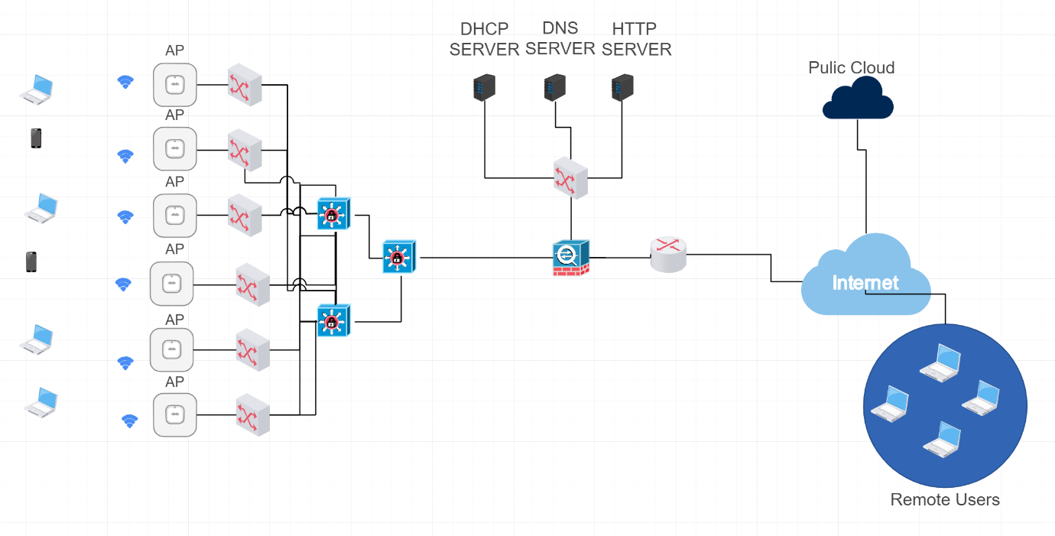
Proposal
Proposed Design:
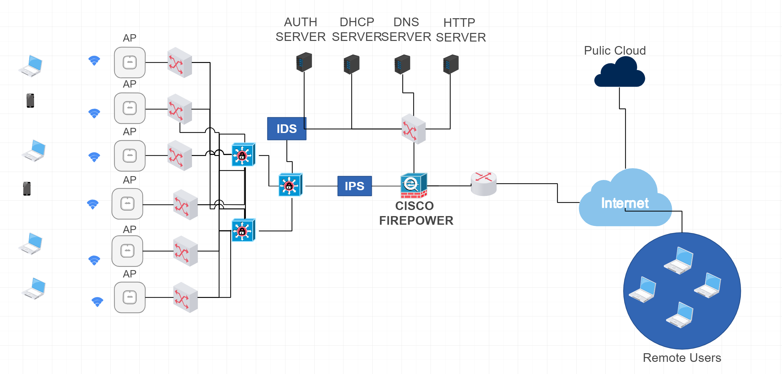
For Services hosted on the public cloud
As the organization migrates its data, applications, and other assets to the cloud, it becomes important to understand how to protect this highly sensitive business information. The organization must do its best to keep in line with industry regulations regarding data privacy or risk huge fines.
1. Deploy Multi-Factor Authentication (MFA)
Protect all of your cloud users with multi factor authentication (MFA) to ensure that only authorized personnel can log in to your cloud apps and access that sensitive data in your on- or off- premise environment.
2. Manage Your User Access
Set proper levels of authorization with an identity and access management (IAM) plan to ensure that each employee can only view or manipulate the applications or data necessary for him or her to do their job.
3. Monitor End User Activities to Detect Intruders
Real-time monitoring and analysis of end-user activities can help you spot irregularities that deviate from normal usage patterns (e.g., log in from a previously unknown IP or devices)
These abnormal activities could indicate a breach in your system so catching them early on can stop hackers in their tracks, and allow you to fix security issues before they cause mayhem.
Security Operation Centre-as-a-Service provider (SOCaaS) solutions can help you out with this, starting with automated 24/7 networking monitoring and management and moving up to advanced cyber security solutions such as:
- Intrusion Detection & Response
- Vulnerability Scanning and Remediation
- Endpoint Detection and Response
As per the organisation’s need.

4. Provide Anti-Phishing Training for Employees on a Regular Basis
Hackers can gain access to secure information by stealing employees' login credentials through social engineering techniques such as phishing, spoofing websites, and social media spying.
Offering ongoing training is the best way to prevent employees from falling victims to these scams and compromising your company's sensitive data.
5. Consider Cloud-to-Cloud Back Up Solutions
The odds of you losing data because of your cloud provider's mistake is very low - but losing that data due to human error is high.
Even though most cloud providers do store deleted data in their data centers for a short period of time, turning to cloud-to-cloud backup solutions may be best in the long run.
For services Hosted on LAN
Misconfigurations on switches, firewalls, and routers can pose serious security risks to an organization. Some common misconfigurations include:
Incorrectly configured routing protocols: Misconfigured routing protocols can cause network loops or allow attackers to redirect traffic to malicious destinations.
Open ports: Opening unnecessary ports on a firewall or router can expose the network to attacks. Only the required ports should be opened and all others should be closed.
Misconfigured access control lists (ACLs): ACLs are used to control network traffic, but misconfigured ACLs can allow unauthorized traffic to pass through.
Weak passwords: Weak passwords can also be a security risk. Passwords that are easily guessed or too short can be cracked by attackers using automated tools.
Unencrypted or inadequately encrypted network traffic or data at rest can make it easy for attackers to intercept sensitive information, access data, or eavesdrop on conversations, highlighting the importance of implementing encryption protocols and other security measures to prevent unauthorized access.
Unpatched software and firmware vulnerabilities are historically one of the biggest contributors to attack surfaces. While patching will mitigate a vulnerability, patches are not always available as in the case of zero day threats. Moreover, some patches may be too disruptive to implement or not economically feasible.
Default passwords – Attackers can leverage automated password crackers to guess the defaults. The attack surface this presents could be large if the same defaults are used across many different endpoints--from desktops to IoT--or accounts.

Cost Analysis:
The proposed cost for implementing the network infrastructure is estimated to be £100,000. The cost breakdown is as follows:
Cisco IPS: £1500
Cisco IDS: £1500
Cisco Firepower 1140 Next-generation Firewall: £3,321
McAfee Endpoint Security:£ 25 per user/year
Microsoft 365 with 1TB cloud: £44 per user/month
Professional/consultancy services: £25,000
Project Plan Timeline:
The project plan timeline for the implementation of the network infrastructure is as follows:
Month 1:
Procure hardware and software
Install and configure Cisco Firepower 1140 Next-generation Firewall and switches
Implement network segmentation and VLANs
Configure access control lists (ACLs) and intrusion prevention system (IPS)
Month 2:
Install and configure Cisco Aironet wireless access points
Implement virtual private network (VPN) with multi-factor authentication
Month 3:
Test and validate the network infrastructure
Conduct employee training and awareness on cybersecurity best practices
Handover the project to A2Z Technologies Ltd's IT team
Types of Attack on Network Infrastructure:
Three common attacks that plague organizations' network infrastructure include:
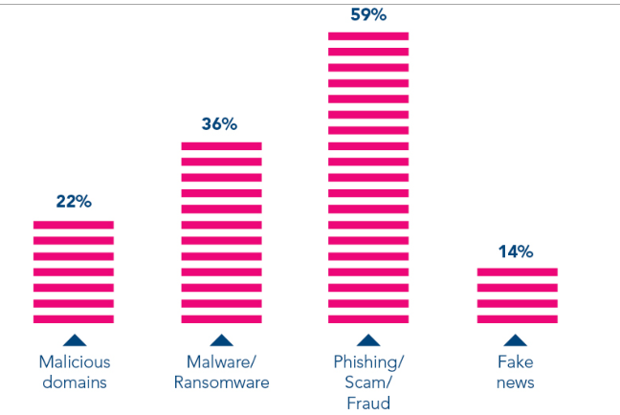
Figure 1 [34]
1. Phishing attacks: One of the most common attacks that organizations face is phishing attacks. Phishing attacks involve sending fraudulent emails, instant messages, or social media messages that appear to be from a reputable source. These messages are designed to trick the recipient into clicking on a link or downloading an attachment that contains malware. Once the malware infects the system, it can steal sensitive data or allow attackers to gain unauthorized access to the network.
2. Distributed Denial of Service (DDoS) attacks: A DDoS attack is a type of cyber-attack where a large number of devices try to access a website or server simultaneously, overwhelming the system and causing it to crash. DDoS attacks are often launched by cybercriminals to extort money from the victim or to cause disruption to their services. DDoS attacks can also be used as a distraction technique to hide other cyber-attacks.
3. Ransomware attacks: Ransomware is a type of malware that encrypts the victim's files and demands payment in exchange for the decryption key. Ransomware attacks are often launched by cybercriminals to extort money from the victim. These attacks can cause significant damage to an organization's reputation and operations.

There should be at least three test to be conducted on the network to check network security of the network, they are:-
Penetration testing is a simulated cyber-attack that attempts to identify vulnerabilities in the system that an attacker could exploit. It involves identifying weaknesses in the network, exploiting them, and testing how far an attacker can gain unauthorized access to the system. The purpose of penetration testing is to identify vulnerabilities before an actual attacker can find them and exploit them.
Vulnerability scanning involves using automated tools to scan the network infrastructure for known vulnerabilities. The tools search for vulnerabilities in software, operating systems, and network configurations. Vulnerability scanning can identify weaknesses that an attacker could exploit and can also help to identify areas where security patches need to be applied.
A security audit is a comprehensive review of the network infrastructure's security policies, procedures, and controls. The audit can be conducted by an internal or external auditor and can identify areas of weakness in the system. The audit can also help ensure that the organization is compliant with relevant regulations and standards.
These tests should be conducted periodically to ensure that the network infrastructure remains secure over time. As new threats emerge and technology evolves, the network infrastructure's security can become outdated. By conducting regular tests, A2Z can identify vulnerabilities and weaknesses in the system and take steps to address them

