SAMEEKSHA JAYRAM
STUDENT NUMBER- 2104985
BA HONS GRAPHIC DESIGN
TUTOR- DONNA WILLIAMS
WORDS- 2460
Investigate the digital graphic design revolution of the mid 1980s. Discuss the work of 3 designers who embraced this new technology to challenge the past and define the future.

I think we can all agree that graphic designers love change. It and hardware and software advances have changed our world dramatically. These advances also influenced a designer’s point of view.
From cave to computers, there has been a huge leap in graphic designs and it can be evidentially seen in the works of various designers. For many people, Swiss design is very synonymous with Helvetica- which in fact means Swiss (in Latin, Switzerland was Confederatio Helvetica). This was designed in 1957 and hit the market in 1960.

The birth of graphic design as such can be dated to the 19th century, when “arts and crafts” and the “applied arts” first began to distinguish themselves from so-called “fine art” (i.e. painting, sculpture and architecture) and establish independent institutions of study. (Bigman, 2016) Post modernism was a huge part in graphic design revolution, where an explosion of creative activity was seen. This was also a period where designers re-examined existing rules and came up with new approaches.
An early use of postmodernism specifically in reference to graphic design occurred in 1977 when the American designer Wilburn Bonell curated an exhibition titled postmodern typography : recent American developments” at the Ryder gallery in Chicago.
Greiman’s covers for the CalArts viewbook and for an issue of the west coast magazine wet in 1979 exemplify many characteristics of the new works. Her electric visual language draws from surrealism, art deco, and ornamental pattern making. “Modernist designers from the Bauhaus in Germany, the De Style in Holland, and Constructivism in Russia, share essentially the same Modernist ideology as designers like Paul Rand, Massimo Vignelli, and Eric Spiekermann.”(Poynor, 2013)

One of the most important movements, which might potentially be why the world looks like the way it does today is called swiss design movement, or international typographic style. A minimal and organised design aesthetic that uses grid systems and sans-serif typography. It prioritised function over decoration, claiming that the content of the work should tell the story rather than the design itself. Modern web design still uses the grid system rule like 50s. NYC’s subway design led by Massimo Vignelli and Bob Norda. They took New York’s previously chaotic design and turned it into cohesive minimalist experience as seen in Figure 1.
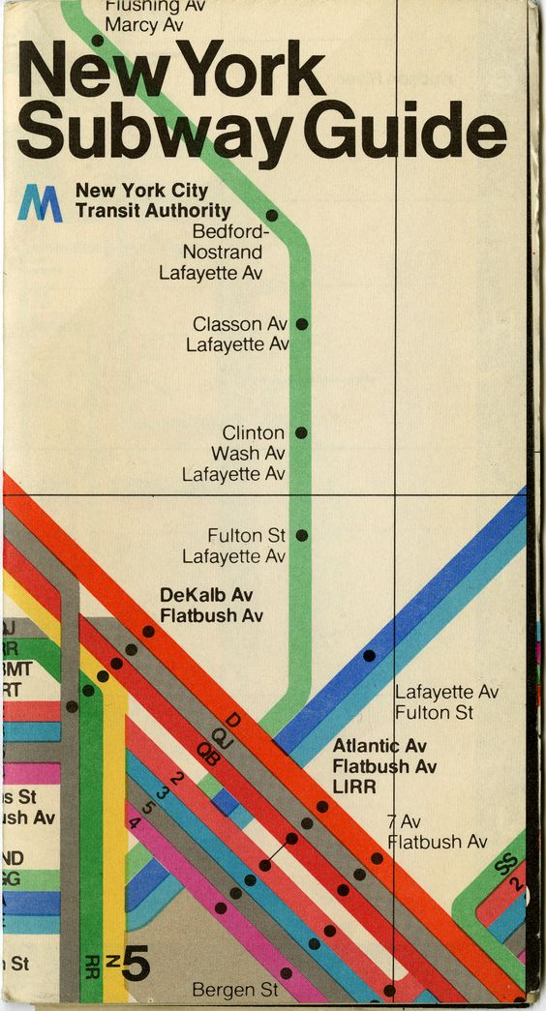
Figure 1
Of course swiss did not create this modern approach out of nowhere. It can be said that they have been inspired by past movements spanning roughly from 1914 to 1939.
Some of the main characteristics of the swiss design movements which we can occlude after looking at works from different artists are the use of grid system, where almost every design starts with a grid, to put information in a consistent and logical way. Josef Muller Brockmann helped spread the main ideas of grid systems. Photography, Swiss typography such as Sans Serif and Helvetica ,Asymmetry, White space and minimal shapes are also some of the other characteristics of this design.
“This era prepared a strong foundation for a future generation of designers. Attention to detail, technical training, and the use of grid systems for organization are strong traits that developed during this era. This is what gives the posters of the Swiss Style a timeless look that continues to have a strong impact amongst audiences.”(Keung, 2021)

Its influence is still seen today, recognisable in corporate publicity and highway signs from Amsterdam to Tokyo and from London to Los Angeles. Major texts on swiss design like Josef Müller Brockmann’s The Graphic Artist and His Problems in 1961; Gerstner’s Designing Programmes, first published in English in 1964; Hofmann’s Graphic Design Manual in 1965; and Müller-Brockmann’s Grid Systems in Graphic Design in 1981.

Other important design style were neon noir, Memphis, cyberpunk, and tropical. Neon Noir is linked with the graphic designers seen on film and television show posters such as Miami Vice, To Live and Die in LA, Risky Business, Thied, Taxi Driver (1976) and David Lynch films such as Blue Velvet (1986) and Lost Highway (1997). Cyberpunk is basically a representation of future technology and cyberspace. Memphis design in the 1980s is basically a style characterised by brightly coloured shapes and lines which are scattered. It typically consist of circles and triangles with black and white graphic patterns such as polka dots and squiggly lines. These include the abstract shapes and colours of Cubism, De Stijl and Harlem Renaissance art.
But no style was more influential on Memphis Design than modern minimalism. Memphis objects were most striking for their use of plastic laminates printed with a wild variety of colourful patterns “WWII further escalated this sentiment as shortages in materials led to largely sparse, utilitarian styles that carried over as the decades marched on”. (99designs, 2021) Ad campaigns like “Where’s the Beef?” from Wendy’s (1984) and “Just do it “ from Nike (1984) started during this time as well. Films like real genius and music videos by Thomas Dolby has a digital look, with prevalence of grids and computer font based graphic text. A lot of designs also used geometric patterns and complimentary colour schemes to give their design a futuristic feel as a lot of people in the 1980s were future inclined.

“In the years after the World War I, visual arts moved beyond the threshold of pictorial imagery towards the invention of pure form. Frank Lloyd Wright, the Glasgow group, the Vienna Secession, Adolf Loos, Peter Behrens, and other graphic designers, architects, and product designers began challenging prevailing notions about form and function. The emergence of the Bauhaus allowed for the modern design aesthetic to emerge, and some of the most famous graphic designers to emerge. In these post-war years, an idea that the good design meant good business also emerged. Many famous graphic designers such as Frank Stanton or William Golden started creating corporate identity for brands that still remain today. The graphic design was shaped for centuries by brave pioneers who explored new forms of expression and visual communication. With so many styles of graphic design and different schools of thought, there are countless creatives who have done their part in shaping the industry in some way.” (www.widewalls.ch, n.d.)

- Armin Hofmann - The Legend of Swiss Design
Armin grew up during the time of swiss graphic design “A legend of Swiss graphic design, Armin Hofmann is recognized for his immeasurable influence on generations of designers. A celebrated teacher at Allgemeine Gewerbeschule Basel School of Art and Craft, his teaching methods were unorthodox and broad-based. His timeless aesthetic was characterized by power and elegance of simplicity and clarity. This famous graphic designer consistently emphasized that design should have a context and meaning, making his work a paragon of effective, timeless and thoughtful design. Relying on the fundamental elements of graphic form - point, line, and shape, Hofmann created a body of work enormously varied - books, exhibitions, stage sets, logotypes, symbols, typography, posters, sign systems, and environmental graphics. “(www.widewalls.ch, n.d.)
Hofmann has been described as one of the most outstanding personalities in Swiss graphic design history. Hoffman has spent much of his career designing posters because he felt that it was one of the best and most efficient forms of communication. His book graphic design module is still an well used reference book for new designers. Hofmann felt that one of the best and most efficient forms of communication was the poster and he spent much of his career designing posters, in particular for the Basel Stadt Theatre.
His ‘Graphic Design Manual’ was, and still is, an excellent reference book for graphic designers
“It showed new techniques of photo-montage, photo-typesetting, experimental composition in general and of course heavily favoured sans-serif typography. It could be said that Hofmann devoted his entire professional life to bringing a creative and artistic integrity to the world of graphic design.” (Designers journal, 2012)
“As a human being he is simple and unassuming. As a teacher, he has few equals. As a practitioner, he ranks among the best” “…He is a rare bird, a daredevil driver, a mountain climber, a teacher par excellence, and a guru. Yet it is difficult, really, to pin him down.”– Paul Rand of Hofmann
Hoffman’s. His posters have been shows as works of art in art galleries round the world. His work is varied from books, exhibitions, logos etc. His posters can be seen to be using a small use of colour and fonts called the “trivialisation of colour”.

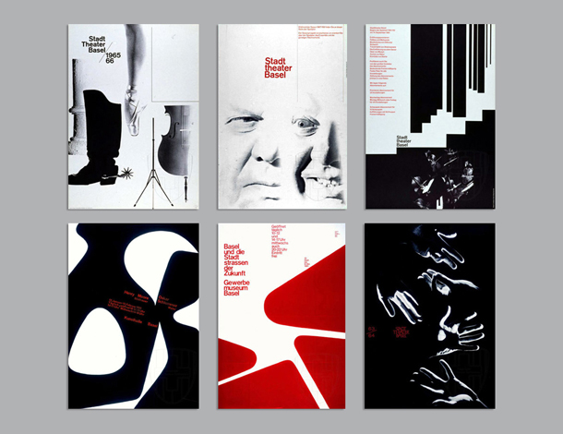
Figure 2
As seen in the above pieces (Figure 2) , Hoffman created numerous posters throughout the 1950s and 60s for the Basel city theatre. The first piece ( top left ) is one of his most famous which he often referred to as feet, because of the incorporation of a ballet slipper and a cowboy boot. His approach of presenting information was used by the theatre throughout the given season, where he utilised a rectangular box to update the weekly schedule of the events.
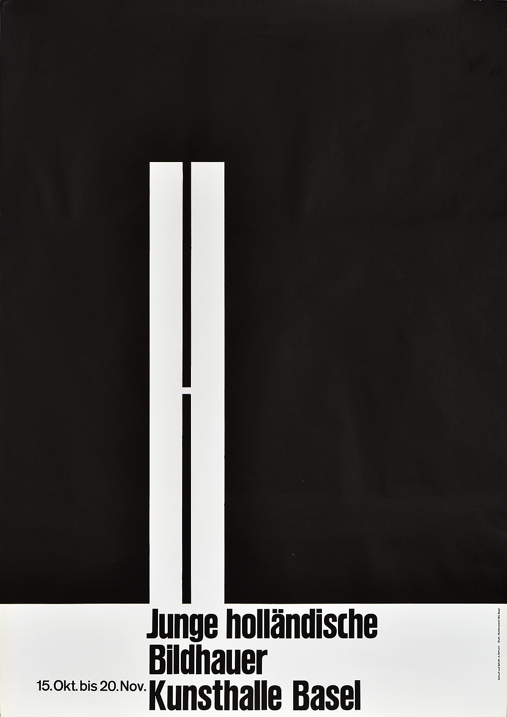
Figure 3
When the majority of his works are knows for photo-offset lithography, Hoffman was also a known for letterpress printing which can be seen in the design above (Figure 3), which was for an exhibition of “Dutch sculptors at the Kunsthalle Basel”. Slight irregularities in the giant “h” can suggest that he used hand cut lino to create the designs.
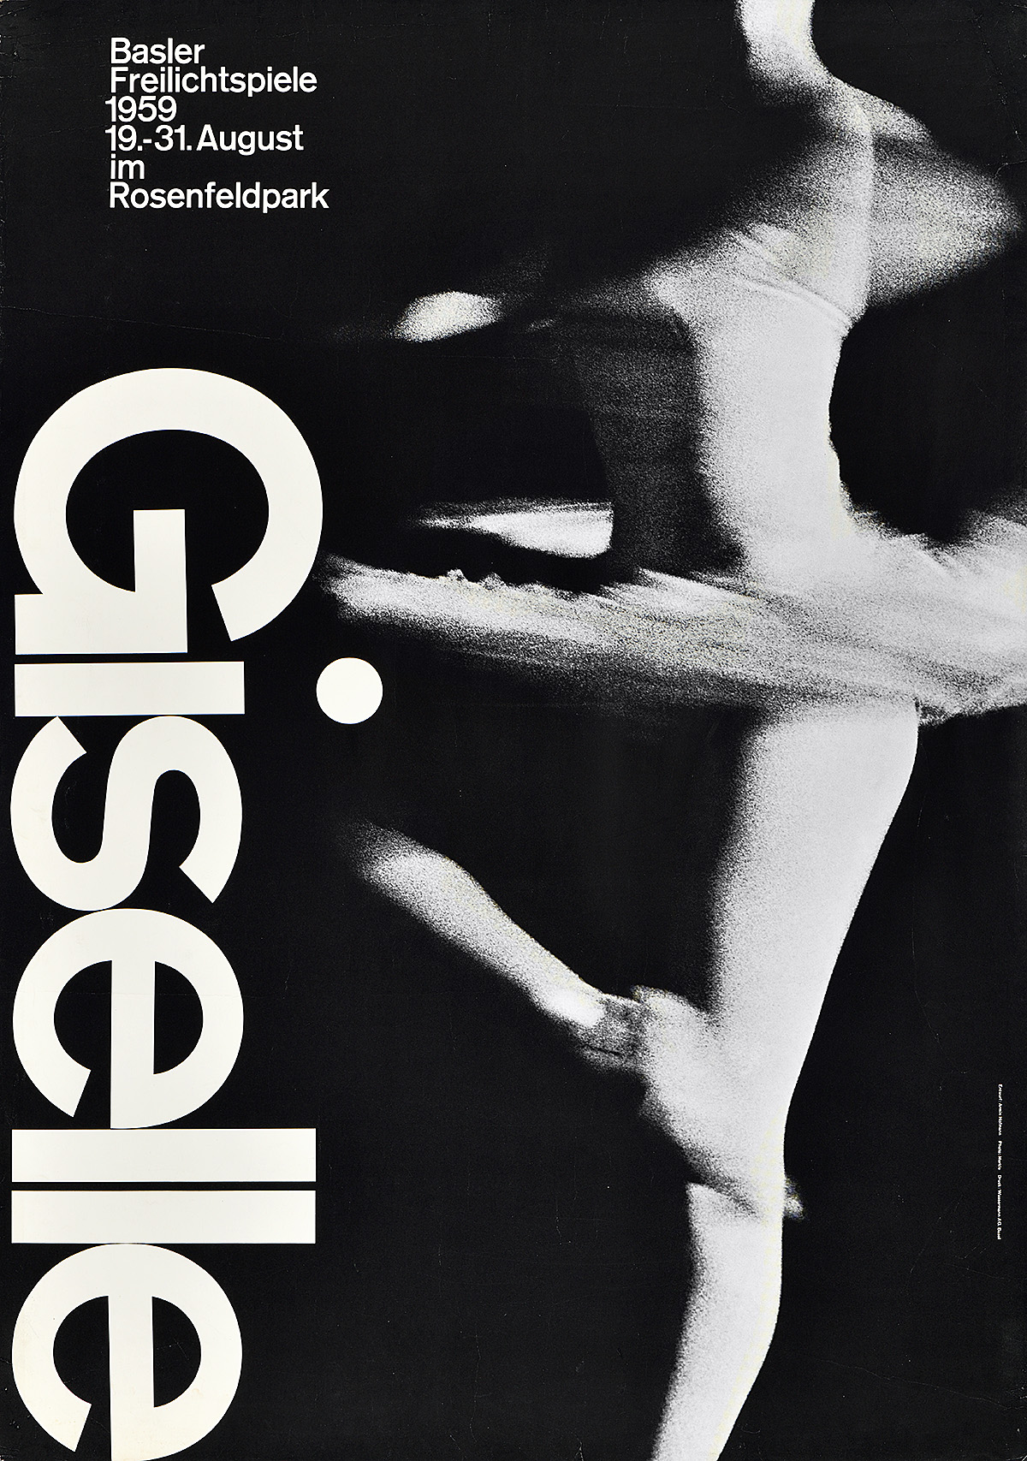
Figure 4
I think the poster above( Figure 4) is one of his most enduring posters, which was for an outdoor production of Giselle. The dot on top of the I, extends beyond the actual letterform, which is subtly nodding to where the dancer’s knee would be. The poster also elegantly suggests movement rather than just a human figure. Katie Crotty’s presentation about Armin Hoffman’s trivialisation of colour theory explains why Hoffman used black and white in his posters where it’s said that Hoffman believes that “someone is more likely to gain a better sense of colour by looking at the subtle harmonies of black and white images than by looking at over the top colourful images”

- CHIP KIDD
While Hoffman is best known for his covers, Chip is best known for his book covers. He has both designed covers for DC and wrote some of their comics too. He has designed around 70 book jackets and has booked for companies like Amazon, Penguin, Columbia university press and Doubleday.
The cover of Jurassic park is one of his most famous works. (Figure 5)
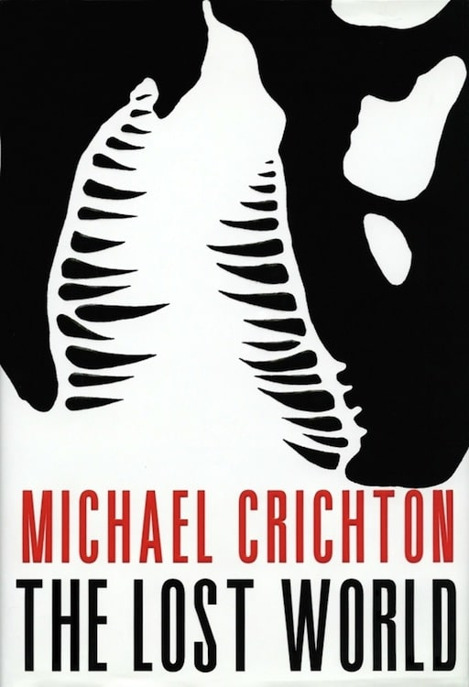
Figure 5
This poster features the skeletal silhouette of a tyrannosaurus rex which creates a slight haunting feeling l. Kidd said, “Because the cover was used for the visual identity of the film, it became one of the most recognizable icons of the 1990s. My obituary will probably lead off with this and not go much further.” (www.aiga.org, n.d.)

It can be said that a lot of chip’s work were like puzzles for the viewer to solve. Since he works with book design, he is often seem to be suggesting themes and clues to the reader about the book.
“It’s not an easy thing to do without getting heavy-handed, but he manages to toe that line perfectly
Kidd is known for his lack of interest in new design trends and his work often harkens back to inspiration from memorabilia and collectibles of the past. ” (Bernabi, 2015)

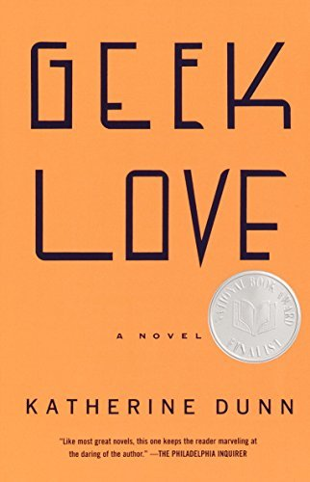
Figure 6
The cover above ( figure 6) has also made an impact because of how simple it is. Just a powerful set of typefaces with a vibrant orange background. Chip Kidd has one of the widest variety of book cover design, with ever cover have its own unique style. In an interview in the Spark and Fire podcast, Chip says how “in book cover design, it’s not quite like that. We live from cover to cover.
There was no way I was going to be able to do another Jurassic Park. It just doesn’t work that way. You can’t do it. The only thing I could do that looked remotely like it was the sequel, The Lost World, okay? Each book is different. I can’t approach another book cover that way because it’s a different book. It would be, I don’t know, aesthetically dishonest to try and copy it.” (Spark and Fire, n.d.)

- NOMA BAR
Noma bar’s work has appeared in many media publications including : time out London, BBC, random house, the economist. He has illustrated over 100 magazine covers, and even release three books of his work: Guess Who- The Many Faces of Noma Bar in 2008, Negative Space in 2009 and Bittersweet in 2018.
Noma Bar has is know for transforming flat illustrations to different forms like 3d wood cuts and light boxes . He also says in his website how he is after the maximum communication with minimum elements” (Dutch Uncle, n.d.). He earned the reputation of a master of illusory illustration. His images have uncanny likeness, even though they only consist of few shapes and lines.
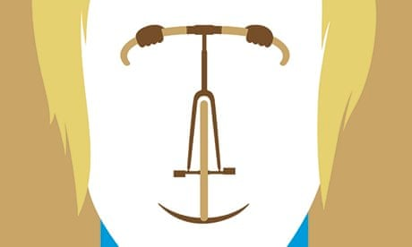
Figure 7
For a celebratory cover of the metro newspaper (Figure 7), he took an image of the racing bike, added blonde hair and turned it into the face of Bradley Wiggins. It can be said that his style of bold block colours comes from a range of precedents like Russian constructivist propaganda and art deco film posters, as well as traditions of Milton Graser, Alan Fletcher etc. (Can be seen in figure 8)

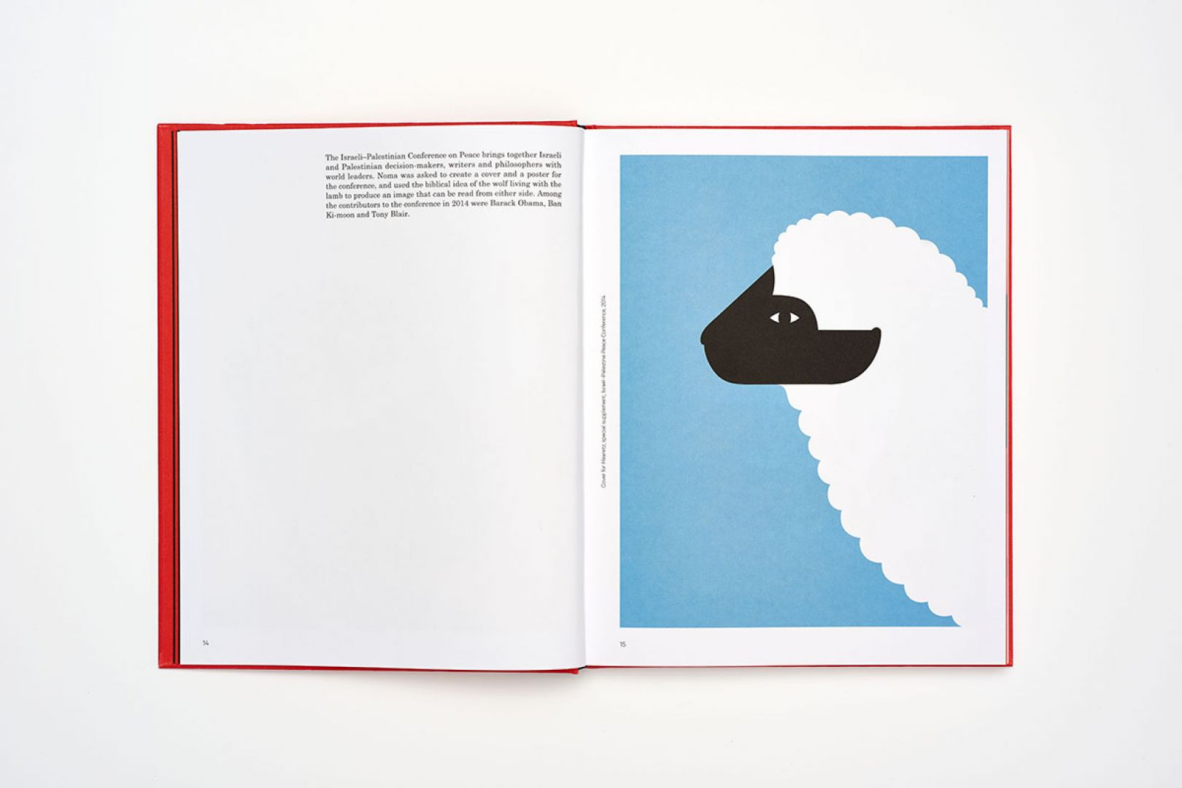
Figure 8
Bar on his interview with creative boom said, “When I’m using words, I feel like they’re not the right communication tool for me. The natural place would not be on the stage to give a talk about my work. I prefer using strong visuals and images to tell stories.” (Creative Boom, 2018). “Noma Bar's ingenious and uncanny illustrations have taken portraiture into a new dimension.” (the Guardian, 2013)
Bar was deeply inspired by pictograms and silent comedies, the art of conveying your message without words. Looking at his wide variety of works, we can take that he sits somewhere at the intersection of caricature, editorial cartooning and graphic design. He executes complex ideas with stunning and deceptive simplicity.

Thus to conclude, we can all agree that graphic design went throughout a series of changes right from its origin. Starting from as basic as cavemen drawing buffalo on the wales of caves to not being able to imagine a graphic design studio without computers equipped with the standard adobe software, we have come a long way. “Music and graphic art evidenced a desire to break the rules and the courage to cross boundaries” (Brändle and Museum Für Gestaltung Zürich, 2014)

These designers, with their unique style, be it negative space, use of pictograms and use of less than three colours respectively, have challenged the existing rules of graphic design and decided to have their own style in design.

BIBLIOGRAPHY
Figure 1- Collective.org, L. (2020). NYC Subway Guide, designed by Massimo Vignelli, 1970. Available at: http://www.laacollective.org/work/all-archives-are-design-archives.
Figure 2 issuu.com. (n.d.). Armin Hofmann, Trivialization of Color by Katie Crotty by Maine College of Art - Issuu. [online] Available at: https://issuu.com/mecagd/docs/kc_ah_gd102_2018.

Figure 3 House, P. (2020b). Junge Holländische Bildhauer, 1960. Available at: https://www.posterhouse.org/wp-content/uploads/2020/12/PH191122_4716-copy.jpg.

Figure 4 House, P. (2020a). Giselle, 1959. Available at: https://www.posterhouse.org/wp-content/uploads/2020/12/PH191122_4605-copy.jpg.
Figure 5 Kidd, C. (n.d.). JURASSIC PARK: THE ORIGINAL TOPPS TRADING CARD SERIES. Available at: https://chipkidd.com/home/wp-content/uploads/2021/12/JURASSIC-PARK-THE-ORIGINAL-TOPPS-TRADING-CARD-SERIES-Chip-Kidd-1.jpg [Accessed 2020].

Figure 6 reads, G. (n.d.). Geek Love. Available at: https://images-na.ssl-images-amazon.com/images/S/compressed.photo.goodreads.com/books/1547399665i/10917689.jpg.

Figure 7 the Guardian. (2013). Noma Bar: ‘My work is a painkiller’. [online] Available at: https://www.theguardian.com/artanddesign/2013/nov/11/noma-bar-portrait-artist.

figure 8 Boom, C. (n.d.). Wolf and sheep. Available at: https://www.creativeboom.com/uploads/articles/5f/5fe083258b6b95b1295cfbdcbb67bae481ab47fa_1620.jpg.

Bigman, A. (2016). What exactly is Swiss Design, anyway? [online] Available at: https://99designs.com.au/blog/design-history-movements/swiss-design/?1539378116=.
Poynor, R. (2013). No more rules : graphic design and postmodernism. London: Laurence King.
Keung, L. (2021). What is Swiss Design and Why You Should Know its History. [online] Design & Illustration Envato Tuts+. Available at: https://design.tutsplus.com/articles/what-is-swiss-design-and-why-you-should-know-its-history--cms-38463.
99designs. (2021). Memphis Design: How the Defining Look of the 1980s Is Making a Comeback. [online] Available at: https://99designs.co.uk/blog/design-history-movements/memphis-design/.
Designers journal. (2012). Heroes – Armin Hofmann | Designers Journal. [online] Available at: http://www.designersjournal.net/jottings/designheroes/heroes-armin-hofmann.
the Guardian. (2013). Noma Bar: ‘My work is a painkiller’. [online] Available at: https://www.theguardian.com/artanddesign/2013/nov/11/noma-bar-portrait-artist.

www.aiga.org. (n.d.). Talks | Chip Kidd | 2014 AIGA Medalist: Chip Kidd | AIGA. [online] Available at: https://www.aiga.org/inspiration/talks/chip-kidd-2014-aiga-medalist-chip-kidd [Accessed 5 Dec. 2022].
Bernabi, A. (2015). Who Is Chip Kidd? [online] Logoworks. Available at: https://logoworks.com/chip-kidd-profile/.
Spark and Fire. (n.d.). Spark & Fire: Chip Kidd on the Jurassic Park cover. [online] Available at: https://sparkandfire.com/chipkidd/.
Dutch Uncle. (n.d.). Dutch Uncle - Noma Bar. [online] Available at: https://www.dutchuncle.co.uk/noma-bar/.
Creative Boom. (2018). Noma Bar on his favourite work, developing his style and saying a lot without using words. [online] Available at: https://www.creativeboom.com/features/noma-bar/.
BrändleC. and Museum Für Gestaltung Zürich (2014). 100 years of Swiss graphic design. Zürich: Lars Müller.

