

WRITTEN REPORT (BUSINESS PLAN)

Programme Name: BA (Hons) Business Management
Module Title: Entrepreneurship
Module Code: LCBB5001

Lecturer Name: Masud Ibrahim
Student Name: Md Abidur Rahman
Student ID: 1815081

Date of Submission: 28-10-2024
Contents
OVERVIEW OF THE BUSINESS IDEA, PRODUCTS OR SERVICES 3
LEGAL FORMAT OF THE COMPANY 4
MANAGEMENT OF THE COMPANY (OWNER, WORKERS, AND STANDARDS FOR OUTSOURCING PROFESSIONALS/EXPERTISE) 6
EVALUATION OF THE BUSINESS IDEA USING THE SWOT ANALYSIS MODEL 9
APPLYING THE 4PS OF MARKETING TO THE BUSINESS IDEA 12
CASH FLOW FORECAST FOR THE FIRST 12 MONTHS 14
CONCLUSION 15
REFERENCES 16

OVERVIEW OF THE BUSINESS IDEA, PRODUCTS OR SERVICES
The business idea lies in creating a new clothes brand targeted at conservative green consumers and selling environmentally friendly, easily adjustable clothing. As for this brand, the primary strategy will be to create perfect-fit garments made from organic, recycled, and/or traded fabrics. Every product will be developed with an option to use different modules that can change the colours, patterns or style according to the customer’s choice (Novaković et al., 2020). The main apparels of operation will be T-shirts, Jackets and accessories bearing the Hepatitis B symbol and a variety of connection clothing as could be ordered online. This interactivity connected option will have a significant positioning point in the brand setting where customers can involve themselves in helping to design their clothes, made to order, which will help to reduce wastage in the production line (Koo and Ma, 2019). Also, the business will embrace a circular economy model as it will provide clothes for repair, second-hand clothes to be taken back for recycling. Digitalizing the store and sustainability strategies also focus on a stimulating increasing niche of consumers who are always looking for the latest trends with an understanding of the environment (Dombek, 2008). Using the £25, 000 in the initial capital, the business will concentrate on the development of a friendly e-business site, sourcing for ethical suppliers and creating awareness of the business and its unique selling proposition among the target consumers.

LEGAL FORMAT OF THE COMPANY
First, The legal structure of this business formation is a private limited company (Ltd), The UK encourages this kind of formation especially to new startups for various reasons as follows, flexibility, the owners’ limited responsibility and convenience in capital suitability. It is the organisation of this type that has a different legal entity as a private limited company because the shareholders and directors will never be legally responsible for the business. Among them, this structure is especially useful for start-ups that often look for external investment: often such investors prefer to work with such companies that have the concept of limited liability that can provide different risks and owes mentioned above.
Advantages of a Private Limited Company (Ltd):
1. Limited Liability: The shareholders also cannot ask for immunity for their personal assets during business economic difficulties or legal disputes because their risks are only to the value of property they invested within the business venture.
2. Separate Legal Entity: For a private limited company it means that the company is a legal aspect of the company possessing identities of its own. As a result, the idea is that the company is capable of buying assets, the company may enter into agreements, and the company can be legally prosecuted independently of shareholders and directors of the company.
3. Ownership and Control: The business can be sold and split, and this makes it easier for a business to obtain capital through sale of its stocks. Since it is a private company, it cannot offer the shares to the public placing the stocks in the stock exchange market and this tell us that there is much control in the hands of founders and initial shareholders.
4. Tax Efficiency: The UK’s private limited company benefit from corporate taxation that might be below the income tax for individuals. In addition, it costs apparently less to distribute the amount to the shareholders in form of dividends as indicated by the figure Income.
5. Credibility and Trust: In business world it is highly desirable to have the confidence of the customer, supplier and investors, and this confidence can be secured easily by incorporating the business as a limited company rather than sole trader or partnership.
Key Considerations for Setting up an Ltd Company:
- Registration and Compliance: To register the company with Companies House and to legally trade under the business name, the name chosen can’t be a clone of another business and cannot be misleading (David and Jane, 2019). Correct Memorandum and Articles of Association will be made and draft out how the company is to be regulated, those of the shareholders and directors inclusive.
- Directors and Shareholders: One director is mandatory while they must perform legal duties including making sure that the filing needs of the company are met. In the first stage of establishment, the company will be private, the intent of the owner will overwhelm the company, and decision-making authority of major strategic business activities will be within the province of the owner.
- Reporting Requirements: Like any other private limited company in the United Kingdom, the business will be expected to prepare annual accounts and tax returns to HMRC. This requires a little bit of paperwork than a sole proprietorship company, but it affords and fosters transparency and accountability which many investors look at before investing (Blank, 2020.).
This choice of legal structure guarantees the form sustains the required protections, authenticity and financial freedom which the business needs to attract £25, 000 and compete in a challenging market.

MANAGEMENT OF THE COMPANY (OWNER, WORKERS, AND STANDARDS FOR OUTSOURCING PROFESSIONALS/EXPERTISE)
As for the organization of the management in the startup, it will be effective, with defined goals on the growth of the company, as well as with the elements of the division of powers (McGrath, 2012). Due to the nature of this business as a start-up company, it will have its management team integrated in a strict manner to enable small establishment; however, it will employ the services of qualified professionals in key areas of specialization outside the management.
Owner and Leadership Team
The company will be created and owned by [Your Name] with [Your Name] acting both as the company’s CEO and ultimately making all major decisions. The owner of this company will have a background in the sustainability of fashion and business management as well as the social impact of the fashion industry as he or she will provide vision and leadership of the company in the areas related to product decisions, marketing and financial decisions (Narkunienė and Ulbinaitė, 2018). Since the owner will be formally launched into this position as the CEO, he or she will be charged with the responsibility of presenting the vision of the company, managing investors relations and providing overall leadership especially during the formative stages of the company when key funding and branding strategies are being determined.
Employees
Initially, the business will employ a small team of key personnel to manage day-to-day operations:
- Operations Manager: It is in charge of supply chain, where proper materials from ethical suppliers are sourced and supplied on time, made to order products. This role will make sure that feasibility of the sustainability objectives of the business is maintained throughout the cycle of the production process.
- Marketing and E-Commerce Manager: This individual will be the firm’s online mediator, who will be taking care of the online store and the social media marketing accounts. It is going to be solely involved with consumer relations, leading digital promotions and analysing web sales metrics.
- Customer Service Representative: For further assistance, a specific customer caretaker will address issues concerning the specific products to be ordered, changes made on the product and also issues on returns and It is in charge of supply chain, where proper materials from ethical suppliers are sourced and supplied on time, made to order products. This role will make sure that feasibility of the sustainability objectives of the business is maintained throughout the cycle of the production process.
This individual will be the firm’s online mediator, who will be taking care of the online store and the social media marketing accounts. It is going to be solely involved with consumer relations, leading digital promotions and analysing web sales metrics
For further assistance, a specific customer caretaker will address issues concerning the specific products to be ordered,
- repair services for the respective products hence promote consumer satisfaction and their continuous patronage of the company’s products.

With increasing business, new coworkers may be required for such fields as stock, product development, demand increase for customer support.

Terms & Conditions for Hiring External Professional Services/Experts
Some of the organization’s functions must be outsourced to independent personnel in order to keep lean and avoid rising costs (Breyer et al., 2021). Key external services will include:

- Accountant: Accountant is going to be hired, who will have qualification of handling all accounts related work including books of accounts, taxes, and financial statements. Besides, they will make sure legal requirements are being followed and offer sound financial directions for expansion.

- Legal Advisor: Intellectual property and contract legal services will be hired as the legal consultant for this company to safeguard the trademarks used for the brand and guarantee that the company entrenches proper ethical mechanisms in supplier contracts.

- Website Development and IT Support: A professional web developer is going to be hired and will be responsible for the design of the e-commerce platform and maintenance of the customization feature of the platform. IT also support services will be outsourced to manage the company’s cyberspace and assure optimal IT operations.

This lean management model coupled with entitle professional assistance will keep the company lean while at the same time gaining the necessary professional industry input to build the foundation for a stable viable business.

EVALUATION OF THE BUSINESS IDEA USING THE SWOT ANALYSIS MODEL
Applying the SWOT analysis, it is possible to make a brief critical evaluation of the business idea to set up a sustainable fashion brand that would offer environmentally friendly custom-made clothes.

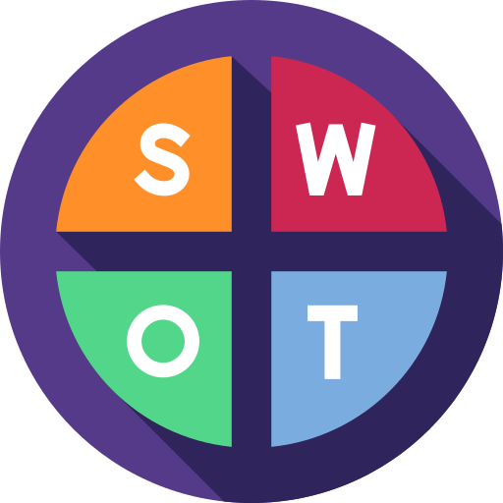

[Figure: SWOT Analysis]

Strengths
- Sustainability Focus: It bases its operations on rising people’s awareness of the environment and orders its products, materials from certified organic farms and recycled products.
- Customization: Clients are free to incorporate their designs on their wears; the USP indicating that the brand is unique in the market (Teoli et al., 2019).
- Circular Economy Approach: Through repair services and take back recycling program the company supports more of its environmental policy as well as its consumers.
- Made-to-Order Model: From this point, there will be less wastage since goods are produced based on the orders, which meet the firm’s environment concern.

Weaknesses
- High Production Costs: Selecting proper foregin material and affirm manufacturing excellent is little costly process than ordinary methods and therefore the profits and as later margins may be little affect (Benzaghta et al., 2021).
- Limited Brand Recognition: In the fashion industry, the brand can only be communicated to the customers and recognize by the target group after sometimes.
- Reliance on Digital Channels: Since the business majors in the online platform on at which to sell the products, there could be a chance to sell to those customers who still prefer to shop physically.
Opportunities
- Growing Demand for Sustainable Fashion: Consumption that is social and sustainable is on this rise across the globe, globally this is presenting good market opportunities.
- Technological Advancements: With influx in the environmentally friendly material and technology then can be used to upgrade the product of clothing.
- Partnerships with Eco-conscious Brands: Businessmen engaged in the same line of business should cooperate to many businesses and explain High Production Costs: Selecting proper foreign material and affirm manufacturing excellent is little costly process than ordinary methods and therefore the profits and as later on margins may be little affect (Benzaghta et al., 2021).
- Limited Brand Recognition: In the fashion industry, the brand can only be communicated to the customers and recognize by the target group after sometimes.
- Reliance on Digital Channels: Since the business majors in the online platform on at which to sell the products, there could be a chance to sell to those customers who still prefer to shop physically
- Growing Demand for Sustainable Fashion: Consumption that is social and sustainable is on this rise across the globe, globally this is presenting good market opportunities.
- Technological Advancements: With influx in the environmentally friendly material and technology then can be used to upgrade the product of clothing.
- Partnerships with Eco-conscious Brands: Businessmen engaged in the same line of business should cooperate to many businesses and expand its Miller circulation.
Threats
- Competition: The market of sustainable fashion is still emerging but there are increasing numbers of proposals for different segments and some of leaders covering the niche of sustainable fashion.
- Economic Instability: Listening to the economy, change of customer habits that may lead to reduced or low disposable income may reduce the capacity of customers to pay for sustainable products (Phadermrod et al., 2019).
- Supply Chain Disruptions: Ethical suppliers may be disadvantageous to the company because they expose the business to several supply chain risks including delay and disruption.
SWOT can reveal some of the opportunities and challenges for an organisation which is useful for operations strategy and level planning and for the assessment of competitive threats.

APPLYING THE 4PS OF MARKETING TO THE BUSINESS IDEA
The four-marketing mix can be defined as A marketing mix is the principal blend of concepts that convey a marketing plan.

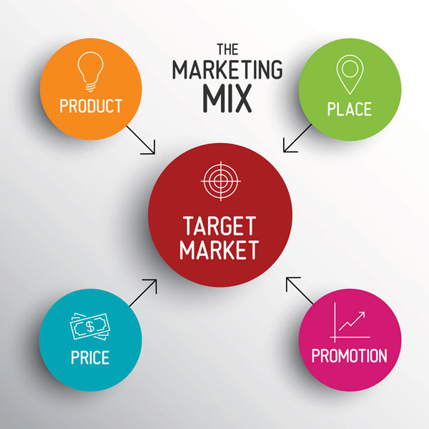

[Figure: Marketing Mix]

Product: The business of fashion and apparel will involve a range of designs that are; organic, recycled and that has facility to order on consumers’ ideas. Some of the products produced for the current range are T-shirts, Jackets, and This is coupled with an option to order custom made items from the comfort of one’s home with such links (Raewf and Thabit, 2018).
Price: Since quality fabric materials used to produce the garments are quality and sustainable and people can opt for customization, the garments will be sold at premium prices. It will be priced as any other brand manufactured by Schneider a relative discount will be given to the regular customers and those people who recycle their products.
Place: The first target distribution channel will be an online store, being an effective way of reaching clients from all over the world by means of DTC with no intermediaries (Lahtinen et al., 2020). This will make it friendly for mobile device users since this platform will be designed to improve shopping.
Promotion: Existing and prospective consumers of social media marketing shall be considered especially Instagram and TikTok since majority of them are environmentally sensitive. Larger amounts spent with influencers who can create green content, the usage of better and more effective SEO, and more examples of the brand will increase the popularity and the desired customer base among the public.

CASH FLOW FORECAST FOR THE FIRST 12 MONTHS
They will begin with an initial capital of $25,000, all which will be properly utilized to cater for important initial business expenses.

- Month 1-3 (Setup Phase):
Website development: £5,000
Initial stock/materials: £4,000
Marketing and branding (social media, influencer campaigns): £3,000
Legal and accounting services: £2,000
Total: £14,000
- Month 4-6 (Launch Phase):
Marketing campaigns: £2,500
Operations and wages (staff/outsourced services): £3,000
Production costs (made-to-order manufacturing): £2,000
Total: £7,500
- Month 7-12 (Growth Phase):
Ongoing operations, marketing, and logistics: £3,500
Expansion and new product development: £2,500
Total: £6,000
Projected Revenue:
Month 4-12: Predicted the revenue of £20,000 with gradual increase in sales.
This forecast also helps ensure that £25,000 of funding is administered effectively while trying to build the brand and get the company started.

CONCLUSION
Here is a comprehensive business plan recommending sustainable fashion brand that caters for the today’s market trends (Karim et al., 2020). Focusing once again on customization strategy, sustainability, and innovation, the firm is suited for growth strategies. The £25,000 will allow the business to set up and grow where competition is high.

REFERENCES
Benzaghta, M.A., Elwalda, A., Mousa, M.M., Erkan, I. and Rahman, M., 2021. SWOT analysis applications: An integrative literature review. Journal of Global Business Insights, 6(1), pp.54-72.
Blank, S., 2020. The four steps to the epiphany: successful strategies for products that win. John Wiley & Sons.
Breyer, C., Lederer, J. and Gasteiger-Klicpera, B., 2021. Learning and support assistants in inclusive education: a transnational analysis of assistance services in Europe. European Journal of Special Needs Education, 36(3), pp.344-357.
David, N. and Jane, B., 2019. Business in Context: An Introduction to Business an its Environment. Cengage Learning, Inc.
Dombek-Keith, K.M., 2008. Re-fashioning the future: eco-friendly apparel design.
Karim, N., Afroj, S., Lloyd, K., Oaten, L.C., Andreeva, D.V., Carr, C., Farmery, A.D., Kim, I.D. and Novoselov, K.S., 2020. Sustainable personal protective clothing for healthcare applications: a review. ACS nano, 14(10), pp.12313-12340.
Koo, S. and Ma, Y.J., 2019. Environmentally responsible apparel consumption and convertible dresses. Journal of the Korean Society of Clothing and Textiles, 43(3), pp.327-348.
Lahtinen, V., Dietrich, T. and Rundle-Thiele, S., 2020. Long live the marketing mix. Testing the effectiveness of the commercial marketing mix in a social marketing context. Journal of Social Marketing, 10(3), pp.357-375.
McGrath, A.S., 2012. Fashioning sustainability: How the clothes we wear can support environmental and human well-being. Sustainable Fashion, 1, pp.1-24.
Narkunienė, J. and Ulbinaitė, A., 2018. Comparative analysis of company performance evaluation methods. Entrepreneurship and sustainability issues, 6(1), pp.125-138.
Novaković, M., Popović, D.M., Mladenović, N., Poparić, G.B. and Stanković, S.B., 2020. Development of comfortable and eco-friendly cellulose based textiles with improved sustainability. Journal of Cleaner Production, 267, p.122154.
Phadermrod, B., Crowder, R.M. and Wills, G.B., 2019. Importance-performance analysis based SWOT analysis. International journal of information management, 44, pp.194-203.
Raewf, M. and Thabit, T.H., 2018. The evaluation of marketing mix elements: A case study. International Journal of Social Sciences & Educational Studies, 4(4), pp.1-11.
Teoli, D., Sanvictores, T. and An, J., 2019. SWOT analysis.

