

Assignment Title: Cloud Computing: An overview and recommendations based on specified case study
Module Title: ACCC5000 Cloud Computing Technologies
Lecturer: Anupam Mazumdar
Student Number: 1815743
Student: Anghel Sandra-Stefania

Abstract

The main objective of this report is to present the benefits and core aspects of Cloud Computing including background, characteristics, service models, deployments models, migration strategies, security aspects and implementation process of SaaS, described into the context of a proposed cloud based solution for London Bikes Ltd organization.

Contents

Case Study 1
Background and terminology 2
Cloud history 2
Basic concepts and terminology 4
Characteristics and benefits 5
On-demand self-service 6
Broad network access 6
Resource pooling 7
Rapid elasticity 7
Measured service 8
Delivery models 9
Software as a Service (SaaS) 10
Platform as a Service (PaaS) 10
Infrastructure as a Service (IaaS) 10
Deployment models 12
Public cloud 12
Private cloud 13
Hybrid cloud 13
Virtualization 14
Migration strategies 15
Security 16
SaaS implementation process 18
Conclusion 20
References 21

Table of figures
Figure 1: Cloud history: 1960 -2005 2
Figure 2: Cloud history: 2005-2020 3
Figure 3: Cloud computing - essential characteristics 5
Figure 4: Cloud characteristic - on-demand self-service 6
Figure 5: Cloud characteristic - broad network access 6
Figure 6: Cloud characteristic - resource pooling 7
Figure 7: Cloud characteristic - rapid elasticity 7
Figure 8: Cloud characteristic - measured service 8
Figure 9: Cloud delivery models 9
Figure 10: Differences between delivery models -pizza example 11
Figure 11: Cloud migration strategies 15
Figure 12: Security trust boundaries based on delivery model 17
Figure 13: SaaS migration approach 18

Case Study

“London Bikes Ltd is a Small & Medium Enterprise (SME) located in the heart of London. They sell low to high-end bicycles specific for city riding, but also take custom orders based on their customers’ desired requirements.
Currently, London Bikes has a website that they host internally. Alongside this, they have a full database management system that is used predominately for customer accounts, orders and billing.
Their IT capabilities are also used to assist administrative staff on in-house tasks such as payroll for their 150 employees.
London Bikes is seeking to learn about Cloud Computing and some of the solutions that they could implement to improve their business process for customers and staff such as Software as a Service (SaaS).
Initially they want to start with a cloud data backup solution to make sure their confidential data is secure and also safe from potential loss.” (ACCC5000 - Cloud Computing Technologies)

Background and terminology

Cloud history

The need of cloud appeared from the limitations that classic environment provided.
London Bike Ltd organization invested into hardware, software, and storage and network resources acquisition. The organization has also additional cost with maintenance operations. This entire effort ad cost can be significantly reduced by using cloud-based resources. In simple terms, instead of building the entire infrastructure from the beginning, the organization requests resources based on the exactly needs and also more important pay only for what it uses.
“The primary purposes behind the need and utilization of cloud computing are convenience and reliability.” (Essentials of cloud Computing)
Cloud computing history is describe as following:
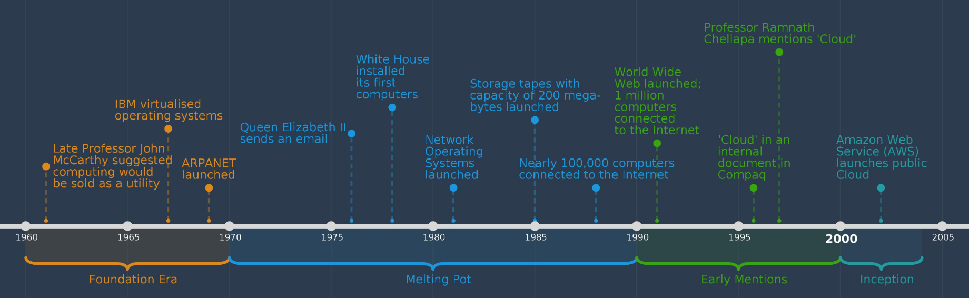
Figure 1: Cloud history: 1960 -2005
Foundation era

During this period, three main cloud aspects appeared the possibility for multiple people to share the same resource using the concept of virtualization, the concept of using a storage as a utility/service and the possibility of accessing these services through network.
Melting pot

Melting pot period came with an improved storage space offered (up to 200 megabytes of data) and a larger network of computers (approx. 100 000) connected to the internet, computers allowed to communicate to each other.
Early mentions

Cloud technologies reached a level of maturity, having more than a million of computers with internet access. This is the period when World Wide Web was launched in 1991. E-commerce became more popular and client-server architecture was introduced as the applications provided front-end to the users and keep the back-end implementation on servers located in the World Wide Web.
Inception

Amazon Web Services (AWS) launched what is as of now known as ‘public cloud’ in 2002, without having competitors. They proposed a solution for small and medium organizations technical difficulties by renting resources and have benefits as scalability and elasticity.

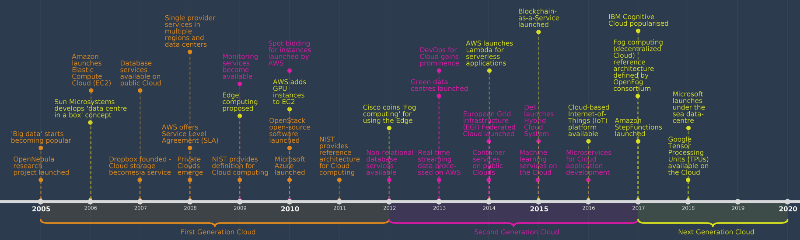
Figure 2: Cloud history: 2005-2020
First generation cloud

This is the period when the applications began to be relocated from a two-layered architecture to cloud based design, having the backed hosted into IT resources offered by cloud providers. The primary thought of cloud was characterized in this period: data centers had a centralized infrastructure and a massive amount of compute and storage resources were provided.

Second-generation cloud

In this period, the concept of hybrid cloud emerged by being a combination of public and private cloud. Cloud became more trusted because of the possibility of monitoring the resources. Databases services suffered changes and non-relational database services started to be provided and also data started to be process by real-time streaming services.
Next generation cloud

While the centralized infrastructure gained popularity, another idea of “cloud in a box” was presented. Graphic processing units (GPUs) were added to the data centers, as the applications need to run faster and consume less CPU. The number of computers connected to internet raise to billions which results into an increased network traffic and communication latency which determined the appearance of micro data centers. Additionally, the serverless computing pricing model was introduced to optimize the payment for idle time.

Basic concepts and terminology

- Cloud
“Cloud computing implies storing and retrieving data and software over the Internet from a remote location rather than local machine’s hard drive.” (Essentials of cloud Computing)
- IT resource
“An IT resource is a physical or virtual IT-related artifact, software-based (e.g. virtual server, custom software program) or hardware-based (e.g. physical server or network device).” (Cloud Computing - Concepts, Technology & Architecture)
- Cloud Consumer
London Bikes Ltd represents a cloud consumer because it “uses IT resources offered by a cloud provider”. (Cloud Computing - Concepts, Technology & Architecture)
- Cloud Provider
“Cloud provider is organization that provides cloud IT resources (e.g. Microsoft Azure, Amazon Web Services, Google Cloud Platform, Oracle Cloud, IBM Cloud etc.)” (Cloud Computing - Concepts, Technology & Architecture)
- Scaling
“Scaling is characterized as the capacity for an IT resource to deal with increased or decreased usage requests. It is one of the most famous and useful highlights of cloud computing, as organizations can scale up or down to fulfill needs dependent on season etc.” (Cloud Computing - Concepts, Technology & Architecture)
There are two types of scaling: horizontal scaling – scale in and out and vertical scaling – scale up and down.

Characteristics and benefits

In order to provide an effective and scalable environment, a specific set of characteristic is required based on National Institute of Standards and Technology (NIST):
- On demand self-service
- Broad network access
- Resource pooling
- Rapid elasticity
- Measured service
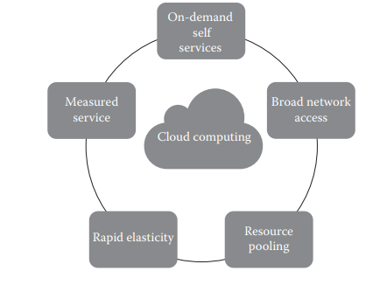
Figure 3: Cloud computing - essential characteristics
Cloud providers and consumers analyze these characteristics individually to be able to measure the value offered by a cloud platform.

On-demand self-service
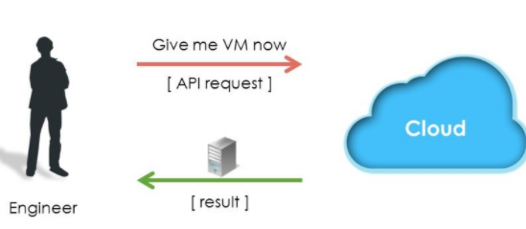
Figure 4: Cloud characteristic - on-demand self-service

“A cloud consumer can ask for and get access to cloud facilities automatically without additional IT staff effort. Getting resources into a classical environment could be difficult and could result in delays that affects the projects. The organization can figure out what is accessible for utilization by simply checking the cloud provider portal interface” (The NIST Definition of Cloud Computing)

Broad network access

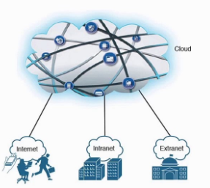
Figure 5: Cloud characteristic - broad network access

“This characteristic implies that the cloud facilities can be accessed via Internet from various locations using different client platforms (e.g., mobile phones, tablets, laptops, and workstations).” (The NIST Definition of Cloud Computing)

Resource pooling

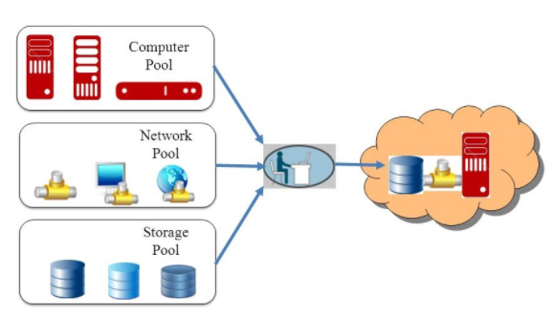
Figure 6: Cloud characteristic - resource pooling
“Using shared IT resources (storage, processing, memory, and network bandwidth etc.) rather than committing separate equipment to each cloud consumer infers that the cloud provider needs less equipment in the data centers. The cloud supplier offers economies of scale, better viability and reduced cost, which can be an advantage for the cloud consumer. This makes it a more reasonable plan from the financial perspective.” (The NIST Definition of Cloud Computing)

Rapid elasticity

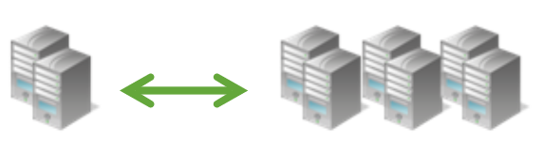
Figure 7: Cloud characteristic - rapid elasticity
The definition of this from the NIST is: “Capabilities can be elastically provisioned and released, in some cases automatically, to scale rapidly outward and inward commensurate with demand.
To the consumer, the capabilities available for provisioning often appear to be unlimited and can be appropriated in any quantity at any time.” (The NIST Definition of Cloud Computing)
In simple terms, if London Bikes Ltd get a higher seasonal demand at springtime, it can automatically extend by easily adding additional servers. When the demand goes down, the servers can be easily turned off. This approach is known as scaling in / out the resources based on the required demand.

Measured service

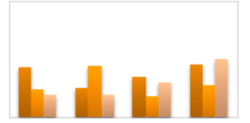
Figure 8: Cloud characteristic - measured service

“Cloud resources can be monitored, controlled and reported which offers a significant level of transparency for cloud provider and consumer. The cloud provider measures how much of the provided services are used by the consumer and bill them. The payment options can be: pay-as-you-g or fixed monthly plans and depend on the required cloud service model (infrastructure as a service, platform as a service or software as a service).” (The NIST Definition of Cloud Computing)

Migrating to cloud could have the following benefits for London Bikes Ltd enterprise:
- Loss prevention - if the organization adopts a cloud-computing solution, then the risk of losing data is significantly reduced. In case of an on premise solution, a local hardware can run into a malfunction from different reasons suck as viruses, age-related deterioration or even human error, which cause the data to not be recovered. In cloud environment data is safe and accessible using any computer with an internet connection.
- Security – cloud providers offers strong monitoring security features which are more efficient than on-promise security systems. Additionally if the data is stored on a local server and it can be accessed for example using a remote connection then it becomes vulnerable for cyberattacks. IT staff spend a lot of time on securing the environment (from ports, group policies applied to not be able to run different file’s extensions, different APIs level security etc.) Using cloud based services, security can be easily implemented at any level (including user level) via different offered settings and data is encrypted when is transmitted over the network which makes more difficult for the unauthorized persons to access it.
- Cost savings – using the pay-as-you-go concept results into a reduced cost as the organization will pay only for needed resources. This advantage reflects also into the possibility to scale the business using also an efficient monitoring service offered by cloud providers. Having a real time analysis of traffic, resources consumption, and cost calculation (e.g. Azure offers a price calculator: https://azure.microsoft.com/en-us/pricing/calculator/) may be useful for organization board to create the budget plan and predict the future cost.
- Access globally – Cloud providers have datacenters all over the globe. London Bikes Ltd can use as a region provided “UK South” which will give the best response time to their customers or in case of a scaling process replications can be applied to ensure the needs.

Delivery models

“A delivery model represents a specific, pre-package combination of IT resources offered by a cloud provider” (ACCC5000 - Cloud Computing Technologies). Based on individual needs, a company can choose one of the following platform types:

- Software as a Service (SaaS)
- Platform as a Service (PaaS)
- Infrastructure as a Service (IaaS)

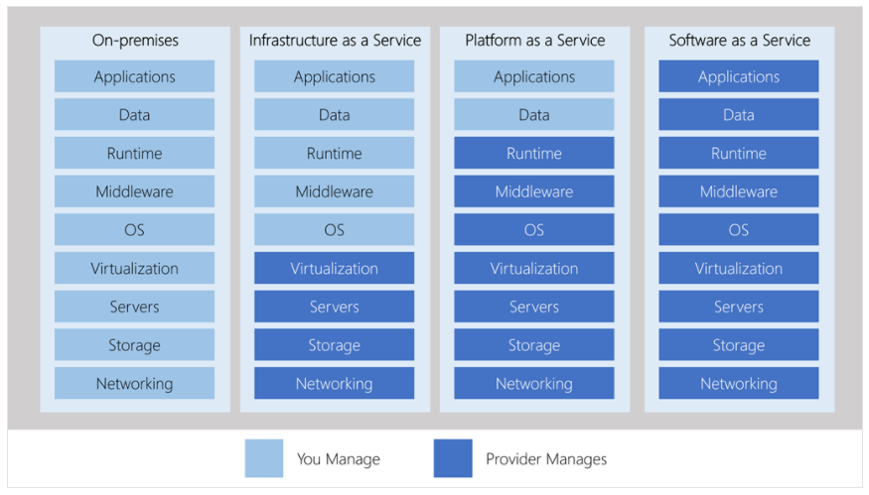
Figure 9: Cloud delivery models

Software as a Service (SaaS)

“The capability provided to the consumer is to use the provider’s applications running on a cloud infrastructure. The applications are accessible from various client devices through either a thin client interface, such as a web browser (e.g., web-based email), or a program interface. The consumer does not manage or control the underlying cloud infrastructure including network, servers, operating systems, storage, or even individual application capabilities, with the possible exception of limited user specific application configuration settings” (The NIST Definition of Cloud Computing)

Platform as a Service (PaaS)

“The capability provided to the consumer is to deploy onto the cloud infrastructure consumer-created or acquired applications created using programming languages, libraries, services, and tools supported by the provider. The consumer does not manage or control the underlying cloud infrastructure including network, servers, operating systems, or storage, but has control over the deployed applications and possibly configuration settings for the application-hosting environment.” (The NIST Definition of Cloud Computing)

Infrastructure as a Service (IaaS)

“The capability provided to the consumer is to provision processing, storage, networks, and other fundamental computing resources where the consumer is able to deploy and run arbitrary software, which can include operating systems and applications. The consumer does not manage or control the underlying cloud infrastructure but has control over operating systems, storage, and deployed applications; and possibly limited control of select networking components (e.g., host firewalls).” (The NIST Definition of Cloud Computing)
Differences between cloud delivery models are easily explained using a basic example of making a pizza:
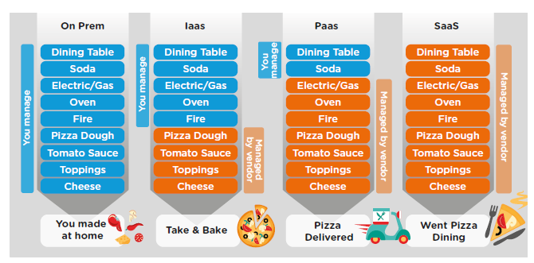
Figure 10: Differences between delivery models -pizza example

On premise | Pizza is make at home – the organization manages all ingredients, equipment, gas and energy
IaaS | Pizza is purchased from the supermarket but needs to be cooked and eat at home.  As an example, London Bike Ltd can buy virtual machines from a cloud provider, but it is responsible with operation system installation, updates, installing different runtime platforms (e.g. Java, .NET framework etc.)
PaaS | Pizza is delivered at home.  London Bike Ltd has access to preconfigured environment and it is not responsible of managing them, but it needs to create the application for its requirement
SaaS | Pizza is eaten in a restaurant.  London bikes Ltd has access to all needed hardware and software

Deployment models

Considering environment’s configurations such as storage size, accessibility and ownership, three cloud deployment models are presented as following:
- Public cloud
- Private cloud
- Hybrid cloud

Public cloud

“As its name suggests, public cloud is available for open use by the general public, being owned entirely by a third-party provider. The IT resources are offered to cloud consumers for usage at a cost, and the cloud provider maintains them.” (Cloud Computing - Concepts, Technology & Architecture)
“A public cloud can be defined as a multitenant environment, each user pays only for the used resources that are shared between multiple customers. The end-user has knowledge only about the location of the data center, but is has no visibility into the physical location where the software is running. Public cloud exposes APIs to end-user and built abstraction layers on top of the physical hardware.” (Architecting The Cloud)
Choosing a public cloud deployment model for “London Bikes Ltd organization has the following advantages:
- Utility pricing - the organization pays only for consumed resources. There is no need for the organization to buy physical hardware and a scaling up or down would be easier to implement.
- Core competency - the organization is not responsible for managing the infrastructure. There will be a considerable reduced time spent on infrastructure and more time allocated to its own core functionality.
Having these huge benefits of reduced cost and scalability could result into an attractive solution, but on the other hand, public cloud has also some risks:
- Control - the organization depends on the cloud provider to meet their performance and uptime requirements
- Limited configurations - any complex computational requirements could be sometimes difficult to meet using a public cloud approach
- Regulatory issues - data privacy issues can make it challenging to deploy in a public cloud environment

Private cloud

“A private cloud is owned by a single organization. In this case, the end-user is using a single-tenant environment. The organization manage the data center and has the flexibility to procure desired hardware. ” (Architecting The Cloud)
For London Bikes Ltd organization, a private cloud model addresses from the beginning the drawbacks exposed by public cloud model (e.g. control, configurations and data privacy), but increase also the cost as the organization is not able to pay-as-you-go and it needs to scale up or down using resources from a shared pool which are managed internally and already bought. (Cloud Computing - Concepts, Technology & Architecture)
As the company’s main requirement is to assure data security and avoid potential data loss, a private cloud model could be a good option, but it needs more effort from IT staff to manage the infrastructure and also a better analysis of needed resources.

Hybrid cloud

“A hybrid cloud environment includes a combination of one or more cloud deployment models. The cloud consumer could choose to keep the sensitive data into a private cloud environment and less sensitive cloud services to a public cloud.” (Cloud Computing - Concepts, Technology & Architecture)
For London Bikes Ltd organization, a hybrid cloud model could involve a private cloud model for keeping critical parts of the application such as payrolls processing, billing or customer data and a public cloud model for deploying the less critical parts such as customers’ orders processing or main company sales website.

Virtualization

“The process of converting a physical IT resource (servers, storage, network etc.) into a virtual IT resource is called virtualization.” (Cloud Computing - Concepts, Technology & Architecture)
Depending on the organization size, implementing virtualization can provide huge benefits like:
- On demand access to server, storage resources and network
- Reduced physical space
- Reduced operational costs
- Reduced downtime
- Increased IT efficiency and productivity

“Virtualization provides flexibility to enable cloud computing, but these concepts are not the same. Virtualization can be defined as a layer of abstraction usually from two perspectives: one-to-many and many-to-one approaches.
In a one-to-many approach, many virtualized resources are created from one physical resource. This form of virtualization allows data centers to maximize resource utilization. Virtual resources hosting individual applications are mapped to physical resources to provide more efficient server utilization.
With a many-to-one approach, a virtual (logical) resource is created from multiple physical resources. This is especially true in the context of cloud computing—multiple physical resources are grouped together to form one cloud.” (Cloud Computing: Automating the Virtualized Data Center)
The following IT resources can be virtualized:
- “Servers -a physical server can be abstracted into virtual server
- Storage - a physical storage device can be abstracted into a virtual storage device or a virtual disk
- Network - physical routers and switches can be abstracted into logical network fabrics (e.g. VLANs)
- Power - a physical UPS and power distribution units can be abstracted into virtual UPSs” (Cloud Computing - Concepts, Technology & Architecture)

Migration strategies

There are six common migration strategies:
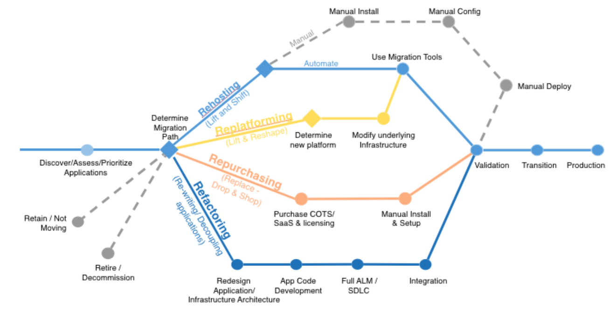
Figure 11: Cloud migration strategies

- Re-hosting
This is a popular strategy for initial migrations, used for a faster move to cloud, but may require a refactoring of the applications later once the cloud in in place.
- Re-platforming
This strategy could have a higher cost as the company needs to migrate the application into an IaaS solution using virtual machines instead of changing the applications’ core.
- Re-purchasing
This strategy is usually used when an organization needs to move to a SaaS platform. For example, London Bikes Ltd can move their customer relationship management system (CRM) to Salesforce.
- Refactoring
This includes a re-writing of different parts of the application. For example instead of having a monolithic architecture, London Bikes Ltd can follow a service-oriented architecture (microservices approach - created services per each component: Payment service, Order service, Billing service, Customer management service etc.)
- Retire
The organization is doing an analysis of the portfolio and turn off the pieces that are no longer used by the customers.
- Retain
Sometimes, because of the high cost of migration some components can remain in-house. This strategy is known as “revisit” and it is a popular strategy when we are talking about hybrid cloud.

Security

Security is one of the most important aspect even if you are talking about on-premise or cloud environments. In cloud-based environments, security become a much bigger challenge comparing with a single tenant environment as the organization does not know where and how data is stored.
These challenges are coming from the following aspects
- The organizations needs to protect data, ensure confidentiality and align with all governmental regulations (e.g. GDPR (General Data Protection Regulation))
- In different cloud services offered by cloud providers, the same resources are used by multiple customers
- Concerns about how auditing or reporting is processed
- Concerns about standards and procedures of how disk space is managed and how data is deleted for meet the disk space requirements

“The public cloud compounds these challenges with data that are readily portable, accessible to anyone connecting with the cloud server, and replicated for availability. And with the hybrid cloud, the challenge is to protect data as it moves back and forth from the enterprise to a public cloud.” (Essentials of cloud Computing)

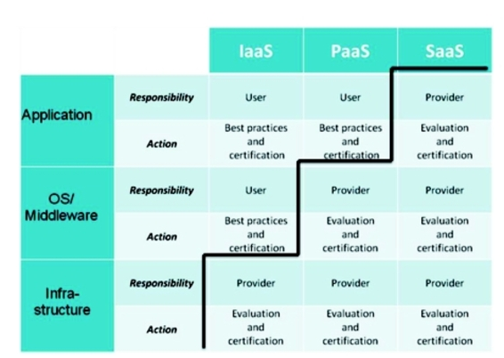
Figure 12: Security trust boundaries based on delivery model
As it can be notices from the previous figure, the cloud provider is responsible for assuring security in a SaaS delivery model. Cloud provider offers secure interface for the customer to interact with used resources and services. (Cloud Computing: Assessing the risks)

SaaS implementation process

Public cloud is a deployment model that meets London Bikes Ltd requirement and represents the optimal proposed solution as it offers the benefits previously describe.
Assuming the existing application has a 2-leyer architecture, the process includes a migration for each layer of the application.
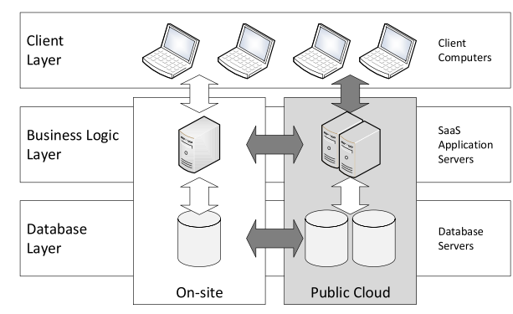
Figure 13: SaaS migration approach
Migrating the existing London Bike Ltd’ system to software as a service cloud can be exemplify using the following steps:

Selecting components
The London Bile Ltd software consists of multiple components:
- customers component (it is responsible for managing the customers’ accounts and it needs to meet GDPR standard)
- payment component (it is responsible for executing payment requests)
- orders component (it is responsible for managing the product orders requests- e.g. adding an order to database when a customer buys a bike, updating the order’ status etc.)
- reporting component (it is responsible for generating the reports and statistics)
- employees component (it is responsible for generating the employee’s payrolls, manage the employees, send payroll email notifications etc.)
- e-commerce main web site (it is responsible for managing and displaying the products and it has integration with the other components except employees component)
Determine cloud provider
The cloud provider used for this migration process is Microsoft Azure.
Microsoft Azure provides scalability and flexibility capabilities, the data storage can be easily scale up based on the business requirements, it offers a pay-as-you-go plan which is an effective way to improve the organization budget and also security is a granted aspect. Microsoft Azure is considered the most trusted cloud provider by U.S government enterprises.
Using Microsoft Azure cloud provider, the components can be migrated as following:
- customers component can be implemented using Salesforce
- each of the components: orders, payment and employees can be implemented using a REST service (Representational State Transfer) and it can have its own databases
- databases are implemented using Azure Databases
- reporting component can be implemented using Azure Power BI
- e-commerce web shop can be implemented using an Azure Web App (London Bike Ltd can benefits of advantages offered by Traffic Manager service for improving the bandwidth, Azure CDN service – for delivering the static images and content of the website, Azure Search service – for searching functionality, Azure Blob Storage – for delivering the bikes images, Azure Cognitive Services – for analyzing customers reviews)

Mitigating security risks
Database security can be assure using Azure Key Vault. Instead of connecting to the database using directly a connection string, the REST services can use a setting defined into Azure Key Vault to encrypt the keys and keep the passwords secrets.
Because the chosen model is public cloud and the information is delivered over the Internet, to increase security HyperText Transfer Protocol Secure (HTTPS) can be used.
The communication between services can be increased using Azure REST API.

Conclusion

The cloud initiative required migrating the selected components and services to cloud. Some selected components may require re-development effort in order to adopt to the new cloud based environment. Long-term perspective comes with benefits as reduced cost and reduce effort when the business needs to scale out.
Additional, performance is improved by taking advantage of features like caching, content delivery, traffic management, logging and monitoring etc.

References

Chandrasekaran, K. (2015). Essentials of cloud Computing. CRC Press.
JARED CARSTENSEN, B. G. (2012). Cloud Computing: Assessing the risks. IT Governance Publishing.
Kavis, M. (2014). Architecting The Cloud. New Jersey: John Wiley & Sons, Inc., Hoboken.
Mazumdar, A. (n.d.). ACCC5000 - Cloud Computing Technologies. Retrieved from https://moodle.uwtsd.ac.uk/
Peter Mell, T. G. (2011). The NIST Definition of Cloud Computing. National Institute of Standards and Technology Special Publication 800-145.
Thomas Erl, Z. M. (2013). Cloud Computing - Concepts, Technology & Architecture. Arcitura Education inc.
Venkata Josyula, M. O. (2012). Cloud Computing: Automating the Virtualized Data Center. Indianapolis: Cisco Press.
https://powerbi.microsoft.com/en-us/power-bi-and-azure/
https://docs.microsoft.com/en-us/azure/architecture/example-scenario/apps/ecommerce-scenario
https://docs.microsoft.com/en-us/rest/api/azure/
https://www.salesforce.com/uk/

