Imogen Lloyd-James
1907207

Scenic Assessment of Gower Beaches (2500 words)

Contents
1. Introduction 3
2. Study area 4
1.2: Oxwich Bay 5
1.3: Rhossili 7
1.4: Caswell 9
1.5: Aberavon 11
1.6: Mewslade 13
1.7: Swansea Bay 15
3. Methodological approach 17
3.1: Beach rating checklist 17
4. Results 21
5. Discussion 23
6. Conclusion 24
7. Reference List 25

Introduction
The recreational use of our coastline has significantly increased over the last few decades. All year-round tourism brings social and economic benefits to local areas; therefore, it is common to assess the aesthetics of our coastline; however, it is very challenging to measure beach user priorities and visitor perception in management plans due to the subjectivity of the topic. Looking from a conservation perspective of safeguarding the surrounding biodiversity, its important to focus on creating a sound coastal and management plan, to preserve our coastline from a range of factors, weather they are biological e.g., coastal erosion or anthropological e.g., litter/pollution. In addition, the assessment and evaluation of the aesthetic quality is requisite for proper consideration of the scenic repercussions of management action (Buhyoff et al, 1994). That is why scenic assessment methods are utilised, which look at the human, physical and biological factors that may be impacting our coastline, to beat the issue of subjectivity and individual perceptions when assessing the coastline and when fabricating management plans. Its important to note that there have been many techniques of scenic assessments implemented over the years (Crofts and Cooke, 1974). Arthur et al., 1977 says there are two main categories of scenic assessments, qualitative and quantitative. We were required to choose the quantitative method. There are advantages and disadvantages to both, but there are issues with the subjective assessments created by individual groups, this will be discussed later. In this scenic assessment, we went to 5 different beaches on the Coast of Gower and Swansea to assess the human, biological and physical factors for assessment. We assessed Oxwich, Rhossili, Caswell, Aberavon, Mewslade and Swansea Bay. The results will be discussed further on. A map of Swansea and Gower is below.
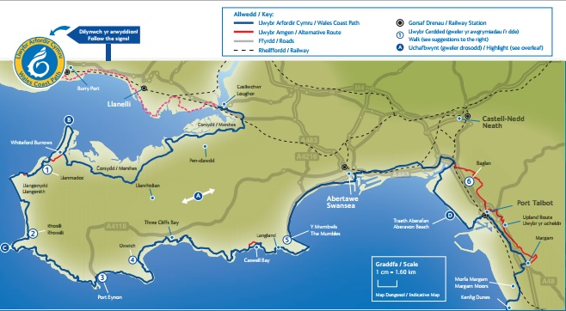
Figure 1- Map of Swansea and Gower Coastline

Study area

Gower is a coastal peninsula which starts on the Western side of greater urban Swansea, it is the UK’s first Area of Outstanding Natural Beauty. It is a popular location for geological field excursions due to its large range of geological and geomorphological phenomena that is found within such a small area (The Geological Society, 2012). There is incredible limestone scenery found on the South coast at Worm’s Head (Rhossili) and Oxwich Bay, as well as Three Cliffs Bay, then in the North you’ll find the salt marshes and dune systems (Natural Resources Wales, 2014). The geology of Swansea and Gower creates stunning scenes and environments that attract tourists all year round, which is why its even more important to establish beneficial management plans.

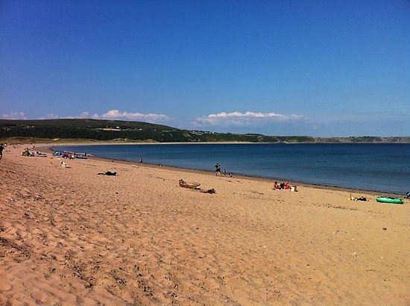
1.2: Oxwich Bay
Figure 2- Photograph of Oxwich Beach from the left

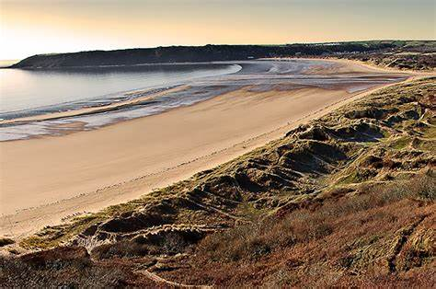
Figure 3- photograph of oxwich bay from the dunes above

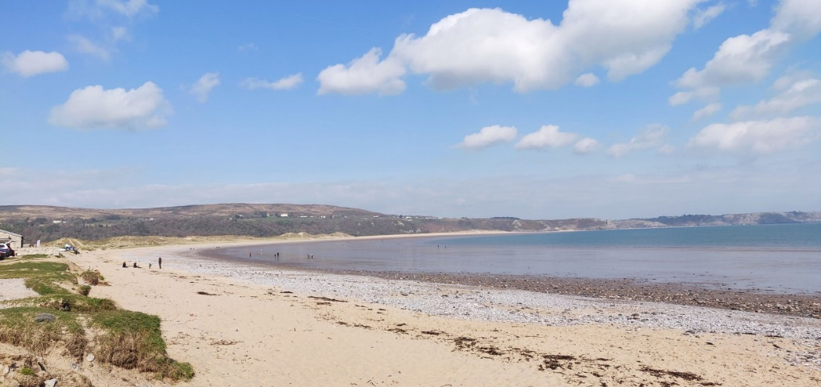
Figure 4- photograph of Oxwich Bay from the left

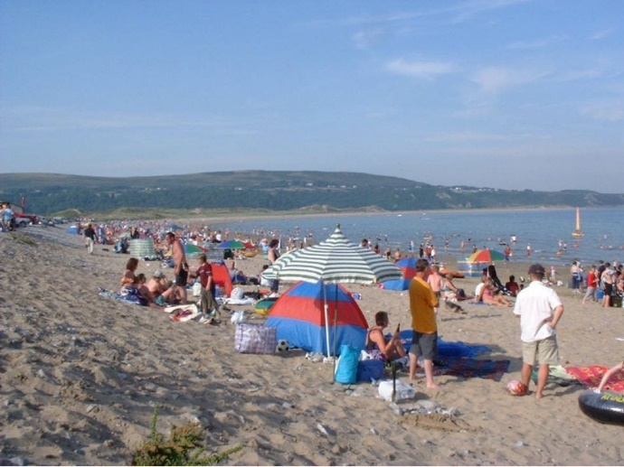
Figure 5- photograph of Oxwich Bay during the summer

Oxwich has been named a Site of Special Scientific Interest (SSSI), it stretches 4km of coastline, and was voted the best beach in Britain in 2007 (Robert Phillips, Jenkins and Cullis, 2011). In terms of geology, Oxwich has a high chalk content in its substrate because of the crushed shells in the sand which is blown inwards from the Bay. That alone supports biodiversity, attracting many chalk loving wild orchids and other wildflowers can be found too e.g. Bee Orchid (Ophrhys Apifera) and Common Twayblade). In between the nature reserve and surrounding natural ash woodland, more than 600 species of plants have been found. The birdlife is also very impressive, rare visitors have been seen such as Cetti Warblers (Cettia cetti), other Warbler species, a Bittern was found after an absence of many years (FirstNature.com, n/d). The beach is easily accessed with a car park, and good quality local amenities since it attracts a lot of visitors (Robert Phillips, Jenkins and Cullis, 2011).
Due to the COVID-19 mitigation plan we could not actually visit the sites, so we based our questionnaires from photographs. I have included the photos in this section named Figures 2-5.

1.3: Rhossili
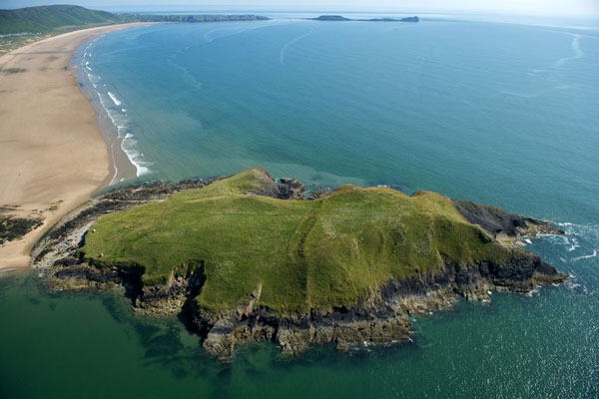

Figure 6- Photograph of Rhossili Bay from the left side

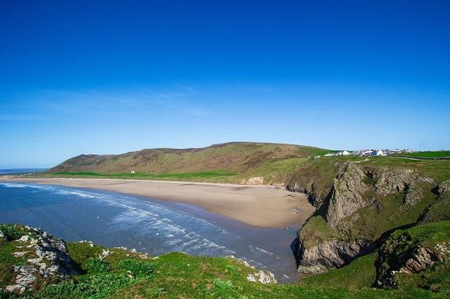
Figure 7-Photograph of Rhossili Bay from the car park side

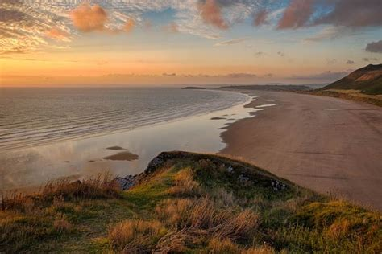
Figure 8- Photograph of Rhossili Bay from the car park side

Rhossili Bay is the furthest site away from Swansea out of the locations we chose. It is an isolated peninsular, if you go nearer to Pobbles Beach (which is more towards Mumbles), small quarries can be found. In terms of rock formation, contorted strata can be seen, showing alternate limestone and shales belonging to the Lower Limestone Shales. Looking from East to West, hard Devonian rocks can be located against overlying shales (The Geological Society, 2012).
Many protected species can have been recorded to have been found in the Rhossili area, for example, the Brown Hare (Lepus europaeus), the Skylark (Alauda arvensis), Marsh Fritillary (Eurodryas aurinia) as well as many more (Gower Commons, n/d).
There is car park access to Rhossili, however it is challenging getting down to the beach itself. Near the car park, there is also direct access to toilets, a visitor centre, exhibition, café, shop and a hotel. Making it very popular for tourists (FirstNature.com, n/d).
The photographs that we based out Scenic Questionnaires off are above (see figures 6-8). This is part of the scenic mitigation plan we were given.

1.4: Caswell
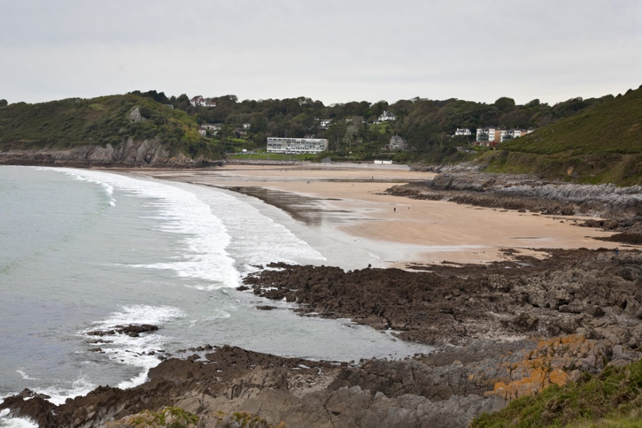
Figure 9- Photograph of Caswell Bay from the coastal path coming from Langland Bay

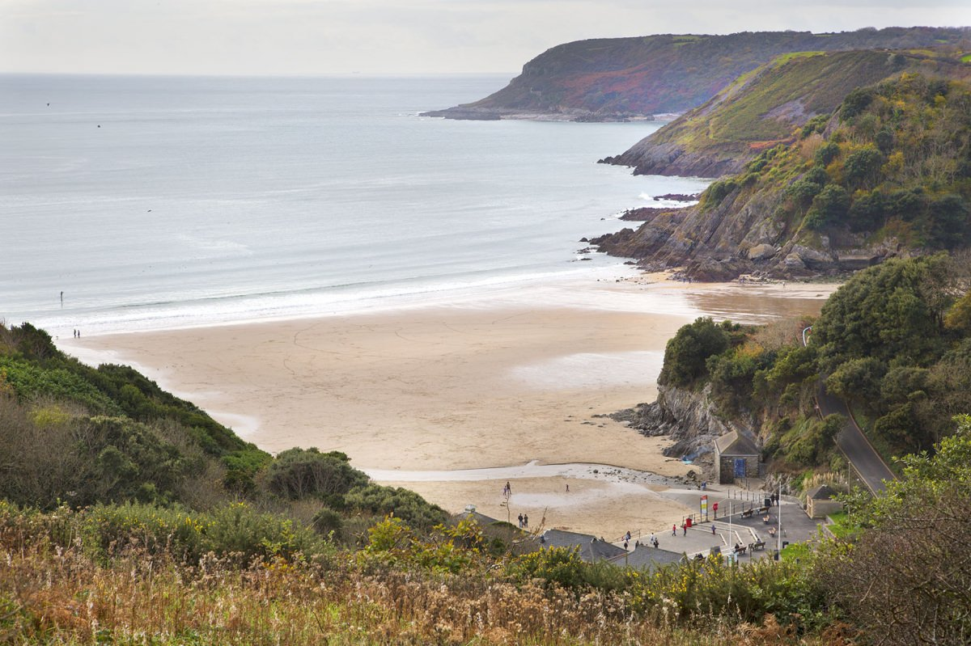
Figure 10- Photograph of Caswell Bay from the cliffs behind

The Bay at Caswell eroded along two North-South faults, one stretches from Caswell Valley and the other directly under the block of apartments behind the Western section of the bay. The geology itself is mainly made of a thinly bedded unit, and a hammock like bedding plane beneath it, this is the top of limestone (The Geological Society, 2012). There is also interesting mudstone formation at Caswell Bay. The limestone and mudstone are exposed in 3 separate sections, repeated by folding (Ramsey, A., 1987). There is parking close to the beach and access onto the promenade, as well as ramped access onto the beach. There is also a café that overlooks the Bay, a local surf school, and a well-established urban environment (Visit Swansea Bay, 2020).
I have included the photographs of Caswell Bay that we used when doing our scenic questionnaire (see figures 9 and 10).

1.5: Aberavon
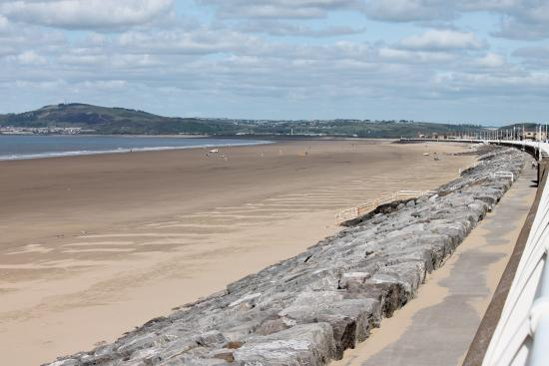
Figure 11- Photograph of Aberavon Bay from the promenade

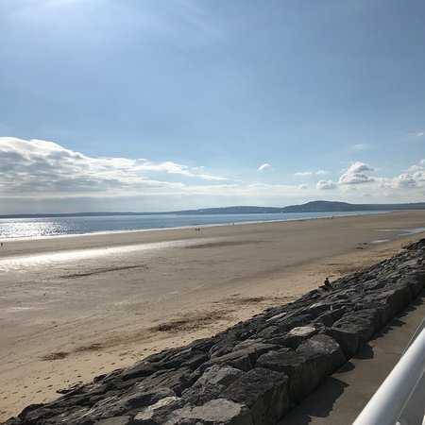
Figure 12- Photograph of Aberavon Bay from the Port Talbot side

Aberavon is located on the Northern- East side of Swansea Bay, and is one of Wales’ longest beaches (3 miles) (Ephotozine.com, 2020). It achieved a Blue Flag Status in 2007. It is rich in animal life, for example, Sand star (astropecten irregularis) can be found, as well as Striped Venus Clams (Chamelea gallina) as well as many more, providing an abundance of wildlife and biodiversity. Aberavon Bay was once known as ‘Aberavon Burrows’ due to its large area of sand dunes. There was a decline in the resort due to economic and social conditions, but in 1998 local authority began utilising strategies to help the physical environment of the area and increase tourism. There are concerns about coastal erosion affecting the beach, as large stones have been implemented to create a deep harbour for Port Talbot Steel Works. Despite the Bays Blue Flag Award, it is still not considered to be in the most aesthetically pleasing location due to TATA Steel works being in such close proximity to the Beach (Engel, M., 2016).
Refer to figures 11 and 12 to see the photographs of Aberavon Bay that we used to complete the scenic questionnaire.

1.6: Mewslade
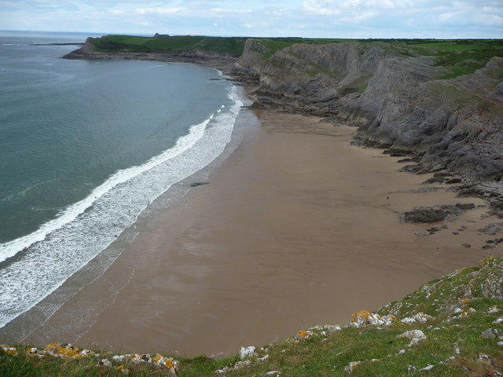
Figure 13- Photograph of Mewslade Bay from the cliffs on the left side

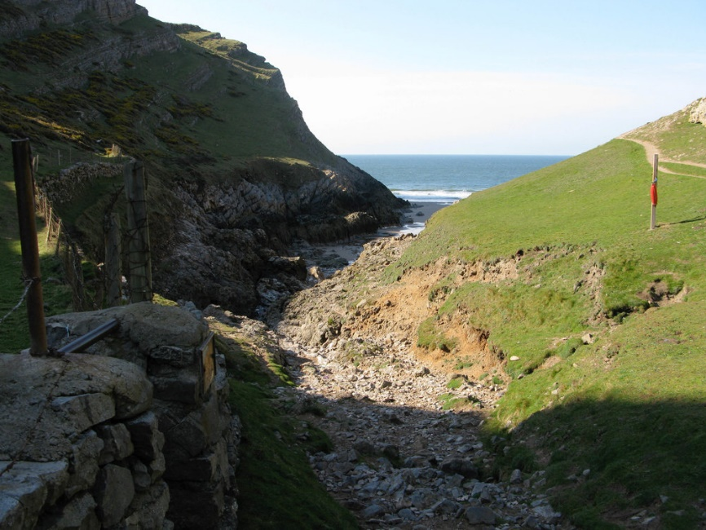
Figure 14- Photograph of the only point of access to Mewslade Bay

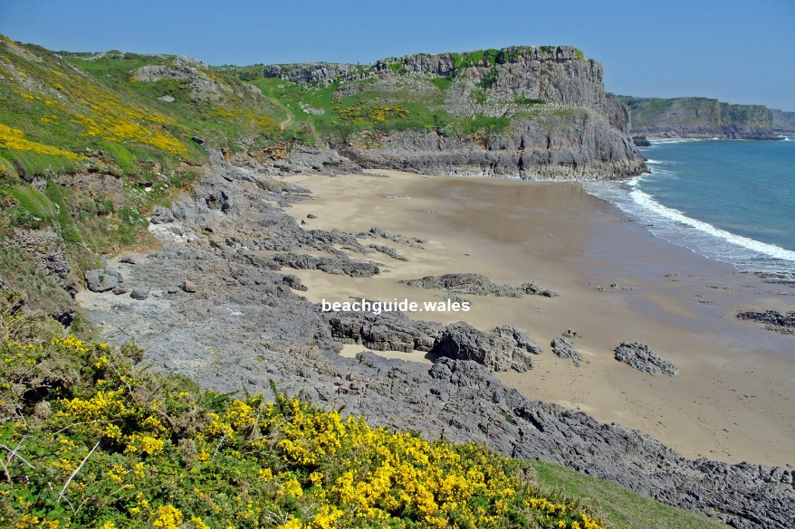
Figure 15- Photograph of Mewslade Beach from the cliffs on the right-hand side of the Bay

Mewslade Beach is a 5-minute drive away from Rhossili Bay. Surrounded by high grassy cliffs and the 70-metre-high rocks of Thurba Head which are made of limestone, which acts as a bastion. At the lowest level there are smooth potholes in the rocks caused by erosion as the waves bring in boulders. Beyond waves reach, one is able to locate orange lichen growing, as well as small plants like thrift (Royal Geographical Society, n/d).
At high tide, it is difficult to access as it is in a remote location. There are no facilities, which make it popular to surfers due to its quiet nature. The nearest car park is over half a mile away (The Beach Guide, 2020).
Refer to figures 13-15 to see the photographs we used for the COVID-19 mitigation plan.

1.7: Swansea Bay

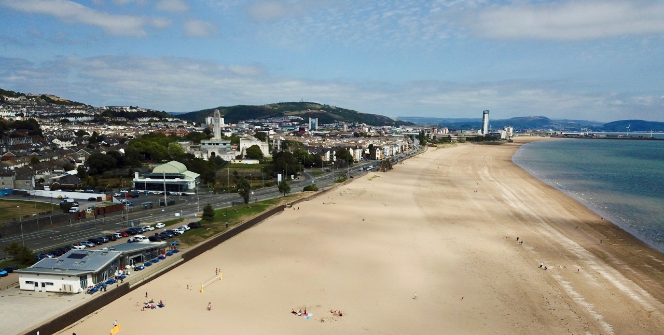
Figure 16- Arial photograph of Swansea Bay (St Helens)
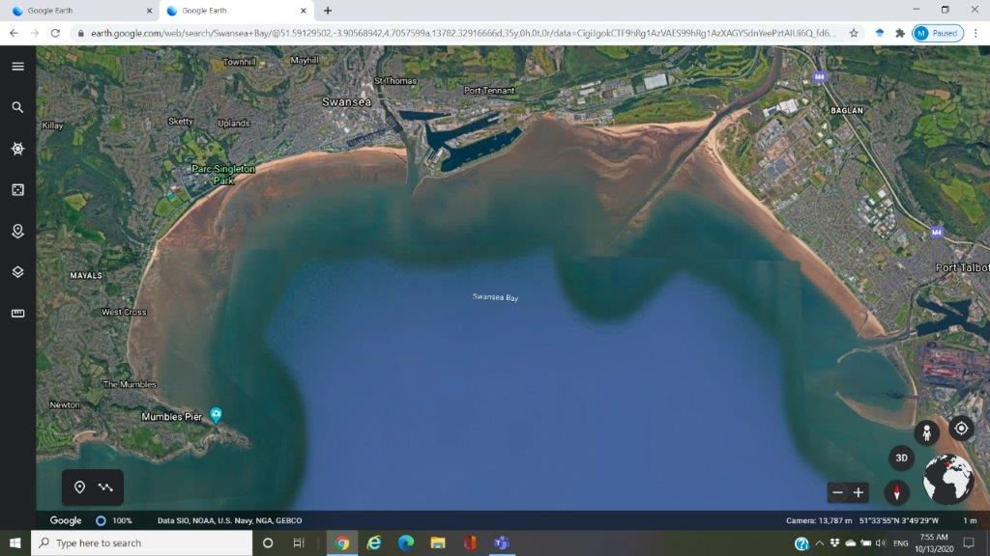
Figure 17- Google maps screenshot of the whole of Swansea Bay

Swansea bay stretches the whole way from Swansea Marina, all the way to Mumbles (See figure 17). Looking at the geology of the bay, the actual bedrock of the Swansea Bay is some 600 feet below the present seabed. Nearer to Swansea town centre, there is a common deposit of boulder clay (glacial till), which is a mixture of clay and large boulders dumped by melting glaciers as a result of the retreat of ice caused by the deposition of various glacial sediments in the region, linking to the Ice Age which saw the polar ice caps advance and retreat drastically (The Geological Society, 2012).
The best area for wildlife can be found in the back of the sand dunes from Singleton Park to Blackpill. For example, summer flowers like Sea Stock (Matthiola sinuate) and Evening Primrose (Oenothera biennis). There is also a lot of Sea Holly (Erynguim planum), Sea Spurge (Euphorbia paralias) and Old Man’s Beard (Clematis vitalba). Marram grass and much dune flora is home to many species, like the Ivy bee (Colletes hederae) and many butterfly species (Garner, J., 2019).
High levels of tourism can also be seen at Swansea Bay, along with the presence of sewage overflow (Data.gov.uk, 2017), are causes for environmental pollution, possibly decreasing the use of the beach for recreational activities when compared to the beaches in Gower. This will be explored in the discussion.
Refer to figures 16 and 17 to see what our scenic questionnaire results are based from.

3. Methodological approach

3.1: Beach rating checklist

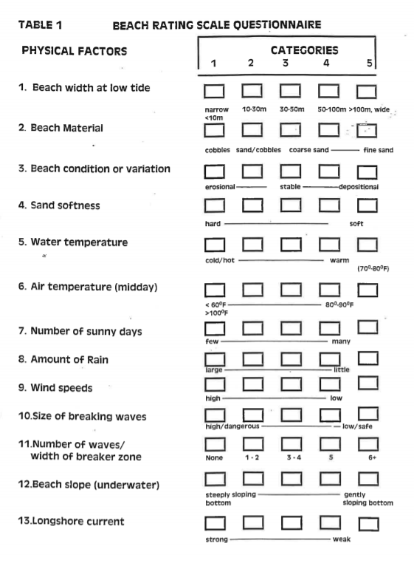

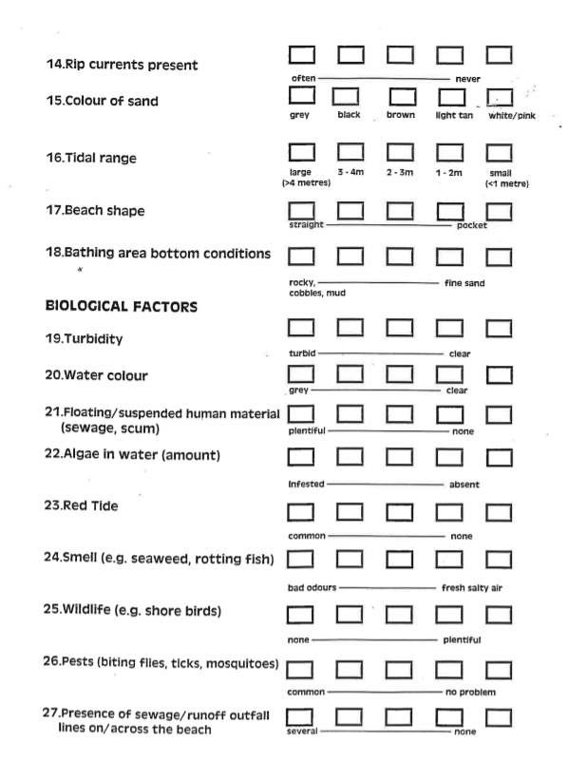

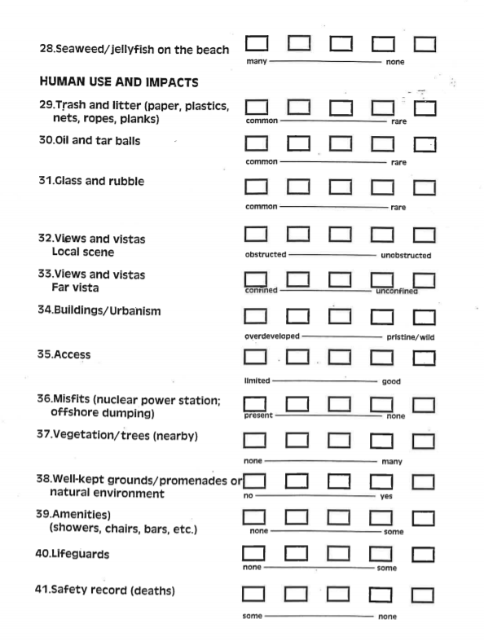
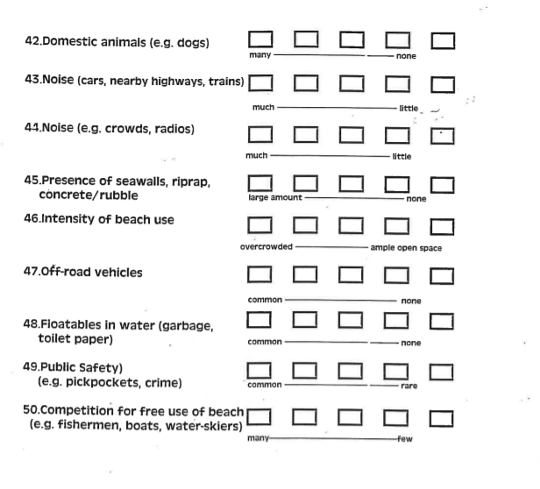
Normally our group would have been taken to visit each site location and complete the surveys in person. However, due to the Covid-19 Pandemic a mitigation plan was applied to this assessment, which was to look at photographs of each site and base our survey answers from them. This technique is an accepted assessment technique; therefore, we aren’t at a huge loss. We all looked at the same photographs to increase validity, and working individually, we used the Beach Rating Questionnaire (2.1) to assess the physical, biological and human impacts seen in each of the site photos. From that point we could then work out what wider management implications can be applied. This was done by filling out the different variables/categories assigned to each resort/beach. From the results we could rank the beaches according to scenic appraisal. Doing our own research then allowed us to determine the more challenging categories that were hard to fill out based off a picture e.g., smell, temperature etc. A couple of examples of our own research would be looking at Blue Flag Awards or news articles which would indicate any sewage present or human usage like litter.

4. Results
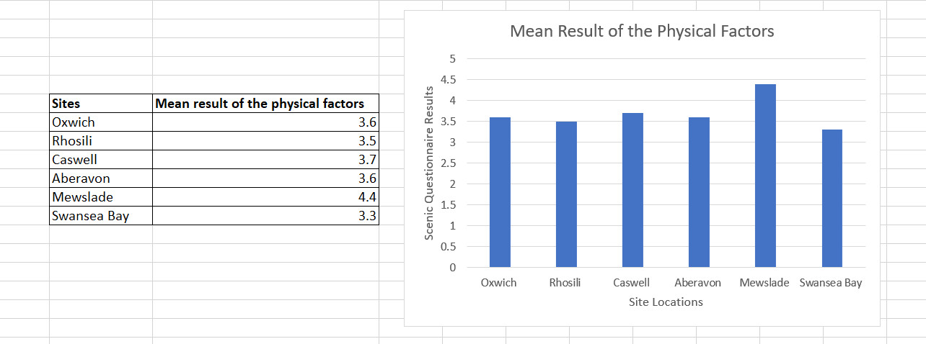
Figure 18- A table and bar chart showing the mean results of the physical factors in the scenic questionnaire
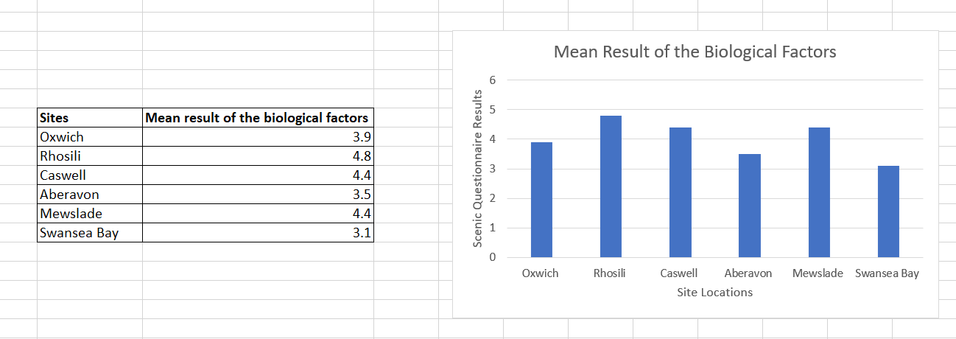
Figure 19- A table and bar chart showing the mean results of the biological factors in the scenic questionnaire

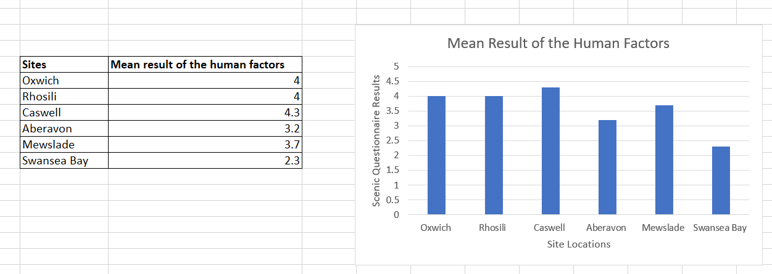
Figure 20- A table and bar chart showing the mean results of the human factors in the scenic questionnaire
From figures 18, 19 and 20 it is clear to notice that the sites closer to Port Talbot scored the lowest in my Scenic Beach Questionnaire, those sites being Swansea Bay and Aberavon. The sites further out into Gower had higher scores, most likely due to the absence of much urban development which causes pollution, and the high amount maintenance that is carried out. In terms of future management, the results can be used to identify what focus needs to be put in place for each of the sites. For example, Mewslade scored high in the physical factors section but lower for biological factors, most likely due to the lack of access to the beach (refer to figure 14). So, a clear management plan can be created that focuses on improving the human factors at Mewslade.

5. Discussion
When it comes to scenic landscape assessments, the main issue would be the subjective nature of the results, whether it be carried out by an individual group or an individual. Priorities and perception of beach visitors when addressing coastal management plans is a very tough factor to measure. For example, characteristics such as vista and beach use intensity are subjective. Another factor that could decrease the reliability of collected results is the issue of bias, so I could have scored by favourite beaches higher just because I personally like that certain beach more than the others. We also had to apply a COVID-19 mitigation plan in which we used photographs to complete the scenic questionnaire. This has both positives and negative aspects; on one hand this method is an accepted methodology, however, there were characteristics which would have been easier to record If we were physically at the sites e.g., smell.
A lot of techniques to calculate scenic appraisal have been recently created (Crofts and Cooke, 1974). These models can be divided into a considerable number of ways (Arthur et al., 1977). One possible way would be into 3 categories, Descriptive Inventories, Public Preference and Quantitative Holistic Techniques. Descriptive Inventories is the biggest division of techniques for assessing scenic resources and uses both qualitative and quantitative methods of evaluating the landscape. Although this technique is useful in providing landscape quality assessments, the objectivity of their application and the quantitative results that are found can shadow any subjectivity.
Public Reference models offer an all-round judgement of a landscape. This methodology contradicts the approach that use the factor definition to explain variation in landscape quality (Dunn, 1976). This category includes common practices such as questionnaires or verbal surveys and interviews, so uses a non-qualitative method for scenic preference sampling (Arthur et al., 1977). An alternate practice would be to provide visual stimuli such as photographs (Shuttleworth, 1980; Wade, 1982). Which is the method that was integrated into our COVID-19 mitigation plan. There are issues with ecological validity too when it comes to photo-based assessments due to on site and photo-based context differences (Hull and Stewart, 1992).
Lastly, Quantitative Holistic Methods combine quantitative surveys that measure public preference, with landscape feature records (Arthur et al, 1977). The use of statistical methodologies is very important when it comes to making mathematical connections between areas of a landscape and the preferences of beach visitors. Nonetheless, this is a predictive model which is more used for research rather than for a scenic assessment (Palmer, 1983).

6. Conclusion
In conclusion, the subjectivity of scenic beach assessments has always proved a challenge, due to the issue of beach user preference. We each carried out a Scenic Beach Questionnaire at 6 different locations in Swansea and Gower. Our COVID-19 mitigation plan in which we used photographs of each location instead of visiting each. This being an actual accepted methodology, it did not create any issues, other than the issue of ecological validity. However, the results I found in my opinion, are accurate when you address each of the characteristics of each site. The beaches closer out into Gower were generally scored higher than the beaches closer to Swansea town. I have highlighted examples in this report that show how scenic beach assessment methodologies can be categorised depending on the type of assessment that is going to be carried out. From our results, we can then use that important information in beach management plans as an indicator of where the most action and conservation efforts need to be taken.

7. Reference List
- Arthur, L.M., Daniel, T.C. and Boster, R.S. (1977) Scenic assessment: an overview. Landscape Planning, 4, 109-129
- Arthur, L.M. (1977) Predicting scenic beauty of forest environments: some empirical tests. Forest Science, 23, 151-160.
- Buhyoff, G.J., Miller, P.A., Roach, J.W., Zhou, D. and Fuller, L.G. (1994) An AI Methodology for Landscape Visual Assessments. AI Applications, 8, 1 – 13
- Crofts, R.S. (1975) The landscape component approach to landscape evaluation. Transactions of the Institute of British Geographers, no 66, 124-129
- Crofts, R.S. and Cooke, R.U. (1974) Landscape Evaluation: A comparison of techniques. Occasional Papers, no 25, Department of Geography, University College London.
- Crofts, R.S. and Cooke, R.U. (1974) Landscape Evaluation: A comparison of techniques. Occasional Papers, no 25, Department of Geography, University College London.
- Dunn, M.C. (1976) Landscape with photographs: testing the preference approach to landscape evaluation. Journal of Environmental Management, 4, 15-26.
- First-nature.com. 2020. Gower Coast National Nature Reserve, Swansea, Southwest Wales. [online] Available at: <https://www.first-nature.com/waleswildlife/sw-nnr-gowercoast.php> [Accessed 10 December 2020].
- Geolsoc.org.uk. 2020. The Geological Society Of London - Gower Field Guide. [online] Available at: <https://www.geolsoc.org.uk/Gower> [Accessed 10 December 2020].
- Geolsoc.org.uk. 2020. The Geological Society Of London - Rhosili. [online] Available at: <https://www.geolsoc.org.uk/GowerTour5> [Accessed 10 December 2020].
- Gower Commons. 2020. Rhossili Down. [online] Available at: <https://www.gowercommons.org.uk/commons-sites/rhossili-down/#:~:text=Rhossili%20Down%20and%20Cliffs%20support,%3A%20marsh%20fritillary%20(Eurodryas%20aurinia)> [Accessed 10 December 2020].
- Geolsoc.org.uk. 2020. The Geological Society Of London - Caswell Bay. [online] Available at: <https://www.geolsoc.org.uk/GowerTour3> [Accessed 10 December 2020].
- Hull, R.B. and Stewart, W.P. (1992) Validity of photo-based scenic beauty judgements. Journal of Environmental Psychology, 12, 101-114.
- National Resources Wales, 2014. National Landscape Character. [ebook] Natural Resources Wales, pp.2-4. Available at: <https://naturalresources.wales/media/682630/nlca39-gower-description.pdf> [Accessed 10 December 2020].
- Palmer, J.F. (1983) Visual Quality and Visual Impact Assessment. In Social Impact Assessment Methods (eds. Finsterbusch, K., Llewellyn, L.G. and Wolf, C.P.), Chap 13, p268-283, Sage Publications.
- Pena-Alonso, C., et al, 2018. Assessment of scenic, natural and cultural heritage for sustainable management of tourist beaches. A case study of Gran Canaria island (Spain), Land Use Policy,. Science Direct, [online] 72(0264-8377), pp.35-45. Available at: <http://www.sciencedirect.com/science/article/pii/S0264837717306233> [Accessed 10 December 2020].
- Ramsey, ATS, 1987. Depositional environments of Dinantian limestones in Gower, South Wales, 265-308 in European Dinantian Environments. Millar, J, Adams, A E and Wright, V P (editors). [Chichester: John Wiley and Sons.]
- Shuttleworth, S. (1980) The Use of Photographs as an Environmental Presentation
- Medium in Landscape Studies. Journal of Environmental Management, 11, 61-76.
- Wade, G. (1982) The relationship between landscape preference and looking time: a methodological investigation. Journal of Leisure Research, 14, 217-222.

