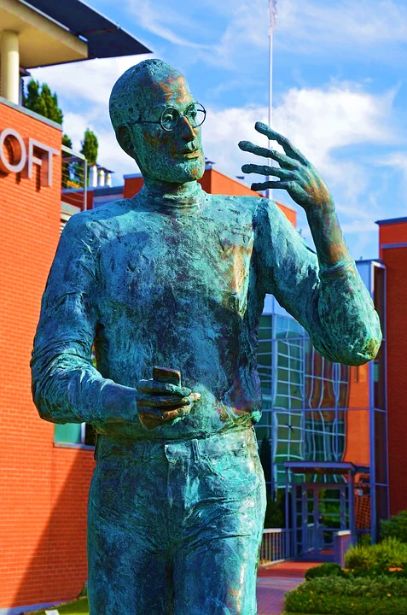  steve Jobs Leadership style | “Effective leadership is not about making speeches or being liked; leadership is defined by result not attributes”  Cristina-Andreea Grasu (1814440)  BMSW 6101-Emergent Leadership Skills

1.0 Introduction

The aim of this essay is to describe the leadership styles and talk about an important leader from the business world. The writer chooses to talk about Steve Jobs and his leadership style, later one it will also be possible to identify a section where the writer will talk about his own leadership style. Moreover, in the findings of the essay it will be possible to find a definition of leadership style as well as two of the leadership styles that are aligned with Steve Jobs leadership style such as autocratic and transformational. Additionally, the writer will also mention traits and motivational theory that describe Steve Jobs personality and his way to motivate employees.

- Findings
Brief description of the Steve Paul Jobs life and inspirations.
Steve Paul Jobs was an American entrepreneur and the co-founder ,chief executive and chairman of Apple Computer, company that today is seen as the evolution of modern technology that keeps innovating and changing the world and the life of people and businesses worldwide. Born in 1955 and gave in adoption by his real parents without being named, Steve Jobs will take the name of his adoptive parents. Steve spends his life in Mountain View California and as a boy during his childhood he loved to spend its time with his father working on electronics in the family garage. His father named Paul showed him how to reconstruct electronic factor that influenced his life and later becomes a hobby. Later, his education seems to be the way that will inspire him to become the leader of the famous Apple computer as when enrolled at Homestead High School he meets his future partner and co-founder Steve Wozniak , soon both found out that they have something in common, which was the passion of electronic mainly computers. ( theBiography.com 2021)
In 1976 Jobs and Wozniak start Apple Computer in the family garage. The name Apple was given by Jobs after he had just visited a farm but also was inspired by his own diet and the name Apple for him seems to be fun and not intimidating at all. The name Apple soon will be successful as it will be a name easy to remind. In the first year the company start selling the computers named “Apple I “ each of them marketed at $666.66 ,price that soon will provide a $774.000 profit for their business. After the announcement of the second model of Apple the company income sales increase by “ 700 percent to $139 million” and by 1980 “Apple Computer became a publicly-traded company with a market value of $1.2 billion by the end of its very first day of trading”. Soon the CEO of Apple Computer will be the marketing expert John Sculley of Pepsi-Cola and with him in the position of CEO of Apple and different businesses that start to develop themselves and be successful Apple experienced design flaws with the next several products factors that will influence Sculley to believed that Steve Jobs it is hurting the company profit influences that will make Steve to leave in 1985 the company that he co-founded. After leaving Apple he reinvented himself and created a new hardware and software enterprise called Next ,Inc company specialized in operating system that Apple by 1996 will buy the company for $429 million event that will highlight the return of Steve Jobs to his post as Apple’s CEO. With more experience about the computer world and new ideas of management Steve Jobs reinvented Apple and start creating new products lie iMac , MacBook Air , iPod, and iPhone all of which determined the evolution of technology ,reason that make Apple become in 2008 the second-biggest retailer in America. ( theBiography.com 2021)

2.1 Leadership style of Steve Jobs and critically evaluation.
As possible to identify from the Steve Jobs early life history it seems that its leadership and management of the early age were not enough to lead Apple to be successful as it is today. Further is possible to see how with experience his leadership style in leading Apple company has changed after he re-jointed the company as CEO together with his own software company NEXT Inc,.
According to Sarah S. there is a difference between leadership and management , inside of organization ,each knowledge comes with different factors that influence the organization success. To be a leader is when people do something that their leader want to because they like it ,while management is when people do something because they must. (Simpson, 2012) A definition of leadership according to Jacques and Clement, (1994) is:
“Leadership is that process in which one person sets the purpose or direction for one or more other persons and get them to move along together with him or her and with each other in that direction with competence and full commitment” Jacques and Clement ,(1994)
According to Chou in 1939 Lewin ,Lippitt and White conducted and experiment based on decision-making between a leader and a follower and they identified different styles of leadership: autocratic , democratic or participative and laissez-faire each of this style has their own characteristic that describe the way a leader leads his company or his followers. (Chou, 2012) As the term of leadership has evolved since first used in 1970s, in the 21st century the leadership play an essential role in achieving better productivity and performance because the knowledge in different areas has growth and people attitudes has changed and they have more expectation and seems that today individuals need to be lead not just managed as subordinates. Nowadays people are looking for motivation , commitment , inspiration persuasion and evolution. (Kippenberg, 2002) According to the writer , all these signs of evolution of 21st century is possible to be identified inside the Apple computer company that has had as leader its own founder Steve Jobs which seems that its leadership style make it successful that even today the company brings the motivation of growth and evolution in people life’s. According to the writer even if Steve Jobs passed away in 2011 seems that its leadership style it is still remembered these days. According to Natalia K. Steve Jobs had an autocratic leadership styles and he is one of the modern world’s greatest leaders because his traits of his own leadership style made from Apple a distinct brand in the computer world. As a leader, and regarding his leadership style Steve Jobs focused his energy more on tasks and organization performing instead than on people feelings, he was listening more to the employee’s ideas rather than deeply understand their feelings. But despite of all his weaknesses Steve Jobs had lots of qualities that made him inspire others. He was reluctant to delegate, he preferred to be at the forefront of every idea instead of collaborating with others and made them feel appreciated , he thought that creativity is the key to connection , he knew how to balance the staff empowerment recognition and motivation and his leading by example to inspire his employees to trust themselves and complete all the tasks on
their own. (Kassim, 2020)
As one of the VP of Apple Jay E. mention in his book that Steve Jobs was seen by different people as an insufferable person because of his way of related with others specially with his own staff ,but also acknowledged as a marvellous and motivational leader. Also , according to the writer Jay E. mention that Steve Jobs despite his strictly, critical, and arduous personality , his innovating and creative style has changed the way we life because he always had a vision in mind about what he wants. Steve Jobs vision was built around the innovation and change regarding the technology and how to make it more human friendly. (Elliot, 2012) On the other side , according to Robert J. Bies et al. , the leadership style of Steve Jobs was seen to involve “yelling and name-calling” but yet Job’s style of leadership did not stop Apple to become what is today.( Bies, Tripp and Shapiro, 2016)
Autocratic – Transformational Leadership Style of Steve Jobs
According to the writer the traits of Steve Jobs leadership style are aligned with the characteristic of a person that has and autocratic leadership style because the manager or lead does not consult employees in their decision making and the person in charge has all the power. Also, this leadership style is characterized by the fact that leaders do not trust employees or allow them to have an input ,usually rely on threats and punishments to influence and motivate employees but also, is one of the most efficient and effective style because leaders have a good control overall and is possible to register an increase in productivity and disciplined environment. Moreover, this style has its disadvantages too, because people around individuals with autocratic leadership style experience a lack of self-confidence , stress , the independence is weakened by the authority of the leader in some cases , and there is no trust or development either freedom of choice. As it possible as well to be identified in same of the criticism that Steve Jobs has received from different authors . (Saqib Khan et al , 2015) Also , according to the writer as Steve Jobs was one of the leaders that transformed Apple technology in one of the most successful company, his leadership style was seen similarly to a transformational style.
The transformational leadership according to the writer is about the engagement that the leaders have with the followers such as the inspiration and motivation that his personality stimulate in others in such a way as to follow his example. Another aspect of this style is the fact that leader’s expectation about employee’s performance it is at high level while expressing a desirable vision for the future and inspiring followers intelligently by immersing work with meaning. In other words, organisation that have leaders with this style are more likely to recognize the values of people, connections, and groups that provide the energy of business. (Steinwart and Ziegler, 2014)
The term of transformational leadership style was introduced by James Downton in a 1973 paper on rebel leadership and it is “ the process by which a leader fosters group or organizational performance beyond expectation by virtue of the strong emotional attachment with his or her followers combined with the collective commitment to a higher moral cause.” (Diaz-Saenz,2011) Steve Jobs personality matches the transformational style because of his charisma , perfect influence , inspirational enthusiasm , intellectual encouragement ,and personalized consideration. Even if Steve Jobs was known as a “tyrant” and sometimes difficult to tolerate his personality yelling and cursing at employees, was not something that was out of the norm for him ,sometimes he fired personnel without warning, but he mentions that “My jobs is not to be easy on people. My job is to make them better” (Jobs,2011). He was more the leader that generate creativity and innovation and then his engineer will make everything happen. Also, to make everything happen and be completed in time he had strict deadlines that needed to be respected and followed without excuses. But to do so, he had to communicate with his employees and people inside his company so he manages to create meetings every two weeks on Monday were individuals where able to communicate and share ideas or changes that could be a transformational inspiration for the future. According to the writer , Steve was seen a transformation leader because of his style that consist of : , attention , enthusiasm , modernization , commitment, and efficient communication. Because he was also focused on inspiration, encourage, and transforming others to help each other .Murray, 2017)
According to Edward M. Steve Jobs was one of the most inspirational entrepreneurs of the world because of his way to approach innovation , creativity, and inspiration in changing the technology, he also mentions that “ ….people don’t know want they want until you show it to them” (Jobs, 2011) and this is want made other to follow his style. An example of and act where he encourages others to dream big is when he convinced the Pepsi president John Sculley to come to Apple because he asked if he wants to sell sugar for the rest of his life or wants to change it and make something bigger happen. Also, other fact that made people what to follow his example is his strong desire for hard work , shared passion, and clear vision in creating the best products that everyone will desire. (Muldrew, 2019)

2.2 Motivational theories aligned with Steve Jobs leadership style
As is possible to identify from the above research of the writer ,Steve Jobs was the leader that made Apple what is today but , to do so , he had to motivate his employees to give their best in achieve Apple objectives and meet the future expectation that the leader has in his vision which was based in making and delivering a high-quality product. To better understand how employees work hard at Apple to achieve all of this ,the writer will critically evaluate the motivational theory model that Steve Jobs use in his career as a leader.
According to the writer ,motivation is the important piece for a business success in the current competitive market particularly in the technology world. Elements that made employees feeling motivated is the fulfilment of their needs , workplace integrity , labour expended , employee development programs and procedures of compensation and gratitude. Satisfying all ,or some of this element is what will encourage employees to give their best at work. Along with motivation comes the communication because when a leader communicates with his team in an effectively way this will further generate trust and motivates everyone around the company to work in an efficient way to achieve business goals. But for someone as Steve Jobs where his leadership style was described as autocratic does not match with what is essential for the motivation of the employees. Autocratic leaders are distant from their employees, also they make all the decision without involving employees or followers and their personality includes punishment ,regulations rules and orders to be given to others. Though , the art of leadership is adaptable to dynamic circumstances as is possible identify , Steve Jobs had also the characteristic of a transformational leadership style. (Rahbi, Khalid and Khan, 2017)
According to the writer as employees for motivation needs to fulfil their main desires, one of the theories that is aligned with what Apple do to motivate its employees is the Maslow theory of needs. Were the human need are illustrated as hierarchical levels within a pyramid. From the bottom of the hierarchy upwards , the need is physiological ,safety, love and belonging , esteem and self -actualization ,in order for employees to be completely motivated they most satisfy every need starting from the bottom to achieve the higher level , the self-actualization. (McLeod, 2020) Apple to meet the employee’s physiological needs they set up an average salary of 108,483. Also, Apple , to ensure the safety of their workers , provides training to help developing the safety and health standards. Furthermore, Apple, to fulfil the needs of belonging provides for their employees a better workplace environment involving assistance of social networks , work group and develop worker-supervisor relationships. Beside all of this , what matters most of Apple is focusing more on the higher needs of his employees. Where Apple , reward the employees that effectively finish their works with a recognition bonus salary from 3 to 5 percent. Moreover , employees will receive a free iPhone which is an effective motivator because employees will have the possibility to see the end results of their effort ,element that stimulate employees to work with responsibility when dealing with company project plan. Additionally, for the self-actualization need ,Apple has encouraged his people by creating opportunities for employees to take part in education and development program. In fact, one of the engineers of Apple sustain that Steve Jobs did not have a particular device in mind but he gave the team the mission l to produce a phone that people will love so much that they would never go outside without it. These examples show that Apple provide the change to their employees to be creative ,grow and innovate. (Management of Apple Inc.n.d)
As Steve Jobs had different strategies as leader including different styles of leadership another motivational theory that applies to his style is the McGregor’s X and Y theory. McGregor’s theory X and Y divide the employees in two distinct groups, X and Y ,where X is about people that have distaste for work in general and not responsible by nature and Y where individuals put effort in everything they do because work is something natural that they like to do. This type of theory when applied at the workplace allows leaders and managers to identify the groups of people that they manage and in which group they can be categorized so is easy to identify the factors that motivate every employee. (Fisher,2009) According to McGregor, theory Y served as a contrast to authoritarian/autocratic leadership style , ,while Theory X is making assumptions about people. Theory Y include those people that are worth of trust ,respect and support because they are more motivated to do the best job. While theory X is about punishment ,controlled and directing employees in orders to motivated them to put effort in what they do. (McGregor and Gershenfeld, 2006) Further is possible to include Steve Jobs leadership autocratic personality with this theory as he sustained that employees are not worth of trust. In fact, he spends a lot of time in hiring and firing the employees because not many of them seems to meet the leader expectation. (Leibowitz, 2021) While this theory applies more to the autocratic style because the leader takes all the decision ,the Maslow theory match the transformational leadership style of Steve Jobs because besides all the critic people are still following his leadership example.
In fact, the leadership styles of Steve Jobs include positive factors that made others find his example as an inspiration because his “bad” behaviour had a reason at that was to make people better. He also followed his passion no matter what problems or critics he had from the world and dedicate his entire creativity and passion to his vision. (Wickham, 2018) According to the writer it is possible to identify from the above information the contrast between his personality while he had seen to lead people in different ways. While he was an autocratic leader ,was because he knew that employees not always give all the best that they had so he need this stile to manage his company to achieve the maximum success and accomplish his vision in giving people the best technology. On the other side , with the transformational style his mainly purpose was to motivate ,inspire and encourage other to change their lives. In accordance with the McGregor theory the writer says that Steve Jobs autocratic style can be identify while he had to deal in motivate people from the group of Theory X ,while the transformational style is aligned with Theory Y as same thing with the Maslow Theory of Needs. Because he knew how to motivate employees that seek to obtain the better changes and inspire creativity with ideas of how to innovate future projects inside Apple company. (Wickham, 2018)

3.0 Own Leadership style

Further the writer under this section will talk about his own leadership styles and how she will use her role to lead the change into an organization.
Based on the “Leadership Style Questionnaire” my style is an authoritarian/autocratic with a score of 23 and democratic with a score of 20.
Definition of authoritarian/autocratic leadership style :
“Authoritarian leadership style refers to any situation where the leader has all the power and authority as possible. Also known as coercive or dictatorial leadership. The intention behind this style is to retain control and the usually require unquestioning obedience and compliance.”
Based on the definition from above I usually find myself in this situation particularly at work when I am in the position of giving orders and the behaviour of individuals does not match the expectations. Most of the time I found myself in the position of having this style because I like to have control and make sure that every decision has a successful result. Also, this style is known as dictatorial, but I cannot define my personality with a severe characteristic as sometimes I tend to put myself in other people shoes because everyone has feeling, and I do care about them. Usually, I prefer listening first and then take a decision and act in based of what I see or on person behaviour because as far as an individual has an adequate conduct I rather help and communicate with those in difficulties to overpass their barriers and meet the expectation of the business. But if one of the individuals show me disrespect or does not follow my advice which is based on company policies and procedure at that point I rather act severally and have this person punished rather than listening to his explanation of why he was acting in this way. Because as far as there is communication between me and employees I can understand if someone is in a difficult position and cannot meet the daily target or expectation in some days, but when someone is completely avoiding communication of the barriers that stop him in meeting the daily target then I prefer using my autocratic personality because I do not like people making fun of me. I could say that this leadership style characterized my personality even in personal life choices as sometimes I like to have the final word and if I think that something is right there is no way for others to interfere with my own decision.
While on the other side seems that my own personality is hiding the democratic leadership style I could first start with a definition of this style.
Advantages and disadvantages of my own autocratic style
As and advantages about my own autocratic style is the fact that I rather listing and communicate efficiently with my employees before taking any decision. On the other side a disadvantage of my own autocratic style is the fact that sometimes I tend to be impulsive and taking decision without listening other people opinion.
Definition of democratic leadership style :
“ Democratic leadership is termed as the most effective leadership style. Democratic leadership relates with increased followers’ productivity, satisfaction, involvement, and commitment. Leaders under this style have confidence and trust their employees.”( Sharma and Singh,2013).
As said before, into the autocratic style if the behaviour of employees meet the expectation and there is a communication between me and them I can put my trust and confidence in their action and words and give them all the responsibility and decision in making choices and have their own word in what need to be change in order to meet the business objective and goals. I usually use this style at work when employees have an effective communication about their needs and are transparent. I also find myself in having a democratic style when I know that an individual can be trust and his behaviour is satisfactory, proper, and polite while working, acting, and communicating with other. Because I rather be kind and polite with employees and be their friend if I see that they work with passion and does not cause trouble than being rude or acting like I do not care about them as a person or about their feeling as human begins.
Regarding my personal life I can say that everything that has to do with family decision aligns with the characteristic of a democratic style. While dealing with friends or other person I prefer always being autocratic because it is not easy for me to trust people that I do not know them.
Advantages and disadvantages of my own democratic style
An advantage of my democratic leadership characteristic is the fact that if I trust people, I allow them to collaborate with their own ideas on how to make improvements and changes around the business. On the other side the disadvantages of my own style are the fact that when I must decide, I rather leave others making a choice in my own place fact that , in a business context it is not seen as something successful because a leader needs to have a clear vision and be ready in making efficient and successful decision.
Based on the result of “Conceptualizing Leadership Questionnaire” my point of view regarding leadership and the perception of someone characteristics concerning the leadership style I can say that founded on the outcome of questionnaire as a person I put a lot of emphasis on the traits ,skills and behaviour of someone’s leadership personality. Because I think that yes maybe leaders are born but to be a successful leader, I have to change myself in worder to meet business changes during the time and align my personality with today’s business expectation because to be effective and efficient as a leader I need to constantly develop my skills ,my behaviour in order to act proficiently and also to be trusted as a leader of my employees. Because to be a leader someone needs the right skills such as, communication skills , organization , motivation , delegation , problem solving , conflict resolution , giving and receiving feedback ,promoting and many others.

4.0 Appendix
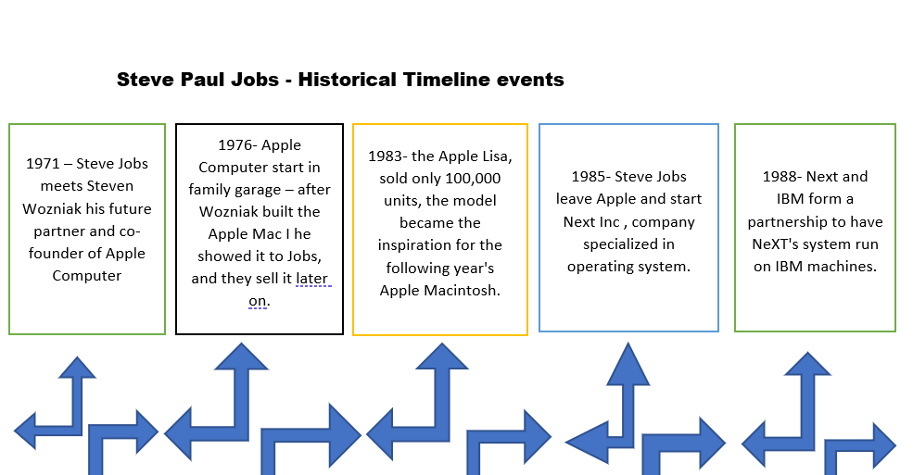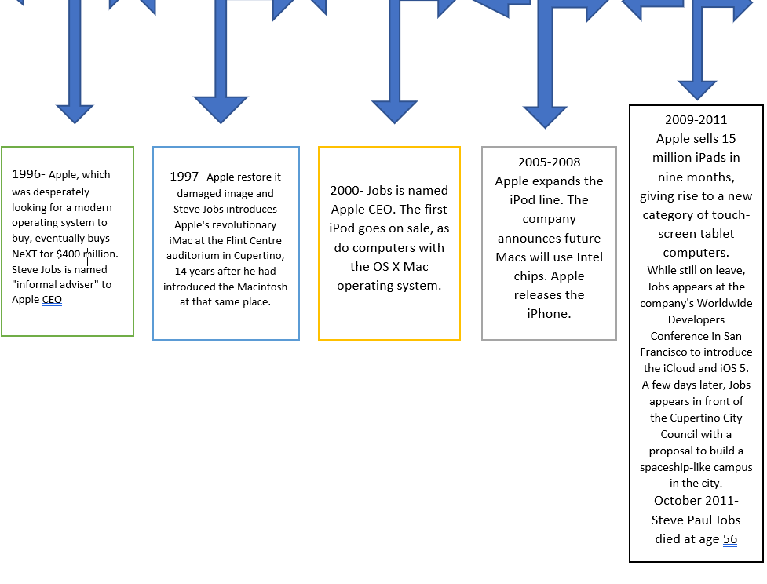

5.0 Bibliography
McCreary, M., n.d. 20 Defining Moments in the Life of Steve Jobs. [online] Entrepreneur. Available at: <https://www.entrepreneur.com/slideshow/289296#7>
Shah, A., 2011. Steve Jobs: A timeline. [online] Computerworld. Available at: <https://www.computerworld.com/article/2498470/steve-jobs--a-timeline.html>
Isaacson, W., 2011. Steve Jobs. New York: Simon & Schuster.

6.0 References
1. he Biography.com website. 2021. Steve Jobs Biography. [online] Available at: <https://www.biography.com/business-figure/steve-jobs> [Accessed 28 February 2021].
2. Simpson, S., 2012. The Styles, Models & Philosophy of Leadership. [online] E-booksdirectory.com. Available at: <https://e-booksdirectory.com/details.php?ebook=8368> [Accessed 2 March 2021].
3. Jaques E. & Clement, S.D ‘Executive Leadership: a practical guide to managing complexity’ Cambridge, MA: Carson-Hall & Co. Publisher (1994) p.4
4. Chou, S., 2012. Millennials in the Workplace: A Conceptual Analysis of Millennials’ Leadership and Followership Styles. International Journal of Human Resource Studies, 2(2), p.73.
5. Kippenberg, T., 2002. Leadership style. Oxford: Capstone, p.4
6. Kassim, N., 2021. Steve Jobs’s Revolutionary Leadership Style and What We Can Learn From It. [online] Ideadrop.co. Available at: <https://ideadrop.co/customer-success/steve-jobs-leadership-style-what-we-canlearn/#:~:text='Steve%20Jobs'%20leadership%20style%20was,'&text=His%20creative%20awareness%2C%20his%20'meticulous,driving%20force%20in%20Apple's%20success.> [Accessed 7 March 2021].
7. Elliot, J., 2012. Leading apple with steve jobs: management lessons from a con. Hoboken ,New Jersey: John Wiley And Sons.
8. Bies J. R., Tripp M. T., and Shapiro L. D., 2016. Abusive Leaders or Master Motivators ? "Abusive" is in the Eye of the Beholder. in Understanding the high-performance workplace, The line Between Motivation and Abuse. New York: Routledge, pp.252-276.
9. Saqib Khan, et al., 2015. The Styles of Leadership: A Critical Review. Public Policy and Administration Research, [online] 5(3), pp.87-90.
Available at: <https://core.ac.uk/download/pdf/234669622.pdf> [Accessed 7 March 2021].
10. Steinwart, M. and Ziegler, J., 2014. Remembering Apple CEO Steve Jobs as a “Transformational Leader”: Implications for Pedagogy. Journal of Leadership Education, 13(2), pp.52-66.

11. Diaz-Saenz H.R. ,(2011) Transformational Leadership in The Sage handbook of leadership. Bryman, A., Collinson, D., Grint, K., Jackson, B. and Uhl-Bien, M. London: Sage Publication Ltd, pp.300-309.

12. Michael M., R., 2017. TRANSFORMATIONAL Case Page: FA17 - PSY 532 Psychological Foundations of Leadership (Dobbs) - Confluence. [online] Wikispaces.psu.edu. Available at: <https://wikispaces.psu.edu/display/P5PFLD/TRANSFORMATIONAL+Case+Page%3A+FA17> [Accessed 14 March 2021].
13. Muldrew, E., 2019. Motivating a workforce by Steve Jobs. [online] Medium. Available at: <https://edwardmuldrew.medium.com/motivating-a-workforce-by-steve-jobs-bf1180c16f5d> [Accessed 14 March 2021].
14. Rahbi, D., Khalid, K. and Khan, M., 2017. The Effects of Leadership Styles on Team Motivation. Academy of Strategic Management Journal, 16(3).
15. Management of Apple Inc. 2021. Motivation. [online] Available at: <https://managementofapple.wordpress.com/motivation/> [Accessed 14 March 2021].
16. McLeod, S., 2020. Maslow's Hierarchy of Needs. [online] Simplypsychology.org. Available at: <https://www.simplypsychology.org/maslow.html#self&gsc.tab=0> [Accessed 14 March 2021].
17. Elizabeth A. Fisher (2009) Motivation and Leadership in Social Work Management: A Review of Theories and Related Studies, Administration in Social Work, 33:4, 347-367,
18. McGregor, D. and Cutcher-Gershenfeld, J., 2006. The human side of enterprise. Ed. Annoted , New York: McGraw Hill Companies Inc.eibowitz, G., 2021. 3 Lessons from Steve Jobs on Building Trust What did Steve Jobs and the CEOs of other iconic companies like Pixar and Disney have in common? The ability to build trust. [online] Inc.com. Available at: <https://www.inc.com/glenn-leibowitz/3-lessons-from-steve-jobs-on-building-trust.html> [Accessed 14 March 2021].
19. Wickham, N., 2018. Six HR Leadership Lessons We Learned From Steve Jobs. [online] Quantumworkplace.com. Available at: <https://www.quantumworkplace.com/future-of-work/six-hr-leadership-lessons-from-steve-jobs/> [Accessed 14 March 2021].

20. Sharma, Dr & Singh, Dr. (2013). A Study on the Democratic Style of Leadership. INTERNATIONAL JOURNAL OF MANAGEMENT & INFORMATION TECHNOLOGY. 3. 54-57.
21.

