Student Name: Shafi Ahmad
Student Number: 2532392
Group: 01
Date: 5/08/2026
Assignment 2
University of Wales Trinity Saint David
Introduction to Web and Database Concepts

Table of Contents
Introduction 2
Website Requirements 3
Purpose 3
Target Audience 3
Website Pages 3
Home Page 3
Menu Page 4
Contact Page 5
6
Website Implementation 6
HTML Features 6
CSS Features 7
Colour Scheme 7
Fonts 8
Abstract 9
Usability Evaluation 9
Accessibility 9
SEO 10
Mobile Friendliness 10
Comparison 11
VALIDATOR: 13
Conclusion 16
References 16
Appendices 18

Introduction
This report explains the design, development, and evaluation of The Royal Bengal Café website. The website was built from scratch using HTML and CSS, without website builders or frameworks such as Bootstrap. The main aim is to promote the café by providing customers with useful information in a simple, attractive way. It consists of three webpages: Home, Menu, and Contact, linked via a navigation menu. The Home page introduces the café and invites visitors to reserve a table; the Menu page lists food and drink options with prices; and the Contact page displays the café's address along with social media links.
The report outlines the planning and implementation process used to create the website and explains the HTML elements and CSS styling applied during development. It also discusses the website's color scheme, typography, layout, and responsive design. In addition, the report compares my website with two professional websites, BBC Sport and Real Madrid, to evaluate similarities and differences in design, navigation, and user experience. The report also presents the results of HTML validation, evaluates the website's usability, accessibility, search engine optimisation (SEO), and mobile responsiveness, and reflects on the overall development process. Finally, the report concludes by discussing what I learned during the project and suggesting possible improvements for future development [1].

Website Requirements

Purpose
The purpose of this website is to promote The Royal Bengal Café and provide customers with important information.
The website allows users to:
- View the café homepage
- Browse the food menu
- Find the café location
- Contact the café

Target Audience
The target audience includes:
- Local customers
- Students
- Families
- Tourists
- Coffee lovers

Website Pages
The website contains three pages.

Home Page
The homepage introduces visitors to the café with a large background image, navigation menu and "Book a Table" button.

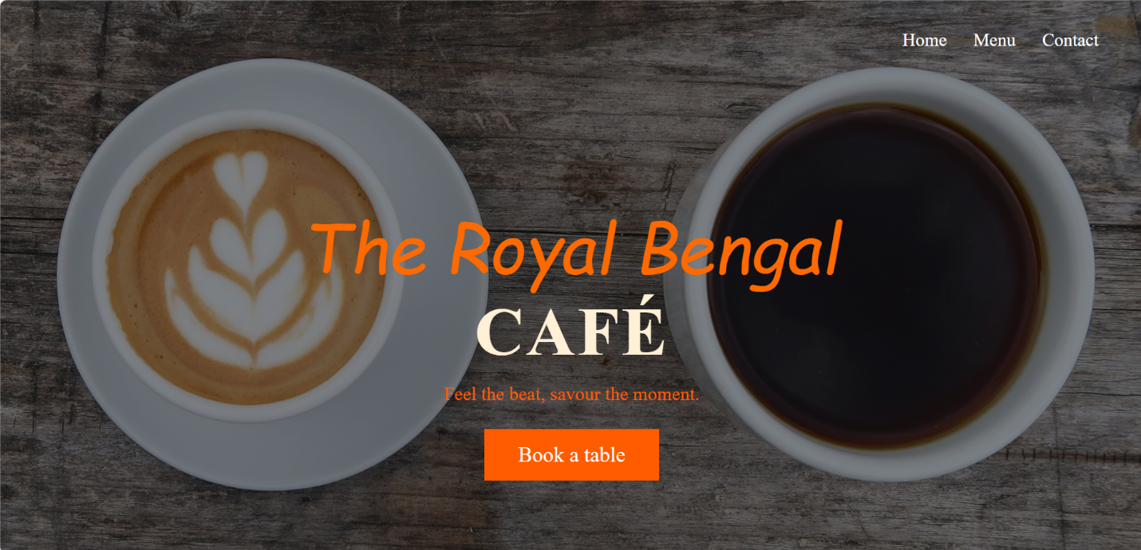
Figure 1: The Home Page
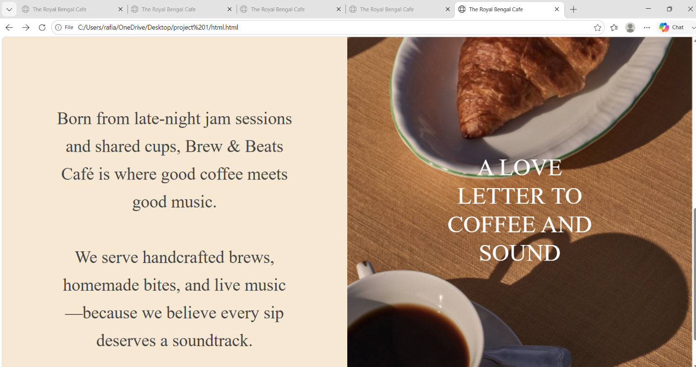
Figure 2: Home Page after scroll.

Menu Page
The menu page displays food and drinks available in the café with images and prices.
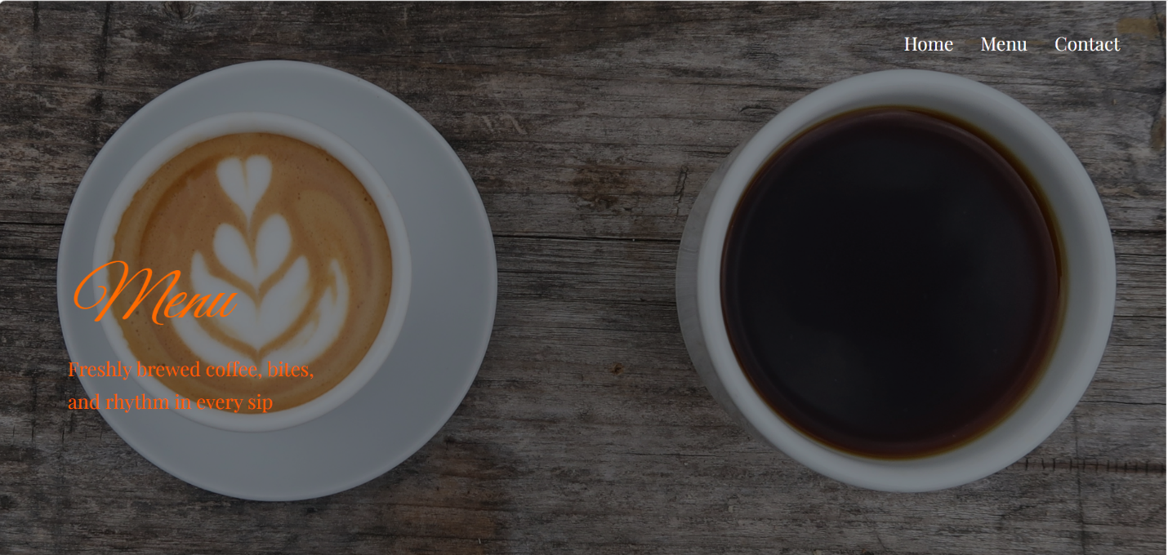
Figure 3: The Menu Page.
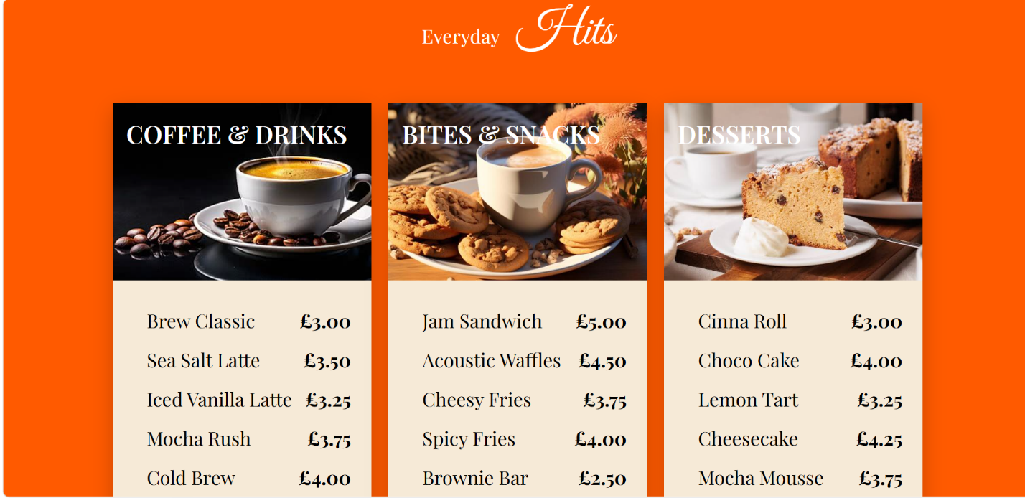
Figure 4: The Menu Page after scroll.

Contact Page
The contact page provides the café address together with social media icons.

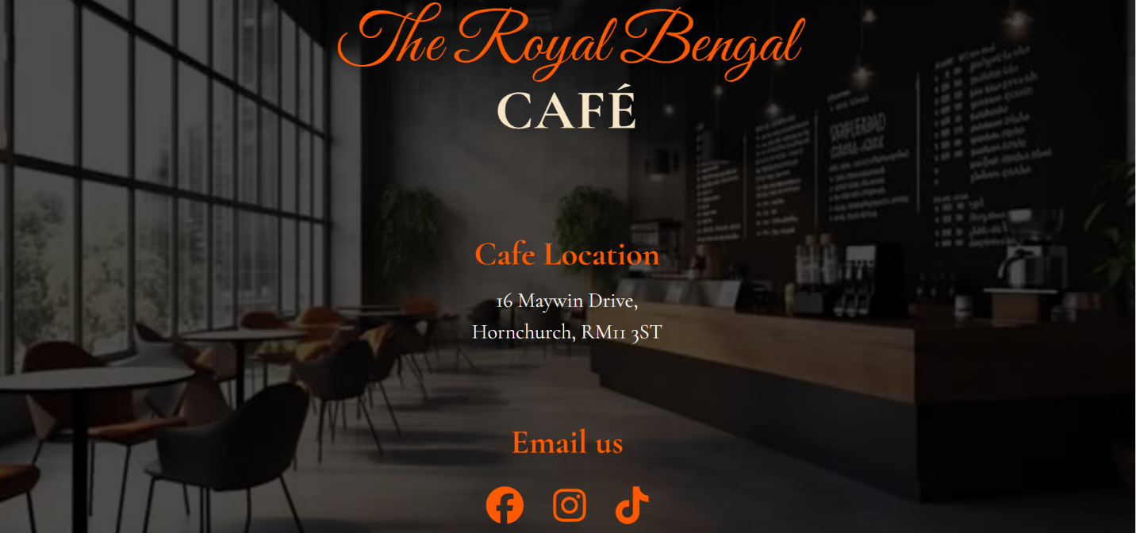
Figure 5: The Contact Page.

Website Implementation
The website was developed using:
- HTML
- CSS

HTML Features
HTML was employed to establish the website’s overall layout and content. Elements were used to structure information and enhance navigation. The <header> element includes the site title and navigation menu, while <nav> links to the Home, Menu, and Contact pages. The <section> element segments the page into different content areas. The <img> element displays images of the café and menu items, and the <a> element creates clickable links and buttons. The <div> element groups related content for styling, and the <footer> provides additional information at the bottom of the page [2].
The following HTML elements were used:
- <header>
- <nav>
- <section>
- <img>
- <a>
- <footer>
- <div>

CSS Features
CSS was used to enhance the website’s visual appearance and user experience. It controls colours, fonts, spacing, and layout to create a modern, attractive design. Warm colours and Google Fonts were selected to match the café theme and create a welcoming atmosphere. CSS was also used to style the navigation menu, buttons, background images, and content sections. Hover effects were added to make buttons and links more interactive when users move the mouse over them. Responsive design techniques ensure the website adapts properly to various screen sizes, offering a consistent experience on desktops, tablets, and mobile devices.
CSS was used for:
- Colours
- Typography
- Layout
- Navigation
- Buttons
- Background images
- Responsive design
- Hover effects

Colour Scheme
The website uses:
Colour | Purpose
Orange | Buttons & headings
Cream | Main title
Black overlay | Improve text visibility
White | Navigation text

Fonts
Google Fonts were used:
- Great Vibes
- Cormorant Garamond
These fonts give the website a luxury café appearance.

Abstract
This report outlines the design, development, and evaluation of The Royal Bengal Café website. The website was built using HTML and CSS, without frameworks or website builders. It comprises three responsive pages: Home, Menu, and Contact. The report covers the website’s requirements, implementation process, comparison with existing websites, validation results, and an evaluation of usability, accessibility, SEO, and responsiveness. Finally, it reflects on the website’s strengths and suggests future improvements.

Usability Evaluation
The Royal Bengal Café website is designed to be simple and easy to use. Users can navigate between the Home, Menu, and Contact pages via the navigation bar. The homepage immediately introduces the café with a large background image and a clear "Book a Table" button. Warm colours and readable fonts create a welcoming atmosphere. Images help visitors understand the products offered by the café. The website is suitable for customers of different ages because the layout is clean and uncluttered. One improvement would be to add an online booking form and a search feature to enhance the user experience.

Accessibility
The website adheres to several WCAG 2.1 accessibility principles. Images are provided with alternative text to assist screen readers in interpreting content. Clear headings enhance the page structure and simplify navigation. The text maintains readability through good color contrast between background and text. The navigation menu remains consistent across all pages, enabling users to find information efficiently. The site is also responsive, adjusting to various screen sizes via responsive CSS. Future updates could include keyboard navigation and the integration of additional accessibility testing tools like WAVE to further enhance accessibility.

SEO
Basic SEO techniques were applied during development. Each page has a descriptive title and uses semantic HTML elements such as <header>, <nav>, and <section>. Images include alt attributes to improve accessibility and search engine indexing. Headings are organized logically with H1 and H2 tags. Internal links connect Home, Menu, and Contact pages, helping users and search engines navigate the site. Future improvements include adding meta descriptions, structured data, sitemap.xml, and robots.txt to improve search engine rankings.

Mobile Friendliness
The website uses responsive CSS to adapt to different screen sizes. Navigation remains easy to use on smaller screens, and images resize correctly without affecting readability. Text remains clear, and buttons are large enough for touch interaction. Responsive design improves the browsing experience for users on smartphones and tablets. Future improvements include using media queries for more screen sizes and further testing on different mobile devices.

Comparison
- BBC Sports:
My website is like the BBC Sport website in that both feature a clear navigation menu at the top of the page and a large hero section to attract users. BBC Sport focuses on delivering sports news through many articles, images, and categories, while my website focuses on promoting a café with a simple, welcoming design. BBC Sport uses a bright yellow and black colour scheme to highlight information, whereas my website uses warm colours and coffee-themed images to create a relaxing atmosphere. My website is less complex, easier to navigate, and designed to give visitors a friendly first impression. [3].
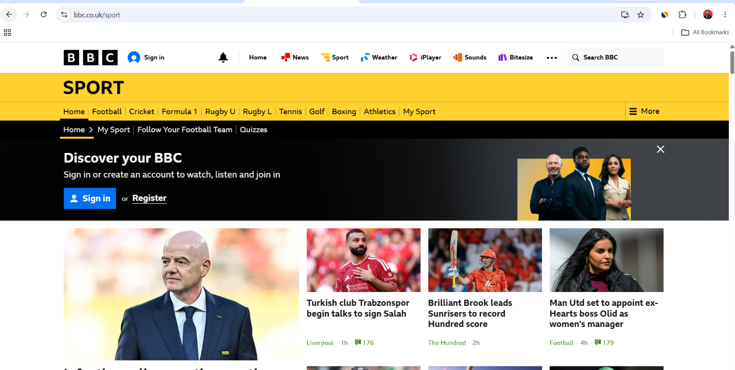

- Real Madrid FC:
My website shares several design similarities with the Real Madrid site. Both feature a full-screen hero image with large text to create a strong visual effect. While the Real Madrid site promotes its football team and memberships, my site focuses on a café and invites customers to book a table. Both use high-quality images, straightforward navigation menus, and a prominent call-to-action button. However, the Real Madrid site has more sophisticated animations and interactive elements. In contrast, my website is simpler, built with HTML and CSS, which makes it easy to understand, responsive, and ideal for a small business [4].
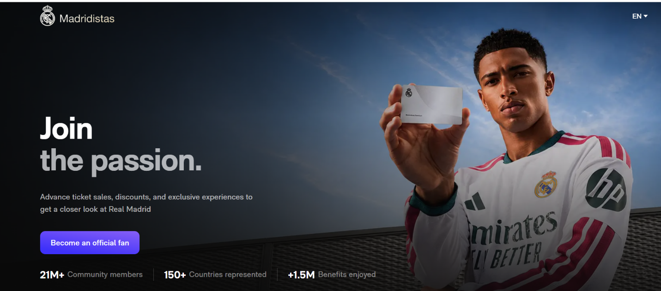

Comparison Table: [5]
Feature | BBC Sport | Real Madrid Website | My Café Website
Purpose | Sports news and updates | Promote football club and membership | Promote café and attract customers
Navigation | Multi-level menu | Simple top navigation | Simple top navigation
Hero Section | News highlights | Large promotional banner | Large café banner
Color Scheme | Yellow, black and white | Dark blue, white and purple | Warm brown, orange and cream
Images | News photographs | Professional promotional images | Coffee and café images
Call-to-Action | Sign In / Register | Become an Official Fan | Book a Table
Complexity | High | Medium to High | Simple
Technologies | Advanced web technologies | Advanced web technologies | HTML and CSS

VALIDATOR:
- Home Page Result: in line 60, it’s giving me a warning because I used <p> tag, it’s asking to use <h1> header tag [6].
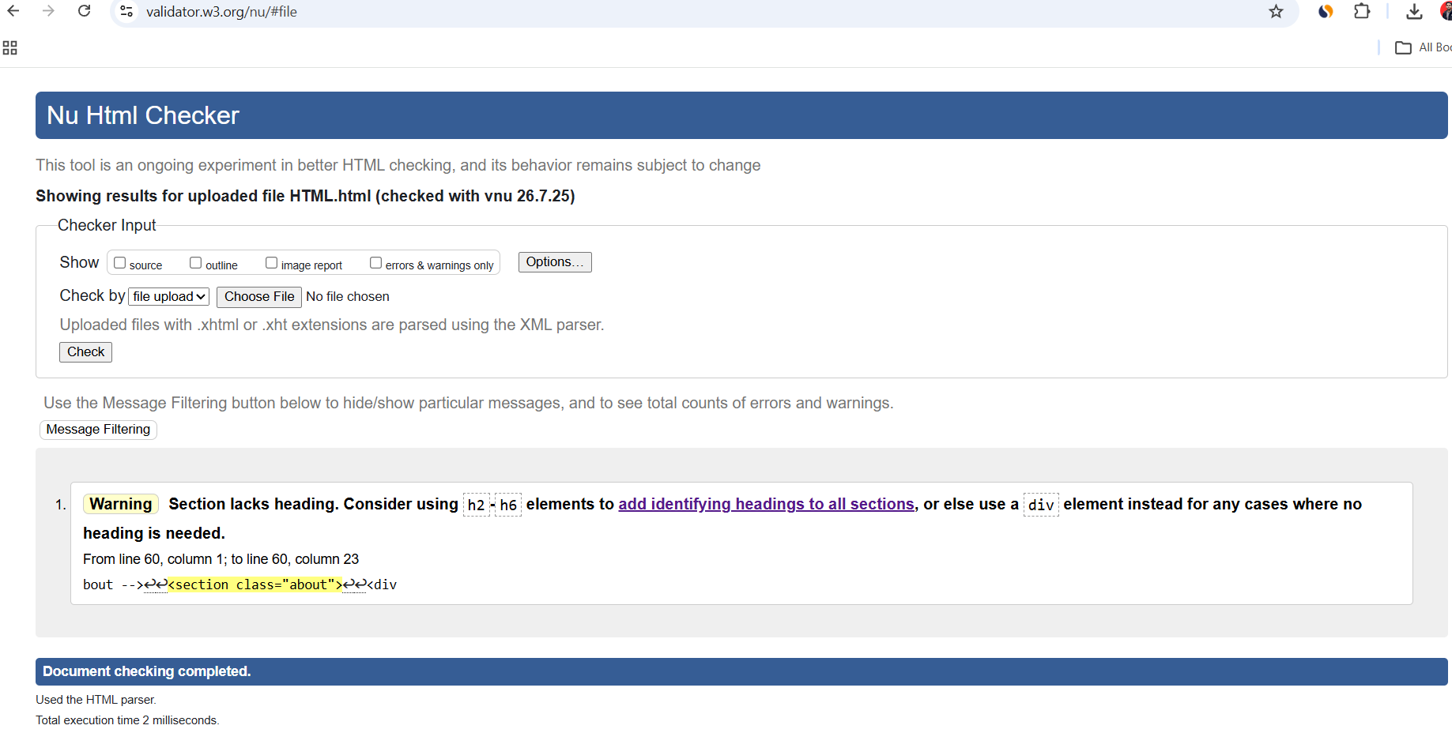
Figure 6: Submitting my Home html file to Vilidator.w3.org and checking the error.

After changing the tags:
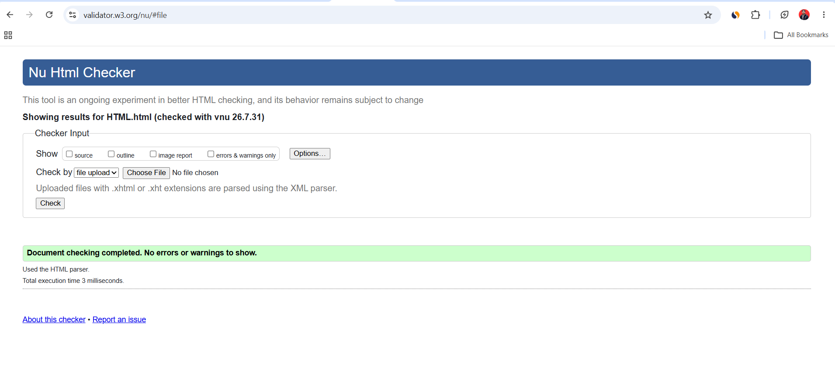
Figure 7: After fixing all the errors.

- Menu Page Result: it came clean result.
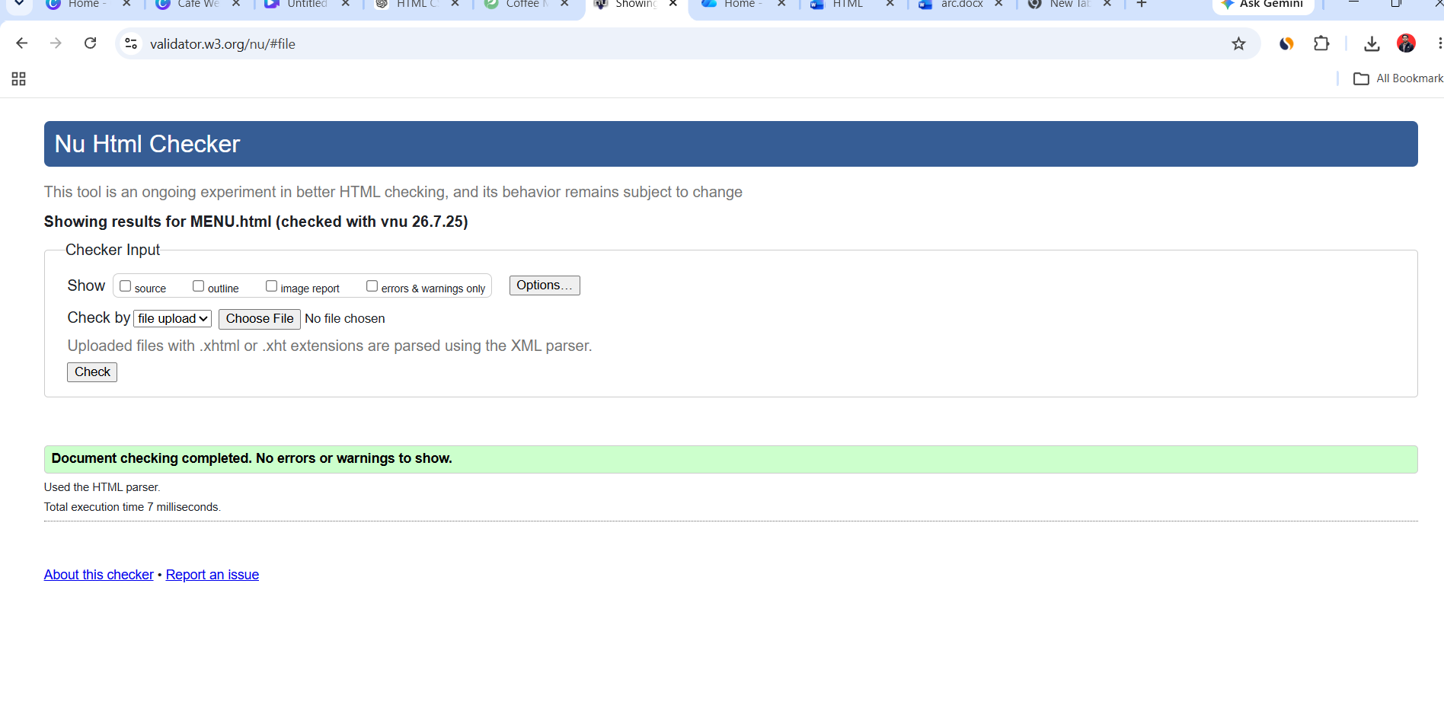
Figure 8: Submitted the menu.html file and got zero errors.
- Contact Page Check: 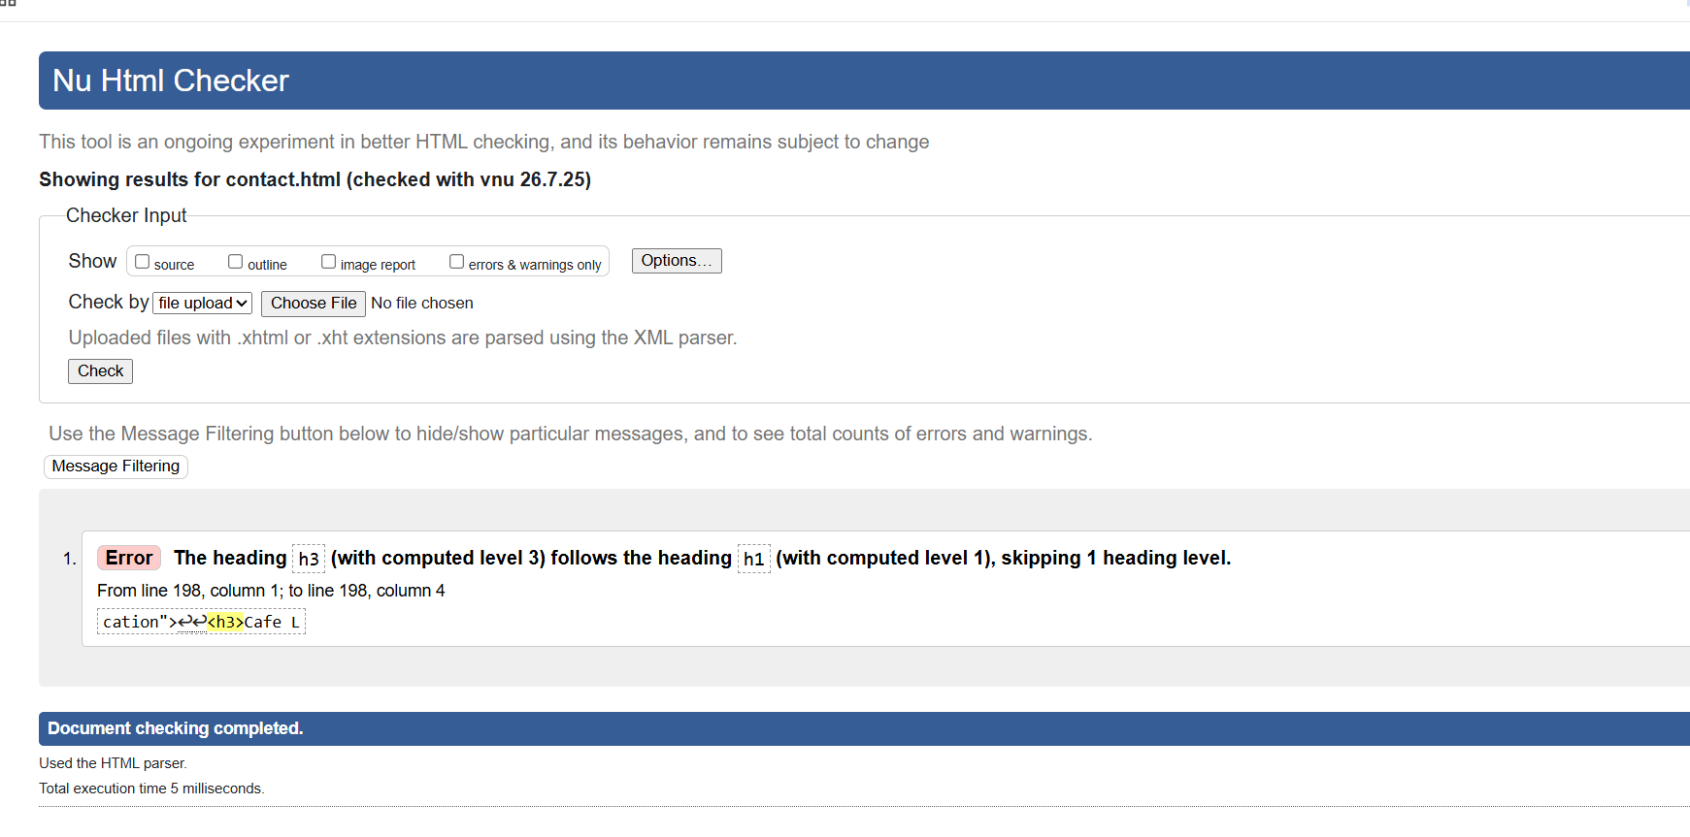
Figure 9: Submitted the contact.html file and got one error.

After the changes:

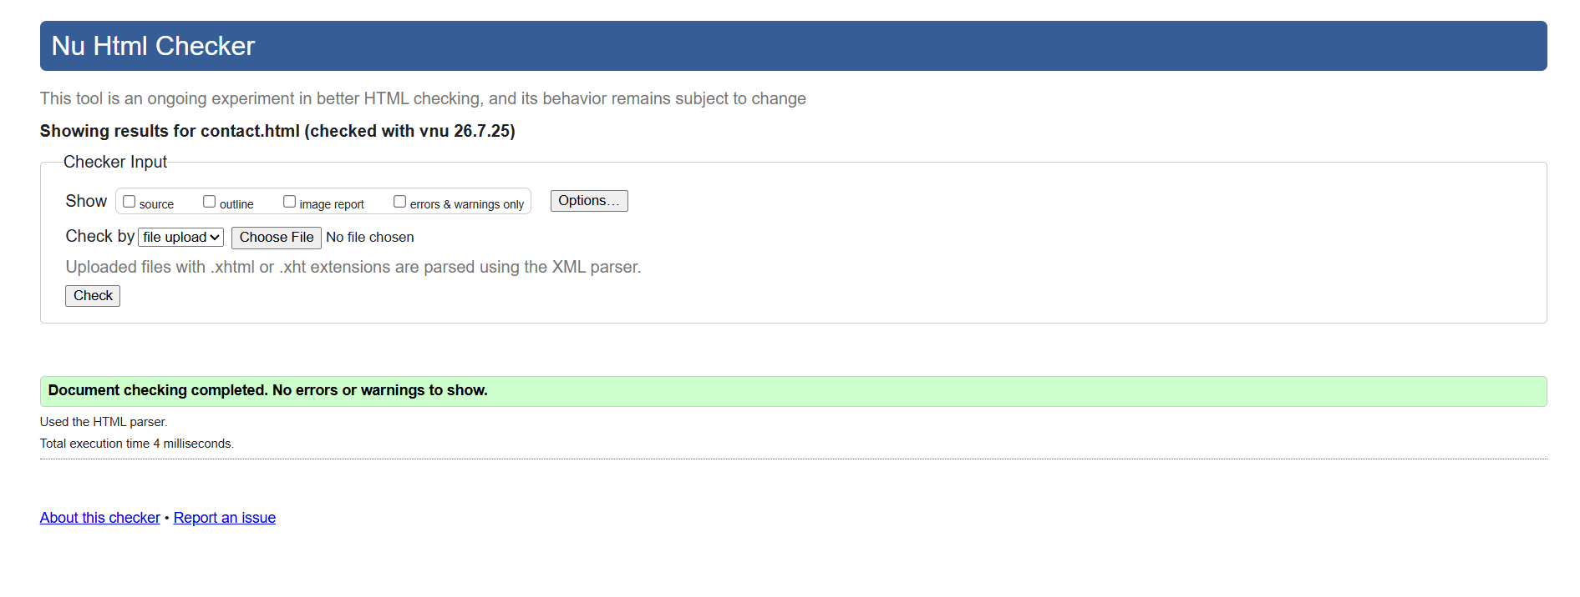
Figure 10: After fixing that error.

CSS Validation Check:
There is no error in my CSS file. As it is professionally designed, it shows no errors.
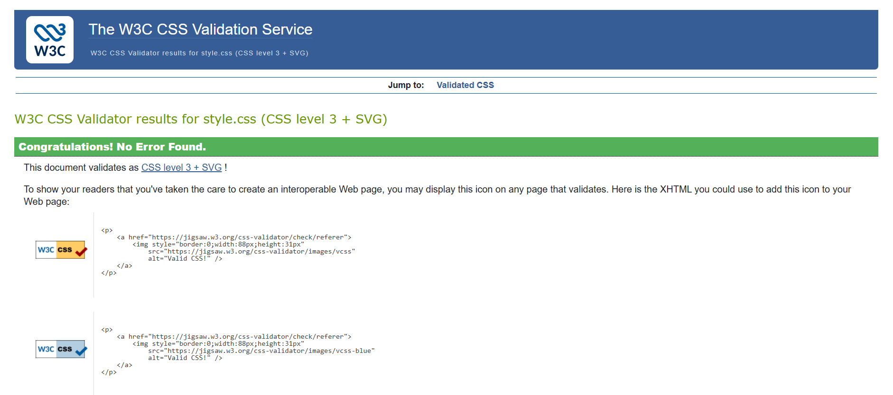
Figure 11: No errors on css.

Conclusion
The Royal Bengal Café website successfully meets its main objective of providing customers with useful information through a simple, attractive, and easy-to-use design. The website was developed using only HTML and CSS and includes three connected pages: Home, Menu, and Contact. Throughout this project, I learned how to create a responsive website, organize web content, and apply CSS to improve the appearance and user experience. I also used Notepad++ for the first time, which helped me understand how to write and edit HTML and CSS code more efficiently. Although the website works well, it could be improved in the future by adding features such as online table reservations, customer reviews, and an online food ordering system. Overall, this project has improved my web development skills and increased my confidence in building websites from scratch.

References

[1] | "HTML: HyperText Markup Language," Mozilla Developer Network (MDN), [Online]. Available: https://developer.mozilla.org/en-US/docs/Web/HTML. [Accessed 4 August 2026].
[2] | "HTML Tutorial," W3Schools, [Online]. Available: https://www.w3schools.com/html/. [Accessed 5 August 2026].
[3] | "BBC Sport," 2026. [Online]. Available: https://www.bbc.co.uk/sport.
[4] | "Real Madrid FC," 2026. [Online]. Available: https://www.realmadrid.com.
[5] | N. Nielsen, "Website Navigation: 10 Best Practices," Nielsen Norman Group, 2024. [Online]. Available: https://www.nngroup.com/articles/navigation-101/. [Accessed 4 08 2026].
[6] | "HTML Validator," W3C, 2026. [Online]. Available: https://validator.w3.org/.

Appendices

Home Page: HTML Code
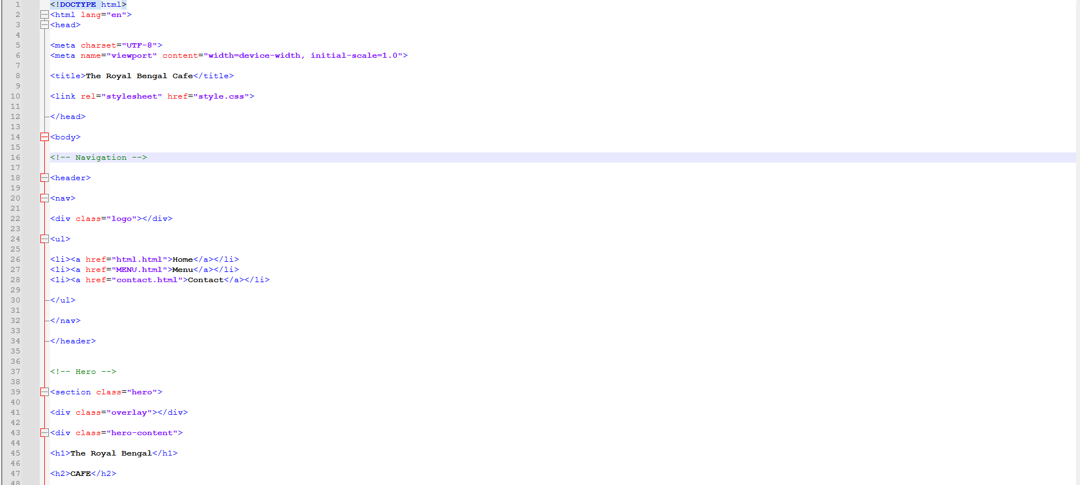
Figure 12: The HTML code for the home page.
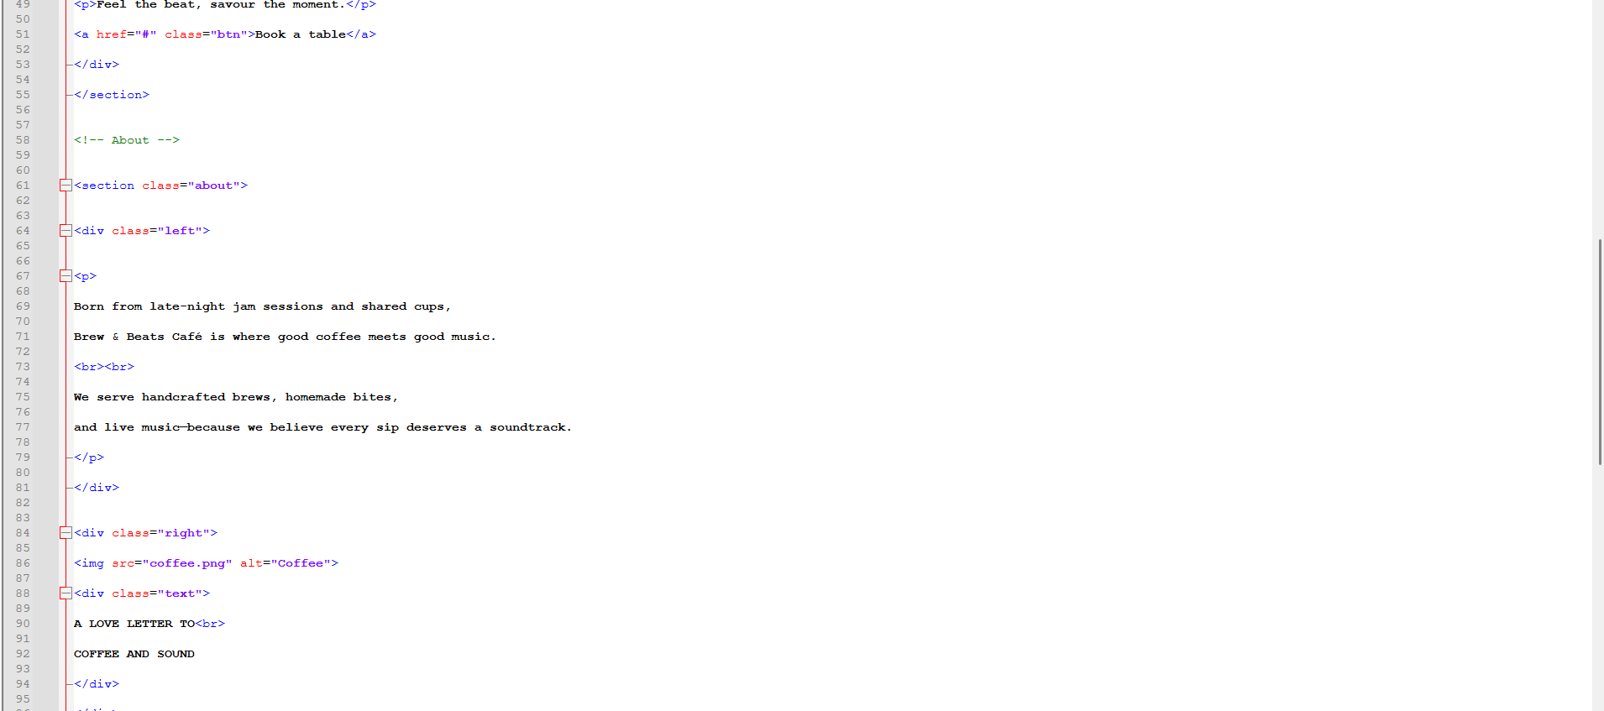
Figure 13: The HTML code for the home page.

Menu Page:
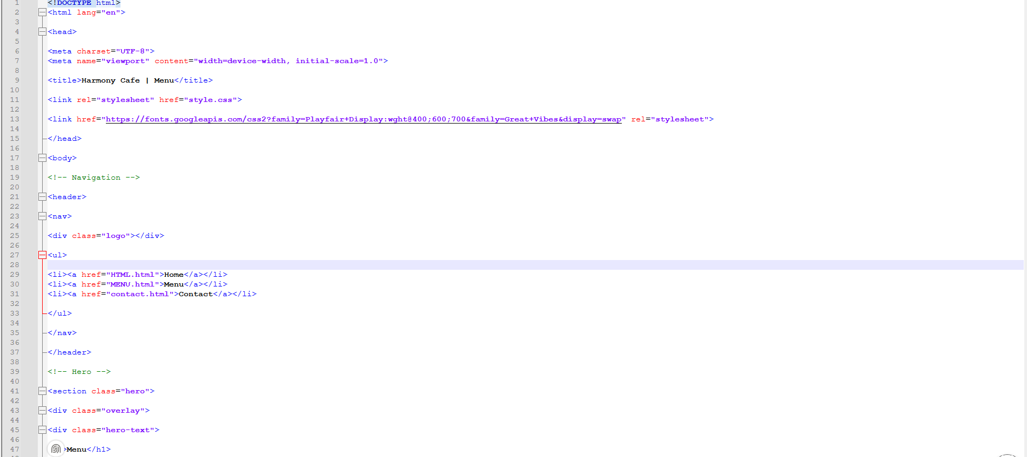
Figure 14: The HTML code for the menu page.

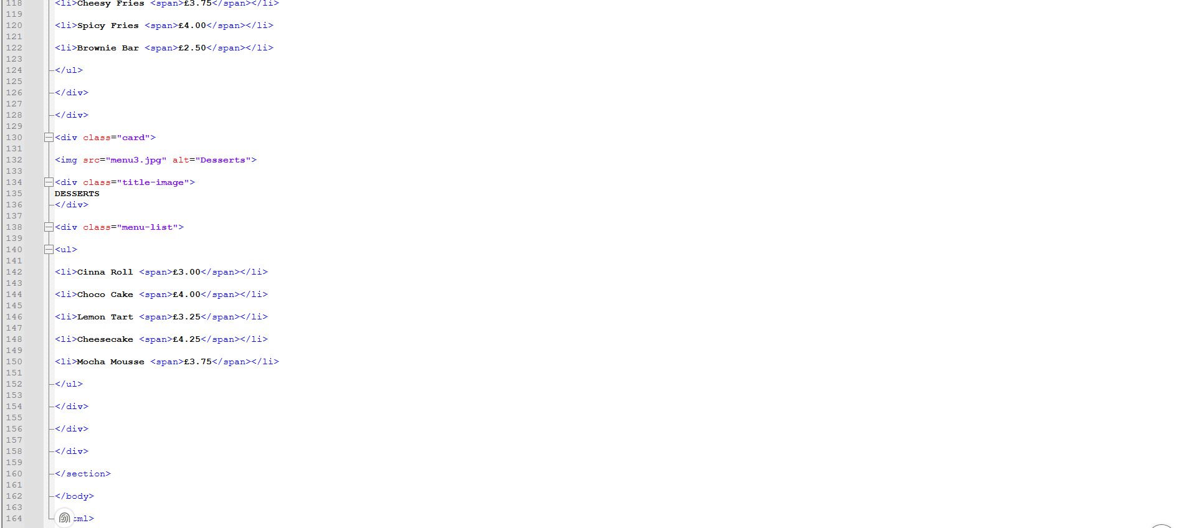
Figure 15: The HTML code for the menu page.

Contact Page:
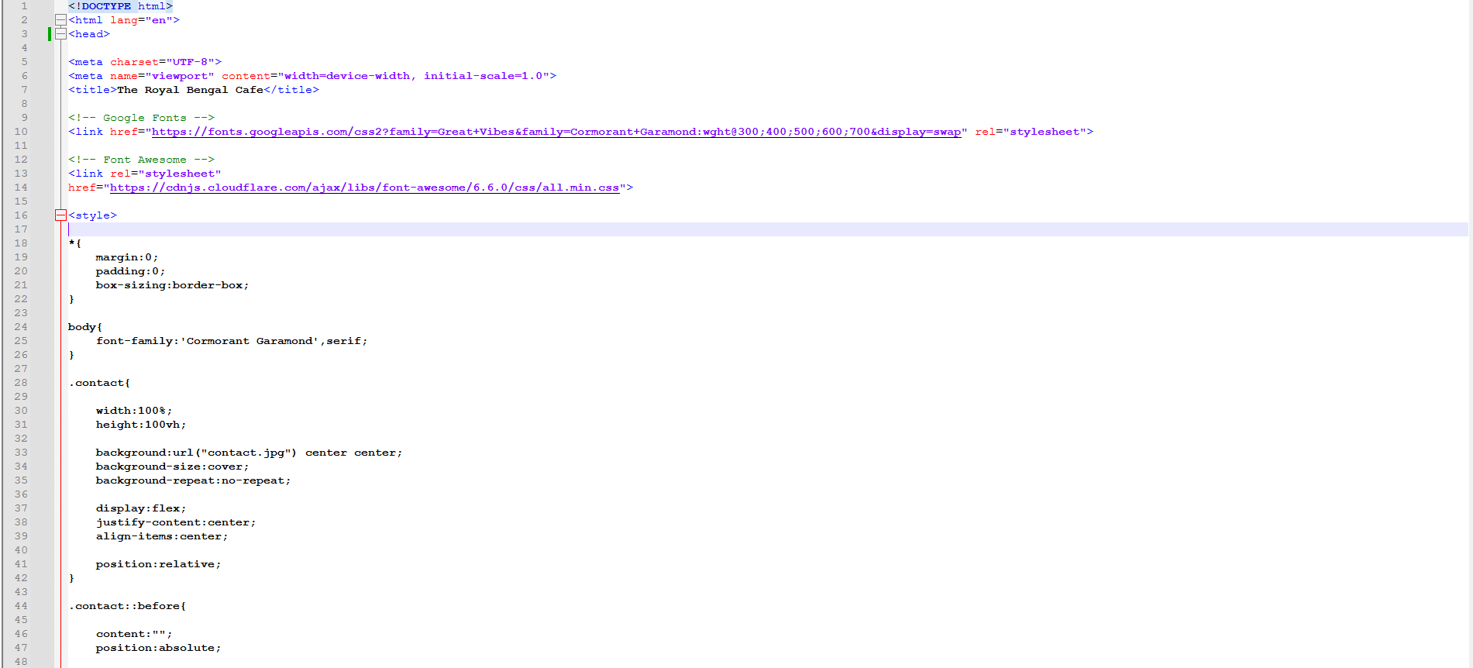
Figure 16: The HTML code for the contact page.

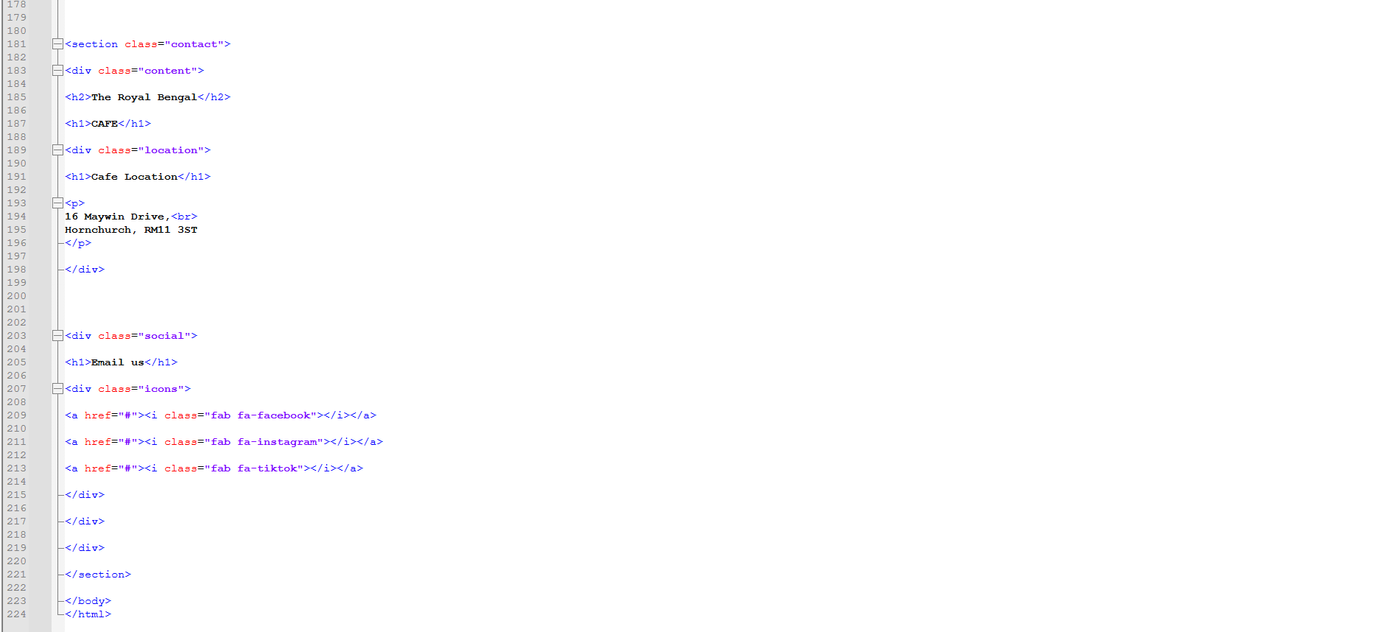
CSS :
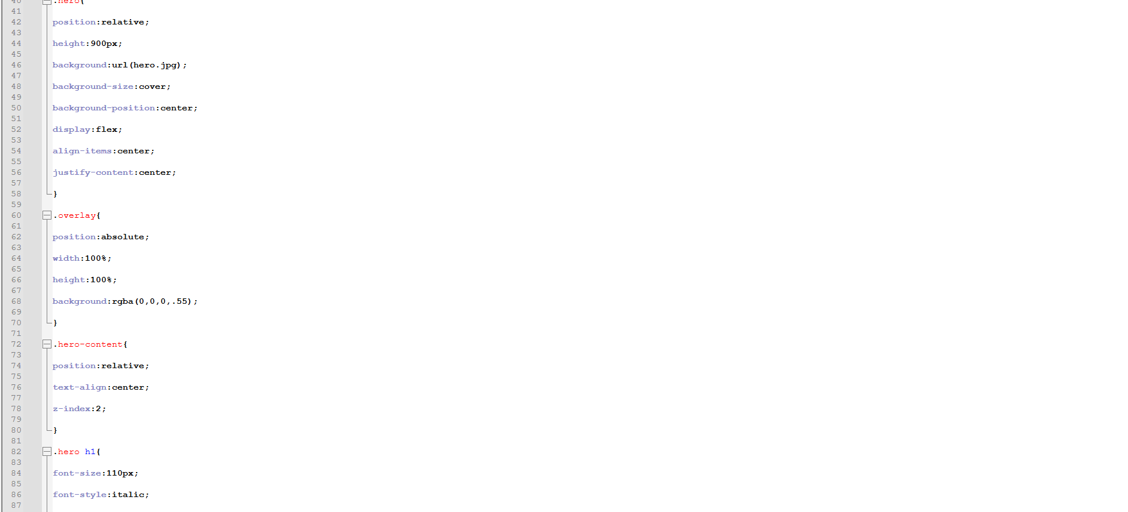
Figure 12: The CSS code for the home, menu and contact page.


