

Student name: Agnieszka Plikunas
Student ID:2512522

Module name: Introduction to Health and Social Care
Module code: LCHS4003
Lecturer name: Mark Kane
Content page

Element 1 ……………………………………………………2…. page
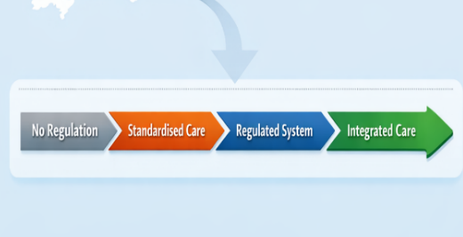

This poster focuses on residential care homes with nursing.
A residential care home is a long-term living arrangement where residents receive assistance with daily tasks. People consider it their home, with staff available to support personal needs (Berg 2021).
The main aims of residential care homes are to provide residential support and personal care for older adults while maintaining their dignity and enhancing their quality of life (National Health Service, 2023). Staff are trained to assist with daily activities, offer emotional support, and supervise residents' care. Healthcare professionals collaborate closely with care staff to monitor residents’ physical and emotional wellbeing (Care Quality Commission, 2023).
A residential care home helps decrease social isolation by providing residents with opportunities to interact with others. Many facilities typically organise a range of activities, such as board games, bingo, art, or social events. These activities promote residents’ mental and physical engagement. This is especially important because social interactions can boost mental health and overall wellbeing (Age UK, 2022).
Residential care home encounters numerous challenges. These include staff shortages, high demand for services, and financial constraints. Delivering high-quality care requires qualified staff, effective management, and oversight by regulatory organisations (The King's Fund, 2023). Despite these challenges, care homes remain a vital part of the system because they support independence by offering targeted assistance to individuals with care needs.
Conclusion:
Residential care homes are vital in supporting older adults and those unable to live independently (Gordon, 2022). They provide accommodation along with 24-hour personal care, making them a crucial part of modern social care. However, challenges such as staff shortages, rising demand, and funding pressures emphasise the need for ongoing improvements to workforce support and regulation. Despite their important role, residential care homes often struggle to balance quality of care with financial constraints and workforce limitations, which can impact residents’ wellbeing and expose systemic weaknesses in social care services (Lewis, 2022).
HISTORICAL JOURNEY
1948 – 5 July – Establishment of the National Health Service (NHS), delivering universal healthcare in England.
1948 – The National Assistance Act 1948 replaces workhouses and enables local authorities to establish residential homes for the elderly.
1984 – The Registered Homes Act 1984 introduces regulation and registration of residential and nursing homes.
2000 – The Care Standards Act 2000 establishes national standards for care services and introduces modern regulation of care homes.
2008 – The Health and Social Care Act formed the legislative structure that underpins regulation across health and social care. (GOV.UK, 2022).
2009 – Care Quality Commission (CQC) becomes the independent regulator of health and social care providers in England.
2014 – Care Act 2014 reforms adult social care, promoting wellbeing, safeguarding, and person-centred care.
2022 – Integrated Care Systems were formally established through the Health and Care Act 2022, reducing gaps between medical care and social support.

Currently, Care in England emphasises person-centred, rights-based, and regulated care, overseen by the Care Quality Commission and provided through Integrated working involving the NHS, local government, and the care sector.

In November 2025, older adults constituted the majority of care home residents, accounting for 93% of the 360,343 residents, while younger adults accounted for only 7% (GOV.UK, 2025).
Integrated Care Diagram in England
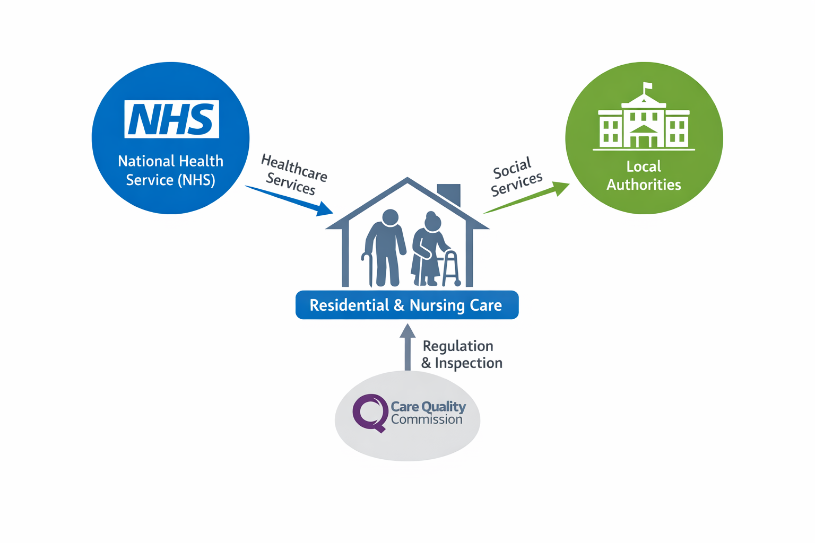



Agnieszka Plikunas, Introduction to Health and Social Care LCHS4003, 2512522@student.uwtsd.ac.uk


Residential Care Home
The current function of the Residential Care Home focuses on nursing.
- Personal care support- Help with essential self‑care tasks, including washing, dressing or eating.
- Safe, stable accommodation -Residents live in a safe and supportive community, reducing risks, particularly for individuals who find it difficult to live independently or whose care needs are increasing (National Health Service, n. d.).
- Support and supervision available 24 hours a day.
- Emotional health and social wellbeing
- Monitoring and managing resident medication.
- Support for individuals who are unable to live independently (Carers UK, n.d.).
Challenges
The main current challenges include staffing shortages and employee retention issues. Work visa problems have become more common, with approval rates falling significantly in 2024, consequently reducing the availability of foreign staff (Health, 2025). There is a high turnover rate and difficulty recruiting new personnel, especially for night shifts and roles requiring specialised care. Increased demands on existing staff can lead to overwork and disrupt continuity of care. The residential care home sector faces growing operational and financial pressures that may impact service delivery and resource deployment. High living costs lead to high salary expectations and increasing National Insurance contributions (Care England, 2025). Insufficient government financial support makes it difficult for smaller care homes to sustain their finances. Finally, the increasing complexity of care needs presents a major limitation. Residents commonly have multiple chronic illnesses, dementia, or mental health conditions, which require highly skilled nursing. Fragmented integration with the National Health Service (NHS) can delay medical treatment, and limited emotional or social support further restricts the general quality of care. The other problem is the development of an appropriate modified diet plan, and, at times, an inflexible, low-nutrient, or culturally inappropriate menu (Bannerman and McDermott, 2011).

Element 2
PHARMACY SERVICES

Pharmaceutical services are essential in healthcare as they guarantee the safe supply and management of medicines and oversee dosage and utilisation (World Health Organization and International Pharmaceutical Federation, 2006). Pharmacists dispense medicines, provide health advice, and assist in managing chronic conditions (NHS, 2023). Over time, pharmaceutical services have evolved from preparing medicines to educating the public about healthcare. This essay examines the historical origins of pharmaceutical services, describes their functions, and critically evaluates them. It discusses their current role within healthcare and highlights their importance in improving the quality of services provided and the wellbeing of individuals (Community Pharmacy Scotland, 2023).

The origins of pharmaceutical services date back to early civilisations, where plants and herbs were used to make medicines. In the Middle Ages, pharmacy became a separate, organised profession distinct from medicine, with pharmacists in Europe responsible for preparing and selling prescribed medicines. The founding of the Royal Pharmaceutical Society in 1948 helped regulate the profession, enhance standards, and ensure pharmacist education, professional training and safe medicine preparation (Anderson, 2020). Today, the National Health Service provides prescription medicines widely, supporting comprehensive pharmaceutical care for everyone (NHS England, 2023).

Today, pharmaceutical services play a crucial role in connecting patients with the healthcare system. Pharmacies not only dispense medicines but also offer advice on their proper use and support the treatment of minor ailments (NHS England, 2023). Pharmacists also administer vaccinations, assist with smoking cessation, and monitor blood pressure (World Health Organisation, 2021). Within the framework of Integrated Neighbourhood Teams, pharmacists collaborate with the National Health Service to ensure patients have access to healthcare (NHS England, 2023; Community Pharmacy Scotland, 2023). Through this partnership, they promote preventative care, encourage healthy lifestyles, and help improve patients' long-term health. Highly trained pharmacists make important contributions to patient safety by reviewing prescriptions for errors and adverse interactions, providing guidance on proper medication use and side effects. They may also suggest safer or more cost-effective alternatives. This advisory role helps to ensure correct medication use and minimise the risk of misuse (General Pharmaceutical Council, 2022).

Pharmaceutical services face significant challenges due to financial pressures and rising demand. Community pharmacies rely heavily on NHS funding, which has not kept pace with rising costs, including wages, rent, and medication prices (Community Pharmacy England, 2024). Consequently, many struggle to remain financially viable, adding further strain to healthcare services (House of Commons Health and Social Care Committee, 2023). Meanwhile, expanding demand, staff shortages, and rising medication costs are impacting service delivery (NHS England, 2024). These pressures have intensified since the introduction of the Pharmacy First programme, resulting in higher workloads without corresponding funding, which may affect consultation times and service quality. Additional challenges include medication shortages, limited patient awareness, and lack of privacy, while balancing clinical and business responsibilities further reduces time available for patient care (Nuffield Trust, n.d.).

Pharmaceutical services improve patients’ quality of life, as community pharmacies offer accessible advice without appointments (NHS England, 2023). They provide treatment for minor ailments, easing the demand on hospitals and general practices, and support chronic conditions such as diabetes and asthma through continuous pharmacotherapy (World Health Organization, 2021). Pharmacies also promote public health by administering vaccinations, conducting screenings, and giving lifestyle advice, which help prevent disease and enhance community health outcomes (Community Pharmacy Scotland, 2023).

Pharmaceutical services have progressed through scientific advances and healthcare reforms, becoming vital to modern healthcare. Pharmacists play a crucial role in dispensing medicines, giving advice, and supporting public health (World Health Organization, 2021; NHS England, 2023). However, many people still prefer to see GPs rather than visit pharmacies, which can add to the pressure on other health services. Despite challenges such as increasing demand and financial strains (Community Pharmacy England, 2024), these services remain essential for improving patient outcomes and quality of life. Continued support and greater public awareness are therefore necessary (Community Pharmacy Scotland, 2023).
References- Element 1
Age UK (2022). Care homes. Available at: https://www.ageuk.org.uk/information-advice/care/care-homes/. (Accessed: 12 March 2026).

Bannerman, E. and McDermott, K. (2011) ‘Dietary and fluid intakes of older adults in care homes requiring a texture modified diet: the role of snacks’, Journal of the American Medical Directors Association, 12(3), pp. 234–239. doi: 10.1016/j.jamda.2010.06.001. (Accessed: 14 March).

Berg, V. (2021). What Is a Residential Care home? [online] Carehome.co.uk. Available at: https://www.carehome.co.uk/advice/what-is-a-residential-care-home. (Accessed: 8 March 2026).

Care England. (2025). The Arrival of the Second Report in Care England and Cornerstone’s New Report Series to Address Care Home Challenges - Care England. [online] Available at: https://www.careengland.org.uk/the-arrival-of-the-second-report-in-care-england-and-cornerstones-new-report-series-to-address-care-home-challenges/. (Accessed: 8 March 2026).

Care Quality Commission (2023). About care homes. Available at: https://www.cqc.org.uk. (Accessed: 12 March 2026).

Carers UK (n.d.). Residential care. [online] Carers UK. Available at: https://www.carersuk.org/help-and-advice/practical-support/arranging-care-and-support-for-someone/residential-care/. (Accessed: 8 March 2026).

Community Pharmacy England (2024). Community pharmacy funding and pressures. Available at: https://cpe.org.uk/. (Accessed: 20 March 2026).

Cqc.org.uk. (2023). Evidence used in this report - Care Quality Commission. [online] Available at: https://www.cqc.org.uk/publications/major-report/state-care/2023-2024/evidence. (Accessed: 8 March 2026).

Gordon, A.L., 2022. From Warkworth House to the 21st-century care homes: progress marked by persistent challenges. Age and Ageing. Available at: https://academic.oup.com/ageing/article/doi/10.1093/ageing/afac169/6648795. (Accessed: 21 March 2026).

GOV.UK (2022). Health and Social Care Act 2008: code of practice on the prevention and control of infections and related guidance. [online] Gov.uk. Available at: https://www.gov.uk/government/publications/the-health-and-social-care-act-2008-code-of-practice-on-the-prevention-and-control-of-infections-and-related-guidance/health-and-social-care-act-2008-code-of-practice-on-the-prevention-and-control-of-infections-and-related-guidance. (Accessed: 14 March 2026).

Health (2025). Adult social care in England, monthly statistics: December 2025. [online] GOV.UK. Available at: https://www.gov.uk/government/statistics/adult-social-care-in-england-monthly-statistics-december-2025/adult-social-care-in-england-monthly-statistics-december-2025. (Accessed: 10 March 2026).

Health (2025). Adult social care workforce survey: April 2025 report. [online] GOV.UK. Available at: https://www.gov.uk/government/statistics/adult-social-care-workforce-survey-april-2025/adult-social-care-workforce-survey-april-2025-report. (Accessed: 8 March 2026).

Lewis, J., 2022. The problems of social care in English nursing and residential homes for older people and the role of state regulation. Journal of Social Policy, 51(1), pp.185–204. Available at: https://www.tandfonline.com/doi/abs/10.1080/09649069.2022.2067650 (Accessed: 21 March 2026).

‌ National Health Service (2023). Care homes. Available at: https://www.nhs.uk/conditions/social-care-and-support-guide/care-services-equipment-and-care-homes/care-homes/. (Accessed: 12 March 2026).

The King's Fund (2023). Social care in England. Available at: https://www.kingsfund.org.uk. (Accessed: 12 March 2026).
‌

References- Element 2

Anderson, S. (2020). Making Medicines: A Brief History of Pharmacy and Pharmaceuticals. London: Pharmaceutical Press, pp.45–47. (Accessed: 18 March 2026).

Community Pharmacy England (n.d.). Community Pharmacy Pressures Survey 2025 Funding and Profitability Report. [online] Available at: https://cpe.org.uk/wp-content/uploads/2025/08/Pharmacy-Pressures-Survey-2025-Funding-and-Profitability-Report.pdf. (Accessed: 18 March 2026).

Community Pharmacy Scotland (2023). What community pharmacy does. Available at: https://cpsc.org.uk/public/what-community-pharmacy-does. (Accessed: 20 March 2026).
. (Accessed: 18 March 2026).

General Pharmaceutical Council (2022). Standards for pharmacy professionals. Available at: https://www.pharmacyregulation.org/standards-for-pharmacy-professionals. (Accessed: 18 March 2026).

House of Commons Health and Social Care Committee (2023). Community pharmacy report. Available at: https://committees.parliament.uk/. (Accessed: 20 March 2026).

NHS (2023). The role of pharmacists in your healthcare. Available at: https://www.nhsgp.net/the-role-of-pharmacists-in-your-healthcare/. (Accessed: 20 March 2026).

NHS England (2023). Community pharmacy services. Available at: https://www.england.nhs.uk. (Accessed: 15 March 2026).

NHS England (2023). The role of community pharmacies in patient care. Available at: https://www.england.nhs.uk/primary-care/pharmacy/. (Accessed: 20 March 2026).

NHS England (2024). Pharmacy First. [online] www.england.nhs.uk. Available at: https://www.england.nhs.uk/primary-care/pharmacy/pharmacy-services/pharmacy-first/. (Accessed: 18 March 2026).

Nuffield Trust. (n.d.). A vision for community pharmacy. [online] Available at: https://www.nuffieldtrust.org.uk/research/a-vision-for-community-pharmacy. (Accessed: 18 March 2026).

World Health Organization (2021). Advancing the role of pharmacists to meet changing patient and health system needs. Available at: https://www.who.int/europe/news-room/feature-stories/item/advancing-the-role-of-pharmacists-to-meet-changing-patient-and-health-system-needs. (Accessed: 19 March 2026).

World Health Organization (2021). The role of pharmacists in health systems. Available at: https://www.who.int. (Accessed: 18 March 2026).

World Health Organization (WHO) and International Pharmaceutical Federation (FIP) (2006). Developing pharmacy practice: A focus on patient care. The Hague: FIP. Available at: https://www.fip.org/files/fip/publications/DevelopingPharmacyPractice/DevelopingPharmacyPracticeEN.pdf. (Accessed: 20 March 2026).

‌

‌

‌

‌

‌

‌

