Student Name: Amanda Griffin

Student Number: 2017950

Lecturer: Richmond Lampley

Content

Job description

Cover Letter

CV

JOB DESCRIPTION

https://careers.lidl.co.uk/jobs/store-manager-47.5-hours-gb-070019

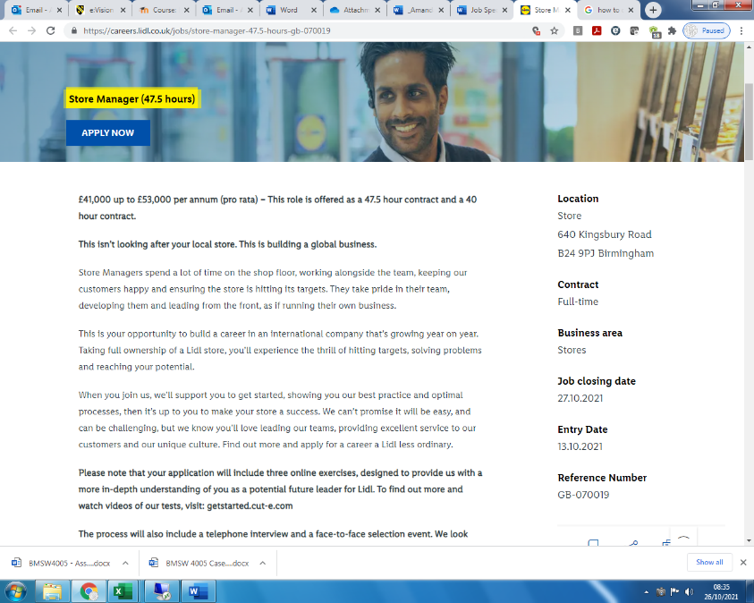
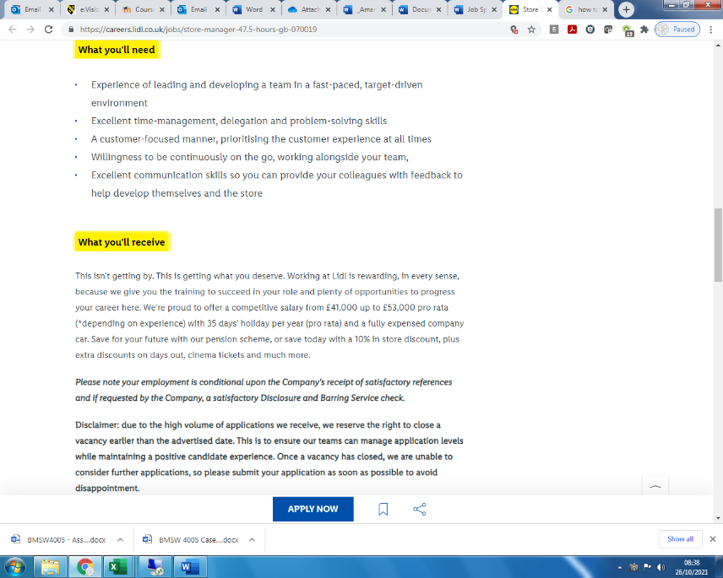

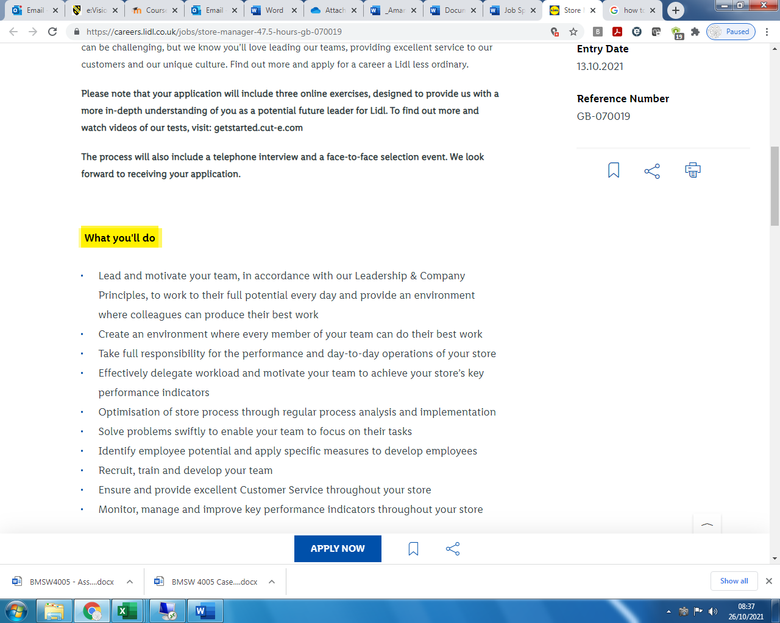

Amanda Griffin Cover Letter

I am proficient and a well organised, an excellent communicator with a big personality, with strong people skills, able to develop effective and positive working relationships with a wide range of clients, colleagues, and staff.

I follow the processes inside-out, and implementation is with a view to understanding and improving the efficiency and effectiveness of its operations. It can be done by updating and maintaining efficient records and training to ensure certain steps are followed. An enthusiastic professional with exceptional written and verbal communication skills with a good eye for details.

I have experience in warehouse management, sales, and accounts. Liaising with customers regarding quality of products and logistical requirements providing feedback and keeping all relevant departments informed and updated.

In my previous role I provided support to the Sales team and our internal customers also. My role was to order stock, liaise with other dealerships for transferring of stock for a swift transaction. Check all orders and ensure they have supporting documents before processing them onto the system. Validate payments have been received before releasing the product. Invoice all orders making sure all relevant information and amount to be paid is correct. I provided weekly stock reports to ensure all was up to date, so stock is not held longer than necessary and amend the system.

I Enjoy working as part of a team offering support to others when needed.
I have the skills and experience to priorities, to get the best out of my daily work and others. Working with a busy Sale team, required excellent time management, as there are always changes, and deadlines to work to. Having the ability to re-arrange my workload and try to plan for changes which may occur.

Thank you for taking time to read my cover letter and considering me for the position.

Amanda GRIFFIN
07843839217
amanda.griffin01@outlook.com

Skills
- 5* Customer service
- Planning & time management skills
- Focus on the job at hand
- Prioritisation of workload according to business expectations
- Work well under pressure.
- Work well in a team and on own initiative.
- Good communicator at all levels, internally and with customers.
- Competent with computer packages: Excel, Word, PowerPoint, Sage, SAP, Vista, Efacs, Csd/ Kerridge, MRM, Opera, Brilliant, Outlook & Lotus notes,
- Multi – line proficiency Avaya system, Meridian, Mitel

Work History

October 2019 – August 2020 Jardine Motors
Sales Administrator
- Highly organised
- Assist retail/ Commercial sales team
- Action all paper work in accurate and within time scale
- Ordering New & Used Cars
- Certify all specifications and accessories are accurate to process the order
- Processing sale documents
- Taxation of all vehicles
- Collating with all departments
- Loading BCA with accurate information for Auction
- Invoicing
- Month end reports
- Filing

Temporary Sept – Oct 2019 Mears Housing
- Carry out inventories
- support the smooth running of a portfolio of properties
- Support the Property Managers
- Key Management
- Uploading All documents
- Archiving
- Filing

February 2019 – Aug 2019 Vehicle Replacement Group
Purchase Ledger
- Matching and coding invoices
- Preparing and running BACS payments
- Reconciling supplier statements and working out VAT payments.
- Contacting suppliers or other departments that handle supplier relation
- Reconcile and identify overdue debtors.
- Validate, confirm, and process purchase and petty cash orders and expenses
- Liaise with clients, debtors, suppliers, and others.

Sales Administrator Listers Land Rover
May 2016 – Jan 2019
- Highly organised
- Assist retail/ Commercial sales team
- Action all paper work in accurate and within time scale
- Ordering New & Used Cars
- Ensure all specifications and accessories are accurate to process the order
- Processing sale documents
- Taxation of all vehicles
- Collating with all departments
- Loading Sellers with accurate information for Auction
- Invoicing
- Filing

Admin/ Receptionist
2015 - 2016
- Meeting and greeting clients.
- Keeping the reception area tidy.
- Answering and forwarding phone calls.
- Logging all calls
- Screening phone calls.
- Updating CRM
- Provide general administrative and clerical support
- Hosting
Sales Coordinator Holiday Inn M6J7
Mar 2015 – Jun 2015
- Plan a range of events, from meetings to conventions, weddings to funerals for regular and new business customers.
- Prepare and follow up on any sales quotations made for clients.
- Negotiate terms, Price & fees to ensure continuation & enhancement of service
- Enquiries via telephone e-mail and walk – in
- Booking Events
- Schedule meeting space, accommodations, food drink, telecommunications, audio-visual needs and transportation.
- The first point of contact for guests enquiring about room reservations
- To conduct effective face-to-face show rounds as and when required for all potential and existing clients.
- Inputting bedroom reservations
- Ensuring all correspondence is correct and up to date
- Liaising with good communication to all departments
- Secure bookings
- Transcribe contract for the client to sign, indicating all of the details agreed upon.
- Filing.

October 2013 - 2015 Stratstone Land Rover
Sales Administrator/ Receptionist
- Supporting the sales team
- Processing sales-related paperwork and arranging appointments
- Point of contact for customers needing assistance, assisting with requests and complaints
- Providing data and reports to help the sales team
- Telephone inquiries
- Screening visiting clients.
- Hosting

June 2008 – December 2008 Wing Yip
National & International Sales & Marketing Administrator
- Purchase Orders - Raising
- Processing Orders via: Mail, telephone, fax, email or internet, UK & International
- Pricing Quotations - Customers
- Queries – Pricing, Orders & Product
- Product & merchandise information dispatching
- Transport Organising – Preparation UK & International
- Liaise with Internal & External Dept.

Jan 2008 – June 2008 Tyco waterworks
National Customer Service Adviser
- Processing Orders- 250 orders per week
- Price & Order Queries- Mail, telephone & E-mail
- Pod Retrieve- Adobe Reader and Internet
- Invoice/ Purchase Order Scanning-
- Efacs – Adobe Reader
- Optimising
- Setting out the invoice supplier information
- Verifying; Invoice lines; dates, numbers & totals

Education / Training
Customer Service Level 2, Computers Level 3, Business Studies Level 2, Excel, Word & Power-point Level 3,
English A Level, Math A Level, Law A Level, Sociology A Level, History Level 3
First Aid at Work Level 2, Impact & Influence Course, Assertive Course

