- Module name : Population Health and Digital Health Promotion
- Task 1: Blog Entries
- Student Name: Priyankaben Mukeshbhai Ahir
- Student number : 2433322
- Module code : 7009
- Lecture’s name: Dr Besty Jose

Blog 1: Critically discuss the impact of an existing digital technology used for the digital health promotion intervention

Cardiovascular disease: A public health concern
Cardiovascular disease (CVD) is one of the leading causes of mortality as it leads to heart attacks, heart failures and strokes. Hypertension is referred to as one of the leading risk factors of CVD because it damages blood vessels and increases the progression of the serious heart condition (Fuchs and Whelton, 2019). In the UK, more than 7.6 million people live with CVD, and each year approximately 480 people die from this disease. Approximately 49,000 people died under the age of 75 due to CVD each year (British Heart Foundation, 2025). Hence, managing this condition becomes essential where various digital technology is used to improve the heart health of the population.
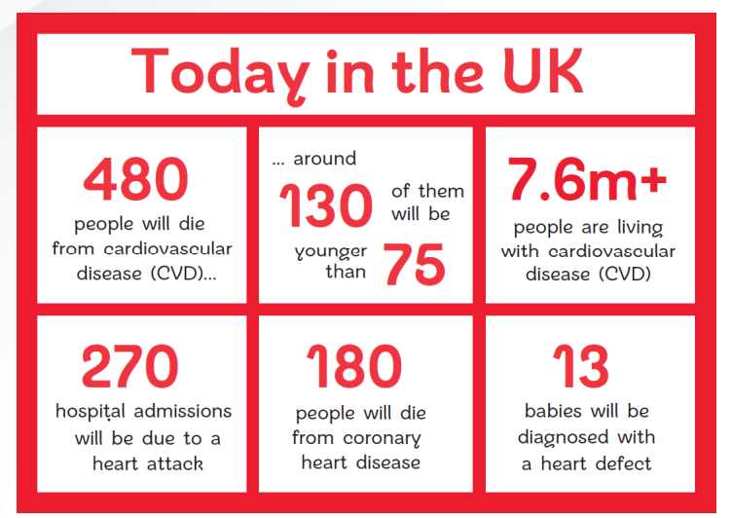
Figure 1: CVD factsheet in the UK, Source: (British Heart Foundation, 2025)

Chosen digital technology
Digital wearables such as the Apple Watch have the capability to facilitate cardiovascular health through preventive care. Apple Watch Series 4 includes several features, such as an electrocardiogram feature and heart rate sensors, which have created opportunities to detect irregular heart rhythms (Apple Support, n.d). This wearable technology improves health promotion and enables users to monitor their cardiovascular health.
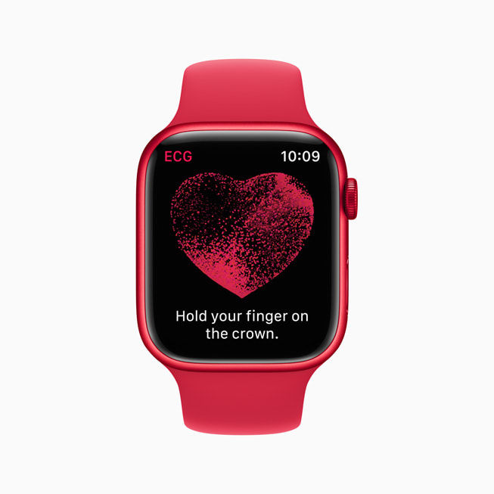
Figure 2: Apple Watch, Source: (Apple Support, n.d)

Evidence about the impact of the chosen technology
A study by Turakhia et al. (2019), based on the Apple Heart study, where more than 400,000 participants were involved, found that the Apple Watch identified AF (“Atrial fibrillation”) among the participants. The positive predictive value is greater than 0.70%, which demonstrates the potential of the Apple Watch to detect heart issues and reduce the risks, such as heart failure and stroke. Hence, this technology contributes to digital transformation for preventive healthcare.

Impact of Apple Watch on health promotion and its advantages and limitations
This technology aligns with Health Promotion principles in terms of encouraging behavioural change and self-management. The device also promotes health literacy and motivates the users to adopt a healthier lifestyle through fitness goal settings, activity tracking and others (Mattison et al., 2023). However, some disadvantages are associated with this wearable technology. For example, the high cost of the device, which is approximately USD 400-800, limits its accessibility among the low-income population. This has created digital equity gaps (Apple Support, n.d). Similarly, it cannot be used as a substitute for medical-grade diagnostics, and even a false positive can develop anxiety.
The concern related to security and data privacy is also associated with this digital health technology (Mattison et al., 2023). Hence, to address these advantages, policymakers should collaborate with technology developers to ensure that the digital device will provide maximum safety to the users. Furthermore, prioritising equitable access to health technologies is essential, where subsidising wearables and integrating low-cost alternatives could be beneficial for the particularly lower-income population.

References
Apple Support (n.d.). Take an ECG with the ECG app on Apple Watch. [online] Apple Support. Available at: https://support.apple.com/en-us/120278.
British Heart Foundation (2025). UK Factsheet. [online] British Heart Foundation. British Heart Foundation. Available at: https://www.bhf.org.uk/-/media/files/for-professionals/research/heart-statistics/bhf-cvd-statistics-uk-factsheet.pdf.
Fuchs, F.D. and Whelton, P.K. (2019). High Blood Pressure and Cardiovascular Disease. Hypertension, [online] 75(2), pp.285–292. https://doi.org/10.1161/HYPERTENSIONAHA.119.14240.
Mattison, G., Canfell, O.J., Forrester, D., Dobbins, C., Smith, D., Reid, D. and Sullivan, C. (2023). A step in the right direction: The potential role of smartwatches to support chronic disease prevention in health care. The Medical Journal of Australia, 218(9). https://doi.org/10.5694/mja2.51920.
Turakhia, M.P., Desai, M., Hedlin, H., Rajmane, A., Talati, N., Ferris, T., Desai, S., Nag, D., Patel, M., Kowey, P., Rumsfeld, J.S., Russo, A.M., Hills, M.T., Granger, C.B., Mahaffey, K.W. and Perez, M.V. (2019). Rationale and design of a large-scale, app-based study to identify cardiac arrhythmias using a smartwatch: The Apple Heart Study. American Heart Journal, 207, pp.66–75. https://doi.org/10.1016/j.ahj.2018.09.002.

Blog 2: Discussion on the impact of digital technology designed for health promotion intervention

Public Health Concerns Related to CVDs
One of the leading causes of mortality is cardiovascular disease in the world. It is estimated that 19.8 million people died from CVDs in 2022, which represents approximately 32% of global deaths (World Health Organisation, 2025). In rural areas, limited access to healthcare and late diagnosis make CVD one of the major health concerns. Hence, it highlights the need for an affordable and community-driven digital solution that can improve early detection among the rural population.
Follow the link below to get more details
https://www.who.int/news-room/fact-sheets/detail/cardiovascular-diseases-(cvds)

Designing a modified digital technology
A low-cost wearable wristband can be designed for the particularly rural population. This wristband will be able to monitor cardiovascular indicators such as oxygen saturation, blood pressure and even heart rate by using optical sensors. Unlike the premium wearables such as the Apple Watch, this new digital technology will be connected to the community health platform, specifically for the rural areas to access and interpret data of the patients for improving their well-being. This new technology, with an integrated mobile app with this wristband, will display colour-coded readings such as red for alerts, green for normal heart rate and yellow indicators for moderate heart rate that will make it user-friendly. This can empower individuals to monitor their cardiovascular health and reinforce digital health equity.

Impact of new digital technology
The purpose of this new technology is to create a bridge between early detection and prevention of CVD. The principles of the “Ottawa Charter for Health Promotion” will be aligned with this technology in terms of strengthening community participation (World Health Organisation, n.d). Besides that, the impact of this technology on health promotion could be transformative by focusing on continuous monitoring of patients’ health. As a result, it will reduce diagnostic delays and, at the same time, enhance preventive behaviours. For example, through regularly monitoring blood pressure and oxygen level, the individual will be aware of their heart condition (Nwibor et al., 2023). As a result, it can inspire them to consult with healthcare professionals, take medication, diet modification and many more.
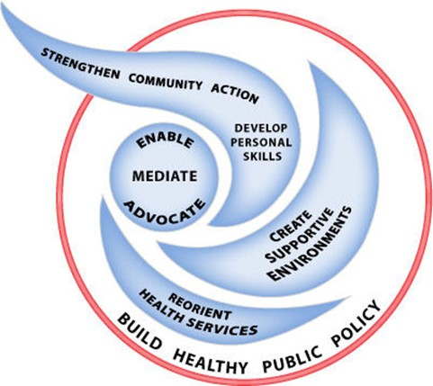
Figure 1: Ottawa Charter for Health Promotion,
Source: (World Health Organisation, n.d)

Advantages and Shortfalls
The advantages of this digital technology are based on showing improvement in hypertension awareness, diet management, regular visits to the healthcare sector and many more. However, some challenges are associated, such as internet connectivity and poor digital infrastructure (Hemanta Kumar Doloi, 2025). Hence, to overcome these barriers, an offline data storage feature could be incorporated, which can allow the device to record without an internet connection. Furthermore, a partnership with a telecommunications provider can strengthen digital infrastructure in rural areas, which will make it an effective model for digital health interventions.

References
Hemanta Kumar Doloi (2025). Digital Inclusion for Rural Growth: Internet Usage and Smart Villages Development. Asia-Pacific Journal of Rural Development, 35(1), pp.40–57. https://doi.org/10.1177/10185291251343357.
Nwibor, C., Haxha, S., Ali, M., Sakel, M., Haxha, A. R., Saunders, K., and Nabakooza, S. (2023). Remote Health Monitoring System for the Estimation of Blood Pressure, Heart Rate and Blood Oxygen Saturation Level. IEEE Sensors Journal, pp. 1–1. https://doi.org/10.1109/jsen.2023.323597
World Health Organisation (n.d.). The 1st International Conference on Health promotion, Ottawa, 1986. [online] World Health Organization. Available at: https://www.who.int/teams/health-promotion/enhanced-wellbeing/first-global-conference.
World Health Organization (2025). Cardiovascular diseases (CVDs). [online] World Health Organization . Available at: https://www.who.int/news-room/fact-sheets/detail/cardiovascular-diseases-(cvds).

