Skills for the Workplace
Module Assignment Submission
Student Name: | Chinedu Onwuchekwa
Student Number: | 1715158
Module No: | BMSK4006
Module Title: | Managing Enterprise in the 21st century
Submission Tittle | Reflective Report
Lecturer Name: | Dr. Isaiah Oino
Counted word:

INTRODUCTION

In this write up I am going to write 2,000 words of Reflective Report on my contribution in helping my group to achieve its goal and how the group on its own achieved its goal of coming out with a Business Plan. I will start my Reflective report writing from the beginning of group formation to the point of the group achieving its goal and also will reflect on what was left undone and how to improve on it if asked in future. The task was to come up with a business plan and how to run a successful business as a team.
A team of five members was formed, this include Mr. A, Mr. B, Mr. C, Mr. D and Mr. E, with the primary aim of contributing their resources to the overall achievement of the team’s goal.
The art of learning to work as a team starts with team development. Studies has shown that teams go through defined stages during their development which include Forming, Storming, Norming, Performing and Adjourning. (Tuckman, 1984).
Reflection is important in academic and workplace because it help us to determine where we are and where we are going, it forms the bases of our correction. Reflecting in what we have done in the past is a pivotal point that change our learning course and the way we do things for the better in future.

Team development

Forming

As its name implies, this is the stage where 5 of us came together and agreed to form a team, we introduced ourselves to one another and get to know one another by name, though at this stage we are still sceptical about the role each person was going to perform in the team. Mr. A was chosen to be the leader of the team because he seems to have a better business plan than any one of us, though at this stage we were still doubtful of one another because we have not known ourselves too well.

Storming
At this stage responsibilities were given out to each member of the group with regard to the chosen business plan which was to open a food supply organisation within London M25. It was a bit difficult for members to agree on the role they were assigned to at the first time. There were issues like, I do not want this role and I prefer that role, at the end Mr. A settled for the role of General Manager, Mr. B as marketing manager, Mr. C as Operation and finance manager, Mr. D as Admin and HR and Mr. E as sales manager.

Norming

After the acceptance of roles by each member in the team, everyone now settles with his responsibility focusing on what he can contribute to the team in other for the team to achieve its goal, because the business plan agreed upon by the team was not well known by individual team members, Mr. A who introduced the business plan was looked upon to explain in details and also come up with more information while individual team member carried out research on their role in the team.

Performing

At this stage the team is focused on how to solve the problem at hand in order to achieve its set goal. By now everyone in the team has known each other well and a lot of things has been agreed upon as at team. Consensus and cooperation is now the other of the day, members are committed to the team’s mission. One rehearsal practice was carried out few hours before the Presentation. Individual team members trying to get use to their work and master how to make a good presentation.

Adjourning

The individual contributions to achieving the teams’ goal is summed up and examined, presentation carried out (in this case) and the team disbanded.

A Reflective report of 2,000 words about my contribution in helping my group to accomplish setting up a business plan and a personal skill which I have learnt or need to improve on set for self-employment.

The 6 stages of reflection in Gibbs’ Reflective Cycle is used in this reflective report as cited in (Dye, 2011).

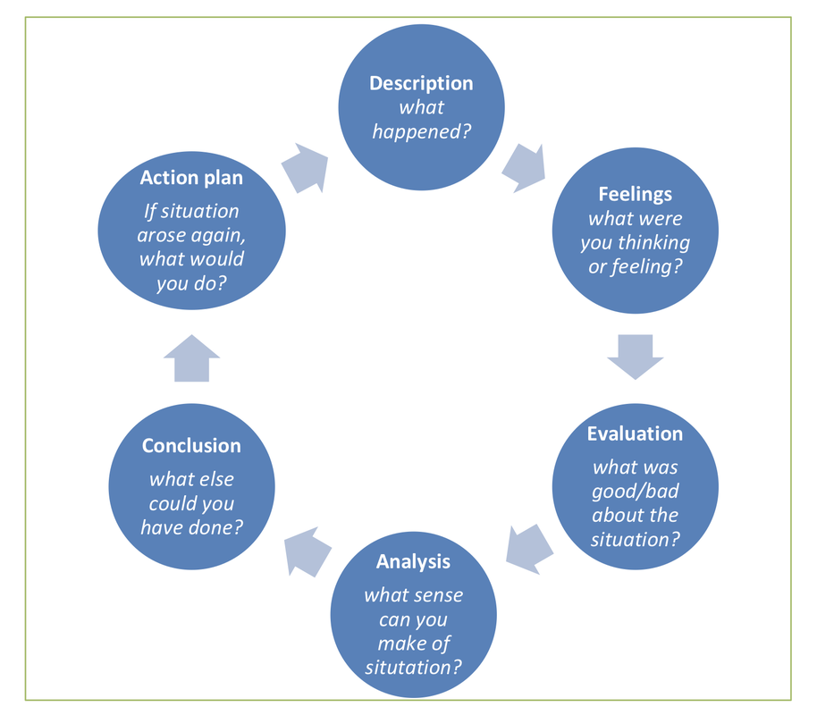

Description
The business plan we choose was to open a food supply organisation to serve other businesses in a similar industry with a view of saving them time and overhead cost. We aim to do this by taking their orders and source it for them and save them logistics and warehouse expenses, because it is believed that by the time they will individually source this good couple with their perishable nature time and waste will be on the high side.

Feelings
At the beginning after forming the group there was this period of uncertainty because I have not done a presentation before nor have I wrote a business plan. Secondly coming up with a business plan in an academic environment with people I know little or nothing about, there was this feeling of not knowing how it will end up, to make matter worse the Topic we choose was a bit strange to me. There was a period of brainstorming when we were choosing a business plan which put everyone in the group into a period of panic, but at the end we were able to settle for one. Role was given to each member of the group. I was given the role of sales manager, with, my background in marking I knew I was not going to have much problem with the responsibility.

Evaluation
Generally I did not think it all went as expected during the presentation. The group never had enough practices or rehearsal to prepare us for the presentation, instead of working as a group most times we were working individually because the leader who introduced the business plan to the group felt that he can carry on alone and opinion of other members of the group was not sort. The quantitative research used to analyse the achievement of the group in relation to the group’s goal was not discussed by members. The good thing is that individually members carried on with their assigned responsibilities and at the end we were able to come up with a good business plan presentation.

Analysis
As I mentioned earlier on in my report, my role in the group was the role of sales manager. I was in charge of order taking and to make sure that orders are prepared on time and ready for delivery by transport section.
As food supply organisation we were required to meet at least minimum health and safety standards on our premises under legal status and licencing, as the sales manager I was given the responsibility to give the group the idea on how our organisation can obtain the required operating licence. During the presentation I introduced the theory of net margin and cost of sales focus, I also suggested to the group if we are to achieve our set goal we should aim at budget scrutiny to increase pressure to optimise return on investment and lower acquisition cost. That in practice helped us in our presentation by achieving our set goal which was to increase our profit from 20% to 30% within one year of trade and increase our target area beyond London M25 within the same trade period.
As a hindrance to the group, one of the group member abandoned the course as well as his role which was later on picked up by the group leader, this was a set back to the group. He was meant to handle the role of marking manager.

Action Plan
In my reflective report I have been able to reflect on how my team was formed, the problems we encountered during the team formation, choosing our topic and role sharing. I also reflected on my experience during the presentation as a member of the team, what was done and what need to be improved and how successful the business plan was. The reflective report has given me above every other thing the opportunity to reflect on what I did right and what I did wrong in my presentation and what could be done to improve on the wrong once and also to make my good better. Such things as to keep an eye contact with the audience while carrying out the presentation making sure that the judges understand everything I said.
In the future I will also make sure I learn from other people’s mistakes and how to avoid them which I think will be a good strategy.
In the future I will carry out a wider research on any role given to me in my group and make sure any Topic we are going to choose in the group will be a popular choice. Secondly the group has to come together for rehearsal and do a thorough preparation before presentation.

Kolb, (1984). Sees learning as a coordinated procedure with each stage being commonly strong of and encouraging into the following. It is conceivable to enter the cycle at any stage and finish it its coherent arrangement.

Be that as it may, successful adapting just happens when a student can execute every one of the four phases of the model. Accordingly, nobody phase of the cycle is compelling as a learning technique all alone.

Successful learning is seen when a student advances through a cycle of four phases: (1) having a solid affair pursued by (2) perception of and reflection on that encounter which prompts (3) the development of dynamic ideas (investigation) and speculations (ends) which are at that point (4) used to test theory in future circumstances, bringing about new encounters (Kolb, 1984, p. 38).

Conclusion
Based on the above analysis the group experienced some setbacks prior to our presentation. Individually we were inexperienced in giving a presentation, little or no rehearsal was arranged prior to the presentation. The business plan selected was not well informed and Mr. ‘B’ dropped out of the course almost half way and there was a problem of who was going to take up his role, which the leader of the group later decided to take on, and was resolved.
In my opinion despite the preparation for the presentation did not go as planned, it was a success at the end but could have been better if as a group we had 2 to 3 sections of rehearsal and if Mr. B did not drop out. Secondly the choice of business plan was poor and that made members to struggle learning their roles within the time limit.
By writing this reflective report, I have realised how important reflection is, it has helped me understand areas that we made mistakes as a team and where I have made mistake and the right corrections to make in future. It has also helped me to understand the importance of good preparation before a presentation. Most importantly lessons has been learned from the feedback received which reflects the above mentioned short fall.

Reference:

Kolb, D. A. (1984) Experience as the source of learning and development.

Tuckman, B. (1965) Team development.

Gibbs, G. (1988) Learning by doing.

