Title: "International Medical Conference in London"

Subtitle: "Fostering Equality, Diversity, and Inclusion in the Medical Industry"
Module Title: International Meetings Management for the Hotel Industry (BMIH6007)

Student Name: Austin Agnelo Fernandes
Student id:2228678

use of AI
I confirm that I have not used any AI tools in the research and creation of this assignment. I confirm that I have not presented any AI generated materials as my own work. I confirm I have copies of my drafts, notes, and other resources I used, which I may be asked to provide in evidence.

Table of Contents
Slide 1: title slide 3
Slide 2: Introduction 4
Slide 3: Conference Objectives and Target Audience 5
Slide 5: Conference Agenda 6
Slide 6: Venue & Logistics 7
Slide 7: Financial Plan 8
Slide 8: Risks & Mitigation Strategies 9
Slide 8: Feasibility Analysis 10
Slide 9: Conclusion 11
Slide 10: references 12

Slide 1: title slide
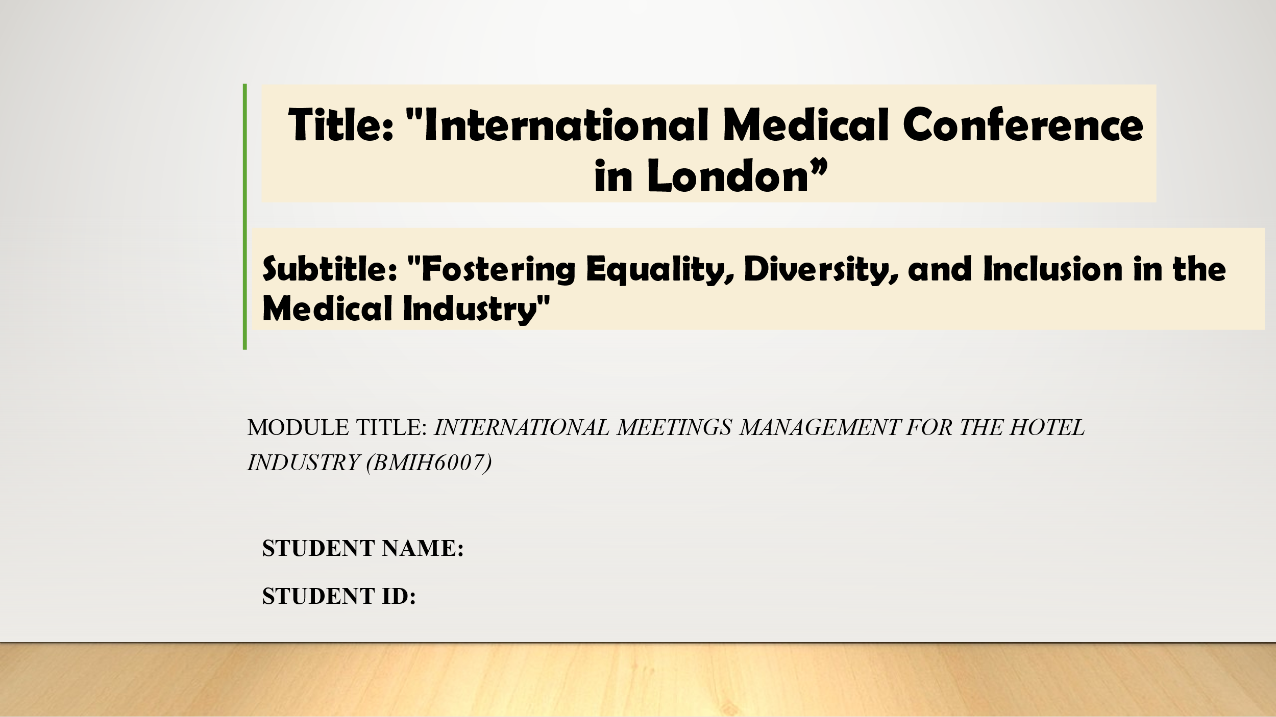

Slide 2: Introduction
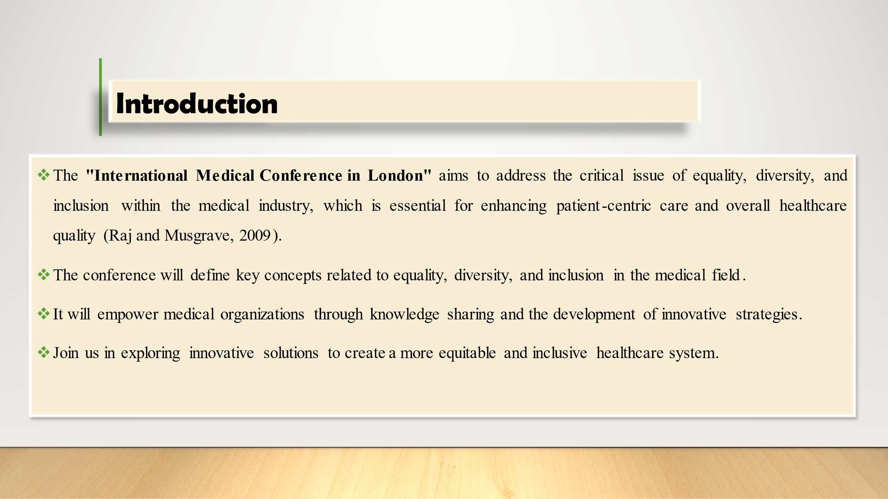
The London International Medical Conference is a critical forum for tackling medical sector problems. The 2020 conference emphasizes making healthcare systems more equitable and inclusive since those elements serve patients better. Members at the conference will establish basic definitions and start discussing how these principles should work in healthcare practice. We aim to help healthcare organizations implement new approaches through shared knowledge and learning to build practical solutions. Global experts meet at this event to find better ways to create fair healthcare services that serve every person involved. Let us build an inclusive healthcare future through our talent for innovation and tender care. So, let us start the presentation session.

Slide 3: Conference Objectives and Target Audience
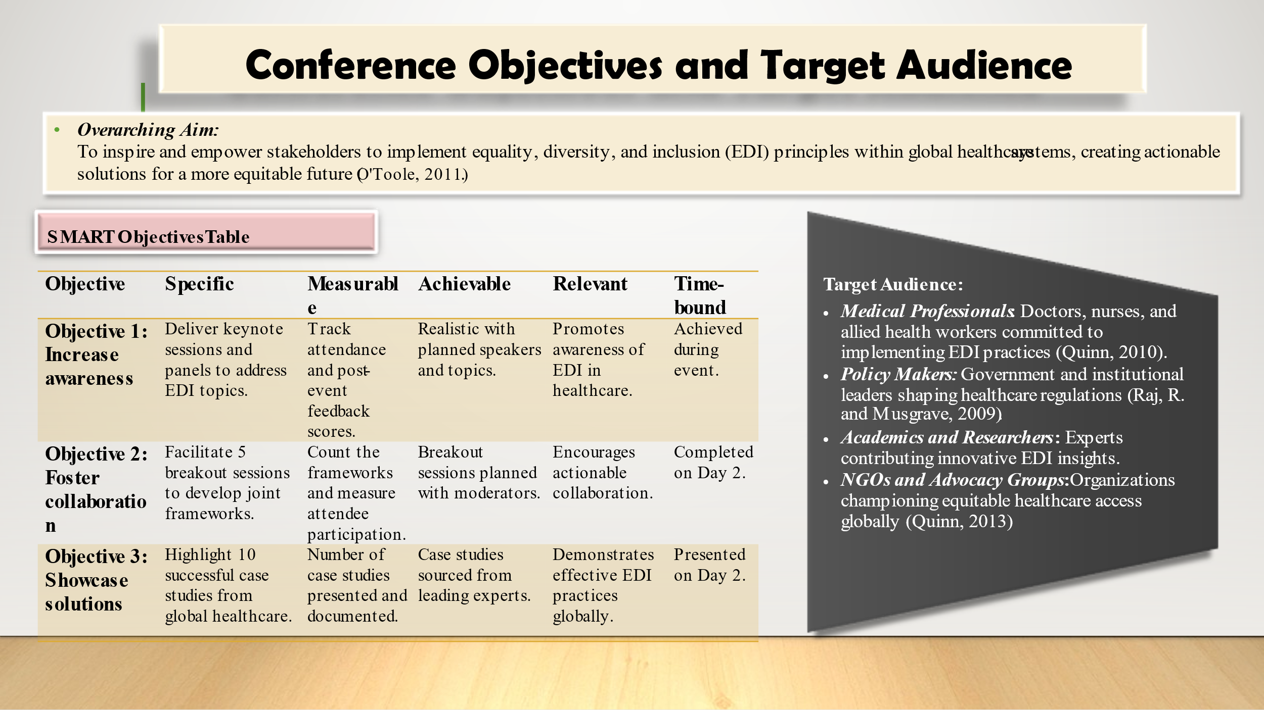
This conference aims at motivating and enabling concerned parties to achieve EDI, Assignment 2 and dynamism within healthcare systems globally. The choice of the SMART objectives is as follows to guarantee powerful consequences: The first objective will involve conducting awareness through keynotes and panel discussions where the number of participants will be used as a measure of performance. The second aims at contributing towards cooperation through the breakout sessions thereby allowing the participants to come up with tangible frameworks. Finally, the presentation of 10 success stories from the healthcare field demonstrates where healthcare organizations have achieved EDI.
The target audience is healthcare providers, policymakers, academics and NGOs are vital stakeholders in the promotion of EDI. This will provide enough interest that will enhance partnerships, encourage creativity, and develop sustainable measures to enhance healthcare equity globally.

Slide 5: Conference Agenda
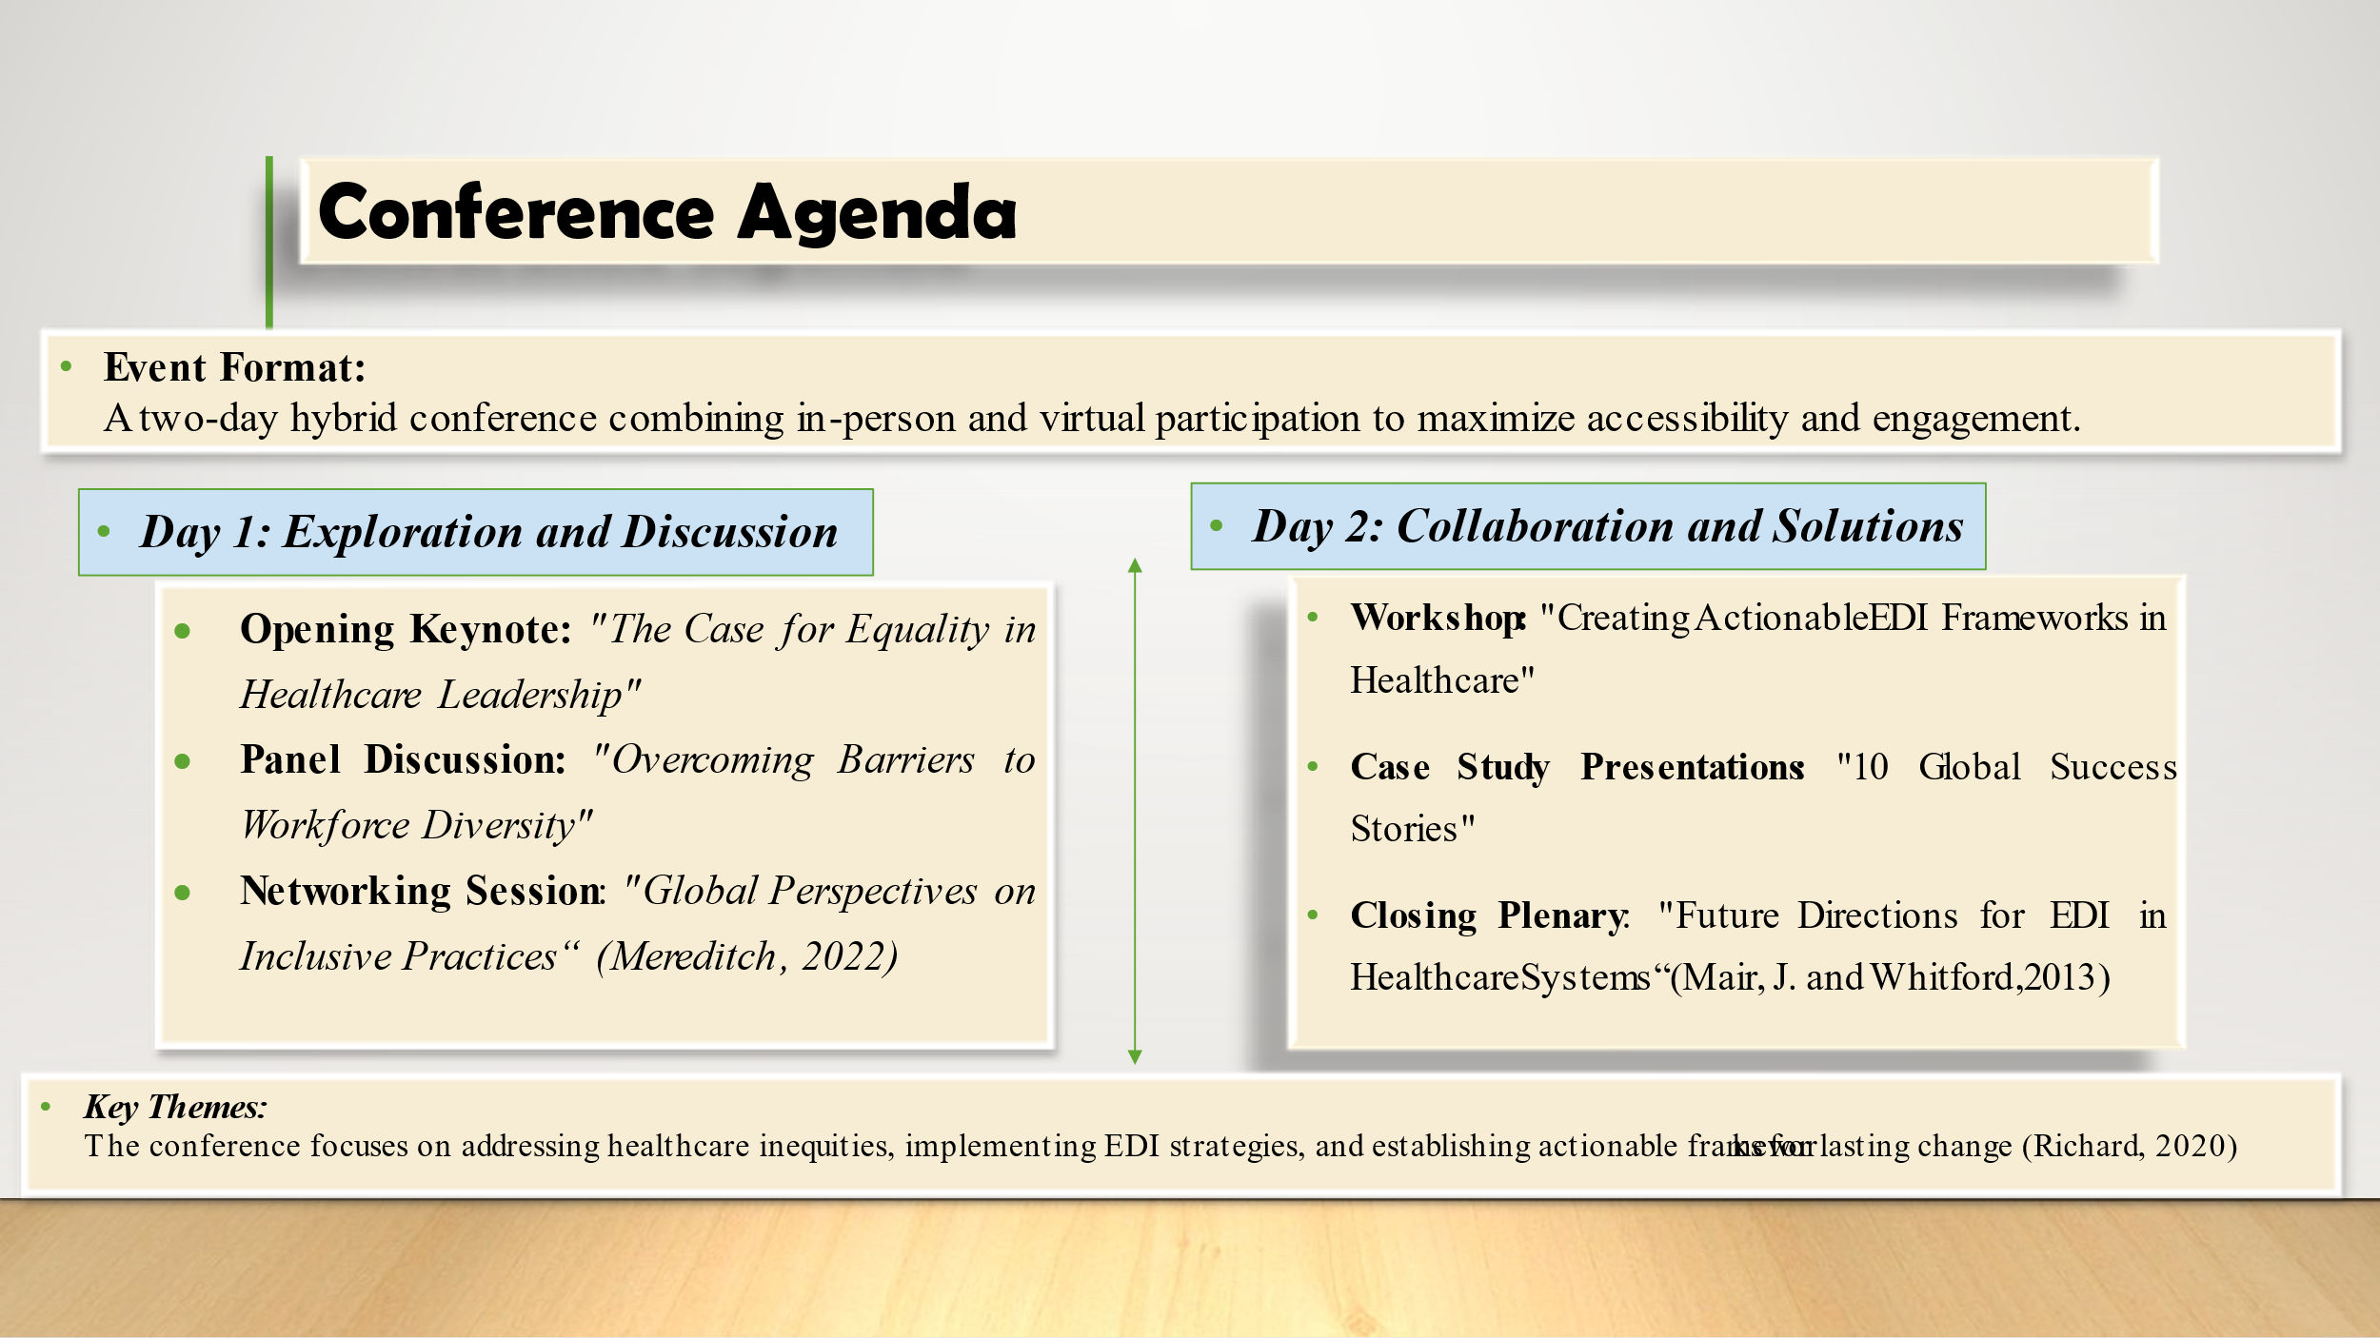
The conference schedule combines learning activities with group work and conversations across two full days. The first day includes a morning keynote on healthcare leadership equality plus a panel to explore workforce diversity challenges. Networking enables participants to talk about how they build inclusive workplaces around the world.
Participants will learn valuable skills on Day 2 during a hands-on workshop that teaches them how to build EDI systems while reviewing international healthcare equality examples. One final meeting focuses on planned directions for Equality Diversity Inclusion programs in healthcare. Programming focuses on fixing disparities in healthcare while putting diversity strategies into action and designing practical plans for long-term change.

Slide 6: Venue & Logistics
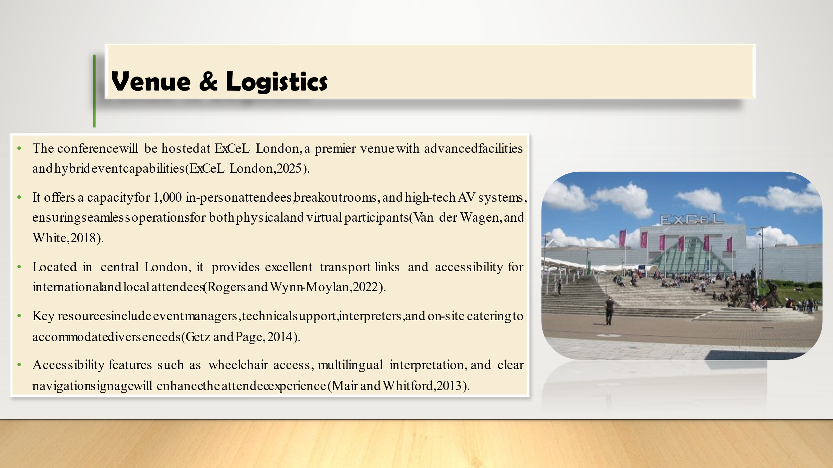
ExCeL London is the most appropriate venue for hosting this hybrid conference because of its modern equipment and strategic position. The venue holds 1000 physical attendees as well as provides advanced technology for virtual conference participation. The building supplies customized breakout areas along with advanced audiovisual tools and food services for all participant's needs. The venue's central London position provides simple travel connections for everyone attending including international visitors and people living nearby. The venue requires full accessibility elements like spaces that work for wheelchairs multiple language interpretations plus clear directions. The event will run well because our professional team handles logistics and our technical staff supports communications and interpretation.

Slide 7: Financial Plan
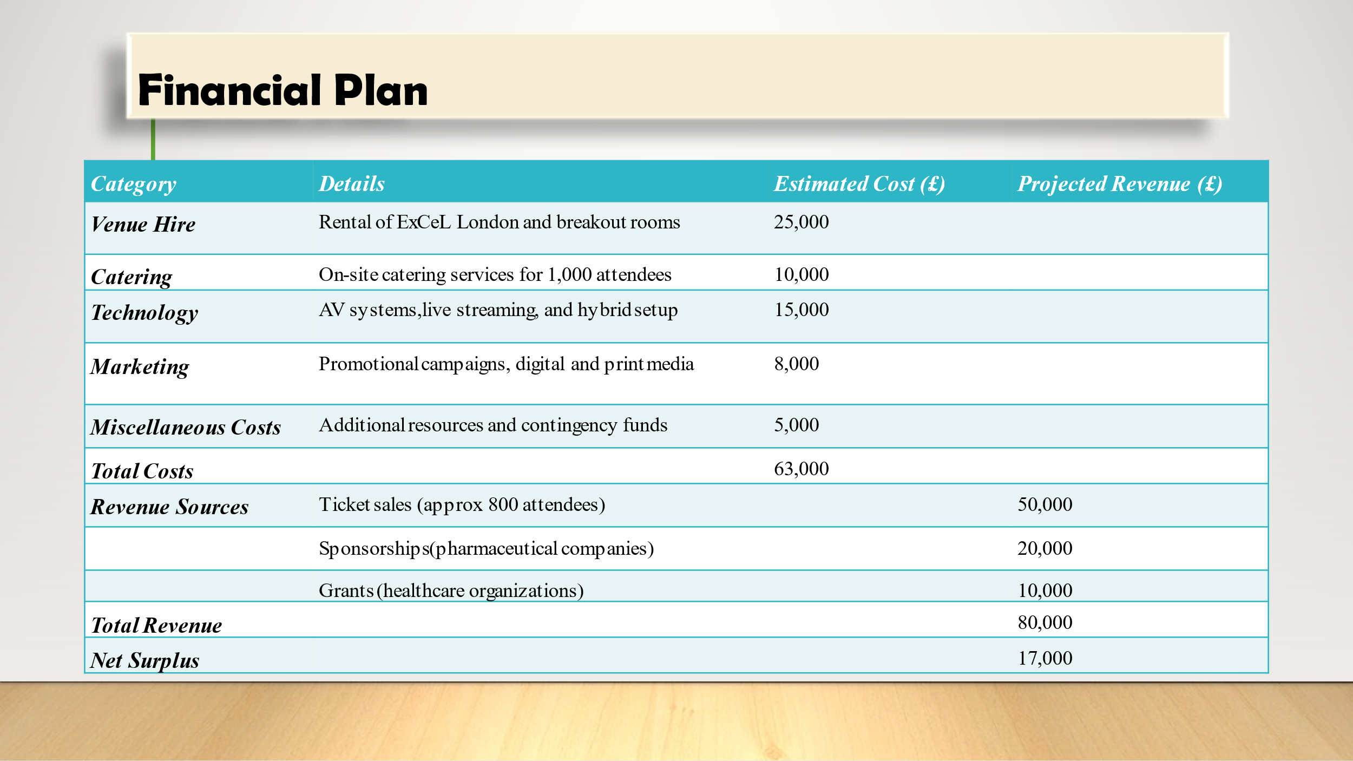
The feasibility aspect of an event is shown in the event’s financial plan. Cumulative costs are estimated to be £63,000, whereby £15,000 will be spent on venue hire, £19, 750 on catering and beverages, £23,500 on technology and £4,750 on marketing. The forecasted revenue shall be £80000 through ticket sales, sponsorship and grants. It is estimated that ticket selling alone will contribute £50,000 while sponsors will contribute £20,000 and grant providers £10,000. This leads to the coefficient of £17,000 for net surplus which indicates organizational financial stability. Holding contingency funds guarantees no emergent expenditure overwhelms the event planning process; it underlines the financial responsivity of the event and its planning.

Slide 8: Risks & Mitigation Strategies
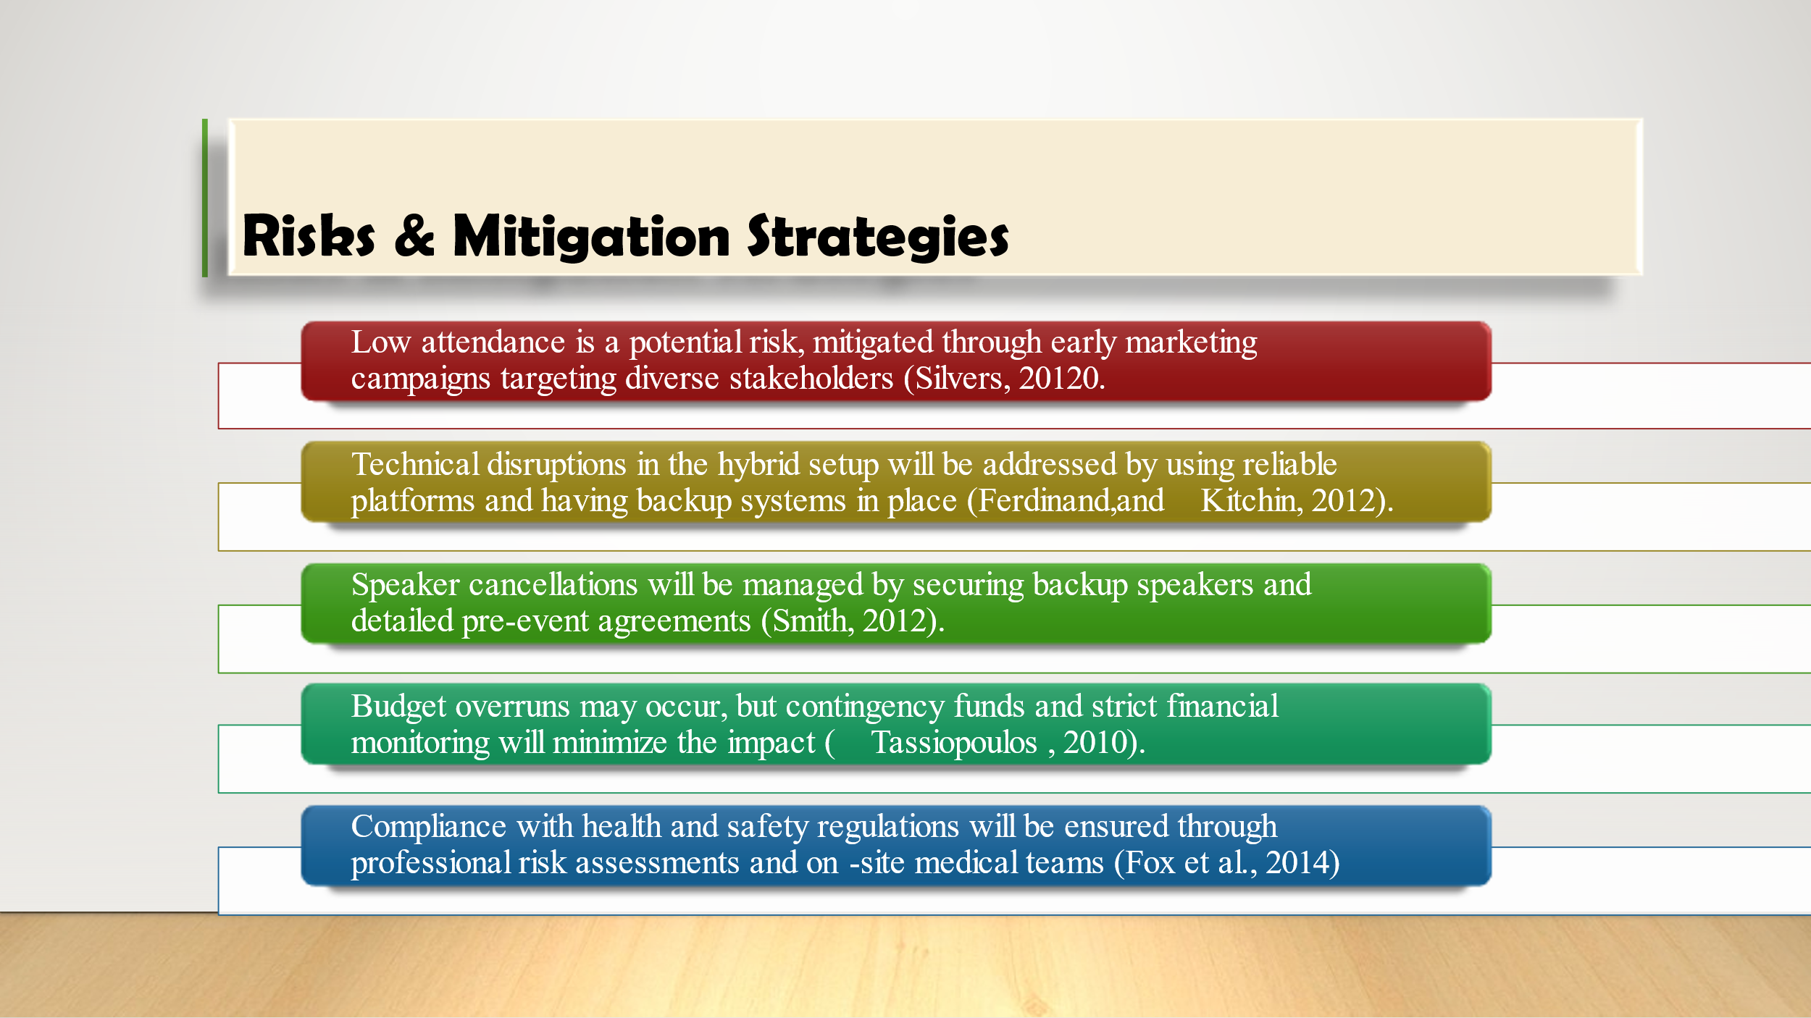
The risks associated with any event are the lack of attendance, technical difficulties, cancellation of speakers, and high expenses. Marketing will start on time and precisely, and besides, there will be efficient virtual platforms that have back-ups. Some of the ways through which the probability of cancellations will be addressed include; Pre-event agreements, and the identification and securing of additional speakers beforehand. To avoid the continuous breakdown of most projects due to cost overruns, Contingency funds and monitoring of the financial aspect of the project will be employed. Health concerns are important, hiring professionals that will assess the risks of the event and having medical personnel present on the site at the event proves to be very beneficial and preventative. Hence, these preventive measures reduce risks and enhance the possibility and effectiveness of the conference.

Slide 8: Feasibility Analysis
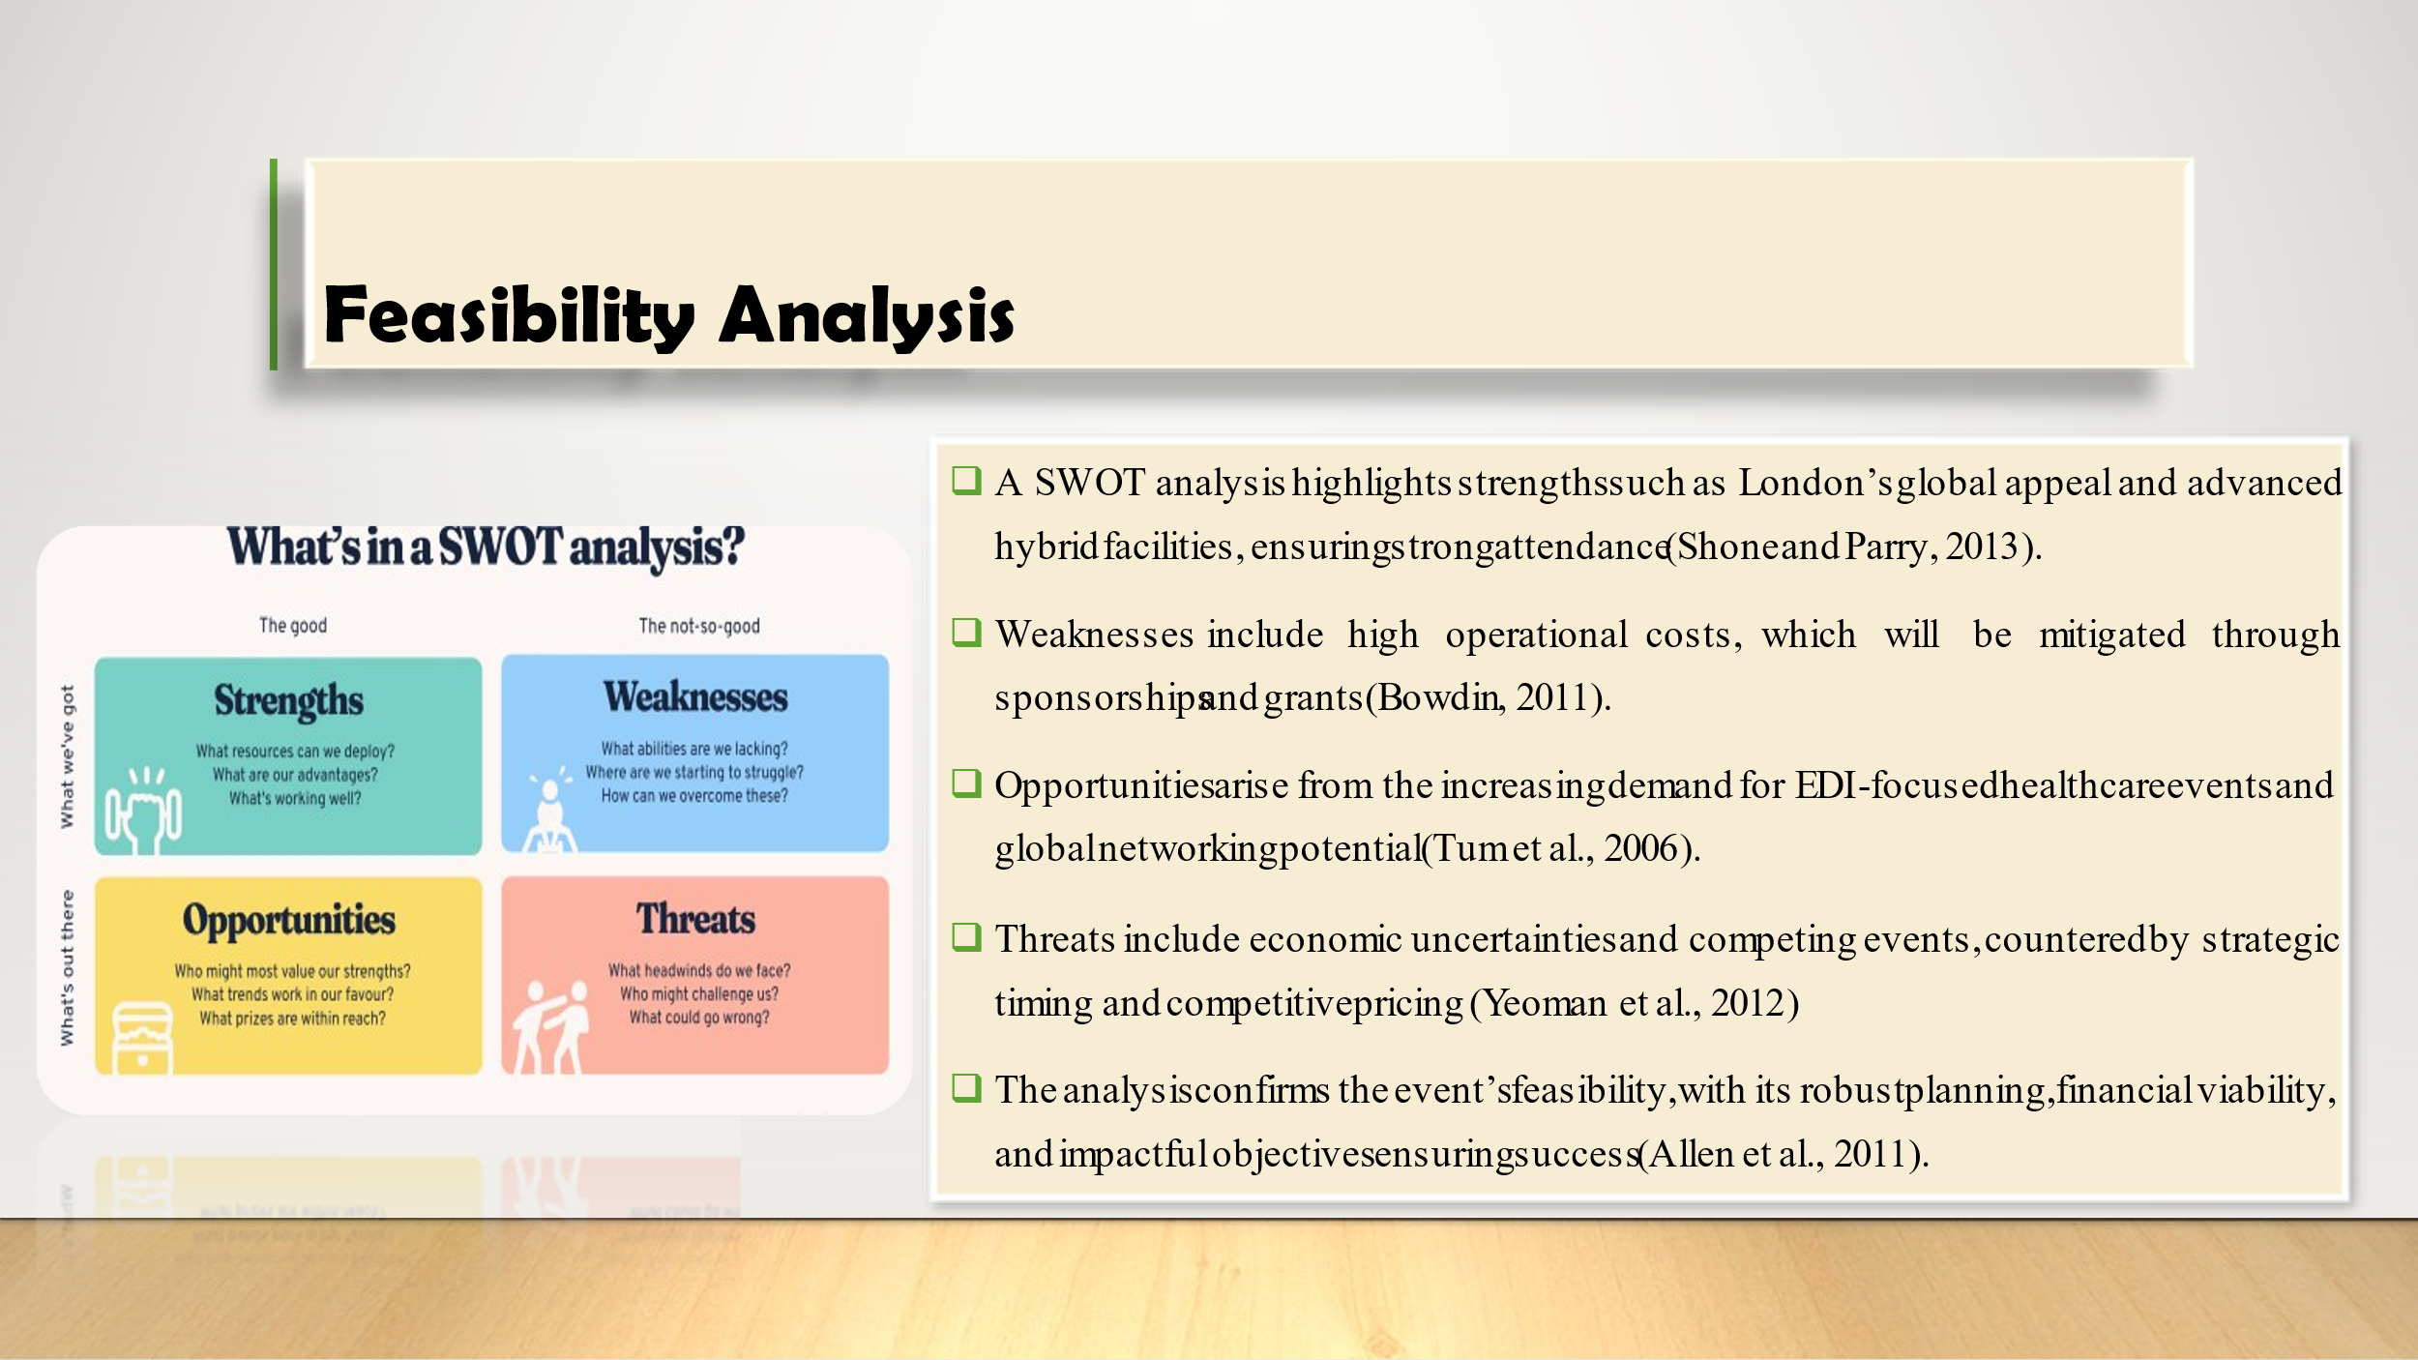
First, the feasibility analysis, given primarily in the form of a detailed SWOT analysis, reveals the actual potential for the success of the event. Strengths: ExCeL London has a generalist versatility that London embraces as an international city with much to attract broad-based attendance. Sponsorships and grants shall be used to handle high operations costs as considered as weakness. The possibilities still exist in the trend of demand shifting to events directed at EDI development and global networking prospects. However, the threat is posed by economic unpredictable situations and competitions through other related events and effective pricing of tickets. In sum, the proposed evaluation supports the event’s feasibility from the practical standpoint, considering organisational requisites, financial considerations, and tangible impacts on the progress of EDI objectives in globalised healthcare settings.

Slide 9: Conclusion
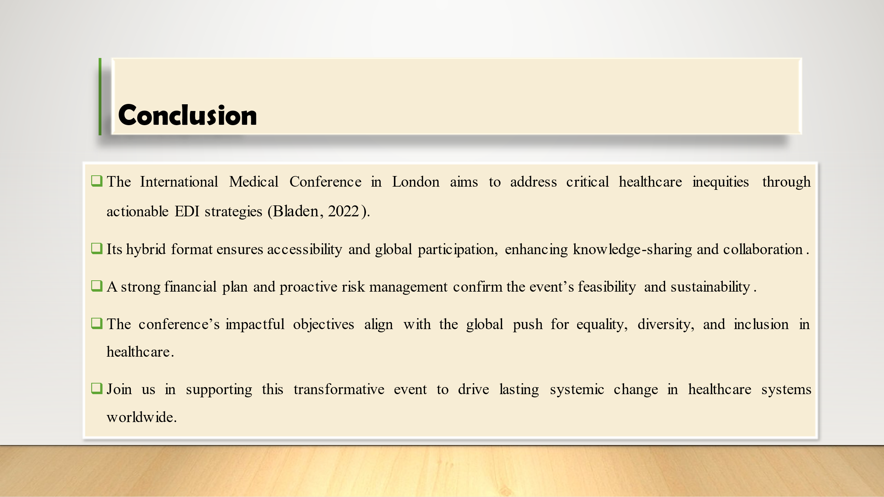
In conclusion, the proposed International Medical Conference in London is a unique attempt to redress the prevailing appalling health disparities by promoting the principles of equity, diversity, and inclusiveness. That way, when having a hybrid-based format, will guarantee people’s access to get involved, as well as encourage them from various countries to take actionable steps and cooperate with others. The formalised framework of the financial plan and active risk management measures ensure the feasibility and sustainability of the plan. The conference also continues the global initiative about EDI in health, which means that such a conference should be meaningful. I hope that all stakeholders engage and contribute to this change-making process to create sustainable improvement to the existing global health systems, and effectively promote the principles of EDI.

Slide 10: references


