Student Name | MD JUEL MIAH
Student ID Number | 2522339
Module Title | Marketing Management
Module Code | LCMB7024
Lecturer’s Name | Laila Maazouz  Dian Mayasari
Assignment Title | Assessment component 1:  Marketing Environment Analysis
Word Count (Actual) | 2684
Submission Date | 26th February 2026

Table of Contents
Introduction 3
Task 1: Macro marketing environment and the role of two macro actors 4
Macro actor 2: Technology and supply-chain ecosystem 6
Task 2: Strategic responses to sustain growth 8
Porter’s generic strategies: Tesla vs BYD 8
Ansoff’s growth matrix: how each firm can grow 10
Critical evaluation 11
Conclusion 12
Reference 14

Macro Marketing Environment Analysis for a Pioneer and a Follower Industry: Battery Electric Vehicles (BEVs)

Introduction
In just ten years, electric vehicles (EVs) have transitioned out of a niche technology and into the mass-market category due to the swift drop in costs of lithium-ion batteries, the growing stricter emissions regulation, and a shift in consumer demands on the subject of digital mobility. According to the International Energy Agency (IEA), by 2023 the sales of global electric cars were close to 14 million and by 2024 the figures reached over 17 million meaning that more than one out of 5 new cars sold in the world was electric (IEA, 2024; IEA, 2025). This market transformation has escalated competition between the first-mover companies that defined the initial market principles and the rapid-follow firms that are rapidly expanding by capitalizing on the learning curve, chain of supply and policy gaps.
Tesla, Inc. is a pioneer and BYD Company Limited a follower in battery electric vehicles (BEVs), the macro marketing environment of which is analyzed in this essay. Tesla is considered the first since it commercialized long-range BEVs at scale, has created a comprehensive charging infrastructure, and standardized software-based vehicle upgrades using over-the-air (OTA) technology. BYD is a follower, since, after the pioneer had shown the market to be viable, it engaged the vertical integration and high-rate model proliferation to compete based on cost and volume in the domestic and foreign markets (Halberstadt et al., 2022). Task 1 critically analyses macro marketing environment and dwells on two external macro-marketing actors that provide opportunities and threats to both companies. Task two involves a comparison of the strategic response based on Porter generic strategies and Ansoff growth matrix on how each company would be able to maintain growth in an unstable regulatory and technology environment.

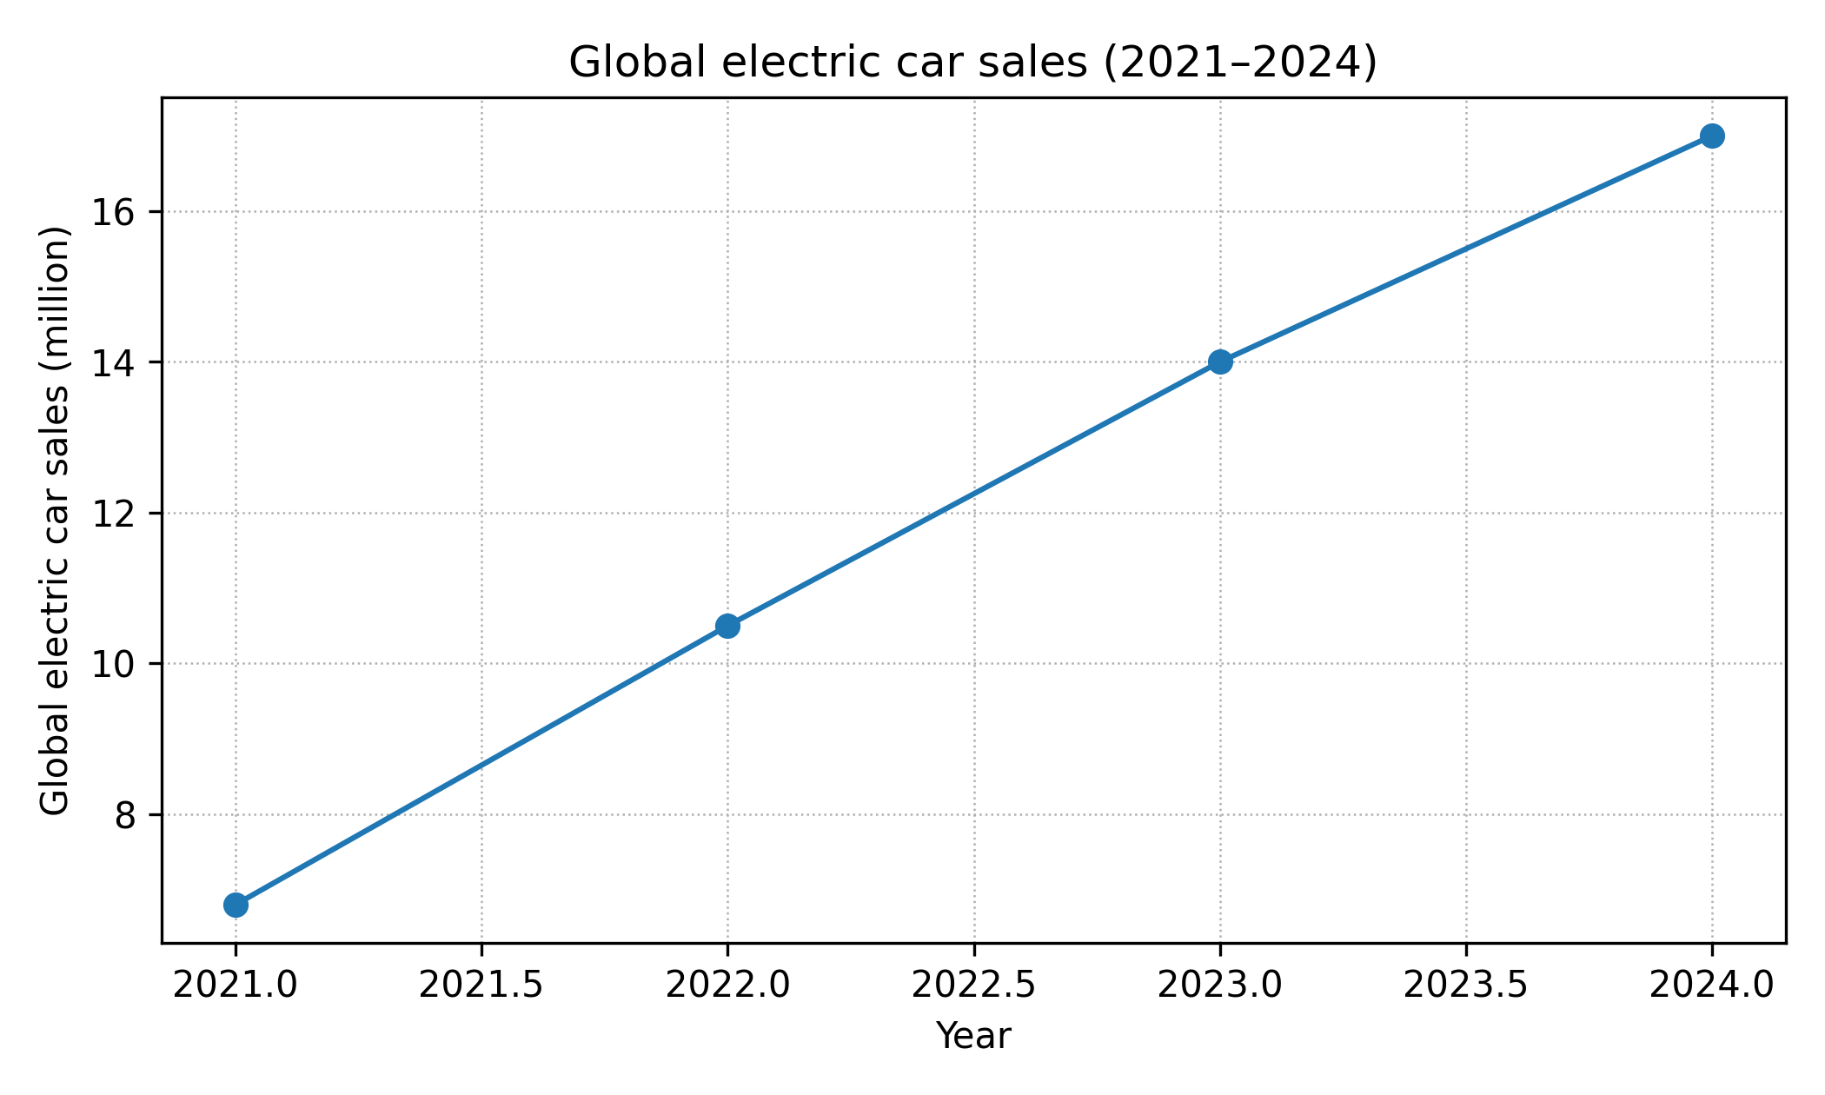
Figure 1. Global electric car sales (2021–2024). Source: derived from IEA (2023; 2024; 2025).

Task 1: Macro marketing environment and the role of two macro actors
Macro environmental forces determine the appeal of an industry and the comparative strength of companies in the industry. Demand and profitability in EVs are abnormally responsive to the design of policies, preparedness of infrastructure as well as input-cost shocks (e.g., critical minerals). Here the analysis is organized around PESTEL lens (political, economic, social, technological, environmental and legal), however, the discussion will focus on two macro-marketing actors whose influence is disproportionately enormous: (1) governments and regulators; and (2) the technology and supply-chain ecosystem (battery innovation, charging standards and critical-materials markets). These players influence the competitive statuses of these firms by changing the customer adoption rates, cost models, as well as scaling strategies viability.
Macro actor 1: Governments and regulators
Governments and regulators: Tesla (Pioneer) opportunities and threats
In the case of Tesla as the first mover, early and fairly stable regulatory indicators (emissions standards, zero-emission requirements and government financing of charging) aided in the legitimization of BEVs and generated demand pressure. Tax credits and other fiscal policies have the potential to decrease the price premiums and enhance the total cost of ownership, one of the fundamental determinants of the EV adoption in the empirical literature (Melton, Axsen and Moawad, 2020; IEA, 2024; Sierzchula et al., 2014; Zhao, Yi and Li, 2024).
Threats can also be created by the same forces. The reinvention or waning away of incentives may undermine demand and make prices more price sensitive, and stricter safety, data and sustainability standards increase compliance and reporting costs (IEA, 2025). Industrial and trade policy may also redistribute competitive advantage among the firms and locations and make localization and regulatory fit more valuable to Tesla in major markets.
Governments and regulators: BYD (Follower) opportunities and threats
In the case of BYD, as a fast follower, positive domestic policy, and regulatory frameworks in China have been a key opportunity that has facilitated category expansion and scale acquisition. Replacing direct purchase subsidies with a credit-based and standards-based scheme (including features of the China dual-credit system) is intended to maintain electrification and habituate firm incentives by helping those producers that can efficiently attain compliance on a large scale (Hsieh, Pan and Green, 2020).
Nonetheless, policy may also be a sharp risk to the international development of BYD. The EU trade policies such as imposing extra tariffs on some of the China-produced EVs increase expenses and risks associated with market-entry (Reuters, 2026a). What is more expansive, localization needs, geopolitical conflicts and policy uncertainties may limit geographic expansion and augment operation threat. In general, governments and regulators both broaden the category and redistribute benefit based on the way firms are predicting and adjusting to change of policy.

Macro actor 2: Technology and supply-chain ecosystem
Technology and supply-chain ecosystem: Tesla (Pioneer) opportunities and threats
In the case of Tesla, battery technology and production learning curve offered the option to differentiate with range, performance and user experience under software. Learning, scale and innovation can be significantly beneficial to the cost of batteries, and the fact that these gains can be better passed on as product features by innovators who invest early can enable them to surpass their competitors (Ziegler, Song and Trancik, 2021; Mauler et al., 2021). The charging ecosystem by Tesla also lessens range anxiety and enhances perceived convenience, a repetitive adoption hurdle in the literature (Rezvani, Jansson and Bodin, 2015).
When the same ecosystem is constrained or the standards of standards change this poses a threat. Squeaky-raw-material markets may disrupt the cost curve, whereas the refining concentration and reliance on critical-minerals put the production at risk of geopolitics (Mauler et al., 2022; Olivetti et al., 2017; Jaffe, 2017). Moreover, supply chains may be affected by trade restrictions and changing technical standards, making the downstream less competitive (Mauler et al., 2021), and Tesla will have to maintain supply chain resilience and compliance in different areas constantly.
Technology and supply-chain ecosystem: BYD (Follower) opportunities and threats
In the case of BYD, the technology ecosystem provides an opportunity in terms of vertical integration of batteries and power electronics which transforms capability into cost leadership and supply security. Pioneer-follower studies indicate that followers may perform better when they are able to utilize manufacturing learning and complementary resources in a better way compared to pioneers (Suarez and Lanzolla, 2007; Halberstadt et al., 2022). The size and model diversification of BYD enable the company to implement technology in every segment and compete in terms of price and achieve the performance requirements.
BYD is however also vulnerable to ecosystem threats largely where supply chains converge with trade policy and standardization. The volatility of the input prices, the shortages of key materials, and international prohibitions may raise expenses and reduce growth (Olivetti et al., 2017; Jaffe, 2017). The use of different safety, battery and sustainability standards in foreign markets, also increases the cost of adaptation. In line with co-evolution views, the results of competition are determined by the manner in which companies align the technology decisions with the institutional and market changes (Olivetti et al., 2017; Jaffe, 2017).
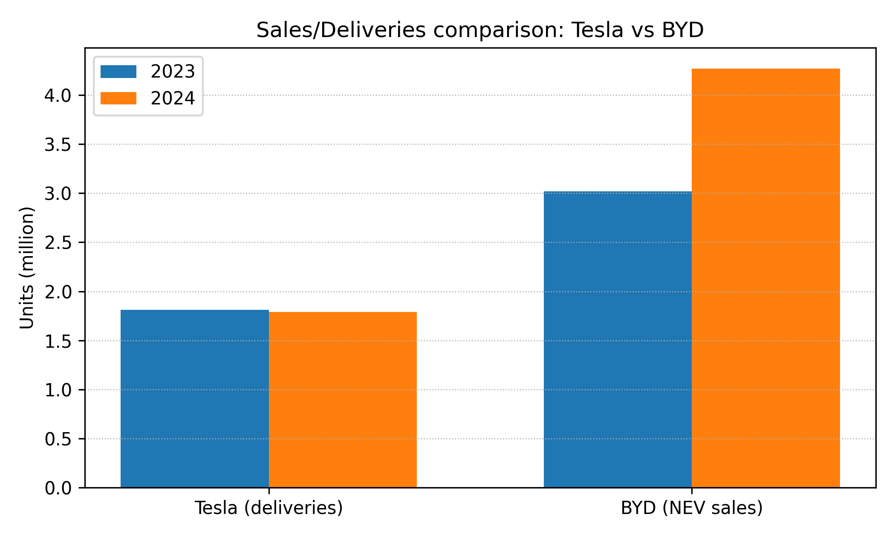
Figure 2. Company comparison: Tesla deliveries and BYD NEV sales (2023–2024). Sources: Tesla (2025); Euronews (2025).
Table 1: Summary table:
Macro actor | Opportunities (impact on pioneer vs follower) | Threats (impact on pioneer vs follower)
Governments and regulators | Category creation via emissions standards and incentives increases total demand and legitimacy (supports Tesla’s early scale; expands the base for BYD’s later acceleration). | Policy volatility, subsidy rollbacks and trade barriers redistribute advantage; EU duties on China-made EVs raise export risk for BYD, while localization rules and compliance costs can pressure Tesla (Reuters, 2026a).
Technology and supply-chain ecosystem | Battery learning curves and digitalization improve EV affordability and performance; Tesla benefits from ecosystem differentiation; BYD benefits from vertical integration and manufacturing scale (Ziegler, Song and Trancik, 2021; Halberstadt et al., 2022). | Critical-minerals volatility and standards uncertainty can raise costs and slow adoption; supply disruptions and trade restrictions threaten both, with stronger exposure for high-growth exporters (Mauler et al., 2022; Zhang et al., 2026).

Task 2: Strategic responses to sustain growth
In order to continue growing, leaders and followers need to ensure that strategy fits the macro environment. It is proposed by the research on strategy that first movers will be able to achieve advantages due to technological leadership, switching costs and ecosystem control, but the advantages will be diminished when the followers scale more rapidly or utilize complementary assets more effectively (Lieberman and Montgomery, 1988; Suarez and Lanzolla, 2007). In EVs, the strategic issue is not just the first to innovate but the fastest to industrialize and adapt in the face of uncertainty in policy and supply-chains. The generic strategies by Porter explain how the various firms compete whereas the matrix by Ansoff explains how the various firms aim at growth.

Porter’s generic strategies: Tesla vs BYD
Porters model isolates the differentiation and focus, cost leadership and differentiation and focus strategy (Porter, 1980). The strategy of Tesla can be described as wide differentiation with careful cost cutting. Brand positioning, software capability, perceived performance and charging ecosystem are some of the areas where differentiation can be seen. The importance of digital capabilities is that EV competition is becoming more similar to platform competition in which software updates and features based on data development of the customer experience (Teece, 2010). The 2023-2024 pricing behavior of Tesla also shows an effort to protect share as competitors expand the availability of the models (IEA, 2025), which represents a shift to cost discipline in differentiation.
BYD, on the contrary, is the nearest to the broad cost leadership with differentiation elements. Its vertical integration in batteries and mass production helps in reducing unit prices and quick proliferation of models at different prices. According to follower-strategy research, followers can emerge victorious provided that they can convert learning and scale into a better cost that is equal to good-enough performance and features (Gomez, Lanzolla and Maicas, 2016; Halberstadt et al., 2022). Nevertheless, export development demands brand loyalty and post sales, and thus the distinction in consistency and service quality turns out to be of greater priority.
The main implication is that the two firms are moving towards being closer to direct rivalry. As Tesla is being dragged downwards through follower scaling and BYD is pushed upwards through brand and ecosystem differentiation as it goes global.
Table 2: Competitive positioning using Porter’s generic strategies
Firm | Primary generic strategy | Key strategic levers | Main risks under current macro conditions
Tesla | Broad differentiation (with increasing cost discipline) | Software-led product, charging ecosystem, brand, continuous product and process innovation. | Erosion of differentiation as competitors catch up; regulatory pressure on charging access; margin compression from price competition.
BYD | Broad cost leadership (with growing value differentiation) | Vertical integration (batteries), scale manufacturing, broad model portfolio, rapid international expansion. | Trade barriers and political risk in export markets; brand and after-sales capability gaps; raw material volatility.

Ansoff’s growth matrix: how each firm can grow
The GG developed by Ansoff presents growth through product development, market development and diversification and market penetration (Ansoff, 1957). The short-term growth strategy of Tesla is penetrating the market and developing products: reducing prices and selling them to access the addressable market, enhancing the efficiency of the manufacturing process, and expanding features via OTA updates and without the new hardware. It also has the market development strategy by regional production footprints and selling in the emerging EV markets, yet its expansion is limited by narrowing policy incentives and increasing competition in the mid-price markets (IEA, 2025). Most evident use of diversification is in energy generation and storage that capitalizes on battery technology outside the automobile sector.
BYD is portfolio based in its growth path. Market penetration in China is also a key factor, although the key lever is market development through exports to Europe, Latin America and other markets where EV shares are increasing on a small base (IEA, 2025). Development of the products happens through quick product models releases within the segments, which enables BYD to align with the heterogeneous consumer demands and regulatory types. Diversification encompasses batteries, energy storage and possible downstream mobile services. According to strategic management studies, such bundling of complementary resources may enhance the achievement of the followers by transforming the scale and supply control into more lasting benefit (Teece, 2010; Markides and Sosa, 2013).
Table 3: Ansoff growth initiatives for Tesla and BYD
Growth option | Tesla (pioneer) | BYD (follower)
Market penetration | Price adjustments, manufacturing efficiency, ecosystem lock-in via charging and software updates. | Aggressive pricing in mass segments, leveraging scale to increase domestic share.
Product development | Incremental innovation (battery, software, autonomy features), refreshed models, improved charging experience. | Rapid new model introductions across segments; continuous battery and platform upgrades.
Market development | Localized production and sales expansion in key markets; leveraging policy windows where incentives exist. | Export growth and localization to reduce tariff exposure; building distribution and after-sales networks.
Diversification | Energy storage and grid services; potential mobility software services. | Energy storage and batteries as a stand-alone business; mobility and infrastructure partnerships.

Critical evaluation
The strategy of both firms is logical in the macro environment and the firm is also strong according to the exposure. The differentiation of Tesla is most intense when there are switching costs and perceived differentiation in the features of the ecosystem and software. Innovation and constant changes in the business model, not just its product, are what maintain pioneers in their advantage (Markides and Sosa, 2013). The threat facing Tesla is that differentiation will become less pronounced as mass consumers focus more on price, and regulators promote interoperability in charging. The first solution is to strike a balance between sustained innovation and selective openness: extending charging coverage whenever it boosts utilization and political acceptance, and retain a high-quality user experience and data-driven services.
Cost leadership based on integration is the strength of BYD, which is useful in the market that is vulnerable to input shocks and subsidy rollbacks. But Chinese exports are more and more politicized in the macro environment. According to Reuters, EU and China have been considering minimum-price measures in place of tariffs, which is indicative of the probability of further restrictions on China-made EVs (Reuters, 2025; Reuters, 2026a). A strong reaction is hence a localization and legitimacy strategy: regional assembly where practical, powerful post-sales support and proactive relations with regulators to lessen the image of unfair benefit.
In both companies, the growth strategies are resilient, which mitigate reliance on any given policy regime and insure supply risks. Empirical policy studies demonstrate that the non-financial incentives and charging infrastructure can have a significant effect on adoption in addition to direct subsidies (Egner and Trosvik, 2018; Melton, Axsen and Moawad, 2020). This helps in more profound relationships with infrastructure providers and governments. Lastly, the necessity of supply-chain risk mitigation is undeniable: the tightening of the materials markets and trade-control can slack down the cost decreases and interfere with the competitiveness (Mauler et al., 2022; Zhang et al., 2026). Not operational but strategic priorities are therefore vertical integration, recycling and diversified sourcing.

Conclusion
Governments and regulators, and the technology-supply ecosystem, have a disproportionately significant influence on the EV macro environment. The opportunities that are created by these actors are growth opportunities because they are fast moving in adoption and reduce costs, but also present threats in the form of volatile policies, trade barriers and input constraints. The pioneering edge at Tesla lies on the brand differentiation, software and ecosystem control, but the company is experiencing margins pressure as competing companies grow. The follower advantage of BYD is based on the cost leadership which is achieved to be based on vertical integration and scale, yet there are political risk and the necessity to establish validity in export markets.
Tesla is best placed strategically by maintaining differentiation and enhancing cost discipline to influence standards with the help of its ecosystem. The best strategy that BYD can have is to continue to lead in costs and invest in brand trust, after sales capability and localization to counter trade and regulatory threats. Infrastructure collaboration and supply-chain resilience should be among the core strategic capabilities of both firms, as the next stage of the market will be determined not only by the product performance but also by the policy and ecosystem alignment.

Reference
Ansoff, H.I. (1957) ‘Strategies for diversification’, Harvard Business Review, 35(5), pp. 113–124.
Egnér, F. and Trosvik, L. (2018) ‘Electric vehicle adoption in Sweden and the impact of local policy instruments’, Energy Policy, 121, pp. 584–596. Available at: https://doi.org/10.1016/j.enpol.2018.06.040
Euronews (2025) ‘Chinese EV giant BYD beats domestic players to hit record 2024 sales’, 3 January. Available at: https://www.euronews.com/business/2025/01/03/chinese-ev-giant-byd-beats-domestic-players-to-hit-record-2024-sales
Gomez, J., Lanzolla, G. and Maicas, J.P. (2016) ‘The role of industry dynamics in the persistence of first-mover advantages’, Long Range Planning, 49(3), pp. 265–281. Available at: https://doi.org/10.1016/j.lrp.2015.12.006
Halberstadt, J., Timm, J.M., Kraus, S. and Gundolf, K. (2022) ‘The role of follower firms in innovation: Evidence from a meta-analysis’, Journal of Business Research, 139, pp. 1209–1223. Available at: https://doi.org/10.1016/j.jbusres.2021.10.043
Hardman, S., Shiu, E. and Steinberger-Wilckens, R. (2019) ‘Comparing high-end and low-end early adopters of battery electric vehicles’, Transportation Research Part A: Policy and Practice, 111, pp. 129–143. Available at: https://doi.org/10.1016/j.tra.2018.11.002
Hsieh, I.Y.L., Pan, M.S. and Green, W.H. (2020) ‘China’s vehicle electrification impacts on sales, fuel use, and battery raw material demand’, Energy Policy, 142, 111492. Available at: https://doi.org/10.1016/j.enpol.2020.111492
IEA (2023) Global EV Outlook 2023: Catching up with climate ambitions. Paris: International Energy Agency. Available at: https://iea.blob.core.windows.net/assets/dacf14d2-eabc-498a-8263-9f97fd5dc327/GEVO2023.pdf (Accessed: 17 February 2026).
IEA (2024) Global EV Outlook 2024. Paris: International Energy Agency. Available at: https://iea.blob.core.windows.net/assets/a9e3544b-0b12-4e15-b407-65f5c8ce1b5f/GlobalEVOutlook2024.pdf
IEA (2025) ‘Trends in electric car markets’, Global EV Outlook 2025. Paris: International Energy Agency. Available at: https://www.iea.org/reports/global-ev-outlook-2025/trends-in-electric-car-markets-2
Jaffe, S. (2017) ‘Vulnerable links in the lithium-ion battery supply chain’, Joule, 1(2), pp. 225–228. Available at: https://doi.org/10.1016/j.joule.2017.09.021
Lieberman, M.B. and Montgomery, D.B. (1988) ‘First-mover advantages’, Strategic Management Journal, 9(S1), pp. 41–58. Available at: https://doi.org/10.1002/smj.4250090706
Markides, C.C. and Sosa, L. (2013) ‘Pioneering and first mover advantages: The importance of business models’, Long Range Planning, 46(4–5), pp. 325–334. Available at: https://doi.org/10.1016/j.lrp.2013.06.004
Mauler, L., Duffner, F., Zeier, W.G. and Leker, J. (2021) ‘Battery cost forecasting: A review of methods and results with an outlook to 2050’, Energy & Environmental Science, 14, pp. 4712–4739. Available at: https://doi.org/10.1039/D1EE01530C
Mauler, L., Lou, X., Duffner, F. and Leker, J. (2022) ‘Technological innovation vs. tightening raw material markets: falling battery costs put at risk’, Energy Advances, 1, pp. 136–147. Available at: https://doi.org/10.1039/D1YA00052G
Melton, N., Axsen, J. and Moawad, B. (2020) ‘Which plug-in electric vehicle policies are best? A multi-criteria evaluation framework applied to Canada’, Energy Research & Social Science, 64, 101411. Available at: https://doi.org/10.1016/j.erss.2019.101411
Olivetti, E.A., Ceder, G., Gaustad, G.G. and Fu, X. (2017) ‘Lithium-ion battery supply chain considerations: Analysis of potential bottlenecks in critical metals’, Joule, 1(2), pp. 229–243. Available at: https://doi.org/10.1016/j.joule.2017.08.019
Porter, M.E. (1980) Competitive Strategy: Techniques for Analyzing Industries and Competitors. New York: Free Press.
Reuters (2025) ‘EU, China will look into setting minimum prices on electric vehicles, EU says’, 10 April. Available at: https://www.reuters.com/business/autos-transportation/eu-china-start-talks-lifting-eu-tariffs-chinese-electric-vehicles-handelsblatt-2025-04-10/
Reuters (2026a) ‘EU tariffs on imports of China-made EVs’, 11 February. Available at: https://www.reuters.com/world/china/eu-tariffs-imports-china-made-evs-2026-02-11/
Rezvani, Z., Jansson, J. and Bodin, J. (2015) ‘Advances in consumer electric vehicle adoption research: A review and research agenda’, Transportation Research Part D: Transport and Environment, 34, pp. 122–136. Available at: https://doi.org/10.1016/j.trd.2014.10.010
Sierzchula, W., Bakker, S., Maat, K. and van Wee, B. (2014) ‘The influence of financial incentives and other socio-economic factors on electric vehicle adoption’, Energy Policy, 68, pp. 183–194. Available at: https://doi.org/10.1016/j.enpol.2014.05.014
Springel, K. (2021) ‘Network externality and subsidy structure in two-sided markets: Evidence from electric vehicle subsidies’, American Economic Journal: Economic Policy, 13(4), pp. 393–432. Available at: https://doi.org/10.1257/pol.20190131
Suarez, F.F. and Lanzolla, G. (2007) ‘The role of environmental dynamics in building a first mover advantage theory’, Academy of Management Review, 32(2), pp. 377–392. Available at: https://doi.org/10.5465/amr.2007.24349587
Teece, D.J. (2010) ‘Business models, business strategy and innovation’, Long Range Planning, 43(2–3), pp. 172–194. Available at: https://doi.org/10.1016/j.lrp.2009.07.003
Tesla (2025) ‘Tesla Vehicle Deliveries and Date for Financial Results & Webcast for Fourth Quarter 2024’, press release, 2 January. Available at: https://ir.tesla.com/press-release/tesla-vehicle-deliveries-and-date-financial-results-webcast-fourth-quarter
Zhang, H., Sun, X., Chen, W., Cheng, H. and Li, Q. (2026) ‘How do trade restrictions affect electric vehicle industry supply chain? Evidence and policy implications’, Resources, Conservation and Recycling, 199, 108744. Available at: https://doi.org/10.1016/j.resconrec.2025.108744
Zhao, S., Yi, S. and Li, S. (2024) ‘Assessing the impact of policy incentives on electric vehicle adoption: A systematic review and meta-analysis’, Energy Policy, 191, 113987. Available at: https://doi.org/10.1016/j.enpol.2024.113987
Ziegler, M.S., Song, J. and Trancik, J.E. (2021) ‘Determinants of lithium-ion battery technology cost decline’, Energy & Environmental Science, 14, pp. 6074–6094. Available at: https://doi.org/10.1039/D1EE01313K

