12/19/2025


Module Name: Introduction to Web and Database Concepts
Module Code: ACCA4023
Student Name: Ma. Crystal Pearl Grajewski
Student ID: 2442405
Group: 1
Lecturer’s Name: Rajeev Nath
Assignment 2
Introduction to Web and Database Concepts
(HTML and CSS WEB Development)
University of Wales Saint David
london campus
Table of Contents

Introduction 2
Main Body 3
Requirements 4
Implementation 5
Validation 10
Evaluation 14
Conclusion 17
References 18
Appendices 19

Introduction

Assessment 2 focuses on the development and creation of functional website using HTML and CSS, Throughout the whole session and discussion, practical test and activities were conducted to facilitate systematic learning of fundamental HTML and CSS standard. This approach enabled learner to understand the concepts following structured procedure and code effectively to create a functional and responsive website.
During the website development process, developers must consider the website’s purpose, target audience, design, content and functionality of the website.
Web development encompasses the process of creating websites and web applications that operate on the internet.
HTML (HyperText Markup Language) is used structuring the content of a webpage. It defines elements such as headings, paragraph, images, links, tables and forms. HTML instructs the browser on the content to display and organises it in purposeful manner using tags and elements.
CSS (Cascading Style Sheet) is utilised to control the presentation and visual aesthetics of the content. Through CSS, developers can style HTML elements by specifying colours, fonts, layouts, spacing and animations. CSS enables websites to appear attractive pleasing, consistent and responsive with different devices and screen sizes.
Learning HTML and CSS serves as the foundation to start a career in web development.
This report/assessment uses HTML, CSS and bootstrap to create simple sample website.

Main Body

Task 1: Design and hand-code a website using web standards
Make a responsive website using web standard.
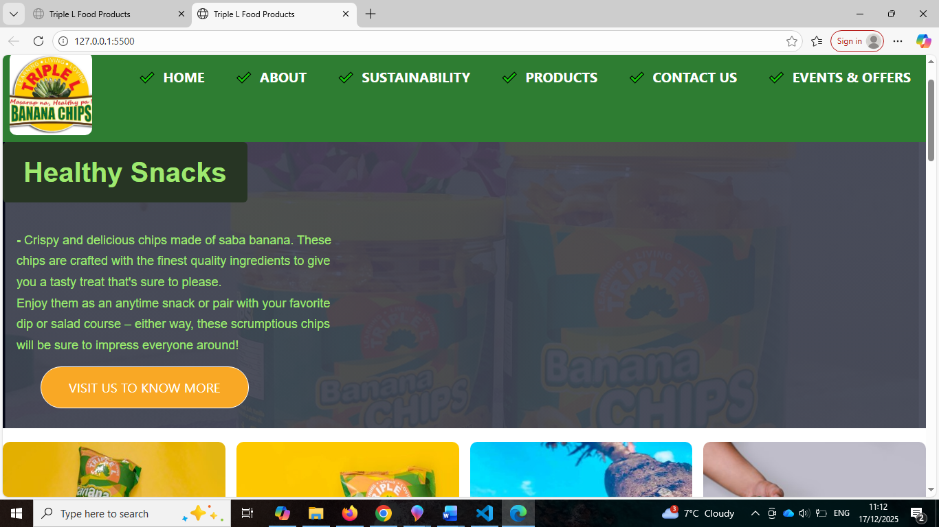
Figure 1

Task 2: Report
About the website, describing important points and research.

Requirements
Purpose and Target of the website

-The aim of creating a website for a banana chips company is to promote their brand, showcase the product, and reach a wider market.
The website serves as an online platform where customers can learn about the banana chips, including their ingredients, flavours, nutritional benefits and production process. It also helps build brand credibility and trust by presenting the company’s story, values, certifications and customer reviews. This website might help the company to increase sales, through online orders or inquiries, helps the company in terms of events and promotional discounts of their products and new release flavour or seasonal products and affiliates. This website also helps them by providing their contact information and customer support and posily help them to expand their marketing from local and regional to global customers.
-The target audience of this website are the people who
- Health-conscious consumers who prefer natural, plant-based healthier snack alternatives.
- Snack lovers of all ages who enjoy tasty and crunchy snacks.
- Professional or student who’s looking for convenience and go for ready-to-eat snacks.
- Retailers and distributors, shop owners or wholesalers interested in expanding their business by stocking banana chips in their stores.
- Online shoppers, who prefer purchasing online platforms.

Implementation
Here is the completed website page of ‘Triple L Food Products’
Home page
-The front page of any website, the first page where user or visitor will see when they open a website.
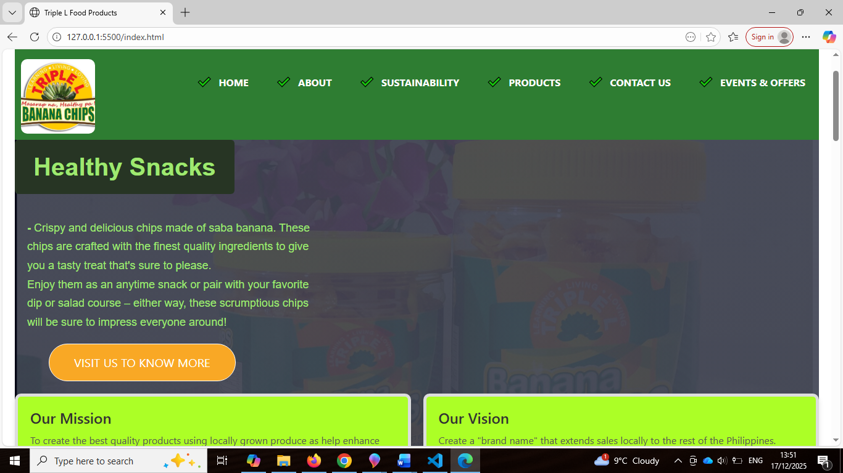
-Here the visitor will see almost all information about the website is. Navigation bar on top to navigate other section of the website. Logo is set in the left opposite of the navigation bar, below is heading and short paragraph promoting about the product’ banana chips’ under is image gallery and then the section ‘why Triple L Food Products’ company and how can they contact the company and last is the footer copyright. Images establish, with alt text for accessibility, CTA use for usability, links and button provided for easy navigation, responsive when point and click.
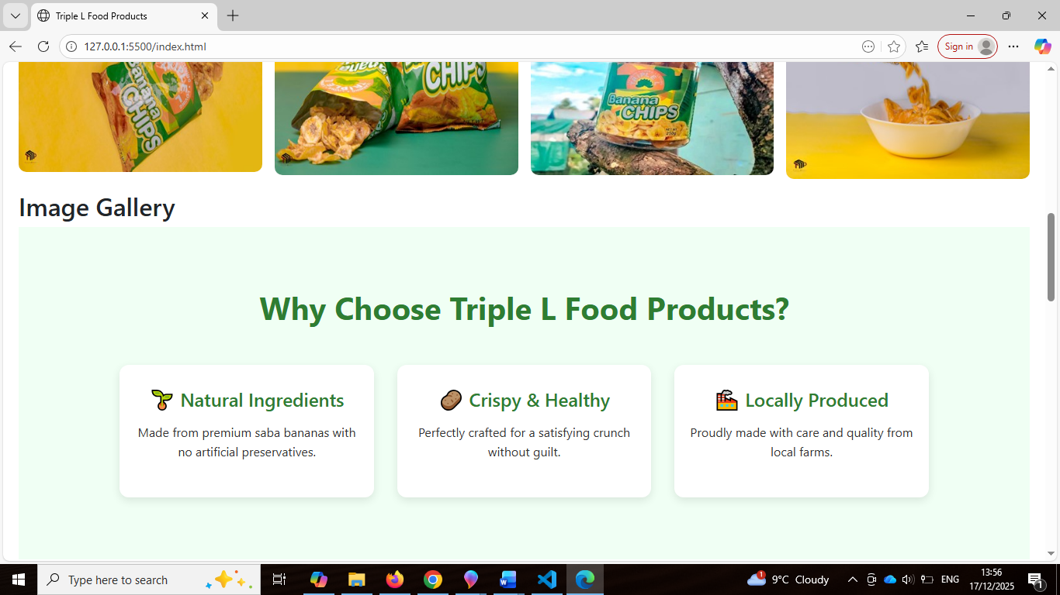
Figure 2
Figure 3
About page
-More detailed information about the company, brief history, their story, mission and vision, the whole team and what encompasses the whole company. Using the PDF copy link into the HTML, all history and about the company and their product information in one.

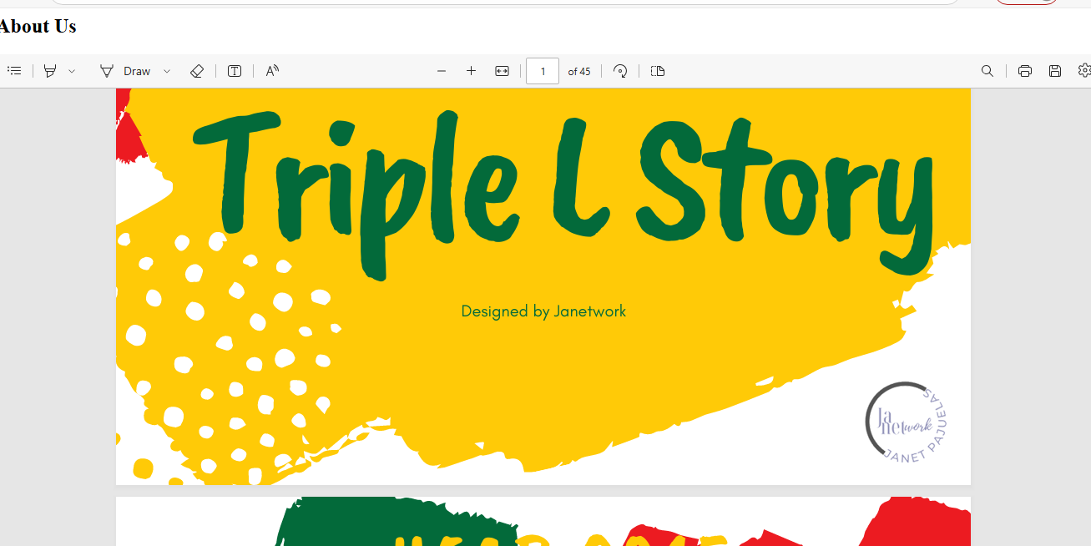
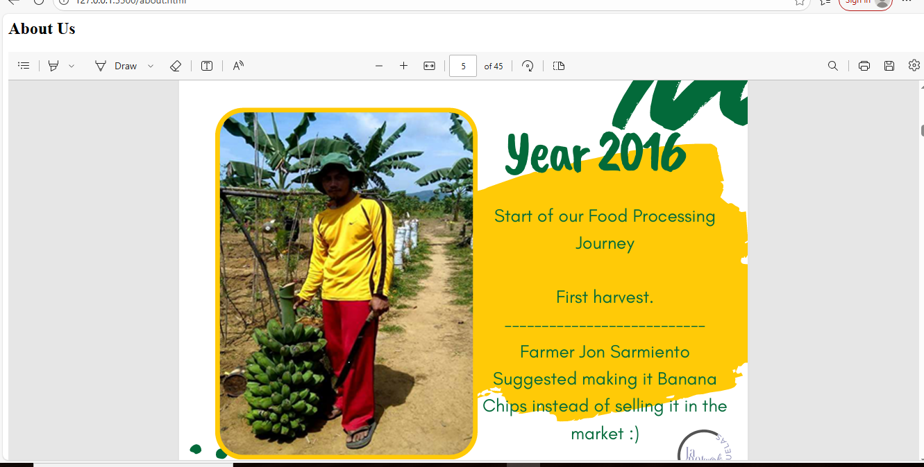
Figure 4
Figure 5

Sustainability page
-use card for content container, below the page is the button to link home, responsive when point, hover effect use, css for styling is used.
-presenting the social and environmental connection, responsibility and commitment of the company. Promoting natural planting, ingredients and products itself, helping local farmers by buying their fresh products, hiring local people and help reducing waste, for example ripe bananas is discarded in making banana chips, instead, company sale this as ripe bananas in the local market or retailer or simply make this another product like banana cue or turon, the peeled skin, instead of putting in bin, they give it to the local who have pigistry, making it a feed for pigs.
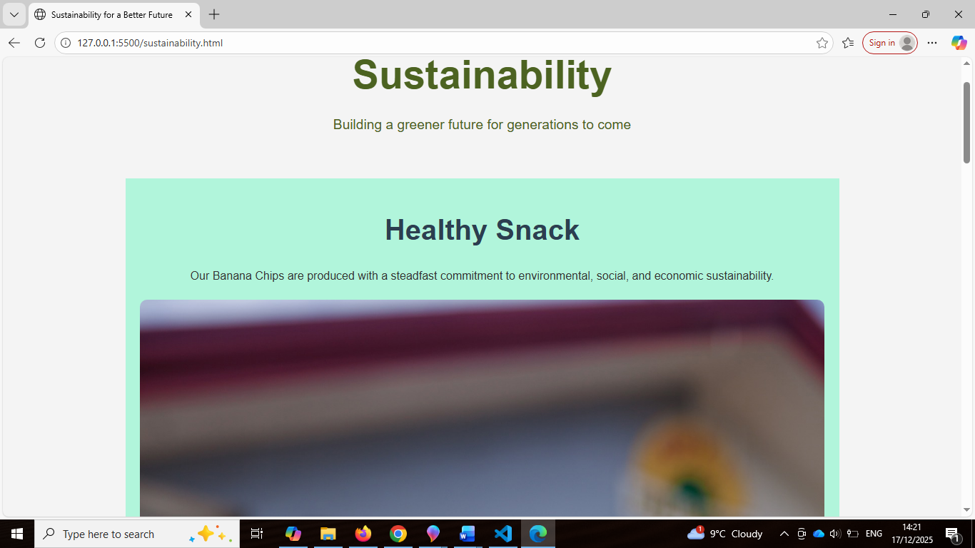
Figure 6
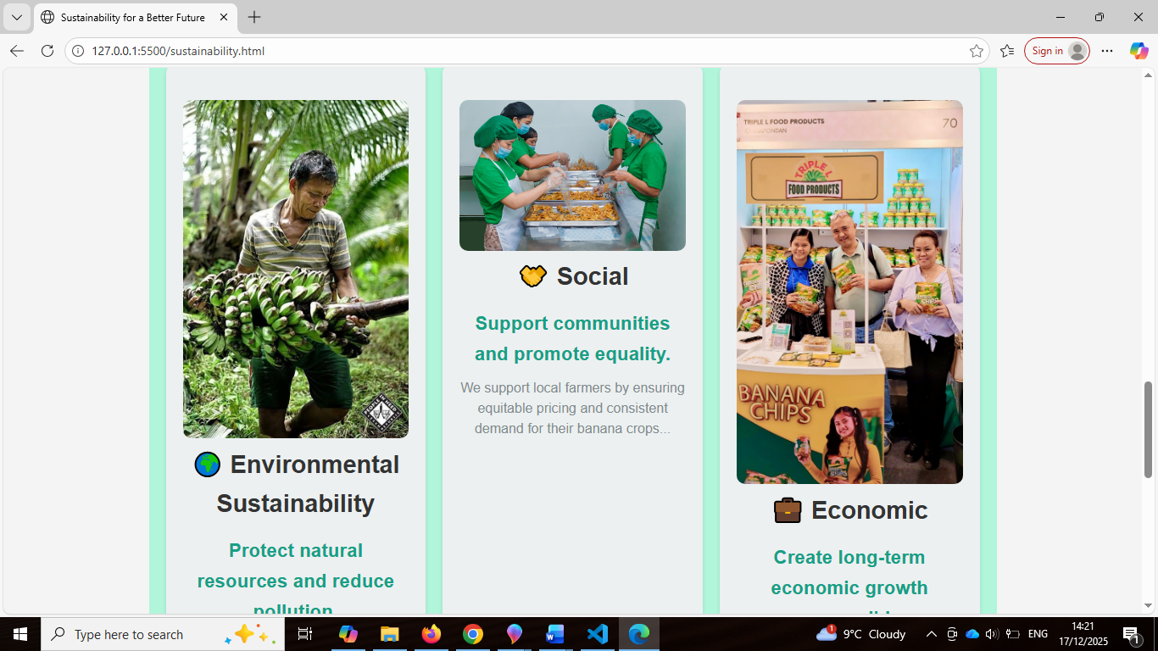
Figure 7
Contact us page
-using input and form container for the contact, with image, style in css to make contact information and customer support. Use map copied from google map and embedded video from facebook. Below is button to navigate back to home.
Contact information of the company, a map or telephone number, any information that the consumer will be able to reach them, whether for inquiry or buying, or simply looking if the company is legit, this is the page where user look at.
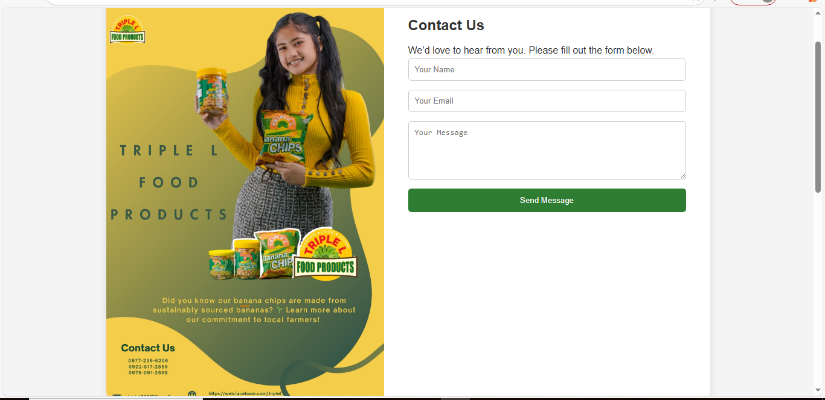
Figure 8
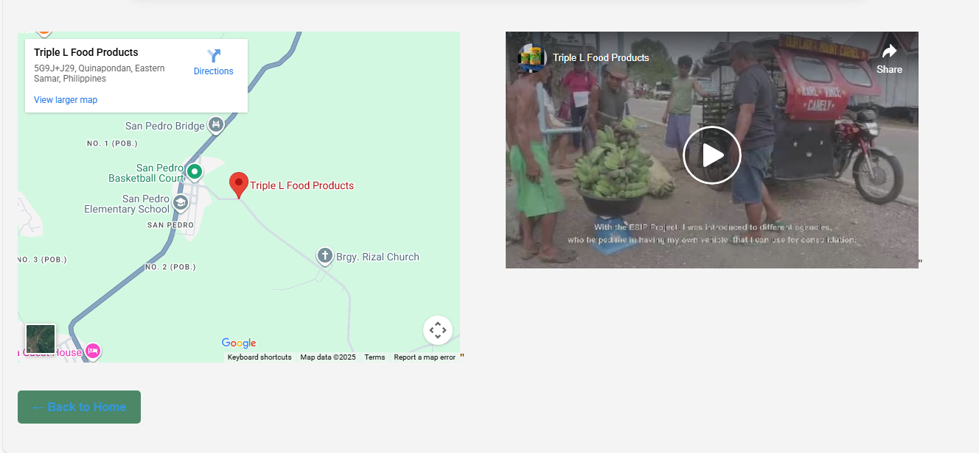
Figure 9
Events and offers page
-prominent feature in this page is using carousel to portray stack of images of products, promotion, hiring adverts and events, with description each image. User can see full navigation bar above and the logo on the left and footer at the end of the page.
- This page contains events, promotional adverts, hiring and discounts products.
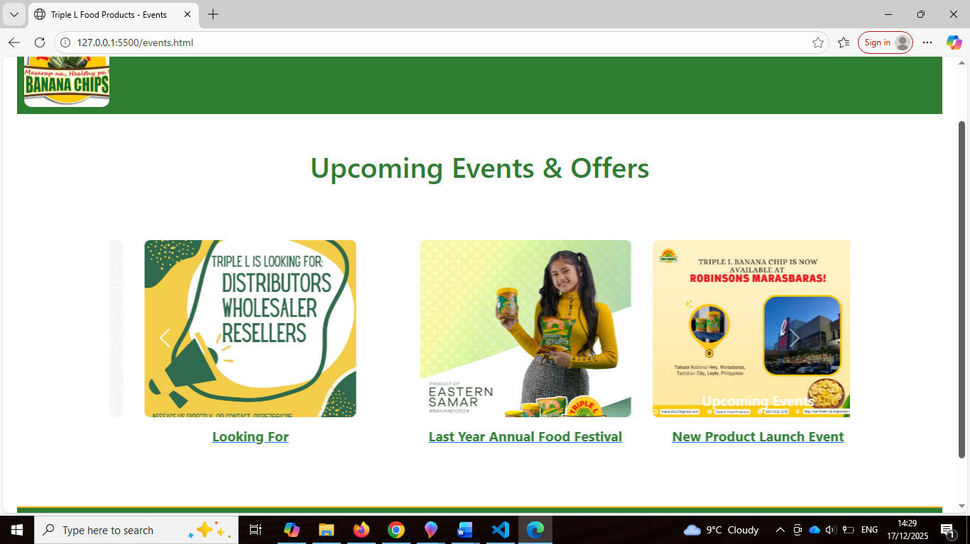
Figure 10
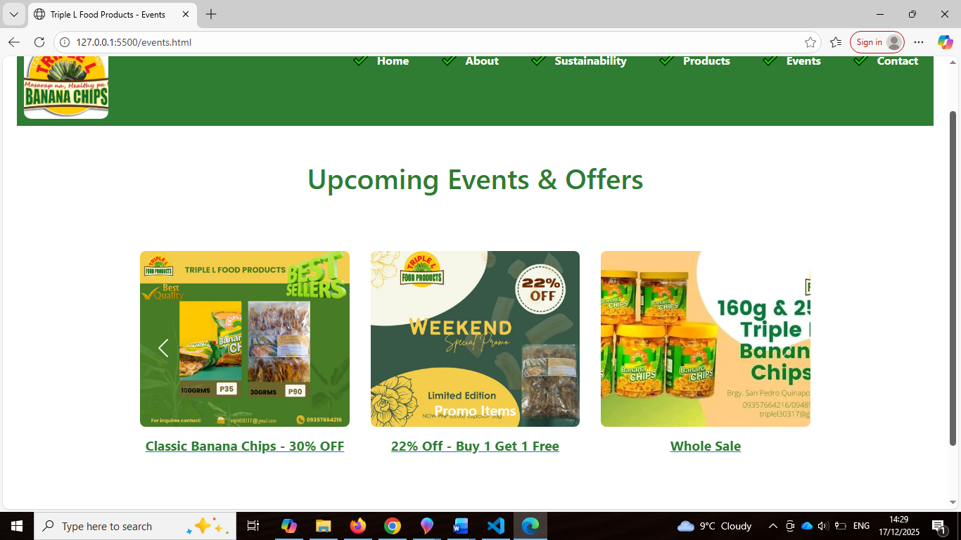
Figure 11

Validation
-Provide validation result.
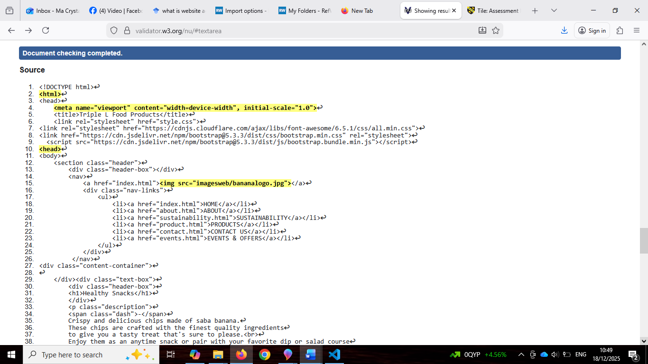
Using http://validator.w3.org/ to validate my entire index.html home page and found several and redundant errors. I have included screenshot, issues and what I did to fix the problem.

Figure 12
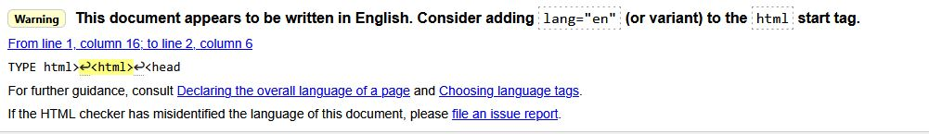
- The validator points out that I did not specify language attribute , therefore I will add this lang=”en” attribute to the start tag.
Figure 13
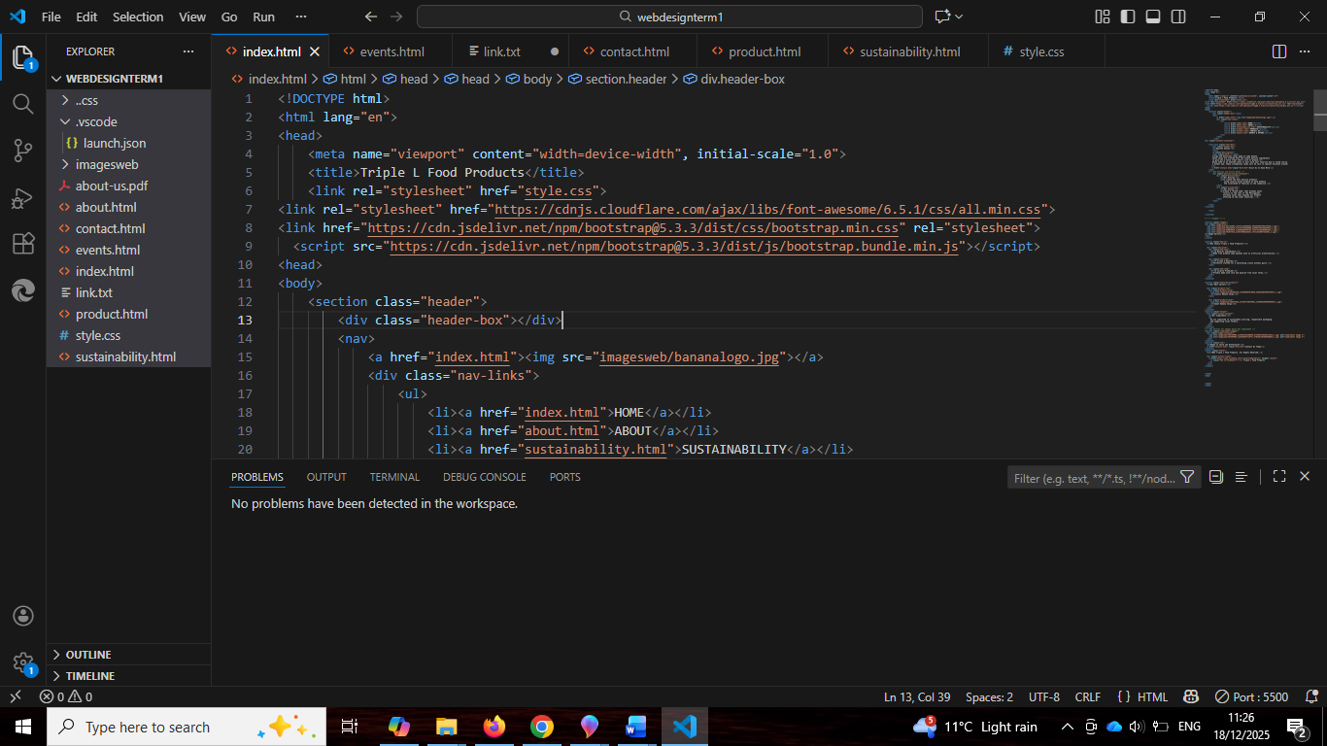
Figure 14

-Adding the language code for HTML, fix the issue. Declaring proper and correct language improves accessibility, and helps tools like screen readers to better interpret the content and can also improve Search Engine Optimization (SEO).

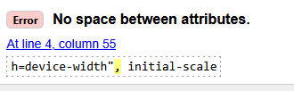
- There is a problem with spacing.
Figure 15
-Put the space between the code, this helps tools to parse the code correctly.

- There is an issue found with XML serialization, which means it break the rules
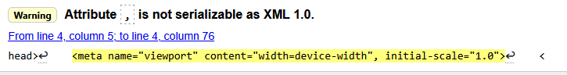
of meta tag attributes.
Figure 16
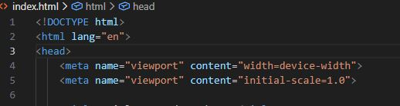
-I fix this by separating meta tag in a way that is valid for XML, and validator did not find any more errors in this case.
Figure 17
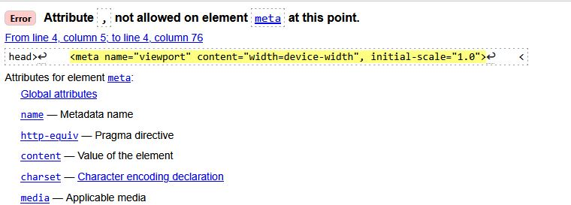
- Error occurs because XML 1.0 does not allow comma separated values, the same way HTML does.
Figure 18
- Fix it by separating the content as shown in Number 3 problem.
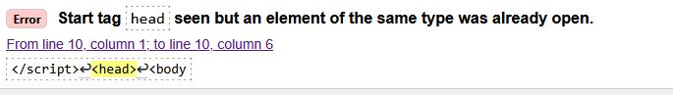
- Error start with the head tag, it says same type is open already.
- Fixing by omitting the other <head> below the HTML codes.
Figure 19
- Rest issues are same with the colon and separation commas and XML rules.

Using CSS validator http://jigsaw.w3.org/css-validator/ for validation, use this in my home page.
- 2 errors generated from the validator:
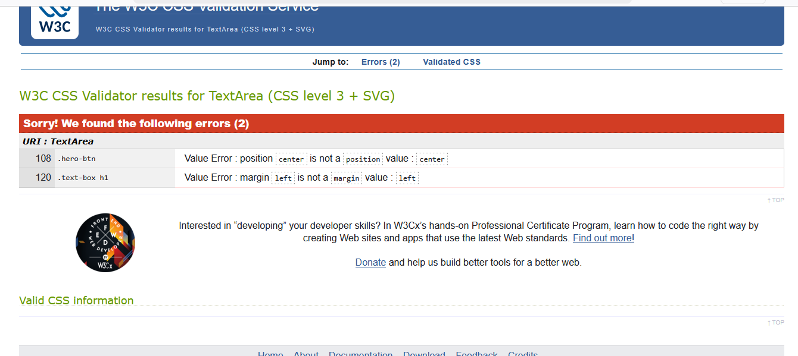
Figure 20
-The hero button has an invalid value stating position: center is not a position value, and the other issue says it has no margin value, to fix this, I would have add more values or different values but will not do it as I am not sure how to fix this. I could try however, since I am not sure how, it could affect other properties in the CSS. I’d prefer not to make adjustment without better understanding of potential impact it may cause.

Evaluation

- Website usability, SEO, accessibility, research these terms and describe, then evaluate and connect in your website:
Usability is crucial determinant of success in a website. Consequently, it is implied to establish effective method for assessing website usefulness. These methods serve a valuable tool assisting website designers and developers.
“Usability is defined in ISO 9241-11 as the extent to which a product can be used by specified users to achieve, specified goals with effectiveness, efficiency and satisfaction in a specified context of use [1]
-Based on the website I created, navigation bar is on top to access pages easily, however there is room for improvement, and I believe there is better style than this. In terms of readability and layout, the text is clear and font is enough to see but the dark background might be the problem causing the text to be a bit hard to read, therefore background might need changing into something light colour. Overall, colour of pages is match and related to the team, health, fresh and green, also same with the company chosen colour. Backspace or link back home is seen in the pages or in back arrow or browser making it easy for user to navigate all over pages. Call to Action (CTA) button is clear and I believe all information about the product and the company is sited widely. The pages can be access in smaller device however there is issue that I may overlook and there is inconsistency, some page cannot be viewed or not mobile-friendly, this is one of the problems I encounter in making the website. Consistency is even in all pages, and the content are relevant to the topic I am portraying. Rating in usability I can say, my website has plenty of room to improve and will continue to study for better result.
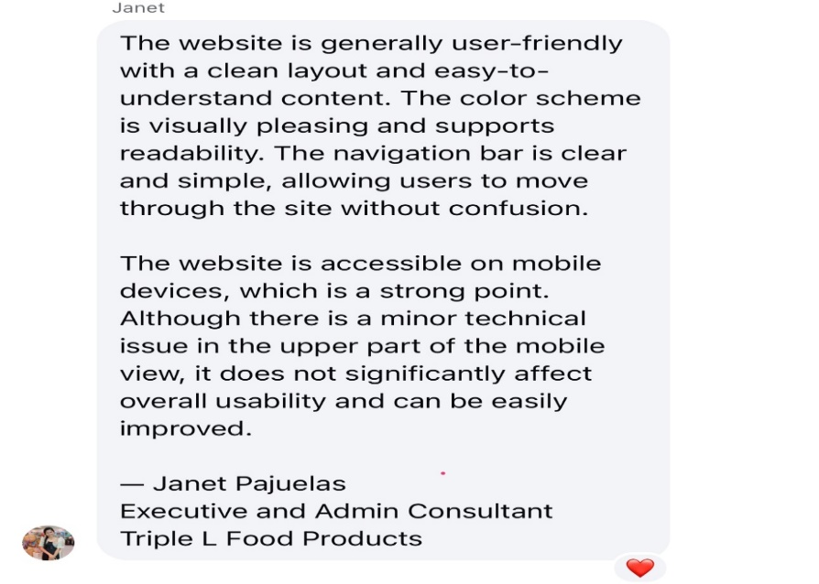

Figure 21 (website feedback from Triple L employee)

Search Engine Optimisation (SEO): A search engine is a software that collects information from websites. It uses programs called spiders or bots to move through web pages using links. These programs gather data like website URLs, keywords, page structure and links, then store this information in a large database called index. This process is called indexing, it is when a user searches for something, the search engine looks through the index and shows the most relevant results in an orderly manner using special character. Search Engine Optimization (SEO) is the technique used to make website easier to find and rank higher in search engine results [2]
It is essential to know how SEO works to understand how search engine fit together to be effective and can function well. Discovery, Storage, Ranking and Return are important to know in order to implement SEO effectively [3]
Applying to the website I created, I demonstrated SEO effectiveness by applying the title tag to add visibility when searching in browser. Another application I put is the meta name “description” content which describes exactly what I am promoting in my website. Heading and paragraphs also says about the website goal. I use alt text in some images which enhance the visibility, all of this demonstrates and helps improve visibility is search engine results.

Accessibility definition varies from Yeliz Yesilada et. Al research, web accessibility means that people with disabilities can use the web, can perceive, understand, navigate and interact with the web, as well as those without. Website is accessible if ite efficient, effective and satisfy the user [4]
Web accessibility refers to the inclusive practice of designing website so that individuals with disabilities can understand and navigate and interact with the content. Numerous sets of guidelines have been pruposed to ensure website accessibility in particular Web Content Accessibility Guidelines (WCAG) [5].
-In connection to the website I created using four main principles of WCAG 2.1 which are perceivable, operable, understandable, and robust (POUR) I use visual code to inspect this element.
Perceivable: text content is readable and the attributes are all related to the website goal, promoting the company’s product. Though some texts are affected by dark colour and needs improvement, mostly colour of pages are related to the product.
Operable: navigation and links are all operable and clickable. However additional links or button is better for effective functionality of operation.
Understandable: contents are clearly about a healthy product promotion. Language are simple describing and defining the goals set to connect with the product promoting and navigation links are easy to follow.
Robust: Basic structure of HTML is followed; however, compatibility is where my website has too many issues and needs a lot of room for improvement.

Compare two lives website with your work.
Area |  | My website | Walkers  (https://www.walkers.co.uk/walkershome/) | Ebay  (www.ebay.com)
Area | Usability | Simple nav. Bar, less refined, needs improvement | Clear menu, consistent design, better button and links design | Intuitive, prominent and consistent layout, help user find what they search.
Area | Accessibility | Alt text in some images, no cookies warning | There are cookies but showed only when clicked. In mobile is more prominent. Alt images are not use. | Alt text use, clear description and caption, buttons and patterns are easy access.
Area | SEO | Title tags, meta description and rich word to define the product but could have been better | Detailed description, and facts about the products, and structured pages. | Structured and well scripted, suggestive when using search bar. Links other products for wide variety of choices
Area | Mobile Friendliness | implemented but requires improvement | Highly implemented | User friendly, responsive and fit to any device
Area | Conclusion | Shows basic website standard but requires further improvement | Generally good and use standard principle of website. | Professionally made with detailed layouts and easy to understand interface.

Conclusion

-In conclusion, the website I created demonstrates the basic application of web principles including usability, accessibility, SEO and mobile responsiveness. Demonstration of working navigation bar and links, buttons are clearly and responsive to use, the content is readable, alt and other attributes and codes are use and basic practices applied in accordance with WCAG 2.1 guidelines.
While the website created shows basic website needs, further improvements is highly recommended, especially the styling of layout and colour.
Familiarizing the codes and its usage are greatly helping to enhance the knowledge to create a responsive website.

References

[1] T. K. Chiew, "Webuse: Website usability evaluation tool," 2003,
[2] N. Yalçın and U. Köse, "What is search engine optimization: SEO?" vol. 9, pp.487–493, 2010,
[3] H. Davis, Search engine optimization, " O'Reilly Media, Inc.", 2006.
[4] Y. Yesilada, et al., "Understanding web accessibility and its drivers", Proceedings of the international cross-disciplinary conference on web accessibility, pp. 1–9.
[5] T. Chatziemmanouil and C. Katsanos, "Accessibility Academy: Interactive learning of the WCAG 2.1 web accessibility guidelines", 2024 IEEE Global Engineering Education Conference (EDUCON), pp. 1–7.

Appendices
Cut and paste copies (text listings) of all your HTML and CSS at the end of your report.
(remember that appendices don’t contribute to the word count, so don’t worry of the total size of the report ends up being fairly large because of the listings!)
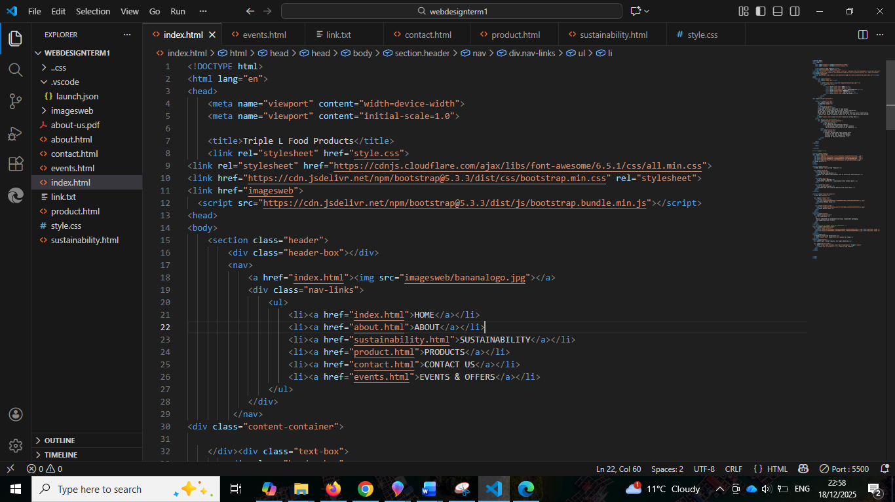

Home page
-too many errors seen when validated but point out few, because of word count and redundant issues.
-tried with facebook link, it actually works but not the style I expected.

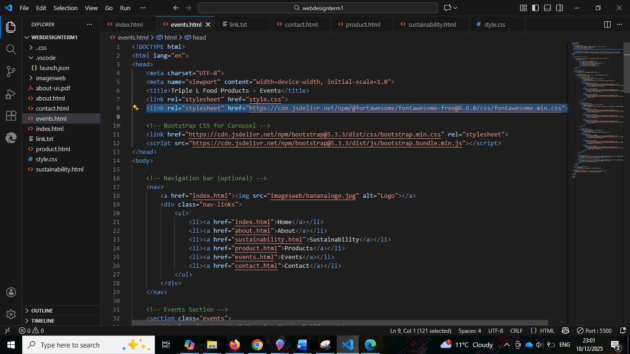
-encounter problem <link rel="stylesheet" href="https://cdn.jsdelivr.net/npm/@fortawesome/fontawesome-free@6.6.0/css/fontawesome.min.css"> for font styling, never work, tried to search possible answer online, some blogs and research, give me answer but too complicated to execute or understand, may require further investigating or demonstration creating another website to test. At some point, Al give me link https://cdnjs.cloudflare.com/ajax/libs/font-awesome/6.5.1/css/all.min.css" that I pasted in my home page and it work on my font styling.

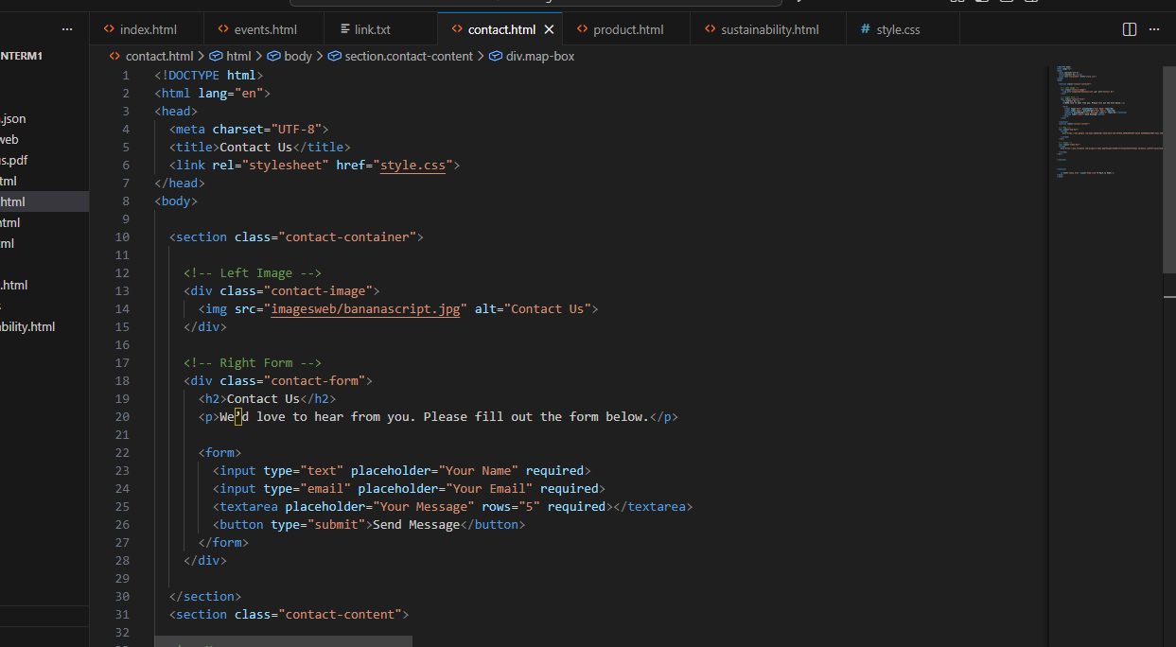
-contact page has some issue also, with the map size, tried possible style in css but the more I edit, the more it went wrong, eventually settled with the map and video on the right side, embedded from facebook. Home button to navigate is working.
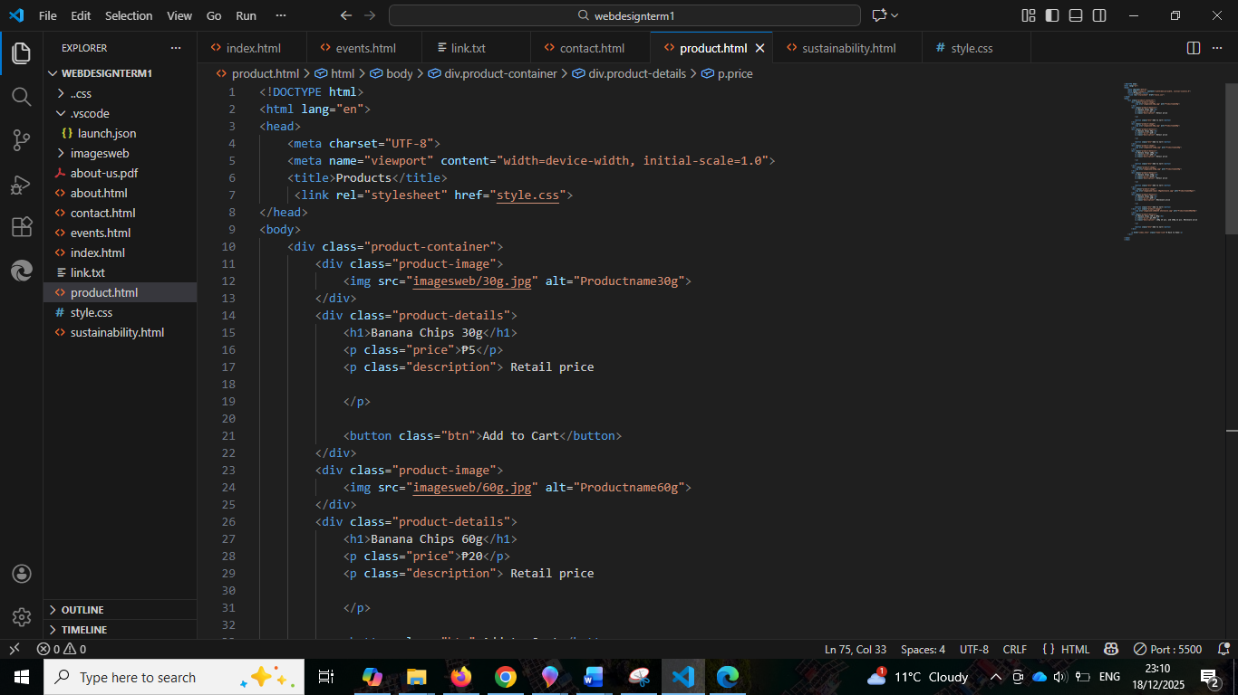
-probably the page I work with less problem, however product is less due to the consumer demands, in the past not only banana chips they are selling, they have incorporated with drinks, the banana chips whips which still edible they make it as polvoron, tried different taste also not just sweet taste banana chips, the company use banana all including the plant itself, however the focus of their company now is to distribute regionally and to be known globally so they focus on 100g, 160g and 250g banana chips.
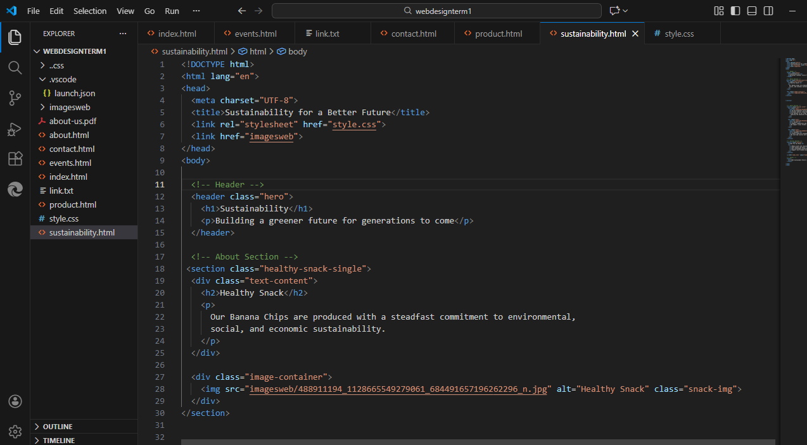
-here the issue also same with the home page, is to put image alongside with heading and paragraph, tried so hard and I cannot comprehend where is wrong, in HTML or CSS area, further testing is required.

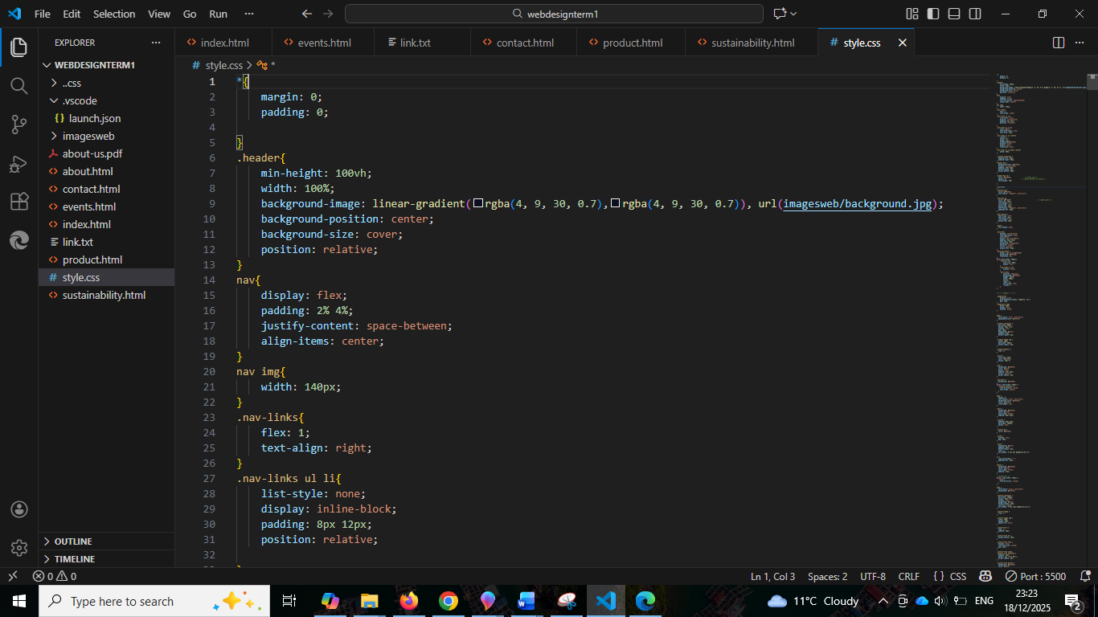
-needs to get the hang of it, includes familiarizing the code to minimize errors.

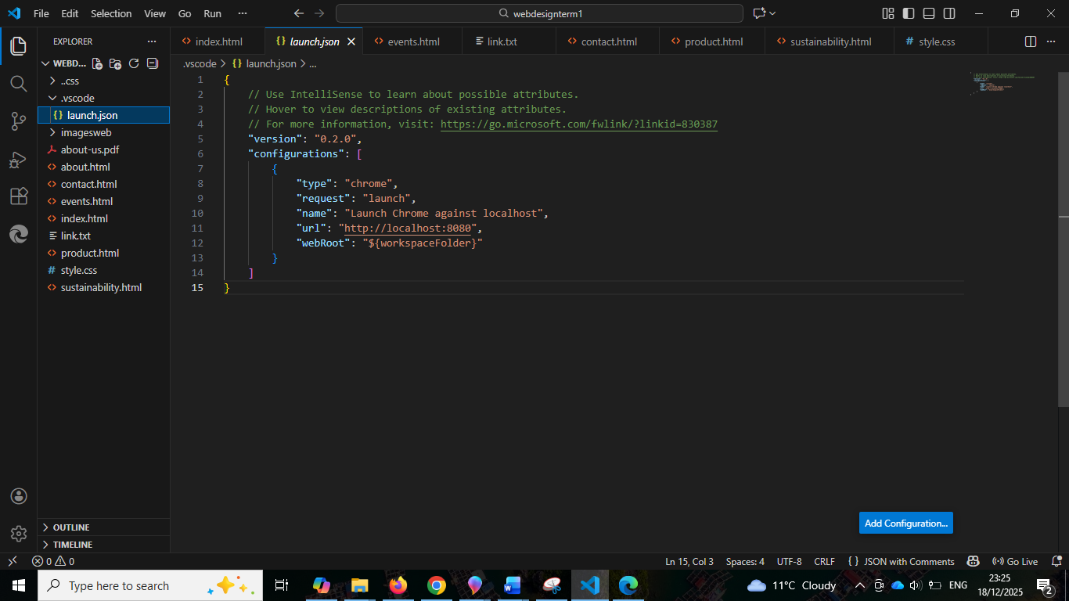
- at the start of HTML, there is no problem at all , but as I go along, putting more element, it gives me this and I cannot use google browser anymore. Tried run debugging and run without debugging but still gives me this problem. Install possible extension, research possible answer, end up in youtube and give me alternate way to open the website by opening server and go live. Used edge to open the website.

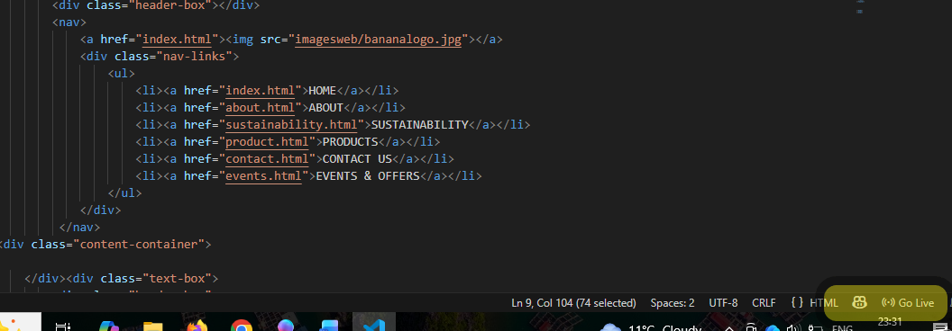

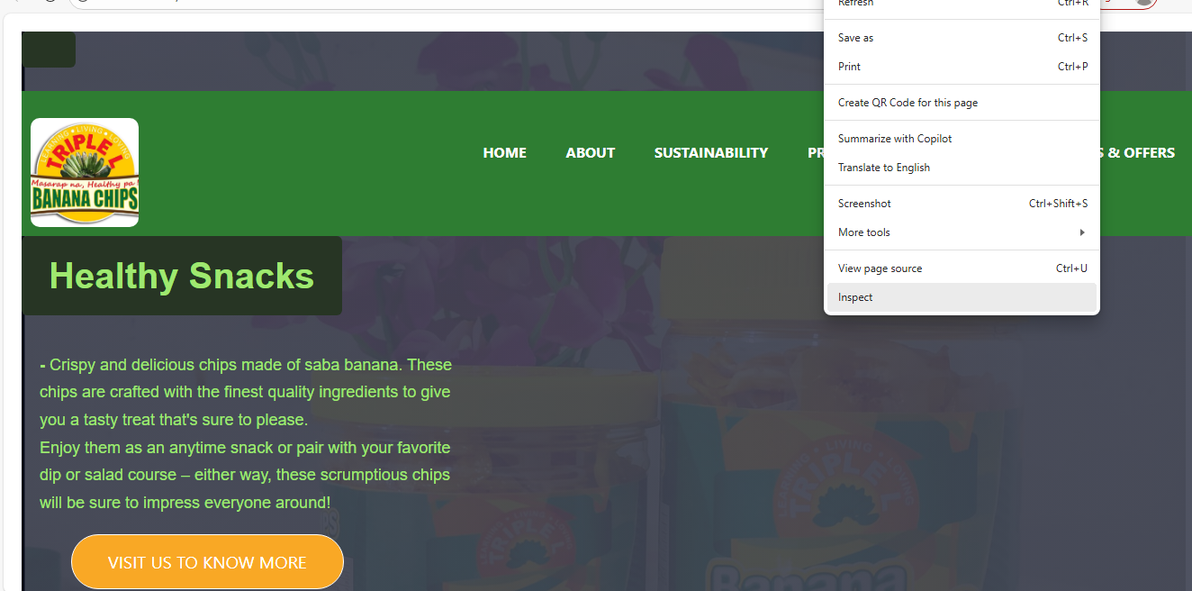

-testing for mobile responsives and any other screen devices by inspecting the resources and elements used.

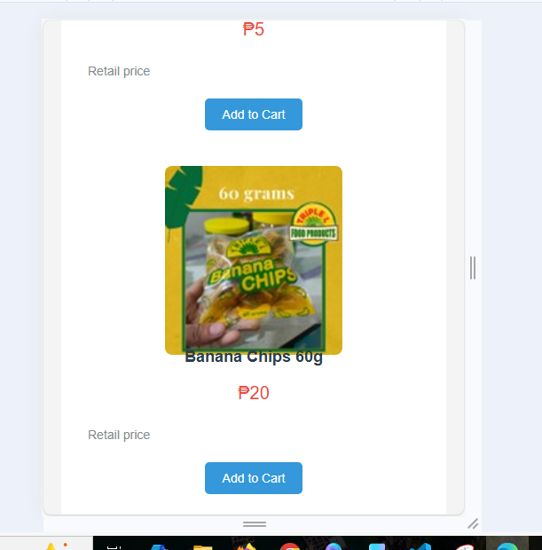
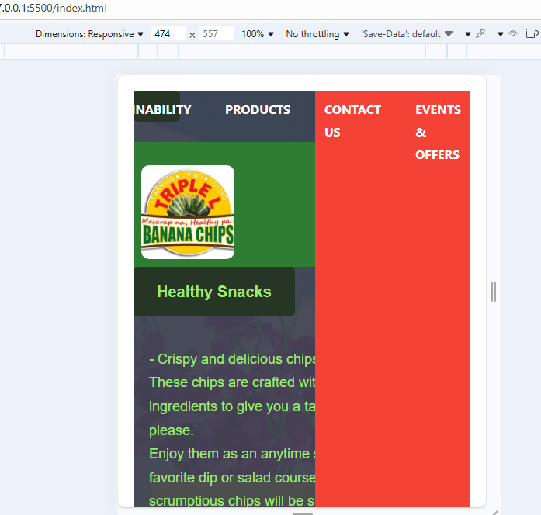
-Top section encountered some issues,vertical lines and ‘x’ mark code did not work to demonstrate accessibility for small screen devices, the rest works fine, font and images fit showing mobile friendliness



