Assessment Three: 3.2. Database Exercise (Modern)
Using the Slave Voyages database, research the voyage(s) of ONE of the following slave ships

With decades of indpendent and academic primary source research and collaboration, the Slave Voyages database offers an active major accessible resource aiming to facilitate and stimulate new research on the transatlantic slave trade. The site has three distinct databases each with detailed information about understanding and using the database, indication of variables and numerous essays relating to the information in the database, as well as detailed pages as to the project and its history, methodology, glossary, legal framework et al. The authors are candid on their methodology page to highlight the limits of such a vast and ongoing undertaking, and offer a caution to scholars to further research primary sources as needed. In addition the site offers a rich resource tab: Images, including manuscripts, places, slaves and vessels, detailed lesson plans and additional links.

For this exercise we are asked to research the voyage of one of four named slave ships. I have choosen the Fabina (1819), particularly as it is a ship that was sailing with enslaved human cargo after the abolition of slavery. The Slave Voyages database lists two Voyages for a ship called Fabiana in 1819, both flying the Spanish Flag / Uruguay Flag:

Voyage ID 2315, Captain Juan Garcia, Owner not listed.
Voyage ID 4344, Captain Yelechy, Owner Hernandez, Gaspar

I have chosen to primarily focus my research voyage ID 2315, Fabiana 1819, captained by Juan Garcia, Owner at this stage unknown.
After some general orietation within the website for background infoprmation, context, history of the project and watchign the introduction vidoe and the 3D slave ship video, I entered the Trans-Atlantic Slave Trade - Database and using the ship tab, serach for Fabiana which returned a full details page. There are nine entries of voyages with different IDs, over seven years attributed to Fabiana over many years, thus using the date range given for this particular exercise, the two voyages are shown.

The Fabiana is registered as a schooner of 117 tonnes, with a standardised tonne listed as 171.6. Voyage 2315 began in Havana, 4 June 1819, with a principal pick up of slave cargo in Trade Town and a principal place of slave landing at Free Town. The Voyage length from the homeport to disembarkation was 121 days, with a middle passage of 15 days. The full record includes the date when the Fabiana departed Africa as 18 September 1819, and arriving with slaves as 3 October 1819. The Liberated Africans page cites the date of sentence as 7 October 1819. It is not clear to me how these dates correlate and requires further research to understand.

This voyage was sailing with thirteen enslaved people as human cargo two years after Spain had agreed abolition of the slave trade north of the equator in 1817, As such she sailed with the risk of being captured by vessels licensed to prevent the now illegal trade. The data-base lists the outcome of this voyage as: ‘Court of Mixed Commission, Sierra Leone, condemned’ and that the Slaves disembarked in the Old World. A google search for Court of Mixed Commission, Sierra Leone, brought me to the Liberated Africans’ website, a site I have yet to research for legitimacy, however, there is it listed that the Fabiana was captured on 3 October 1819 by the British ship Morgiana, Captain Charles Burrough Strong under the internationnal anti slave trade treaties. According to the site the case was heard by the British and Spanish Court of Mixed Commission, Sierra Leone and the ship condemned. All thirteen slaves disembarked.
Following one of the activities from one of the lesson plans on the Slave Voyages website, I searched in the African Names database under ship name and voyage ID. The following table from the database outlines the names, ages and sex of each of the enslaved people who disembarked from the Fabiana at Free Town in 1819.

ID | Name | Age | Height (in) | Sex/Age | Origin
2 | Flam | 30 | 64.0 | Man
3 | Dee | 28 | 65.0 | Man
4 | Pao | 22 | 62.5 | Man | Crue
5 | Mufa | 16 | 59.0 | Man | Crue
6 | Latty | 22 | 67.5 | Man
7 | So | 20 | 62.0 | Man | Crue
8 | Trua | 30 | 65.5 | Man | Crue
9 | Tou | 18 | 61.5 | Man
10 | Quaco | 23 | 62.0 | Man
11 | Teagu | 30 | 67.5 | Man | Crue
12 | May | 25 | 66.0 | Man
13 | By | 23 | 60.0 | Man
14 | Fugra | 15 | 58.0 | Woman

The slaves were between fifteen and Thirty years old, with the single woman amongst them the youngest at fifteen.
There are five people listed as ‘Crue’ in origin. The only reference I have found thus far is for a group of people called ‘Kru’: known to inhabit part of the West African coast 400 miles from the British Colony of Sierra Leone since I799. It is beyond my scope at this point to further explore this anomaly, however, it is intriguing to wonder if this is simply a different spelling or otherwise.

The Liberated Africans has a number of images of manuscripts (see below) it was after finding them I thought to check the images within the slave voyages website and found a copy of image two that declares that: ‘The register was kept as a formal record of emancipation that helped protect the individual from subsequent re-enslavement. The image is reproduced courtesy of the British National Archives.’
This voyage and many others also listed on the database, took place two years after abolition. Whilst the legal structures were in place, nonetheless pressure to continue trading human cargo was clearly prevalent. Court proceedings and prosecutions would have played a vital role in changing this over time, and one might assume increased measures to protect the rights of now freed people. It is not clear what circumstances people found themselves in when freed and what support or reparations were made in the personal sphere when, as in this case returned to Sierra Leone, such an exploration is outside of this exercise.
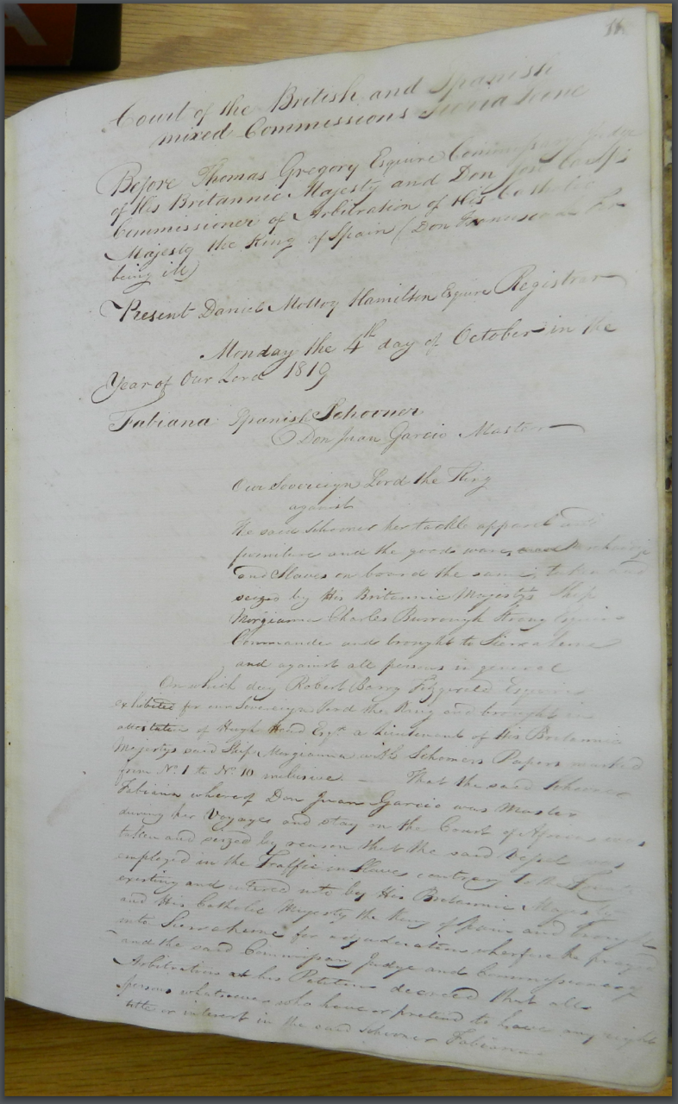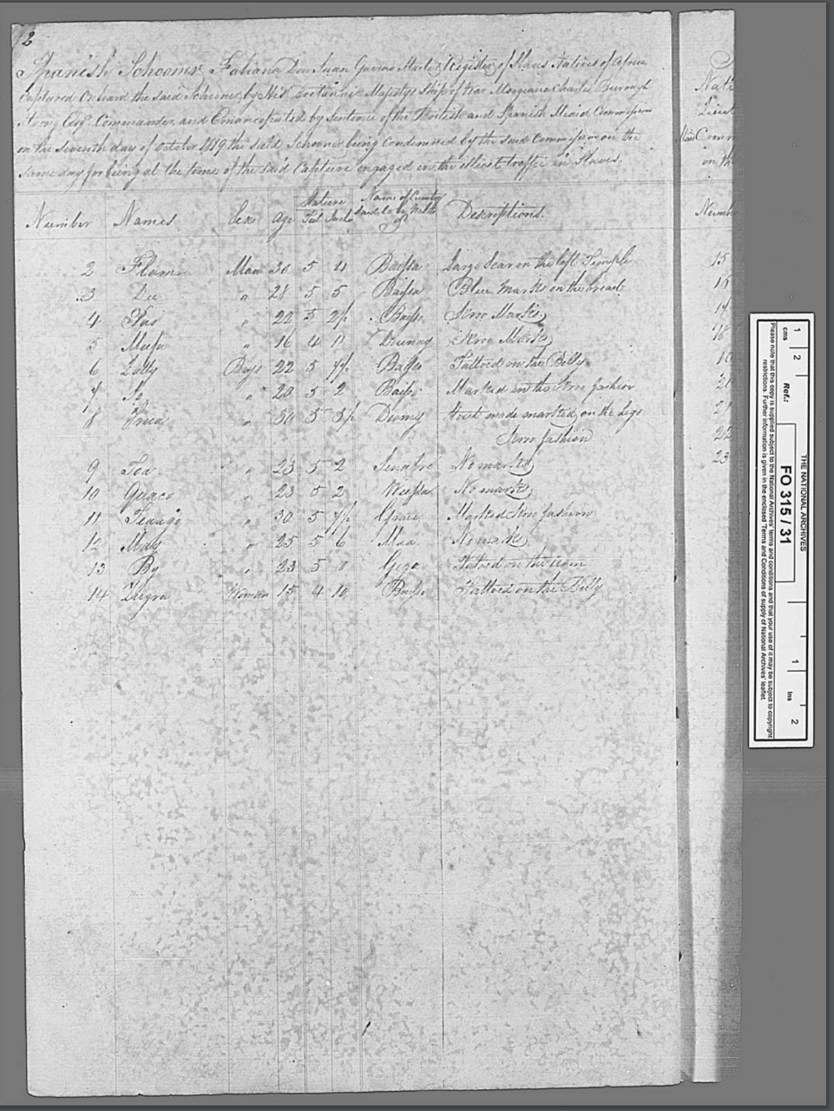
Image 1: Report on the seizure of the Fabiana Image 2: Register of 13 People on Fabiana

The Slave Voyages website is a monumental work of diligence and tenacity. As a live project still being updated it is a vital research tool for scholars and for education. I am grateful for the reminder on the methodology page of the limits and choices made by project researchers inputting data. As a focus for research it is an extraordinary site, and, It behoves one to be diligent and to follow up primary sources. As an exercise I am very grateful, it is a first step into a navigating this site and it is clear tehre is much more time needed to begin to absorb some of the wake of slave trade and its impact today.

Bibliography

Bethell, Leslie, ‘The Mixed Commissions for the Suppression of the Transatlantic Slave Trade in the Nineteenth Century’, The Journal of African History, 7 (1966), 79–93

Biyi, Esu, ‘The Kru and Related Peoples, West Africa. Part I’, Journal of the Royal African Society, 29 (1929), 71–77

‘Image Detail’, https://www.slavevoyages.org/resources/images/category/Manuscripts/3 [accessed 14 November 2021]

Kew, The National Archives, Africa Project, Spanish Schooner Fabiana, FO315-31 f12, https://la.regeneratedidentities.org/project/DataFiles/AD000001/1819-10-07%20Fabiana%20V2315%20FO315-31%20f12.pdf [accessed 14 November 2021]

Kew, The National Archives, Africa Project, Spanish Schooner Fabiana, FO315-31 f12, https://la.regeneratedidentities.org/project/DataFiles/AD000001/1819-10-07%20Fabiana%20V2315%20FO315-26%20f13-15.pdf, [accessed 14 November 2021]

‘Liberated Africans’ https://liberatedafricans.org/events.php?court%5B%5D=2&court%5B%5D=3&country%5B%5D=Cuba&from=2019&to= [accessed 14 November 2021]

Kew, The National Archives, Africa Project, Spanish Schooner Fabiana, FO315-31 f12, https://la.regeneratedidentities.org/project/DataFiles/AD000001/1819-10-07%20Fabiana%20V2315%20FO315-26%20f13-15.pdf, [accessed 14-11-2021]
Leslie Bethell, ‘The Mixed Commissions for the Suppression of the Transatlantic Slave Trade in the Nineteenth Century’, The Journal of African History, 7.1 (1966), 79–93.
‘Liberated Africans’.
Esu Biyi, ‘The Kru and Related Peoples, West Africa. Part I’, Journal of the Royal African Society, 29.113 (1929), 71–77.
‘Image Detail’.
Kew, The National Archives, Africa Project, Spanish Schooner Fabiana, FO315-31 f12, https://la.regeneratedidentities.org/project/DataFiles/AD000001/1819-10-07%20Fabiana%20V2315%20FO315-31%20f12.pdf [accessed 14-11-2021]

