Dissertation proposal

Shaunna Bowen P149848

Graphic design W210

1904 words

I want to explore my area of study of which is Graphic Design. I intend to broaden my knowledge of graphic designers and what have influenced the world of graphic design today. As a female graphic designer I’m naturally interested in the influential women within the graphic design world. Through some initial research I was soon to find out that there are generally more well- known male designers than female designers – which rises another question I will look into. The question being, why is this? Is this put down to gender, being provocative or another reason I’m yet to discover. Through my dissertation I will look into all types of different designers. Initially looking at the male designers and the controversy behind them but also paying close attention to the most influential women within the graphic design industry who don’t get the recognition they deserve.
 Figure 1 Stefan Sagmeister (1999) AIGA Detroit Poster. [web image]

My first keyword is controversial. The keyword itself could be quite controversial as it could be said that it depends on opinions. I will look into the controversial side of graphic design and what is cleared considered to be controversial and why. I want to explore into questions that I have about this keyword. Are graphic designers controversial in their work because it has more of a reaction which in turn gives them more publicity or are they controversial in their work because they just want to be.

Within this keyword, I will delve into the graphic designers that are well known as a controversial designer. The likes of Stefan Sagmeister who I’ve been familiar with since being involved in the design world. Is this because he’s well known for being controversial and producing provocative graphics or does he produces provocative graphics because he’s well known? In Creative pro (2016) Sagmeister was asked if he has a design philosophy and his reply was, ‘Try to touch the heart of the viewer’. So maybe controversy is how he does that. Stefan Sagmeister have said, ‘For this lecture poster for AIGA Detroi we tried to visualize the pain that seems to accompany most of our design projects. Our intern Martin cut all the type into my skin. Yes, it did hurt really bad.’ According to AGDA (2015), they say,

Stefan Sagmeister is famous. Hardly any graphic designers are famous. But as far as words describing the design legend go, ‘famous’ is at the lower end of the spectrum. He’s unfathomably creative. Famous? Okay. Unconventional? Without a doubt. Which could lead me onto another unconventional designer who doesn’t conform to what is ‘normal’.

The graphic designer that l will explore will be David Carson. Carson is considered to be one of the most influential but also one of the most controversial designers. As graphic design is based around rules and following guides, Carson goes against all these rules, some people love it and some people don’t. It’s been said in Magenta,
‘For graphic designers, success and controversy rarely go hand in hand. But David Carson flaunted that rule, along with just about every design principle he became the founding art director of Ray Gun.’

David Carson says in Magenta (2018), ‘If I have one overall approach or philosophy, it’s, Why not?’ I’m going to explore into what it is that David Carson does that doesn’t oblige by the rules of Graphic Design and why it’s made him successful over others. Some people believe that his work is a blasphemy while others believe it’s changed graphic design and influenced a whole generation. The biggest questions that I will base these designers and keyword about are whether they crave to be well known so much that the only way of doing so is to produce very controversial work. In turn this raises another question, is this why there is thought to be more men working within the graphic design industry than women?
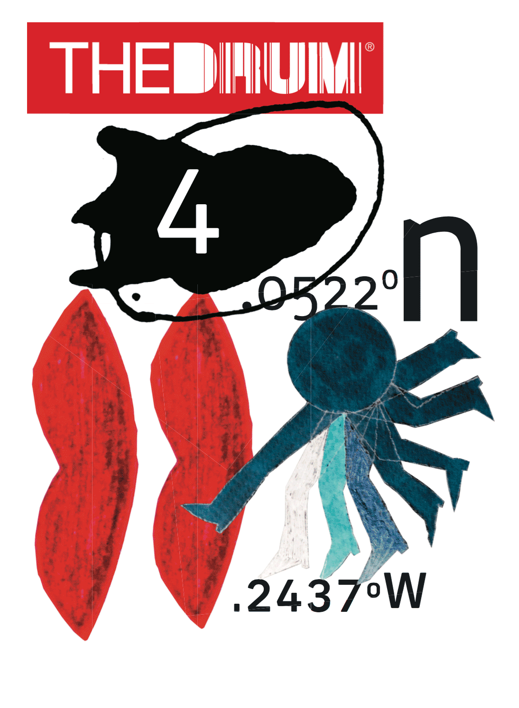 Figure 2 David Carson Cover for the Drum magazine (2017) - [web image]

My second keyword is non-controversial. My main reason for this is because I want to see the difference in how well known and valued pieces of work that may be beautifully designed but because they’re not provocative or controversial – they don’t grab people’s attention as much. A designer whose work I will research into is Jessica Hische Jessicahische.is (2018) She produces beautiful designed typographic pieces and amazing posters and book covers. I will look into different mediums that she’s worked with and explore different pieces of work that she’s created.
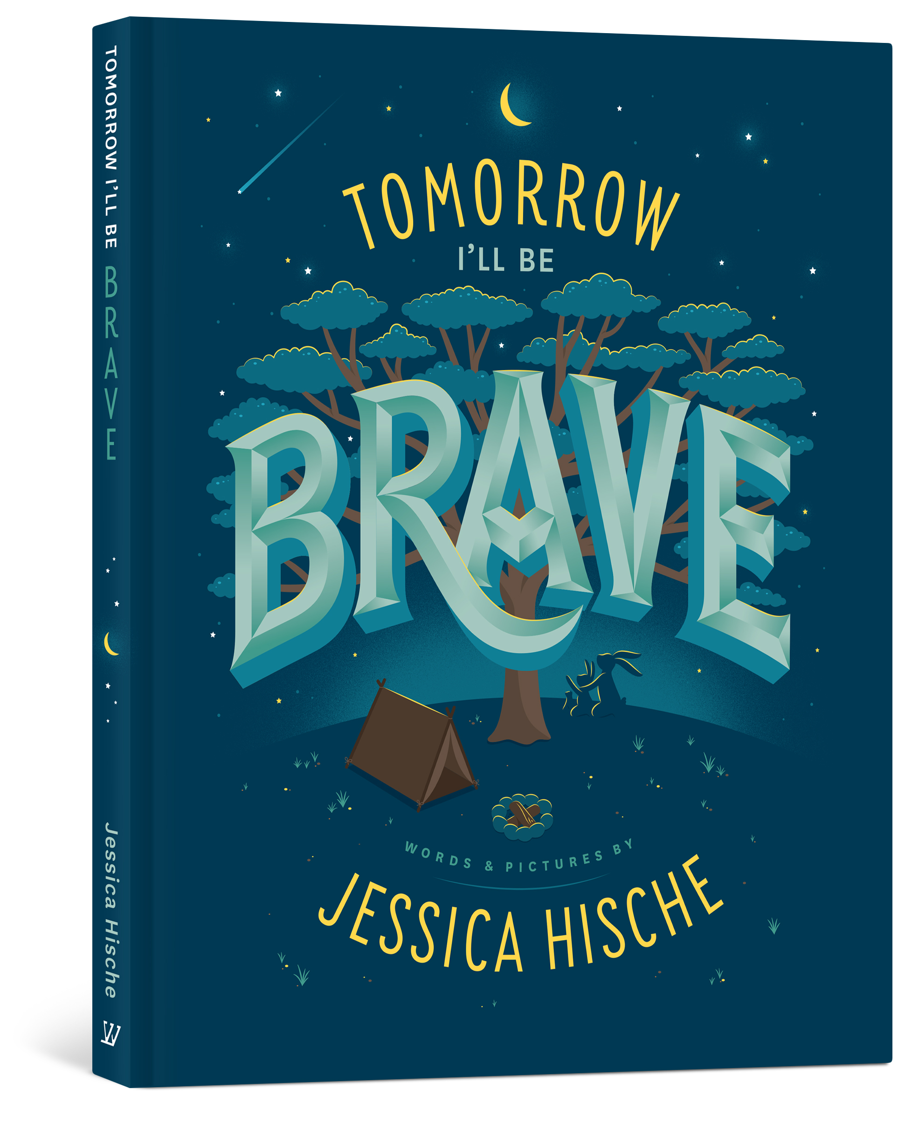Figure 3 Jessica Hische Tomorrow I’ll be brave (2018) [web image]
My first two keywords will be a small part of my dissertation. Controversy and non-controversy graphics is something that will lead onto a bigger question. I think by exploring these two keywords first, it leads nicely on to my third keyword. My third keyword is gender equality. After researching into this I’ve already noticed that there seems to be a lot more male designers that people know about rather than female designers. It’s hard to believe that gender inequality still goes on but it does. Whether that’s a big issue or not is something I want to develop more knowledge on.

My third keyword is influential women designers, I want to research into this because as a female designer, I have a genuine interest. It’s been said that women designers are over looked. 99designs(2018) say ‘Although 54% of designers in the US are women, the ones we know and talk about are often men.’
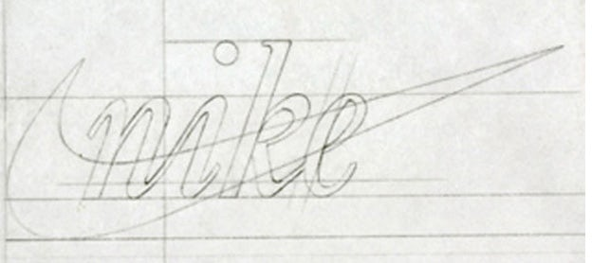Figure 4, Carolyn Davidson’s sketch.
One of the main designers I will talk about and look into more detail in my dissertation is Carolyn Davidson who is quite unknown compared to the likes of Sagmeister. Carolyn Davidson who’s described as a woman that no one knows, designed potentially the most famous logo there is – the Nike logo. She was a graphic design student at the time and got paid just 35 dollars for it (roughly 200 dollars now) This is quite shocking that no one really knows who designed this – if this was designed by a man would that designer be more well known for it? A question that I want to find out more about.

Another designer that I have to write about in my dissertation if I’m talking about influential female designers is Paula Scher. 99designs (2018) provides information of Scher, she is the partner and first female principle of Pentagram, she was an innovator of not only typography but also layout and colour within the graphic designer industry. Described by McLaughlin (2018) as one of the giants of graphic design in the US.

Design Indaba, 2018 explains how Britain’s road signs are familiar with everyone and probably affect everyone’s daily lives. However, it’s unlikely that many people know who designed those signs. Margaret Calvert and Jock Kinneir designed the entire road signs system. Design Indaba, 2018 also explained, ‘She designed the transport font used on road signs and the rail alphabet font used on the British railway system.’

In order to support female graphic designers in Central St Martin’s, there’s an exhibition of work that’s came from St Martin’s college’s female alumni and also the staff. It’s Nice That (2018) has asked the curator why this still needs to go on. Her response,
Until quite recently, there weren’t many female graphic designers to be found in design history books, exhibitions and design school curricula. But this has started to change in recent years. Museums are beginning to put on shows that recognise the contribution that women have made to graphic design.
There is also a book on Women in graphic design that female designers like Tomoko Miho and Lillian Bassman have wrote. It’s Nice that (2018) goes on to explain that there is still a pay gap and female designers are not well represented. I will go into this in more depth within my dissertation as there’s a lot of facts that point towards the divide between the male and female divide within design.
There’s also another article online that I’ve came across on the New York Times, Jr (2018) based around the opinion that ‘Women will never be rock star designers’ The designer, Milton Glaser who’s very much famous for the design of ‘I heart NY’. Was asked on his opinion on ‘why so few women achieve greatness in graphic design’. He replied, ‘women get pregnant, have children, go home and take care of their children’ He went on to explain that they’ve missed vital years where men were building their career and getting noticed, they were at home taking care of their children. Is this the answer to why there’s a gap within the two genders in design? I want to delve into this further and potentially see if I could get in contact with a female designer to see what their opinion is of whether or not women are ‘forgotten about’.

Eyeondesign.aiga.org (2018) states ‘Gender issues are being talked about all the time now; we’re arguably in a fourth wave of feminism, so I thought it was a good time to enter the conversation specifically from the graphic design education point of view.’
In Behindthedesign.represent.uk.com (2018) it states,
The discrepancy between a majority of female design students and a minority of women working as designers is a particular cause for concern. “I worry that some women suffer from a belief that they cannot compete in such a male-dominated industry, and that management is the ‘safer’ option,” she explains. “Both areas of an agency are amazing and the trends need to be challenged. I would love to see more male account managers and more female designers.

Glamour Magazine, 2017 confronts the pay gap within two graphic designers. The online video that confronts the pay gap where by two graphic designers compare their salaries. The man, Eric earns $62,500 whilst the female designer, Kelli earns $41,000. I will investigate this in more depth within my dissertation.

To summarise, I have begun my research by exploring and researching briefly about controversy within my specialised subject, graphic design. By looking at controversial pieces of graphic design it also came to my attention that a lot of the designers that people know about that are either very controversial or male. Is controversy and the male gender a link in itself? I then started looking more into female graphic designers and the type of work they produced, I began with the designers I like and are familiar with but then my research slowly took me on a journey to the less known graphic designers which surprised me as the work that some of the female designers produced affect our daily lives and we have no idea who designed them. Would that be a different story if it was a man who designed it? Which is something I want to take forward with me into my dissertation.

This research has led me to develop a question for my dissertation that I now feel strongly towards and eager to find out more. However, it has changed since beginning my dissertation proposal but I feel very much involved in the question I’m taking forward as it not only affects me but also the future of other aspiring female designers. My question is, through investigation I’m going to explore whether there are genders issues within the graphic design industry and find out who are the influential female designers?

References
99designs. (2018). 13 influential women designers you need to know - 99designs. (online) Available at: https://99designs.co.uk/blog/famous-design/important-women-designers-youve-never-heard/ (Accessed 2 May 2018).

Agda.com.au. (2018). AGDA - Stefan Sagmeister / Design and Happiness Review. [online] Available at: https://www.agda.com.au/inspiration/articles/2015/03/stefan-sagmeister-design-and-happiness-review/ (Accessed 2 May 2018).

Behindthedesign.represent.uk.com. (2018). Summary. (online) Available at: http://behindthedesign.represent.uk.com/index.php/the-gender-debate (Accessed 6 May 2018).
Carolyn Davidson Nike logo (1971). [web image] (https://99designs.co.uk/blog/famous-design/important-women-designers-youve-never-heard/ (Accessed 8 May 2018)

Design Indaba. (2018). Margaret Calvert | Design Indaba. (online) Available at: http://www.designindaba.com/profiles/margaret-calvert (Accessed 6 May 2018).

Eyeondesign.aiga.org. (2018). 5 Groundbreaking Ways Women Changed Graphic Design | Eye on Design. (online) Available at: https://eyeondesign.aiga.org/5-groundbreaking-ways-women-changed-graphic-design/ (Accessed 6 May 2018).

Glamour Magazine (2017). Confronting the Pay Gap: Two Graphic Designers Compare Salaries | Glamour. (video) Available at: https://www.youtube.com/watch?v=jZ1KDzrVUWg&t=146s (Accessed 8 May 2018).

It’s Nice That. (2018). 100 years of women graphic designers: why do we still need a female-only exhibition?. (online) Available at: https://www.itsnicethat.com/articles/a-plus-100-yrs-of-visual-communication-by-women-at-csm-150216 (Accessed 6 May 2018).

Jessicahische.is. (2018). Jessica Hische - Home. (online) Available at: http://jessicahische.is (Accessed 8 May 2018).

Jessica Hische Tomorrow I’ll be brave (2018) [web image] Available at: http://jessicahische.is (Accessed 8 May 2018).

Jr., T. (2018). Women Will Never Be Rock Star Designers. (online)The Lede. Available at: https://thelede.blogs.nytimes.com/2006/12/07/women-will-never-be-rock-star-designers/ (Accessed 6 May 2018).

Magenta. (2018). The Father of Grunge Typography Calls Out Lazy Design. (online) Available at: https://magenta.as/the-father-of-grunge-typography-calls-out-lazy-design-daae470a685a (Accessed 2 May 2018).

McLaughlin, A. (2018). The most influential female designers of the last century. (online)Design Week. Available at: https://www.designweek.co.uk/issues/5-11-february-
2018/the-most-influential-female-designers-of-the-last-century/ (Accessed 2 May 2018).

Stefan Sagmeister AIGA Detroit Poster(1999) – [web image] Available at: https://medium.com/fgd1-the-archive/agia-detroit-poster-1999-1bfd2e0d181a (Accessed 8 May 2018)

David Carson Cover for the Drum magazine (2017) - [web image] Available at: http://www.davidcarsondesign.com (Accessed 8 May 2018)

Strizver, I. (2018). TypeTalk: The Typographic Expressions of Stefan Sagmeister - CreativePro.com. (online) CreativePro.com. Available at: https://creativepro.com/typetalk-the-typographic-expressions-of-stefan-sagmeister/ (Accessed 2 May 2018).

