PD05 – A3 Project Risk

Prepare a Standing Operating Procedure (SOP) that details how the project is to be controlled and any how risks that may affect the successful completion are to be monitored and their effects eliminated or minimised (Assessment criteria 2.5.1, 3.2.1, 3.3.1, 3.4.1, 3.6.1 and 4.2.1).

Your SOP should be no more than 2,500 words (+/- 10%)

Word Count: 2640

Student Number: 1708503

1.0 Introduction

The following report aims to provide a Standard Operating Procedure (SOP) concerned with the management of risk in a project environment. Following a definition of risk in relation to project management, The SOP report will instruct the implementation of project risk analysis, including an appropriate mechanism for risk categorisation. Building on initial risk identification and categorisation, the SOP will instruct how such risks should be suitably mitigated. Furthermore, the report will discuss neccessary control procedures (and responsibilities) relating to the continuous review, authorisation and acceptance of risks as a project progresses. Finally, the SOP will introduce the concept of project Quality Assurance and discuss its importance to ensuring that project outputs meet planned requirements.

The project subject to this risk SOP concerns the migration of Biotage GB’s Enterprise Resource Planning (ERP) system from Micrsoft Dynamics AX 2009 to Microsoft’s latest iteration; Dynamics AX 365 (Microsoft, 2019). Biotage is a multinational organisation, specialising in the manufacture and distribution of consumables and instruments for analytical chemistry related industries, including; healthcare, academic institutes, food, beverage and pharmacutical manufacturers. Biotage currently employees 330 people, producing its products in South Wales and operating sales and distribution hubs in Europe, Asia and the USA (Biotage, 2018).

2.0 Project risk identification and analysis

2.1 Project risk

Prince2 (2012) defines risk as ‘an uncertain event or set of events that, should it occur, will have an effect on the achievement of objectives’. Contiuing further, Prince2 (2012) suggests that as projects are intended to generate change, risks are inevitable and have the ability to affect paramters including time, cost, quality and scope.

For this reason, Prince2 (2012)’s methodology instructs the use of risk analysis to systematically appraise potential project risks. Burkov et al (2018), identifies two key variables that determine the seriousness of risk; probability (the likelihood of occurance) and impact (the severity if realised). However, whereas Burkov et al discuss project risk only as a detrimental project influence to be eliminated or minimized, Prince 2 (2012) identifies the existance of positive risk, which should be treated as an opportunity and therefore maintained or enhanced.

2.2 Risk analysis

In order to identify and assess risks, Lock (2007) identifies two methods, which can be implemented. Firstly, utilising project team expertise qualatitative analysis can be used to provide a perceived assessment of project risk. However, in supporting the dimensions of risk identified by Burkov et al (2018), Lock (2007) and Prince2 (2012) instead advocate the use of quantatative risk analysis, by which the probability and impact of risks can be accurately assessed numerically. By doing so, Lock (2007) and Prince2 (2012) suggest that organisations are able to establish a system for accurately ranking risks and planning approriate mitigating actions.

2.3 Biotage risk analysis

Based on the components of risk discussed in sections 2.1 and 2.2, Biotage’s SOP instructs 3 key stages of risk identifcation and analsyis:

Stage 1 – Risk Identification

In order to identify risks, this SOP instructs that a SWOT (Strengths, Weaknesses, Opportunities and Threats) analysis be utilised. Dyson (2002) identifies SWOT analysis as a valuable tool to ensure that an organisation realises its full potential, by ensuring that neither internal competencies or external factors are overlooked when planning and managing activities (such as projects). Continuing further, Dyson (2002) proposes SWOT as a strategically balanced management tool, with the simultaneous consideration of positive, negative, internal an external factors contributing to effective resource-based planning decisions.

When considering the Opportunities and Threats facing the project, this SOP instructs that PESTLE (Political, Economical, Social, Technological, Legal and Environmental) analysis be applied. Indeed, Rastogi and Trivedi (2016) suggest that PESTLE enables a thorough evaluation of the external business evironment and the identifcation of risks. Reaffirming Biotage’s risk chosen identification methodology, Rastogi and Trivedi (2016) also propose that SWOT and PESTLE should be used simultenously, to enable organisations to conduct comprehensive risk identification.

Stage 2 – Risks probability and impact analysis

Upon identifcation of the risks posed to the ERP migration project, quantatitive analysis will be applied through the use of a probability/impact table – see figure 1. By implementing this activity, Biotage will be able to evaluate individual risks based on likelihood and impact, using the following formula:

(Likelihood x Impact) = Risk Rating

Following the calculation of individual risk ratings, risks will then be categorised accordingly; either as a low, moderate or high risk – see figure 2. By conducting a systemised categorisation of risks, Prince2 (2012) and the Association of Project Management (APM) (2012) suggest that organisations are able to effectively assign mitigating activities that are appropriate to the level of identified risk.

Figure 1 – Biotage’s probability/impact grid

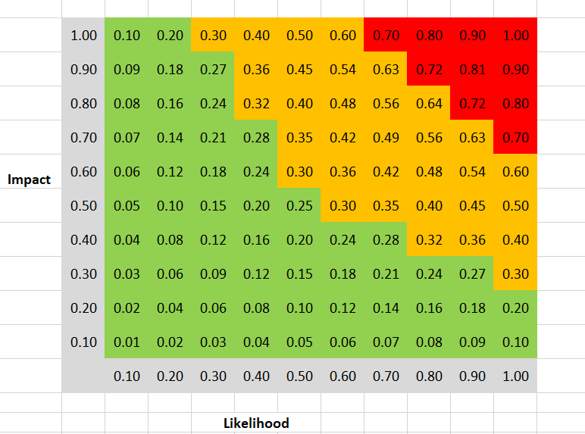

Figure 2 – Biotage’s risk categorisation table

Stage 3 – Registering risks and mitigating actions

The third and final stage of Biotage’s risk analysis process is the entry of analysed risks on a Project Risk Register, advocated by both Prince2 (2012) and APM (2012) as an effective platform for the ongoing management and mitigation of risks. Figure 3 illustrates a selection of Biotage’s recorded ERP upgrade risks, with each record including the following information:

- Risk ID – unique to each risk and can be referenced elsewhere within the project
- Risk description – the nature of the risk and the project area(s) which it concerns
- Risk impact – quantatitive rating of risk impact severity
- Risk likelihood – quantatitve rating of risk probability
- Risk rating – calculated by impact x likelihood to provide an overall risk rating (see stage 2)
- Risk classification – the classification in which the risk rating lies – low, moderate or high
- Risk owner – the person(s) responsible for managing the risk and implementing the necessary mitigating actions
- Risk response strategy – actions and initiatives taken to address the risk (see 3.0)

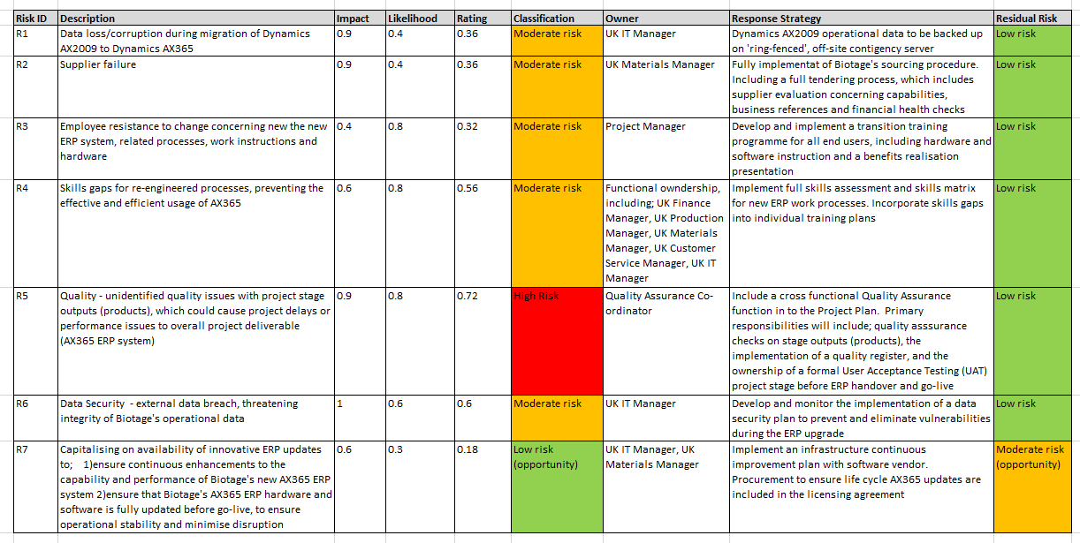
Figure 3 – Biotage ERP project risk registe
3.0 Biotage risk management

Following the identification, classification and recording of project risks outlined in 2.0, this SOP instructs the implementation of the following framework to guide their ongoing management and mitigation throughout the duration of the project:

3.1 Management of high risks – Exception reporting and planning

For risks categorised as high, Biotage recognises that these have the potential to threaten the ongoing feasability of the project. Therefore, this SOP requires such risks to be escalated for review by the Project Board (IT Director, Operations Director, UK (country) director) through Exception Reports. Prince2 (2012) proposes the use of Exception Reports as a tool to clearly communicate a high level risk, its description and impact, options and recomendations to address the risk.

Upon review of the Exception Report, the Project Board will approve (or reject) the development of an Exception Plan. The Exception Plan will include an in-depth breakdown of the recommended measures to address the risk between the present time and the conclusion of the relevent project stage. Upon development of the Exception Plan, the plan will require submission, review, consultation and approval from the Project Board, resulting in the release of resource from the Project Risk budget (see 3.3.1). Upon approval of the Exception Plan, the Project Manager will be able to excecute the exception plan and if required, revise the Project Plan.

3.2 Management of moderate and low risks

For risks categorised as moderate or low risks against the Probability Impact Grid, several activities will be implemented, depending on the severity of likelihood and impact.

For low risks (with a maximum Probability/ Impact rating of 0.30), Biotage recognises that any corrective actions or project plan revisions would not be viable with regards to return on resources invested. Therefore, this SOP instructs that Biotage implements ‘acceptance’ as an initial risk response, followed by periodic risk monitoring during Stage Reviews (see 3.3.2) for changes to probability and impact. This will enable the Project Team to identify whether any changes are required to risk classification and the subsequent risk response.

For the management of moderate level risks, this SOP proposes the use of 3 diferent types of risk response as outlined by Prince2 (2012):

- Reduce – Initiatives within a project stage to reduce the probability or impact of a risk occuring, thereby reducing its total Probability/Impact score
- Fallback – Reactive initiatives concerned with minimising the impact of risk, but not probability, such as contingency planning
- Enhance opportunity – Initiatives within a project stage to increase the probability or impact of an opportunity occuring, thereby increasing its total Probability/Impact score
Considering the greater level of probability and impact of moderate risks in comparison to low risks, this SOP instructs their continuous monitoring throughout project stages (rather than periodic). This is due to the greater potential for such risks to escalate to a high risk classification, which could pose a threat to ongoing project feasbility.

3.3 Non-risk specific management initiatives

3.3.1 Risk budget

In line with the Prince2 (2012) methodology, Biotage’s ERP upgrade project plan incorporates a risk budget. Through the inclusion of a risk budget, Biotage is able to ensure resource availability for the project critical mitigation of high risks, as communicated through Exception Plans. For any Exception Plan which requires the release of risk budget resource, this SOP requires the following information to be submitted to the Project Board for approval:

- The cost of risk impact
- Description of risk response (including activities, timeframe and responsibilities)
- The cost of risk response
- The planned level of residual risk upon succesful implmentation of the mitigation plan

Upon consultation and review of the plan, the project board will either approve the plan (resulting in the release of risk budget resource), or reject the plan (requiring a reformulation and resubmission of the plan).

In developing the Project Plan’s risk budget, the Project Manager is required to provide an expected risk budget utlisation, based on the risk identification and analysis framework discussed in 2.0 conducted during the formulation of the Project Plan. From this, should the risk budget requirement exceed a tolerance of 5% at any point during the project, this SOP instructs a full review of the project plan, including ongoing project feasability.

3.3.2 Stage reviews and release of resource

In line with the methodology outlined by both Prince2 (2012) and APM (2012), Biotage’s ERP upgrade project plan is divided into stages. As identified through risk analysis in 2.0, the project will be subject to several risks of varying severity; of which some have the potential to influence ongoing project feasability. As a result, upon the completion of project stages (and their required products), this SOP instructs the use of stage reviews. By conducting stage reviews, Lock (2007) proposes that organisations can periodically review existing project risks and identify any changes to impact or probability, which may require a change in categorisation and mitigating response. Continuing, Lock (2007) also suggests that stage reviews can also be used as a periodic review of the project enviornment and provide organisations with an opportunity to identify, analyse and regcord new project risks.
Through the implementation of stage reviews and the re-evaluation of project risks, this SOP aims to provide a platform for Biotage to ratify the feasability of the project progressing to the next stage. Stage reviews shall be conducted between the Project Board, Project Manager and Team Managers. This provision aims to ensure that the stage review group includes the necessary decision makers, experience and cross functional expertise to conduct an effective evaluation and judgement concerning whether the proceeds to the next stage.

In conjunction with stage reviews, Biotage will also implement phased resource release as proposed by APM (2012). As a result, necessary resources (including time, financial, physical and human) for the next project stage will not be released until the preceeding stage review has been completed and progression to the subsequent stage authorised. By implementing this strategy, Biotage can maintain a greater level of resource control and minimise risk by not releasing all requirements at the beginning of the project (APM, 2012).

4.0 Quality planning and assurance

As part of Biotage’s project Risk Management SOP, Prince2 proposes the use of quality planning and quality assurance activities throghout a project, to ensure that it remains within scope and the paramaters of the Project Plan and business case. Furthermore, quality assurance activities will ensure that outputs such as stage products are within specification and fit for purpose.

As a result, this SOP instructs the following quality assurance activities:

4.1 Quality Assurance (QA) testing

Quality assurance testing will be applied to all project products and implemented by a cross functional QA Team, external to the Project Team. In line with the Prince2 (2012) methodology, the QA Team will analyse stage products both in proccess and post output. The aim of this analysis is to only to ensure that products meet Project Plan specifications (or sit within assigned tolerances), but to also ensure compliance with the organisation’s wider standards and systems. For example, when testing the ERP IT architecture, the QA Team will ensure that:

- the output architecture meets the product specification outlined in the Stage Plan and Project Plan
- is compliant with Biotage’s corporate IT and data protection policies

4.2 Quality Register

The Quality Register include records of all outputed products, which have been tested against project specifications. This SOP instructs the following information to be included in Quality Register records, to enable effective management and traceability of product testing and verfication:
  - Quality record ID
  - Product specification
  - Description of quality assurance activities implemented
  - Quality assurance test date
  - Quality assurance resut – pass or fail
  - Record owner
  - Product ID entered on to Product Register (if pass)
  - Other comments (as appropriate)

4.3 User Acceptance Testing

Before the handover of Dynamics AX365 to the end users (Biotage operations), User Acceptance Testing (UAT) will be implemented to validate that the new ERP system, hardware and software is fit for purpose in accordance with the Project Plan’s specifications. Supporting this strategy, the University of Edinburgh (2016) proposes that ‘a well-managed UAT process will give the Project Sponsor, Project Team and end users confidence that the solution being delivered meets the requirements’.

Due to the business critical nature of the ERP upgrade project, Biotage’s project plan incorporates two stages of User Acceptance Testing; UAT1 and UAT2. UAT1 is intended to conduct a full operational appraisal of the ERP system to identify any functional issues or specification discrepancies, which may have been missed by previous quality assurance tests. This SOP instructs the second stage (UAT2) to validate any corrective actions or product modifications (resulting from UAT1) and to ensure that the system is fit for purpose and handover to Business As Usual (BAU).

In order to strengthen quality assurance performance on future pojects, this SOP instructs that all UAT1/2 quality issues are recorded on a Lessons Learned Register, in addition to the Quality Register. By using a Lessons Learned Register to record instances where discrepenecies were missed by earlier in-stage testing, corrective action plans can be implemented and monitored to manage necessary improvements to Quality Assurance testing processes (Kwak and Stoddard, 2004).

5.0 Conclusion

In conclusion, this report suggests that Biotage has developed a robust risk management SOP, enabling the organisation to systematically conduct effective and efficient risk management throughout the duration of its AX365 ERP upgrade project.

Firstly, a comprehensive quantitative risk identification process (through risk registration and probability/impact analysis) provides the platform for Biotage to thoroughly appraise the internal and external project environment, and strategise mitigating measures appropriate to risk severity. Furthermore,the SOP has also integrated several trigger points (through stage reviews), by which Biotage is able to continuously appraise identified risks and ensure continued project feasability, before releasing further resources required for the delivery of subsequent deliverables.

In addition to addressing risks concerned with the project environment, Biotage has also incorporated several Quality Assurance initiatives, concerning comprehensive in-process and output checks on project deliverables. By validating that project deliverables meet required specifications, this SOP ensures that the organisation effectively mitigates quality risks within the project scope and minimises the probability/impact of disruption during live operations, which could result in catastrophic consequences to the organisation.

References:

Dyson R.G., (2002), Strategic development and SWOT anlysis at the University of Warwick, European Journal of Operational Research, Volume 152, pp631-640

Lock D. (2007), Project Management, Ninth Edition, Gower

Burkov V., Burkova I., Barkhi R., Berlinov M., (2018), Qualitative Risk Assessments in Project Management in Construction Industry, MATEC Web of Conferences, 01 January 2018, Vol.251, p.06027

Prince2 (2012) Managing successful projects with Prince 2, 2009 Edition (2012 impression), The Stationary Office - London

Rastogi N., Trivedi M.K., (2016), PESTLE technique – a tool to identify external risks in construction projects, International Research Journal of Engineering and Technology (IRJET), Volume 3 (Issue)1

Kwak Y.H., Stoddard J.,(2004), Project risk management: lessons learned from software development environment, Technovation, Vol.24, Issue 11, November 2004, pp 915-920

Explore Dynamics 365 for Finance and Operations capabilities, Microsoft, Accessed 21/08/2019 at 12:35, Available at: https://dynamics.microsoft.com/en-gb/finance-and-operations/capabilities/

APM Knowledge (2012), APM Body of Knowledge, 6th Edition, The Association of Project Management

User Acceptance Test, (2016,) The University of Edinburgh, Accessed 24/08/2019 at 17:30, Available at: https://www.projects.ed.ac.uk/project/has001/user-acceptance-test-plan/user-acceptance-test

About Biotage, Biotage AB, Accessed 23/07/2019 at 16:30, Available at: http://www.biotage.com/page/about-biotage

